**Instructions**

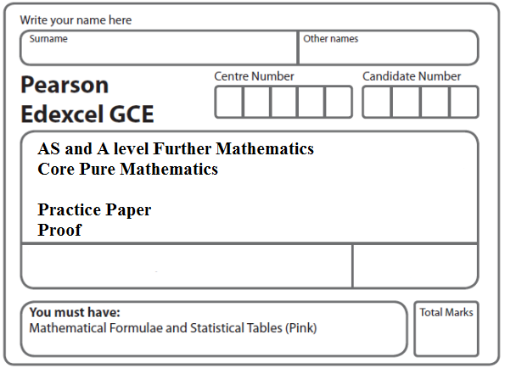

* Use black ink or ball-point pen.
* If pencil is used for diagrams/sketches/graphs it must be dark (HB or B).
* Fill in the boxes at the top of this page with your name, centre number and candidate number.
* Answer all the questions and ensure that your answers to parts of questions are clearly labelled.
* Answer the questions in the spaces provided – there may be more space than you need.
* You should show sufficient working to make your methods clear. Answers without working may not gain full credit.
* Inexact answers should be given to three significant figures unless otherwise stated.

**Information**

* A booklet ‘Mathematical Formulae and Statistical Tables’ is provided.
* There are 6 questions in this question paper. The total mark for this paper is 53.
* The marks for each question are shown in brackets – use this as a guide as to how much time to spend on each question.
* Calculators must not be used for questions marked with a * sign.

**Advice**

• Read each question carefully before you start to answer it.

• Try to answer every question.

• Check your answers if you have time at the end.

• If you change your mind about an answer, cross it out and put your new answer and any working underneath.

**1.** (i) Prove by induction that, for *n* ∈ ℤ+,

 = 

**(6)**

(ii) Prove by induction that, for *n* ∈ ℤ+,



**(6)**

**(Total 12 marks)**

**___________________________________________________________________________**

**2.** (i) A sequence of numbers is defined by

*u*1 = 6, *u*2 = 27

*un*+2 = 6*un*+1 – 9*un n* ⩾ 1

Prove by induction that, for *n* ∈ ℤ+

*un* = 3*n*(*n* + 1)

**(6)**

(ii) Prove by induction that, for *n* ∈ ℤ+

f (*n*) = 33*n*–2 + 23*n*+1 is divisible by 19

**(6)**

**(Total 12 marks)**

**___________________________________________________________________________**

**3.** Prove by induction that, for *n* ∈ ℤ+,

f(*n*) = 8*n* – 2*n*

is divisible by 6.

**(Total 6 marks)**

**___________________________________________________________________________**

**4.** Prove by induction, that for *n* ∈ ℤ+,

(*a*)  = 

**(6)**

(*b*) f(*n*) = 72*n* − 1 + 5 is divisible by 12.

**(6)**

**(Total 12 marks)**

**___________________________________________________________________________**

**5.** A sequence of numbers *u*1, *u*2, *u*3, *u*4, . . .,is defined by

*un* + 1 = 4*un* + 2, *u*1 = 2.

Prove by induction that, for *n* ∈ ℤ+,

*un* = (4*n* – 1).

**(5)**

**(Total 5 marks)**

**___________________________________________________________________________**

**6.** Prove by induction that, for *n* ∈ℤ+,

f(*n*) = 22*n* – 1 + 32*n* – 1

is divisible by 5.

**(Total 6 marks)**

**TOTAL FOR PAPER: 53 MARKS**