

**Higher IGCSE (9 – 1) Revision Pack**

**Calculus**

**Name --------------------------------**

**Questions**

**Q1.**

A particle is moving in a straight line which passes through a fixed point *O*.  
 The displacement, *s* metres, of the particle from *O* at time *t* seconds is given by

*s* = 10 + 9*t*2 − *t*3

(a) Find an expression for the velocity, *v* m/s, of the particle at time *t* seconds.

*v* = ...........................................................

**(2)**

(b) Find the time at which the acceleration of the particle is zero.

...........................................................seconds

**(2)**

**(Total for question = 4 marks)**

**Q2.**

A particle moves along a straight line.   
The fixed point *O* lies on this line.   
The displacement of the particle from *O* at time *t* seconds is *s* metres, where

*s* = *t*3 − 6*t* + 3

(a)  Find an expression for the velocity, *v* m/s, of the particle at time *t* seconds.

*v* = ...........................................................

**(2)**

(b)  Find the acceleration of the particle at time 5 seconds.

........................................................... m/s2

**(2)**

**(Total for Question is 4 marks)**

**Q3.**

For *y* = *x*3 − 6*x*2 + 20

(a) (i) show that *y* = 4 when *x* = 2

(ii) complete the table of values

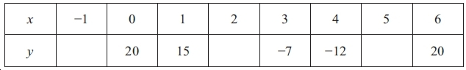

**(2)**

(b) On the grid, draw the graph of *y* = *x*3 − 6*x*2 + 20 for values of *x* from −1 to 6

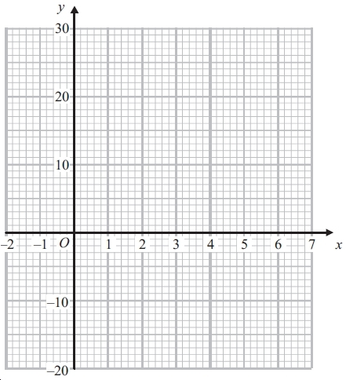

**(2)**

(c) For the curve with equation *y* = *x*3 − 6*x*2 + 20



(i) find

..............................................................

(ii) find the gradient of the curve at *x* = −3

...............................

**(4)**

**(Total for question = 8 marks)**

**Q4.**

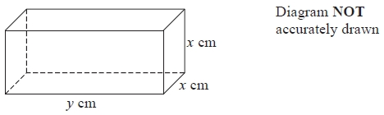

The diagram shows a cuboid of volume *V* cm3 The length of the cuboid is *y* cm The width and height of the cuboid are both *x* cm

The total length of all the edges of the cuboid is 112 cm

(a)  Show that *V* = 28*x*2 − 2*x*3

**(3)**

  
(b)  Find

 = ...........................................................

**(2)**

(c)  Find the maximum value of *V*  
       Give your answer correct to 3 significant figures.

*V* = ...........................................................

**(3)**

**(Total for question = 8 marks)**

**Q5.**

A farmer has 180 metres of fencing.   
With the 180 metres of fencing, he makes an enclosure divided into eight equal, rectangular pens.   
The fencing is used for the perimeter of each pen.

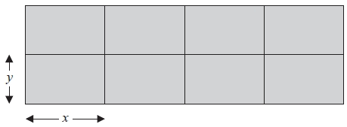

The length of each pen is *x* metres and the width of each pen is *y* metres.

(a) (i) Show that *y* = 18 − 1.2*x*

The total area of the enclosure is *A* m2.

(ii) Show that *A* = 144*x* − 9.6*x*2

**(3)**

  
(b)   Find

...........................................................

**(2)**

(c)   Find the maximum value of *A*.

*A* = ...........................................................

**(3)**

**(Total for Question is 8 marks)**

**Q6.**

(a)   *y* = 2*x*3 + 3*x*2 + 2



Find

...........................................................

**(2)**

(b)   The point *P* lies on the curve with equation *y* = 2*x*3 + 3*x*2 + 2

The gradient of the curve at *P* is − 3⁄2

Find the coordinates of *P*.

(........................................................... , ...........................................................)

**(5)**

**(Total for Question is 7 marks)**

**Q7.**

For the curve **C** with equation

*y* = 2*x*3 − 3*x*2 − 12*x* + 9

(a)  find

...........................................................

**(2)**

(b)  Find the gradient of **C** at the point with coordinates (2, −11)

...........................................................

**(2)**

The curve *C* has a gradient of −12 at the point where *x* = *k* and at the point where *x* = *m*.   
Given that *k* > *m*

(c)  find the value of *k* and the value of *m*.

*k* = ...........................................................

*m* = ...........................................................

**(3)**

**(Total for question = 7 marks)**

**Q8.**

For the curve with equation *y* = 4*x*3 − 2*x* + 5

  
(i)  find

...........................................................

(ii) find the coordinates of the two points on the curve where the gradient of the curve is 1

(.............. , ..............) and (.............. , ..............)

**(Total for Question is 6 marks)**

**Q9.**

*y* = *x*3 – 6*x*2 – 15*x*



(a)  Find



= ...........................................................

**(2)**

The curve with equation *y* = *x*3 – 6*x*2 – 15*x* has two stationary points.

(b)  Work out the coordinates of these two stationary points.

( ................ , ................ )

( ................ , ................ )

**(4)**

**(Total for question = 6 marks)**

**Q10.**

*y* = *x*3 − 4*x*2 + 4*x* + 3

(a)  Find

...........................................................

**(2)**

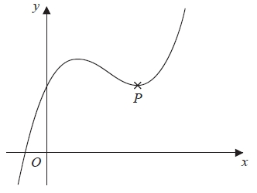

The diagram shows a sketch of the curve with equation *y* = *x*3 − 4*x*2 + 4*x* + 3   
The point *P* is a turning point on the curve.

(b)  Work out the coordinates of *P*.   
       Show clear algebraic working.

(............................. , .............................)

**(4)**

(c)  Write down the range of values of *x* for which the curve has a negative gradient.

...........................................................

**(2)**

**(Total for question = 8 marks)**

**Q11.**

*y* = *x*2 −



(a)  Find

  
  
  
  
  
 = ...........................................................

**(3)**

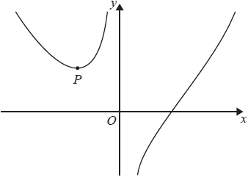

  
The graph shows part of the curve with equation *y* = *x*2 −

The point *P* is the turning point of the curve.

(b)  Work out the coordinates of *P*.

(............................. , .............................)

**(4)**

**(Total for question = 7 marks)**

**Q12.**

*y* = *x*3 – *x*2 – 54*x* + 10



(a)  Find

...........................................................

**(2)**

The curve with equation *y* = *x*3 – *x*2 – 54*x* + 10 has two turning points.

(b)  Find the *x* coordinate of each of these two points.

...........................................................

**(3)**

**(Total for question = 5 marks)**

**Q13.**

A curve has equation *y* = *x*3 – 4*x*2 + 5*x* + 4

(a)  Find

...........................................................

**(2)**

(b)  Find the *x* coordinates of the points where the curve with equation *y* = *x*3 – 4*x*2 + 5*x* + 4 has a gradient of 1

Show clear algebraic working.

...........................................................

**(4)**

**(Total for question = 6 marks)**

**Q14.**

(a) Differentiate with respect to *x*

(i) 8*x*2

...........................................................

(ii)  2/x

...........................................................

**(3)**

(b) The curve with equation *y* = 8*x*2 + 2/x has one turning point.

Find the coordinates of this turning point.  
 Show your working clearly.

(.............................. , .............................)

**(4)**

**(Total for question = 7 marks)**

**Q15.**

A particle is moving along a straight line.   
The fixed point *O* lies on this line.   
The displacement of the particle from *O* at time *t* seconds is *s* metres where

*s* = 2*t*3 − 12*t*2 + 7*t*

(a)  Find an expression for the velocity, *v* m/s, of the particle at time *t* seconds.

*v* = ...........................................................

**(2)**

(b)  Find the time at which the acceleration of the particle is instantaneously zero.

........................................................... seconds

**(2)**

**(Total for question = 4 marks)**

**Q16.**

The diagram shows a cylinder inside a cone on a horizontal base.   
The cone and the cylinder have the same vertical axis.   
The base of the cylinder lies on the base of the cone.   
The circumference of the top face of the cylinder touches the curved surface of the cone.

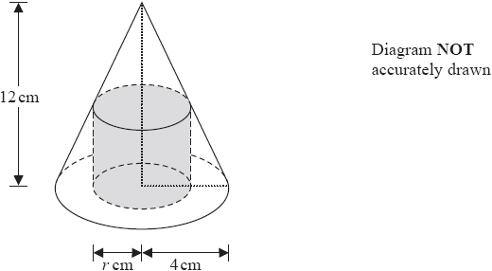

The height of the cone is 12cm and the radius of the base of the cone is 4cm.

(a)  Work out the curved surface area of the cone.

Give your answer correct to 3 significant figures.

........................................................... cm2

**(3)**

The cylinder has radius *r* cm and volume *V* cm3

(b)  Show that *V* = 12*πr*2 – 3*πr*3

**(3)**

(c)  *V* = 12*πr*2 – 3*πr*3

Find the value of *r* for which *V* is a maximum.

*r* = ...........................................................

**(4)**

**(Total for question = 10 marks)**

**Q17.**

The curve with equation *y* = 10*x*2 + 9*x* + 5 has a minimum at point *A*.

Find the coordinates of *A*.   
Show your working clearly.

( ................................ , ................................ )

**(Total for question = 4 marks)**

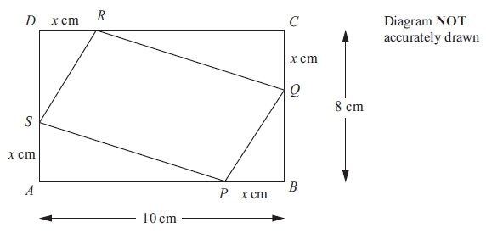**Q18.**

*ABCD* is a rectangle.  
*AB* = 10 cm.  
*BC* = 8 cm.  
*P*, *Q*, *R* and *S* are points on the sides of the rectangle.  
*BP* = *CQ* = *DR* = *AS* = *x* cm.

(a) Show that the area, *A* cm2, of the quadrilateral *PQRS* is given by the formula

*A* = 2*x*2 − 18*x* + 80

**(3)**

(b) For *A* = 2*x*2 − 18*x* + 80



(i) find

...........................................................

(ii) find the value of *x* for which *A* is a minimum.

*x* = ...........................................................

(iii) Explain how you know that *A* is a minimum for this value of *x*.

      ..............................................................................................................................................

      ..............................................................................................................................................

**(5)**

**(Total for question = 8 marks)**

**Q19.**

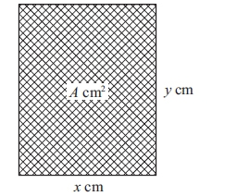

The diagram shows a rectangular photo frame of area *A* cm2.   
The width of the photo frame is *x* cm.   
The height of the photo frame is *y* cm.   
The perimeter of the photo frame is 72 cm.

(a) Show that *A* = 36*x* − *x*2

  
  
  
  
  
  
  
  
  
  
**(3)**

(b) Find

...........................................................

**(2)**

(c) Find the maximum value of *A*.

*A* = ...........................................................

**(3)**

**(Total for question is 8 marks)**

**Q20.**

The curve *C* has equation    *y* = *x*2 – 6*x* + 4

Using the axes below, sketch the curve *C*.   
On your sketch show clearly

(i)  the exact coordinates of any points of intersection of *C* with the coordinate axes,

(ii)  the coordinates of the turning point.

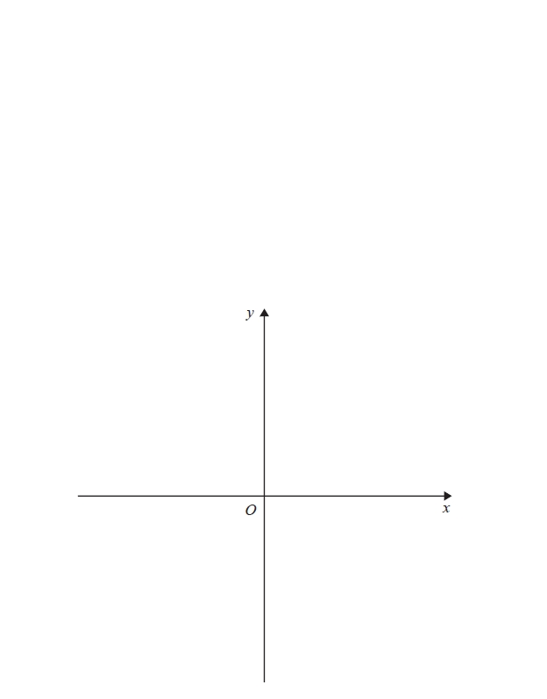

**(Total for question = 6 marks)**

**Q21.**

A particle moves along a straight line.   
The fixed point *O* lies on this line.   
The displacement of the particle from *O* at time *t* seconds is *s* metres where



Find the velocity of the particle at time 5 seconds.

........................................................... m/s

**(Total for question = 3 marks)**

**Q22.**

A farmer has 120 metres of fencing.   
He is going to make a rectangular enclosure *PQRS* with the fencing.   
He is also going to divide the enclosure into two equal parts by fencing along *MN*.

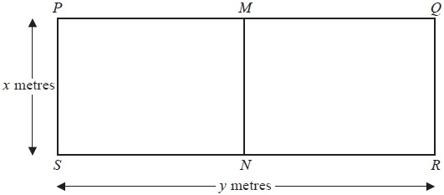

The width of the enclosure is *x* metres.   
The length of the enclosure is *y* metres.

(a)  (i)  Show that *y* = 60 − 1.5*x*

The area of the enclosure *PQRS* is *A* m2

(ii)  Show that *A* = 60*x* − 1.5*x*2

**(3)**

  
(b)  Find

...........................................................

**(2)**

(c)  Find the maximum value of *A*.

*A* = ...........................................................

**(3)**

**(Total for Question is 8 marks)**

**Q23.**

The curve *C* has equation *y* = 3*x*2 – 12*x* + 8

(a)  Find

  
  
  
  
  
  
  
  
 = ...........................................................

**(2)**

(b)  Find the coordinates of the point on *C* where the gradient of the curve is 18

(........................... , ...........................)

**(3)**

**(Total for question = 5 marks)**

**Q24.**

Curve **C** has equation    *y* = 8*x*3 − 3*x*2 − 25*x*

(a)  Find

...........................................................

**(2)**

(b)  Find the *x* coordinates of the points on **C** where the gradient is 5

Show clear algebraic working.

...........................................................

**(4)**

**(Total for question = 6 marks)**

**Q25.**

(a) Find f(10)

...........................................................

**(1)**

(b) State which values of *x* must be excluded from a domain of *f*

...........................................................

**(2)**

The diagram shows part of the graph of *y* = g(*x*)

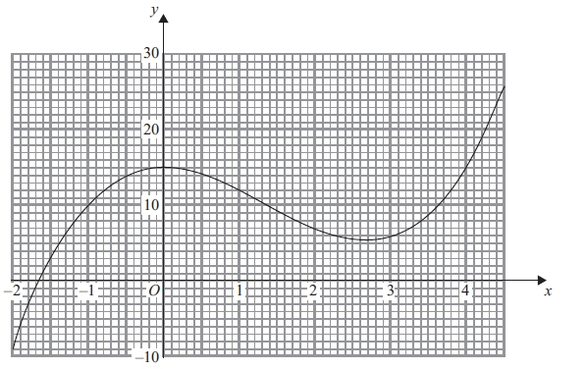

(c) Find g(2)

...........................................................

**(1)**

(d) Find fg(0)

...........................................................

**(2)**

(e) One of the solutions of g(*x*) = *k*, where *k* is a number, is *x* = 1

Find the other solutions.   
Give your answers correct to 1 decimal place.

...........................................................

**(3)**

(f) Find an estimate for the gradient of the curve at the point where *x* = 3.5   
Show your working clearly.

...........................................................

**(3)**

**(Total for question is 12 marks)**