

**Higher IGCSE (9 – 1) Revision Pack**

**Straight Lines 2 Perpendicular Lines**

**Name --------------------------------**

**Q1.** (*a*) Write down the equation of a straight line that is parallel to *y* = 5*x* + 6

**(1)**

(*b*) Find an equation of the line that is perpendicular to the line *y* = 5*x* + 6 and passes through the point (–2, 5).

**(3)**

**(Total 4 marks)**

**Q2.** (*a*) Write down an equation of a straight line that is parallel to the straight line *y* = 3*x* – 5

**(1)**

A straight line, L, is perpendicular to the straight line *y* = 3*x* – 5 and passes through the   
point (6, 5)

(*b*) Find an equation of L.

**(3)**

**(Total 4 marks)**

**Q3.** The straight line **L** has equation *y* = 3*x* – 4

(*a*) Write down an equation of the line parallel to **L** which passes through the origin.

**(2)**

(*b*) Find an equation of the straight line that passes through (0, 5) and is perpendicular to **L**.

**(2)**

**(Total 4 marks)**

**Q4.** The straight line **L** has equation *y* = 2*x* − 5

Find an equation of the straight line perpendicular to **L** which passes through (−2, 3).

**(Total 3 marks)**

**Q5.** (*a*) Find an equation of the line that passes through the points (−3, 5) and (1, 2)

Give your answer in the form *ax* + *by* = *c* where *a*, *b* and *c* are integers.

**(4)**

Line **L1** has equation *y* = 3*x* + 5

Line **L2** has equation 6*y* + 2*x* = 1

(*b*) Show that **L1** is perpendicular to **L2**

**(2)**

**(Total 6 marks)**

**Q6.**

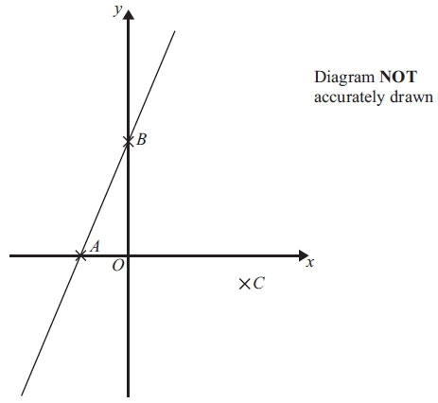

|  |  |  |
| --- | --- | --- |
| In the diagram | *A* is the point | (−2, 0) |
|  | *B* is the point | (0, 4) |
|  | *C* is the point | (5, −1) |

Find an equation of the line that passes through *C* and is perpendicular to *AB*.

**(Total 4 marks)**

**Q7.** A straight line, ***L***, is perpendicular to the line with equation *y* = 1 – 3*x*.

The point with coordinates (6, 3) is on the line ***L***.

Find an equation of the line ***L***.

**(Total 3 marks)**

**Q8.** Find an equation of the straight line that is perpendicular to the straight line *x* + 2*y* = 5 and that passes through the point (3, 7).

**(Total 4 marks)**

**Q9.**

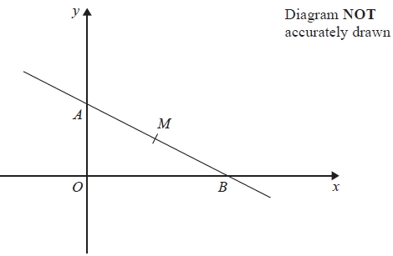

In the diagram

*A* is the point (0, 4)

*B* is the point (6, 0)

*M* is the midpoint of *AB*.

Find an equation of the line that passes through *M* and is perpendicular to *AB*.

**(Total 4 marks)**

**Q10.** The points *A*(6, 1) and *B* (−2, 5) are on the line with equation 

*M* is the midpoint of *AB*.

Find an equation of the line through *M* that is perpendicular to 

**(Total 4 marks)**

**Q11.** *A* is the point with coordinates (1, 3)

*B* is the point with coordinates (4, −1)

The straight line *L* goes through both *A* and *B*.

Is the line with equation 2*y* = 3*x* − 4 perpendicular to line *L*?

You must show how you got your answer.

**(Total 4 marks)**

**Q12.**



*ABCD* is a rhombus.

The coordinates of *A* are (5,11)

The equation of the diagonal *DB* is **

Find an equation of the diagonal *AC*.

**(Total 4 marks)**

**Q13.** *P* has coordinates (–9, 7)

*Q* has coordinates (11, 12)

*M* is the point on the line segment *PQ* such that *PM* : *MQ* = 2 : 3

Line **L** is perpendicular to the line segment *PQ*.

**L** passes through *M*.

Find an equation of **L**.

**(Total 5 marks)**

**End of questions**