

**Word Processing: Basic Editing Task 1**

**Functional Skill:** Format text to enhance its effect

**Skills:**

* basic title formatting
* using the spell check tool
* adding words to the dictionary
* paragraph spacing
* paragraph and formatting marks
* format painter
* automatic hyphenation
* page numbers
* inserting the date and time
* saving as a different version
* page breaks
* bullet points
* borders
* header and footer
* changing margins
* inserting symbols

**TASKS**

1. Open and save the document called ‘Task2.docx’ to your area.

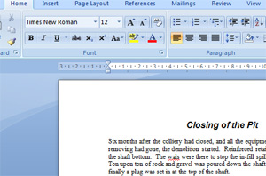

2. Add a title called ‘Closing of the Pit’

* Centre the title.
* Make it size 14
* Change the title font to Ariel
* Make the font bold and italic.

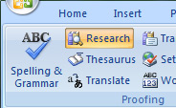

3. Go to the ‘review’ ribbon

Go to the ‘proofing’ section

Click on ‘spelling and grammar’

Use the ‘Spell check’ tool to find any spelling mistakes and alter them.

Delete any repeated words.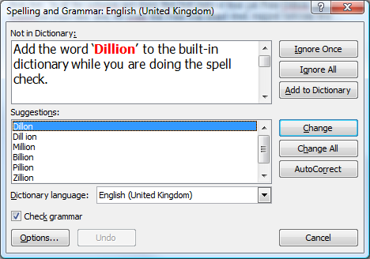

Add the word ‘Dillion’ to the built-in dictionary while you

are doing the spell check.

4. Change the spacing on the paragraphs

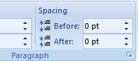

Highlight the first paragraph on your page of text

Go to the ‘page layout’ ribbon

Click on the small arrow in the corner of the paragraph section

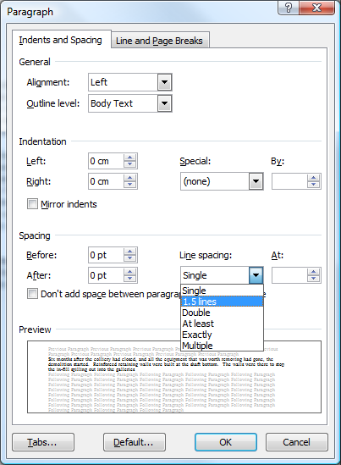This will bring up the paragraph window

Make sure you are on the ‘indents and spacing’ tab

Then choose ‘Spacing’

Then ‘line spacing’

From the drop down arrow, format your paragraphs as follows:

* Paragraph 1 – single line spacing
* Paragraph 2 – 1.5 line spacing
* Paragraph 3 – double line spacing

5. . Apply spacing above and below the centre paragraph:

Highlight the centre paragraph

Make sure you are on the ‘page layout’ ribbon

Go to the ‘paragraph’ section



Then choose ‘Spacing’ and change:

Before – change to 18

After – change to 18

You should notice that you now have extra space above and below your centre paragraph.

6. Viewing paragraph and formatting marks

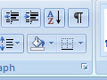

* Go to the ‘home’ ribbon
* Go to the ‘paragraph’ section
* Find this symbol
* And click it.

You should see all of the paragraph marks and formatting appear.

Click it again to switch this view off.

7. Using the format painter tool to copy formats from one piece of text to another

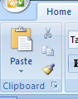

Highlight the centre paragraph and italicise the text.

Make sure that the centre paragraph is still highlighted as you want to copy this format.

Find the ‘format painter’ tool on the home ribbon > clipboard section.

Click on the ‘format painter’ tool. Notice your cursor changes to a paint brush icon so that you can ‘paint’ your formatting somewhere else.

Highlight the third paragraph. You should see the formatting from the centre paragraph be applied to the third paragraph.

8. Apply hyphenation to paragraphs

* 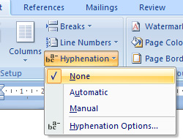Go to the ‘page layout’ ribbon
* Go to the ‘page setup’ section
* Highlight paragraphs 2 and 3.

You are going to make sure that these are set NOT to hyphenate.

* Find ‘hyphenation’
* Click on the arrow
* Choose ‘none’

You are going to set paragraph 1 to automatically hyphenate.

* Highlight paragraph 1
* Click on the arrow next to ‘hyphenation’
* Select ‘automatic’

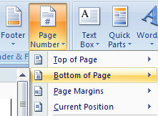

9. Insert page numbers

* Go to the ‘insert’ ribbon
* Go to the ‘header and footer’ section
* Find ‘page number’ and click on the arrow
* Select ‘bottom of page’
* An extra menu should appear giving you lots of different formatting options.
* Try different page numbering options until you find one you like.

10. Inserting the current date and time.

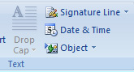

* Place your cursor underneath paragraph 3
* Go to the ‘insert’ ribbon
* Go to the ‘text’ section
* Look for ‘date & time’
* The ‘date and time’ window will pop up.
* Choose your preferred display format
* Tick ‘update automatically’ – this means that every time you open the document, the date and time will be updated to that day.

11. Save the document using the same name but add a version number i.e. ‘Word2 corrected version 2’

Insert a page break before paragraph three

* 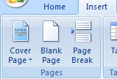Click where you want to start a new page (above paragraph 3)
* Go to the ‘insert’ ribbon
* Go to the ‘pages’ section
* Click on ‘page break’

Paragraph 3 will be placed onto a new page.

12. Underneath paragraph 3 and above the date, type the following:

Colliery Closes

Equipment removed

Demolition starts

Reinforcing walls built at bottom of shaft

Gravel poured down shaft

* Highlight the list that you have just entered.
* Go to the ‘home’ ribbon
* Go to the ‘paragraph’ section
* Apply bullet points to your list.

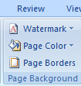13. You are going to put a border around a paragraph

* Highlight paragraph 2
* Go to the ‘page layout’ ribbon
* Go to the ‘page background’ section
* Click on ‘page borders’

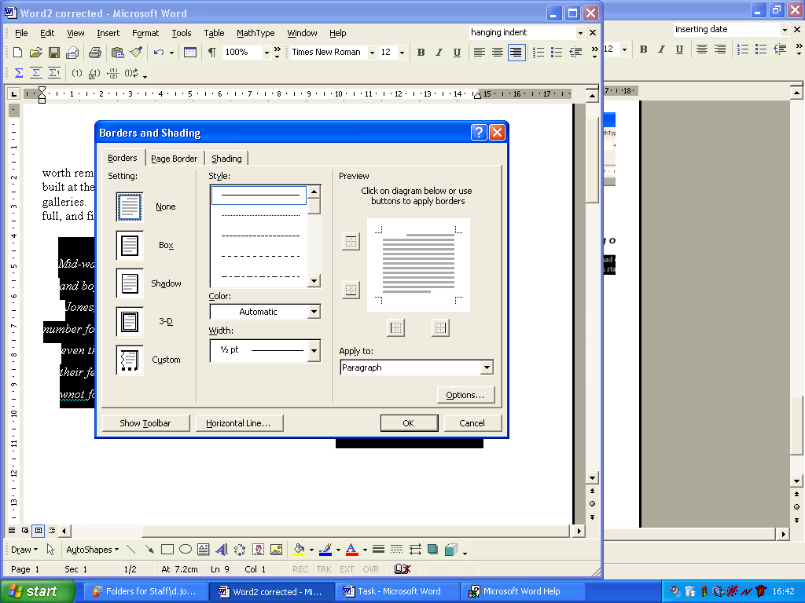The ‘borders and shading’ window will appear

* Make sure you are on the ‘borders’ tab
* Choose a box from the left hand side
* Then choose one of the first three styles
* Choose the colour and the width
* Go to the ‘shading’ tab and add a background shade.
* Then click OK.

You should have a border around paragraph 2.

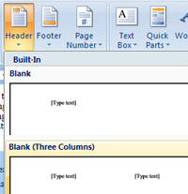

14. Insert details into the header or footer

* Go to the ‘insert’ ribbon
* Go to the ‘header and footer’ section
* Choose ‘Header’
* Choose the style of header that you prefer
* Enter information such as your name or the title of the document
* Close the header by clicking back onto the main part of your document

Try editing the text in your header.

* Go to the ‘header and footer’ section
* Click on ‘header’
* Go to the bottom of the list and choose ‘edit header’
* Change some of the text in your header

15. Changing the margins on your document:

* Go to the ‘page layout’ ribbon
* Go to the ‘page setup’ section
* Click on ‘margins’
* Try some of the default options that you are offered
* 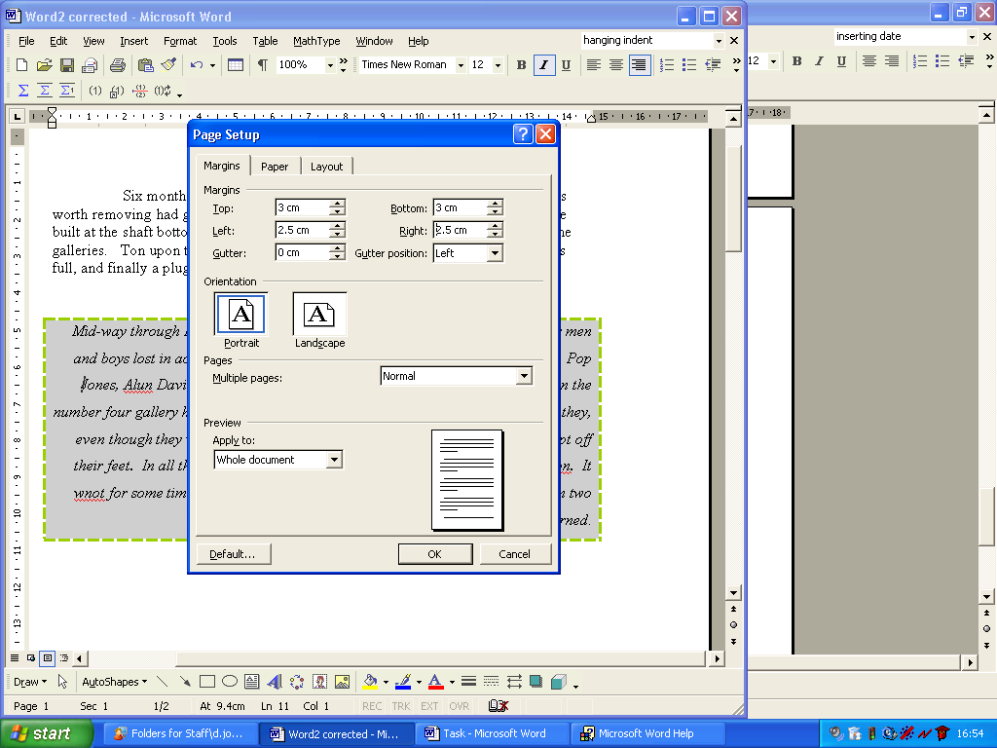Click on ‘margins’ again
* Go down to the bottom of the menu and choose ‘custom margins’
* The ‘page setup’ window will appear
* Change the margins so that the top and bottom margins are 3 cm and the left and right ones are 2.5 cm.
* Click ‘ok’ to apply your settings.

16. Insert a symbol

There are various symbols that you can insert into your document such as: © √ ∞ ≈

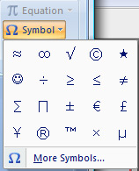

* Go to the ‘insert’ ribbon
* Go to the ‘symbols’ section
* Click on ‘symbol’

You will see the most commonly used symbols displayed.

* Choose the ©
* Click on ‘more symbols’
* Have a look at the other symbols which are available.
* Choose another 2 symbols to insert into your work.