**3.3.8 Aldehydes & ketones**

**AS Link:**

**3.1.5 – Introduction to organic chemistry (mechanisms & nomenclature)**

**3.2.10 – Alcohols (oxidation)**

**A level link:**

**3.3.7 – Optical isomers**

**Introduction**

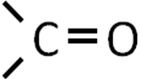

This is a carbonyl group

|  |  |
| --- | --- |
| ***Physical properties*** - carbonyl group is **strongly polar** Cδ+ = Oδ- so has **dipole-dipole** forces, giving **higher boiling points** than alkanes of comparable Mr but not as high as alcohols, which have hydrogen bonds. |  |
|  |  |
| ***Solubility in water*** – **shorter** chained aldehydes and ketone will **dissolve** in water due to **hydrogen bonding** between O on carbonyl and water. As the chain length increases they become less soluble. |  |
|  |  |
| ***Reactivity*** – The C=O bond is **strong** (stronger than C=C). This would suggest the carbonyl group in these compounds will be least reactive but most reactions involve C=O bond due to the big difference in **electronegativity**. It is susceptible to **reactions with nucleophiles,** which **are attracted to the Cδ+** giving rise to the **unsaturated** double bond opening up in an **addition** reaction. |  |
|  |  |
| ***Shape –*** C=O bond is **planar**; nucleophiles can approach carbon from **either side equally** giving rise to **optical isomers**. |  |

Aldehydes and ketones

The addition of different atoms or alkyl chains to the carbonyl group produces:

|  |  |
| --- | --- |
| **Aldehydes** | **Ketones** |
|  |  |
| Carbonyl is at the end of the chain | Carbonyl is in the middle of the chain |

Aldehydes and ketones are **isomers** of each other.

Nomenclature

|  |  |
| --- | --- |
| **Aldehydes** | **Ketones** |
| Suffix –al  No need to number functional group – always on carbon 1 | Suffix –one  Carbon chains longer than 5 – number functional group |
|  |  |
| 2-ethylpentanal | 3-methylbutan-2-one |

**Oxidation**

**Primary alcohols** can be oxidised to **aldehydes** (removal of 2 hydrogens), further oxidation can occur to give a **carboxylic acid**.

***Partial oxidation***

Partial oxidation of alcohol to form aldehydes

# Reactant: 1o alcohol + potassium dichromate (VI) (K2Cr2O7)

# Conditions: warm & acidic (dil. H2SO4)

Product: aldehyde

|  |  |
| --- | --- |
| ***Oxidation***  Oxidation of alcohol Reactant: 1o alcohol + excess potassium dichromate (VI) (K2Cr2O7)Conditions: hot & acidic (conc. H2SO4) & reflux(*evaporation then condensation back into the flask prevents escape of aldehyde, allowing it be converted into the carboxylic acid*) Product: carboxylic acid |  |

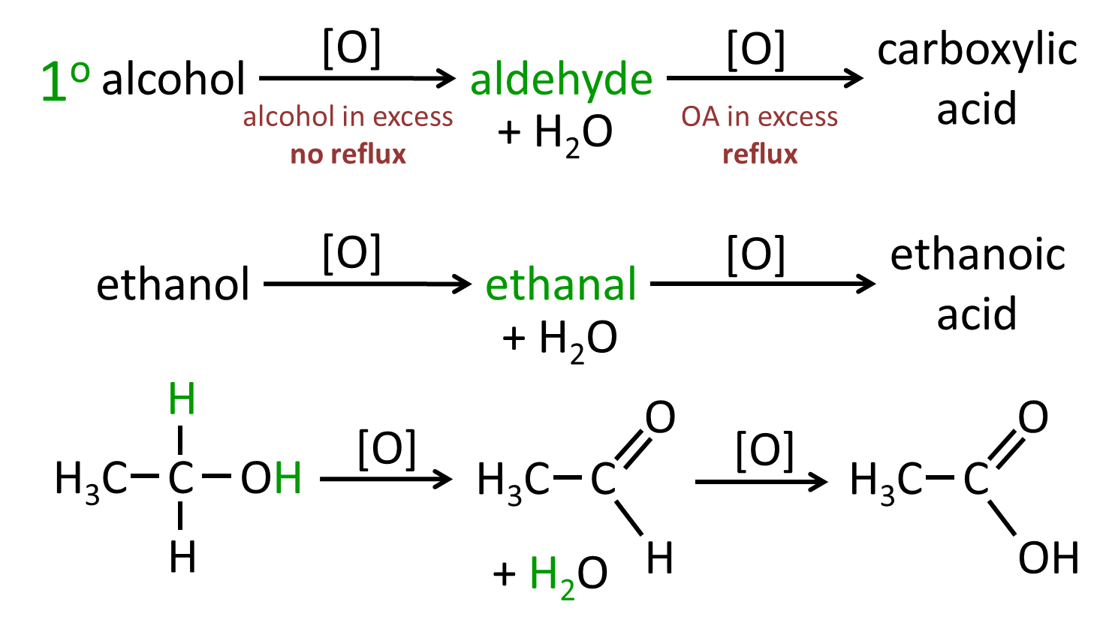

**Secondary alcohols** can be oxidised to ketones – with no hydrogen atoms attached to carbonyl (C=O) carbon they cannot easily be oxidised further.

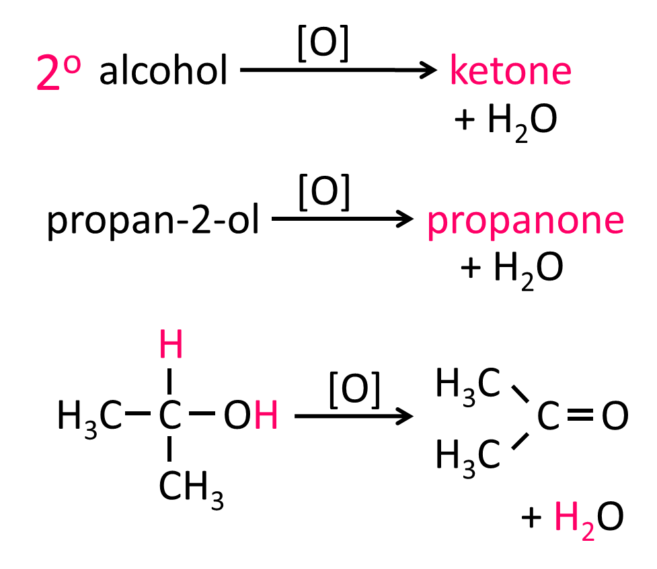

***Starter: 4.1 – Oxidation of alcohols***

Distinguishing between aldehydes and ketones

|  |  |  |  |
| --- | --- | --- | --- |
| **Reagent** | **Aldehyde** | | **Ketone** |
| **Test with Tollens’** | complex ion [Ag(NH3)2]+  oxidises the 1o alcohol  complex ion reduced  to give  **SILVER MIRROR** |  | no silver mirror |
| *Tollens’ is oxidising agent*  *colourless Ag(I) ion reduced to metallic silver*  *so alcohol oxidised to an aldehyde* | *Tollens’ is unable to oxidise*  *2o alcohol or ketone* |
| Red: Ag+ (aq) + e- → Ag (s)  colourless → silver metal |

|  |  |  |  |
| --- | --- | --- | --- |
| **Reagent** | **Aldehyde** | | **Ketone** |
| **Test with Fehling’s**  **(Benedict’s)** | complex ion copper(II)  gently warm  complex ion reduced to give  **RED PRECIPITATE** |  | no red precipitate |
| *Fehling’s is oxidising agent*  *deep blue Cu(II) ion reduced to red Cu(I) oxide*  *so alcohol oxidised to an aldehyde* | *Tollens’ is unable to oxidise*  *2o alcohol or ketone* |
| Red: Cu2+ (aq) + e- → Cu+ (s)  deep blue soln → red ppt |

***Starter: 4.2 – Tests for aldehydes & ketones***

**Reduction**

**Aldehydes** and **ketones** can be converted back into primary and secondary **alcohols** **by** **reducing them**. There are many different reducing agents that can be used. Just like in oxidation reactions the **oxidising agent** is represented by **[O]**, in a reduction reaction the **reducing agent** is represented by **[H]**. Remember they must balance.

|  |  |
| --- | --- |
|  |  |

They undergo **reduction via a nucleophilic addition** reaction with a **hydride ions** as the **nucleophile**.

Summary

|  |  |
| --- | --- |
|  |  |

**Nucleophilic addition reactions**

Aldehydes and ketones can undergo **nucleophilic addition** reactions because they contain a **carbonyl group** which is **unsaturated**, and polar.

The general mechanism looks like this:

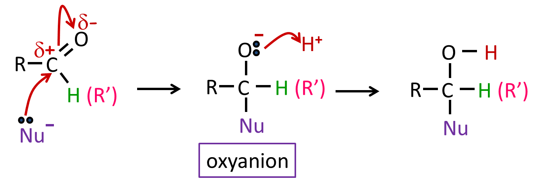

|  |  |  |
| --- | --- | --- |
| **Nucleophiles**: | **Products**: | **Notes:** |
| * Hydride ion (H-) from * Hydrogen gas (H2) * Sodium tetrahydridoborate(III) (NaBH4) | Alcohols  1O & 2O | These are also **reduction** reactions  Nucleophile is a **reducing agent** |
| * Cyanide ion (CN-) from   + Hydrogen cyanide (HCN)   + Sodium cyanide (NaCN)   + Potassium cyanide (KCN) | Hydroxynitriles | With aldehydes and asymmetrical ketones the products are **optical isomer**  Cyanide compounds **toxic** |

**Catalytic hydrogenation**

A catalyst causes the **hydrogen molecule to split heterolytic** (unequal splitting of electron pair) to **produce** the **nucleophile**.

**H2 → H:- + H+**

Reducing agent: Hydrogen gas

Nucleophile: H- (hydride ion)

# Reactant: aldehyde + H2 (g) & ketone + H2 (g)

# Conditions: Ni catalyst

Product: 1o alcohol & 2o alcohol

Equation: RCHO + H2 → RCH2OH 1o alcohol

RCOR + H2 → RCH(OH)R 2o alcohol

Or use of [H] to represent reduction

RCHO + 2[H] → RCH2OH

RCOR + 2[H] → RCH(OH)R

Example: CH3CHO + 2[H] → CH3CH2OH

CH3COCH3 + 2[H] → CH3CH(OH)CH3

***Task: Work out the mechanism – nucleophilic addition***

Mechanism: Nucleophilic addition

# **Nu:-** attacks C=O to form an **oxyanion intermediate** followed by addition of second **H+**

|  |  |
| --- | --- |
| Aldehyde | Ketone |
|  |  |

# **Sodium tetrahydridoborate**

# The **reducing agent** is **NaBH4**, sodium tetrahydridoborate (III) liberatesthe **H-**, hydride ion which is a **nucleophile.** This reducing agent **can reduce Cδ-=Oδ+** but **not C=C** as it is **repelled** by the **high electron density** in the C=C bond but is **attracted** to the **Cδ-** to the C=O bond. So negatively charged **nucleophile** is **repelled** by double bond.

Reducing agent: NaBH4

Nucleophile: H- (hydride ion)

# Reactant: aldehyde + NaBH4 & ketone + NaBH4

# Conditions: aqueous ethanol

Product: 1o alcohol & 2o alcohol

Equation: RCHO + 2[H] → RCH2OH 1o alcohol

RCOR + 2[H] → RCH(OH)R 2o alcohol

Example: CH3CHO + 2[H] → CH3CH2OH

CH3COCH3 + 2[H] → CH3CH(OH)CH3

***Task: Work out the mechanism – nucleophilic addition***

# Mechanism: Nucleophilic addition *Identical to hydrogenation*

**Nu:-** attacks C=O, intermediate oxyanion is **protonated by H+ from water or weak acid**

|  |  |
| --- | --- |
| Aldehyde | Ketone |
|  |  |

***Application: CGP177 PQ1-3***

***Fact recall: CGP177 Q1-5***

Producing hydroxynitriles

Hydroxynitriles contain both a **hydroxyl group** (OH) and a **nitrile group** (CN).

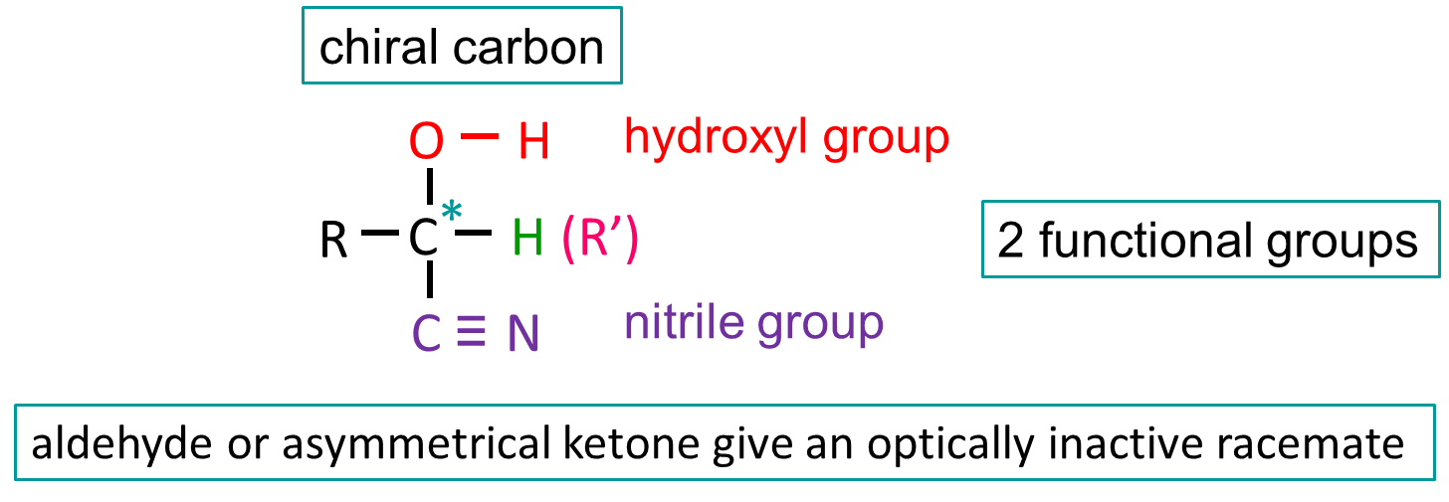

|  |  |
| --- | --- |
|  | 2-hydroxypropanenitrile |

The nitrile is the most important group so it takes the **suffix –nitrile** and the **carbon** attached to the nitrogen is **carbon-1**. The alcohol then uses the **prefix hydroxy-**.

**A level link:**

**3.3.7 – Optical isomers (synthesis of lactic acid)**

When this reaction is carried out with an **aldehyde or an asymmetrical ketone** an **optically inactive racemate** (containing equal quantities of each enantiomers) will be produced. This is because the **carbonyl group is planar** and the cyanide ion can **bond** with **carbon atom approaching** from **either side** **equally**.

**Using sodium or potassium cyanide** **or hydrogen cyanide**

TOXIC

Reagent: NaCN or KCN or HCN

Reactions to generate: KCN(aq) K+(aq) + CN-(aq)



NaCN(aq) Na+(aq) + CN-(aq)



HCN(aq) H+(aq) + CN-(aq)



Nucleophile: CN-

# Reactant: aldehyde & ketone

# 

Conditions (NaCN & KCN): dilute acid

Conditions (HCN): aqueous

Product: hydroxynitrile



Equation: RCHO + CN- RCH(OH)CN



RCOR + CN- RCR(OH)CN

Example: ethanal + cyanide ion → 2-hydroxypropanenitrile



CH3CHO + CN- CH3CH(OH)CN

propanone + cyanide ion → 2-hydroxymethylpropanenitrile



CH3COCH3 + CN- (CH3)2C(OH)CN

***Task: Work out the mechanism – nucleophilic addition***

# Mechanism: Oxyanion intermediate formed then accepts a proton

|  |  |
| --- | --- |
| Aldehyde | Ketone |
|  |  |

***Notes:***

NaCN and KCN are **ionic** compounds which **dissociate** in water to give the metal ions and **cyanide ions**, which **act as nucleophiles**. They are used as a **source** of **cyanide** **ions** to **produce hydroxynitriles**. A **dilute acid** is then added to supply a **hydrogen ion**.

Hydrogen cyanide is a **poisonous liquid** that **boils just above**[**room temperature**](http://en.wikipedia.org/wiki/Room_temperature) . The gas is **difficult to stop escaping**. This high toxicity makes it difficult to handle. It’s also a **weak acid** **so partially ionised** giving a **low concentration cyanide ions**.

So, **sodium or potassium cyanide** are preferred, although they are **also toxic,** but they are **safer to handle** because they are **crystalline solids**. They work as poisons in the mitochondria by inhibiting the uptake of oxygen during respiration.

Hydrogen cyanide can also be used to make hydroxynitriles. It **dissociates** into a **cyanide ion** and **hydrogen ion,** so **no acid** is **needed** to provide a proton.

The products are useful intermediates in the synthesis of other organic compounds and it’s an **important** reaction because the addition of a cyanide ion **increases the chain length**.

***Application: CGP180 PQ1-3***

***Fact recall: CGP180 Q1-3***

***Exam questions: Homework question sheet***