**Types of hazards questions**

1. Define what is meant by a natural hazard. **(1 mark)**
2. Complete the table below by adding two hazards to each column from the list beneath the table. **(8 marks)**

|  |  |  |  |
| --- | --- | --- | --- |
| **Tectonic** | **Geomorphological** | **Atmospheric** | **Biological** |
|  |  |  |  |
|  |  |  |  |

|  |
| --- |
| Avalanche * Disease epidemic * Earthquake * Flooding * Forest fires * Hurricane * Tornado * Volcano |

1. What is the difference between a hydrological hazard and a tectonic hazard? **(2 marks)**

**Figure 1** shows the change in natural hazards over time from 1900-2019.

**Figure 1**

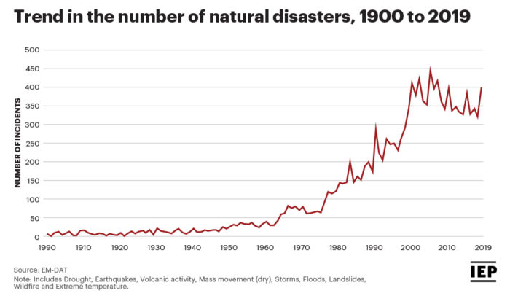

1. Describe what Figure 1 shows. **(3 marks)**
2. Explain reasons for the trend shown in Figure 1. **(4 marks)**

**Figure 2** shows the total number of hazards experienced in the world between 1980 and 2019.

**Figure 2**

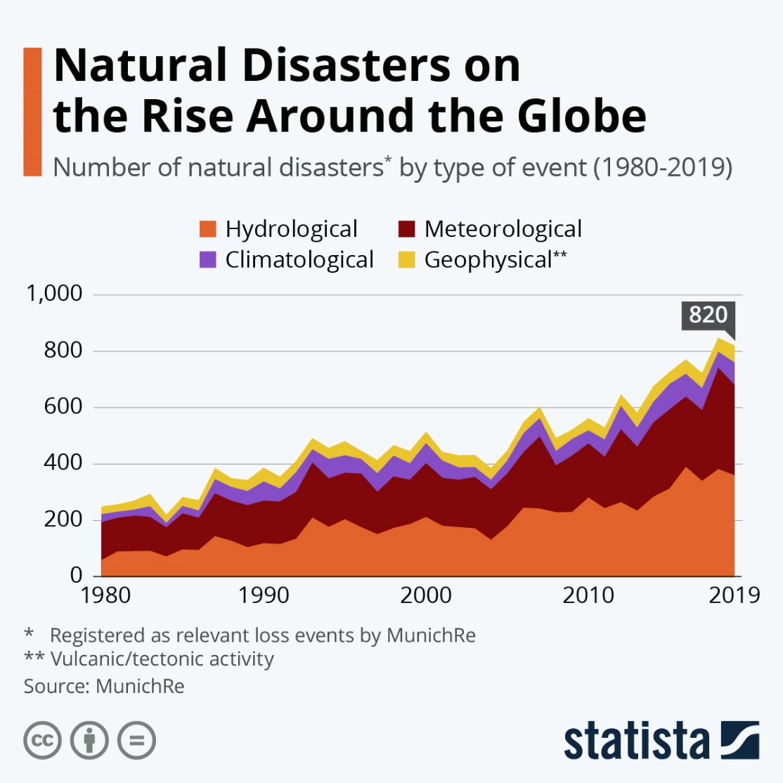

1. What was the largest hazard type in 2019? **(1 mark)**
2. Which of the following statements is FALSE about Figure 1? **(1 mark)**

Hydrological hazards were greatest in 2019.

Hydrological and meteorological hazards make up around 90% of all hazards in 2019

There were more than triple the number of hazards in 2019 than 1980

Geophysical hazards show the most fluctuation from 1980 to 2019.

**Figure 3** shows the natural disasters that inflict the most economic damage.

**Figure 3**

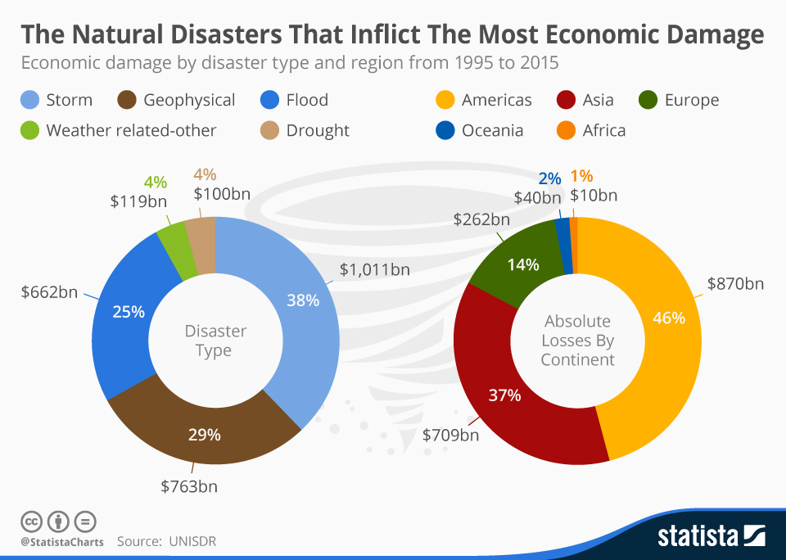

1. Shade in the **TWO** statements that are TRUE about **Figure 3**. **(2 marks)**

Storms and geophysical hazards account for 67% of economic damage.

Drought and weather-related hazards produced $100bn of economic damage between 1995 and 2015.

Floods are more likely to generate economic damage than geophysical hazards.

HICs are more impacted by the economic damage caused by natural hazards than NEEs and LICs.

Asia has been most impacted by the economic costs of natural hazards.

**Total: 22 marks**