GCSE Religious Studies



# Paper 2: Thematic Studies

# Crime and Punishment

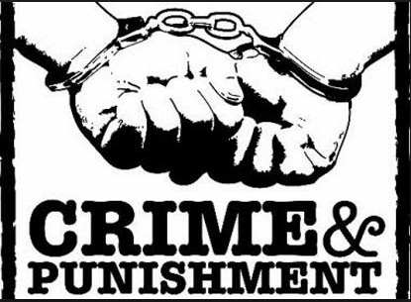

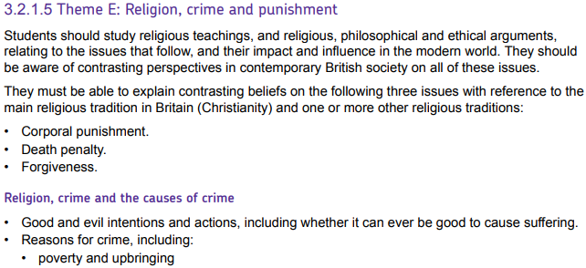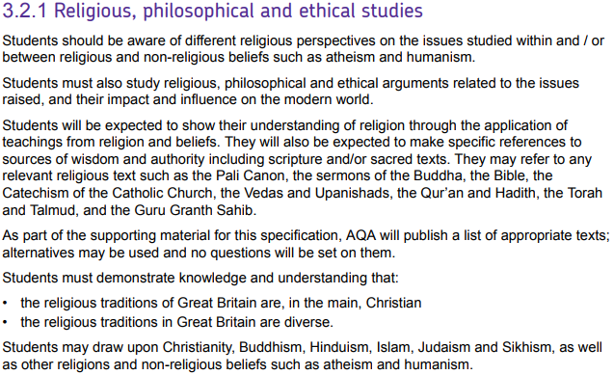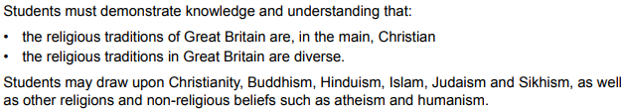

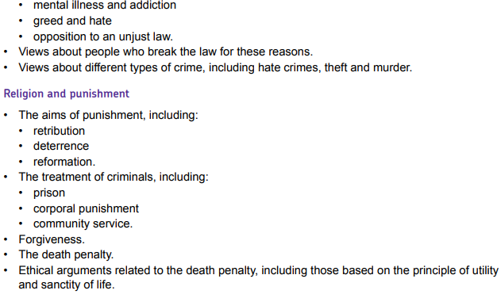



|  |  |
| --- | --- |
| **Key Term** | **Definition** |
| **Capital punishment** | The death penalty; execution as punishment for a crime. |
| **Community service** | A way of punishing offenders by making them do unpaid work in the community. |
| **Conscience** | The inner voice in our head that tells us right from wrong. It is also seen as the sense of feeling guilty when you have done something wrong. Many religious people believe it is God’s guidance. |
| **Corporal punishment** | Punishment of an offender by causing them physical pain. |
| **Crime** | A breach of the law |
| **Deterrence** | An aim of punishment - to put people off committing future crimes. |
| **Evil** | The opposite of good; an act which is immoral or wicked. |
| **Forgiveness** | Pardoning someone for what they have done wrong. |
| **Free will** | The ability of people to make decisions for themselves without constraint. |
| **Hate crimes** | Crimes which are motivated by hatred of a person’s race, religion, sexuality, disability, sex or gender. |
| **Incapacitation** | An aim of punishment – to prevent the criminal from committing more crimes. |
| **Justice** | What is right and fair. |
| **Law and order** | The rules of our society and how they are enforced. These rules exist to try to keep society a calm and safe place. |
| **Morality** | A belief concerning what is right or wrong in terms of judging behaviour and action. |
| **Punishment** | Something legally done to somebody as a result of being found guilty of a crime |
| **Reformation** | An aim of punishment – to change someone’s character so they do not commit future crimes. |
| **Retribution** | An aim of punishment - for the criminal to ‘get what they deserve’. |
| **Sanctity of life** | The belief that all life is sacred because it is created and loved by God. |
| **Shari’ah** | Islamic holy law |
| **Sin** | An act which goes against God’s will. |
| **Suffering** | A feeling of pain, harm, distress or hardship |

What is crime?

A crime is any action which breaks the law. In the UK, there are two forms of law:

Parliamentary laws

These are made by the Government and apply to everyone in the country.

Broadly speaking, these laws place crimes into two categories. ***Non-indictable offences*** are minor crimes that are usually dealt with in a Magistrates’ Court.

***Indictable offences*** are much more serious crimes (e.g. murder). These are dealt with in Crown Court with a judge and jury, and usually carry much harsher potential penalties.

Bye-laws

These are laws that are made by elected councillors and apply to a local area.

They cover things like parking restrictions, alcohol free zones and environmental concerns.

Breaking this type of law may result in a fine, community service or another less-severe punishment, but you do not get a criminal record.

Civil Law

Civil law is different from criminal law in that it does not involves the breaking of criminal statutes. Instead, **civil law** concerns disputes between private individuals or groups. This includes such matters as the settlement of a divorce, disputes between landlords and tenants and disputed wills. Cases are usually dealt with in a small claims court although in more serious cases, the case will be heard in Crown Court.

Different types of crime

|  |  |
| --- | --- |
| Crimes against the person  Offences causing direct harm to a person.  Examples: | Crimes against property  Offences that damage or deprive people of their property.  Examples: |
| Hate crimes  A crime motivated by hatred of a person’s race, religion, sexuality, disability or gender.  Examples: | Crimes against the state  Offences that potentially endanger everyone or affect the smooth running of society.  Examples: |

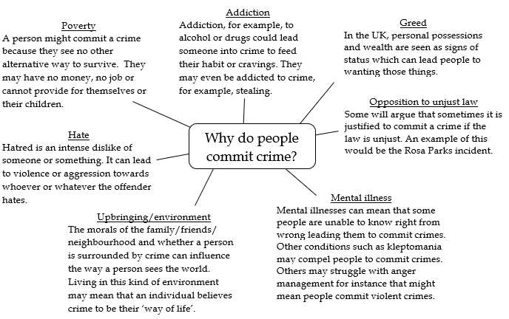

Good and Evil Intentions and Actions

For Christians, **Jesus** made it very clear that good intentions lead to good actions and that evil intentions (although they may not always lead to evil actions) were still evil in themselves:

*“You have heard that it was said to those of old, ‘You shall not commit adultery.’But I say to you that whoever looks at a woman to lust for her has already committed adultery with her in his heart.”*

*“I say to you, love your enemies, bless those who curse you, do good to those who hate you, and pray for those who persecute you.”*

An evil action is usually considered to be an action that causes suffering. In a religious sense, evil is sometimes linked with the Devil (see page 22 in the Christian Beliefs and Teachings booklet) who is often considered to be the source of all that is considered evil. However, when we speak about evil criminal actions, we usually mean that the offence is a profoundly immoral and wicked choice made by an individual.

Is it ever good to cause suffering?

As is clear above, Christians are generally opposed to causing others to suffer. Jesus taught that people should love each other and care for those in trouble. However, as no human is perfect, it is inevitable that Christians may be the cause of suffering at some point. Whatever the cause, Christians believe they should try to help others who are suffering. The Bible even talks about how good can come out of suffering:

***“We also glory in our sufferings, because we know that suffering produces perseverance, character and hope.”***

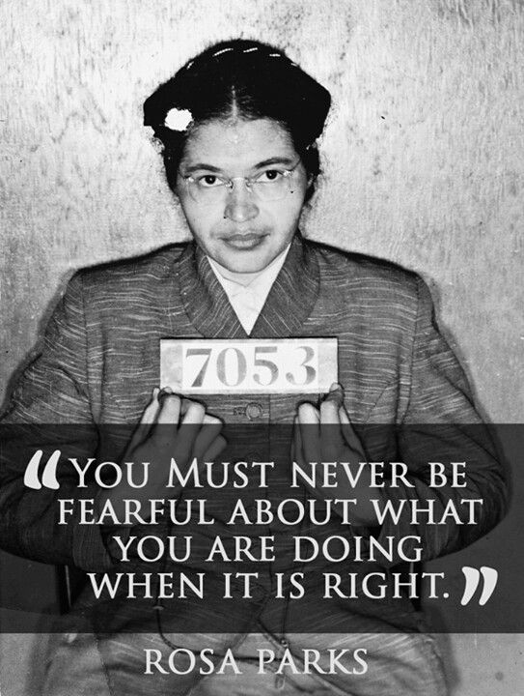Christian attitudes to the law

In general, Christians are against people breaking the law. They would believe that laws are generally in place to protect citizens and should therefore be respected. There is biblical support for this principle:

(Also consider how these quotations would affect Christians’ views on different ***types*** of crimes.)

*“Let every person be subject to the governing authorities. For there is no authority except from God, and those that exist have been instituted by God.”*

*“Love thy neighbour.”*

There may be occasions, such as in the case of Rosa Parks, where they may believe that the law is unjust and so ought to be challenged.

*“There is neither Jew nor Gentile, slave nor free, male nor female, for you are all one in Christ.”*

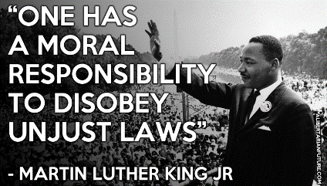

*“Thou shalt commit no murder.”*

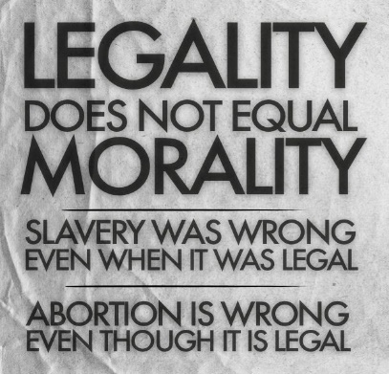However, Christians would argue that although morality may well influence the law, they are not necessarily the same thing. There is no law that mandates supporting charities, but doing so is usually considered to be a good thing.

Similarly, many Christians believe that even though actions such as adultery are legal, they should still be considered wrong.

*“One witness is not enough to convict anyone accused of any crime or offense they may have committed. A matter must be established by the testimony of two or three witnesses.* *If a malicious witness takes the stand to accuse someone of a crime,**the two people involved in the dispute must stand in the presence of God before the priests and the judges who are in office at the time. The judges must make a thorough investigation.”* (Deuteronomy)

The law also governs what should happen to those who are accused of a crime. Christians support the principle of the accused being presumed innocent until proven guilty and that all accused deserve a fair trial. The Old Testament, over 3,000 years ago even characterised what would qualify as a fair trial (see right).

Christians also believe that those found guilty of a crime should face a consequence:

*“You have heard that it was said to the people long ago, ‘You shall not murder’, and anyone who murders will be subject to judgement.”*

Notes:

Purposes of Punishment

Once a criminal has been found guilty of a crime, they will face a punishment. There are four reasons given for punishing a criminal. These aims are not mutually exclusive, a punishment may fulfil more than one of these aims.

|  |  |
| --- | --- |
| Retribution  Image result for pay backRetribution means that society, on behalf of the victim, is getting its own back on the offender. This would involve the criminal getting what they deserve.  Examples:  Positives/Negatives  +  - | Incapacitation  Incapacitation is physically removing offenders’ ability to commit future crimes and in doing so protect society.  Examples:  Positives/Negatives  +  - |
| Deterrence  Image result for trespassers will be shotA deterrent is intended to put someone off committing a future crime. This could apply to the original offender or other members of a society.  Examples:  Positives/Negatives  +  - | Related image Reformation  Reformation seeks to help offenders by working with them to help change their character so that they do not want to commit future crimes.  Examples:  Positives/Negatives  +  - |

Religious attitudes towards criminals

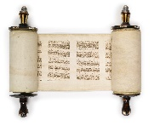Many Jews and Muslims believe that **RETRIBUTION** should be a main aim of punishment. An early form of this is introduced in the **Old Testament** and **the Qur’an**:

*“You are to take life for life, eye for eye, tooth for tooth, hand for hand, foot for foot, burn for burn, wound for wound, bruise for bruise.”*

This quote is not normally interpreted literally but instead taken to mean that an offender should receive a punishment severe enough to match the seriousness of their crime.

However, Jesus teaches explicitly against this saying:

*“You have heard that it was said, ‘Eye for eye, and tooth for tooth.****9****But I tell you, do not resist an evil person. If anyone slaps you on the right cheek, turn to them the other cheek also.”*

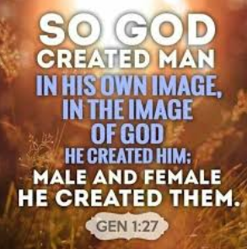Christians believe at all people are created *“in the image of God”* and therefore deserving of respect and value. This belief would also lead Christians to believe that there is no such thing as an ‘evil person’; God created people to be good. Therefore, they are unlikely to commit a heinous crime unless there is a clear reason, e.g. a psychological illness. The concept of ‘original sin’ (see page 22 of the Christian Beliefs and Teachings booklet) may also help explain why people created good might commit crimes. This view of humanity leads most Christians to argue that **REFORMATION** should be the primary aim of punishment because it treats criminals with compassion and tries to help them.

This idea is supported by Paul’s writings in the **New Testament**:

*“Do not take revenge, my dear friends, but leave room for God’s wrath, for it is written: ‘It is mine to avenge, I will repay’ says the Lord. On the contrary: ‘If your enemy is hungry, feed him; if he is thirsty, give him something to drink […] Do not be overcome by evil, but overcome evil with good.”*

Many Christians take these two principles together and believe that, while **REFORMATION** is the most important aim of punishment, it should not supersede **RETRIBUTION**. Instead, it should be done at the same time. For example, criminals should be put in prison for a length of time appropriate to the severity of their crime, but while in prison, offenders should be helped so that they can live fulfilling, crime-free lives following their release.

Community Service

Community service is court-ordered unpaid work, intended to be of social use, that an offender is required to do instead of going to prison. Examples of community service include:

* removing graffiti
* clearing wasteland
* decorating public places and buildings - for example, a community centre

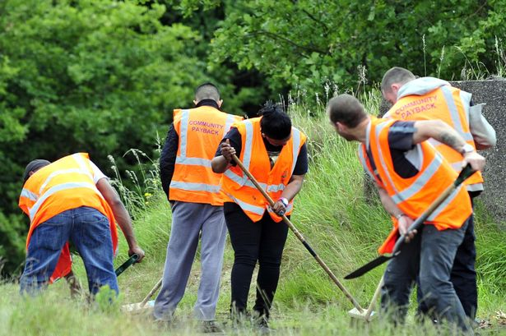This work will usually be done in the offender’s local area and is managed by a Community Payback supervisor. Offenders must wear a high visibility orange vest while they work so everybody can see that they have been convicted of an offence.

Community sentences are often given for crimes such as:

* damaging property
* benefit fraud
* assault

In addition to the community payback aspect of this kind of sentence, the court may also order that the offender attend treatment programmes for medical conditions and drug or alcohol abuse if required, as well as counselling sessions and basic education services. This another big part of trying to help **reform** criminals.

Christian Views

Because the aims of community service are positive and offer the chance for reform, most Christians agree that it is a suitable punishment for relatively minor offences. In 2007, the Church of England produced a report that commended programmes for offenders which required unpaid work in the community, counselling and treatments for addiction in a mainstream setting.

Corporal Punishment

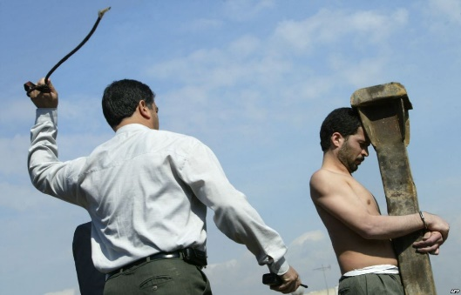Corporal punishment is to use physical pain as a punishment for a criminal act. It deliberately inflicts pain through smacking, whipping, branding or amputation (removal of a body part).

This type of punishment in banned in Europe and only remains in parts of Africa, the Middle East, Asia and South America.



|  |  |
| --- | --- |
| **Arguments FOR corporal punishment:** | **Arguments AGAINST corporal punishment:** |
| * Crime rates are lower in Islamic countries that use corporal punishment. E.g. It is estimated that theft is 140 times higher in the USA compared to Saudi Arabia. * It is much cheaper than imprisonment. In the UK it is estimated that each new prison place costs £119,000 and that the annual average cost for each prisoner exceeds £40,000. | * Corporal punishment is inhumane and violates internationally recognised human rights:   *“No-one shall be subjected to … cruel, inhuman or degrading treatment or punishment.”*  (Article 5 of the International Convention on Human Rights.)   * It is not effective. A state inflicting violence on its own citizens brutalises society and normalises violence. Long-term, studies have shown that children who are subjected to corporal punishment are significantly more likely to exhibit criminal behaviour. |

Religious Views on Corporal Punishment

 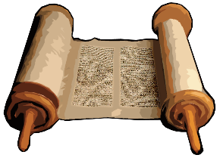Christian views

*“He who spares the rod hates their children, but the one who loves their children is careful to discipline them.”*

*“Foolishness is bound up in the heart of a child; The rod of correction will drive it far from him.”*

*“The rod and rebuke give wisdom.”*

Some Christians defend corporal punishment because of the above quotations from the book of Proverbs in the **Old Testament.** These verses seem to suggest that, in fact, corporal punishment is a loving act and helps teach discipline and wisdom.

……………………………………………

However, many Christians will point to the example of Jesus to suggest that corporal punishment should not be permitted. There are a number of passages where Jesus appears to condemn physical violence:

*“If someone slaps you on the right cheek, turn and offer him your left.”*

In addition, when Jesus is being arrested, one of Jesus’ followers attempts to physically defend him, resulting in one of the High Priests’ servants having his ear cut off. Jesus does not support this. He heals the ear of his enemy and says:

*“Those who live by the sword will die by the sword.”*



Muslim Views

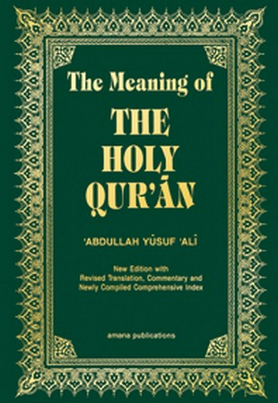In Islam, there is no question about the place of corporal punishment and it forms a key part of the justice system in Islamic countries (inc. Saudi Arabia, Iran, Iraq, Qatar and UAE). Muslims view corporal punishment as fair **RETRIBUTION** and acts as a clear **DETERRENT**.

The Qur’an it makes it clear that corporal punishment is required in order to fulfil the Shari’ah (holy law):

***“If a woman or man is guilty of adultery, flog each of them 100 times”***

***“As for the thief, male or female, amputate their hand.”***

Capital Punishment

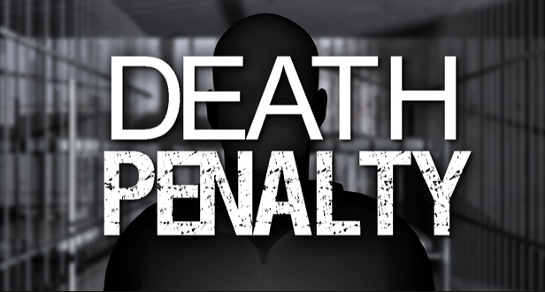Capital Punishment is the execution of a criminal who has been found guilty of a serious crime. It has been abolished in most of the developed world but is still retained in 57 countries including Belarus (the only country in Europe to use it) and the USA.

Methods of execution vary and include firing squad, stoning, electrocution, hanging and lethal injection.

|  |  |
| --- | --- |
| **Arguments FOR capital punishment:** | **Arguments AGAINST capital punishment:** |
| * The death penalty is the ultimate DETERRENT. People are less likely to commit crime if they know the consequence is execution. * It is also the ultimate INCAPACITATION of a criminal. If we execute those who commit serious crimes, they cannot commit these crimes again. * If someone has taken the life of another they *deserve* to be killed also: the principle of RETRIBUTION. * The execution of a criminal provides closure for a victim and/or their families. | * It is not an effective deterrent. States in America that have the death penalty have a higher murder rate than those that don’t. * The death penalty does not allow us to correct for mistakes. There have been lots of cases where people have been executed from crimes and then were found to be not guilty. * Many argue that the state cannot expect society to consider killing to be wrong if they themselves kill their own citizens. * Some could argue that the death penalty is not punishment enough. They argue that life imprisonment without possibility of parole causes much more suffering to the offender than a painless death. |

Religious Views on Capital Punishment

Christian views

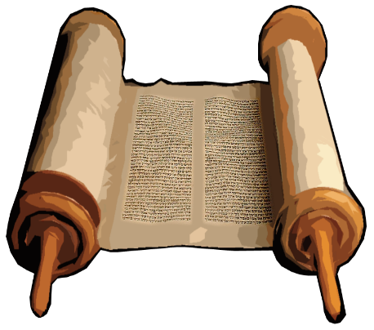There are different views on capital punishment within Christianity.

Some Christians support the death penalty as fair RETRIBUTION in cases of serious crimes. The **Old Testament** clearly mandates death as the appropriate punishment for a number of crimes and also states:

*“Whoever sheds the blood of man, by man shall his blood be shed.”*

……………………………………………

However, many Christians oppose the death penalty due to their belief in the **sanctity of life**. They would argue that only God has the right to take life. Christians believe in the principle of REFORMATION for criminals which is clearly not possible when an offender has been executed. In the **Old Testament**, the prophet **Ezekiel** writes on behalf of God:

*“I take no pleasure in the death of the wicked, but would rather that they turn away from their ways and live”*

Jesus also appears to take a position against the death penalty. He directly responds to the verse in the Old Testament saying:

*“You have heard that it was said, ‘Eye for eye, and tooth for tooth.’**But I tell you, do not resist an evil person. If anyone slaps you on the right cheek, turn to them the other cheek also.”*

The Old Testament lists adultery as a capital crime and the Gospel of John records an occasion when a woman is brought before Jesus having been caught in the act. The intention is to stone her to death but instead Jesus stops them.

Having told the woman she will not be condemned to death, he instructs her to: *“Go, and sin no more.”* This further reinforces the Christian commitment to REFORMATION.



Muslim Views

Although the death penalty is accepted by most Muslims, there are some who argue against it for the following reasons:

* Although capital punishment is allowed in the Qur'an that does not mean it is compulsory.
* The [**Shari'ah**](https://www.bbc.co.uk/education/guides/znhf9j6/revision/4#glossary-z3mwtfr) states that the family of a murder victim can accept money as [reparation](https://www.bbc.co.uk/education/guides/znhf9j6/revision/4#glossary-z6ft34j) rather than enforce the death penalty.
* They believe that only Allah has the right to take life, and therefore carrying out the death penalty is 'playing God'.

Muslims believe that the death penalty is established by Allah (God) in the Qur’an as part of the **Shari’ah**:

*“Do not take life, which God has made sacred,*

***except by way of justice and law****.”*

*“Life for life, eye for eye, tooth for tooth.”*

The *Hadith,* which details the actions and sayings of the Prophet Muhammad, also records him ordering the death penalty for a number of crimes including murder, adultery and apostasy.

Forgiveness

Forgiveness is to pardon someone for what they have done wrong. The Greek word used in the Bible for “forgiveness” literally means “to let go,” as when a person does not demand payment for a debt. Therefore, forgiveness is to let go of any grudge or ill-feeling towards an offender.



Christian beliefs

Forgiveness is a core belief in Christianity and one that Jesus emphasised in much of his teaching:

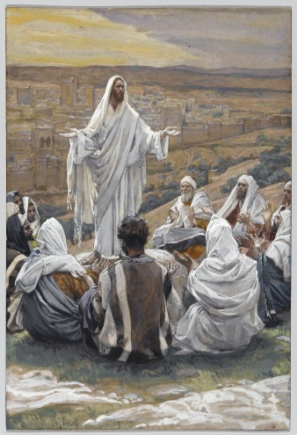*“Forgive us our sins, as we forgive those who sin against us”.*

Peter asked; *“’Lord, how many times shall I forgive my brother when he sins against me? Up to seven times?’* *Jesus answered, ‘I tell you, not seven times, but seventy-seven times.’”*

As he dies on the cross, Jesus cries out: *“Father forgive them, for they know not what they do.”*

These Christian beliefs are exemplified by the family of Anthony Walker, a teenager murdered in a brutal, racist attack. Following the sentencing of her son’s attackers, Mrs Walker, with her daughter Dominique, said: *"Do I forgive them? At the point of death Jesus said 'I forgive them because they don't know what they did'. I've got to forgive them. I still forgive them. My family and I still stand by what we believe: forgiveness."*

However, most Christians would argue that forgiveness does not replace punishment. It is still possible to both forgive somebody and to believe that justice needs to be done within the legal system. This is true in the case of Mrs. Walker who said: *"It's been real hard going, but I feel justice has been done. I'm sure they will get the maximum sentence."* However, this is not to say that forgiveness is dependent on punishment, instead it is a cancelling of a personal debt. *“Love keeps no record of wrong.”*



Muslim views

In Islam, there is a much greater focus on punishment rather than forgiveness. According to Muslims, punishment satisfies the demands of society and especially the person who was wronged.

Despite this, forgiveness is an important element in Islam. It falls into two categories:

|  |  |
| --- | --- |
| Forgiveness from God | Forgiveness from other humans |
| *“Surely, Allah forgives all sins. Indeed He is the most Forgiving, the Merciful.”* (Qur’an) | “Pardon each other’s faults and [God] will grant you honour.” (Hadith) |

For Muslims, forgiveness depends upon someone *asking* to be forgiven and truly repenting.

**(This is a key difference from the concept within Christianity.)**

Notes:

Possible exam questions

Question 1: (1 mark)

1) Which term expresses the religious idea that one aim of punishment should be to encourage people not to commit any more crimes?

1) What term means trying to put people off committing crimes?

Question 2: (2 marks)

2) Give two examples of religious moral laws which some criminals break.

2) Give two religious beliefs about forgiveness.

2) Give two aims of punishment.

Question 3: (4 marks)

3) Explain two contrasting beliefs in contemporary British society about the death penalty for murder.

3) Explain two similar religious beliefs about people who break the law.

3) Explain two contrasting religious beliefs about forgiveness.

Question 4: 5 marks

4) Explain two religious beliefs about breaking the law in order to get a bad law changed.

4) Explain two religious beliefs about the death penalty.

4) Explain two religious beliefs about suffering.

**You must** refer to scripture or sacred writings in your answer.

Question 5: (12 marks)

5) ‘Corporal punishment can never be justified.’

5) ‘Reformation is the best aim of punishment.’

5) ‘Breaking the law is never acceptable’

Evaluate the statement. In your answer you should:

• refer to Christian teaching

• give developed arguments to support this statement

• give developed arguments to support a different point of view

• reach a justified conclusion.