|  |
| --- |
| Name: _______________________________________________ |
|  |
|  |
|  |
|  |
| **U6: Topic 1 Biological molecules** |
| **Calculators allowed** |
| **Date:** |
|  |
|  |
|  |
|  |
| **Time:** 60 minutes Extra time: 75 minutes |
|  |
| **Total marks available:** 48 |
|  |
| **Total marks achieved:** ______ |
|  |
|  |
|  |
|  |
|  |
|  |
|  |
|  |
|  |
|  |
|  |
|  |
|  |
|  |
|  |
|  |
|  |
|  |
|  |
|  |
|  |
|  |
|  |
|  |
|  |
|  |

**Questions**

**Q1.**

**Answer the questions with a cross in the boxes you think are correct . If you change your mind about an answer, put a line through the box  and then mark your new answer with a cross .**

Genetic information is encoded in DNA. DNA is made from monomers called nucleotides.

A DNA nucleotide is composed of three molecules joined together in condensation reactions.

(i)  These shapes represent the components of DNA.

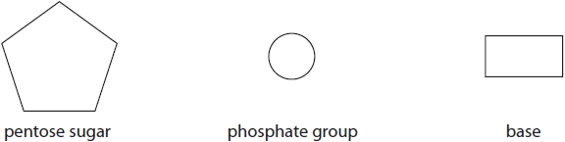

Draw a DNA nucleotide using these shapes.

**(2)**

(ii)  Which row shows three components that can be found in a DNA molecule?

**(1)**

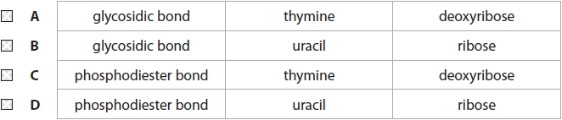

(iii)  In a molecule of DNA, 17% of the bases were guanine.

What percentage of the bases in the molecule were thymine?

**(1)**

   **A**    17%

   **B**    33%

   **C**    66%

   **D**    83%

**(Total for question = 4 marks)**

**Q2.**

Meselson and Stahl carried out an experiment that demonstrated the semiconservative replication of DNA.

They grew bacteria in a medium containing heavy nitrogen (15N) for a period of time. The density of the DNA extracted from these bacteria is shown by the position of the band in tube 1.

The bacteria were then transferred to a medium containing light nitrogen (14N) and allowed to replicate.

Complete the diagram to show the positions of the DNA bands in tubes 2 and 3.

**(2)**

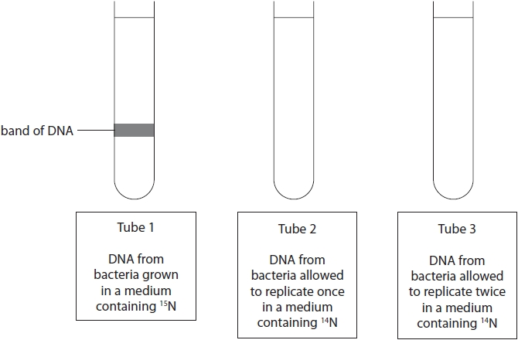

**(Total for question = 2 marks)**

**Q3.**

Give three differences between replication of DNA and transcription of DNA.

**(3)**

1 ..........................................................................................................................................

.............................................................................................................................................

.............................................................................................................................................

2 ..........................................................................................................................................

.............................................................................................................................................

.............................................................................................................................................

3 ..........................................................................................................................................

.............................................................................................................................................

.............................................................................................................................................

**(Total for question = 3 marks)**

**Q4.**

Blood plasma contains many different proteins. Prothrombin is a plasma protein that is involved in the blood clotting process.

(i)  The protein prothrombin is composed of monomers called amino acids.

Complete the diagram to show the structure of an amino acid.

**(2)**



(ii)  Name the products formed when several amino acids are joined together.

**(1)**

.............................................................................................................................................

**(Total for question = 3 marks)**

**Q5.**

**Answer the question with a cross in the box you think is correct . If you change your mind about an answer, put a line through the box  and then mark your new answer with a cross .**

Different compounds have been given different sweetness values by comparing them with the sweetness of sucrose.

The table shows some of these compounds and their sweetness values.

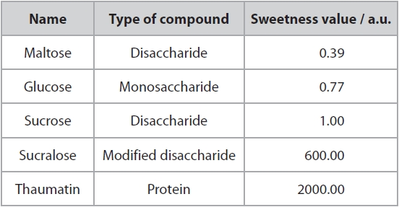

(i)  Lactose is found in milk. The sweetness value of lactose is 0.16.

Calculate the ratio of the sweetness value of sucrose to lactose.

**(2)**

Answer ...........................................................

(ii)  Which of the following describes lactose?

**(1)**

   **A**    disaccharide

   **B**    modified disaccharide

   **C**    monosaccharide

   **D**    protein

**(Total for question = 3 marks)**

**Q6.**

Explain how the structures of amylopectin and glycogen make them suitable for storing energy.

**(3)**

.............................................................................................................................................

.............................................................................................................................................

.............................................................................................................................................

.............................................................................................................................................

.............................................................................................................................................

.............................................................................................................................................

.............................................................................................................................................

.............................................................................................................................................

.............................................................................................................................................

**(Total for question = 3 marks)**

**Q7.**

**Answer the questions with a cross in the boxes you think are correct . If you change your mind about an answer, put a line through the box  and then mark your new answer with a cross .**

Starch is an important component of the human diet.

The main sources of starch are plants such as maize and potatoes.

(i)  Starch is composed of amylose and amylopectin.

Which of the following terms is the correct description of amylose?

**(1)**

   **A**    disaccharide

   **B**    monosaccharide

   **C**    polysaccharide

   **D**    trisaccharide

(ii)  Starch can be broken down by a

**(1)**

   **A**    condensation reaction involving ester bonds

   **B**    condensation reaction involving glycosidic bonds

   **C**    hydrolysis reaction involving ester bonds

   **D**    hydrolysis reaction involving glycosidic bonds

(iii)  Give **one** structural difference between amylose and amylopectin.

**(1)**

.............................................................................................................................................

.............................................................................................................................................

.............................................................................................................................................

**(Total for question = 3 marks)**

**Q8.**

**Answer the question with a cross in the boxes you think are correct . If you change your mind about an answer, put a line through the box  and then mark your new answer with a cross .**

The diagram shows part of a DNA molecule.

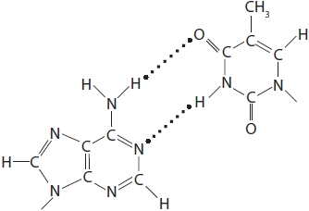

(i)  Which part of the DNA molecule is shown?

**(1)**

   **A**    deoxyribose molecule

   **B**    one mononucleotide

   **C**    two complementary organic bases

   **D**    two mononucleotides

(ii)  Which type of bond holds the strands of DNA together?

**(1)**

   **A**    disulfide

   **B**    glycosidic

   **C**    hydrogen

   **D**    peptide

(iii)  Analysis of a sample of DNA found that 35% of the nucleotides contained thymine.

Determine the percentage of guanine in the same sample of DNA.

**(1)**

Answer ........................................................... %

**(Total for question = 3 marks)**

**Q9.**

**Answer the question with a cross in the box you think is correct . If you change your mind about an answer, put a line through the box  and then mark your new answer with a cross .**

Haemoglobin is a protein made of four polypeptide chains.

There are two identical chains each consisting of 141 amino acids. The other two identical chains each consist of 146 amino acids.

Which of the following is the minimum number of nucleotides present in the mRNA coding for haemoglobin?

**(1)**

   **A**    287

   **B**    574

   **C**    861

   **D**    6862

**(Total for question = 1 mark)**

**Q10.**

The table shows the number of bases in the DNA strand used in the synthesis of mRNA.

Complete the table to show the percentage of bases in the mRNA synthesised.

**(3)**

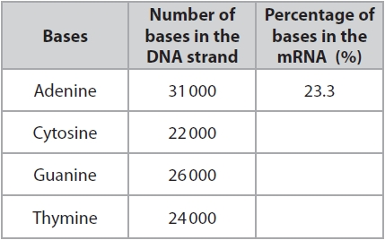

**(Total for question = 3 marks)**

**Q11.**

**Answer the question with a cross in the box you think is correct . If you change your mind about an answer, put a line through the box  and then mark your new answer with a cross .**

The graph shows the DNA content of a cell during four stages, I, II, III and IV, of one cell cycle.

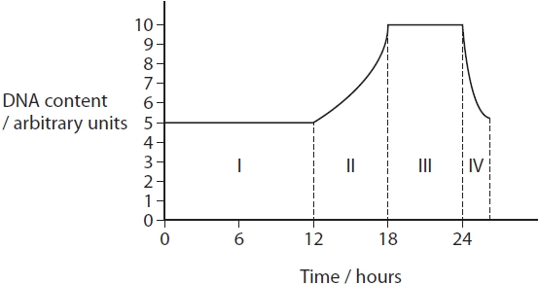

(i)  In which stage does DNA replication take place?

**(1)**

   **A**    stage I

   **B**    stage II

   **C**    stage III

   **D**    stage IV

(ii)  Explain the role of the enzyme ligase in DNA replication.

**(3)**

.............................................................................................................................................

.............................................................................................................................................

.............................................................................................................................................

.............................................................................................................................................

.............................................................................................................................................

.............................................................................................................................................

.............................................................................................................................................

.............................................................................................................................................

.............................................................................................................................................

**(Total for question = 4 marks)**

**Q12.**

The chemical mercaptoethanol breaks disulfide bonds.

The graph shows the initial rate of reaction of RNase with no added mercaptoethanol.

Sketch a line on the graph to show the effect of a low concentration of mercaptoethanol on the activity of RNase.

**(1)**

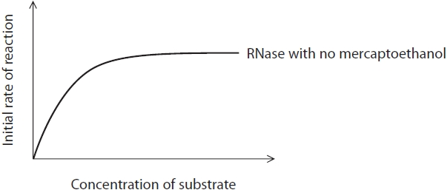

**(Total for question = 1 mark)**

**Q13.**

The chemical mercaptoethanol breaks disulfide bonds.

The graph shows the initial rate of reaction of RNase with no added mercaptoethanol.



Analyse the information to explain the effect of adding mercaptoethanol on the activity of RNase.

**(3)**

.............................................................................................................................................

.............................................................................................................................................

.............................................................................................................................................

.............................................................................................................................................

.............................................................................................................................................

.............................................................................................................................................

.............................................................................................................................................

.............................................................................................................................................

.............................................................................................................................................

**(Total for question = 3 marks)**

**Q14.**

**Answer the questions with a cross in the boxes you think are correct . If you change your mind about an answer, put a line through the box  and then mark your new answer with a cross .**

Short sequences of nucleotides are being developed as potential drugs.

They act by binding to selected sites on DNA or RNA molecules and prevent the   
synthesis of a specific protein associated with a disease.

Two types of drug to treat genetic disorders are:

• antisense drugs, which are RNA nucleotides that bind to mRNA  
• triplex drugs, which are DNA nucleotides that bind to DNA forming a three-stranded helix.

(i)  The type of bonds that hold the two strands of a DNA molecule together in a double helix are

**(1)**

   **A**    glycosidic bonds

   **B**    hydrogen bonds

   **C**    phosphodiester bonds

   **D**    peptide bonds

(ii)  Antisense drugs inhibit protein synthesis by interfering with

**(1)**

   **A**    protein folding

   **B**    replication

   **C**    transcription

   **D**    translation

(iii)  Triplex drugs inhibit protein synthesis by interfering with

**(1)**

   **A**    protein folding

   **B**    replication

   **C**    transcription

   **D**    translation

**(Total for question = 3 marks)**

**Q15.**

Which of the following statements is true for the total number of bases in a double-stranded DNA molecule?

**(1)**

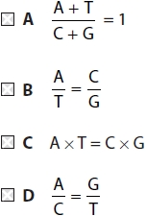

**(Total for question = 1 mark)**

**Q16.**

The table shows the sequence of bases in part of an mRNA molecule.

Complete the table to show the base sequence of **each** of the following:

(i)  the corresponding coding strand of DNA that produced this mRNA sequence

**(1)**

(ii)  the base sequence of an antisense drug that will bind to this mRNA.

**(1)**

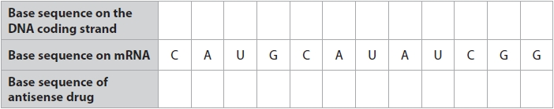

(iii)  State the number of amino acids that would be coded for by the part of mRNA shown in this table.

**(1)**

.............................................................................................................................................

**(Total for question = 3 marks)**

**Q17.**

Catalase is an enzyme found in potato cells.

Explain how a gene mutation can prevent the production of catalase in potato cells.

**(3)**

.............................................................................................................................................

.............................................................................................................................................

.............................................................................................................................................

.............................................................................................................................................

.............................................................................................................................................

.............................................................................................................................................

.............................................................................................................................................

.............................................................................................................................................

.............................................................................................................................................

.............................................................................................................................................

**(Total for question = 3 marks)**

**Q18.**

The graph shows the results of an experiment investigating the effect of temperature on the hydrolysis of starch using the enzyme amylase.

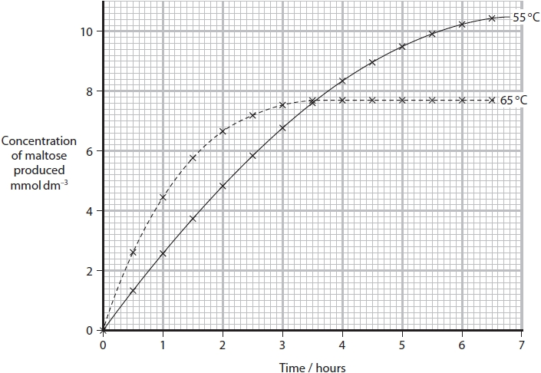

Calculate the initial rate of reaction at 55 °C in mmol dm–3 min–1.

**(2)**

Answer ...........................................................

**(Total for question = 2 marks)**

**Mark Scheme**

Q1.

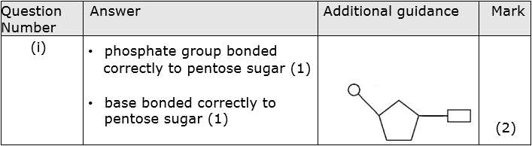

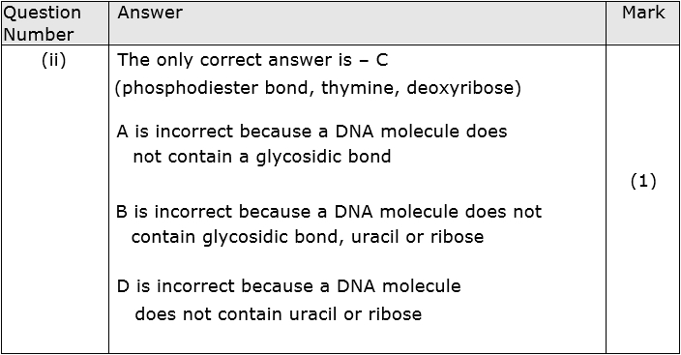

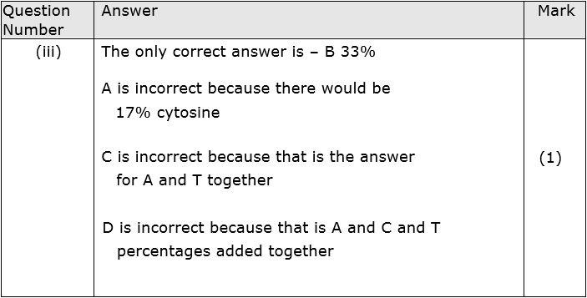

**Q2.**

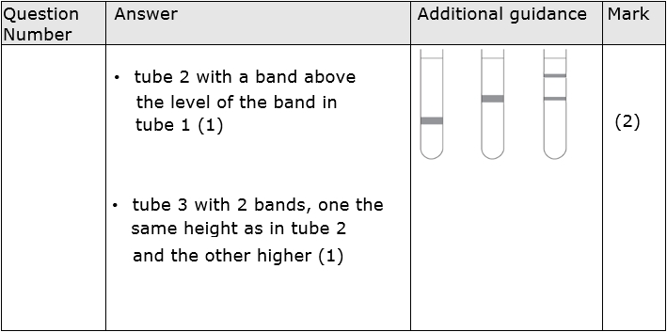

**Q3.**

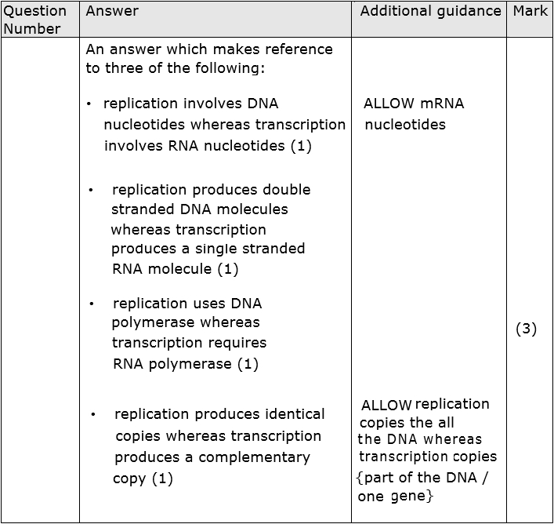

**Q4.**

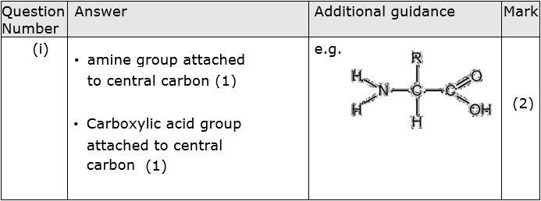

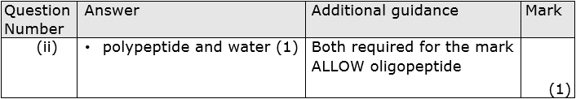

**Q5.**

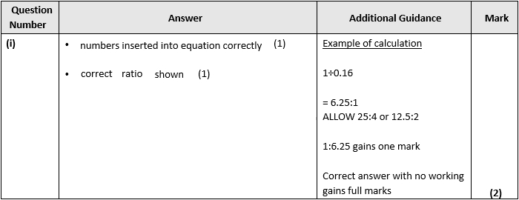

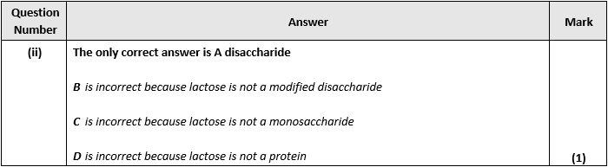

**Q6.**

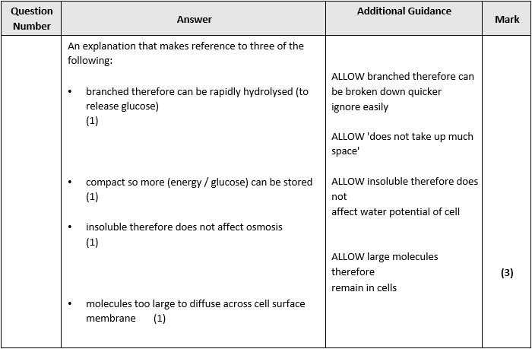

**Q7.**

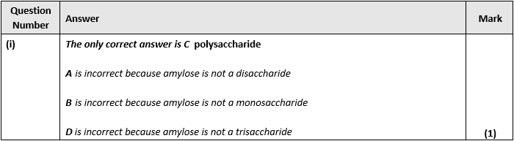

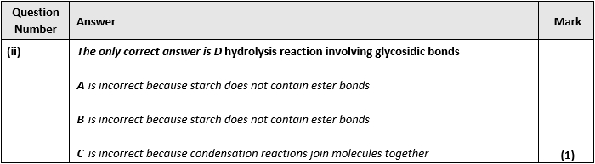

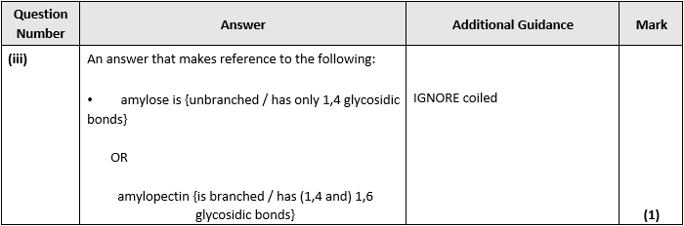

**Q8.**

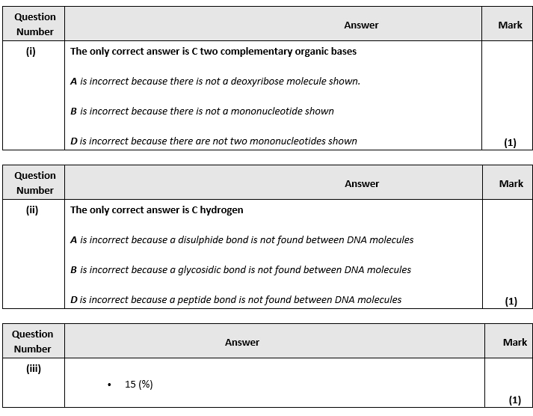

**Q9.**

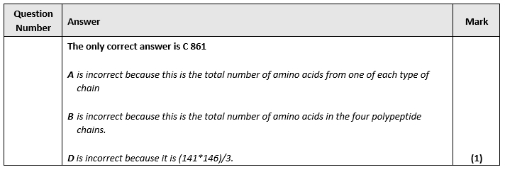

**Q10.**

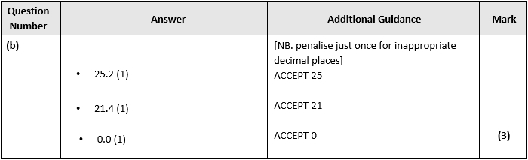

**Q11.**

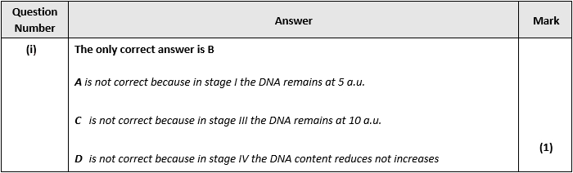

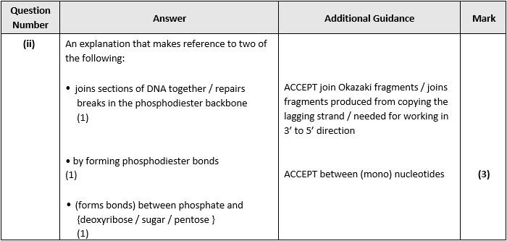

**Q12.**

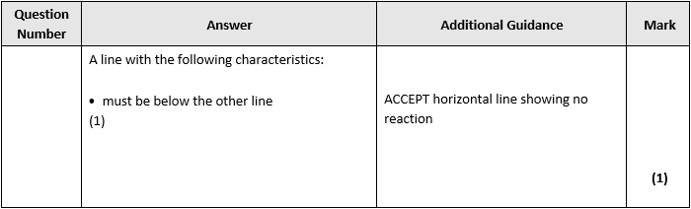

**Q13.**

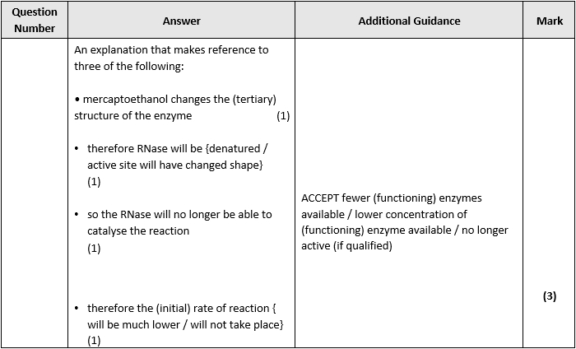

**Q14.**

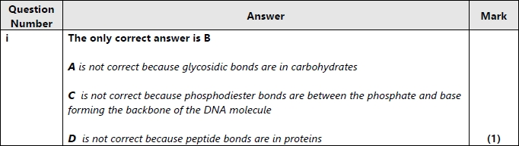

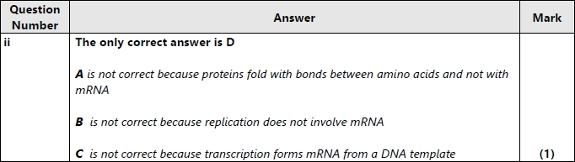

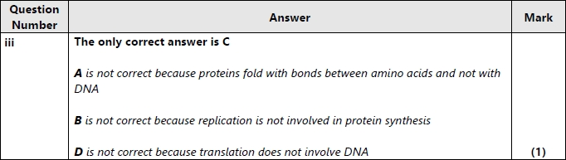

**Q15.**

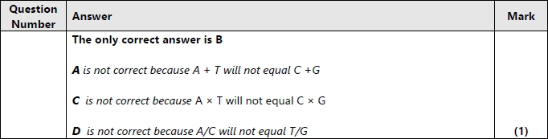

**Q16.**

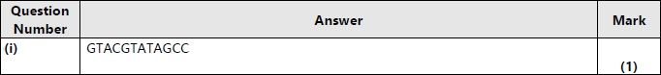

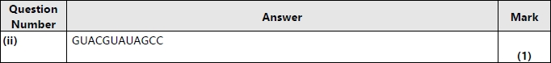

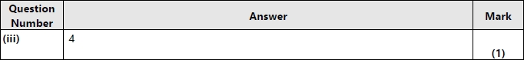

**Q17.**

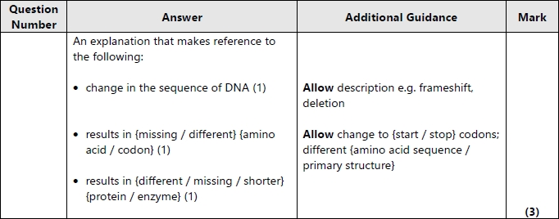

**Q18.**

