

# GCSE Religious Studies

# Paper 1: The study of religions: Islamic beliefs and teachings



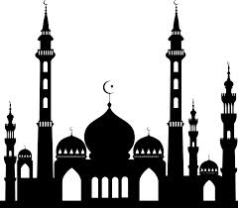

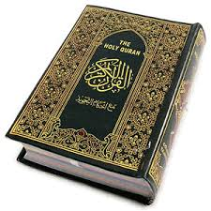

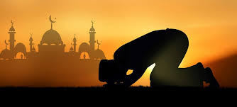

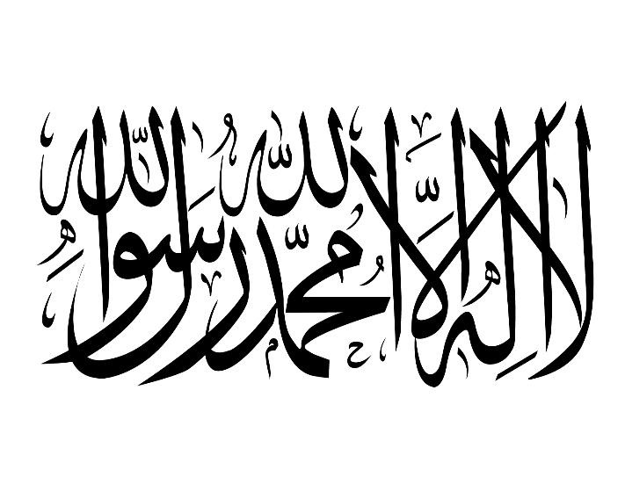

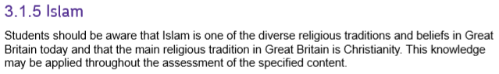

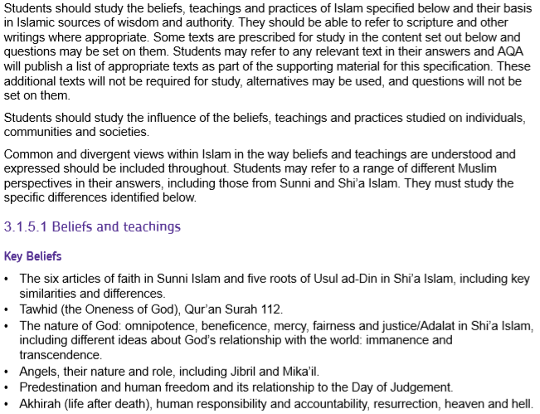

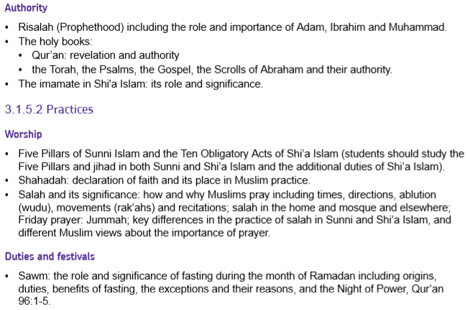





|  |  |
| --- | --- |
| **Key Term** | **Definition** |
| **Akhirah** | Everlasting life after death. |
| **Allah** | The Arabic name for God. |
| **Angels** | Spiritual beings believed to act as messengers of God. |
| **Caliph** | A person considered to be a political and religious successor to the prophet Muhammad, and the leader of the Sunni Muslim community. |
| **Day of Judgement** | A time when the world will end and every soul will be judged by God, and either rewarded or punished. |
| **Fairness** | The idea that God treats people impartially (non-biased) without favour or discrimination. |
| **Gospel (Injil)** | A holy book revealed by God to Jesus. |
| **Hadith** | The sayings of the Prophet Muhammad. Not all Hadith are accepted as genuine by all Muslims, e.g. Shi’a only accept those passed down by Ali and his followers. |
| **Hajj** | The annual pilgrimage to Makkah (Mecca) that every Muslim should try to make at least once in their life. |
| **Heaven** | The state of eternal happiness in the presence of God; also called paradise. |
| **Hell** | The state of total separation from God. |
| **Iblis (Satan)** | A spiritual being, created from fire, who was thrown out of paradise for refusing to bow to Adam. |
| **Id-ul-Adha** | A Muslim festival that celebrates the prophet Ibrahim’s willingness to sacrifice his son for God. |
| **Imam** | 1. A person who leads communal prayer  2. In Shi’a Islam, the title given to Ali and his successors. |
| **Imamate** | The divine appointment of the Imams. |
| **Immanent** | The idea that God is present in and involved with life on earth and in the universe; a quality of God. |
| **Islam** | 1. The name of the religion followed by Muslims;  2. To submit to the will of God.  3. Peace |
| **Jibril** | The Arabic name for Gabriel, the archangel who brought God’s message to the prophets, particularly Muhammad. |
| **Justice**  **(Adalat in Shi’a)** | The idea that God is just and fair and judges human actions, rewarding the good and punishing the bad. |
| **Ka’aba** | The black, cube-shaped building in the centre of the Grand Mosque in Makkah (Mecca); the holiest place in Islam. |



|  |  |
| --- | --- |
| **Merciful** | The quality of God that shows compassion or forgiveness to humans, even though he has the power and right to punish them. |
| **Mika’il** | The Arabic name for Michael, the archangel of mercy who rewards good deeds and provides nourishment to people. |
| **Monotheistic** | A religion that believes there is only one God. |
| **Muslim** | One who has submitted to the will of God and has accepted Islam. |
| **Omnibenevolent/**  **Beneficent** | All loving; all good; a quality of God. |
| **Omnipotent** | All powerful. |
| **Predestination** | The idea that God knows or determines everything that will happen in the universe. |
| **Prophet** | A person who proclaims the message of God. |
| **Prophethood** | When God makes someone a prophet to communicate his message to people. |
| **Psalms (Zabur)** | A holy book revealed by God to David. |
| **Qur’an** | The holy book revealed to Muhammad by the angel Jibril; God’s final revelation to humankind. |
| **Resurrection** | Rising from the dead or returning to life. |
| **Risalah** | The belief that prophets are an important channel of communication between God and humans. |
| **Shi’a (Shi’i)** | Muslims who believe in the Imamate, the successorship of Ali. |
| **Sunnah** | The teachings and deeds of Muhammad. |
| **Supremacy** | A supreme power or authority; a quality of God. |
| **Tawhid** | The Oneness and unity of God. |
| **Torah (Tawrat)** | The five books revealed by God to Moses. |
| **Transcendent** | The idea that God is beyond and outside life on earth and universe; a quality of God. |



The word ‘**Islam**’ translates as ‘submission’ or ‘obedience’. Muslims believe that they should ‘submit’ to the will of Allah.

The Arabic word ‘**Islam**’ also derives from the root word ‘*salam*’ which means ‘peace’. Islam teaches that obeying God’s will helps a person achieve peace in themselves.

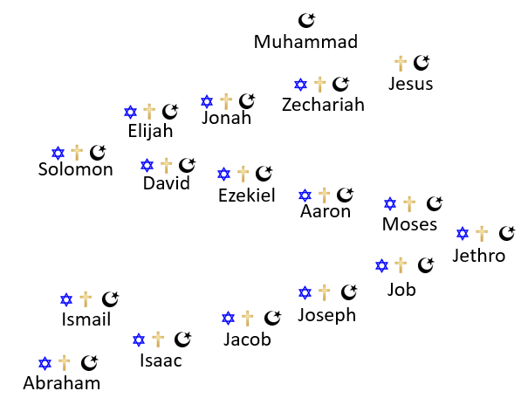**The Abrahamic Faiths**

Judaism, Christianity and Islam are referred to as the

Abrahamic faiths because they all revere Abraham

as their first prophet.

As the diagram on the right shows, the three

religions share a number of prophets

(although may refer to them by different

names) and there are strong links in beliefs

between the faiths.

Islam considers itself to the be the final and

complete revelation from God (Allah) and views

Judaism and Christianity as containing truth

but having been changed and corrupted

over time.

Muslims, and the Qur’an itself, often refer to Jews and Christians as ‘people of the book’ emphasising a community of faith among the monotheistic faiths. **Ibrahim** (Abraham in English) is considered the founding father of these three religions and is such an important figure as he was the first to preach **monotheism** (belief in one God).

**The Oneness of God**

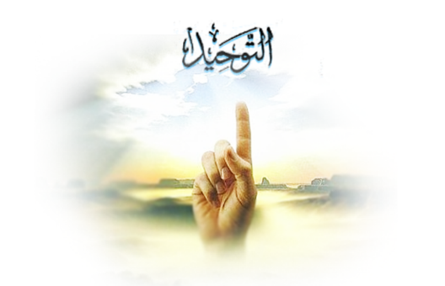

One of the most important beliefs for all Muslims is **Tawhid**: the belief that there is only one God.

The Arabic word Allah means ‘the God’, that is ‘the one and only God’ which is expressed in the Qur’an, Surah (chapter) 112:

*“Say, ‘He is God the One, God the eternal. He was not created. No one is comparable to Him.”*

This belief is repeated daily as the opening of the Shahadah (declaration of faith): *“There is no God but Allah and Muhammad is his prophet.”*

The passage from the Qur’an also expresses the belief that God is unique; there is nothing like God. No one can picture or describe God because there is nothing to compare God to. This is the reason why there are no images or pictures of God in mosques or in Muslim books or homes. Instead, decoration often takes the form of beautiful calligraphy of verses from the Qur’an.

**The Supremacy of God’s Will**

For Muslims, God is the one and only creator and controller of everything: therefore nothing takes place unless God allows it to happen, no matter whether good or bad. Muslims believe that God must have a good reason for letting it happen. Therefore, Muslims believe they should accept whatever happens as the will of God.

***“Misfortunes can only happen with God’s permission”*** Qur’an 64:11

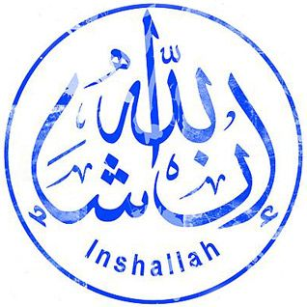Muslims will often add the word ‘*Inshallah’*, meaning ‘God willing’ after discussing what they are going to do, demonstrating their belief that God is in control.

***“You who believe, obey God and the Messenger.”***

**Qur’an 4:29**

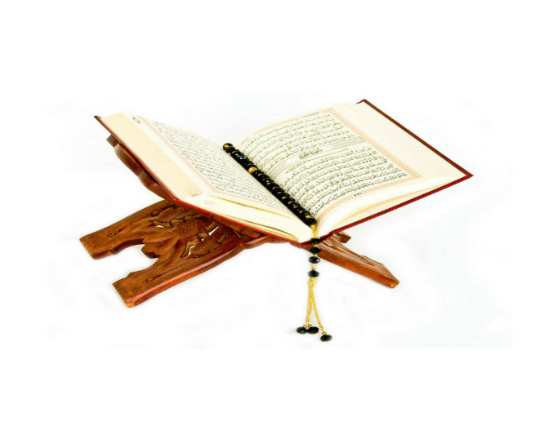Despite believing in the **supremacy** of God’s will, many Muslims believe that God does not ***control*** what people do. They would argue that God sets out clear directions on how to live a good life but ultimately gives people freedom to choose how to behave. Muslims believe their duty therefore is to choose to obey God.

The word Muslim means ‘one who has submitted to God’ and so a Muslim accepts that God is in control over what happens but also tries to live according to God’s will.

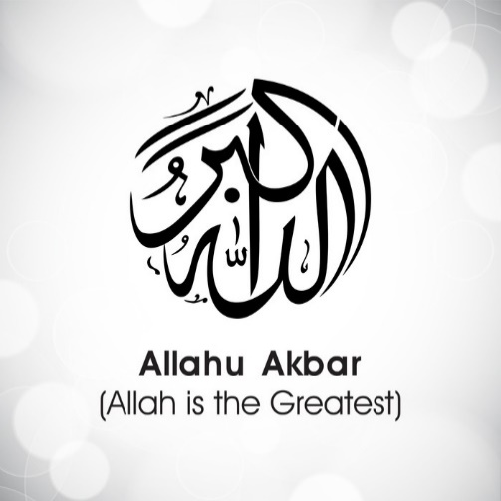**Nature of God**

Every day, Muslims hear and say the words **‘*Allahu Akbar’***, every prayer begins with these words, which means ‘God is the greatest’.

Being an Abrahamic faith, Muslims share many Jewish and Christian beliefs about the nature of God. The Qur’an refers to God by 99 different names which include:

|  |  |  |  |  |
| --- | --- | --- | --- | --- |
| ***Ar Raheem:*** | The most merciful |  | ***Al Muhyi:*** | The giver of life |
| ***Al Khaaliq:*** | The creator |  | ***Al Hayy:*** | The eternal |
| ***Al Fattaah:*** | The ultimate judge |  | ***Al Qaadir:*** | The all powerful |
| ***Al Alim:*** | The all- knowing (omniscient) |  | ***Al Barr:*** | The most righteous (good) |
| ***Al Basir:*** | The all-seeing |  | ***Al Ghafur:*** | The all-forgiving |
| ***Al ‘Adl:*** | The just |  | ***Al Wadud:*** | The loving, kind one |

Immanent: ***“He is with you wherever you are.”*** Qur’an 57:4

Transcendent: ***He is Allah, the one God, the Sovereign, the Pure, the Perfection, the Overseer, the Exalted in Might, the Transcendent, the Superior.”* Qur’an** 59:23

**Sunni and Shia**

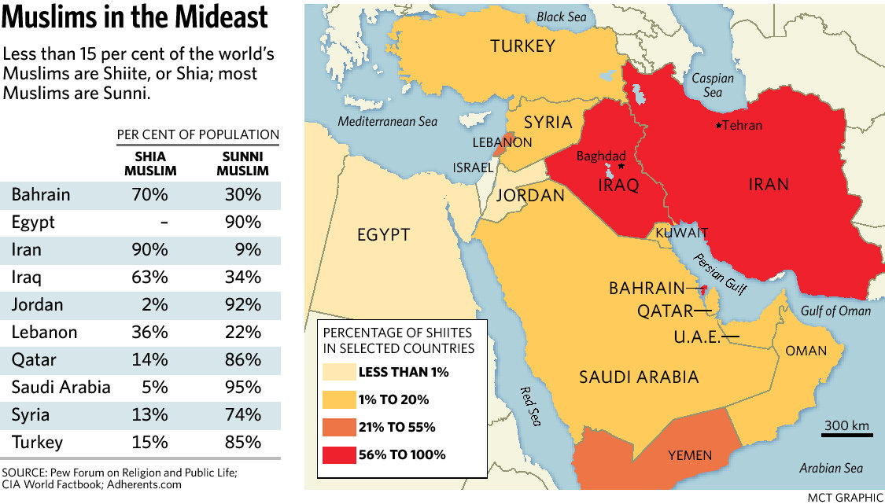As with Christianity, Islam is divided into different sects. In Islam, the two largest sects are known as Sunni and Shia.

Members of the two sects have co-existed for centuries and share many fundamental beliefs and practices such as belief in one God, the prophethood of Muhammad, the revelation of the Qur’an and the following of the Sunnah. There are however differences in doctrine, ritual, law, theology and religious organisation.

**Origin of Sunni Islam**

When Muhammad died, the majority of Muslims thought that only the **Qur’an** and the **Sunnah** (Muhammad’s teaching and actions) had the authority to guide the beliefs and behaviour of Muslims. They elected **Abu Bakr** to be their **Caliph** (leader). The Caliph did not make laws; they enforced them one the community had considered the views of scholars who had studied the Qur’an and the Sunnah. This group of Muslims became known as **‘Sunni’,** meaning followers of the Sunnah.

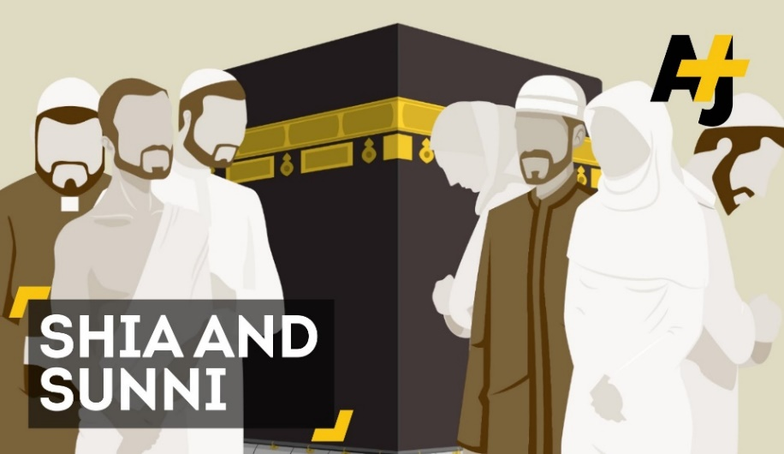**Origin of Shi’a Islam**

Another group of Muslims believed that Muhammad had named his cousin **Ali** as his successor. Ali was one of the first converts to Islam and was married to Muhammad’s daughter Fatima. Ali and his supporters thought that the true leader (Imam) had to be a relation of Muhammad and each leader would identify the next one before they died.

The believe **the Imamate** (Muhammad, Ali, and his 11 successors) to be infallible and perfect examples of humanity.

Ali’s claims to be leader were ignored by many Muslims. Over time though, a split developed among the Sunni and the Shi’a which persists today. Shi’a have a different interpretation of Islam and only accept **Hadith** that were passed down by Ali and his followers.

**The Six Articles of Faith in Sunni Islam**

Sunni Muslims hold six main beliefs:

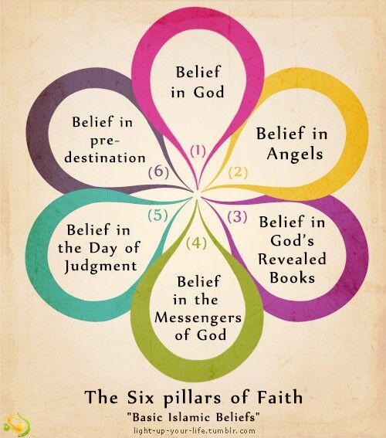1. There is only one God, ‘Allah’.

2. Angels communicate the message of God to humans (see page 10)

3. The Qur’an (meaning ‘recitation’) is the revealed word of God and is the highest authority in Islam.

4. The prophets of God. This means the belief in the human messengers of God, who were shown divine revelations and tasked with teaching humankind about God. The most important prophet in Islam is Muhammad.

5. The Day of Judgement is when all humanity will be judged by God and sent to paradise or hell.

6. God both knows and controls everything that happens in the world. This is known as predestination.

**The Five Roots of ‘Usul ad-Din in Shi’a Islam**

***Usad ad-Din*** means *‘the principles (or roots) of religion’*. The roots of the tree keep it alive and firmly attached to the source of its life. For Shi’a Muslims, these five principles keep them firmly rooted in God, the source of life.

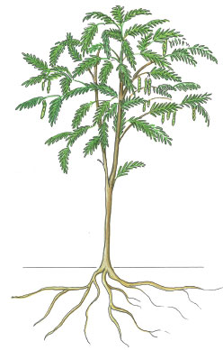

1. Tawhid:

2. Prophethood means accepting that Muhammad is God’s last prophet, and that God’s revelation through him are true.

3. God is just and wise, cannot do wrong, and holds humans accountable for their actions.

4. The Imamate means that the twelve Imams are the leaders of Islam and guard the truth of the religion without error.

5. Shi’a Muslims believe that after death they will be resurrected to be judged by God.

**Comparison of Sunni and Shi’a Islam**

|  |  |
| --- | --- |
| **Similarities** | **Differences** |
|  | Sunnis believe that Abu Bakr succeeded Muhammad as the Caliph. Shi’a Muslims believe that the Twelve Imams succeeded the Prophet and they are infallible.  Sunnis believe that the revelation of Allah’s laws ended with Muhammad. Shi’a do not believe that Allah would leave them without guidance and so believe that Imams are able to interpret the Qur’an infallibly.  Sunnis interpret the Qur’an literally but Shi’as claim that its hidden meaning was given by Muhammad to Ali and this is passed down by the Imamate.  Sunnis accept six books of Hadith which they call the *Kutub al-Sittah* (the accurate six). Shi’as have their own collection of Hadith, mostly passed on through the Imams.  Shi’as expect the Mahdi (the hidden Imam and ‘the divinely guided one’) to appear before the Day of Judgement and bring in a reign of peace and justice. There is no established doctrine of the Mahdi in Sunni Islam and ideas vary among Sunni scholars. |

**Angels**

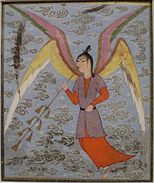

For Sunni Muslims, the belief in angels is one of the six articles of faith. Angels are part of the unseen world. They are supernatural beings, created by God from light.

*“Praise be to God, Creator of the heavens and earth, who made angels messengers with two, three, four [pairs] wings.”* **Qur’an 35:1**

Muslims believe that angels are able to receive God’s words directly from him and pass them on to the prophets of God. They can do this because they are pure and sinless.

Angels have no free will so they cannot do anything to displease God, they ceaselessly praise and worship him.

‘Angel Blowing a Woodwind', ink and opaque watercolour painting from Iran, c. 1500

\

For Muslims, angels are involved with human beings throughout their lives and even beyond death. Below are quotations from the Qur’an which refer to the role angels play in people’s lives:

*“There are guardians over everyone, both before him and behind him, who guard him by Allah's command.”* **Qur’an 35:1**

*“Moreover, there are two scribes, one each sitting on the right and the left, recording everything.”* **Qur’an 50:17**

*“The angel of death who has been charged with your souls shall gather you, and then you shall be brought back to your Lord.”* **Qur’an 32:11**

When referring to the angel Jibril (Gabriel) appearing to Maryam (Mary), the mother of Isa (Jesus): *"…Then We sent to her, Our angel, and he appeared before her as a man in all respects."* **Quran 19:17**

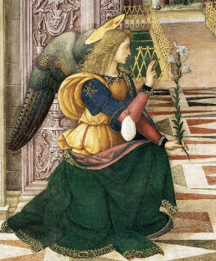**Jibril**

Jibril (Gabriel) is the angel most familiar to Christians and Jews as well as to Muslims. He is an archangel (a special angel with higher status that others) who is a trusted messenger of God. As well as being the angel who revealed to the Virgin Maryam (Mary) that she would give birth to Isa (Jesus), Jibril was the angel who relayed the Qur’an to Muhammad from God. (See page ***** of the Islam Practices booklet for more information.)

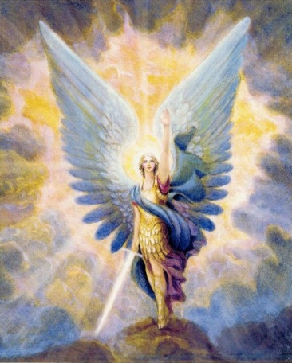**Mika’il**

Mika’il (Michael) is another high ranking archangel who is also known to Christians and Jews. Muslims believe that Mika’il is an angel of mercy. God has assigned Mika’il to reward righteous people for the good they do during their lives on earth. God has also given Mika’il responsibility for sending rain, thunder and lightning.

The Qur’an mentions Mika’il when it warns that anyone who is an enemy of God’s angels, Jibril and Mika’il, is also an enemy of God.

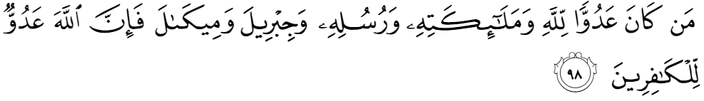

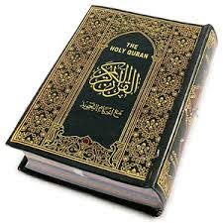*“Whoever is an enemy to Allah and His angels and His messengers and Gabriel and Michael - then indeed, Allah is an enemy to the disbelievers.”* **Qur’an 2:98**

Muslims believe that Jibril and Mika’il have brought nourishment to human beings: Jibril brought the spiritual nourishment of God’s words in the Qur’an, and Mika’il brings nourishment for the earth and human life through the weather.

**Jinns and Shaytan**

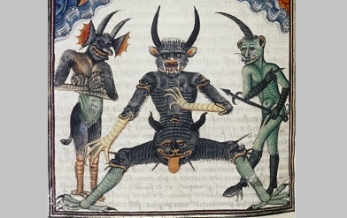

Allah created angels from divine light (nur). He then also created other spirits called **Jinns** which were created from fire. He then made the first human, Adam, from clay. Allah ordered all the angels and Jinn to bow down to Adam. Iblis, one of the Jinn, refused saying: *“I am not one to prostrate myself to man.”*

As a result, Allah said: *“Then get thee out from here; for thou are rejected, accursed. And the curse shall be on thee til the Day of Judgement”*

Notice the parallels here between Iblis and the Christian belief in the devil. However, the crucial difference is that in Islam, **Iblis is not an angel.**

**Predestination and Free will**

As we have seen on page 6, Muslims believe in the supremacy of God’s will. This leads to a belief in Qadr (predestination). This raises questions about how this affects human free will. Read the Quranic quotations below and explain what they teach about predestination and/or free will.

*“Only what God has decreed will happen to us.”* **Qur’an 9:51**

*“Obey Allah, and obey the Messenger, and those charged with authority among you.”* **Qur’an 4:59**

*“Do you not know that Allah knows all that is in heaven and on Earth? Indeed it is all in a record, and that is easy for Allah.”* **Qur’an 22:70**

*“You shall not will except as Allah wills.”* **Qur’an 81:29**

*“Allah has created you and all your handiwork.”* **Qur’an 37:96**

*“Mischief has appeared in the land. This is what mankind has earned so that Allah may give them a taste of some of their deeds in order that they may turn their backs from evil.”* **Qur’an 30:41**

*“God does not change the condition of a people unless they change what is in themselves.”* **Qur’an 13:11**

*“Those who believe, do good deeds, keep up the prayer, and pay the prescribed charity will have their reward with the Lord.”* **Qur’an 2:277**

**Is predestination compatible with free will?**

**Life After Death**

For Muslims, death is not the end but the beginning of a new stage of life called **Akhirah.**

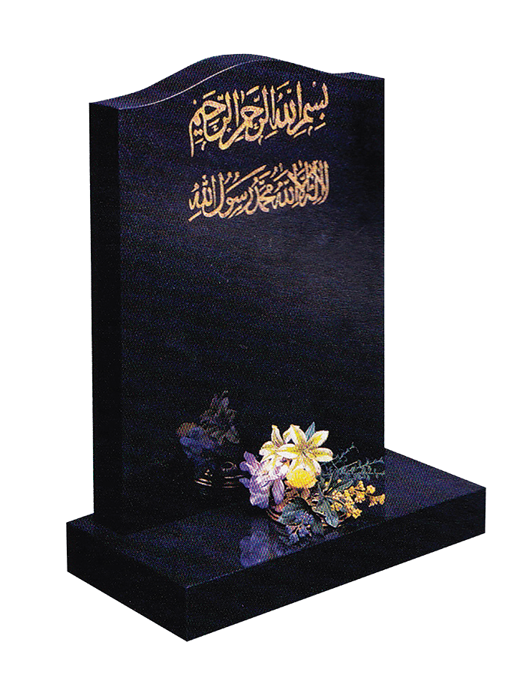Many Muslims believe that after death the person still has a conscious existence in the grave. Here they will enter a stage of waiting called **barzakh**, which means ‘a barrier’: no one can cross the barrier to amend things they have done or warn the living of what comes after.

People stay here until the **Day of Judgement.** On that day, they will be raised from their graves and brought before Allah and judged on how they lived their earthly lives. This belief is known as the resurrection of the body.

Muslims believe that as they lie in the grave, God sends two angels to question them about their faith. If people answer correctly, they will see the rewards to come, but if they deny God, they will see the punishments they will have to endure.

**The Day of Judgement and Resurrection**

Muslims believe that a day will come when God’s purpose for the universe has been fulfilled. Only God knows when that will be:

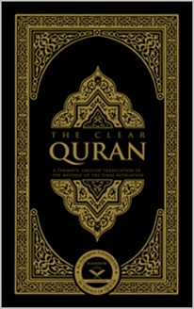

*“On that Day, people will come forward in separate groups to be shown their deeds: whoever has done an atom’s weight of good will see it, but whoever has done an atom’s weight of evil will see that”***(Qur’an 99:6-8).**

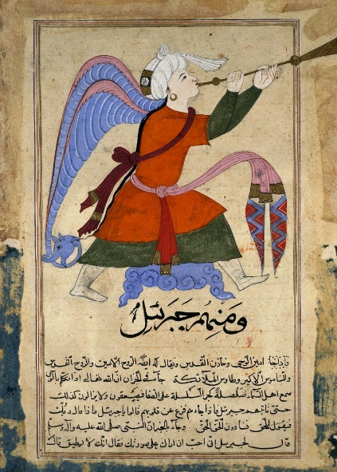On this day the angel Israfil will blow a trumpet to announce that the world will be destroyed. The present world will be totally transformed into a new world (**Akhirah**) and then the angel Israfil will blow the trumpet again. Everyone who has ever lived will be raised from the dead (resurrection) and judged by God.

People will be given new bodies and the book of their life will be handed to them to read out. If people are given it in their right hand they will go to heaven; if they receive it in their left hand they will go to hell.

Everyone will then face their good and bad deeds. If they are believers who have shown sorrow for their failings, God will forgive them but they must first cross the ‘Sirat Bridge’ that spans the fires of hell. Those with fewer sins will be transported across the bridge quickly and enter heaven.

**Heaven and Hell**

|  |  |
| --- | --- |
| **Heaven (Jannah)**  *“On couches of well-woven cloth*  *they will sit facing each*  *other; everlasting youths will*  *go round among them with*  *glasses, flagons, and cups of*  *a pure drink that causes no*  *headache or intoxication;*  [there will be] *any fruit they*  *choose; the meat of any bird they like;*  *and beautiful-eyed maidens like*  *hidden pearls; a reward*  *for what they used to do.”* | **Hell**  *“They* [those who reject God and do evil] *will dwell amid scorching wind and scalding water in the shadow of black smoke, neither cool nor refreshing.”* **Qur’an 56:42-44**  *“Garments of fire will be tailored for those who disbelieve; scalding water will be poured over their heads, melting their insides as well as their skins; there will be iron crooks to restrain them; whenever, in their anguish, they try to escape, they will be pushed back in and told, ‘Taste the suffering of the fire’.* **Qur’an 22:19-22** |

**Comparison between Christian and Muslim beliefs in life after death**

## **Prophethood**

Muslims believe that God has chosen my **prophets** (messengers from God) to bring the message of Islam to the people. This belief in the prophets and their importance is known as **Risalah**.

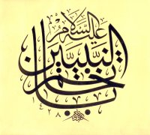Prophethood – when someone is made a prophet – is a gift given by God to help humankind understand his message.

The prophets are important for Muslims because:

* They provided a method of communication between God and human beings.
* They are able to teach people how to live in the way God desires.

Islamic seal of prophethood

* They call people back to the right path when humans have forgotten, misunderstood or changed God’s message.
* They act as role models for how to live a good life.

There are 25 prophets named in the Qur’an but Muslims believe there have been up to 124,000 prophets. Many of these prophets, including the most important: Adam, Ibrahim (Abraham), Musa (Moses), Isa (Jesus) are also prophets in Judaism and Christianity (see page 5).

The most important Islamic prophet however, Muhammad, is exclusive to Islam.

**Adam**

Muslims believe that Adam was the first man on Earth and the first prophet of Islam. Created by God from the dust of the ground, he is regarded as the father of the human race and so is treated with reverence and great respect.

*“One of His signs is that He created you from dust and – lo and behold! – you became human and scattered far and wide.”* **Qur’an 32:7-9**

God *“taught Adam understanding and the names of all things”* and asked Adam to demonstrate his superior knowledge to the angels. God told the angels and jinns (see page 11) to bow down to Adam out of respect and admiration for his knowledge, but Iblis refused. His defiance resulted in Iblis being thrown out of paradise and vowing to tempt humans to sin.

In order to prevent Adam from being lonely, God created Hawwa (Eve) and they lived in the Garden of Bliss. God gives them one rule they must obey: they must not eat of the fruit a particular tree in the garden. Iblis deceived them into eating the fruit and, as a result, they were thrown out of the garden. Their actions brought sin into the world and all humans would now be judged on the Day of Judgement.

Adam is important to Muslims as a prophet because God first gave him understanding and knowledge of how to live a good life (including food they are allowed to eat, how to repent for wrongdoing and how to bury the dead) which was passed down to the human race.

**Ibrahim**

*“Who could be better in religion than those who direct themselves wholly to God, do good, and follow the religion of Ibrahim, who was true in faith? God took Ibrahim as a friend.”*

**Qur’an 4:125**

Ibrahim is the Arabic name of the prophet Abraham who is also revered in Judaism and Christianity (see page 5). Ibrahim/Abraham is such an important prophet in all three religions because he reinstated monotheism at a time when the world worshipped many Gods.

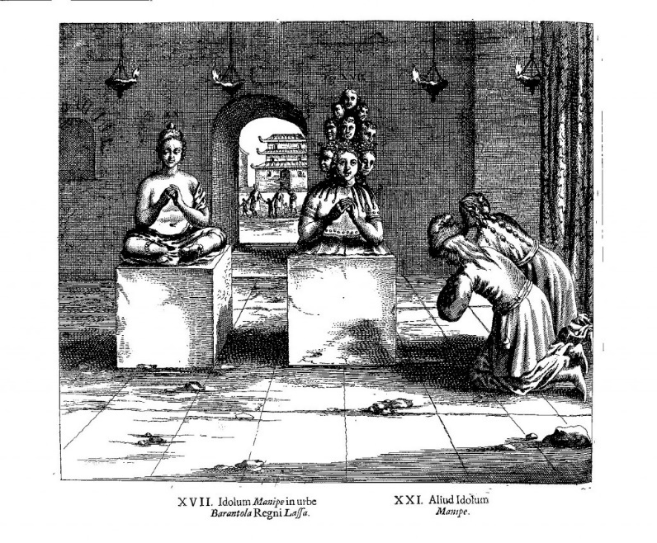Muslims believe that he fulfilled all the tests and commands given to him by God, and so was promised to be the father of all nations. They believe that the prophet Muhammad was descended from Ibrahim through his first son, Isma’il.

Because of his firm belief in monotheism, Ibrahim was determined to stop the worship of statues and other idols. One day the people of his community were out celebrating and Ibrahim went to the place where the idols were kept and broke them up, apart from the big one. He hung the axe around the neck of the big idol and then went away. When the people returned they were shocked and accused Ibrahim. Ibrahim replied,

*“The big idol must have done this, he has the axe around the neck, why don’t you ask it?”*

The people grew angry: *“The big idol doesn’t have the power to move so how can it break the other idols? The big idol doesn’t have the power to talk so how can it tell us about the broken idols?”* Ibrahim explained to them that if these idols are powerless and can’t do anything, then why do you pray to them?”

The people became very angry and decided to punish Ibrahim (peace be upon him). They would punish him by lighting a huge fire and throwing him into it. Ibrahim remained quiet and was confident that Allah would save him. They loaded Ibrahim into a catapult and pelted him into the fire. Allah commanded the fire to remain cool for Ibrahim and not to harm him with its flames and heat. Following these events, many people converted to Islam because of what they had seen in Ibrahim.

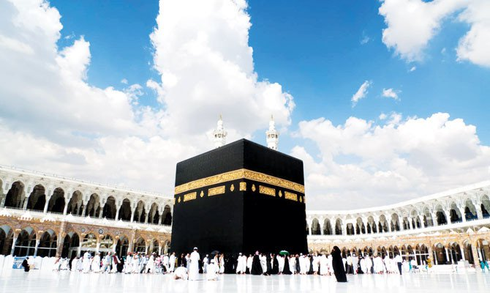The Qur’an presents Ibrahim as a role model because of his obedience to God (he was prepared to sacrifice his son), his kindness and compassion, and his refusal to worship idols.

Muslims also believe that Ibrahim rebuilt the Ka’aba which is the holiest place in Islam and which all Muslims face when they pray. It is believed that the original Ka’aba was built by Adam but then destroyed by the flood at the time of Noah.

Much of the compulsory pilgrimage of Hajj (see Islamic Practices booklet) commemorates Ibrahim and his life.

**Muhammad**

Muslims believe that Muhammad ***“is God’s messenger and the seal of the prophets****”*.

Muslims believe that Islam is a faith that has always existed and that it was gradually revealed to humanity by a number of prophets, but the final and complete revelation of the faith was made through the Prophet Muhammad in the 7th century CE.

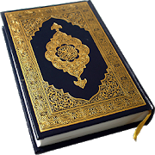Muhammad was born in Mecca in Saudi Arabia in 570CE. He was a deeply spiritual man, and often spent time in prayer on Mount Hira. The [Qur'an](http://www.bbc.co.uk/religion/religions/islam/texts/quran_1.shtml) tells how, one night in 610CE, he was praying in a cave on the mountain when he was visited by the angel Jibreel who ordered him to [recite](http://www.bbc.co.uk/programmes/p0092pw0). Muhammad began to recite [words](http://www.bbc.co.uk/programmes/p0030sqm) which he came to believe were the words of God. During the rest of his life Muhammad continued to receive these revelations. The words were remembered and recorded, and form the text of the Holy Qur’an, the Muslim scripture.

Three years after the first revelation, Muhammad began preaching the words he had received and he spent the remainder of his life proclaiming that there is one God and that complete surrender to God is the acceptable way to live. He challenged the people of Mecca on their sinful ways and encouraged them to give up cheating, drinking alcohol, gambling and idol worship. This message was not received well and Muhammad was forced to flee persecution with his followers to Medinah in 622CE. This event is known as the **Hijrah** (departure) and marks the beginning of the **Ummah** (the worldwide family of Muslims).

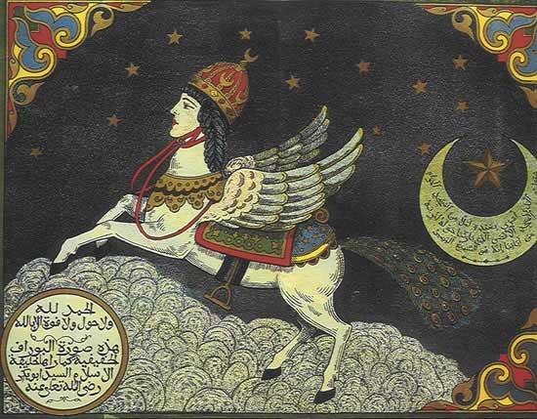Before the Hijrah, the Qur’an records an experience that Muhammad had in which the angel Jibril took Muhammad on a miraculous journey to Jerusalem known as **the Night Journey**. Muhammad was carried on a winged horse named al-Buraq. From Jerusalem, Muhammad ascended to heaven where he saw spoke to prophets such as Isa (Jesus) and had extraordinary signs of God. Among other things, Muhammad returned with the revelation that Muslims should pray 5 times a day.

In Medinah, Muhammad united the tribes and gathered an army of 10,000 Muslim converts. He marched on Mecca and, with God’s help, conquered the city and claimed it in the name of Islam. The idols at the Ka’aba were destroyed and Muhammad set about introducing **Shariah**.

Muslims believe Muhammad is the most important prophet in Islam because:

* He is a perfect role model and his example is recorded in the **Sunnah**.
* He revealed the word of God through the Qur’an.
* He also revealed many other truths which now form part of the **Hadith**.
* He is responsible for the spread of Islam.

**The Holy Books in Islam**

**The Qur’an**

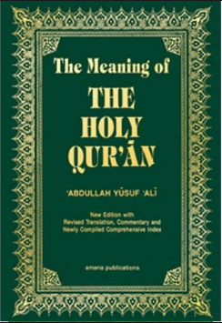Muslims believe that the Qur’an is the perfect word of God which was revealed to the prophet Muhammad over a period of around 22 years. Islamic scholars regard the Qur’an that is beautifully written in perfect Arabic such that it is not replicated in ordinary speech. For this reason, although some of the meaning can be communicated through translations to other languages, unless written in the original Arabic, a Qur’an cannot be considered authentic.

Since Muhammad could not read or write, he memorised the words of the Qur’an and they were passed on by word of mouth until after his death when they were written down. The third Caliph, Uthman, was concerned about the Qur’an being changed or misremembered and so commissioned on official written version to be followed everywhere. This was completed in 650CE and the words are believed to be exactly the same now as were revealed to Muhammad. Muslim children will learn Arabic from an early age so that they can read the original text of the Qur’an. Many Muslims learn to the whole Qur’an from memory. People who do this are called ***hafiz*.**

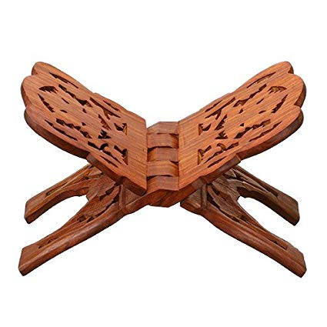

Because it is believed to be the literal word of God, the Qur’an is treated with great respect. It is always kept on the highest shelf with nothing above it, when it is not being read it is kept wrapped up, it is never allowed to touch the floor and so placed on a small stool called a ***rihal*** while being read, this also means that is not even touched unnecessarily.

The Qur’an is broken down into 114 surahs (chapters) which contain a mixture of historical accounts and guidance on how to live a good life. The opening surah, al Fatihah is used in daily prayers and is a prayer to ask God for guidance. The remaining surahs are approximately arranged in order of length with the longest first, not in the order they were revealed.

**Other holy books**

*“We sent Jesus, son of Mary, to confirm the Torah that had been sent before him: We gave him the Gospel with guidance, light, and confirmation of the Torah already revealed – a guide and lesson for those who take heed of God.”* **Qur’an 5:46**

Muslims believe that the Jewish (**Torah, Psalms**) and Christian scriptures (**Gospels**) were also revelations from God and contain truth. However, they believe that these revelations have been corrupted and changed over time. Over time, prophets have been sent by God to correct for this until, ultimately, Muhammad was sent by God to be the final seal of revelation.

Possible exam questions

Question 1: (1 mark)

1) What is meant by the term Tawhid?

1) What is the meaning of Adalat?

Question 2: (2 marks)

2) Give two of the Holy books, other than the Qur’an.

2) Give two angels that are mentioned in the Qur’an.

2) Give two articles of faith in Sunni Islam.

Question 3: (4 marks)

3) Explain two ways in which a belief in life after death influences Muslims today.

3) Explain two ways in which belief about heaven and hell influence Muslims today.

3) Explain box two ways in which belief in predestination influences Muslims today.

Question 4: 5 marks

4) Explain two Muslim teachings about angels.

4) Explain two Muslim teachings about Tawhid (the Oneness of God).

4) Explain two Muslim beliefs about the role of prophets.

**You must** refer to scripture or sacred writings in your answer.

Question 5: (12 marks)

5) ‘To describe God as ‘omnipotent’ is the best way to understand God.’

5) ‘For Muslims, Adam is a more important Prophet than Ibrahim.’

5) ‘The Qur’an is the only authority a Muslim needs in life.’

Evaluate the statement. In your answer you should:

• refer to Muslim teaching

• give developed arguments to support this statement

• give developed arguments to support a different point of view

• reach a justified conclusion.