Structure and Bonding Summary – Covalent
Structure – the arrangement of the atoms
Bonding – how the atoms are held together
Changing state - amount of energy needed to change state depends on strength of forces between particles in a substance - the stronger the forces the higher the melting point and boiling point of the substance

Type | Structure | Bonding | Property | Reason
Small molecules  Non-metals  Atoms share pairs of electrons | Small molecules or molecular  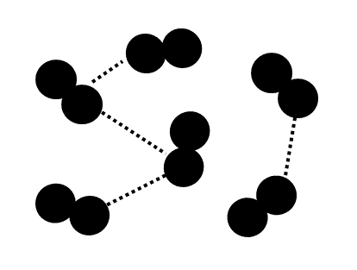 | Shared pairs of electrons form strong covalent bonds  Weak forces between molecules  Intermolecular forces  are weak compared with covalent bonds | Gases or liquids with low melting and boiling points  Larger molecules have higher melting and boiling points | Weak intermolecular forces are broken (not the strong covalent bonds)  The intermolecular forces increase with the size of the molecules
 |  |  | Do not conduct electricity | Do not have an overall electric charge
Giant molecules  Non-metals  Atoms share pairs of electrons | Giant covalent  structures or macromolecular | Shared pairs of electrons form strong covalent bonds between all atoms
Diamond | Tetrahedral  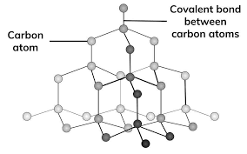 | Each carbon atom forms four covalent bonds with other carbon atoms | Very high melting point | All atoms are bonded to other atoms by strong covalent bonds which must be broken to melt
 |  |  | Very hard | All atoms are bonded to other atoms by strong covalent bonds which must be broken to melt
 |  |  | Does not conduct electricity | Do not have an overall electric charge
Graphite | Layers of hexagonal rings with no covalent bonds between the layers  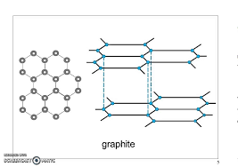  Layers held by weak forces | Each carbon atom forms three covalent bonds with three other carbon atoms  One electron from each carbon atom is delocalised and able to move along the layers | Very high melting point | All atoms are bonded to other atoms by strong covalent bonds which must be broken to melt
 |  |  | Soft and slippery | Weak forces between layers are easily broken
 |  |  | Does conduct electricity | Delocalised electrons carry electrical charge along the layers

