
Foundation IGCSE (9 – 1) Revision Pack

Areas, perimeters, volumes, and symmetry
(Foundation)

Name --------------------------------
Questions
Q1.
The diagram shows 7 shapes, A, B, C, D, E, F and G, on a centimetre square grid.
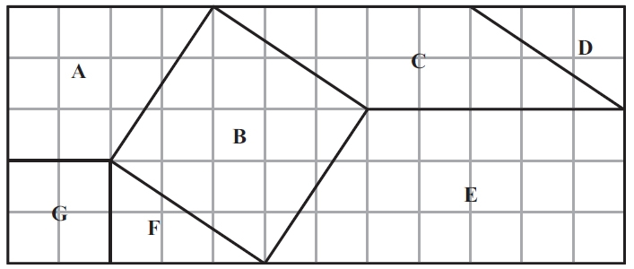
(a) What is the mathematical name of shape E?
...........................................................
(1)
(b) Write down the letters of the two shapes which are congruent.
............................. and ...............................
(1)
(c) Mark an obtuse angle on one of the shapes.
Label your angle x.
(1)
(d) How many lines of symmetry has shape B?
...........................................................
(1)
(e) Work out the area of shape C.
...........................................................cm²
(2)
(Total for question = 6 marks)

Q2.
The length of a rectangle is 12 cm.
The width of the rectangle is 7 cm.
Work out the area of the rectangle.
...........................................................cm²
(Total for question = 2 marks)

Q3.
Here is a rectangle made from 12 square tiles.
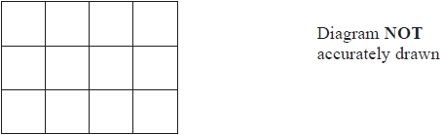
The perimeter of each tile is 20 cm.
Work out the area of the rectangle.
........................................................... cm²

(Total for question = 3 marks)

Q4.
The diagram shows a quadrilateral ABCD on a centimetre grid.
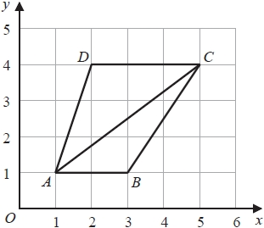
(a) Work out the area of triangle ABC.
You must include the units with your answer.
...........................................................
(3)
(b) Give a reason why angle ACD is equal to angle CAB.
.............................................................................................................................................
(1)
(c) Write down an equation for the straight line that passes through D and C.
...........................................................
(1)

(Total for question = 5 marks)

Q5.
Here is an isosceles triangle.
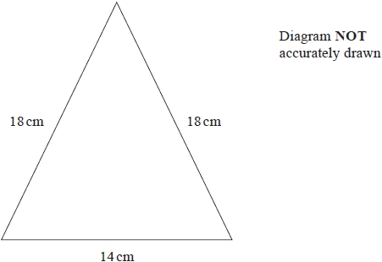
Work out the area of the triangle.
Give your answer correct to 3 significant figures.
........................................................... cm²
(1)

(Total for question = 4 marks)

Q6.
The diagram shows a shape.
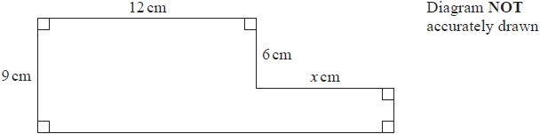
The shape has area 129 cm²
Work out the value of x.
x = ...........................................................

(Total for question = 4 marks)

Q7.
Here is a solid prism.
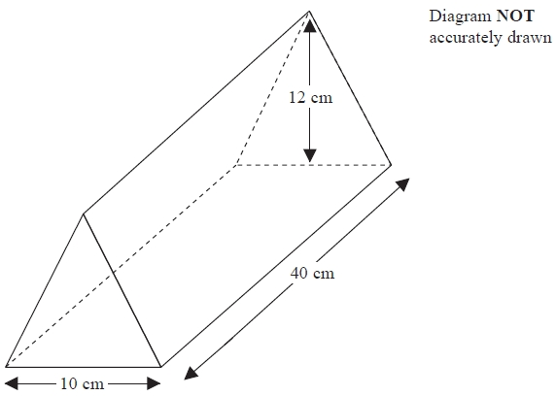
The cross section of the prism is a triangle.
(a) How many edges has this prism?
...........................................................
(1)
(b) How many faces has this prism?
...........................................................
(1)
The base of the triangle is 10 cm.
The height of the triangle is 12 cm.
The length of the prism is 40 cm.
(c) Work out the volume of the prism.
........................................................... cm³
(2)
(Total for question = 4 marks)

Q8.
The diagram shows a solid cuboid.
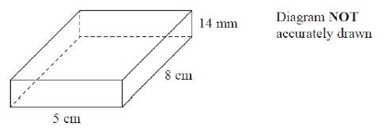
(a) How many faces has this cuboid?
...........................................................
(1)
(b) How many edges has this cuboid?
...........................................................
(1)
The cuboid has width 5 cm, length 8 cm and height 14 mm.
(c) Work out the volume, in cm³, of the cuboid.
........................................................... cm³
(3)

(Total for question = 5 marks)

Q9.
A cylinder has diameter 14 cm and height 20 cm.
Work out the volume of the cylinder.
Give your answer correct to 3 significant figures.
........................................................... cm³

(Total for question = 2 marks)

Q10.
The diagram shows a solid cuboid made from wood.
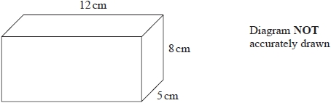
The wood has density 0.7 g/cm³
Work out the mass of the cuboid.
........................................................... grams
(Total for question = 3 marks)

Q11.
(a) On the centimetre grid, draw a rectangle with an area of 8 cm²
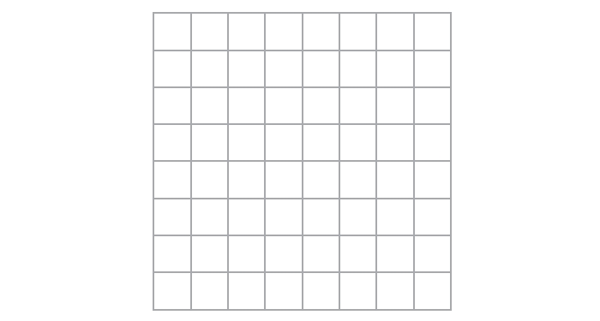
(1)
(b) On the centimetre grid, draw an isosceles triangle with an area of 8 cm²
(2)

(Total for question = 3 marks)

Q12.
The diagram shows a picture of a ship and four containers.
The ship and the containers are drawn to the same scale.
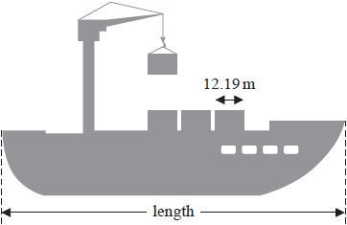
The length of each container is 12.19 m.
(a) Work out an estimate for the length of the ship.
Show your working clearly.
........................................................... m
(2)
A different container is a cuboid with length 6.2 m, width 2.4 m and height 2.5 m.
(b) Work out the volume of this container.
........................................................... m³
(2)

(Total for question = 4 marks)

Q13.
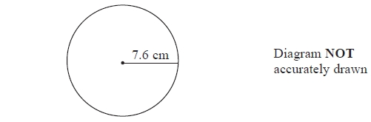
(a) A circle has a radius of 7.6 cm.
Work out the area of the circle.
Give your answer correct to 3 significant figures.
........................................................... cm²
(2)
The radius, 7.6 cm, is correct to 1 decimal place.
(b) (i) Write down the upper bound of the radius.
........................................................... cm
(ii) Write down the lower bound of the radius.
........................................................... cm
(2)
(Total for Question is 4 marks)

Q14.
The diagram shows a shape with one line of symmetry.
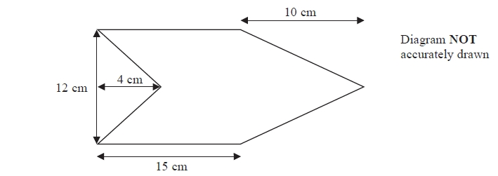
Work out the area of the shape.
...........................................................cm²

(Total for question = 4 marks)

Q15.
The diagram shows an isosceles triangle.
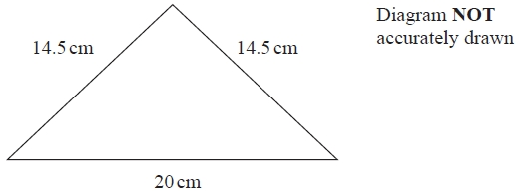
Work out the area of the triangle.
........................................................... cm²

(Total for question = 4 marks)

Q16.
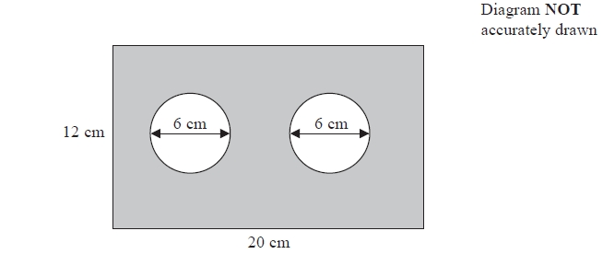
The diagram shows a metal plate in the shape of a rectangle.
The rectangle has length 20 cm and width 12 cm.
Two identical circles, each of diameter 6 cm, have been cut out of the plate.
Work out the area of the shaded region of the metal plate.
Give your answer correct to the nearest cm².
........................................................... cm²
(Total for Question is 4 marks)

Q17.
Here is a trapezium ABCD.
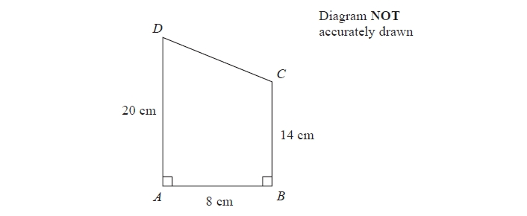
Angle DAB = angle ABC = 90°
AD = 20 cm
AB = 8 cm
BC = 14 cm
(a) Calculate the area of the trapezium ABCD.
.......................................................... cm²
(2)
(b) Calculate the length of CD.
.......................................................... cm
(4)

(Total for question = 6 marks)

Q18.
Here is a rectangle made from centimetre squares.
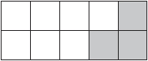
(a) Find the area of this rectangle.
........................................................... cm²
(1)
(b) What percentage of the rectangle is shaded?
........................................................... %
(1)
60% of a triangle is shaded.
(c) What percentage of the triangle is not shaded?
........................................................... %
(1)
(d) Write 60% as a decimal.
...........................................................
(1)
(e) Change 60% to a fraction.
Give your answer in its simplest form.
...........................................................
(2)

(Total for question = 6 marks)

Q19.
The diagram shows a shape drawn on a centimetre grid.
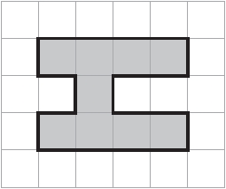
(a) (i) Find the area of the shape.
........................................................... cm²
(ii) Find the perimeter of the shape.
........................................................... cm
(iii) On the grid, draw the line of symmetry of the shape.
(3)
Here is a different shape.
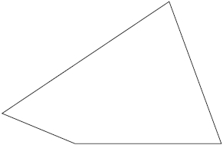
(b) On this shape, mark an obtuse angle.
Label your angle O
(1)

(Total for question = 4 marks)

Q20.
The wheel of the Singapore Flyer is a circle with a diameter of
150 metres.
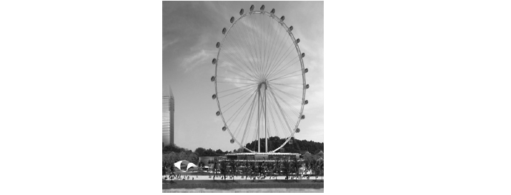
(a) Calculate the circumference of the wheel.
Give your answer correct to the nearest metre.
.......................................................... metres
(2)
The wheel takes 30 minutes to rotate once.
(b) Work out the average speed of a point on the circumference of the wheel as it
rotates once.
Give your answer in metres per second correct to 3 significant figures.
.......................................................... metres per second
(3)
The diagram shows a giant wheel above horizontal ground.
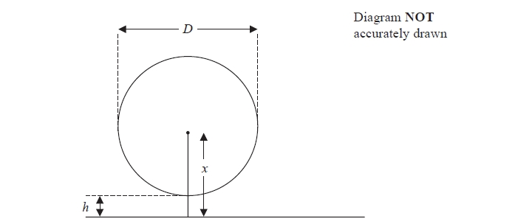
The wheel is a circle of diameter D metres.
The lowest point of the wheel is h metres above the ground.
The centre of the wheel is x metres above the ground.
(c) Express h in terms of D and x
..........................................................
(2)

(Total for question = 7 marks)

Q21.
A circle has a diameter of 7.6 cm.
Work out the circumference of the circle.
Give your answer correct to 3 significant figures.
...........................................................
(Total for question = 2 marks)

Q22.
There is a World Peace Bell in South Korea.
At its widest, the bell has a circular cross section with a diameter of 2.5 m.
(a) Work out the circumference of a circle with diameter 2.5 m.
Give your answer correct to 3 significant figures.
........................................................... m
(2)
The World Peace Bell in South Korea has a height of 4.7 m.
At its widest, the bell has a circular cross section with a diameter of 2.5 m.
A scale model is made of the bell.
At its widest, the scale model has a circular cross section with a diameter 10 cm.
(b) Work out the height of the scale model.
Give your answer in centimetres.
........................................................... cm
(2)

(Total for question = 4 marks)

Q23.
A cylinder has diameter 12 cm and length 30 cm.
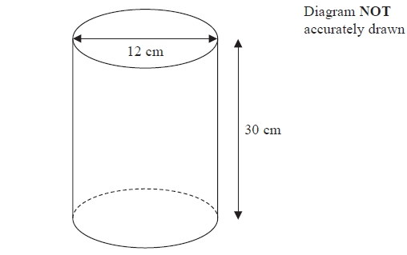
Work out the curved surface area of the cylinder.
Give your answer correct to 3 significant figures.
........................................................... cm²
(Total for Question is 3 marks)

Q24.
The diagram shows a rectangle and a right-angled triangle.
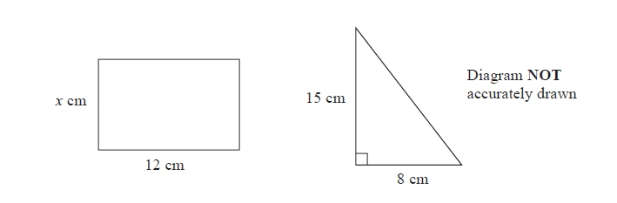
The area of the rectangle is the same as the area of the triangle.
Work out the value of x.

x =...........................................................

(Total for question = 3 marks)

Q25.
The diagram shows a shape ABCDE made from a square BCDE and an equilateral triangle ABE.
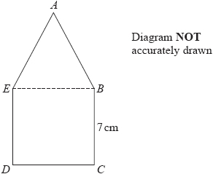
BCDE is a square of side 7 cm.
Work out the perimeter of shape ABCDE.
........................................................... cm

(Total for question = 2 marks)

Q26.
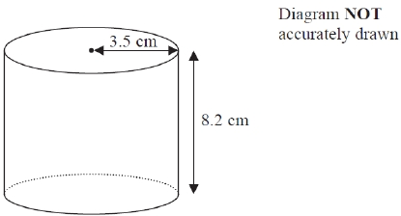
A solid cylinder has radius 3.5 cm and height 8.2 cm.
Work out the total surface area of the cylinder.
Give your answer correct to 3 significant figures.
........................................................... cm²

(Total for question = 3 marks)

Q27.
The diagram shows a solid cylinder.
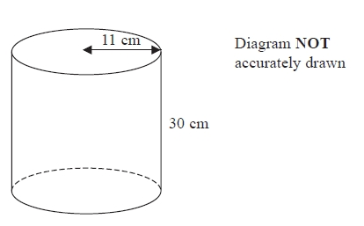
The cylinder has a height of 30 cm and a radius of 11 cm.
(a) Work out the total surface area of the cylinder.
Give your answer correct to 2 significant figures.
...........................................................cm²
(4)
(b) The height of the cylinder is 30 cm, correct to the nearest centimetre.
(i) Write down the lower bound of the height of the cylinder.
...........................................................cm
(ii) Write down the upper bound of the height of the cylinder.
...........................................................cm
(2)

(Total for question = 6 marks)

Q28.
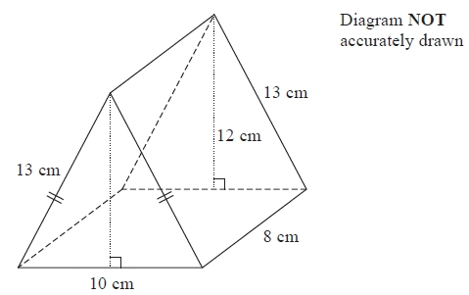
The diagram shows a prism.
The cross-section of the prism is an isosceles triangle.
The lengths of the sides of the triangle are 13 cm, 13 cm and 10 cm.
The perpendicular height of the triangle is 12 cm.
The length of the prism is 8 cm.
Work out the total surface area of the prism.
........................................................... cm²
(Total for Question is 3 marks)

Q29.
The diagram shows a rectangle and a circle.
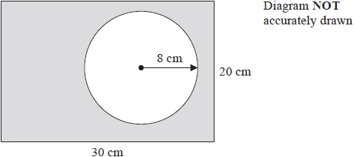
The rectangle has length 30 cm and width 20 cm.
The circle has radius 8 cm.
Work out the area of the shaded region.
Give your answer correct to 3 significant figures.
........................................................... cm²

(Total for question = 4 marks)

Q30.
The diagram shows triangle P drawn on a centimetre grid.
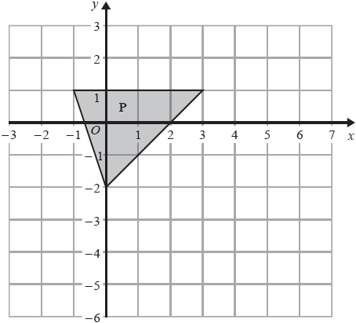
(a) Work out the area of triangle P.
........................................................... cm²
(1)
Triangle E is an enlargement of triangle P with centre O and scale factor 2
(b) On the grid, draw triangle E.
(2)
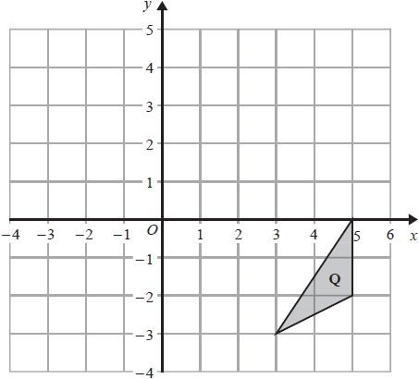
(c) On the grid, reflect triangle Q in the line x = 1
(2)
(Total for question = 5 marks)

Q31.
ABCD is a square, with sides of length 10 cm, made from four rectangles.
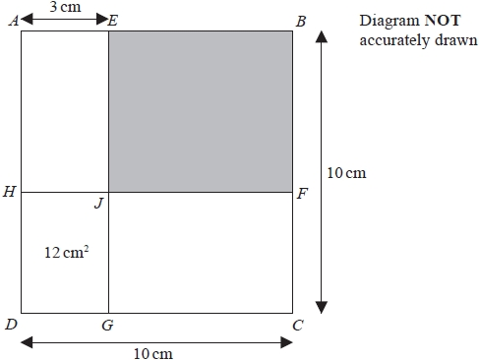
EJG and HJF are straight lines.
E is the point on AB such that AE = 3 cm.
The area of rectangle DHJG is 12 cm²
Find the area of the shaded rectangle EBFJ.
........................................................... cm²

(Total for question = 4 marks)

Q32.
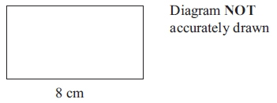
The length of a rectangle is 8 cm.
The area of the rectangle is 52 cm².
Work out the perimeter of the rectangle.
............................................................ cm
(Total for question = 3 marks)

Q33.
Here are two cuboids, A and B.
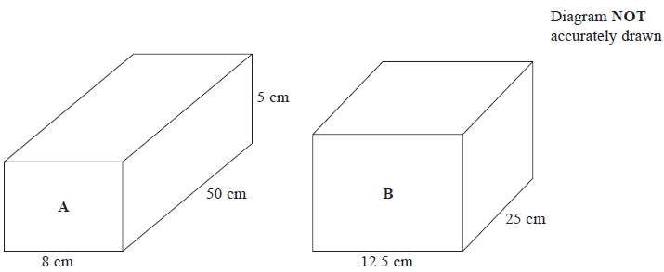
Cuboid A has a width of 8 cm, a length of 50 cm and a height of 5 cm.
(a) Calculate the volume of cuboid A.
.......................................................... cm³
(2)
Cuboid B has a width of 12.5 cm and a length of 25 cm.
Cuboid B has the same volume as cuboid A.
(b) Calculate the height of cuboid B.
.......................................................... cm
(3)
(Total for question = 5 marks)

Q34.
The diagram shows a cuboid.
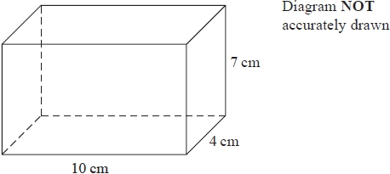
The cuboid has length 10 cm, width 4 cm and height 7 cm.
Work out the volume of the cuboid.
........................................................... cm³

(Total for question = 2 marks)

Q35.
Here is a cuboid.
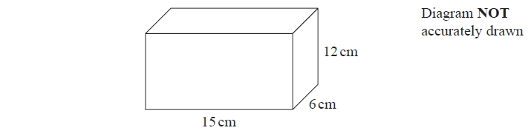
(a) Work out the volume of the cuboid.
........................................................... cm³
(2)
(b) (i) How many vertices has a cuboid?
...........................................................
(ii) How many edges has a cuboid?
...........................................................
(2)

(Total for question = 4 marks)

Q36.
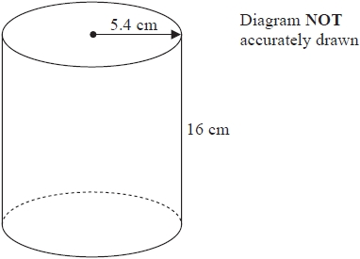
A cylinder has radius 5.4 cm and height 16 cm.
(a) Work out the volume of the cylinder.
Give your answer correct to the nearest whole number.
........................................................... cm³
(2)
The radius 5.4 cm is correct to 2 significant figures.
(b) (i) Write down the upper bound of the radius.
........................................................... cm
(ii) Write down the lower bound of the radius.
........................................................... cm
(2)
(Total for question = 4 marks)

Q37.
Here is a prism.
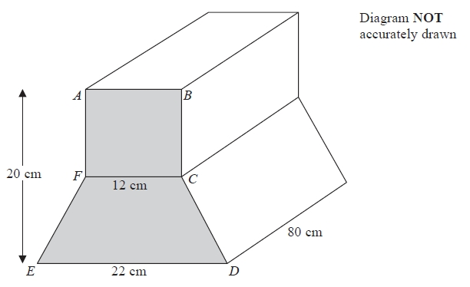
ABCDEF is a cross section of the prism.
ABCF is a square of side 12 cm.
FCDE is a trapezium.
ED = 22 cm.
The height of the prism is 20 cm.
The length of the prism is 80 cm.
Work out the total volume of the prism.
........................................................... cm³

(Total for question = 5 marks)

Q38.
Sahil has a fish tank in the shape of a cuboid, as shown in the diagram.
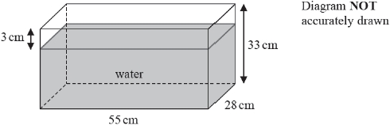
The tank is
55 cm long
28 cm wide
33 cm high
The surface of the water in the tank is 3 cm below the top of the tank.
Sahil is going to put some neon tetra fish in his tank.
He must allow 4 litres of water for each of the neon tetra fish he puts in the tank.
What is the greatest number of neon tetra fish Sahil can put in his tank?

(Total for question = 4 marks)

Q39.
Here is a quadrilateral.
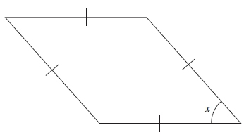
(a) What is the mathematical name for this type of quadrilateral?
...........................................................
(1)
(b) (i) Measure the size of angle x.
...........................................................°
(ii) What type of angle is angle x?
...........................................................
(2)
(c) Find, by measuring, the perimeter of the quadrilateral.
...........................................................cm
(2)
(Total for question = 5 marks)

Q40.
The diagram shows a quadrilateral PQRS drawn on a centimetre grid.
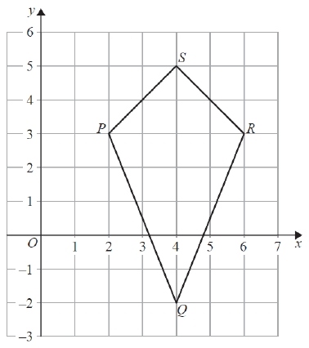
(a) Write down the mathematical name of the quadrilateral PQRS.
...........................................................
(1)
(b) Measure the length of PQ.
Give your answer in millimetres.
........................................................... mm
(1)
(c) Write down the coordinates of
(i) the point P,
(........................... , ...........................)
(ii) the point Q.
(........................... , ...........................)
(2)
(d) On the quadrilateral PQRS, draw the line of symmetry.
(1)
(e) Work out the area of the quadrilateral PQRS.
........................................................... cm²
(2)

(Total for question = 7 marks)

Q41.
(a) Write down the mathematical name of each of these 3-D shapes.
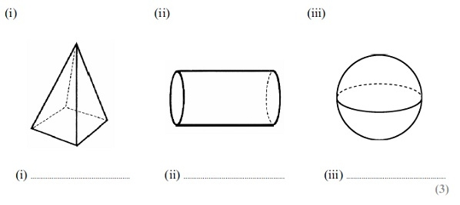
(3)
(b) (i) How many faces has shape (i)?
...........................................................
(ii) How many edges has shape (i)?
...........................................................
(2)
(c) Here is a solid prism made from centimetre cubes.
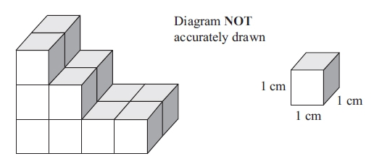
Find the volume of the solid prism.
Give the units of your answer.
.............................. ..............................
(3)
(Total for question = 8 marks)

Q42.
M and N are points on a circle, centre O.
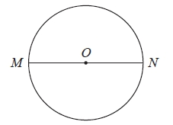
(a) Write down the mathematical name for the straight line MN.
...........................................................
(1)
(b) Measure the length of line AB.
State the units of your answer.
AB
...........................................................
(2)
(c) Write down the mathematical name for each of these 3-D shapes.
(i) (ii)
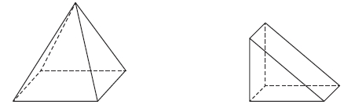
........................................................... ...........................................................
(2)
(d) (i) How many edges has the shape in (c)(i)?
...........................................................
(ii) How many faces has the shape in (c)(ii)?
...........................................................
(2)
(Total for Question is 7 marks)

Q43.
The diagram shows triangle ABC drawn on a centimetre grid.
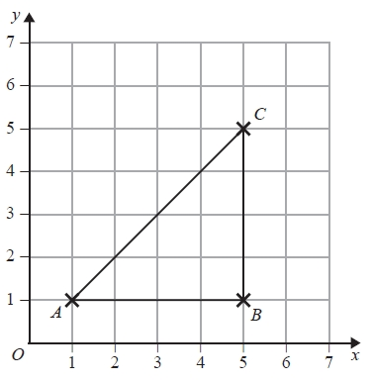
(a) Write down the coordinates of the point B.
(.......................... , ..........................)
(1)
(b) Measure the length of the line AC.
Give your answer in millimetres.
........................................................... mm
(1)
(c) Find the area of triangle ABC.
........................................................... cm²
(2)
D is the point such that ABCD is a trapezium with AD = 3 cm.
(d) On the grid, mark with a cross (×) the position of the point D
Label your point with the letter D.
(1)

(Total for question = 5 marks)

Q44.
The diagram shows quadrilateral ABCD on a centimetre grid.
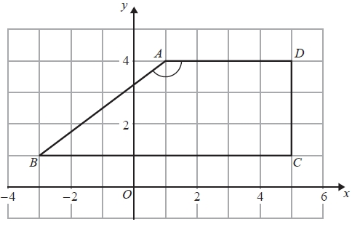
(a) Write down the coordinates of the point A.
(........................................................... , ...........................................................)
(1)
(b) Write down the coordinates of the point B.
(........................................................... , ...........................................................)
(1)
(c) Write down the mathematical name for quadrilateral ABCD.
...........................................................
(1)
(d) (i) Measure the size of angle BAD.
........................................................... °
(ii) Write down the mathematical name for this type of angle.
...........................................................
(2)
(e) Work out the area of quadrilateral ABCD.
........................................................... cm²
(2)
(Total for Question is 7 marks)

Q45.
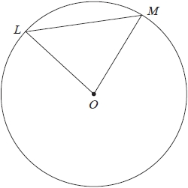
L and M are points on a circle, centre O.
(a) Write down the mathematical name for the straight line OM.
...........................................................
(1)
(b) Write down the mathematical name for the straight line LM.
...........................................................
(1)
(c) On the diagram, shade a segment.
(1)

(Total for question = 3 marks)

Q46.
(a) Write down the mathematical name of this 3-D shape.
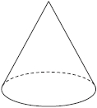
......................................................................................................................
(1)
(b) (i) Write down the mathematical name of this 3-D shape.
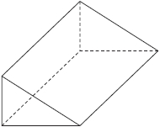
......................................................................................................................
(ii) How many vertices does this shape have?
...........................................................
(iii) How many edges does this shape have?
...........................................................
(3)
The diagram shows a solid prism made from centimetre cubes.
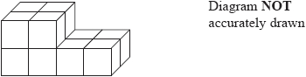
(c) Find the volume of the prism.
Give the units of your answer.
.............................. ..............................
(3)

(Total for question = 7 marks)

Q47.
Here is a shape made from centimetre squares.
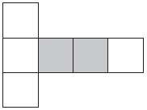
(a) On the shape above, draw the line of symmetry.
(1)
(b) What fraction of the shape is shaded?
Give your fraction in its simplest form.
...........................................................
(2)
(c) Find the perimeter of the shape.
........................................................... cm
(1)
(d) Add two squares to the shape below to make a shape with rotational symmetry of order two.
(1)
(Total for Question is 5 marks)

Q48.
The diagram shows a shape on a centimetre grid.
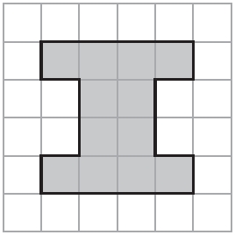
(a) On the grid, draw all the lines of symmetry of the shape.
(2)
(b) Write down the order of rotational symmetry of the shape.
...........................................................
(1)
(c) Find the area of the shape.
........................................................... cm²
(1)
(Total for Question is 4 marks)

Q49.
The diagram shows a parallelogram PQRS drawn on a centimetre grid.
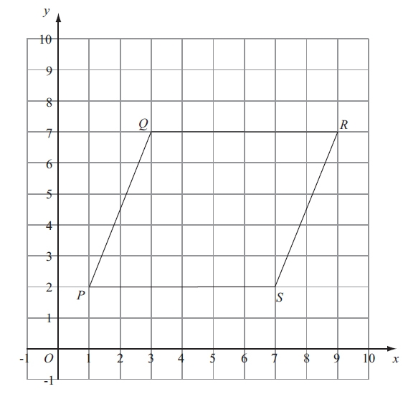
(a) Measure the length of PQ.
........................................................... cm
(b) Write down the coordinates of the point R.
(...................., .......................................)
(1)
(c) Work out the area of the parallelogram PQRS.
Give the units of your area.
........................................ ..............................................................................
(3)
(Total for question = 5 marks)

Q50.
The diagram shows a shape on a centimetre grid and a line AB.
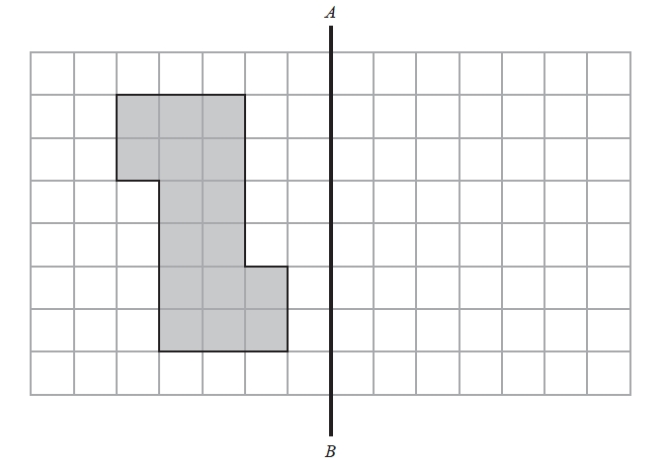
(a) Measure the length of the line AB.
...........................................................cm
(1)
(b) Write down the order of rotational symmetry of the shape.
...........................................................
(1)
(c) Work out the perimeter of the shape.
...........................................................cm
(1)
(d) Work out the area of the shape.
...........................................................cm²
(1)
(e) Reflect the shape in the line AB.
(2)

(Total for question = 6 marks)
Q51.
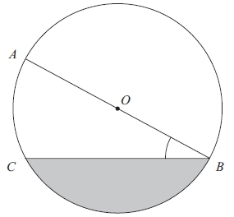
A, B and C are points on a circle, centre O.
(a) Measure the length of CB.
...........................................................cm
(1)
(b) Measure the size of angle ABC.
...........................................................°
(1)
(c) Write down the mathematical name for
(i) the line OA,
...........................................................
(ii) the shaded region.
...........................................................
(2)
(Total for question = 4 marks)

Q52.
(a) Write down the mathematical name of this 3-D shape.
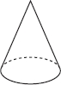
...........................................................
(1)
(b) (i) Write down the mathematical name of this 3-D shape.
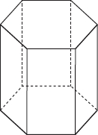...........................................................
(ii) How many vertices has this shape?
...........................................................
(iii) How many edges has this shape?
...........................................................
(3)
Here is a solid prism made from centimetre cubes.
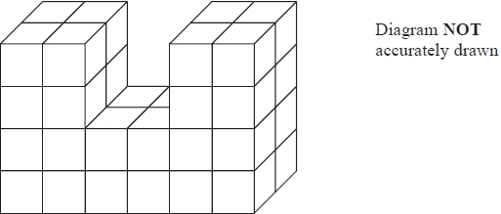
(c) Work out the volume of the prism.
........................................................... cm³
(2)
(Total for question = 6 marks)

Q53.
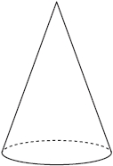
(a) Write down the mathematical name of this 3-D shape.
...........................................................
(1)
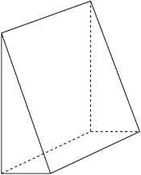
(b) (i) Write down the mathematical name of this 3-D shape.
...........................................................
(ii) How many edges has this shape?
...........................................................
(iii) How many vertices has this shape?
...........................................................
(3)

(c) Here is a cuboid.
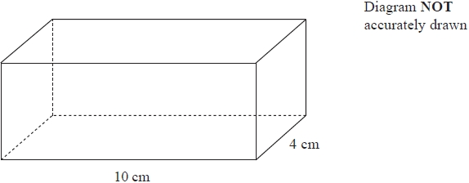
The volume of the cuboid is 280cm³
The cuboid has length 10cm and width 4cm.
Work out the height of the cuboid.
...........................................................cm
(2)

(Total for question = 6 marks)

Q54.
(a) Write down the mathematical name for each of these 3-D shapes.
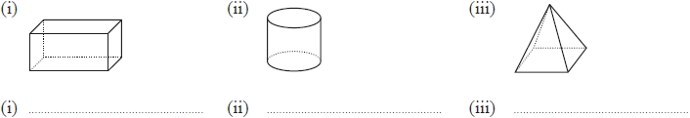
(3)
Here is a solid prism made from centimetre cubes.
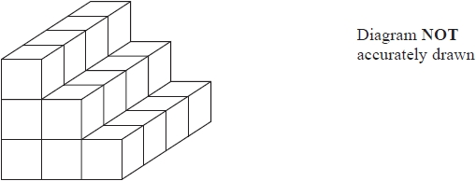
(b) Work out the volume of the prism.
........................................................... cm³
(2)

(Total for question = 5 marks)

Q55.
A, B, C are points on a circle, centre O.
AOB is a straight line.
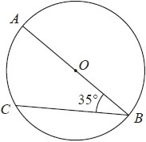
(i) Write down the mathematical name for the line AB
...........................................................
(ii) Write down the mathematical name for the line BC
...........................................................
(iii) Write down the mathematical name for an angle of 35°
...........................................................

(Total for question = 3 marks)

Q56.
Here is a circle with some straight lines.
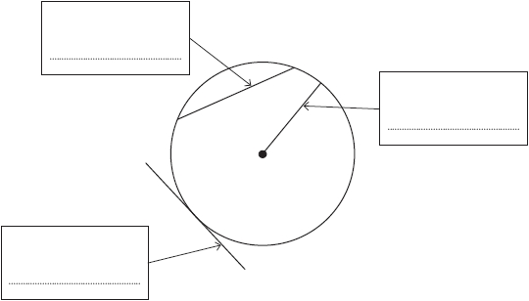
For each line, choose a word from the list below that describes the line to which the arrow points. Write each answer in the box.
radius circumference diameter sector tangent chord arc

(Total for question = 3 marks)

Q57.
Here are nine shapes on a grid of centimetre squares.
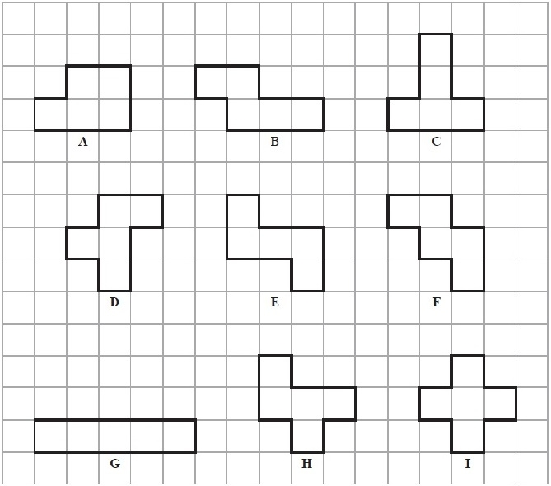
(a) Shape A is a 6-sided polygon.
Write down the mathematical name for a 6-sided polygon.
...........................................................
(1)
(b) Find the area of shape B.
........................................................... cm²
(1)
(c) Find the perimeter of shape C.
........................................................... cm
(1)
(d) Two of the shapes each have exactly 1 line of symmetry.
Write down the letters of these two shapes.
............................ and ............................
(2)
(e) On shape I, draw all its lines of symmetry.
(2)
(f) Write down the letter of the shape which has
(i) rotational symmetry of order 2 and 2 lines of symmetry,
...........................................................
(ii) rotational symmetry of order 2 but no lines of symmetry.
...........................................................
(2)
(g) Two of the shapes are congruent.
Write down the letters of these two shapes.
............................ and ............................
(1)
(h) Explain why shape I is not a regular polygon.
.............................................................................................................................................
(1)

(Total for Question is 11 marks)

Q58.
(a) Here is a shaded quadrilateral drawn on a grid of centimetre squares.
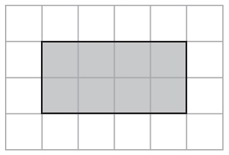
(i) Write down the mathematical name of this shaded quadrilateral.
...........................................................
(ii) Find the perimeter of this shaded quadrilateral.
....................... cm
(2)
(b) Here is another shaded quadrilateral drawn on a grid of centimetre squares.
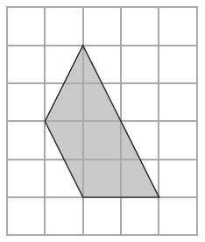
(i) Write down the mathematical name of this shaded quadrilateral.
...........................................................
(ii) On this shaded quadrilateral, mark with arrows (>) a pair of parallel lines.
(iii) Find the area of this shaded quadrilateral.
........................................................... cm²
(4)
(c) The lines AB and CD are the 2 lines of symmetry of a quadrilateral.
The diagram shows part of the quadrilateral.
On the grid, complete the drawing of the quadrilateral.
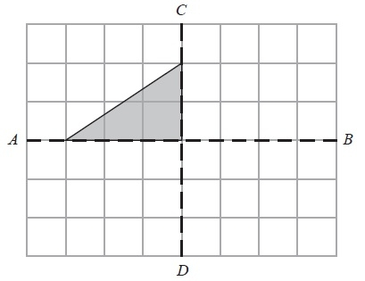
(2)
(d) A quadrilateral has rotational symmetry of order 4 about the point P.
The diagram shows one side of the quadrilateral.
On the grid, complete the drawing of the quadrilateral.
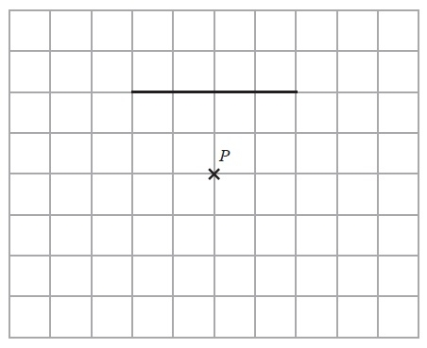
(2)

(Total for Question is 10 marks)

Q59.
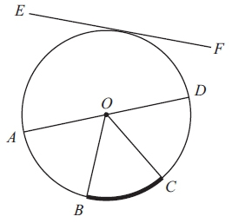
A, B, C and D are points on a circle, centre O.
The line EF touches the circle.
Write down the mathematical name for
(i) the straight line AD,
...........................................................
(ii) the part of the circumference of the circle between B and C,
...........................................................
(iii) the straight line EF
...........................................................
(Total for question = 3 marks)

Q60.
The diagram shows a shape drawn on a centimetre grid.
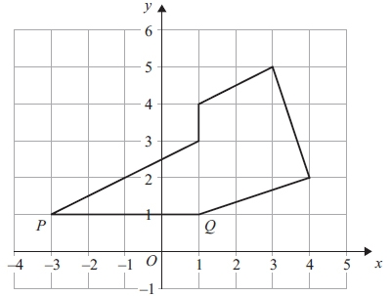
(a) On the shape, mark with crosses (×) a pair of perpendicular lines.
(1)
(b) On the shape, mark an obtuse angle.
Label your angle A.
(1)
(c) Write down the coordinates of the point P.
(.............................. , ..............................)
(1)
(d) Write down the equation of the line PQ.
............................................................
(1)
(e) Find the area of the shape.
Give the units of your area.
............................................................
(3)
(Total for question = 7 marks)

Q61.
Here is a square.
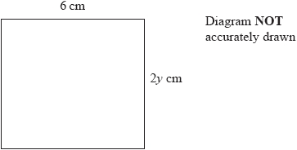
(a) Find the value of y.
y = ...........................................................
(1)
Here is a rectangle.
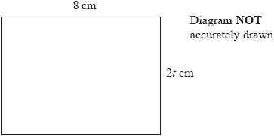
The rectangle has an area of 80 cm²
(b) Find the value of t.
t = ...........................................................
(2)

(Total for question = 3 marks)

Q62.
Write your answers in the spaces provided.
You must write down all the stages in your working.
The diagram shows an isosceles triangle ABC and a semicircle with centre O and diameter 12 cm.
The point B lies on the semicircle.
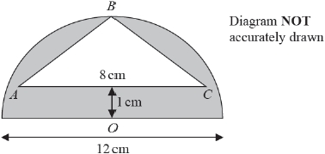
The line OB is the line of symmetry of the diagram.
AC is 1 cm from the diameter of the semicircle and AC = 8cm.
Work out the area of the shaded region.
Give your answer correct to 3 significant figures.
cm²

(Total for question = 4 marks)

Q63.
Here are a rectangle and a square.
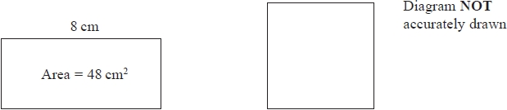
The rectangle has length 8 cm and area 48 cm²
The perimeter of the square is the same as the perimeter of the rectangle.
Calculate the area of the square.
........................................................... cm²
(Total for question = 4 marks)

Q64.
The width of a rectangle is 8 cm less than the length of the rectangle.
The perimeter of the rectangle is 54 cm.
Find the area of the rectangle.
........................................................... cm²

(Total for question = 4 marks)

Q65.
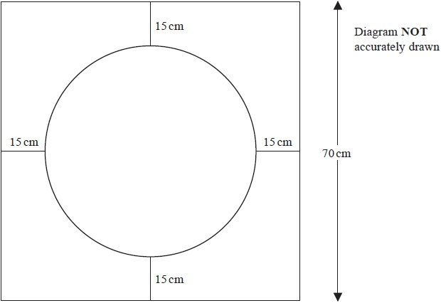
The diagram shows a design made from wire.
The design is made from
a square with side 70 cm,
a circle with diameter 40 cm,
4 straight pieces each of length 15 cm.
Find the total length of wire needed for the design.
Give your answer correct to the nearest centimetre.
........................................................... cm

(Total for question = 4 marks)

Q66.
The lengths of the sides of a triangle are in the ratios 2 : 6 : 7
The length of the longest side of the triangle is 24.5cm.
Work out the perimeter of the triangle.
...........................................................cm

(Total for question = 3 marks)

Q67.
The diagram shows a vegetable garden in the shape of a rectangle.
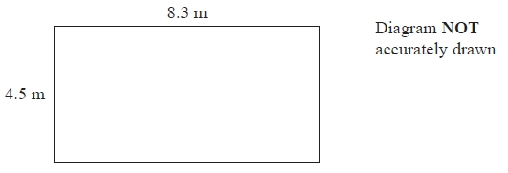
The vegetable garden has length 8.3 m and width 4.5 m.
Dan wants to put fencing completely around the edge of the vegetable garden.
He already has 10.6 m of fencing.
How much more fencing does Dan need?
........................................................... m

(Total for question = 3 marks)

Q68.
The diagram shows a circle and a trapezium.
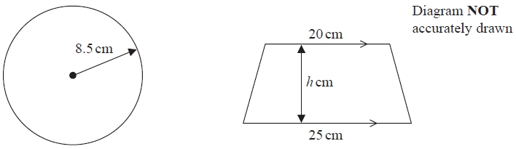
The height of the trapezium is h cm.
The area of the circle is equal to the area of the trapezium.
Work out the value of h.
Give your answer correct to 1 decimal place.
...........................................................

(Total for question = 4 marks)

Q69.
Cartons are packed into a box.
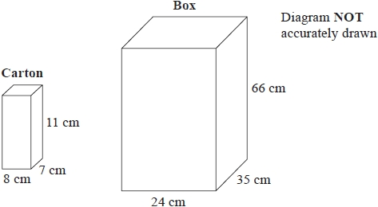
Each carton is 8 cm by 7 cm by 11 cm.
The box is 24 cm by 35 cm by 66 cm.
The box is completely filled with cartons.
Work out the number of cartons in the box.
...........................................................

(Total for question = 3 marks)

Q70.
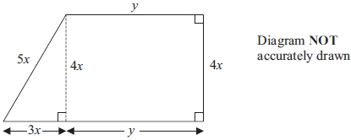
The shape in the diagram is made from a rectangle and a right-angled triangle.
The diagram shows, in terms of x and y, the lengths, in centimetres, of the sides of the
rectangle and of the triangle.
The perimeter, P cm, of the shape is given by the formula
P = 12x + 2y
(a) Work out the value of P when x = 3 and y = 7
P = ...........................................................
(2)
(b) Work out the value of x when P = 43 and y = 6.5
x = ...........................................................
(3)
(c) Find, in terms of x and y, a formula for the area, A cm², of the shape.
Give your answer as simply as possible.
A = ...........................................................
(2)
(Total for question = 7 marks)

Q71.
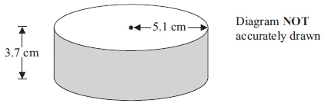
A solid cylinder has a radius of 5.1 cm and a height of 3.7 cm.
Work out the total surface area of the cylinder.
Give your answer correct to 3 significant figures.

...........................................................cm²
(Total for question = 3 marks)

Q72.
Here are six shapes made from centimetre squares.
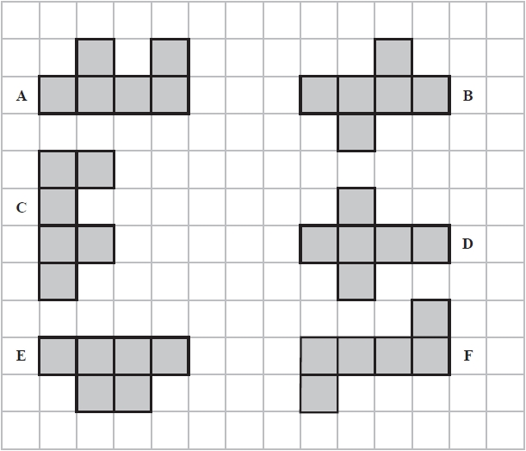
(a) Write down the letter of a shape with rotational symmetry of order 2
...........................................................
(1)
(b) How many lines of symmetry has shape D?
...........................................................
(1)
(c) Work out the perimeter of shape E.
........................................................... cm
(1)
Two of the shapes are congruent.
(d) Write down the letters of these two shapes.
........................... and ...........................
(1)
(Total for question = 4 marks)

Q73.
(a) On the rectangle, draw all the lines of symmetry.
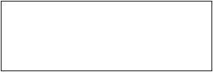
(2)
(b) Write down the order of rotational symmetry of a rectangle.
...........................................................
(1)
Here is a shape made from centimetre squares.
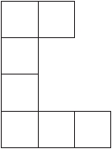
(c) Find the perimeter of the shape.
........................................................... cm
(1)

(Total for question = 4 marks)

Q74.
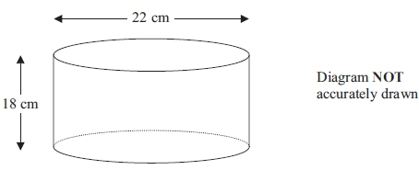
A cylinder has a diameter of 22 cm and a height of 18 cm.
Work out the volume of the cylinder.
Give your answer correct to 3 significant figures.
...........................................................cm³
(Total for question = 3 marks)

Q75.
The diagram shows a prism made from centimetre cubes.
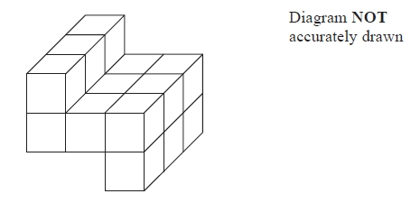
Find the volume of the prism.
Give the units of your answer.
........................................................... ...........................................................
(Total for Question is 3 marks)

Q76.
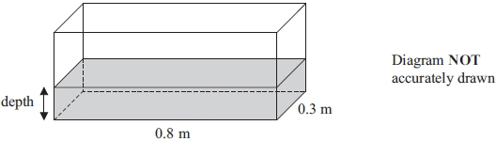
A fish tank is in the shape of a cuboid.
The length of the fish tank is 0.8 m and the width is 0.3 m.
The volume of water in the fish tank is 108 litres.
1 m³ = 1000 litres.
Work out the depth of the water in the fish tank.
............................................................m
(Total for question = 3 marks)

Q77.
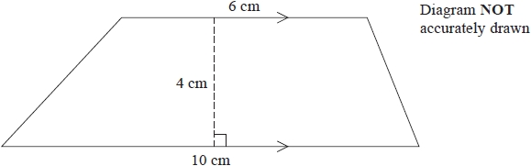
Work out the area of this trapezium.
........................................................... cm²

(Total for question = 2 marks)

Q78.
The diagram shows a quadrilateral ABCD on a centimetre grid.
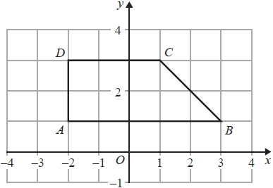
(a) Write down the coordinates of
(i) point B,
(........................... , ...........................)
(ii) point D.
(........................... , ...........................)
(2)
(b) Write down the equation of the line AB.
...........................................................
(1)
(c) Work out the area of quadrilateral ABCD.
........................................................... cm²
(1)

(Total for question = 4 marks)

Q79.
The diagram shows triangle ABC drawn on a centimetre grid.
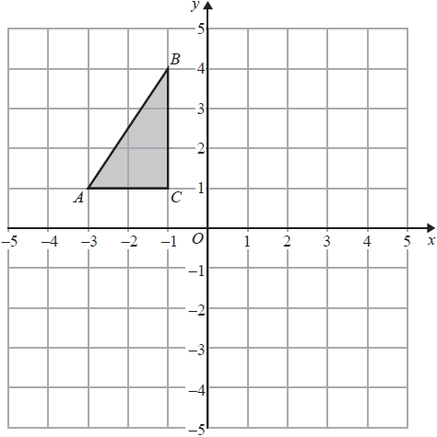
(a) Write down the coordinates of point A.
(........................... , ...........................)
(1)
(b) Reflect triangle ABC in the x-axis.
(1)
(c) Work out the area of triangle ABC.
You must include the units with your answer.
...................................... ................
(2)
(Total for question = 4 marks)

Mark Scheme
Q1.
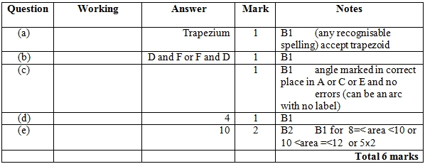

Q2.
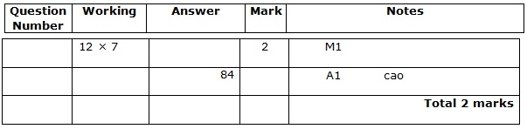

Q3.
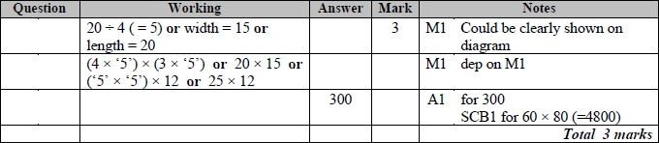
Q4.
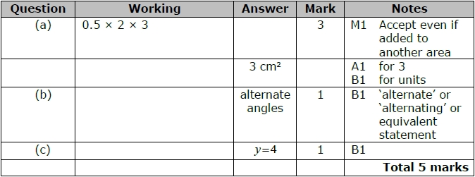
Q5.
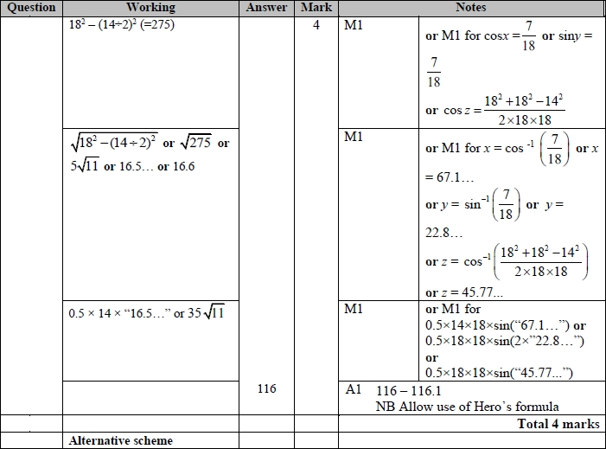
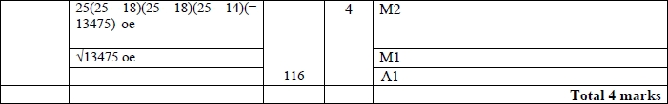

Q6.
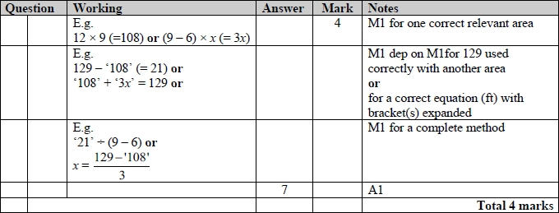
Q7.
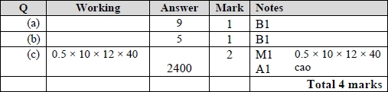

Q8.
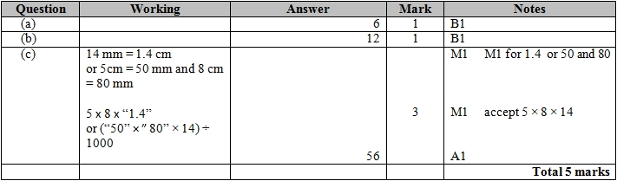

Q9.
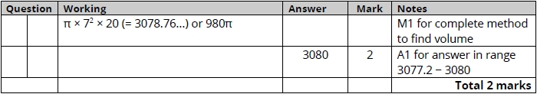

Q10.
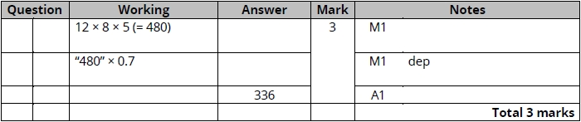

Q11.
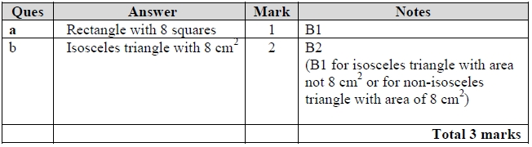

Q12.
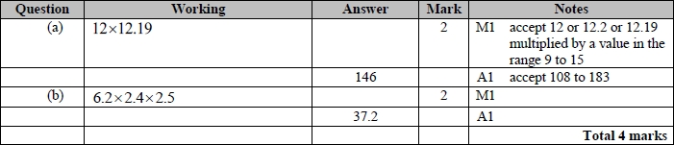

Q13.
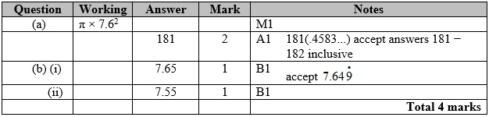

Q14.
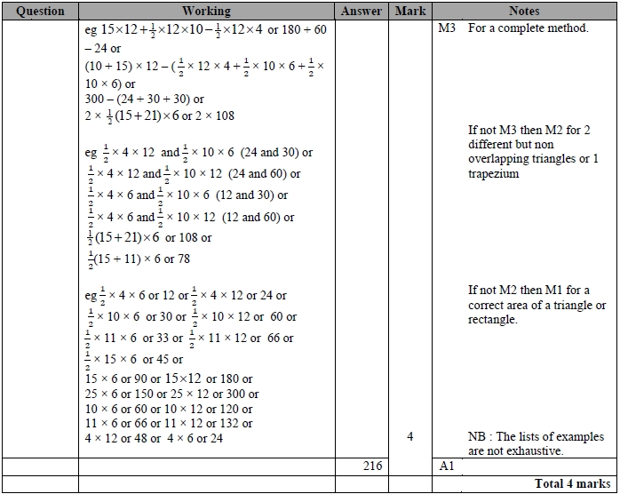

Q15.
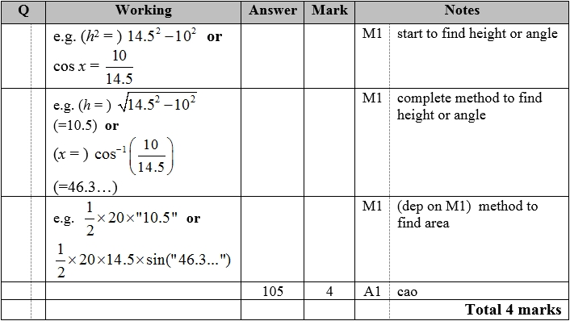
Q16.
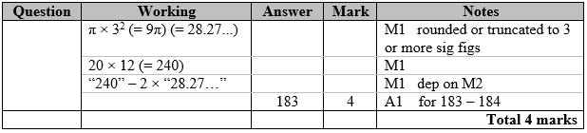

Q17.
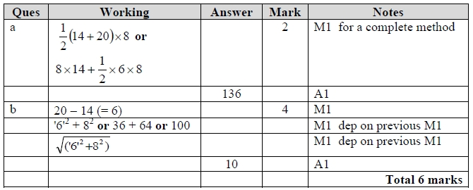

Q18.
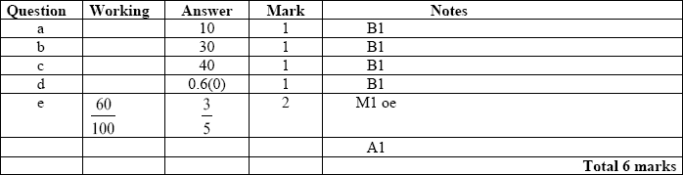

Q19.
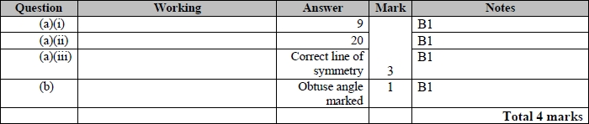

Q20.
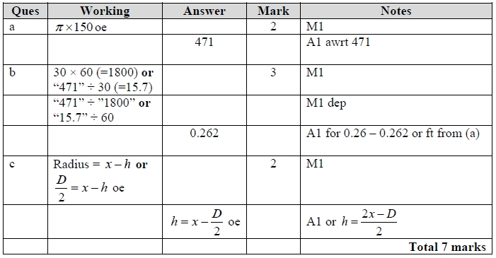

Q21.
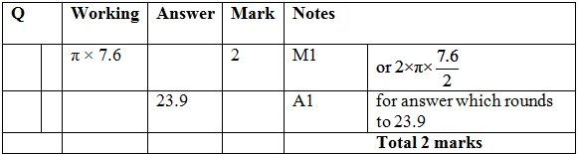

Q22.
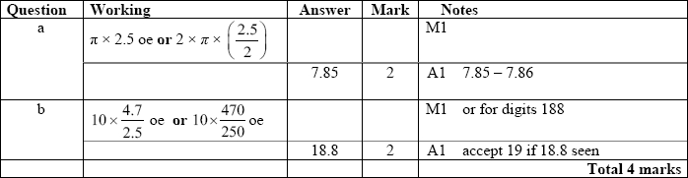

Q23.
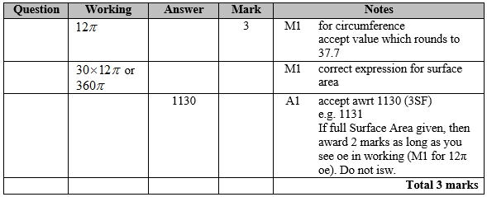

Q24.
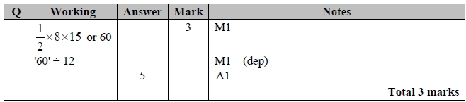

Q25.
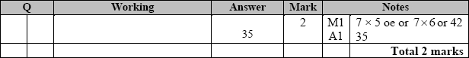

Q26.
The correct answer, unless clearly obtained by an incorrect method, should be taken to imply a correct method.
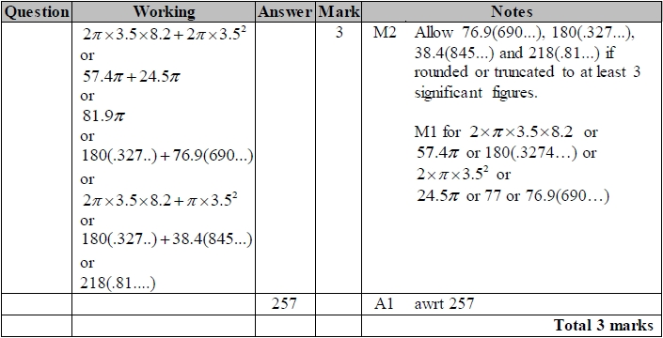

Q27.
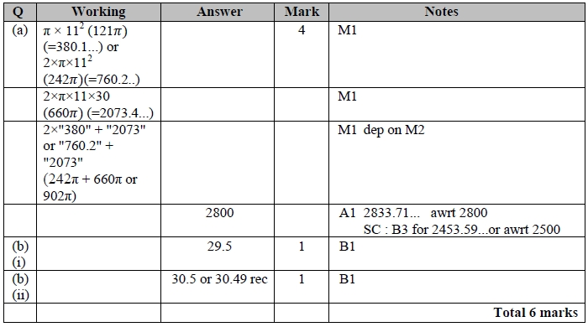

Q28.
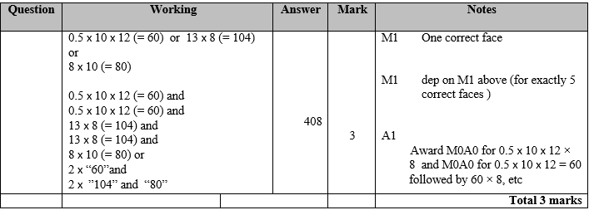

Q29.
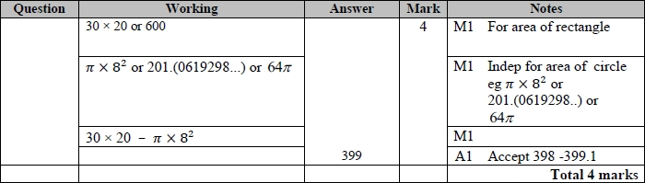

Q30.
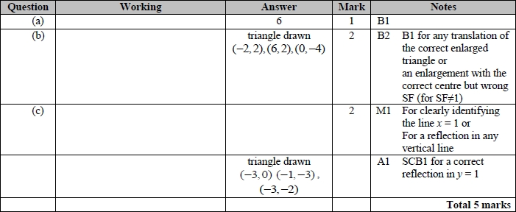
Q31.
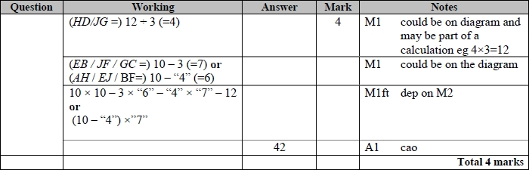

Q32.

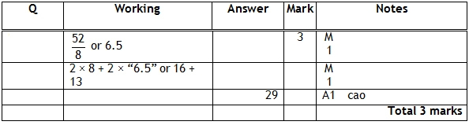

Q33.
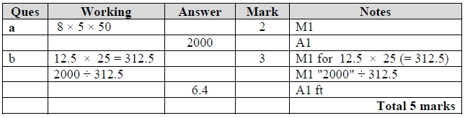

Q34.
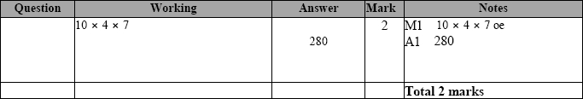
Q35.
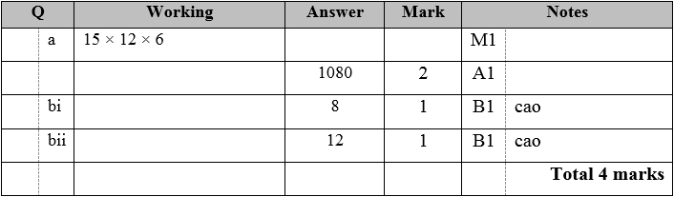

Q36.
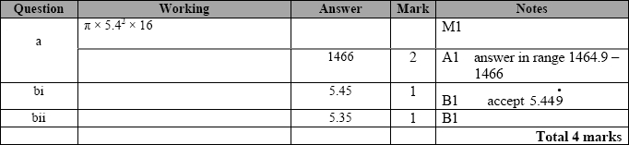

Q37.
For all questions, the correct answer, unless clearly obtained by an incorrect method, should be taken to imply a correct method.
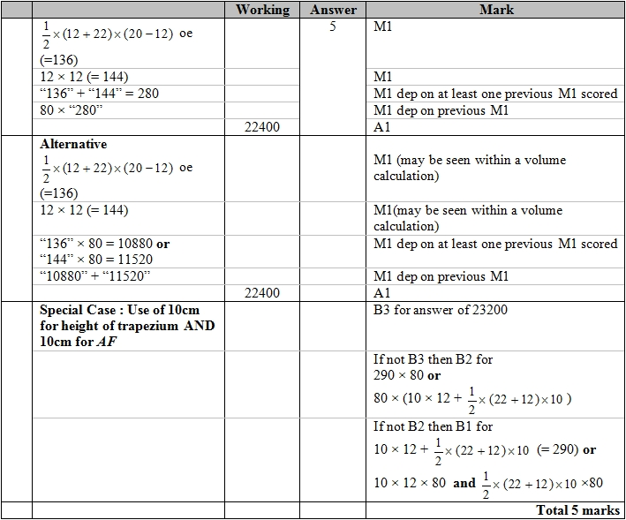

Q38.
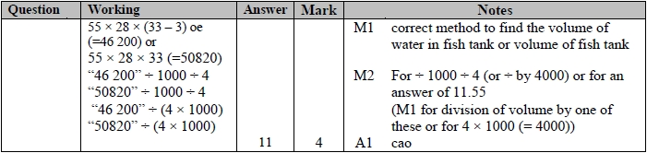

Q39.

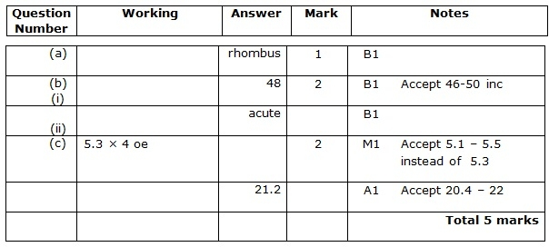

Q40.
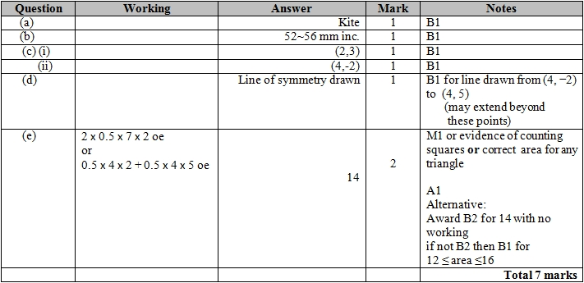
Q41.

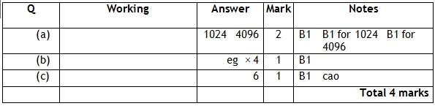

Q42.
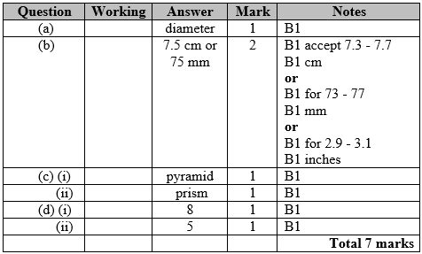

Q43.
For all questions, the correct answer, unless clearly obtained by an incorrect method, should be taken to imply a correct method.
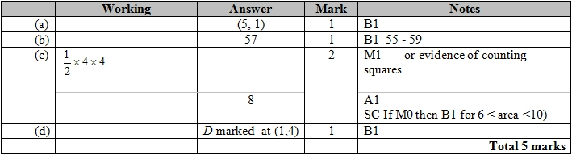

Q44.
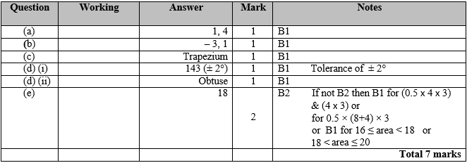

Q45.
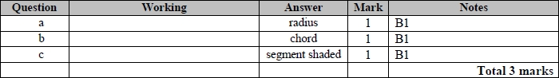

Q46.
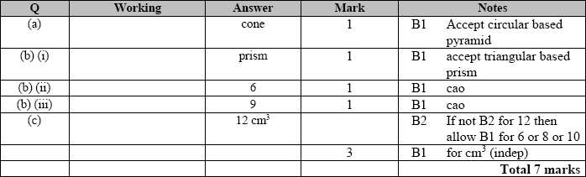
Q47.
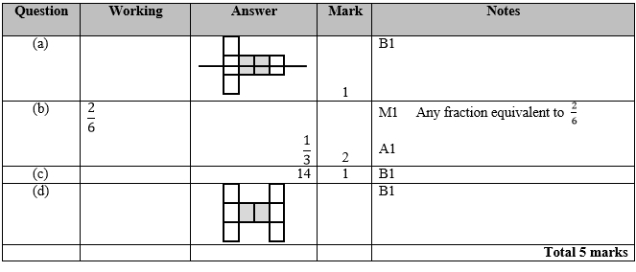
Q48.
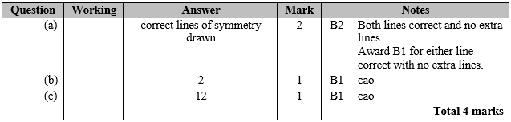

Q49.
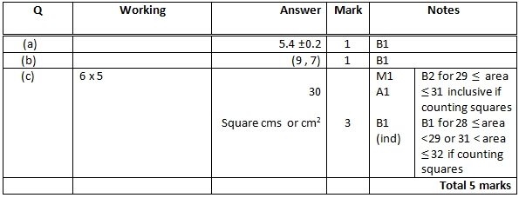

Q50.
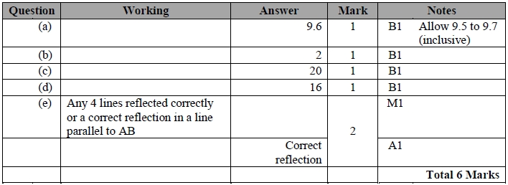

Q51.
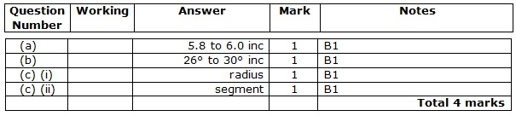

Q52.
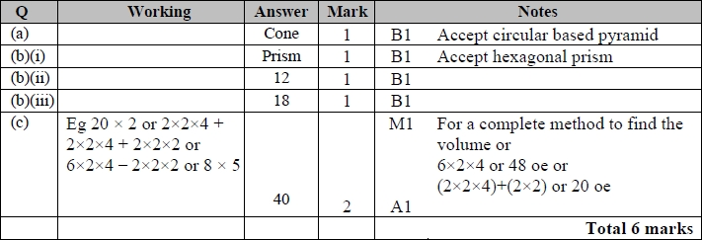

Q53.
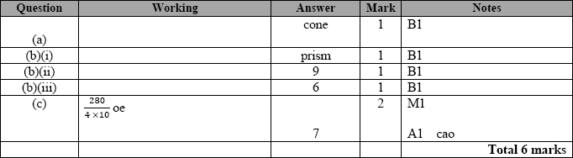

Q54.
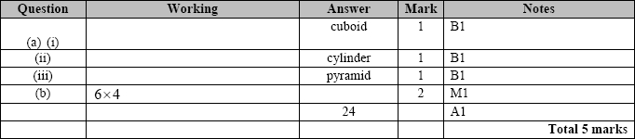

Q55.
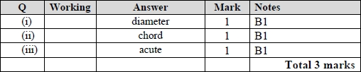

Q56.
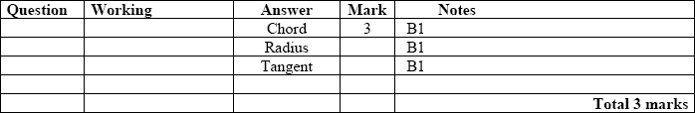

Q57.
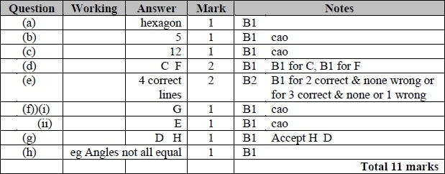

Q58.
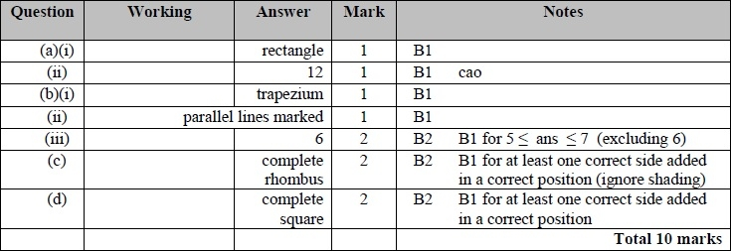

Q59.
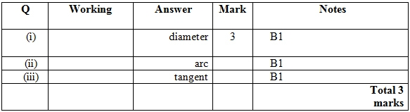

Q60.

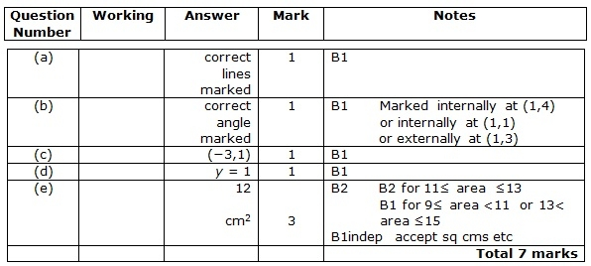

Q61.
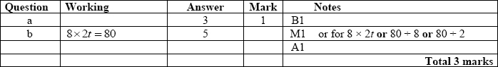

Q62.
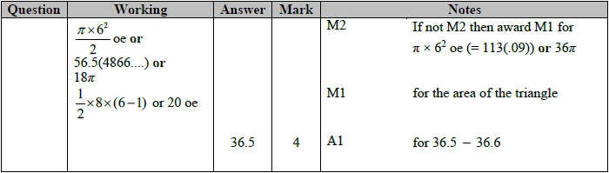

Q63.
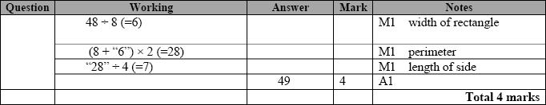
Q64.
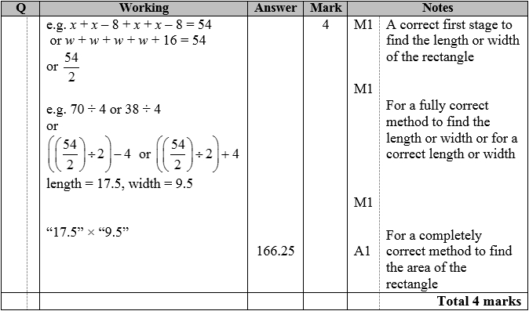
Q65.
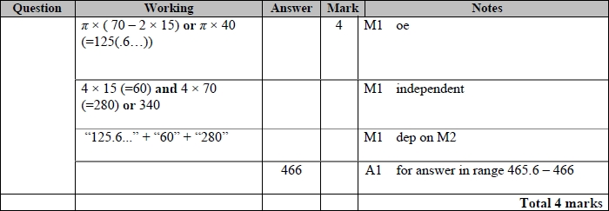
Q66.
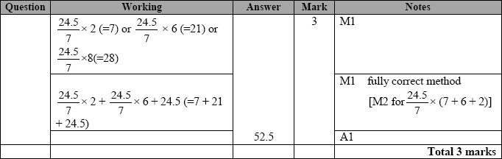

Q67.
Apart from question 18c where the mark scheme states otherwise, the correct answer, unless clearly obtained by an incorrect method, should be taken to imply a correct method.
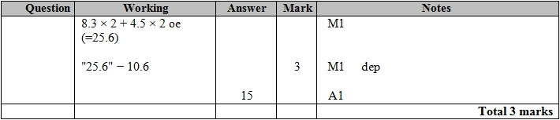

Q68.
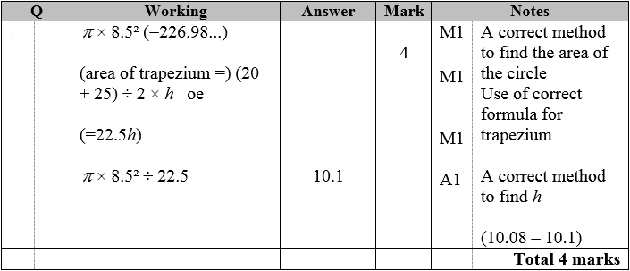

Q69.
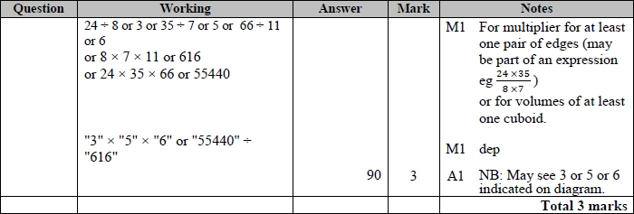

Q70.

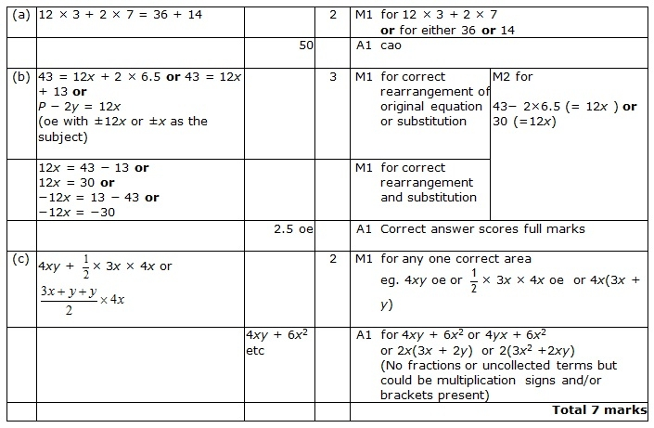

Q71.

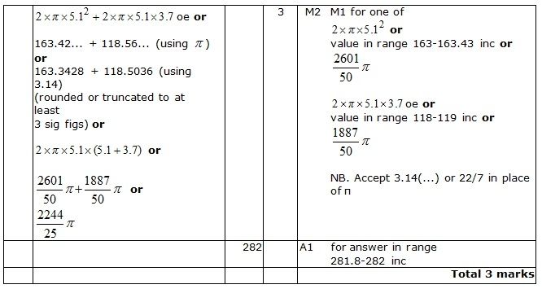

Q72.
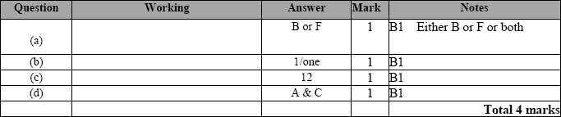
Q73.
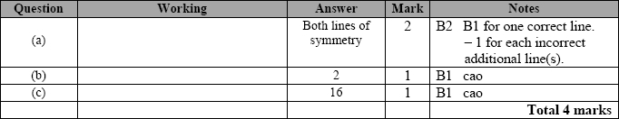
Q74.
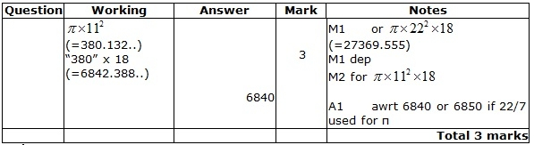

Q75.
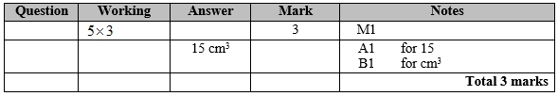

Q76.
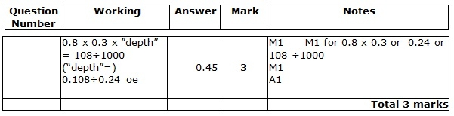

Q77.
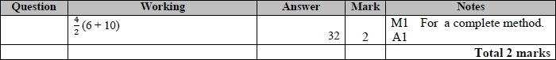

Q78.
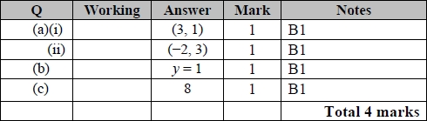

Q79.
