**Introduction to the Iliad**

**The heroes**

*Sort through the hero cards and decide whether they belong to the army of the Achaeans or the Trojans:*

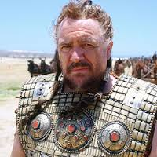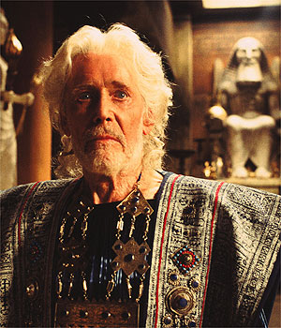

|  |  |
| --- | --- |
| Trojans | Achaeans |
|  |  |

****The Gods**

*Test yourself on your knowledge of the main Greek gods on sporcle. There’s one example here if you scan the QR code.*

*Based on your readings of Homer so far, think of as many ways as possible a god might help or hinder a hero:*

I think I’ll help my favourite mortals by…

I could really screw things up for these mortals by…

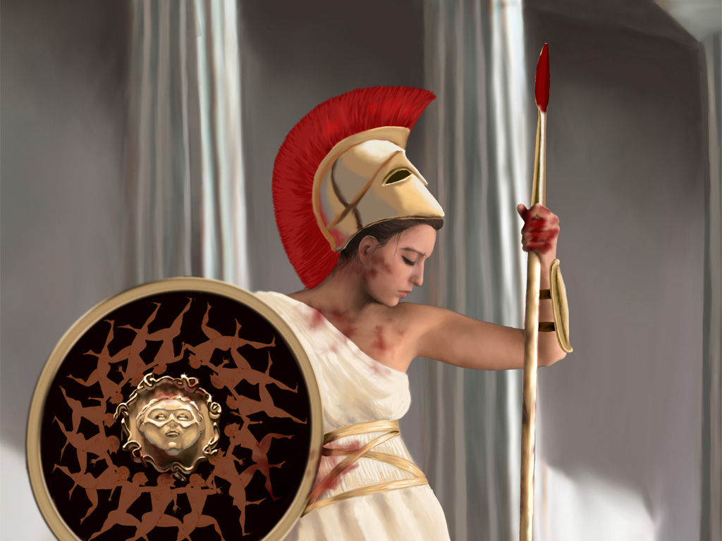

**Technical Terminology**

*Think of as many terms specific to your studies on Homer so far. Write down these words and their definition in the table below:*

|  |  |
| --- | --- |
| Term | Definition |
| *kleos* | Glory in death, the way a hero is remembered |
|  |  |
|  |  |
|  |  |
|  |  |
|  |  |
|  |  |

**Story Telling: Oral vs Written**

*There are numerous differences between stories that are told orally and stories that are written for a reader. Below, write down anything that characterizes these types of story telling:*

**Written Stories**

**Oral Stories**

**Vivid, Dramatic and Exciting Writing**

*Homer uses many devices to keep his audience entertained. Here are some noteworthy ones:*

* Visual realism
* Additional detail
* Homeric similes and other comparisons
* Repetition of phrases
* Shock
* Sentence length
* Dramatic speech
* Character portrayal (including their emotions)
* *Pathos* (audience feels as the characters do)
* Personification of actions (e.g. ‘the bow sang’)
* Suspense and anticipation
* Irony (the audience is aware of what some characters are not).

Look at the following gobbits from the first few books of the Iliad. For each one, see how many devices you can spot and explain their effectiveness.

**Gobbit A**

So he spoke, and the old man, seized by fear, obeyed. Silently, he walked the shore of the echoing sea; and when he was quite alone, the old man prayed deeply to Lord [Apollo](http://www.poetryintranslation.com/PITBR/Greek/IlindexA.htm#Apollo), the son of bright-haired [Leto](http://www.poetryintranslation.com/PITBR/Greek/IlindexFGHILMN.htm#Leto):  ‘Hear me, Silver Bow, protector of [Chryse](http://www.poetryintranslation.com/PITBR/Greek/IlindexBCDE.htm#Chryse) and holy [Cilla](http://www.poetryintranslation.com/PITBR/Greek/IlindexBCDE.htm#Cilla), high lord of [Tenedos](http://www.poetryintranslation.com/PITBR/Greek/IlindexRSTUWXZ.htm#Tenedos): if ever I built a shrine that pleased you, if ever I burned the fat thighs of a bull or goat for you, grant my wish: [Smintheus](http://www.poetryintranslation.com/PITBR/Greek/IlindexRSTUWXZ.htm#Smintheus), with your arrows make the Greeks pay for my tears.’

          So he prayed, and Phoebus Apollo heard him. Down he came, in fury, from the heights of [Olympus](http://www.poetryintranslation.com/PITBR/Greek/IlindexOP.htm#Olympus), with his bow and inlaid quiver at his back. The arrows rattled at his shoulder as the god descended like the night, in anger. He set down by the ships, and fired a shaft, with a fearful twang of his silver bow. First he attacked the mules, and the swift hounds, then loosed his vicious darts at the men; so the dense pyres for the dead burned endlessly.

[Homer, *Iliad*, 1]

**Gobbit B**

Now, as the sea-swell beats on the sounding shore, wave on wave driven before the westerly gale, each crest rising out of the depths to break thundering on the beach or rearing its head to lap the headland and spew out briny foam, so the Danaan ranks advanced, battalion on battalion, remorselessly into battle, while the captains’ voices rose in command as the men marched on in silence, as if that moving mass lacked tongues to speak, mute as they were, fearful of their generals, while on every man the inlaid armour glittered. But the Trojan clamour rang out from their ranks, like the endless bleating of countless ewes in a rich man’s yard, there to yield their white milk, when they hear the cries of their lambs, for the Trojan army, gathered from many lands, lacked a common language, speaking a myriad tongues…

          So they met in fury with a mighty crash, with the clash of spears, shields-bosses, bronze-clad warriors, till the last moans of the fallen mingled with the victory cries of their killers, and the earth ran red with blood. Like the sound a shepherd deep in the mountains hears; the mighty clash of two wintry torrents that pour down from high sources to their valleys’ meeting place in a deep ravine; such was the tumult raised by those armies toiling together in battle.

          Of the Trojans, noble [Echepolos](http://www.poetryintranslation.com/PITBR/Greek/IlindexBCDE.htm#EchepolusTrojan), son of [Thalysius](http://www.poetryintranslation.com/PITBR/Greek/IlindexRSTUWXZ.htm#Thalysius), was first to die, fighting in the vanguard, downed in his armour by [Antilochus](http://www.poetryintranslation.com/PITBR/Greek/IlindexA.htm#Antilochus). The spear struck the ridge of his horse-hair crested helmet, and the point drove through the skin of his forehead into the bone. Darkness filled his eyes, and he dropped like a fallen tower on the field. Once downed, [Elephenor](http://www.poetryintranslation.com/PITBR/Greek/IlindexBCDE.htm#Elephenor), son of [Chalcodon](http://www.poetryintranslation.com/PITBR/Greek/IlindexBCDE.htm#Chalcodon), prince of the fierce [Abantes](http://www.poetryintranslation.com/PITBR/Greek/IlindexA.htm#Abantes), seizing him by the feet, tried to drag his body out of range, ready to strip it swiftly of armour; yet not for long, for brave [Agenor](http://www.poetryintranslation.com/PITBR/Greek/IlindexA.htm#Agenor) saw him drag the corpse aside, and with a thrust of his bronze-tipped spear, striking him in the flank exposed by his shield as he stooped, loosened all his limbs. His spirit fled, and the Greeks and Trojans struggled grimly over the corpse. They leapt at one another like wolves, and staggered locked in each other’s fierce embrace.

[Homer, *Iliad*, 4]