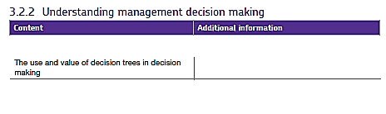3.2.2 Decision Trees

Decision trees look at the chance that something will occur. They use financial forecasts and probabilities to work out which option a firm should go ahead with.

**What do we mean by probability?**

We mean the chance that a specific outcome will occur – how likely it is that something will happen. If there is a chance that something will happen, there is also a chance that something won’t happen.

For example – how likely is it that it will rain today? ___________%. By knowing this, we can also know how likely it is that it won’t rain – the probabilities have to add up to 1 (or 100%), so the chance it won’t rain is ___________%.

If a particular event has a 0.65 chance of occurring, **what is the probability that it will not happen?**

**How and why might businesses use this information?**

Firms want to know how likely something is to happen as it helps them to plan. For example, they want to be able to assess if strategies will be successful or maybe to know what the % chance is that their sales will rise or fall.

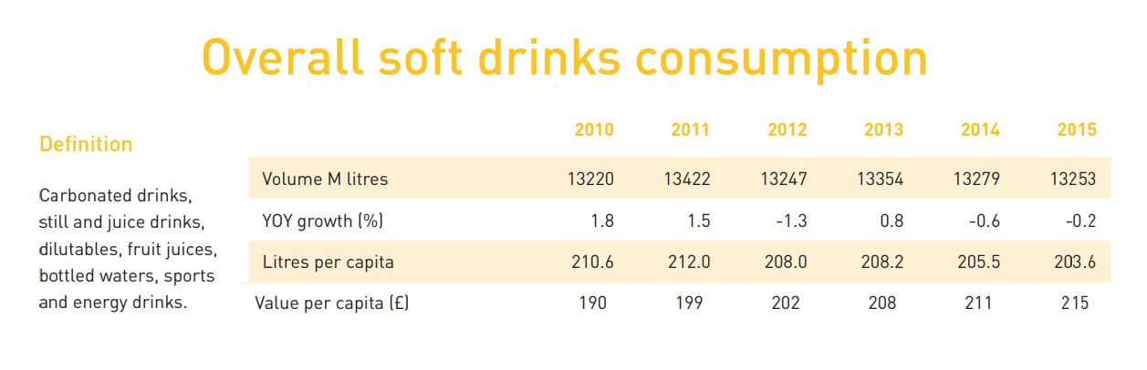The information below is about the UK soft drinks market. It shows sales between 2010 and 2015.

From looking at this information, how likely do you think it is that total soft drink sales (volume) will fall in 2016? _____________________. How likely is it that the value per capita will rise? __________________.

Information about forecasts and probabilities can be put onto a diagram to help a firm choose between 2 options, this is a **decision tree**.

A decision tree is a **mathematical model** used to help managers make decisions. It uses **estimates** and **probabilities** to calculate likely financial outcomes and helps to decide whether the **net gain** (the likely financial benefit) from a decision is worthwhile.

How is a decision tree is constructed?

A decision tree starts with a decision to be made and the options that can be taken. Don't forget that there is **always an option to decide to do nothing**!

1. The first task is to show the decision and possible outcomes
2. Add in the known information
3. Add financial information and probabilities

# Calculate the likely Expected value (EV) for each option

**Expected value = (outcome A x probability + outcome B x probability)**

1. multiply the probabilities by the expected financial results
2. add together for each outcome

# Calculate the Net gain (NG) of each option

1. deduct the initial cost of the option to work out the likely net gain

**Net gain = (outcome A x probability + outcome B x probability) – associated cost of the option**

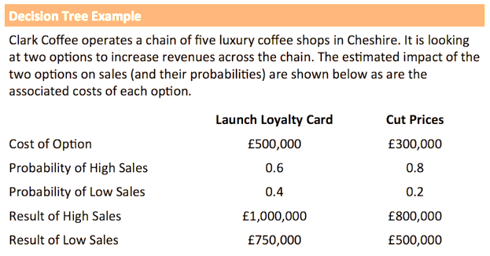Let’s look at an example:

Here we have 2 options and we are told they each have a chance of low or high sales (outcome A and outcome B), we are also told the Probability (or % chance) of each outcome happening.

**Benefits and advantages of decision trees**

* Choices are set out in a logical way
* Potential options & choices are considered at the same time
* Use of probabilities enables the “risk” of the options to be addressed
* Likely costs are considered as well as potential benefits
* Easy to understand & tangible results
* It makes managers think about the different options available to them and consider the consequences of each option.
* Completing a decision tree may result in a more logical and less rushed process based on evidence rather than gut feeling.
* It forces the manager to quantify the impact of each decision considering the forecast costs, benefits and probabilities of events happening.

**Disadvantages and drawbacks of decision trees**

* Probabilities are just estimates – always prone to error
* Uses quantitative data only – ignores qualitative aspects of decisions
* Assignment of probabilities and expected values prone to bias
* Decision-making technique doesn’t necessarily reduce the amount of risk
* The process only includes financial and quantifiable data. They do not include qualitative issues such as the workforce’s reaction to the different alternatives or the impact to the firm’s image.
* Decision trees use estimates of the probability of different outcomes and the financial consequences of each outcome. The value of decision tree analysis depends heavily on the accuracy of these estimates.
* Probabilities themselves are estimates and this makes decision trees open to manipulation by managers determined to achieve a desired outcome.
* Decision trees are not effective when there is a broad range of possible outcomes and when those outcomes are unclear. Some possible outcomes cannot be easily quantified.
* Decision trees are less useful when making **un-programmed decisions** or **strategic decisions** because the manager will be dealing with the unfamiliar and sometimes ‘one off’ situations.