**The Iliad – Book 3**

**Read lines 1-13**

Compare two similes of the advancing armies by annotating these pictures and explain why Homer might have used them.

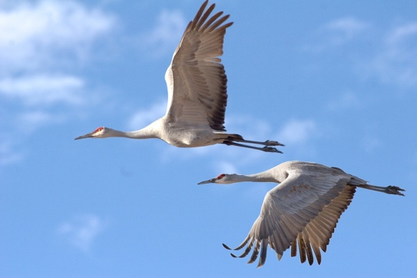

**Read lines 14-37**

Sketch Paris’ description over this template.



Compare two similes used to describe Menelaus and Paris with annotations and explain why Homer might have used them.

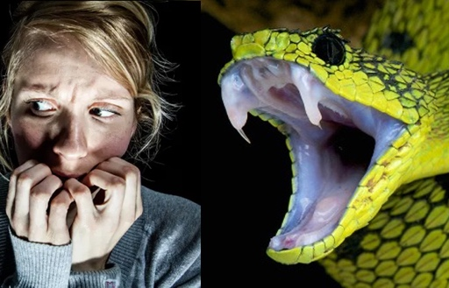

**VS**



**Read lines 38-120**

Which arguments of Hector does Paris accept and which does he object to?

|  |  |
| --- | --- |
| **Accepts:** | **Objects:** |
|  |  |

Draw up an agreement scroll based on Hector and Menelaus’ proposed duel

**Read lines 121-166**

List all the things that surprise you about the depiction of Helen and the way characters interact with her in this passage.



**Read Lines 167-245**

Fill the though bubbles of Priam with his impressions (and those given by Helen) of Agamemnon, Odysseus, Menelaus, Ajax and Idomeneus

**Odysseus**

**Agamemnon**

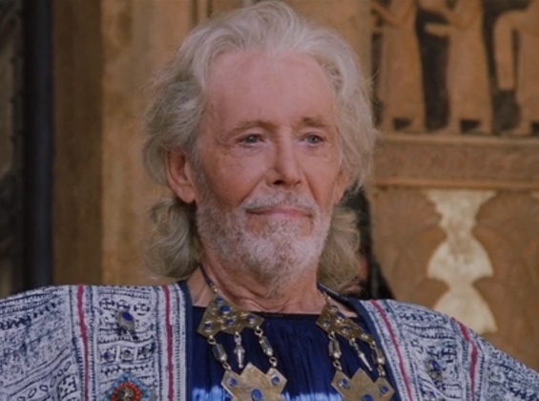

**Ajax**

**Idomeneus**

**Menelaus**

What do we realise that Helen doesn’t know about her brothers?

**Read lines 246-328**

What additional things are done in the forming of the truce not agreed earlier (cf. your scroll)?

How does Homer evoke pathos for Priam?

**Read lines 329-383**

Now sketch the new improved Paris’ description following him being armed for the duel.



Duel?

Complete this story board of Paris and Menelaus’ duel.

|  |  |  |
| --- | --- | --- |
| Can spears made from wood really block swords? How do ancient weapon makers  make wooden spears strong against swords (to some extent)? - Quora |  | Forcing Cancer to Put up a Broken Shield | Lifespan.io |
|  |  | What is the Pink Cloud Phase of Addiction Recovery? - Awakenings Treatment  Center |
|  | Make a story using only images |  |
|  |  |  |

**Read lines 384-461**

What do we learn about Helen’s relationship with both Paris and Aphrodite?

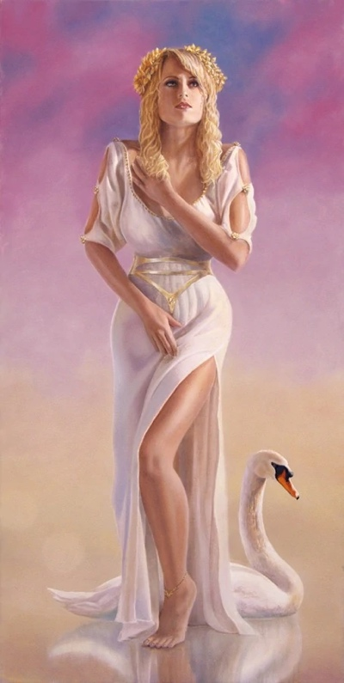

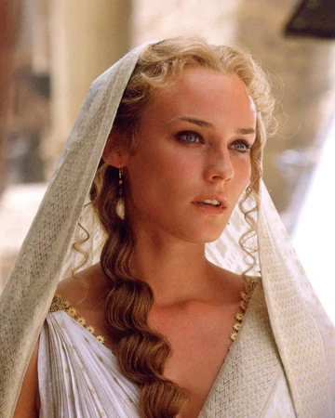

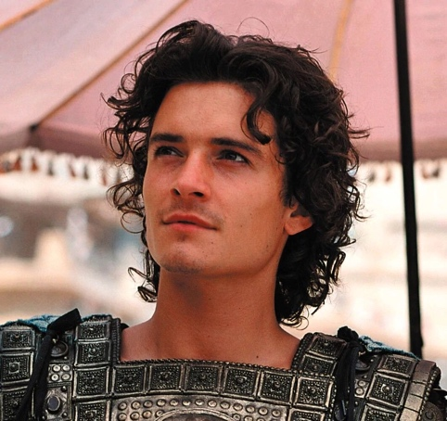

What do you think of Paris’ claim that Athena helped Menelaus?

What is Agamemnon’s conclusion from the episode and what appears to be his aims?

**Appendix: Helen**

Homeric literature provides us with two detailed examinations of Helen. Telemachus encounters her back in Sparta in the Odyssey (Book 4 & 15). Here in Book 3, she interacts with Priam as he watches the Achaeans from the Scaean Gate, as well as with Aphrodite and Paris after the duel.

See if you can find a parallel from this book to the following traits highlighted in the Odyssey.

|  |  |  |
| --- | --- | --- |
| Trait | Odyssey Quote: | Iliad Quote: |
| Her beauty is viewed as divine. | …from her tall, scented room came Helen, like Artemis of the golden spindle… [Book 4] |  |
| She has great domestic skills | …a golden spindle, and a silver basket on wheels, with a golden rim. This was what Phylo, her maid, brought, placing it beside her. It was full of fine-spun yarn, and the spindle was laid across it, charged with dark purple wool... [Book 4] |  |
| She regrets leaving Menelaus | ‘While the rest of the Trojan women were wailing their grief, my spirit was glad, since my heart was already longing for home … abandoning daughter and bridal chamber, and a husband lacking neither in wisdom nor looks.’ [Book 4] |  |
| She is at odds with Aphrodite | …and I sighed at the blindness Aphrodite had dealt me, drawing me there from my own dear country… [Book 4] |  |
| She is astute and her opinion is valued. | ‘… it stuns me to look, as the likeness of this man to great-hearted Odysseus: surely this is the son whom he left at home...’ Yellow-haired Menelaus replied: ‘I see the likeness now, wife, as you do…’ [Book 4] |  |