**The Iliad – Book 17**

**Read lines 1-60**

This vase depicts the fight over Patroclus’ body. Explain the way both Euphorbus and Menelaus try to convince the other to back away:

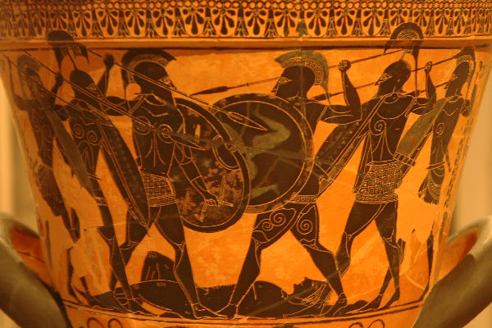

**Menelaus Euphorbus**

Why do you think Homer has made these two characters contend for the body?

How and why are spears made to be important in this meeting of the two characters?

**Read lines 61-119**

How does Homer use two lion similes to contrast Menelaus’ state before and after the arrival of Hector?

**Before After**

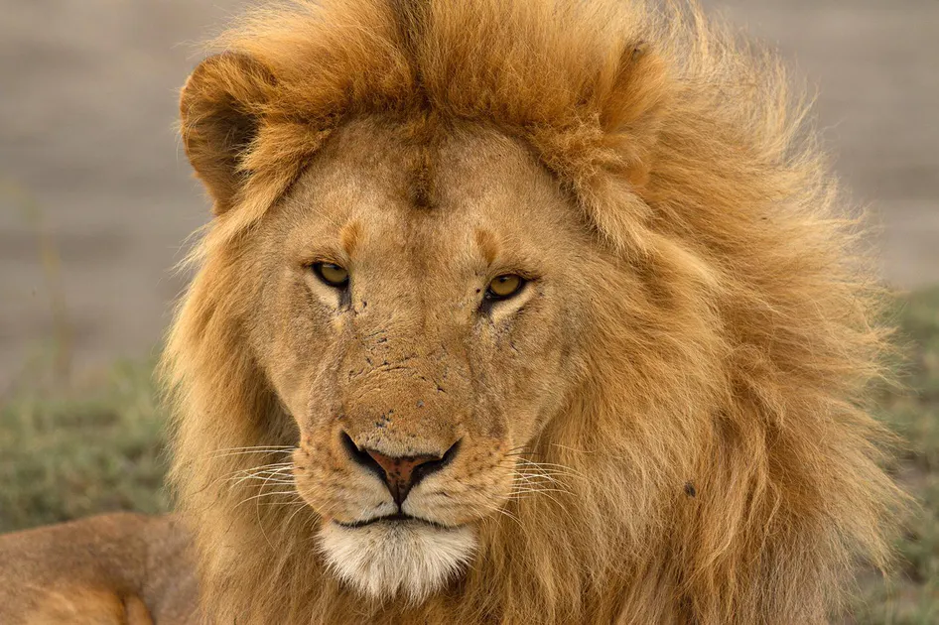

Why do you think Apollo is so anxious to prevent the recovery of Patroclus’ body?

How do the following quotes invoke other parts of the story?

*‘you are running around in the pursuit of the*

*Unattainable – the horses of warlike Achilles, which*

*are hard to master and difficult to drive, at any*

*rate for a mere man…’*

*‘his armour glittering, looking like the*

*inextinguishable flames in the furnace of the*

*blacksmith god Hephaestus.’*

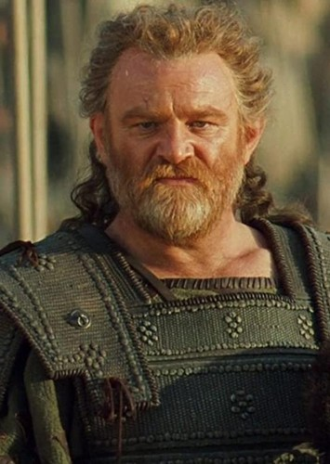

*‘Patroclus, who fell here fighting to avenge wrongs*

*done to me’*

*‘If only I knew where Ajax, master of the battle-*

*cry, was’*

**Read lines 120-187**

How do the following make Ajax a good defender of Patroclus’ body?

|  |  |
| --- | --- |
| Feature | Explanation: |
| Ajax’s previous use of his shield |  |
| Ajax’s past experience with Hector |  |
| Ajax’s reputation at the ships against the Trojans |  |

What similarity is there between the simile describing Ajax’s defence of the body and the first one applied to Menelaus in this book?

Why does Glaucus complain to Hector so strongly?

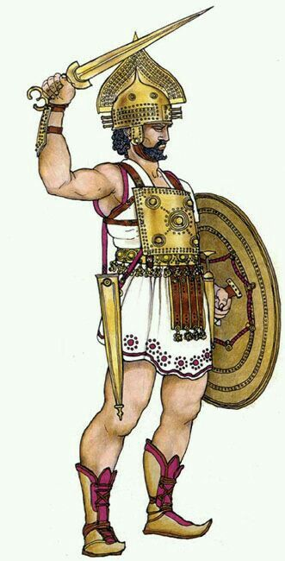

**Hector’s conduct in battle:**

**The treatment of the Lycians as allies:**

**The abandonment of Sarpedon’s body:**

**The wasted opportunity:**

How do you think Hector takes Glaucus’ rebuke? Mark it on here and explain:

**Read lines 188-261**

Find a quote in this passage that shows foreboding for the following characters:

**Achilles:**

**Hector:**

**The Trojans attacking Ajax:**

What effect does Achilles’ armour have on Hector and the Trojans?

Whose rallying speech do you think is the more inspiring to his men?

**Menelaus**

**Hector**

**Read lines 262-400**

How does Ajax bring the situation under better control for the Achaeans in this section?

What impression do you get of Aeneas in this passage?

Collect quotes to show that the battle still hung in the balance and both sides still competed for the body:



Why do you think Homer has it that Thrasymedes and Antilochus have not learnt of Patroclus’ fate yet?

**Read lines 401-542**

Why is Homer careful to tell us that Achilles has not learnt anything from his mother about Patroclus’ fate?

Create your own storyboard to describes Automedon’s charge from the weeping of the horses to the death of Aretus:

|  |  |  |  |  |
| --- | --- | --- | --- | --- |
|  |  |  |  |  |
| Achilles’ horses are weeping and cannot be controlled. |  |  |  |  |
|  |  |  |  |  |
|  |  |  |  | Automedon strips the armour from the fallen Aretus |

**Read lines 543-761**

How does Zeus appear to change his mind in this passage?

Compare Athena’s intervention with Menelaus to Apollo’s intervention with Hector:

|  |  |  |
| --- | --- | --- |
| **Parallel** | **Menelaus** | **Hector** |
| God who visits them: | *Athena* | *Apollo* |
| Disguise they take and its relationship to the hero: |  |  |
| Manner of the rebuke given: |  |  |
| Description of the hero’s spear: |  |  |
| Action of their immediate victim as they kill/wound them: |  |  |

How does Idomeneus show down with Hector justify the exasperated remark of Ajax that follows it?

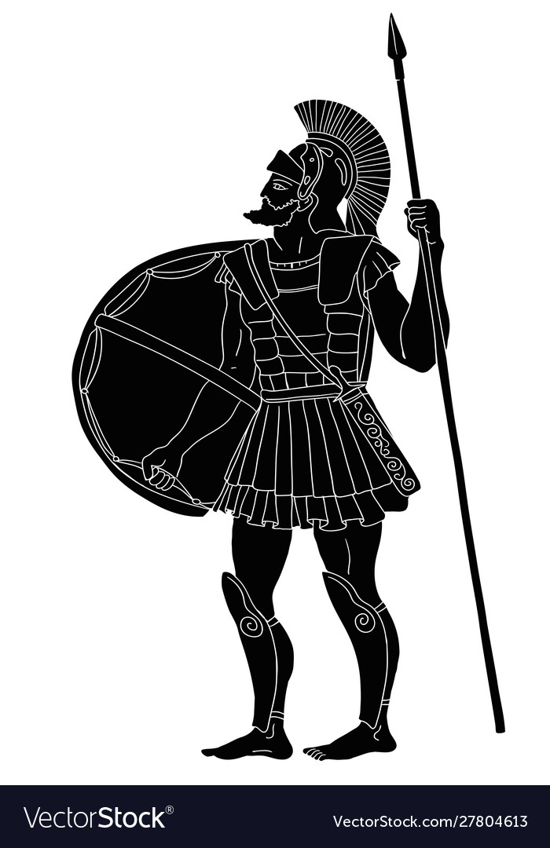As Menelaus runs to and fro, describe the journeys and the characterization of him and those he meets

**Thrasymedes**



**Ajax son of Telamon**

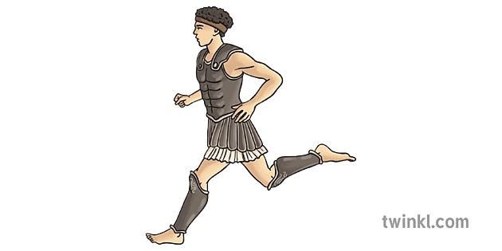

**Antilochus**

**Thrasymedes**

**Menelaus**

**Menelaus**

**Antilochus**

**Meriones**

**Ajax son of Oileus**



**Ajax son of Telamon**



**Meriones**



**Ajax son of Oileus**





**Hector and Aeneas**

**Meriones & Menelaus**

**Ajaxes**

**Appendix: The Death of Patroclus (Books 16-17)**

The classicist, William Allan, describes Patroclus’ death as ‘the turning point in the *Iliad*’, which ‘prepares for the subsequent conduct and fate of Hector.’

*Até*

Allan notes that Homer describes Patroclus as possessed by ‘Recklessness’ (the Greek mentions *Até*). Consider your encounters with this goddess already and what the following lines show us about her role in the pivotal moments of the Iliad:

|  |  |  |
| --- | --- | --- |
| Earlier | Patroclus | Hector |
| How was Até responsible for the Iliad’s plot unfolding? | 16.684-7, 16.784-8 & 16.805 | *Complete this column after finishing the rest of the appendix!* |

Of course, *Até’s* most notable victim is Achilles himself. Allan notes that whilst the death of Patroclus foreshadows Hector’s demise, both point towards the eventual fate of Achilles, which remains left untold by the end of the Iliad.

The *time* of Armour

Allan also argues that the dramatic build up to Patroclus’ death, which features the stripping of two sets of armour, helps justify the major preoccupation of Book 17: the fight for Patroclus’ armour. How do these descriptions show the importance of claiming armour?

|  |  |
| --- | --- |
| Sarpedon and Cebriones | Patroclus (Book 17) |
| 16.530-683 and 16.751-82 |  |

Homer prepares us (through multiple prophecies) for a show down between Hector and Patroclus at the end of Book 16, with the expectation that Hector will triumph. However, Hector’s *kleos* is diminished. Although Hector acquires Patroclus’ armour, Homer gives many clues as to why we might consider it to have been a mistake by Hector to assume he was worthy of the armour (with *Até* at work again). How do the following diminish his possession of this?

|  |  |
| --- | --- |
| Euphorbus’ Intervention  (16.806-15) |  |
| Patroclus’ final words (16.843-6 & 16.849-50[1]) |  |
| Euphorbus’ claim to the armour (17.12-7) |  |
| A reminder of the armour’s origins and that Patroclus was not the owner (17.194-7) |  |
| Zeus’ disapproval of Hector putting it on (17.201-8) |  |
| Thetis notes Hector’s hubris here (18.130-3) |  |

Hector also hopes for other things that ought to be beyond his reach:

|  |  |
| --- | --- |
| Earlier | Later |
| Diomedes’ armour (8.194-5); note his approval of Dolon’s aspirations (10.329-31). | Achilles’ divine horses (17.483-90), just after Zeus has vowed to protect them (17.448-50) |

*You will find a continuation of this discussion in the appendices of Book 22.*

1. The Greek is telling in Patroclus’ words – we might translate *ektanen*, used to describe Fate, Apollo and Euphorbus’ action, as ‘killed’, whilst he uses the word *exenarizeis*, to describe Hector’s actions. Although many translations opt for ‘killed’ here too, the better translation would be to ‘despoil’ (take spoils from something).