Gateways School

**Carbonyls**

**Revision PPQ**

42 marks

**Name: ______________________________ Date: __________**

**Q1.**

Two isomeric ketones are shown below.

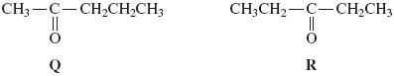

(a)     Name and outline a mechanism for the reaction of compound **Q** with HCN and name the product formed.

Name of mechanism ________________________________________________

Mechanism

Name of product ___________________________________________________

**(6)**

(b)     Some students were asked to suggest methods to distinguish between isomers **Q** and **R**.

One student suggested testing the optical activity of the products formed when **Q** and **R** were reacted separately with HCN.

By considering the optical activity of these products formed from **Q** and **R**, explain why this method would **not** distinguish between **Q** and **R**.

___________________________________________________________________

___________________________________________________________________

___________________________________________________________________

___________________________________________________________________

___________________________________________________________________

**(3)**

**(Total 9 marks)**

**Q2.**

(a)     Write an equation for the formation of methyl propanoate, CH3CH2COOCH3, from methanol and propanoic acid.

___________________________________________________________________

**(1)**

(b)     Name and outline a mechanism for the reaction between methanol and propanoyl chloride to form methyl propanoate.

*Name of mechanism* _________________________________________________

*Mechanism*

**(5)**

(c)     Propanoic anhydride could be used instead of propanoyl chloride in the preparation of methyl propanoate from methanol. Draw the structure of propanoic anhydride.

**(1)**

(d)     (i)      Give **one** advantage of the use of propanoyl chloride instead of propanoic acid in the laboratory preparation of methyl propanoate from methanol.

______________________________________________________________

______________________________________________________________

(ii)     Give **one** advantage of the use of propanoic anhydride instead of propanoyl chloride in the industrial manufacture of methyl propanoate from methanol.

______________________________________________________________

______________________________________________________________

**(2)**

(e)     An ester contains a benzene ring. The mass spectrum of this ester shows a molecular ion peak at *m/z* = 136.

(i)      Deduce the molecular formula of this ester.

______________________________________________________________

______________________________________________________________

______________________________________________________________

(ii)     Draw **two** possible structures for this ester.

**(3)**

**(Total 12 marks)**

**Q3.**

The triester, **T**, shown below is found in palm oil. When **T** is heated with an excess of sodium hydroxide solution, the alcohol glycerol is formed together with a mixture of three other products as shown in the following equation.

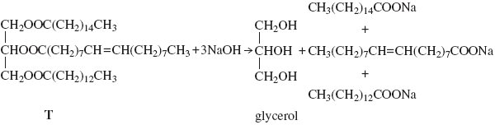

(a)     (i)      Give the IUPAC name for glycerol.

______________________________________________________________

**(1)**

(ii)     Give a use for the mixture of sodium salts formed in this reaction.

______________________________________________________________

**(1)**

(b)     When **T** is heated with an excess of methanol, glycerol is formed together with a mixture of methyl esters.

(i)      Give a use for this mixture of methyl esters.

______________________________________________________________

**(1)**

(ii)     One of the methyl esters in the mixture has the IUPAC name  
methyl (*Z*)-octadec-9-enoate. Draw **two** hydrogen atoms on the diagram below to illustrate the meaning of the letter *Z* in the name of this ester.

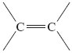

**(1)**

(iii)     One of the other methyl esters in the mixture has the formula CH3(CH2)12COOCH3Write an equation for the complete combustion of one molecule of this ester.

______________________________________________________________

**(1)**

**(Total 5 marks)**

**Q4.**

(a)     Consider the following pair of isomers.

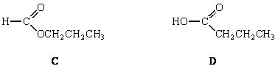

(i)      Name compound **C**.

______________________________________________________________

(ii)     Identify a reagent which could be used in a test-tube reaction to distinguish between **C** and **D**. In each case, state what you would observe.

*Reagent* ______________________________________________________

*Observation with* ***C*** ______________________________________________

*Observation with* ***D***______________________________________________

**(4)**

(b)     Consider the following pair of isomers.

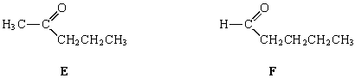

(i)      Name compound **E**.

______________________________________________________________

(ii)     Identify a reagent which could be used in a test-tube reaction to distinguish between **E** and **F**. In each case, state what you would observe.

*Reagent* ______________________________________________________

*Observation with* ***E*** ______________________________________________

*Observation with* ***F***______________________________________________

**(4)**

(c)     Draw the structure of the chain isomer of **F** which shows optical isomerism.

**(1)**

**(Total 9 marks)**

**Q5.**

A student prepared a sample of aspirin (melting point 135 °C) in the laboratory and attempted to purify it by recrystallisation. To check the purity of the aspirin the student determined its melting point.

(a)     State **two** observations, during this melting point determination, that would indicate that the sample is **not** pure.

Observation 1 _______________________________________________________

___________________________________________________________________

Observation 2 _______________________________________________________

___________________________________________________________________

**(2)**

(b)     Suggest why a pure sample of aspirin may sometimes appear to melt at a temperature different from 135 °C.

___________________________________________________________________

___________________________________________________________________

**(1)**

**(Total 3 marks)**

**Q6.**

How many structural isomers, which are esters, have the molecular formula C4H8O2?

**A**       2

**B**       3

**C**       4

**D**       5

**(Total 1 mark)**

**Q7.**

The structural formula of ethyl 2-methylpropanoate is

**A**       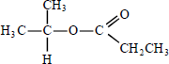

**B**       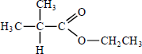

**C**       

**D**       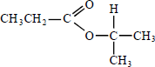

**(Total 1 mark)**

**Q8.**

Acid hydrolysis of 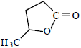 produces

**A**       CH3CH(OH)CH2CH2COOH

**B**       CH2(OH)CH2CH2CH2COOH

**C**       CH3CH(OH)CH2CH2OCHO

**D**       CH2(OH)CH2CH2CH2OCHO

**(Total 1 mark)**

**Q9.**

Which one of the following can react both by nucleophilic addition and by nucleophilic substitution?

**A**       

**B**       

**C**       

**D**       

**(Total 1 mark)**