Seven Kings/ The Regal Period
- Romulus (754-715)
Very little known about the early kings.
- Numa Pompilius (715-673)
- Tullus Hostilius (673-642)
- Ancus Marcius (642-617)
- Lucius Tarquinius Priscus (617-579)
- Servius Tullius (578-535)
The Etruscan kings
- Lucius Tarquinius Superbus (535-510)

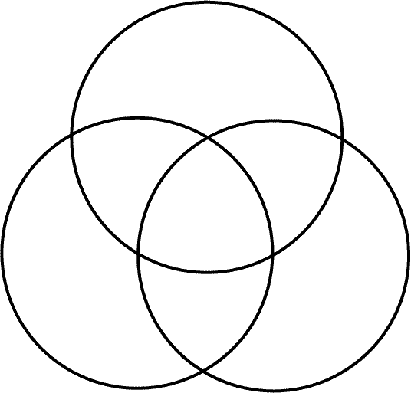
Sort out the changes made under the kings to place them in the venn diagram below:
Urbanisation
Military
Political
Which of the changes do you think will have the greatest impact on each area of Rome’s development?

