***Odyssey* Books 5-8: Themes and story-telling**

The gods

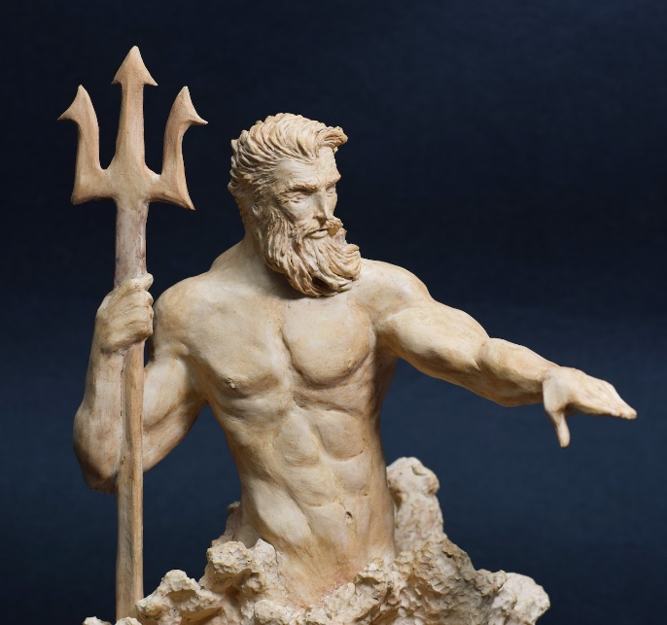How do Poseidon and Athene affect what happens to Odysseus in Books 5-6?



What is nostos? Where do we see Odysseus feeling this in Book 5?

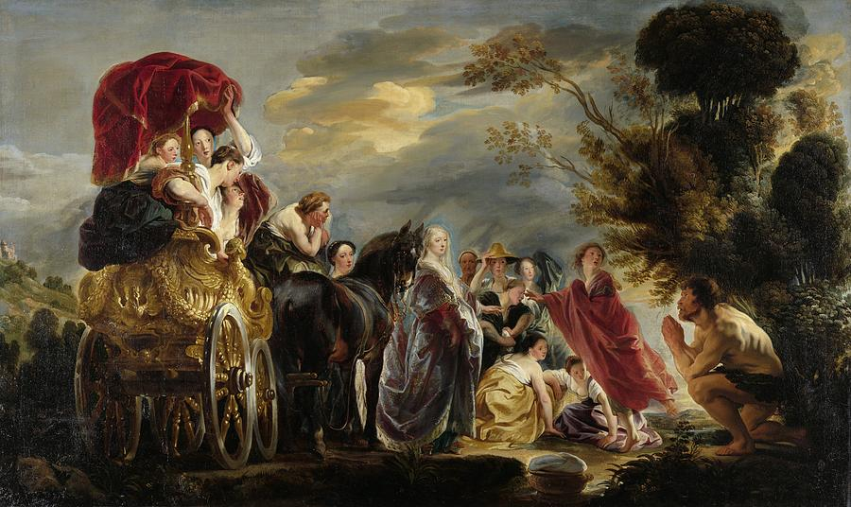Who is Nausicaa? How and why is she in a position to help Odysseus in Book 6?

**The Phaeacians – Fact File**

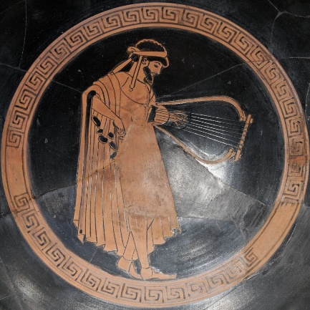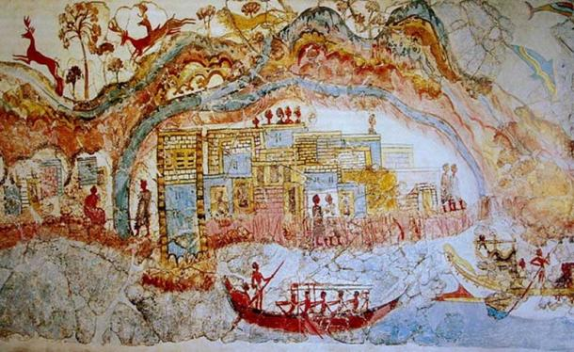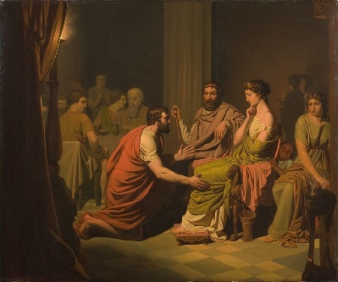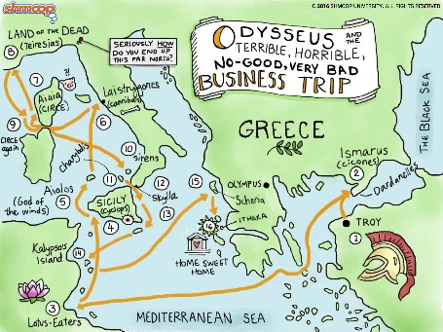

Skills and pursuits:

Palace:

King and Queen:

Island:

Real or magical – or both?

Read the following extracts and explain what xenia is:

…we will summon a fuller gathering of the elders to entertain our visitor here and to sacrifice to the gods. We will then take up the matter of his passage so as to ensure him without trouble or anxiety the happiness of a speedy return to his country under our escort, however far away it is. We will safeguard him on the way from any further hardship or accident till he sets foot on his own land.

The mighty King Alcinous … took the wise and subtle Odysseus by the hand, raised him from the hearth and seated him on a tall polished chair, from which he moved the friendly Laodamas, his favourite son, who was sitting next to him. A maid came with water in a beautiful golden jug and poured it out over a silver basin to rinse his hands. Then she drew a wooden table to his side, and the faithful housekeeper brought some bread and put it by him with a choice of delicacies, helping him liberally to all she could offer.

…mix a bowl of wine and fill the cups of all the company in the hall, so that we may now make a drink offering to Zeus the Thunderer, patron of suppliants, who deserve respect.

Demodocus the bard – story-telling

Highlight phrases from the description of Demodocus and make notes here to show:

* How bards are favoured by the gods
* The respect in which bards are held

The herald returned, leading their skilful bard, whom the [Muse](http://www.poetryintranslation.com/PITBR/Greek/OdindexFGHILMN.htm#Muse) loved more than other men, though she gave him both good and evil: she robbed him of his sight, but gifted him the power of sweet song. [Pontonous](http://www.poetryintranslation.com/PITBR/Greek/OdindexOP.htm#Pontonous), the herald, placed a silver-embossed chair in the midst of them all, with its back against a high pillar, and hung the ringing lyre on a peg above his head, and showed him how to find it with his hands. And he set a handsome table by his side, with a basket of bread, and a cup of wine to drink if he was so minded. Then they all stretched out their hands to the fine feast spread before them.

When they had satisfied their need for food and drink, the Muse inspired her [bard](http://www.poetryintranslation.com/PITBR/Greek/OdindexBCDE.htm#Demodocus) to sing of the heroes’ glorious deeds, part of that tale whose fame had risen to high heaven, the quarrel between [Achilles](http://www.poetryintranslation.com/PITBR/Greek/OdindexA.htm#Achilles), [Peleus](http://www.poetryintranslation.com/PITBR/Greek/OdindexOP.htm#Peleus)’ son, and [Odysseus](http://www.poetryintranslation.com/PITBR/Greek/OdindexOP.htm#Odysseus), who argued fiercely at the gods’ rich festival, though [Agamemnon](http://www.poetryintranslation.com/PITBR/Greek/OdindexA.htm#Agamemnon), king of men, was secretly pleased to see a dispute between the [Achaeans](http://www.poetryintranslation.com/PITBR/Greek/OdindexA.htm#Achaeans)’ finest. For [Phoebus](http://www.poetryintranslation.com/PITBR/Greek/OdindexOP.htm#Phoebus) [Apollo](http://www.poetryintranslation.com/PITBR/Greek/OdindexA.htm#Apollo) had prophesied, at sacred [Pytho](http://www.poetryintranslation.com/PITBR/Greek/OdindexOP.htm#Pytho), where Agamemnon had crossed the stone threshold to consult the oracle, that after a quarrel sorrow would begin to overtake the [Trojans](http://www.poetryintranslation.com/PITBR/Greek/OdindexRSTWZ.htm#Trojans), though by [Zeus](http://www.poetryintranslation.com/PITBR/Greek/OdindexRSTWZ.htm#Zeus)’ will it was the beginning of sorrow for the [Greeks](http://www.poetryintranslation.com/PITBR/Greek/OdindexBCDE.htm#Danaans) as well. This was the bard’s song, and Odysseus clutched at his long purple cloak with his great hands, and dragged it over his head to hide his handsome face, ashamed lest the [Phaeacians](http://www.poetryintranslation.com/PITBR/Greek/OdindexOP.htm#Phaeacia) see the tears pouring from his eyes. Whenever the divine bard stopped singing, Odysseus wiped the tears away, drew the cloak from his head, and reaching for his two-handled cup made libations to the gods. But when the bard began again, prompted by the Phaeacian lords who enjoyed his song, Odysseus covered his head once more and groaned.

* The skill of Demodocus in particular
* What Demodocus sings about
* The effect of Demodocus’ song on Odysseus
* How Demodocus’ story-telling leads into Odysseus’: explain the ‘flashback’ structure of the *Odyssey.*

The herald rose at godlike [Alcinous](http://www.poetryintranslation.com/PITBR/Greek/OdindexA.htm#Alcinous)’ words and brought the hollow lyre from the king’s hall. Then nine elected officials, who organised the games, cleared a space, and marked out a wide arena for the dance. Next, the herald came forward carrying [Demodocus](http://www.poetryintranslation.com/PITBR/Greek/OdindexBCDE.htm#Demodocus)’ ringing lyre. The bard stood in the centre and round him a group of dancers, boys in the first flush of youth, skilled in dancing, and Odysseus marvelled as he gazed at their flashing feet, striking the sacred dancing floor.

Then the bard struck the chords that began his sweet song, and told of the love of [Ares](http://www.poetryintranslation.com/PITBR/Greek/OdindexA.htm#Ares) and [Aphrodite](http://www.poetryintranslation.com/PITBR/Greek/OdindexA.htm#Aphrodite) of the lovely crown, how they lay together in secret in [Hephaestus](http://www.poetryintranslation.com/PITBR/Greek/OdindexFGHILMN.htm#Hephaestus)’ house, and how Ares gave her a host of gifts while dishonouring the Lord Hephaestus’ bed… This was the song of the famous bard, that delighted [Odysseus](http://www.poetryintranslation.com/PITBR/Greek/OdindexOP.htm#Odysseus) and the [Phaeacians](http://www.poetryintranslation.com/PITBR/Greek/OdindexOP.htm#Phaeacia) famed for their long-oared ships.

With that he seated himself next to King [Alcinous](http://www.poetryintranslation.com/PITBR/Greek/OdindexA.htm#Alcinous), since they were already serving the food and mixing the wine. Then the herald approached leading good [Demodocus](http://www.poetryintranslation.com/PITBR/Greek/OdindexBCDE.htm#Demodocus) the bard, whom all honoured, and seated him in the midst of the throng, on a chair that leant against a tall pillar. Resourceful [Odysseus](http://www.poetryintranslation.com/PITBR/Greek/OdindexOP.htm#Odysseus), first cutting slices from the chine of a white-tusked boar rich with fat on either side, of which there was plenty left, spoke to the herald: ‘Take this portion of food to Demodocus, Herald, and let me welcome him, despite my grief. Bards are honoured and revered by every man on earth, for the Muse has shown them the path to poetry, and loves the tribe of poets.’

He finished, and the herald took the food and handed it to noble Demodocus, who was delighted. So they stretched out their hands to the good things before them, and when they had sated their desire for food and drink, resourceful Odysseus spoke to the bard, saying: ‘Demodocus, I praise you above all mortal men, one taught by the [Muse](http://www.poetryintranslation.com/PITBR/Greek/OdindexFGHILMN.htm#Muse), [Zeus](http://www.poetryintranslation.com/PITBR/Greek/OdindexRSTWZ.htm#Zeus)’ daughter, or perhaps by [Apollo](http://www.poetryintranslation.com/PITBR/Greek/OdindexA.htm#Apollo), for you sang the [Achaeans](http://www.poetryintranslation.com/PITBR/Greek/OdindexA.htm#Achaeans)’ fate with truth and feeling, all of their actions and their suffering, all the efforts they exerted, as if you had been there, or heard it from one who was. Now, come, change your theme, and sing of the making of the Wooden Horse, that [Epeius](http://www.poetryintranslation.com/PITBR/Greek/OdindexBCDE.htm#Epeius) fashioned with [Athene](http://www.poetryintranslation.com/PITBR/Greek/OdindexA.htm#Athene)’s help, that noble Odysseus contrived to have dragged inside the citadel, filled by cunning with warriors who then sacked [Troy](http://www.poetryintranslation.com/PITBR/Greek/OdindexRSTWZ.htm#Trojans). Tell the tale as it happened, and I will say to all mankind that the god has given you freely of the power of divine song.’

          At his words the bard, inspired by the god, began, and raising his voice picked up the tale… So sang the famous bard. And [Odysseus](http://www.poetryintranslation.com/PITBR/Greek/OdindexOP.htm#Odysseus)’ heart melted, and tears poured from his eyes.