**The Iliad - Book 18**

**Read lines 1-147**

What is ominous about Achilles’ thoughts as Antilochus approaches?

|  |  |  |
| --- | --- | --- |
| How does Homer powerfully show Achilles is stunned by grief? | | |
| Quote: | | Effect |
|  | |  |
|  | |  |
|  | |  |
|  | |  |
|  | |  |
|  | |  |
| How does Homer show the other characters join Achilles in grief? | | |
| Character(s) | Actions | |
| Antilochus |  | |
| The slave girls |  | |
| Thetis |  | |
| The Nymphs |  | |

How might Thetis’ mourning be more about the future than the present?

As Achilles turns his thoughts to killing Hector, Homer avoids the theme of heroic revenge, opting for a heroic tragedy instead. How do the following points reflect this?

Thetis tells Achilles that all he as asked for Zeus has brought about.

**Tragic Meaning**

**Point**

Achilles tells Thetis that she will not persuade him otherwise now that his mind is made up.

Achilles asserts that he will go and win great glory (*kleos*)

Achilles concludes that he must let go of his anger towards Agamemnon

Achilles uses the verb *apolesa*, which could mean either ‘I have lost him’ or ‘I have destroyed him’

What will stop Achilles entering the fray immediately and how will his mother help?

**Read lines 148-242**

Surround the picture with quotes that show Hector is determined to get Patroclus’ corpse?

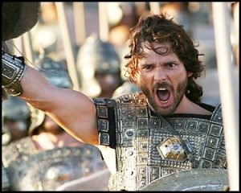

What does Iris say to try and shame Achilles into action?

What two reasons does Achilles give for not joining the struggle?

1)

2)

What is Iris’ second suggestion?

Complete the following table for Achilles’ appearance at the ditch:

|  |  |
| --- | --- |
| How Homer describes Achilles? | Effect on the Trojans |
|  |  |

**Read lines 243-309**

Complete the following:

|  |  |
| --- | --- |
| Polydamas’ advise: | Hector’s advise: |
| His reasons: | His reasons: |

What is tragic about Hector’s mention of Zeus?

**Read lines 310-368**

How does Homer continue to show how much Achilles cared for Patroclus in this passage?

|  |  |
| --- | --- |
| Quote | Effect |
|  |  |
|  |  |
|  |  |
|  |  |
|  |  |

How are Zeus and Hera shown to be as petty as any humans?

**Read lines 369-467**

What do we learn about the tripods Hephaestus is working on?

How does Hephaestus’ wife, Charis, behave well on Thetis’ arrival?

What do we learn about Hephaestus’ and Thetis’ past friendship?

|  |  |  |
| --- | --- | --- |
| Hephaestus’ opinion | How Thetis helped? | What he now offers? |
|  |  |  |

Around the picture, write down as many details as you can find that describe Hephaestus and his actions:

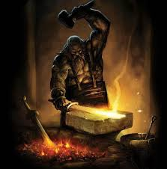

What does it imply about Hephaestus that he has to be told the full tale by Thetis?

Who does Thetis say killed Patroclus? Why do you think this is?

**Read lines 468-617**

What steps does Hephaestus take to craft Achilles’ new shield?

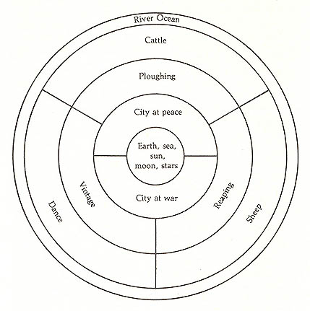

Annotate each section of the shield with details from Homer:

**Appendix – The Shield of Achilles**

* Achilles’ shield is quite unique in Homer and should not be compared to other arming scenes in the *Iliad* or *Odyssey*.
* The shield design is given an unprecedented 130 lines!
* Note that this is the finest work by the finest workman and that the design is actually in motion!
* The subject material is predominantly peaceful, a curious irony for the shield of the greatest fighter. Note that the *Iliad* includes peaceful scenes throughout.

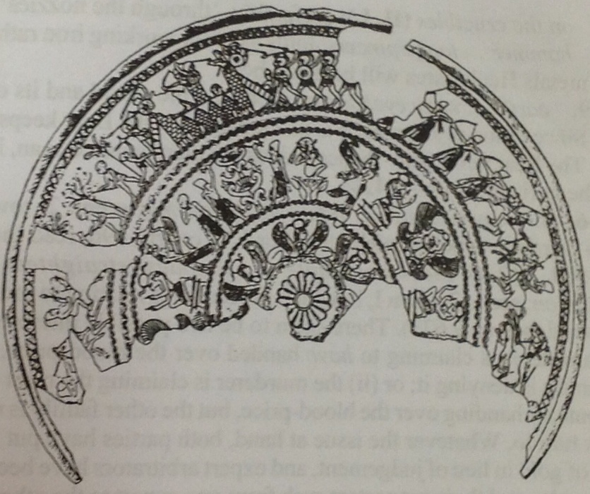**Theories of design**

Homer might have envisaged a design similar to contemporary shields and dishes.

(*Left*) Phoenician dish from Cyprus, c. 700 BC