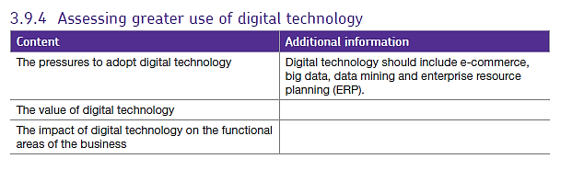3.9.4 Use of digital technology

Contents

What is digital technology? 2

E-commerce 2

Advantages of e-commerce to business 3

Disadvantages of e-commerce to business 4

Advantages of e-commerce to customers 4

Disadvantages of e-commerce to customers 4

Big data and data mining. 5

Uses of big data 6

Issues involving the use of big data 6

Examples of users and their uses of big data 7

ERP 8

The main benefits of Enterprise Resource Planning (ERP): 8

Why do businesses use enterprise resource planning (ERP)? 8

The value of digital technology. 9

The impact of digital technology. 9

The pressures to adopt digital technology 10

The threats of digital technology for businesses 10

Impacts on different functional areas: 11

On operations management 11

On marketing 11

On financial management 12

On HRM 12

# What is digital technology?

Digital technology contrasts with analogue technology which uses electronic signals to transmit data. Digital technology enables a greater volume of data to be stored and processed.

Digital technology has helped businesses and individuals to utilise the internet more fully for commercial purposes, through e-commerce (and more recently, through m-commerce). Mobile communication has changed the way in which people organise their lives.

The greater efficiency of digital technology in comparison to other technologies has created pressures on businesses to adopt digital technology. It has also encouraged a more integrated approach so that each functional area of business can coordinate its activities more easily with other functional areas.

Some of the major aspects of the use of digital technology to improve business performance are include the following aspects of business:

* e-commerce
* big data
* data mining
* enterprise resource planning (ERP).

# 

# E-commerce

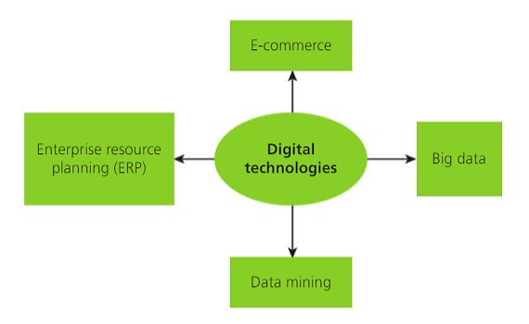As we saw in 3.7.6, the use of internet for online shopping is growing rapidly. **E-commerce** (business over the internet using a website) and **M-commerce** (business over mobile devices often using an app) often form part of a firm’s digital strategy – making use of these technologies to increase awareness of their products and raise revenue and facilitate **digitally-enabled commercial transactions**. Online sales are used in B2B, B2C and C2C markets (e.g. eBay or Gumtree).

E and M-commerce have enabled **multichannel** (numerous ways to purchase) and **omnichannel** retailing (numerous ways to research and purchase) to increase hanging the emphasis in the marketing mix for many businesses. These could include traditional outlets such as catalogues, brick-and-mortar stores, mail, and telephone as well as, online stores, mobile stores, mobile app stores, telephone sales and any other method of transacting with a customer. Firms use web-rooms rather than / as well as showrooms to get people to engage with products and buy, customers may also use a smartphone to download a voucher before purchasing etc.

Many small firms who would no normally be able to get online can now sell online through marketplace websites such as Amazon, where small firms can often sell many products in very small quantities – as opposed to small range of best-selling items.

# Advantages of e-commerce to business

Cost-effectiveness. E-commerce allows businesses to cut certain costs e.g. owning or renting shops in expensive city or town centre locations. It may also allow a business to save money by using more flexible staffing. Retail outlets base their staffing on the estimated numbers of customers expected to visit a store on any day. This can lead to over-staffing and consequently high wage costs. However, online retailing uses customer order numbers to dictate how many staff are needed to process and service their orders. Consequently, staff on flexible contracts can be called into work in accordance with the number of known orders received online.

Flexibility. Retailers can provide greater flexibility by storing all of their goods in one particular factory or warehouse and delivering them to customers in accordance with orders from the customers. This overcomes the problem of having inventory held in the wrong shops. With ‘click and collect’ deliveries online customers are able to visit the store knowing the good is available for collection, although in fact, it may have been transferred from another store in response to an online order.

Increased demand. Online retailing increases the customer base of a business, to the extent that, in theory, any business can enter global markets. Using the internet is particularly useful for customers with mobility difficulties and can also save expenses by reducing transport costs and time, because comparing alternative online retailers is a much simpler process than comparing physical shops in a town centre. If a business has a unique selling point or competitive advantage, online retailing allows this to be shown to a much greater range of customers.

Improved efficiency. Because online retailing tends to be based on specific orders, businesses are more likely to be able to organise their production to match demand. Consequently, there is less waste and so average (unit) costs of production should fall.

Greater profit margins. Manufacturers can enjoy greater profit margins as a result of e-commerce. Traditionally manufacturers would sell their products to retailers at relatively low prices, because the retailers would then add their margin to the price. E-commerce allows manufacturers to sell directly to customers, because deliveries can be made directly from the factory. Thus, the profit that was previously made by the retailer is now taken by the manufacturer. Furthermore, for bulky goods the transport costs may be cheaper because goods may be delivered directly from the factory to the customer.

Impact on marketing. E-commerce gives businesses a much greater understanding of the individual requirements of their customers and the ability to tailor-make promotions to specific individuals. Consequently, marketing should be much more cost-effective and successful in achieving greater sales, although the scope to sell more may be negated by the fact that competitors also have this benefit.

# Disadvantages of e-commerce to business

Greater competition. Because of the ease of entry to online markets, existing firms may find their market becoming much more competitive. This can lead to a fall in demand in the short term, as market share is spread between a wider range of businesses. In the long term this may lead to some businesses being forced to exit the market, particularly if they have been slow to adapt to e-commerce.

Costs of new technology. Establishing IT systems can involve considerable expense in order to offer online selling. Website design must be user-friendly to attract customers through search engines. Search engines often require payment for good placings on their websites - many smaller businesses are therefore harder for customers to find through online searches. Also, businesses require a distribution network, and this can involve considerable expense and reliance on external logistics firms - however, the competitive nature of the distribution industry in the UK does tend to keep down distribution costs.

Lack of tactile experience for customers. For many customers the ability to experience the physical qualities of a product is vital, particularly for items such as clothing and fragrances. Although online retailing gives visual clues, it is unable to match shops in offering this more direct contact with, or experience of, a product.

## Advantages of e-commerce to customers

Wider choice of products. Goods and services are no longer limited to the retail outlets that a customer can visit. This means that customers are more likely to be able to purchase their preferred product.

Greater convenience. Shopping can be conducted at any time of day and from any place, particularly with the growth of mobile commerce. This is particularly advantageous to people who work during the hours that most stores are open. Deliveries can be made to the customer’s home.

Improved information. Websites and related support systems allow customers to get much greater information about products, this can also include access to customer reviews. These reduce the risk of customers making a poor choice when buying a new product.

Lower prices. Since businesses can reduce costs through online retailing, they may be able to reduce prices or have more promotional offers, there may also be greater competition between businesses which can drive down prices for customers.

# Disadvantages of e-commerce to customers

Security. Online retailing relies on secure payment systems. There have been a number of instances where personal financial details have been accessed by ‘hackers’ and instances where payments have been taken but no goods delivered.

Lack of tactile or personal experience. For some customers, and for some products, the lack of ability to experience the product before purchasing it can be a major issue. Many consumers would perceive the lack of human interaction as a disadvantage.

Faulty products. Returning faulty goods can be a time-consuming and possibly costly activity, although in most cases any costs would be incurred by the supplier. It is usually much more convenient to return goods to a retailer.

## Big data and data mining.

Firms can use digital technology for online sales / brand awareness but also to analyse data to identify patterns and trends (data mining) which often needs to be done through the use of big data.

Data mining can support decision-making and use of decision trees, CPA or market mapping and correlation / extrapolation.

Much of data mining is based on statistical techniques. However, whereas statistical analysis was often based on sampling in order to prove (or disprove) ideas, the volume of data now available is likely to lead to more certainty in the conclusions and predictions that arise from analysing the data.

Because of the sheer volume of data available, businesses in the past had to prioritise the data that they elected to retain and analyse. Big data uses the analytical tools provided by software to enable a business to not only store more information, but also to allow their computing facilities to generate a multitude of connections between different data. For example, it has been found that the background colour of a website may have a significant influence on consumer reactions to the content of the website. This type of connection between data would not have been analysed in the past, but data mining allows computer programs to analyse random links, such as the impact of different colours, and present the results of these analyses where there appears to be some logical cause present. It is then left to the skill and intuition of business analysts to decide whether this connection is causal or merely coincidental.

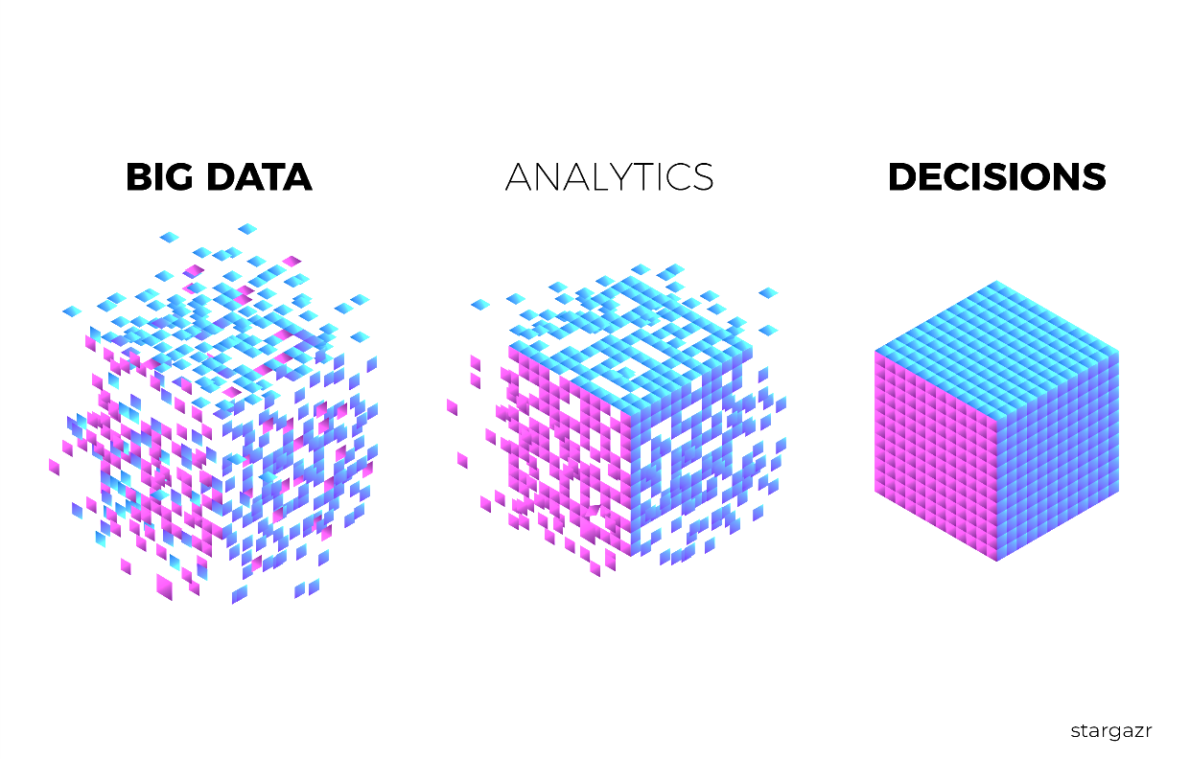The ability to analyse data is a key growth area for employment and is vital to the successful use of data mining. Data mining can take many forms and its precise use depends on the type of analysis required by a business.

Big data (huge amount of available information available from many sources which can be analysed - this includes messages, updates etc. posted on social media, GPS data (think Google maps). Can be used for analysing own performance – operations management, marketing – develop products, payment systems etc. and possibly looking at security issues.

The rapid growth of the use and analysis of data by businesses is often expressed in terms of its high volume (quantity), high velocity (speed of transmission) and variety (the range of different data).

● Volume: This refers to the quantity of data being produced for business analysis. Businesses have always generated data but have tended to lack the ability to interpret its meaning. In many cases businesses also experienced difficulties in storing high volumes of data. Furthermore, the relevance of some data was not recognised. However, the costs of data storage are now lower and analytical software enables businesses to discover relationships and correlations arising from their data.

● Velocity: The speed with which data can be recorded has increased dramatically. In addition, analytical software allows it to be interpreted much more quickly too. This has increased the usefulness of big data because much of the information is very up to date and therefore conclusions based on this information are likely to be more reliable indicators, even in markets in which there is rapid change.

● Variety: Traditionally businesses relied on structured numerical data in databases, with most of this data being based on output, sales levels and financial information. Big data provide the opportunity for more unstructured information, such as e-mails, qualitative customer feedback and social media comments.

## Uses of big data

The uses of big data can vary considerably and depend on the needs of the business and, sometimes, on the data available for analysis. Some examples of big data usage are as follows:

* Analysis of operations. The growing use of computerised machinery, sensors and meters has led to increased data on the performance of a business’s operations. The speed with which data can be gathered enables businesses to correct errors such as quality defects, much more rapidly. Equipment can be easily / remotely adjusted, so that action can be taken to ensure that problems do not continue. This analysis can register factors such as speed of production, accuracy of specifications and customer experience. Combining this data with data such as costs of manufacturing and levels of repeat purchases can enable a business to recognise the level of financial benefits that arise from rectifying different problems, so that priorities can be established.
* Marketing information. The data allows a business to gather much more detailed information on its customers so that they can understand their needs. Data from loyalty cards, websites, credit cards and other payment systems and customer feedback may enable the business to ascertain levels of brand loyalty of individual customers, key factors that influence their buying habits, how they are likely to react to different forms of promotion and price changes, how and where they prefer to shop and possible clues to changes in their future buying habits.
* Improving decision making. The analysis of internal data may be used to ascertain the effectiveness of new strategies introduced into a business and the consequences of decisions made by managers within a business. By analysing this data, a business should be able to recognise its successes and failures, and so recognise its strengths and minimise the impact of its weaknesses. This data can then be linked with other data that might be able to explain the reasons for success or failure, in order to improve future decision making.
* Improving security. Security issues are a major threat to the growing use of data in business. Analysis of customer records from the business itself and from external sources can enable a business to reduce its risks of fraud or customer default. The technology may also help a business to develop systems that are more secure and thus prevent the possibility of security breaches in future.

## Issues involving the use of big data

Although big data provides many advantages to businesses, there are certain factors that need to be considered in its use.

Firstly, data protection legislation prohibits the use of data when the person, usually a customer, has not agreed to its use. Although most big data is considered to be gathered legally, the level of data gathering is so high that it is difficult for a business to be sure that this is in fact the case.

Secondly, the reliability of the data can be questionable, particularly if it is from external sources or opinions. If the data is unreliable, then any analysis based on it is likely to be incorrect. Consequently, incorrect conclusions are likely to be drawn.

Finally, although data analysis can be conducted much more effectively, it can still use a lot of resources. The big data market is predicted to grow to a market worth $48.6 billion in 2019. The global business consultancy, Gartner, expects this industry to produce 4.4 million jobs globally, with each IT job created by big data likely to generate three more non-IT jobs. However, this huge expansion in job opportunities will only occur if businesses can be sure that the benefits of big data outweigh the costs of using it.

## Examples of users and their uses of big data

* Online retailers: retailers can get much better data from their online customers than from those that use shops. Retailers can track the behaviour of online customers by observing what they buy, but also by noting what other products they looked at. It is also possible to observe features such as how consumers navigate a website, to what extent they are influenced by promotions and reviews, and the impact of page layouts on their behaviour. Consequently, retailers are often able to predict what products a consumer would like and what they are likely to want in the future, through noting their reactions to different information and promotions. To businesses such as Amazon big data is a source of competitive advantage.
* Transport scheduling: airports have been beneficiaries of big data. Previously they relied on estimated times of arrival from pilots, 10 per cent of which were incorrect by more than ten minutes in US airports. This meant that staff, such as baggage handlers, were in the wrong place at the wrong time. However, analysis of big data provided by computer programs, which incorporate factors such as localised weather conditions, has led to much greater accuracy of arrival times.
* More personalised marketing: by centralising all data on sales and inventory holdings a business can match the availability of products to the likely demand, the latter being based on their improved observations of consumer behaviour. This matching automatically creates instructions to increase (or run down) inventory levels where the availability does not match the anticipated demand. In traditional organisations, these items of data would be held by different departments, and so this type of co-ordination would have been difficult to achieve.

<https://www.tesco.com/help/privacy-and-cookies/privacy-centre/tesco-and-your-data/>

# ERP

This stands for Enterprise Resource Planning, it is software which allows the business to integrate the management of many activities together i.e. it links the different parts of the business together to give an overview of what’s happening in the firm.

Although the introduction and management of ERP systems is both complex and costly, there are some significant business benefits if ERP is implemented successfully.

## The main benefits of Enterprise Resource Planning (ERP) are:

* Integration of all business processes so that all aspects of a business work towards the same goals. Usually one individual is responsible for a particular customer and their orders so that consistent messages are conveyed to customers. ERP links together all of the functional areas of a business so that each area is working towards meeting the needs of the customer rather than its own specific targets.
* Greater efficiency from automation. The automation of these processes reduces the possibility of human error and provides better co-ordination, so that time management is more effective, thus cutting costs.
* Closer scrutiny of all activities. Because ERP tends to be integrated with suppliers and other external organisations, it tends to mean that the business has a much clearer picture of all of the activities being undertaken in the production and delivery of its goods.
* Reports. ERP software analyses the effectiveness of the performance of the various activities that it co-ordinates and provides reports to management. This enables managers to identify the strengths and weaknesses of their activities and to take appropriate action to improve efficiency.

## Why do businesses use enterprise resource planning (ERP)?

The benefits outlined in the previous section provide reasons for businesses to choose to use ERP. A number of surveys have confirmed that the main motives behind the adoption of ERP by a business are as follows:

* to reduce costs (this is the main motivation)
* 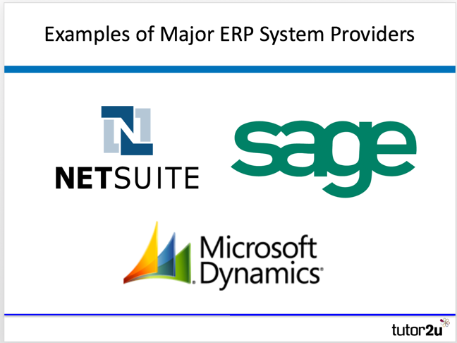to make a business more accessible for other businesses to do business with
* to efficiently manage future growth
* to manage growth expectations in a co-ordinated manner
* to improve customer response times
* to overcome difficulties in co-ordinating activities taking place in different locations
* to help innovation in order to increase added value.

# The value of digital technology.

Ecommerce can bring many advantages to businesses:

* Access to domestic and international markets by operating 24/7 should increase demand
* It is very cost-effective as there is less expense involved in owning and maintaining shops
* Retailers can store all their goods in one place and distribute from there rather than having to have separate storage at each shop, they can also offer click and collect so greater flexibility for customers
* Lower overall costs should facilitate increased profit margins and there can be relatively cheap set-up costs for new businesses although they may find it hard to compete longer-term
* Marketing can be carried out via e-commerce through social media
* Greater access to suppliers – the ability to find cheaper suppliers more easily.
* ERP can improve productivity and efficiency, lead to better quality decision making and improve flexibility through being able to coordinate parts of the business more effectively.

#### However, there are also drawbacks;

#### 

* Many people have seen their work-rate increase as technology makes the communication of data much faster and many customers (and managers) expect responses to be sent much more quickly. Deadlines are shorter and this can increase stress which leads to sickness and absence.
* Many staff may be concerned about their ability to adapt to new technology and therefore be worried about their jobs, this causes low morale if fewer staff are needed and there is de-layering.
* There is a high cost involved in introducing and continually updating digital technology and this is not just the start-up cost but must be budgeted for on an annual basis, the cost of ‘keeping up’ can mean that some firms cannot get into the market – it acts as a barrier to entry to smaller firms.
* Drawbacks of ERP include the need for investment in IT infrastructure, staff training which may meet with resistance and the need to fully plan everything before anything can be implemented which can lead to long planning periods where nothing seems to be happening.

# The impact of digital technology.

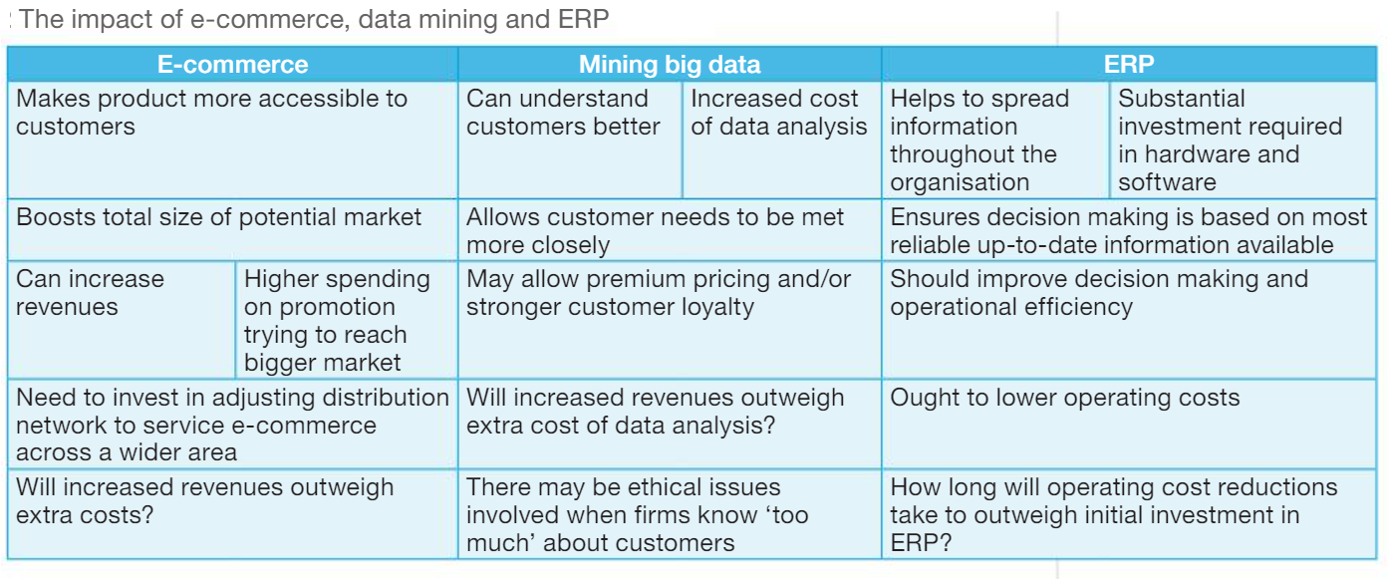The table below shows some of the main impacts of digital technology within businesses.

There are many benefits if using technology but it has also **disrupted** many markets including:

### **MEDIA STREAMING**

Netflix | youtube | Spotify | Apple imusic & itunes | Amazon Prime | BBC iplayer | Hulu

### **GROCERY RETAILING**

Ocado | Amazon Pantry & Fresh | Graze

### **TRAVEL & ACCOMMODATION**

Expedia | Trip Advisor | airbnb

### **FASHION RETAIL**

ASOS | Net A Porter | missguided

### **SHARING (GIG) ECONOMY**

Uber | blablacar | airbnb

This means it has changed how the market works and caused firms to have to compete differently because customers can now access products or services in a different way.

## <http://www.bbc.co.uk/news/resources/idt-sh/disruptors_how_may_I_help_you>

# The pressures to adopt digital technology

The pressures to adopt digital technology include the following:

The need to keep up with the market. If customers are researching online, for example, and don’t

find a particular business when they search, then that business will miss out on sales. If customers

are expecting an online presence and a company don’t have one, it can expect to be overlooked.

E-commerce provides part of a multi-platform strategy; without it a business may be fighting with

one hand tied behind its back.

The need to keep pace with competitors’ decision making and strategy. If competitors are gathering

and using data more wisely to make their strategic decisions, then they are likely to be more efficient

and effective, and a less effective business may struggle to compete.

The need to keep costs down. By operating online rather than on the high street, for example, costs

can be reduced. This can be a very strong driver for small businesses entering a market.

# The threats of digital technology for businesses

According to McKinsey, the management consultants, there are a number of pressures on businesses as a

result of digital technology.

Downward pressure on prices and on profit margins - digital technology is making it easier for potential buyers to compare prices, levels of service and the performance of different products. Customers can find alternatives and switch accounts more easily, increasing rivalry in the market. The level of competition is further increased by new businesses bringing together information to make it even easier for consumers to compare offerings and prices of different businesses. In South Korea, for example, OK Cashbag has a mobile app that brings together product promotions and loyalty points from more than 50,000 retailers. In the UK, there are websites such as GoCompare and Expedia. These forces push both prices and profit margins downwards.

#### New unexpected competitors

Digital technology removes many of the old barriers to entry to a market and enables new competitors to

come from unexpected places. Setting up an insurance company or bank now no longer requires physical

distribution networks. New competitors can often be smaller companies that can do a lot of damage to

established firms. In the retailing industry, for instance, new businesses can focus on niche markets, attacking the edges of the more mainstream retailers. Competition is made easier by the fact that it is

becoming increasingly easy to buy and integrate aspects of an online business from other providers. Amazon, for instance, offers businesses logistics, online retail ‘storefronts’ and IT services.

#### Keeping up with change

Change is increasingly rapid and is changing the shape of industries. Major players can quickly find themselves offering the wrong product. Look at the music industry, where the business model has shifted from selling tapes and CDs (and then MP3s) to subscription models, like Spotify. In transport markets digital technology (including a combination of mobile apps, sensors in cars and data in the cloud) has created a business model for companies such as Zipcar, where people pay to use cars when they need them rather than owning them. Driverless vehicles are increasingly being tested in cities around the world, again moving the transport industry forward and bringing in new competitors. We may buy Google cars not Ford cars in the future. This affects not just the producers but related industries.

# Impacts on different functional areas:

### On operations management

The need to maintain an effective logistics system, which ensures that customers get their products quickly and conveniently without excessive cost, is vital for successful e-commerce. The use of ERP has had a huge impact on operational systems, by improving coordination and communication.

Using robotics in production (in firms such as Nissan) or automating parts of the production process and using CAD or 3D printing for rapid-prototyping. Technology can also be used in quality control in factories such as McVities where the machinery can detect imperfect products e.g. misshapen biscuits or in stock control using EPOS where retailers can have automatic re-ordering of stock when levels run low e.g.

<https://www.foodmanufacture.co.uk/Article/2017/03/14/Seabrook-Crisps-see-inside-the-factory#news>

### On marketing

Can eliminate the need for expensive advertising campaigns if digital marketing is done well, this can lead to significant cost savings. It can also lead to changes to the ‘place’ where products are sold as it opens up the online market place and reduces the need for shops, firms such as Thomas Cook and Thomson Holidays (Tui) have seen changes to the balance of their business as more people now book online. There is also greater scope for added value as firms can make use of digital information to get to know their customers better e.g. data mining their customer loyalty data through cards such as Clubcard or Nectar.

Digital technology has a significant impact on marketing. E-commerce has transformed the way products are promoted and distributed. It is important that a business’s website is constantly updated and is easy for customers to use when ordering online. Big data and data mining enable businesses to build up accurate customer profiles and identify trends in buying habits. Social media and electronic messaging provide valuable promotional methods to target consumers with personalised offers. The use of dynamic pricing enables businesses to alter their prices according to demand.

### On financial management

Technology allows for much more efficient financial monitoring; many processes can be automated and different scenarios can be modelled efficiently. Variances can be monitored to ensure projects don’t go over budget whilst in completion and reducing the need to borrow to cover cash flow problems. Trends to changes in accounting ratios can be easily spotted.

### On HRM

Many businesses have had to retrain staff to cope with new technology and, in some cases the implementation of technology has led to redundancies. There is also increased communication between staff in organisations with some staff receiving many emails which, under the old-fashioned system, they may not have received, this can increase the pressure to complete work is much greater. There are many new jobs which have been created through technology such as web-design or digital marketing professionals and new industries have sprung up around these occupations.