The Aeneid – Book 10

Read lines 1-118
What enemy general of Rome does Jupiter allude to at the start of this Book? What do you think Virgil thought of Rome’s wars with him?

How do Venus and Juno highlight the suffering of their respective sides?

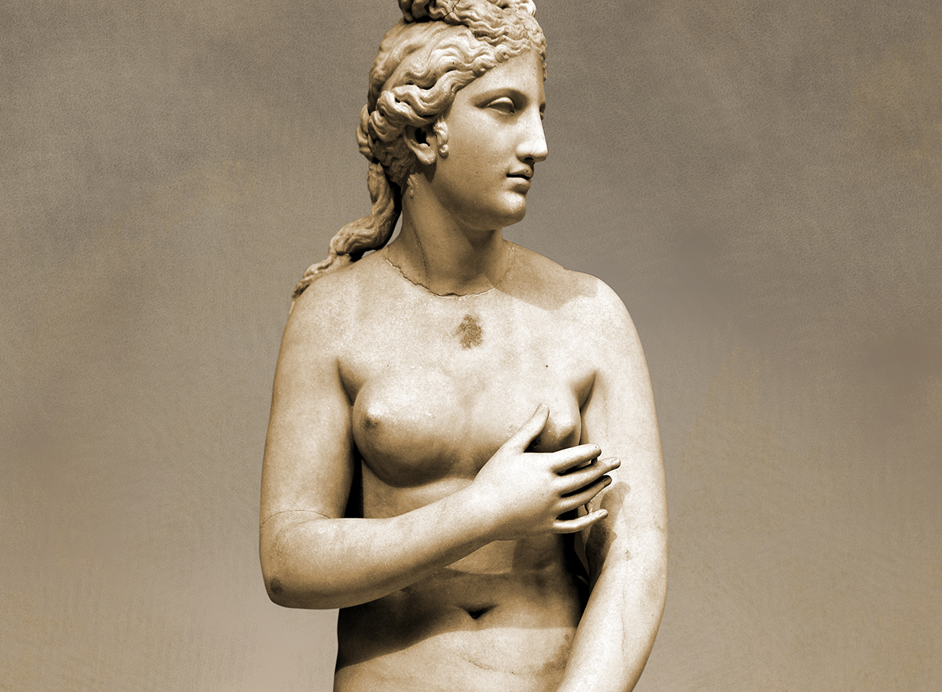

Suffering of the Trojans

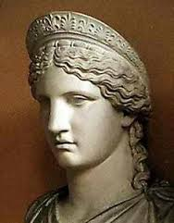

Suffering of the Italians/Latins
What past events are the goddesses alluding to with each of these quotes?
Venus
Quote | Past Event
‘Will you never allow them to be free of besiegers?’

‘…from Arpi the Aetolian Diomede is once more rising against the Trojans.’
‘I suppose I shall soon be wounded again’

‘…by the smoking ruins of the sacked Troy

‘…give them back their Xanthus and their Simois.’

Juno
Quote | Past Event
‘He was goaded into it by the ravings of Cassandra!’

‘You can steal Aeneas away from the hands of the Greeks…’
‘…when the Trojan adulterer stormed the walls of Sparta.’
‘Was it I who kindled the fires of war and lust?’

What does this reveal about these two goddesses and the current conflict?

How is Jupiter shown to be the most authoritative god, presiding over Fate?
Quote: | Explanation:

Read lines 119-146
How are the following shown to be heroic?
Acmon:

Ascanius:

Ismarus:

Think of one other hero of which each of these remind you.

Read lines 147-215
‘…he had entered the Etruscan camp and gone to their king to tell him his name and nation, what he wanted, what he offered and what armed forces Mezentius was winning to his support. He told him too of the violent passions of Turnus and reminded him that in human affairs there is no room for certainty, and to all this he added his appeal for help.’
Reread 8.479-503 and explain why Aeneas is able to convince the Etruscans to ally with him.

Complete the following table:
Captain | Homeland | Description of the Ship | Description of the Fighters
Massicus | Clusium and Cosae | Called Tiger; ‘bronze plated’ | 1000 men armed with light quivers of arrows
Abbas

Asilas

Astyr

Cycnus

Ocnus and Aulestes

Mantua was Virgil’s hometown. How can you tell he is fond of it?

Read lines 216-259
Which of the following words apply to Cymodocea and the other nymphs’ visit to Aeneas? Explain your answer below:
Word Bank
Fate Glory Piety Supernatural

Vengeance Roman Visual Pathos

Read lines 260-308
Find quotes to support the following descriptions of each hero:

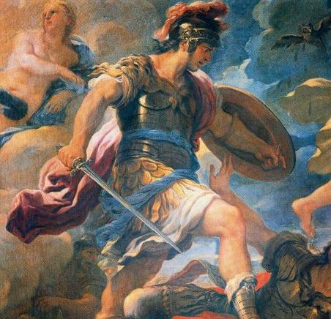
Inspirational:

Aeneas
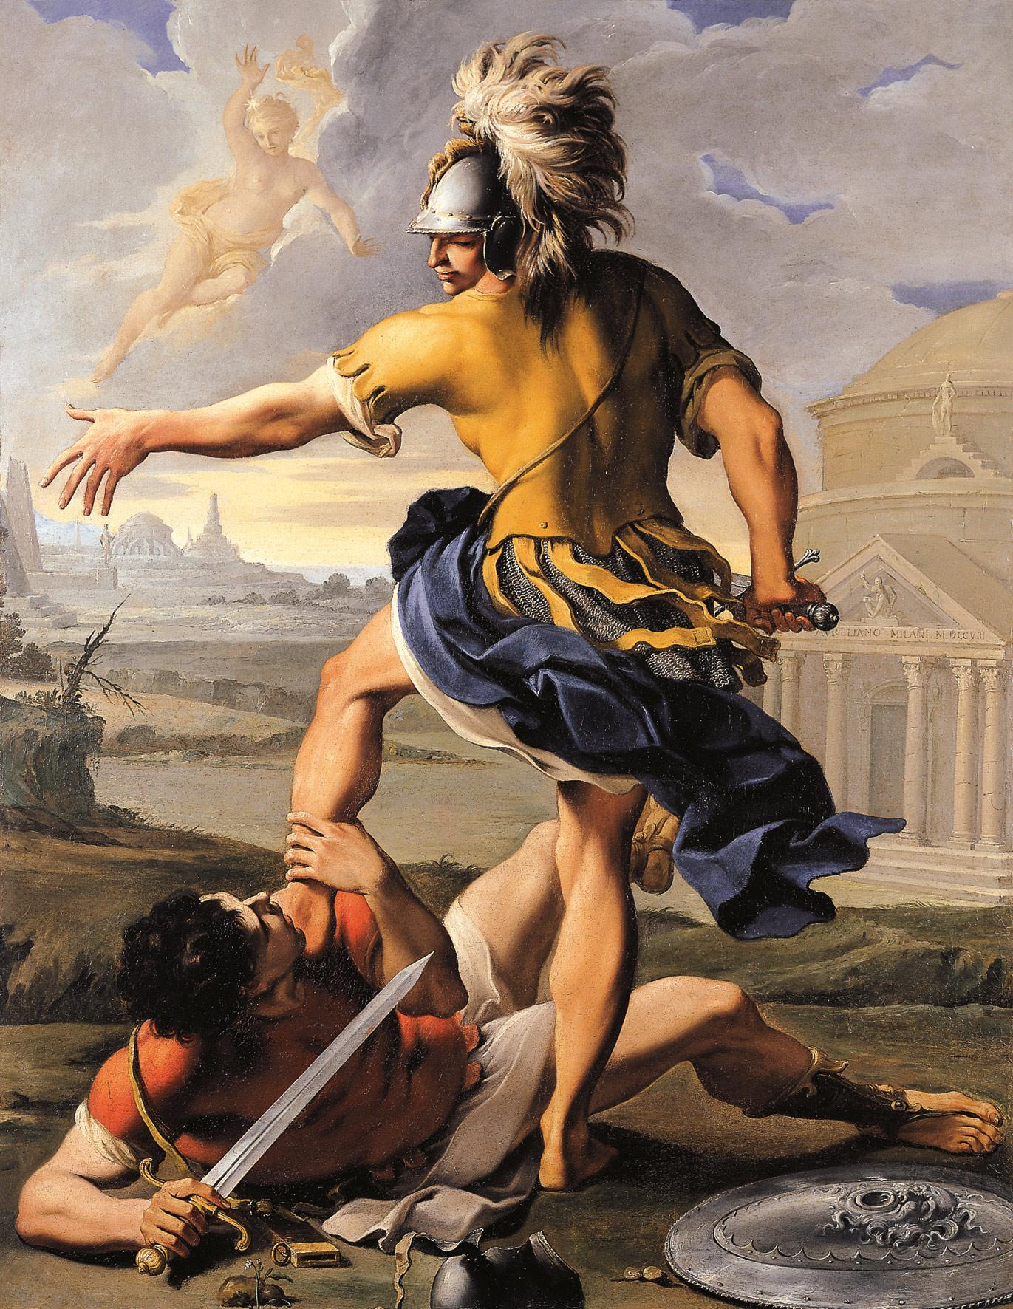
Inspirational:

Turnus

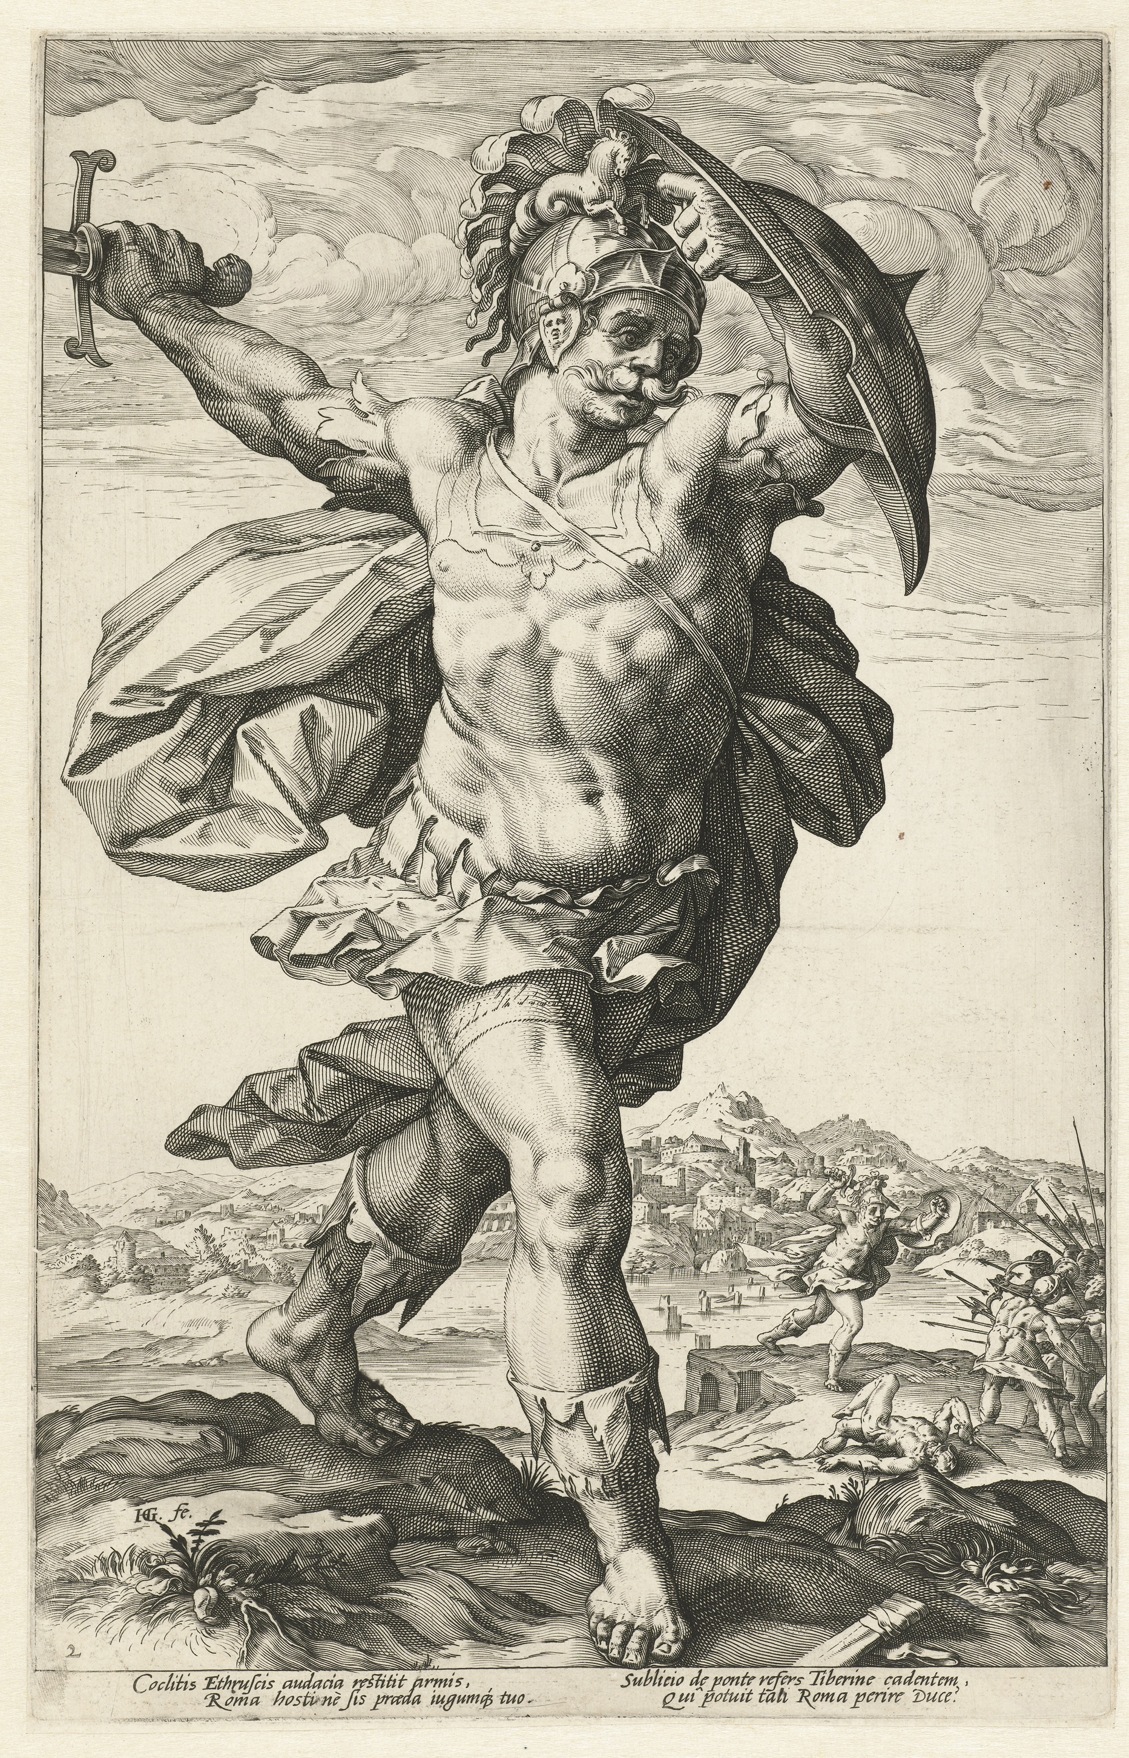
Eager:

Tarchon
What features in Turnus’ speech to his men show he has a more Roman view of heroics than a Homeric one?

Read lines 309-361
How does Virgil include typical aspects of a Homeric aristeia in this scene?
Component | Example(s)
Felling of a series of heroes
Role of arms emphasised

Exhortations in the middle of combat
Light wounds sustained by the hero(es)
Style | Example(s)
Visual depictions of the carnage

Mini back stories provided for opponents
Homeric simile used mid narrative

Read lines 362-438
How doe Pallas encourage the Arcadians to continue the fight?

Extension: Read Ajax’s speech in Iliad 15.733-741. How are the two speeches similar?

Annotate the picture below with all the features that occur in Pallas’ aristeia that occurred in Aeneas one:

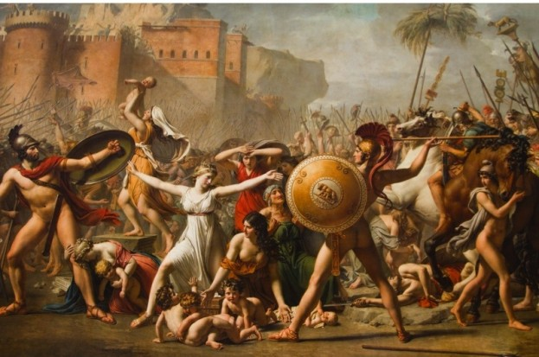

Pallas

What episode in Pallas’ aristeia tells us about the nature of Fate? What does it tell us? Of what might it be reminding us?

What parallels are drawn between Pallas and Lausus?
Pallas
Lausus

Read lines 439-509
Throughout this passage, write down all the ways Turnus gloats:

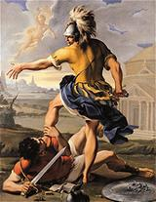

Pallas’ Spear
For what does Pallas ask Hercules?

Why is it Hercules to whom he prays?

What effect does it have?

What does Jupiter say to show Hercules Fate is unavoidable?
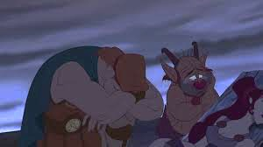

What effect does it have?
What does Turnus say before throwing his spear?
Turnus’ Spear

Pallas’ Baldric


How does Virgil foreshadow the future significance of this?

Read lines 510-606
What does Aeneas picture in his mind when he hears of Pallas’ death? Why does this send him into a frenzy?

Collect quotes to show how Aeneas is now relentless in battle:
Quote

Complete the following for the victims who attempt to supplicate Aeneas



How did Magus supplicate Aeneas?

How does Aeneas respond?

Magus

How does Virgil’s comparison of Aeneas to Aegaeon convey the hero’s speed?

How did Tarquitus supplicate Aeneas?

How does Aeneas respond?

Tarquitus


How did Liger taunt Aeneas?

How does Aeneas respond?

Lucagus

How did Liger supplicate Aeneas?

How does Aeneas respond?
Liger

Which of the following does Aeneas remind you of the most? Explain your answer with reference to events of the Iliad:
Hector Achilles Paris Odysseus

Read lines 607-634
What part of the Iliad does Juno’s argument that Turnus offered plentiful sacrifices to Jupiter recall?

What does Jupiter’s response reveal about the role of Fate?

Read lines 635-688
Extension: Read Iliad 5.449-460. How is this similar to Juno’s actions following her conversation with Jupiter?

Annotate the following to show Turnus’ perspective of the episode:

Read lines 689-783
Now begins Mezentius’ aristeia, which is the most Homeric in its betrayal and builds him up as a formidable warrior. Why does Virgil do this?

How does Virgil use the following Homeric similes to embellish his narrative?
Jutting Rock
How is Mezentius described? | Why does it suit the narrative?

Wild Boar
How is Mezentius described? | Why does it suit the narrative?
Ravening Lion
How is Mezentius described? | Why does it suit the narrative?
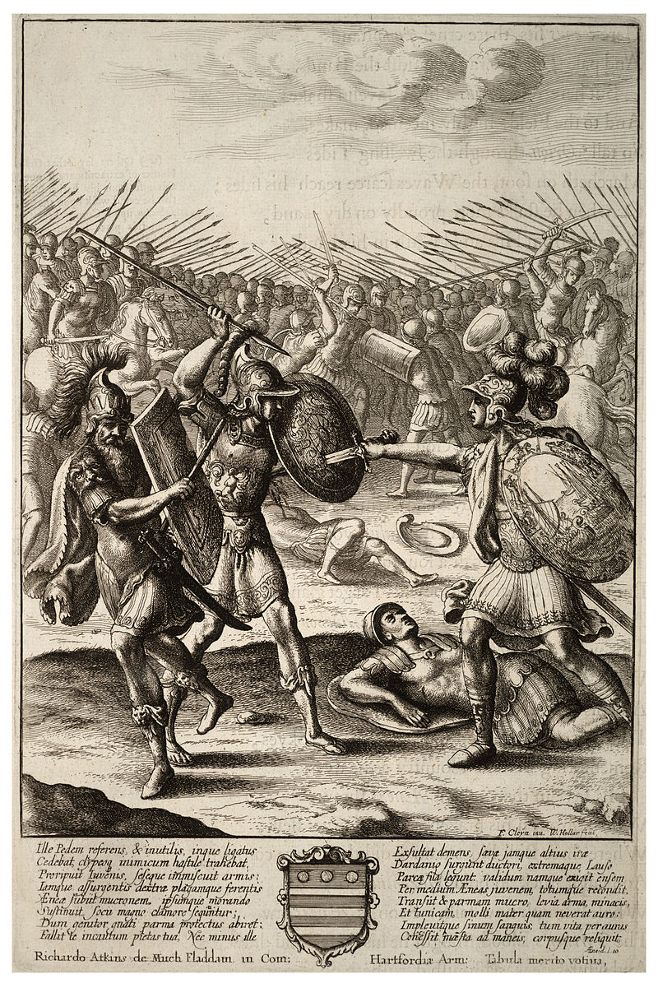

Orion
How is Mezentius described? | Why does it suit the narrative?

‘My vow is to strip the armour from that brigand’s body and clothe you with it, Lausus. My trophy over Aeneas will be my own son!’
Why might a Roman audience consider this impious?

Read lines 784-909
How can you tell Virgil is fond of Lausus? Why do you think this is?

Hail Storm
How is Aeneas described? | Why does it suit the narrative?

‘It pierced, too, the tunic his mother had woven for him with a soft thread of gold and filled the folds of it with blood.’ How does this invoke pathos for Lausus?

Contrast Turnus’ reaction to the death of Pallas with that of Aeneas to the death of Lausus:

Aeneas’ Reaction
Turnus’ Reaction

What is the significance of these lines?

Quote
‘Take your armour, that gave you so much pleasure.’
Significance

Significance

Quote
‘..his weeping comrades were carrying him back on his shield…’

The death of Mezentius has been described as ‘a masterpiece of unsentimental pathos’. What do you think this means?

How could the following parts of Mezentius’ final part in the Aeneid be described as ‘unsentimental pathos’?

Why is Aeneas’ shield important in his victory over Mezentius?
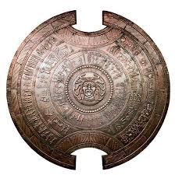

What is the significance of these lines?
Quote
‘Death holds no terrors for us and we give not a thought for the gods.’
Significance

Quote
‘One thing I ask, if the defeated can ask favours from their enemies, to let my body be buried in the earth.’
Significance

Appendix - Pallas, Lausus and the Pity of War

The Civil Wars were fresh in living memory as Virgil wrote the Aeneid. Virgil was well aware of the suffering war had inflicted upon the inhabitants of Italy. He was himself from the northern Italian town of Mantua. His earlier collection of poems, the Eclogues, preserves a love for idyllic, rural Italy. But some of his characters appear disgruntled too:

‘Some godless and ungrateful soldier will take over my carefully tended fields.’

‘See where civil strife has brought us poor citizens.’

Virgil’s Fondness for Italy
Virgil’s love of rural Italy helps appreciate why the suffering of warfare comes through in his writings.
Aspect of Virgil’s Writing | Example(s)
Origin stories behind place names | - Mound named after Palinurus explained by the Sibyl in Book 6
Descriptions of the landscape

Descriptions of the Italian peoples

Pallas and Lausus – Youth Killed before their Time
The fate of these two youths conveys Virgil’s own understanding of war’s merciless nature. Another example is Euryalus (see below). Complete the following:
Feature | Pallas | Lausus
How are they shown entering the war?

How does Virgil indicate that they are outmatched because of their youth?
How do their father’s react to the death of their sons? | See Book 11
How does Aeneas react to their deaths?

Suffering

