|  |
| --- |
| Name: _______________________________________________ |
|  |
|  |
|  |
|  |
| **Atherosclerosis and CHD** |
|  |
| **Date:** |
|  |
|  |
|  |
|  |
| **Time:** 35 minutes |
|  |
| **Total marks available:** 32 |
|  |
| **Total marks achieved:** ______ |
|  |
|  |
|  |
|  |
|  |
|  |
|  |
|  |
|  |
|  |
|  |
|  |
|  |
|  |
|  |
|  |
|  |
|  |
|  |
|  |
|  |
|  |
|  |
|  |
|  |
|  |

**Questions**

**Q1.**

Atherosclerosis is responsible for many deaths that result from cardiovascular disease (CVD).

The diagram below shows an external view of a human heart. The position of an atheroma (plaque) is shown and a region of dead heart muscle is shaded.

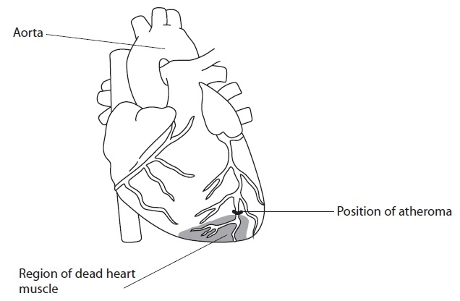

(a) (i) Explain how the structure of the aorta relates to its function.

**(3)**

.............................................................................................................................................

.............................................................................................................................................

.............................................................................................................................................

.............................................................................................................................................

.............................................................................................................................................

.............................................................................................................................................

.............................................................................................................................................

.............................................................................................................................................

(ii) Describe **two** differences between the structure of a capillary and the structure of a vein.

**(2)**

1

.............................................................................................................................................

.............................................................................................................................................

.............................................................................................................................................

2

.............................................................................................................................................

.............................................................................................................................................

.............................................................................................................................................

(b) (i) Suggest how the location of the atheroma results in the position and size of this region of dead heart muscle.

**(3)**

.............................................................................................................................................

.............................................................................................................................................

.............................................................................................................................................

.............................................................................................................................................

.............................................................................................................................................

.............................................................................................................................................

.............................................................................................................................................

.............................................................................................................................................

(ii) On the diagram below, shade an area to show the position and size of dead heart muscle, if the atheroma occurred at position B.

**(2)**

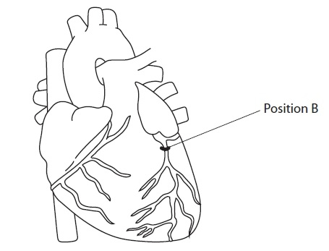

**(Total for question = 10 marks)**

**Q2.**

There is evidence for a causal relationship between blood cholesterol levels and cardiovascular disease (CVD).

(a) Explain the meaning of the term **causal relationship**.

**(1)**

.............................................................................................................................................

.............................................................................................................................................

.............................................................................................................................................

.............................................................................................................................................

.............................................................................................................................................

Lipoproteins are composed of phospholipids, cholesterol and proteins.

(i) Proteins are made up of amino acids.

Describe how amino acids join together to form the three-dimensional structure of a protein.

**(4)**

.............................................................................................................................................

.............................................................................................................................................

.............................................................................................................................................

.............................................................................................................................................

.............................................................................................................................................

.............................................................................................................................................

.............................................................................................................................................

.............................................................................................................................................

(ii) The diagrams below show part of the structure of the surface of high-density lipoprotein (HDL) and low-density lipoprotein (LDL).

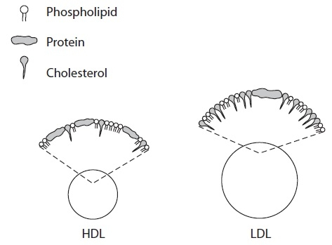

Using the information in the diagram, describe the differences between the structure of HDL and the structure of LDL.

**(2)**

.............................................................................................................................................

.............................................................................................................................................

.............................................................................................................................................

.............................................................................................................................................

.............................................................................................................................................

.............................................................................................................................................

(c) Obesity and high blood pressure are also factors that increase the risk of CVD.

The graph below shows the percentage of people with CVD who have high blood pressure or have high blood cholesterol or are obese for the period 1960 to 1990.

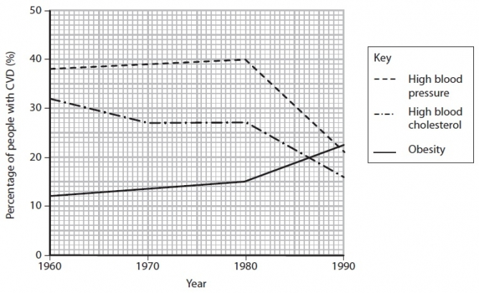

(i) Using the information in the graph, describe the overall changes that have occurred in these risk factors during this period.

**(3)**

.............................................................................................................................................

.............................................................................................................................................

.............................................................................................................................................

.............................................................................................................................................

.............................................................................................................................................

.............................................................................................................................................

.............................................................................................................................................

.............................................................................................................................................

(ii) Suggest **two** reasons for the overall change in high blood cholesterol as a risk factor.

**(2)**

1

.............................................................................................................................................

.............................................................................................................................................

.............................................................................................................................................

2

.............................................................................................................................................

.............................................................................................................................................

.............................................................................................................................................

(ii) State **two** factors, other than obesity, high blood pressure and high blood cholesterol, that increase the risk of CVD.

**(1)**

1

.............................................................................................................................................

2

.............................................................................................................................................

**(Total for question = 13 marks)**

**Q3.**

An investigation was carried out to study the effect of dietary salt on systolic blood pressure.

A group of people had the salt content of their diet changed during a 12-week period.

The people had a diet containing 8 g day−1 of salt for four weeks. Their blood pressure was then measured.

The diet was then changed to 6 g day−1 of salt for four weeks. Their blood pressure was measured again.

Finally, the diet was changed to 4 g day−1 of salt for four weeks. Their blood pressure was measured again.

The table shows the results of this investigation.

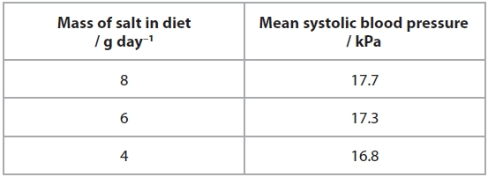

(a)  Which of the following is the best explanation of the data in the table?

**(1)**

   **A**    less salt decreases the water potential of plasma

   **B**    less salt increases the water potential of plasma

   **C**    less salt decreases the water potential of erythrocytes

   **D**    less salt increases the water potential of erythrocytes

(b)  Explain how an increase in dietary salt can lead to the development of atherosclerosis.

**(5)**

.............................................................................................................................................

.............................................................................................................................................

.............................................................................................................................................

.............................................................................................................................................

.............................................................................................................................................

.............................................................................................................................................

.............................................................................................................................................

.............................................................................................................................................

.............................................................................................................................................

.............................................................................................................................................

.............................................................................................................................................

.............................................................................................................................................

.............................................................................................................................................

**Q4.**

Over 20% of the population of the UK is classified as obese. Obesity is a significant   
risk factor in the development of cardiovascular disease (CVD).

Suggest **one** piece of medical advice that could be given to someone who does   
not have high blood pressure but who is obese.

Explain why this will help to reduce their risk of developing CVD.

**(3)**

Medical advice: .....................................................................................................................

.............................................................................................................................................

Why this will reduce the risk of developing CVD: ..................................................................

.............................................................................................................................................

.............................................................................................................................................

.............................................................................................................................................

.............................................................................................................................................

.............................................................................................................................................

.............................................................................................................................................

**Examiner's Report**

Q1.

**(a) (i)** Most candidates scored highly for this question providing good descriptions of the parts of the wall of the aorta and relating the collagen, muscle and elastic tissue to their functions. There were some candidates who just stated that the aorta was large and described its function as pumping oxygenated blood around the body and therefore failed to score many marks.

This response scored all three marks available.

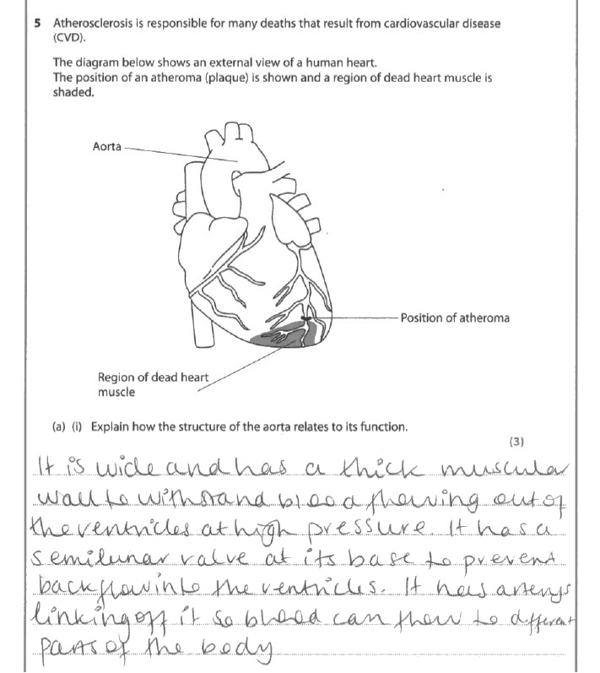

**Results Plus: Examiner Comments**

This response gained credit for the following seven points:

- the thick wall - to withstand high pressure;

- muscular wall;

- semi lunar valve - to prevent back flow;

- branching - to supply blood to different parts of the body.

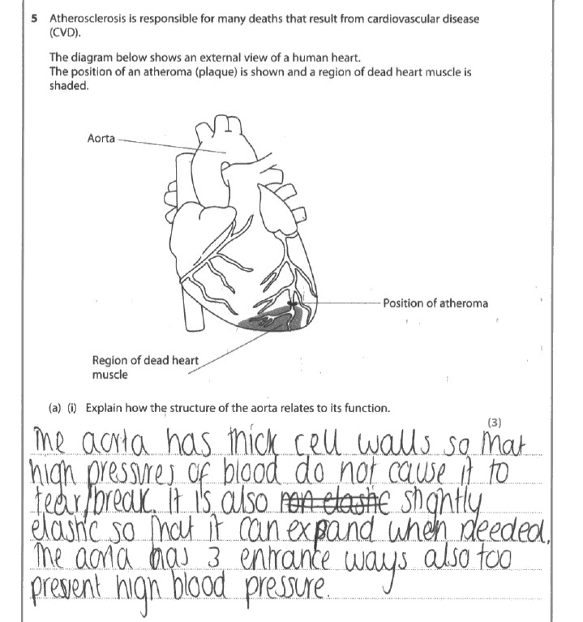

**Results Plus: Examiner Comments**

This response gained one of the three marks available. The aorta does not have a cell wall (it is not a plant of prokaryotic cell), but it did gain credit for recognising the function of a thick wall. Slightly elastic is too vague for credit and the aorta does not have three entrances so this was not credited as branching.

**Results Plus: Examiner Tip**

Be careful when you use the term 'cell wall' as it is a specific cellular structure, so if you are describing a wall as being thick or thin then refer to the number of cells e.g. the aorta has a thick wall with many cell layers.

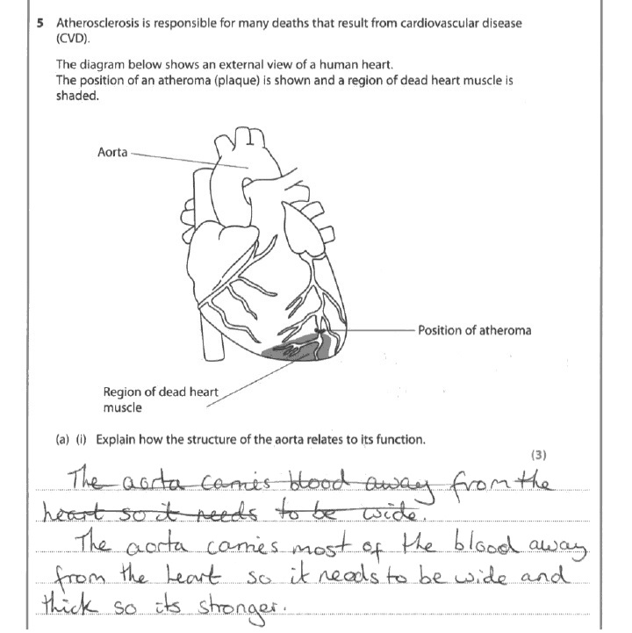

**Results Plus: Examiner Comments**

This response gained no marks. Wide is not clear enough to be credited as a large lumen. Thick does not specifically refer to the wall of the aorta, so again is not clear enough for credit.

**Results Plus: Examiner Tip**

Make sure your points are clear about what they refer to e.g. wall or lumen.

**(a) (ii)** Many candidates gained full marks here, most commonly for knowing that veins have valves and also have muscle/elastic tissue in their wall. A significant number of candidates lost a mark for just stating that capillaries are one cell thick, not making it clear whether they were referring to the wall of the lumen. Simply stating that capillaries were narrow or veins were wide is not enough for credit - at this level they should be referring to the lumen for credit.

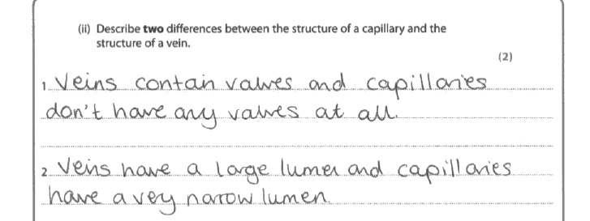

**Results Plus: Examiner Comments**

This is an example of a good response that makes two clear comparative points and therefore gained both of the available marks.

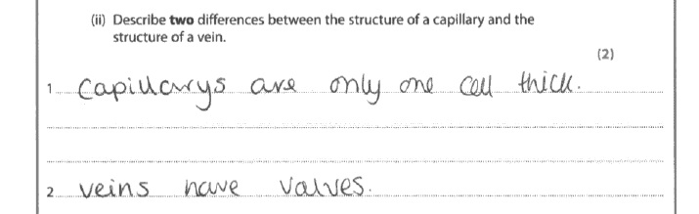

**Results Plus: Examiner Comments**

This response gained one mark for 'veins have valves'. Capillaries are only one cell thick is not enough for credit because it could refer to the thickness of the wall or the lumen.

**Results Plus: Examiner Tip**

Be specific about what is only one cell thick.

Ideally comparative answers should clearly refer to both structures being compared.

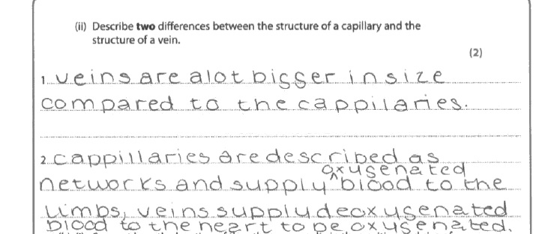

**Results Plus: Examiner Comments**

This response failed to score any marks. Veins are bigger than capillaries is too vague as it is not clear what is bigger - the wall, lumen, length?

**Results Plus: Examiner Tip**

Be specific about what you are referring to when comparing sizes e.g. the thickness of the wall or width of the lumen.

When asked to describe structures avoid describing functions instead.

**(b) (i)** Many responses to this question were long winded and vaguely presented. Many mentioned the blockage without referring to the dead heart muscle later on. Most marks were gained for recognising that the arteries supply oxygen. There were also a significant number of good descriptions of the position and size effect or where the area of dead muscle would be. Only a few candidates referred to the lack of respiration causing cell or tissue death. A small number of candidates wasted time and space with descriptions of atheroma formation, again not reading the question carefully.

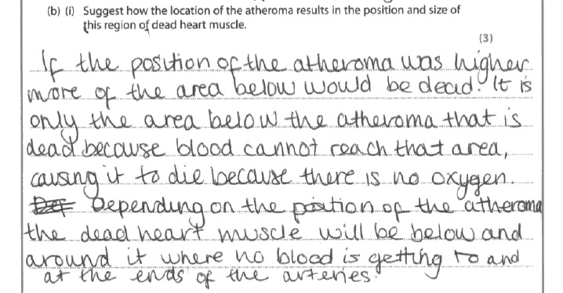

**Results Plus: Examiner Comments**

This response gained all three marks available for recognising:

- that if the atheroma was higher up more of the heart muscle would die;

- that they are affected downstream of the atheroma;

- the artery supplies the muscle with oxygen.

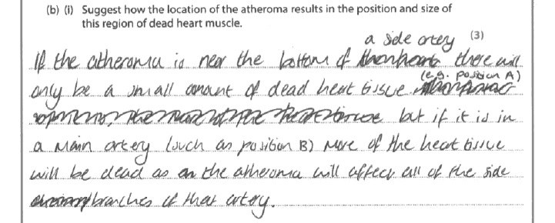

**Results Plus: Examiner Comments**

This response gained just one mark for making a very clear point about the position of the atheroma affecting the size of the dead heart tissue.

**Results Plus: Examiner Tip**

When you see the command word suggest you should explain your answer. For example, in this case you should explain why the heart muscle dies in the region affected by the atheroma.

**(b) (ii)** Over 85% of candidates managed to score both marks available for this question by managing to shade the area supplied by the affected arteries and avoiding shading above the position of the atheroma.

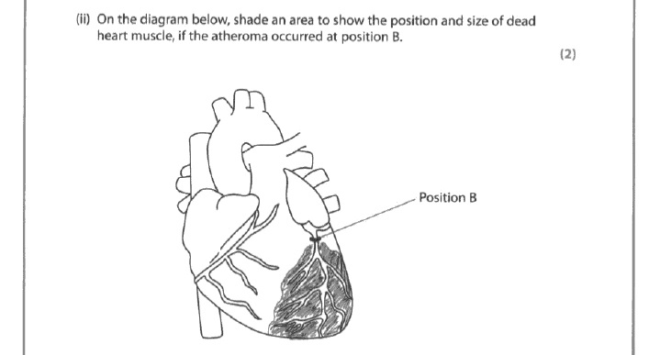

**Results Plus: Examiner Comments**

This response is typical of the majority of responses that gained both available marks.

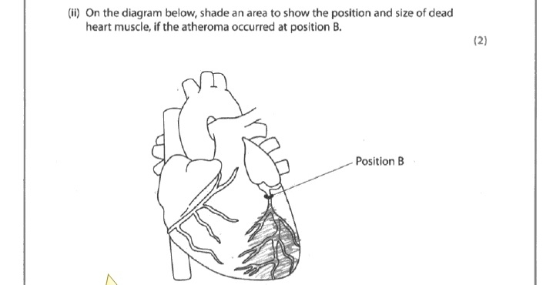

**Results Plus: Examiner Comments**

This response only gained one of the two available marks because the area shaded does not cover the ends of the blood vessels affected.

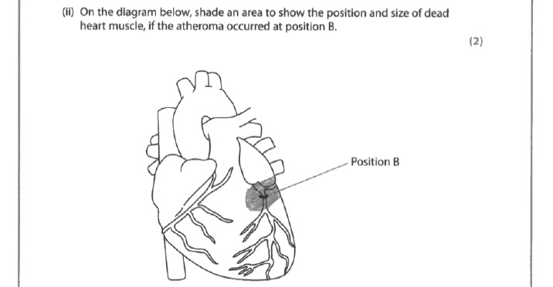

**Results Plus: Examiner Comments**

This response did not gain any marks because the area shaded does not cover all the total area of the heart supplied by the artery affected, it also extends above the atheroma suggesting that heart muscle dies upstream of the atheroma.

**Q2.**

**(a)** Many candidates gave a correct definition often stating that 'one variable causes a change in another variable'. Some candidates correctly used examples, but sadly, others did not use examples properly to bring out the idea of causation. A significant number of candidates read it as "casual relationship", another indication of candidates not reading questions carefully enough - a recurring theme. There were a significant number of candidates who did not gain the mark by simply mentioning trends, links, relationships, correlations etc.

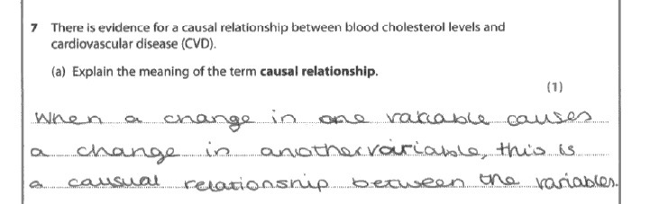

**Results Plus: Examiner Comments**

This is an example of a response that gained the mark.

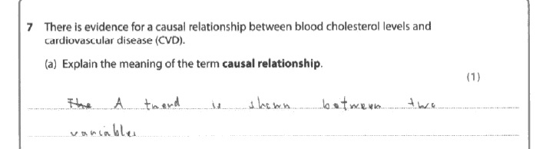

**Results Plus: Examiner Comments**

This is an example of a response that failed to gain the mark - a causal relationship is more than just a trend.

**(b) (i)** Most candidates demonstrated a good understanding of protein structure. Most gained marks for mentioning peptide bonds, providing details of the secondary structure and naming further bonds responsible for the folding of the protein. Few candidates provided specific details of where the peptide bonds form and many just mentioned primary structure without making it clear what the primary structure actually is.

This response gains all four marks available.

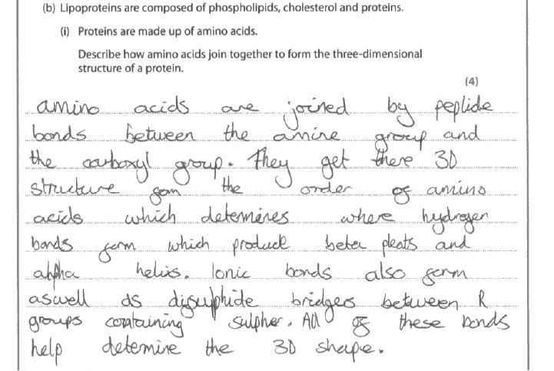

**Results Plus: Examiner Comments**

Mpt 1, 2, 5, 4 and 6 given

This response gains credit for:

- peptide bonds;

- where the peptide bond forms;

- describing the secondary structures;

- naming other bonds involved;

- recognising that bonds are formed between the R groups.

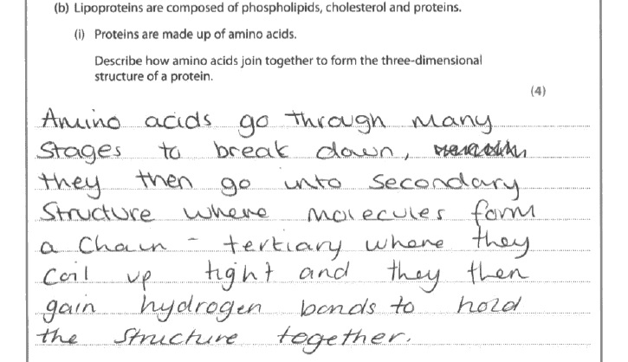

**Results Plus: Examiner Comments**

This response gains just one of the available four marks for recognising that hydrogen bonds are involved.

**Results Plus: Examiner Tip**

Just naming secondary and tertiary structure is not enough - make sure you describe what they are.

**(b) (ii)** The vast majority of candidates managed to gain both available marks for making clear comparisons between HDL and LDL. Where marks were lost it was for often just stating the number of molecules in the diagram or for comments about the surface area. Some candidates lost marks for using the words 'high' or 'low' rather than lower / higher / more / less etc. A number of candidates compared protein and cholesterol levels within either HDL or LDL rather than compare cholesterol or protein levels between HDL or LDL.

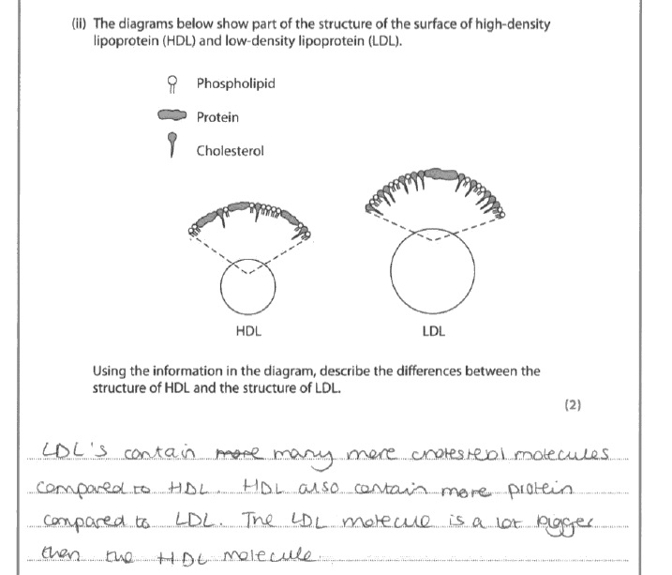

**Results Plus: Examiner Comments**

This response gained both marks having made three clear comparative comments.

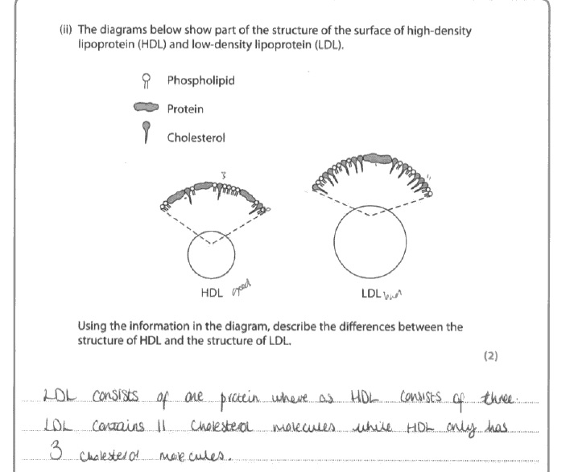

**Results Plus: Examiner Comments**

Just counting the molecules in the small part of the molecule depicted is not sufficient for the comparison so this response gained no marks.

**(c) (i)** With this question too many candidates failed to follow the instruction to describe overall changes (1960 - 1990) and only described changes between 1980 and 1990 or described changes for each decade leaving the examiner to link all the parts of their answer together. As a result many candidates did manage to pick up a couple of marks e.g. for the trend for obesity but often lost the mark for blood pressure by failing to make the overall trend clear by just describing a "steady increase" and "rapid decrease".

This response gained all three marks available.

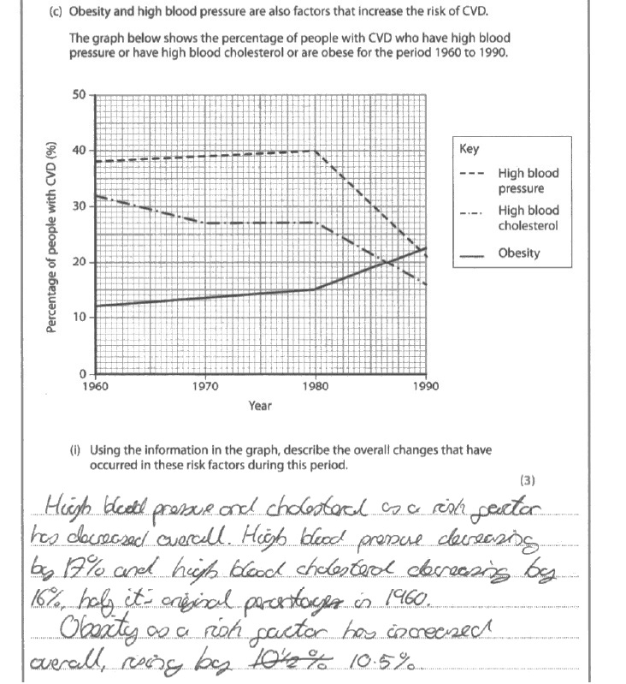

**Results Plus: Examiner Comments**

This response correctly identifies all three overall trends, also supports the trends with some correct calculations of the overall changes in the risk factors.

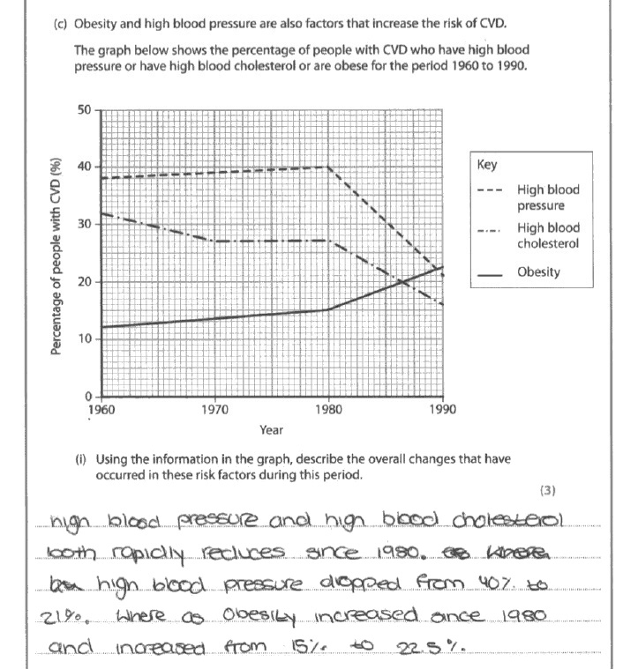

**Results Plus: Examiner Comments**

This response gained no marks because it only describes changes in the last ten years of the data rather than the total period of 1960-1990 as requested in the question.

**Results Plus: Examiner Tip**

Read the question carefully to make sure you cover the data required in your answer.

**(c) (ii)** The majority of candidates picked up one or two marks for this question. Where marks were lost, candidates vaguely referred to use of drugs to lower cholesterol, 'improving diet' or 'better medication'. A few candidates misread the question and described the effects of high cholesterol, or described ways to reduce blood pressure (such as using antihypertensives and eating less salt).

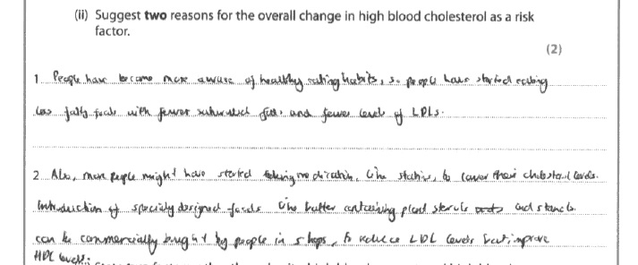

**Results Plus: Examiner Comments**

This is typical of a response that gained both marks available for identifying two clear reasons for the drop in high blood cholesterol as a risk factor.

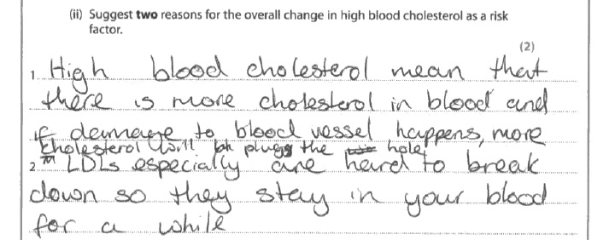

**Results Plus: Examiner Comments**

This response gained no marks because instead of suggesting why high blood cholesterol is reducing as a risk factor, it attempts to explain why blood cholesterol is a risk factor.

**Results Plus: Examiner Tip**

Read the question carefully and answer the question asked.

**(c) (iii)** Most candidates could identify two risk factors for CVD. Failure to qualify an answer was the most common reason for not gaining the mark. For example just stating age instead of increase in age or just stating gender instead of indicating which gender (i.e. male).

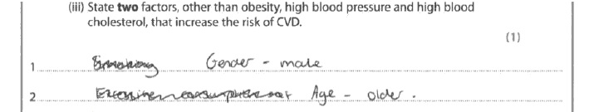

**Results Plus: Examiner Comments**

This response gained the mark because it provided suitable qualification of who is most at risk with both age and gender.

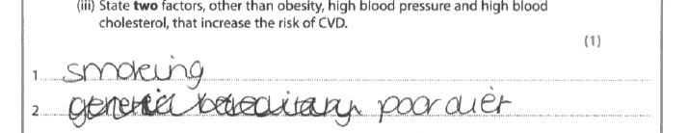

**Results Plus: Examiner Comments**

Smoking is a relevant factor, but poor diet is not specific enough so this response did not gain the mark available.

**Q3.**No Examiner's Report available for this question

**Q4.**

Many candidates chose to approach this from the exercise point of view. However, there were a number who merely stated "exercise" without qualifying this with "increased" or "regular". Often candidates did not then go on to describe the change in the balance of the energy budget although many appreciated that this would reduce weight or reduce the risk of atherosclerosis.

Other candidates chose to focus on reduced saturated fats or cholesterol in their diets. Often, however, they then failed to make it clear that this would reduce the blood cholesterol (often stating that this would lower cholesterol in the body) but usually did then appreciate that this would reduce the risk of atherosclerosis.

Some candidates merely stated that a healthier diet would be beneficial without qualifying this with anything of credit, i.e. what would be a healthier diet and what effect it would have on obesity or the risk of CVD.

Some candidates did not respond to the context of the question and discussed eating less salt or the use of beta blockers to lower blood pressure which was not accepted for credit.

This response gains all three marks available.

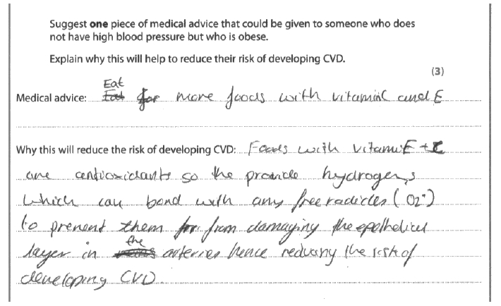

**Results Plus: Examiner Comments**

This response gains credit for providing a specific change to the diet and a clear explanation about how this will lower the risk of CVD - antioxidants and therefore reduce free radical damage.

This response gained no marks.

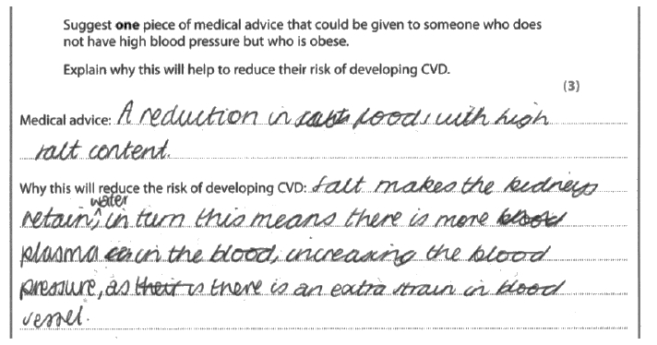

**Results Plus: Examiner Comments**

This response focuses on the reduction of salt and therefore blood pressure. The reason they have received no marks is that they have not addressed the context of the question which is obesity and specifically not high blood pressure.

**Results Plus: Examiner Tip**

Always read the context of the question carefully.

**Mark Scheme**

Q1.

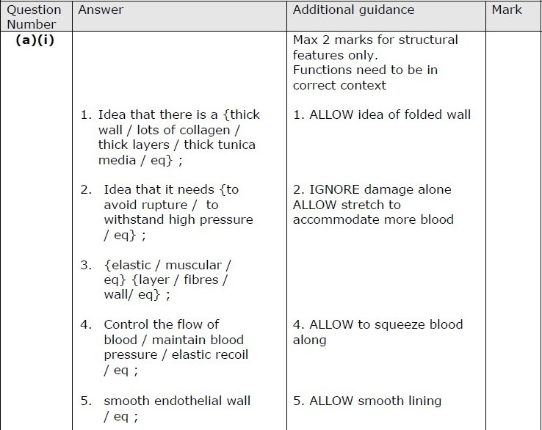

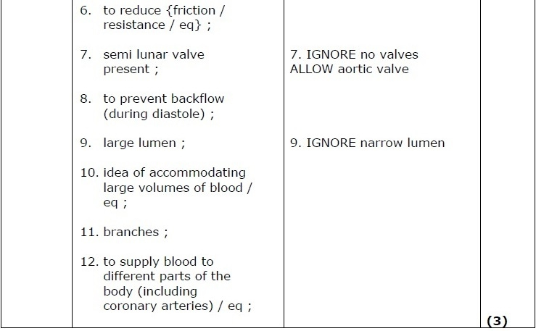

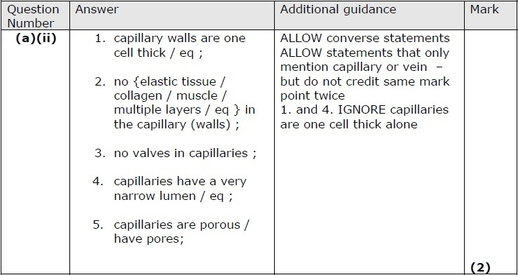

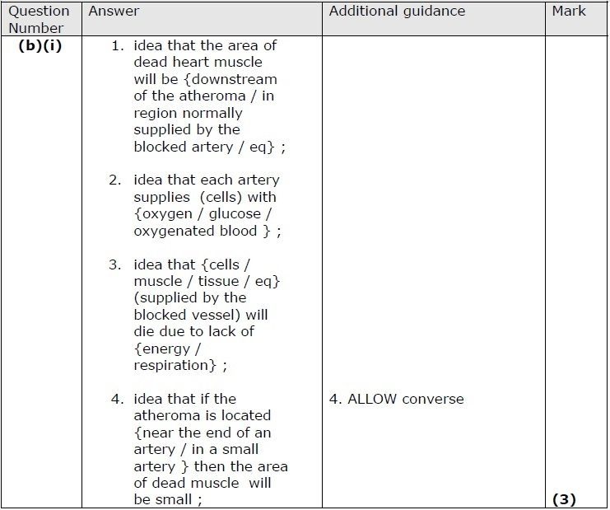

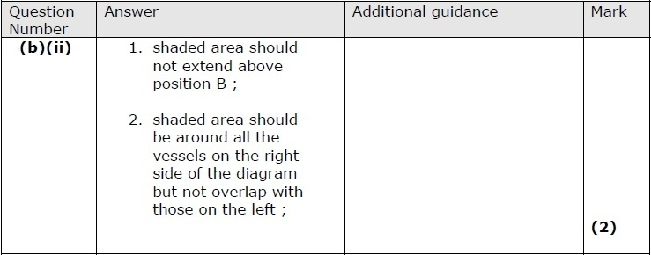

**Q2.**

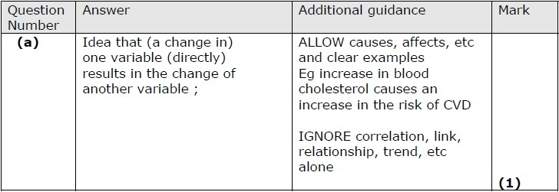

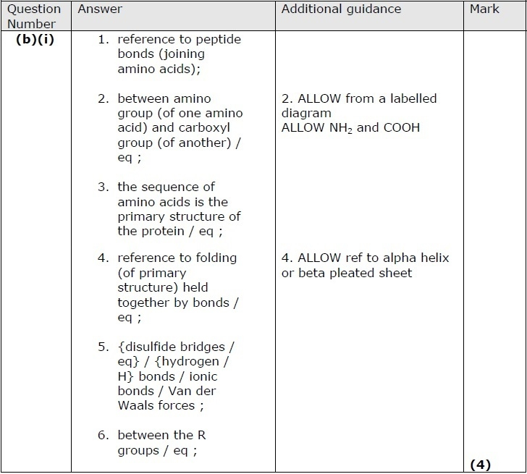

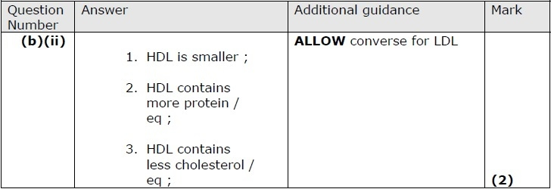

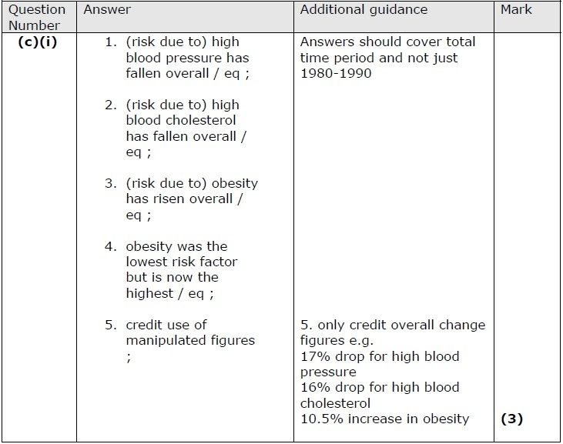

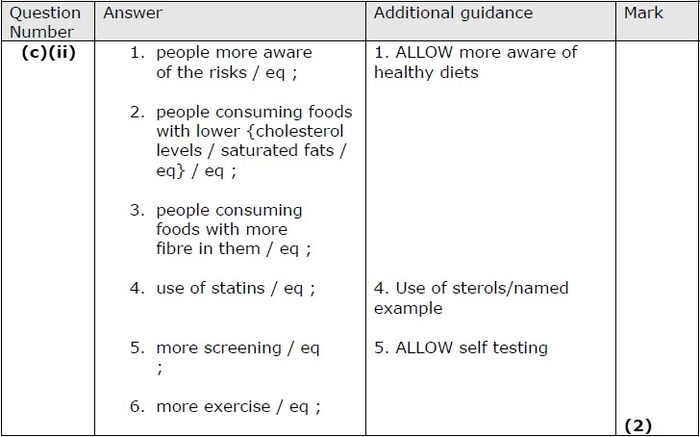

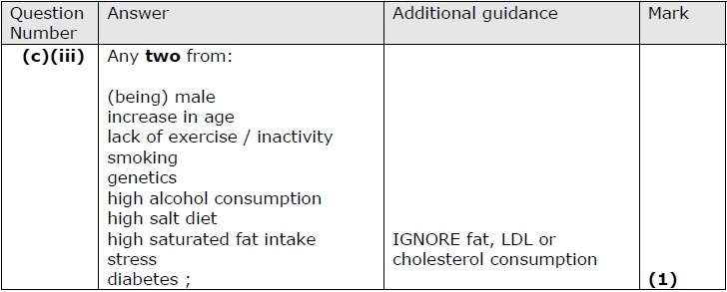

**Q3.**

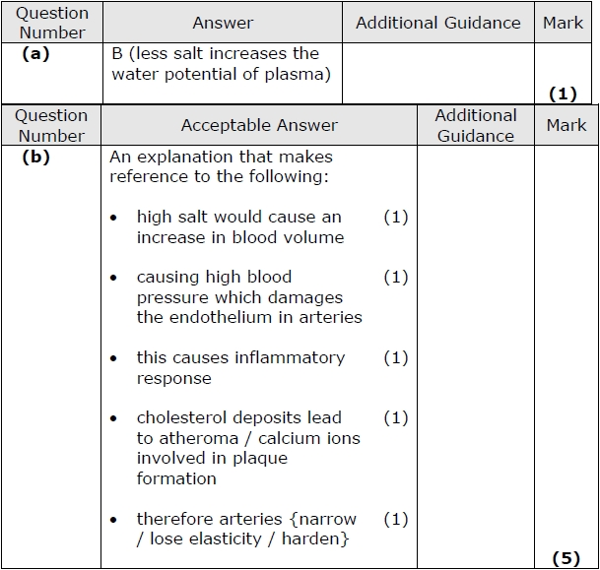

**Q4.**

