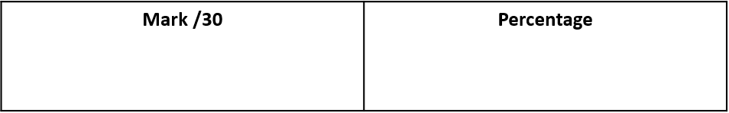

Name ……………………………………………………..

Date ……………………………..

**Energy & Cells HW**

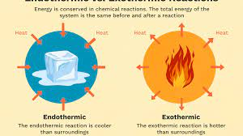

**Q1.** This question is about chemical cells and batteries.

(a)  Three different types of battery can be used to power a TV remote control.

The table below gives information about these batteries.

|  |  |  |  |
| --- | --- | --- | --- |
|  | **Zinc-carbon battery** | **Alkaline battery** | **Nickel-metal hydride battery** |
| Cost of battery in £ (pounds) | 0.17 | 0.50 | 1.50 |
| Rechargeable? | No | No | Yes |
| Time before needing to replace or recharge in months | 5 | 12 | 8 |

Give **one** advantage of each type of battery.

Zinc-carbon _________________________________________________________

___________________________________________________________________

Alkaline ____________________________________________________________

___________________________________________________________________

Nickel-metal hydride __________________________________________________

___________________________________________________________________ **(3)**

(b)  **Figure 1** shows a symbol printed on batteries.

**Figure 1**

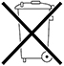

This symbol shows that batteries should not be put in household waste.

Suggest why batteries should **not** be put in household waste.

___________________________________________________________________

___________________________________________________________________ **(1)**

**Figure 2** shows a chemical cell.

**Figure 2**

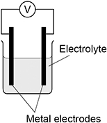

(c)  The order of reactivity of three metals is shown below.

|  |  |
| --- | --- |
| Iron | (Most reactive) |
| Tin |  |
| Copper | (Least reactive) |

Which combination of metal electrodes would give the highest voltage in the chemical cell in **Figure 2**?

Tick (**✓**) **one** box.

|  |  |
| --- | --- |
| Copper and iron |  |
| Iron and tin |  |
| Tin and copper |  |

**(1)**

(d)  The voltage produced by the cell in **Figure 2** depends on the type of electrodes and the type of electrolyte.

Suggest **one** other factor that could affect the voltage produced.

___________________________________________________________________

___________________________________________________________________

**(1)**

(e)  Water is produced in a hydrogen fuel cell.

Complete the word equation to show the reaction that produces water in a hydrogen fuel cell.

__________ + __________ → water

**(2)**

**Q2.** This question is about temperature changes.

(a)     A student investigated the temperature change when 8 g of sodium nitrate dissolves in 50 cm3 of water.

The diagram below shows the apparatus the student used.

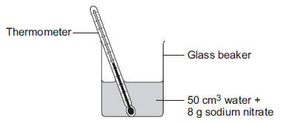

The student did the experiment five times.

**Table 1** shows the results.

|  |  |
| --- | --- |
| **Table 1** | |
| **Experiment** | **Decrease in temperature of water in °C** |
| 1 | 5.9 |
| 2 | 5.7 |
| 3 | 7.2 |
| 4 | 5.6 |
| 5 | 5.8 |

(i)      Calculate the mean decrease in temperature.

Do not use the anomalous result in your calculation.

______________________________________________________________

______________________________________________________________

Mean decrease in temperature = ___________________ °C **(2)**

(ii)     Suggest **one** change in the apparatus in the diagram above which would improve the accuracy of the results.

Give a reason for your answer.

______________________________________________________________

______________________________________________________________

______________________________________________________________

______________________________________________________________

**(2)**

(b)     The student investigated the temperature change when different masses of sodium carbonate were added to 50 cm3 of water at 20 °C.

**Table 2** below shows the results.

|  |  |
| --- | --- |
| **Table 2** | |
| **Mass of sodium carbonate in g** | **Final temperature of solution in °C** |
| 2.0 | 21.5 |
| 4.0 | 23.0 |
| 6.0 | 24.5 |
| 8.0 | 26.0 |
| 10.0 | 26.6 |
| 12.0 | 26.6 |
| 14.0 | 26.6 |

Describe the relationship between the mass of sodium carbonate added and the final temperature of the solution.

Use values from **Table 2** in your answer.

___________________________________________________________________

___________________________________________________________________

___________________________________________________________________

___________________________________________________________________

___________________________________________________________________

___________________________________________________________________ **(3)**

**Q3.** V2 rockets were used during the Second World War.

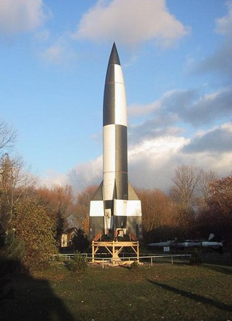

                                            By aronsson [CC BY-SA 2.0], via Flickr

V2 rockets were powered by liquid oxygen and ethanol. Oxygen and ethanol react to produce carbon dioxide and water.

The energy level diagram represents the energy changes during this reaction.

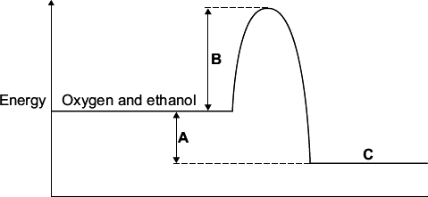

(a)     On the energy level diagram what is represented by the letter:

**A** _________________________________________________________________

**B** _________________________________________________________________

**C** _________________________________________________________________ **(3)**

(b)     What type of reaction is represented by this energy level diagram?

___________________________________________________________________

___________________________________________________________________ **(1)**

**Q4.** This question is about hydrogen and compounds of hydrogen.

**Figure 1** shows the displayed formulae for the reaction between hydrogen and chlorine.

**Figure 1**



The table below shows the bond energies.

|  |  |  |  |
| --- | --- | --- | --- |
| **Bond** |  |  |  |
| **Bond energy in kJ/mol** | 436 | 346 | 432 |

(a)  Which expression shows how to calculate the overall energy change for the reaction in **Figure 1**?

Use the table above. Tick (**✓**) **one** box.

|  |  |  |  |
| --- | --- | --- | --- |
| 436 + 346 + 432 kJ/mol |  | 436 + 346 − 432 kJ/mol |  |
| 436 + 346 + (2 × 432) kJ/mol |  | 436 + 346 − (2 × 432) kJ/mol |  |

**(1)**

The reaction between hydrogen and chlorine is exothermic.

(b)  Explain why this reaction releases energy to the surroundings.

___________________________________________________________________

___________________________________________________________________

___________________________________________________________________

___________________________________________________________________ **(2)**

(c)  **Figure 2** shows part of a reaction profile for the reaction between hydrogen and chlorine.

Complete the reaction profile in **Figure 2**.

You should:

•   label the activation energy

•   label the overall energy change.

**Figure 2**

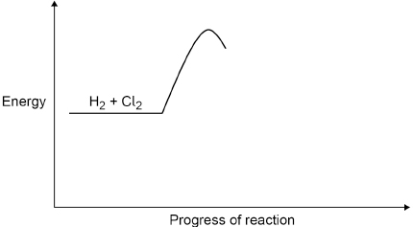

**(3)**

**Q5.** The word equation below shows a reaction used in an industrial process.

chromium oxide   +   aluminium    →    chromium   +   aluminium oxide

          The reaction is highly exothermic.

(a)     What is an exothermic reaction?

___________________________________________________________________

___________________________________________________________________ **(2)**

(b)     Name the products of this reaction.

___________________________________________________________________ **(1)**

(c)     In the reaction one substance is reduced.

(i)      Name the substance which is reduced.

______________________________________________________________ **(1)**

(ii)     What happens to the substance when it is reduced?

______________________________________________________________

______________________________________________________________ **(1)**

Mark schemes

**Q1.**

(a)  (zinc-carbon) cheap(est)

**1**

(alkaline) long(est) lasting

**1**

(nickel-metal hydride) rechargeable

*allow do not have to be thrown away*

**1**

(b)  any **one** from:

•   (metal / alkaline waste) can be toxic / harmful / corrosive

*allow (batteries) can ignite / explode*

•   (metal / alkaline waste) could cause pollution in landfill sites

•   recycling would save resources

*ignore dangerous*

**1**

(c)  copper and iron

**1**

(d)  any **one** from:

•   temperature (of electrolyte / solution)

•   concentration (of electrolyte / solution)

*ignore type of electrode / electrolyte*

*allow size / mass / length of electrode*

*allow surface area of electrode*

*allow distance between electrodes*

*allow volume of solution / electrolyte*

**1**

(e)  hydrogen

*allow H2*

**1**

oxygen

*allow O2*

**1**

**[8]**

**Q2.**

(a)     (i)      5.75 **or** 5.8

*correct answer with or without working gains* ***2*** *marks*

*correct working showing addition of any four results and division by 4 gains* ***1*** *mark*

***OR***

*6(.04) for* ***1*** *mark*

**2**

(ii)     use a polystyrene cup **or** lid

*accept insulate the beaker*

**1**

to prevent energy/heat gain

*accept to prevent energy/heat transfer*

*do* ***not*** *accept energy/heat loss*

**OR**

use a digital thermometer

*allow use a data logger*

easier to read (to 0.1°C)

**1**

(b)     (as mass increases) the final temperature increases

**1**

then stays constant

**1**

correct reference to a value above 8 g up to and including 10 g as mass when the trend changes

**1**

**[7]**

**Q3.**

(a)     A = energy / enthalpy change / difference

*allow heat change* ***or*** *∆H*

*allow energy released*

**1**

B = activation energy / EA

*allow definition of activation energy*

**1**

C = carbon dioxide and water

*accept products*

**1**

(b)     exothermic

*allow combustion / redox / oxidation*

*ignore reduction / burning*

**1**

**[4]**

**Q4.**

(a)  436 + 346 - (2 × 432) kJ/mol

**1**

(b)  energy is needed to break bonds

**and**

energy is released when bonds form

**1**

(and) the energy released is greater than the energy needed

*allow the energy transferred in bond making is greater than the energy transferred in bond breaking*

*allow 2 x 432 (kJ/mol) is greater than 436 + 346 (kJ/mol)*

*allow the overall energy change is negative*

**1**

(c)  profile completed with product energy below reactant energy

**1**

activation energy labelled from reactant energy to top of curve

**1**

overall energy change labelled from reactant energy to product energy

**1**

an answer of

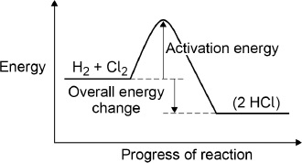

scores **3** marks

*ignore arrow heads*

**Q5.** (a)     gives out

heat

*each for 1 mark*

**2**

(b)     chromium and aluminium oxide

**1**

(c)     (i)      chromium oxide

**1**

(ii)     oxygen removed/gains electrons

**1**

**[5]**