

**Foundation IGCSE (9 – 1) Revision Pack**

**Represent and interpret data (Foundation)**

**Name --------------------------------**

**Questions**

**Q1.**

The bar chart gives information about the population, in millions, of each of five cities.

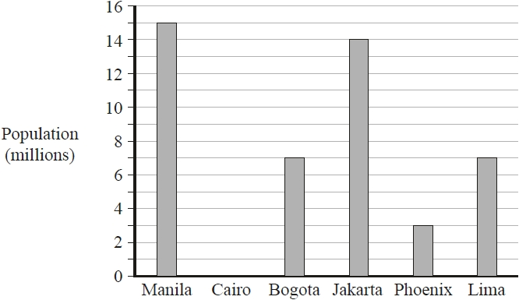

Cairo has a population of 12 million.

(a)  Draw a bar on the bar chart to show this information.

**(1)**

The populations of two cities are equal.

(b)  Write down the names of these two cities.

............................................................ and ............................................................

**(1)**

(c)  Write down the name of the city with a population of 15 million.

...........................................................

**(1)**

(d)  Work out the difference in population between Jakarta and Phoenix.

........................................................... million

**(1)**

In Manila, there are 90 badminton clubs and 60 football clubs.

(e)  Find the ratio of the number of badminton clubs to the number of football clubs.

Give your ratio in its simplest form.

...........................................................

**(2)**

**(Total for question = 6 marks)**

**Q2.**

The bar chart shows information about the weight, in millions of tonnes, of bananas produced by each of four countries in 2016

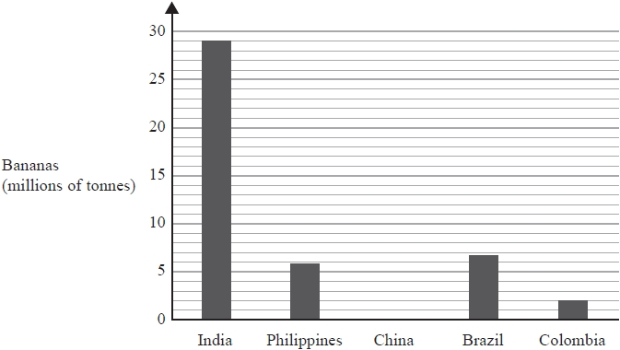

In 2016, China produced 13 million tonnes of bananas.

(a)  Draw a bar on the bar chart to show this information.

**(1)**

One of these countries produced 6.8 million tonnes of bananas in 2016

(b)  Which country?

...........................................................

**(1)**

In 2016, a total of 113 million tonnes of bananas was produced worldwide.

(c)  What fraction of the 113 million tonnes of bananas was produced in India in 2016?

...........................................................

**(2)**

**(Total for question = 4 marks)**

**Q3.**

The bar chart shows information about the number of candidates for an examination from  
 each of five countries.

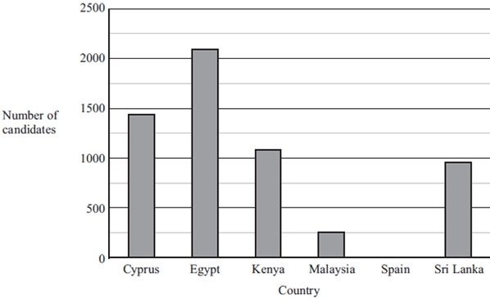

(a) Which of the five countries had the greatest number of candidates?

...........................................................

**(1)**

(b) Write down the number of candidates from Malaysia.

...........................................................

**(1)**

(c) The number of candidates from one country was 1086   
 Which country was this?

...........................................................

**(1)**

(d) The number of candidates from Spain was 727

Draw a bar on the bar chart to show this information.

**(1)**

**(Total for question = 4 marks)**

**Q4.**

The bar chart gives information about the total number of medals won by each of six countries at the 2016 Olympic Games.

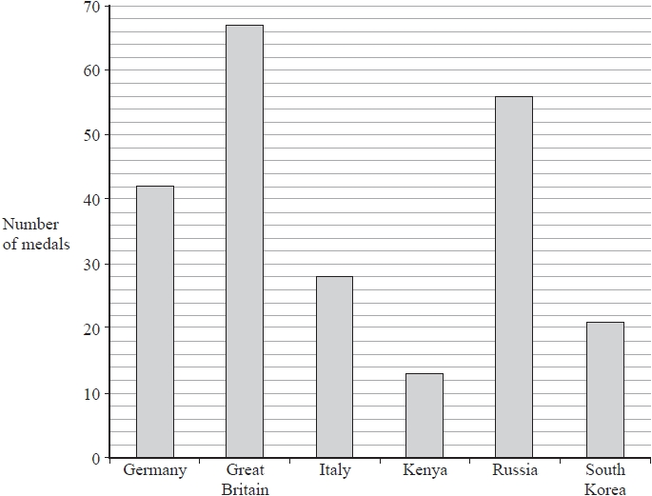

(a)  Which of these countries won the fewest total number of medals?

...........................................................

**(1)**

Great Britain won 27 gold medals.

(b)  How many of the medals won by Great Britain were **not** gold medals?

...........................................................

**(2)**

(c)  Write down the ratio of the total number of medals won by Russia to the total number of medals won by Germany.

Give your ratio in its simplest form.

...........................................................

**(2)**

The USA won

46 gold medals   
37 silver medals   
38 bronze medals

(d)  What fraction of the total number of medals won by the USA were gold medals?

...........................................................

**(2)**

**(Total for question = 7 marks)**

**Q5.**

Ben throws a dice 20 times.   
He records the score for each throw.   
Here are his scores.

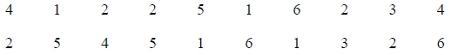

(a)  Complete the frequency table for his scores.

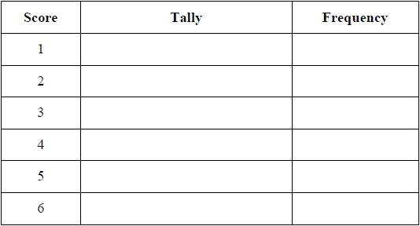

**(2)**

(b)  Write down the mode of his scores.

...........................................................

**(1)**

(c)  Find the range of his scores.

...........................................................

**(1)**

Ben throws the dice again.

(d)  Draw a circle around the word in the box that best describes the likelihood that his score will be 6.



**(1)**

**(Total for question = 5 marks)**

**Q6.**

Rayna has a fair 4-sided spinner.   
The spinner can land on 3, 5, 7 or 9

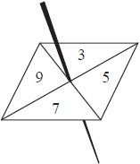

Rayna spins the spinner 20 times.   
She records the score for each spin.   
Here are her scores.



(a)  Complete the frequency table for these results.

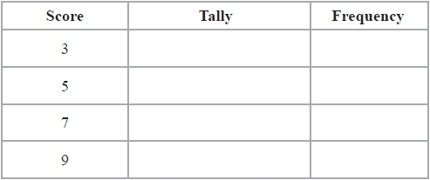

**(2)**

(b)  Write down the mode of her scores.

...........................................................

**(1)**

(c)  Find the range of her scores.

...........................................................

**(1)**

Rayna says that 3, 5, 7 and 9 are all prime numbers.

(d)  Explain why Rayna is wrong.

.............................................................................................................................................

.............................................................................................................................................

**(1)**

Rayna now spins her spinner twice.   
She adds the two numbers together to get the total.

(e)  Complete the table to show the total for each possible outcome.   
Five of the totals have been done for you.

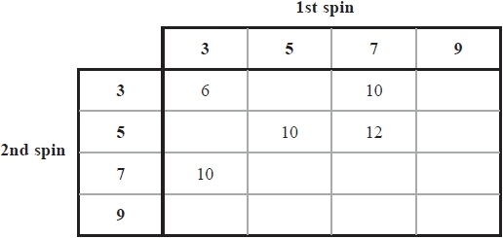

**(2)**

Rayna spins the spinner twice.

(f)  (i)  Write down the probability that she will get a total of 10

...........................................................

(ii)  Write down the probability that she will get a total greater than 12

...........................................................

**(3)**

**(Total for question = 10 marks)**

**Q7.**

The table shows the average monthly temperatures, in °C, for four months in London and in Cairo.

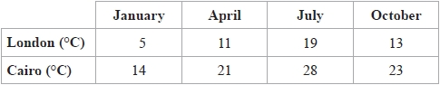

Show this information by drawing a suitable diagram on the grid below.



**(Total for question = 4 marks)**

**Q8.**

The table shows the number of goals scored for a football team by each of four players during part of a football season.

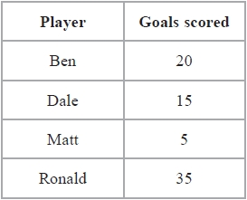

(a)  On the grid, draw a bar chart to show this information.

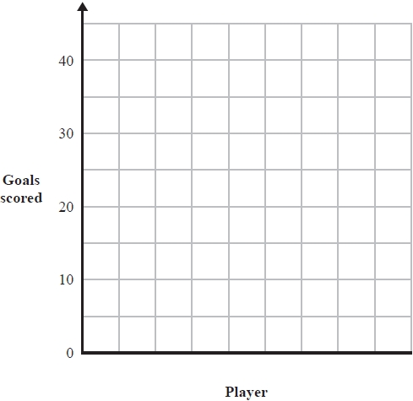

**(3)**

(b)  Work out the mean of the numbers of goals scored by these players.

...........................................................

**(2)**

(c)  Work out the range of the numbers of goals scored by these players.

...........................................................

**(2)**

(d)  Write down the ratio of the number of goals scored by Ronald to the number of goals scored by Dale.   
Give your answer in its simplest form.

...........................................................

**(2)**

**(Total for question = 9 marks)**

**Q9.**

The bar chart shows information about how some students travelled to school one day.

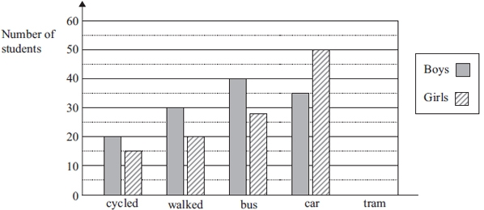

(a) Write down the number of boys who walked.

...........................................................

**(1)**

(b) Write down the number of girls who travelled by bus.

...........................................................

**(1)**

(c) 25 boys and 10 girls travelled by tram.   
Show this information on the bar chart.

**(1)**

(d) Find the ratio of the number of boys who cycled to the number of girls who cycled.   
Give your ratio in its simplest form.

...........................................................

**(2)**

**(Total for question = 5 marks)**

**Q10.**

Kim asked 40 people how many text messages they each sent on Monday.   
The table shows her results.

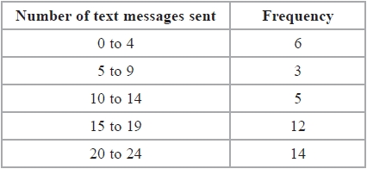

Kim is going to draw a pie chart for this information.

(a)  Work out the size of the angle on the pie chart for the sector representing 0 to 4 text messages.

...........................................................°

**(2)**

(b)  Write down the modal class.

...........................................................

**(1)**

(c)  Calculate an estimate for the mean number of text messages sent.

...........................................................

**(4)**

(d)  What percentage of these 40 people sent 20 or more text messages?

........................................................... %

**(2)**

**(Total for question = 9 marks)**

**Q11.**Jerry went on holiday to a game reserve.   
He recorded the number of each of five different types of animal he saw.

The pie chart below gives information about his results.

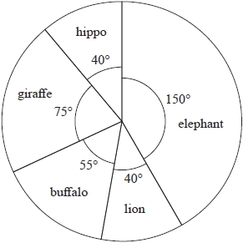

(a)  Write down the ratio of the number of elephants Jerry saw to the number of giraffes he saw.

Give your ratio in its simplest form.

**(2)**

Jerry saw 8 lions.

(b)  How many giraffes did Jerry see?

**(2)**

Lesley went on holiday to the same game reserve.   
She also recorded the number of each of five different types of animal she saw.   
The pie chart below gives information about her results.

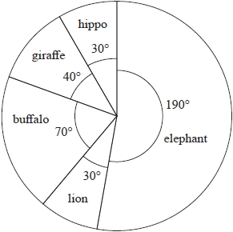

Lesley says,

"The pie charts show that I saw more elephants than Jerry saw."

(c)  Is Lesley correct?

You must give a reason for your answer.

**(1)**

**(Total for question = 5 marks)**

**Q12.**

Kwo asked 40 people where they went on holiday last year.   
He is going to draw a pie chart for his results.

16 of the 40 people said they went to Egypt.

(a)  Work out the size of the angle in the pie chart for Egypt.

........................................................... °

**(2)**

Tiffany asked some people what type of holiday they each like the best.   
She used her results to draw this pie chart.

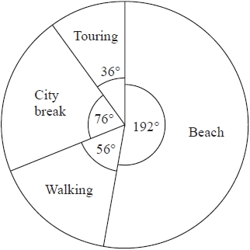

48 of the people that Tiffany asked said they like beach holidays the best.

(b)  Work out how many of the people Tiffany asked said they like walking holidays   
the best.

...........................................................

**(2)**

**(Total for question = 4 marks)**

**Q13.**

Last Thursday, 135 students each bought one item of fruit.   
The table shows information about the 135 items of fruit they bought.

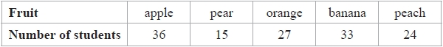

One of the 135 students is chosen at random.

(a)  Find the probability that this student bought an apple or a banana.

...........................................................

**(2)**

A pie chart is drawn for the information in the table.

(b)  Work out the size of the angle in the pie chart for oranges.

........................................................... °

**(2)**

**(Total for question = 4 marks)**

**Q14.**

The pictogram gives information about the number of rickshaws sold from a garage each   
month from January to April.

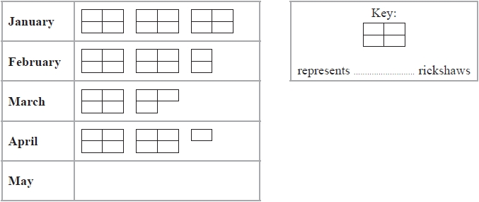

36 rickshaws were sold in January.

(a)  Complete the key.

**(1)**

(b)  How many rickshaws were sold in February?

...........................................................

**(1)**

15 rickshaws were sold in May from the garage.

(c)  Show this information on the pictogram.

**(1)**

Sandeep makes a profit of 5000 rupees on each rickshaw sold from the garage.

His target profit for January was 200 000 rupees.

(d)  Did Sandeep reach his target profit for January?   
You must show your working.

**(2)**

**(Total for question = 5 marks)**

**Q15.**

**Write your answers in the spaces provided.**

**You must write down all the stages in your working.**

The pictogram shows some information about the number of books read by Theodore during each of five weeks.

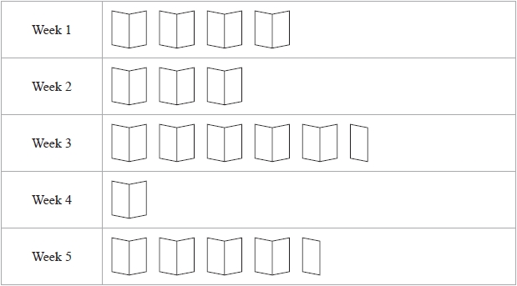

(a)  During which week did Theodore read the greatest number of books?

Week

**(1)**

Theodore read 16 books during Week 1

(b)  (i)  How many books does represent?



(ii)  How many books did Theodore read during Week 2?

(iii)  How many books did Theodore read during Week 5?

**(3)**

**(Total for question = 4 marks)**

**Q16.**

240 people were asked why they had come to Dubai.   
The pie chart gives information about their answers.

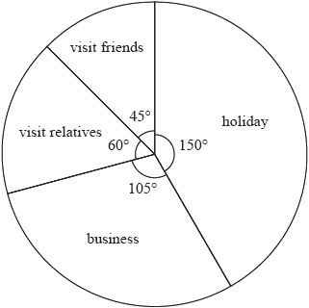

(a)  How many of these people had come to Dubai on business?

...........................................................

**(2)**

Tavish asked 300 people at an airport in Sri Lanka why they had come to Sri Lanka.   
He is going to draw a pie chart for his results.

120 of the 300 people said that they had come to Sri Lanka for a holiday.   
Tavish draws a sector on his pie chart for this information.

(b)  Work out the size of the angle of this sector.

........................................................... °

**(2)**

**(Total for question = 4 marks)**

**Q17.**

The pictogram shows information about the number of goals scored by each of five netball teams on Saturday.

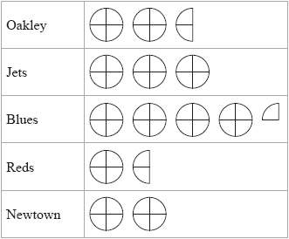

(a)  Which team scored the greatest number of goals on Saturday?

...........................................................

**(1)**

On Saturday, the number of goals scored by one of the teams was twice the number of goals scored by Reds.

(b)  Which team?

...........................................................

**(1)**

Newtown scored 8 goals on Saturday

(c)  (i)  How many goals did Jets score on Saturday?

...........................................................

(ii)  How many goals did Oakley score on Saturday?

...........................................................

**(3)**

**(Total for question = 5 marks)**

**Q18.**

The pictogram shows information about the number of goals scored by each of five hockey teams in March.

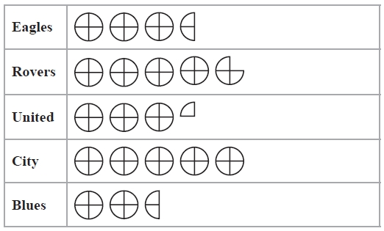

The total number of goals scored in March by the five hockey teams was 152

How many goals did City score in March?

...........................................................

**(Total for question = 4 marks)**

**Q19.**

The pictogram gives information about the number of medals won by each of five countries in the 2014 Commonwealth Games.

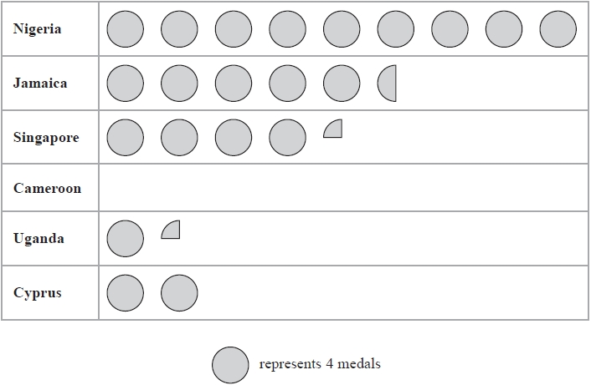

(a)  How many medals were won by Nigeria?

...........................................................

**(1)**

Jamaica won more medals than Cyprus.

(b)   How many more?

...........................................................

**(2)**

Cameroon won 7 medals in the 2014 Commonwealth Games.

(c)  Show this information on the pictogram.

**(1)**

**(Total for question = 4 marks)**

**Q20.**

The bar chart shows information about the population of each of five countries in 2013

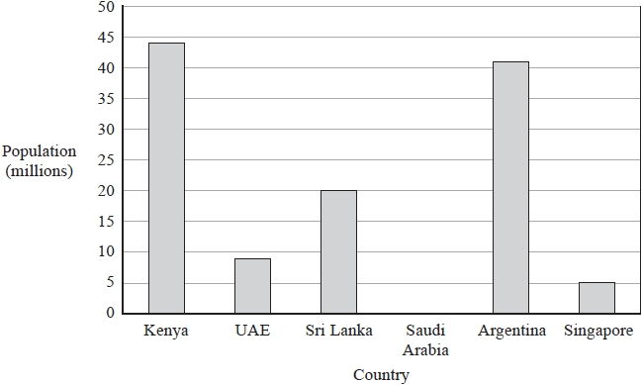

(a)  Write down the population of Sri Lanka.

........................................................... million

**(1)**

(b)  Write down the population of the UAE.

........................................................... million

**(1)**

(c)  Which country had a population of 41 million?

...........................................................

**(1)**

Suki says,



"In 2013, the population of Singapore was of the population of Sri Lanka."

(d)  Is Suki correct?   
       You must give a reason for your answer.

.............................................................................................................................................

.............................................................................................................................................

**(1)**

In 2013, the population of Saudi Arabia was 29 million.

(e)  Draw a bar on the bar chart to show this information.

**(1)**

In 2013, the ratio of the population of India to the population of the UK, in millions, was 1252:64

(f)  Write the ratio 1252:64 in its simplest form.

...........................................................

**(2)**

**(Total for question = 7 marks)**

**Q21.**

Students at a college were asked to choose their favourite sport from cricket, football, hockey, basketball and rugby.   
The bar chart shows some information about their answers.

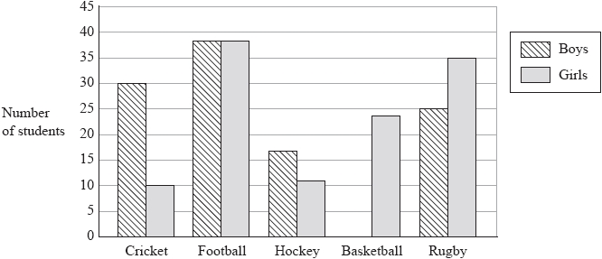

(a)  Which sport was chosen by the same number of boys as girls?

...........................................................

**(1)**

More boys than girls chose cricket as their favourite sport.

(b)  How many more?

...........................................................

**(1)**

40 boys chose basketball as their favourite sport.

(c)  Show this information on the bar chart.

**(1)**

(d)  Find the ratio of the number of boys who chose rugby to the number of girls who chose rugby.

Give your ratio in its simplest form.

...........................................................

**(2)**

**(Total for question = 5 marks)**

**Q22.**

The bar chart gives information about the weight of tomatoes, in millions of tonnes, grown in five countries in 2012

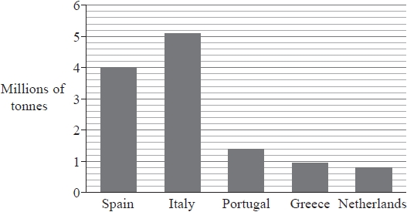

The weight of tomatoes grown in Spain in 2012 was greater than the weight of tomatoes grown in the Netherlands in 2012

(a)  How much greater?

...........................................................million tonnes

**(2)**

The weight of tomatoes grown in Portugal in 2012 was 1400000 tonnes.   
60% of these tomatoes were exported.

(b)  Work out 60% of 1400000

...........................................................million tonnes

**(2)**

In 2012, the weight of tomatoes grown in France was 0.6 million tonnes.

(c)  Write the weight of tomatoes grown in France as a fraction of the weight of tomatoes grown in Spain.   
Give your fraction in its simplest form.

...........................................................

**(2)**

**(Total for question = 6 marks)**

**Q23.**

The bar chart shows the number of gold medals won by each of five countries at the 2014 Winter Olympic Games.

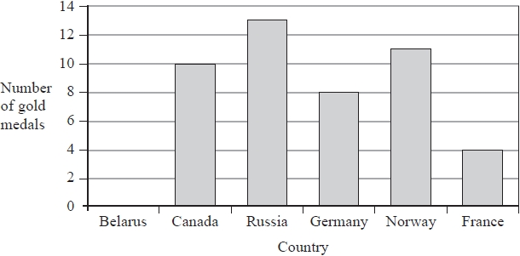

(a)  How many gold medals were won by Germany?

...........................................................

**(1)**

(b)  Which country won 11 gold medals?

...........................................................

**(1)**

Belarus won 5 gold medals.

(c)  Draw a bar on the bar chart to show this information.

**(1)**

Russia won more gold medals than Germany.

(d)  How many more?

...........................................................

**(1)**

(e)  Find the ratio of the number of gold medals won by Canada to the number of gold medals won by France.

Give your ratio in its simplest form.

...........................................................

**(2)**

**(Total for question = 6 marks)**

**Q24.**

The bar chart shows information about the number of league titles won by each of five football clubs up to 2016

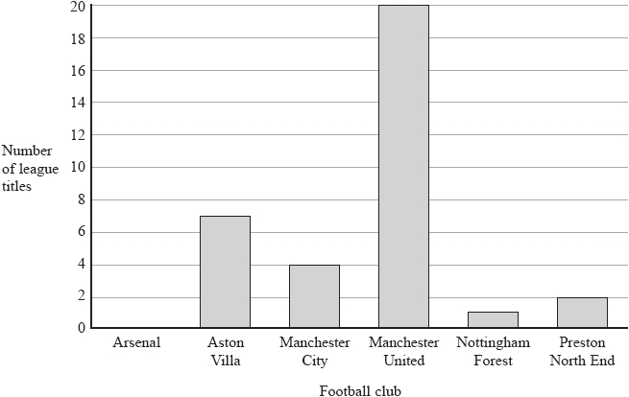

(a)  Write down the number of league titles won by Aston Villa.

...........................................................

**(1)**

Arsenal has won 13 league titles.

(b)  Draw a bar on the bar chart to show this information.

**(1)**

Alex says,

'The number of league titles won by Manchester City is of the number of league titles won by Manchester United'.



(c)  Explain why Alex is wrong.

.............................................................................................................................................

.............................................................................................................................................

**(1)**

(d)  Find the ratio of the number of league titles won by Manchester United to the number of league titles won by Preston North End.

Give your answer in its simplest form.

...........................................................

**(2)**

**(Total for question = 5 marks)**

**Q25.**

The pictogram gives information about the number of books Matilda borrowed from a library in January, in February and in March.

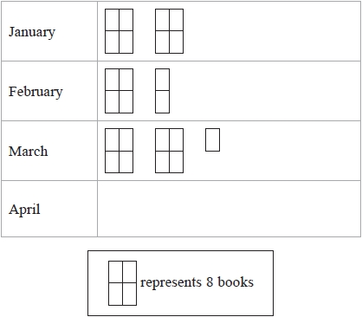

(a)  How many books did Matilda borrow from the library in January?

...........................................................

**(1)**

(b)  How many books did Matilda borrow from the library in February?

...........................................................

**(1)**

In April, Matilda borrowed 4 more books than she borrowed in March.

(c)  Show this information on the pictogram.

**(2)**

**(Total for question = 4 marks)**

**Q26.**

The bar chart shows information about the average weekly wage of top football players in five countries.

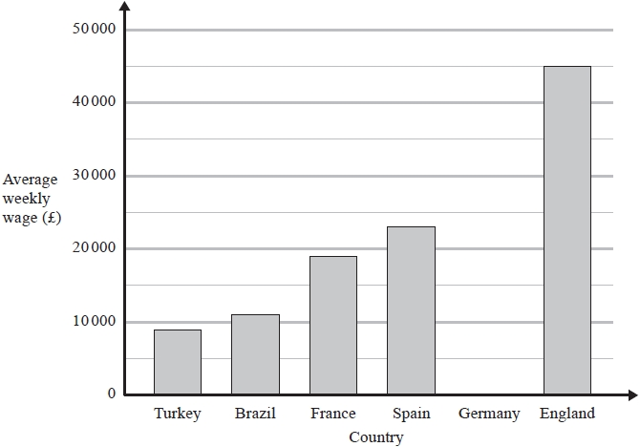

(a)  Find the average weekly wage of top football players in England.

£ ...........................................................

**(1)**

(b)  In which of these countries is the average weekly wage of top football players £19 000?

...........................................................

**(1)**

The average weekly wage of top football players in Germany is £28 000

(c)  Show this information on the bar chart.

**(1)**

The table shows the average income per year for top football clubs in each of six countries.

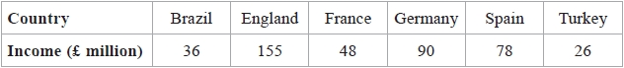

(d)  Find the range.

£ ........................................................... million

**(2)**

The table below shows information about the number of goals scored by a football club in each of its last 45 games.

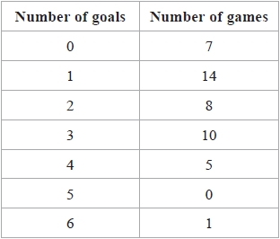

(e)  Find the median number of goals.   
       Show your working clearly.

...........................................................

**(2)**

**(Total for question = 7 marks)**

**Q27.**

The pie chart shows information about the grades achieved by all of the candidates in Keval's school who took AS Level English in 2015.

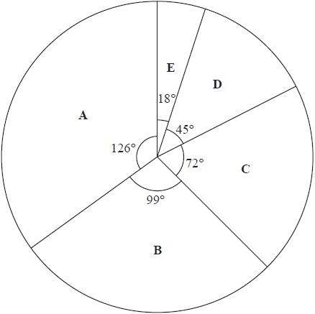

8 candidates achieved grade **C**.

(a)  Work out the number of candidates in Keval's school who took AS Level English in 2015.

...........................................................

**(2)**

(b)  Work out the number of candidates in Keval's school who achieved grade **A** in AS Level English in 2015.

...........................................................

**(2)**

**(Total for question = 4 marks)**

**Q28.**

The pie chart shows information about the typical intake of food, in grams, each week for any man living in Western Europe.

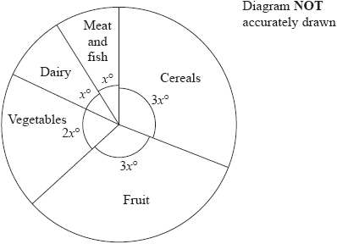

(a)  Work out the value of *x*.

...........................................................

**(3)**

The pie chart below shows information about the typical intake of food, in grams, each week for any man living in North Africa.

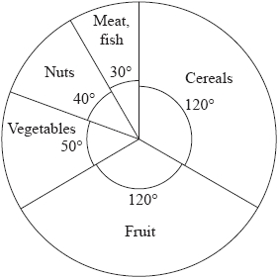

Ibrahim lives in North Africa.   
His intake of food is typical.   
One week his total intake of food was 5400 grams.

(b)  Work out his intake of nuts.

........................................................... grams

**(3)**

**(Total for question = 6 marks)**

**Q29.**

The pie chart shows information about the ages in years of the population of Bangladesh.

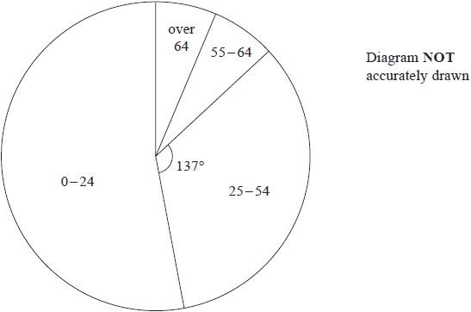

The angle in the pie chart for the 25–54 age group is 137°

(a)  Work out the percentage of the population of Bangladesh in the 25 – 54 age group.   
       Give your answer correct to 1 decimal place.

........................................................... %

**(2)**

5% of the population of Bangladesh are in the over 64 age group.

(b)  Work out the size of the angle in the pie chart for the over 64 age group.

........................................................... °

**(2)**

**(Total for question = 4 marks)**

**Q30.**

The bar chart gives information about the numbers of students in the 4 classes of Year 11 in a school.

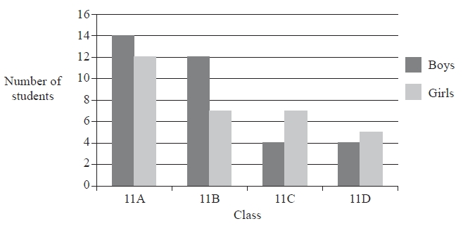

(a)  Write down the number of boys in class 11A.

...........................................................

**(1)**

There are more girls in class 11C than there are girls in class 11D.

(b)  How many more?

...........................................................

**(1)**

(c)  Work out the total number of students in Year 11

...........................................................

**(2)**

(d)  Work out what percentage of Year 11 students are in class 11A.

........................................................... %

**(2)**

**(Total for question = 6 marks)**

**Q31.**

The pie chart shows information about the use of water by people in a village in Zambia on one day.

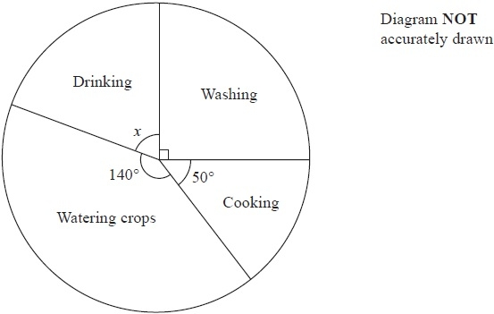

(a)  (i)  Calculate the size of angle *x*.

........................................................... °

(ii)  Explain how you found your answer.

.............................................................................................................................................

**(2)**

(b)  90 litres of water were used for cooking.   
How many litres were used for watering crops?

........................................................... litres

**(3)**

**(Total for Question is 5 marks)**

**Q32.**

Michael carried out a survey.   
He asked some students what they thought was the most important benefit of reading.   
The pie chart shows some information about their responses.

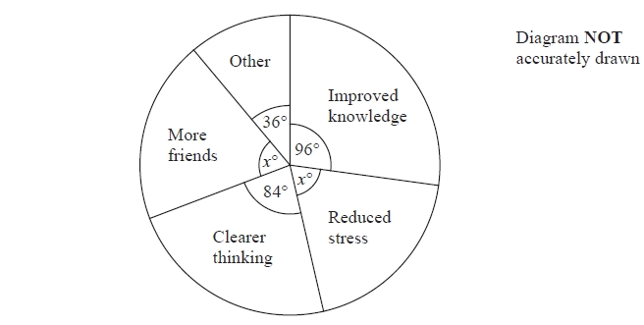

(a)   What fraction of the students gave Reduced stress as their response?

...........................................................

**(2)**

The number of students who gave Improved knowledge as their response was 48

(b)   Work out how many students were in the survey.

...........................................................

**(2)**

**(Total for Question is 4 marks)**

**Q33.**

The pie chart gives information about the amounts spent by a gas company in one year.

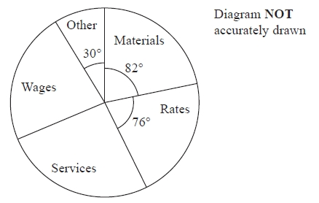

The amount spent on materials was 225.5 million euros.

The amount spent on services was the same as the amount spent on wages.

Work out the amount spent on services.

........................................................... million euros

**(Total for question = 3 marks)**

**Q34.**

The pie chart gives information about the amounts spent by a gas company in one year.

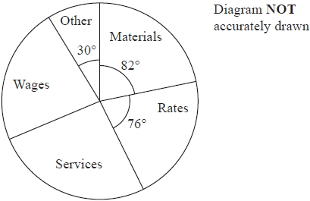

The amount spent on materials was 225.5 million euros.   
The amount spent on services was the same as the amount spent on wages.

Work out the amount spent on services.

........................................................... million euros

**(Total for question = 3 marks)**

**Q35.**

The pie chart shows information about the favourite film type chosen by each of the students at a sixth form college.

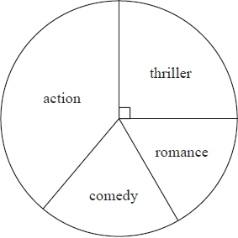

135 students chose "thriller" as their favourite film type.

(a)  Work out how many students there are at the sixth form college.

...........................................................

**(2)**

(b)  By measuring the appropriate angle, work out how many students chose "action" as their favourite film type.

...........................................................

**(3)**

**(Total for question = 5 marks)**

**Mark Scheme**

Q1.

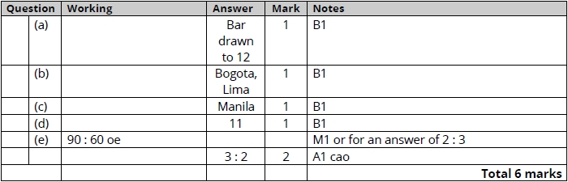

**Q2.**

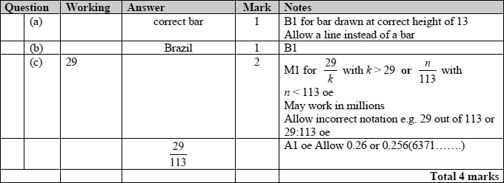

**Q3.**

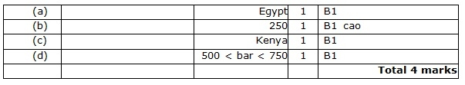

**Q4.**

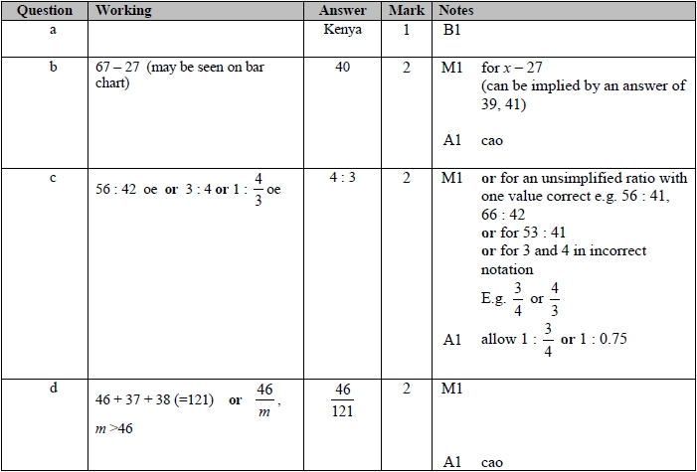

**Q5.**

The correct answer, unless clearly obtained by an incorrect method, should be taken to imply a correct method.

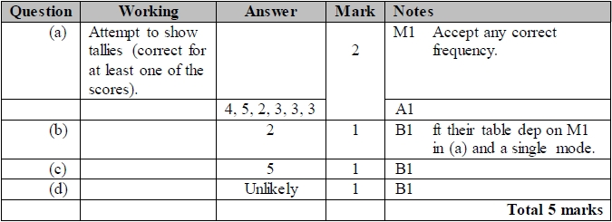

**Q6.**

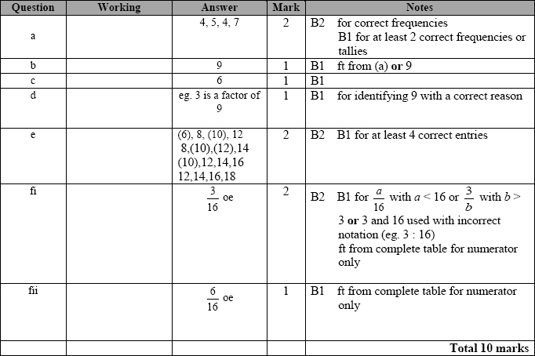

**Q7.**

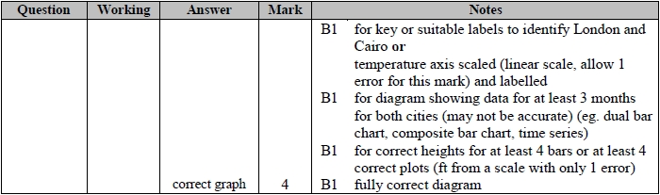

**Q8.**

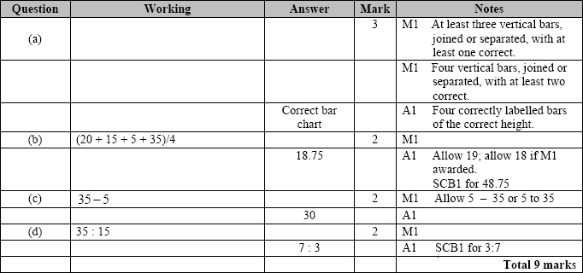

**Q9.**

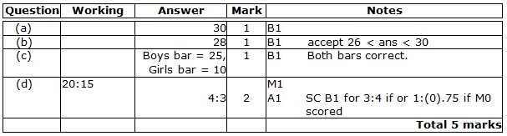

**Q10.**

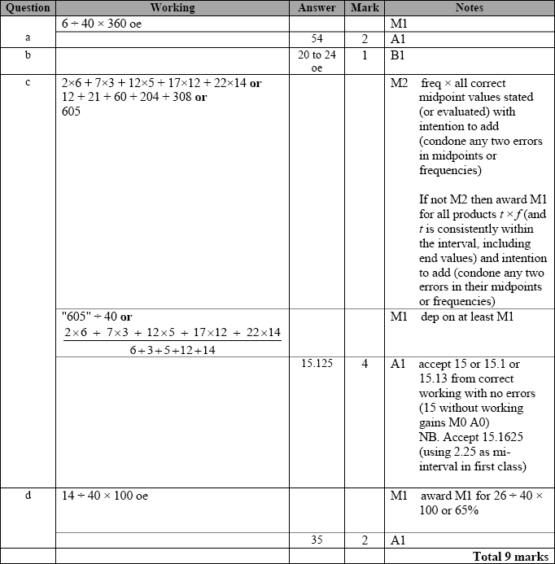

**Q11.**

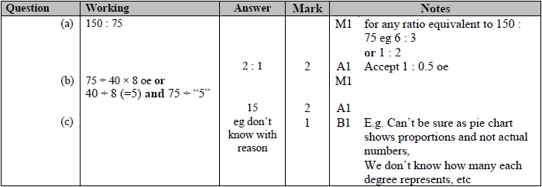

**Q12.**

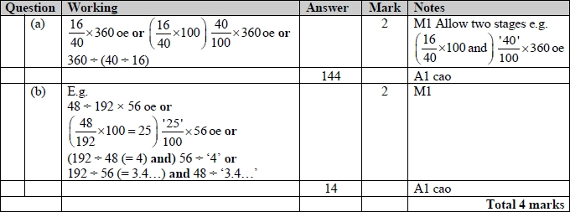

**Q13.**

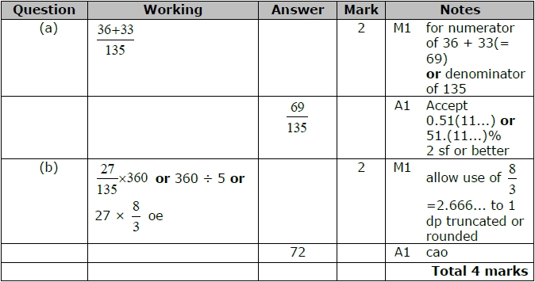

**Q14.**

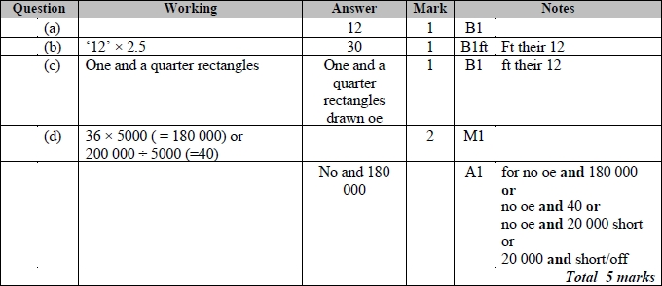

**Q15.**

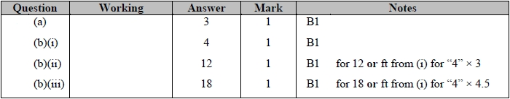

**Q16.**

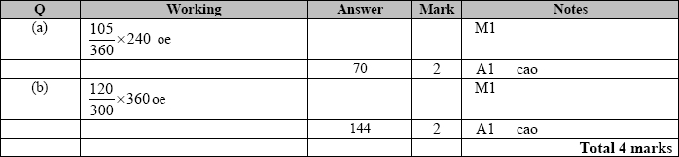

**Q17.**

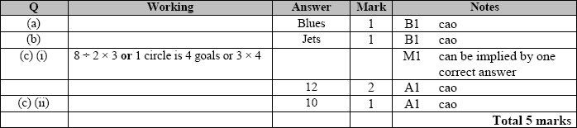

**Q18.**

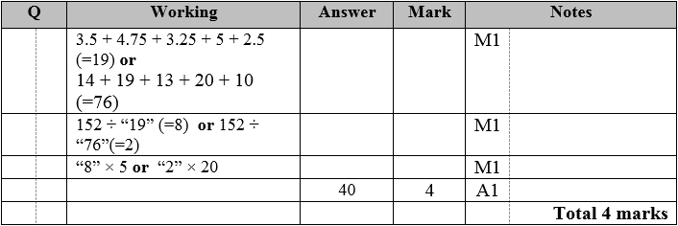

**Q19.**

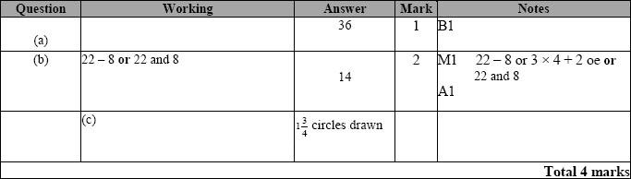

**Q20.**

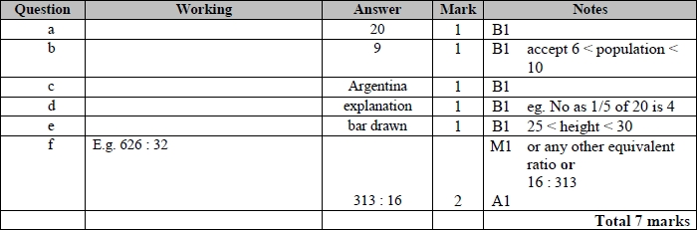

**Q21.**

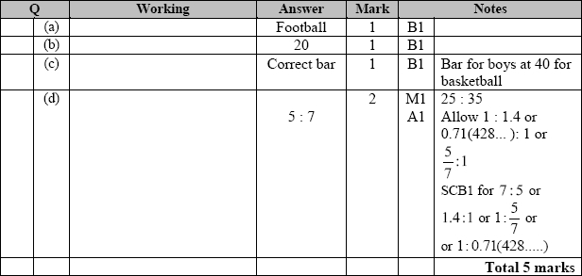

**Q22.**

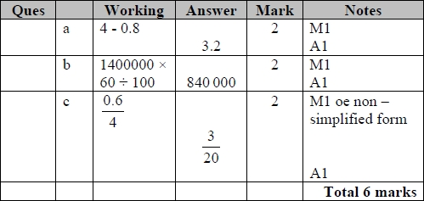

**Q23.**

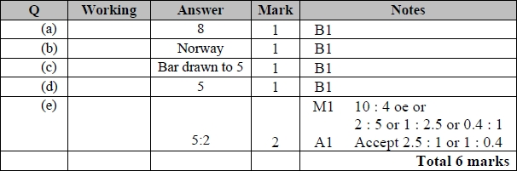

**Q24.**

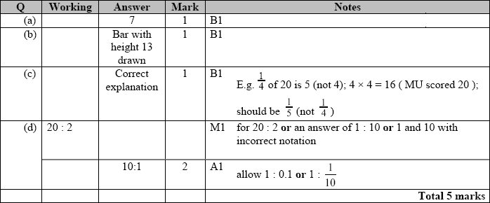

**Q25.**

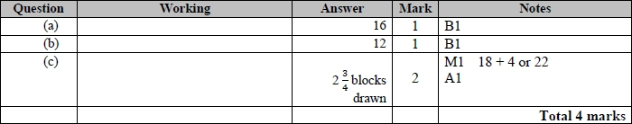

**Q26.**

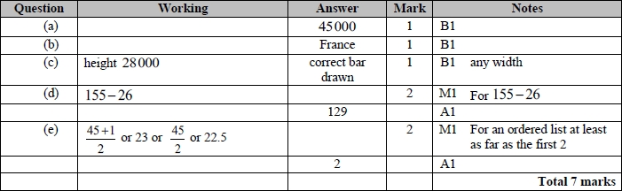

**Q27.**

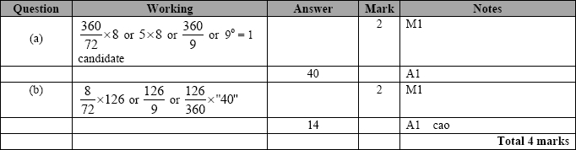

**Q28.**

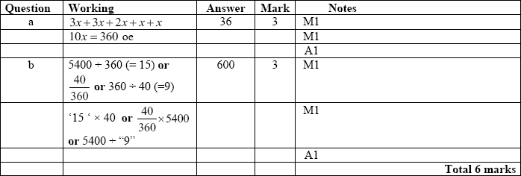

**Q29.**

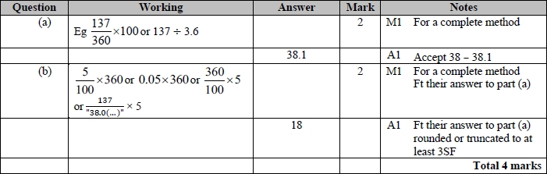

**Q30.**

For all questions, the correct answer, unless clearly obtained by an incorrect method, should be taken to imply a correct method.

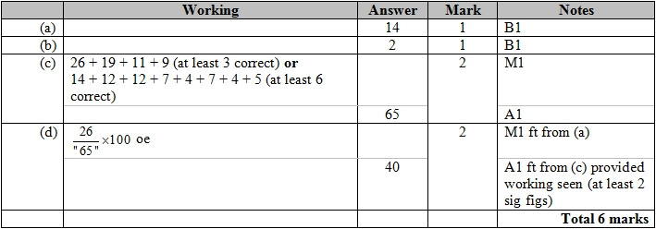

**Q31.**

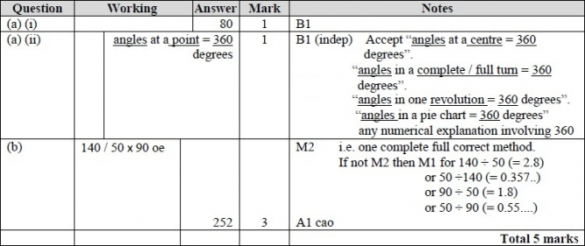

**Q32.**

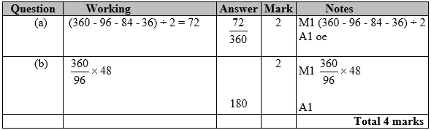

**Q33.**

For all questions, the correct answer, unless clearly obtained by an incorrect method, should be taken to imply a correct method.

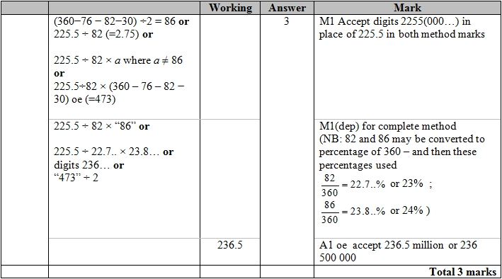

**Q34.** The correct answer, unless clearly obtained by an incorrect method, should be taken to imply a correct method.

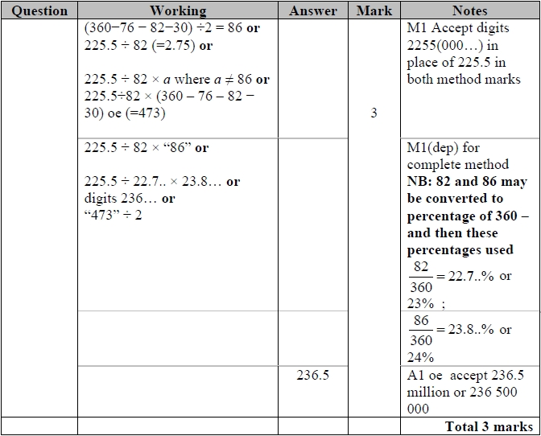

**Q35.**

