Afternoon (Time: 45 minutes)

Thursday 30March 2023

Paper 1F-2F

Paper 1F-2F

L53 March 2023 Test



**Instructions**

* Use **black** ink or ball-point pen.
  + **Fill in the boxes** at the top of this page with your name,

centre number and candidate number.

* Answer **all** questions.
* Without sufficient working, correct answers may be awarded no marks.
* Answer the questions in the spaces provided  
   *– there may be more space than you need.*
* **Calculators may be used.**
* You must **NOT** write anything on the formulae page.

Anything you write on the formulae page will gain NO credit.

**Information**

* The total mark for this paper is 100.

44.

* The marks for **each** question are shown in brackets  
   *– use this as a guide as to how much time to spend on each question.*

**Advice**

* Read each question carefully before you start to answer it.
* Check your answers if you have time at the end.

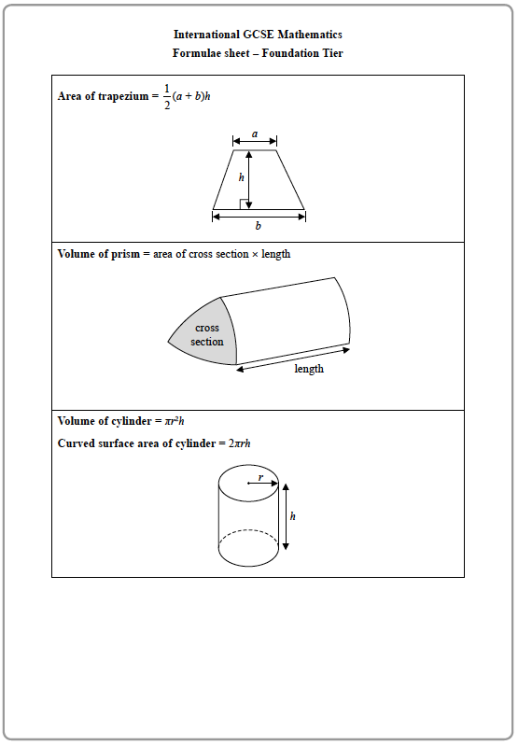

**Answer ALL TWENTY questions.**

**Write your answers in the spaces provided.**

**You must write down all the stages in your working.**

**Question 1**

**8**(*a*)Simplify 2*e* – 3*f* + 4*e* – 7*f*

.......................................................

**(2)**

(*b*)Expand and simplify 5(4*x* + 3) – (3*x* – 1)

.......................................................

**(2)**

(*c*)Factorise fully 4*p* + 6*pq*

.......................................................

**(2)**

**(Total for Question 8 is 6 marks)**

**______________________________________________________________________________**

**Question 2**

**9** *h* = 6*q* – 2*u*

(*a*)Work out the value of *h* when *q* = 3 and *u* = –5

*h* = .......................................................

**(2)**

*B* = 3*m* + 2*p*

(*b*)Work out the value of *p* when *B* = 2 and *m* = 5

*p* = .......................................................

**(2)**

**(Total for Question 9 is 4 marks)**

**______________________________________________________________________________**

**Question 3**

**12** On the grid, draw the graph of *y* = 2*x* – 3 for values of *x* from –1 to 4

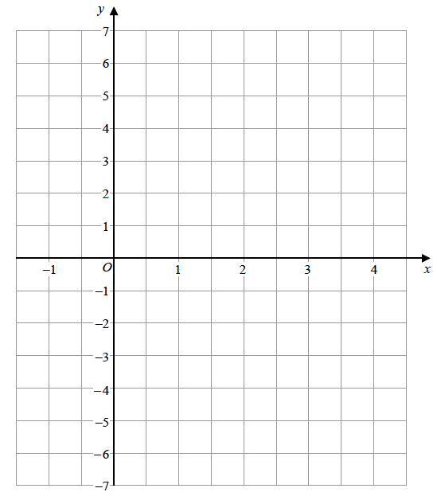

**(Total for Question 12 is 3 marks)**

**______________________________________________________________________________**

**Question 4**

**13**(*a*)Expand and simplify (*e* + 3)(*e* – 5)

.......................................................

**(2)**

(*b*)Solve *y* = 

Show clear algebraic working.

*y* = .......................................................

**(3)**

(*c*)Solve *x*2 + 3*x* – 18 = 0

Show your working clearly.

.......................................................

**(3)**

**(Total for Question 13 is 8 marks)**

**______________________________________________________________________________**

**Question 5**

**4**(*a*)Simplify 4*m* + 2*m* – *m*

.......................................................

**(1)**

(*b*)Simplify 5*p* × 7

.......................................................

**(1)**

(*c*)Solve 8*g* = 40

*g* = .......................................................

**(1)**

(*d*)Solve 19 – *k* = 4

*k* = .......................................................

**(1)**

**(Total for Question 4 is 4 marks)**

**Question 6**

**5** The table shows the average monthly temperatures, in °C, for four months in London and

in Cairo.

|  |  |  |  |  |
| --- | --- | --- | --- | --- |
|  | **January** | **April** | **July** | **October** |
| **London (°C)** | 5 | 11 | 19 | 13 |
| **Cairo (°C)** | 14 | 21 | 28 | 23 |

Show this information by drawing a suitable diagram on the grid below.



**(Total for Question 5 is 4 marks)**

**______________________________________________________________________________**

**Question 7**

**11**(*a*)Solve 5*m* + 7 = 24

*m* = .......................................................

**(2)**

(*b*)Make *t* the subject of **

.......................................................

**(2)**

(*c*)Simplify *p*8 ÷ *p*3

.......................................................

**(1)**

(*d*)Simplify *n*0

.......................................................

**(1)**

(*e*)Simplify (3*x*2*y*5)3

.......................................................

**(2)**

**(Total for Question 11 is 8 marks)**

**______________________________________________________________________________**

**Question 8**

**18** E= {1, 2, 3, 4, 5, 6, 7, 8, 9, 10, 11, 12}

*A* = {odd numbers}

*A* ∩ *B* = {1, 3}

*A* ∪ *B* = {1, 2, 3, 4, 5, 6, 7, 9, 11, 12}

Draw a Venn diagram to show this information.

|  |  |
| --- | --- |
| E |  |

**(Total for Question 18 is 4 marks)**

**Question 9**

**24** The line **L** is drawn on the grid.



Find an equation for **L**.

.......................................................

**(Total for Question 24 is 3 marks)**

**______________________________________________________________________________**

**TOTAL FOR PAPER IS 44 MARKS**

**Marking Scheme**

**Question 1**

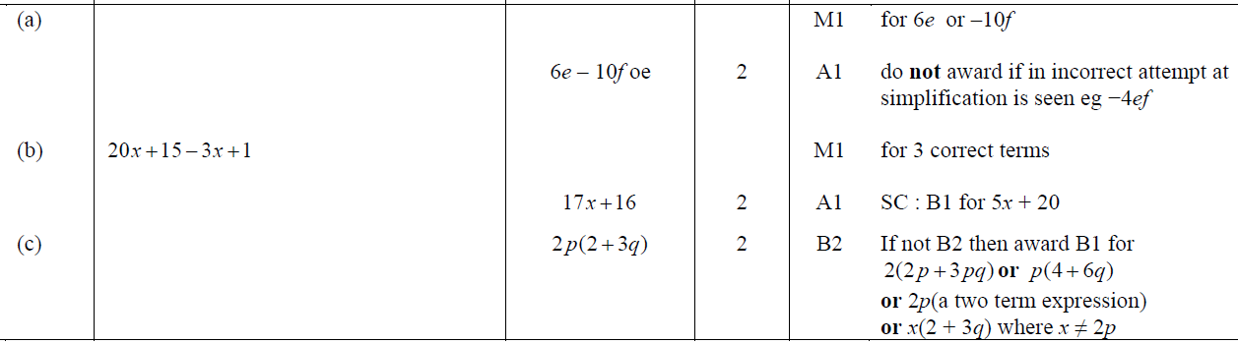

**Question 2**

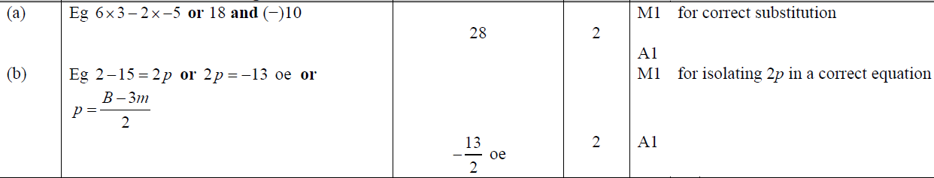

**Question 3**

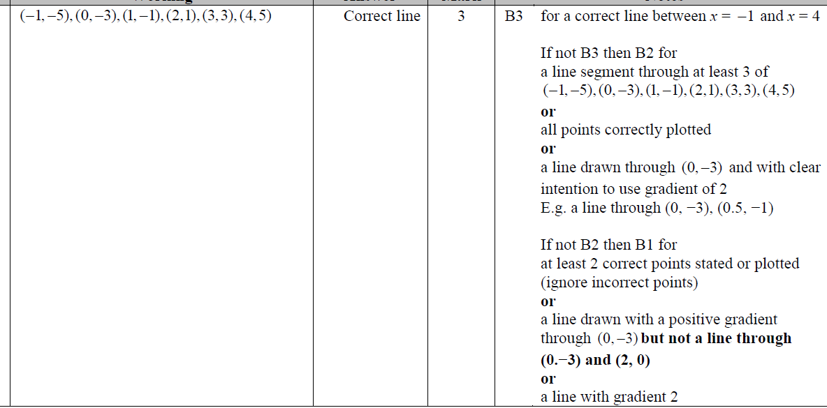

**Question 4**

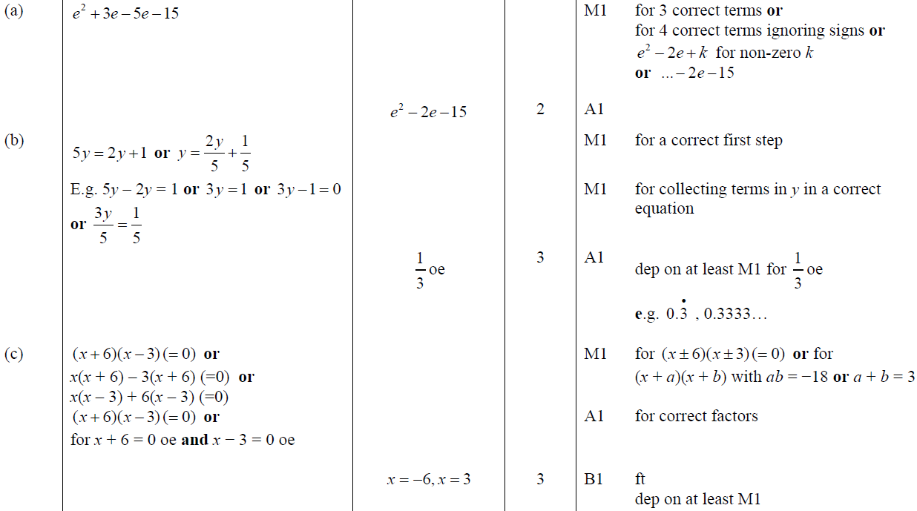

**Question 5**

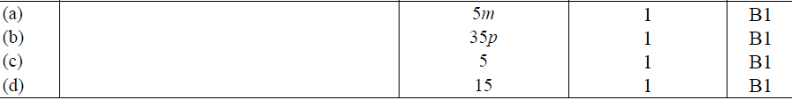

**Question 6**

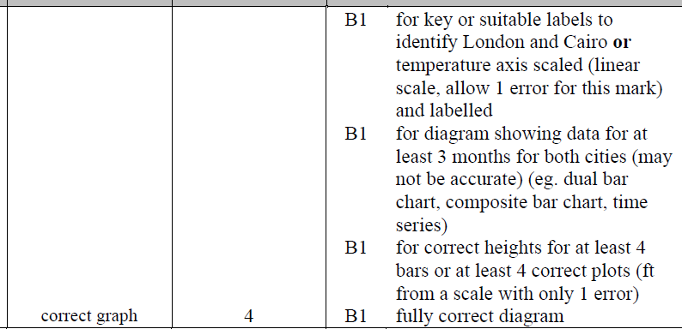

**Question 7**

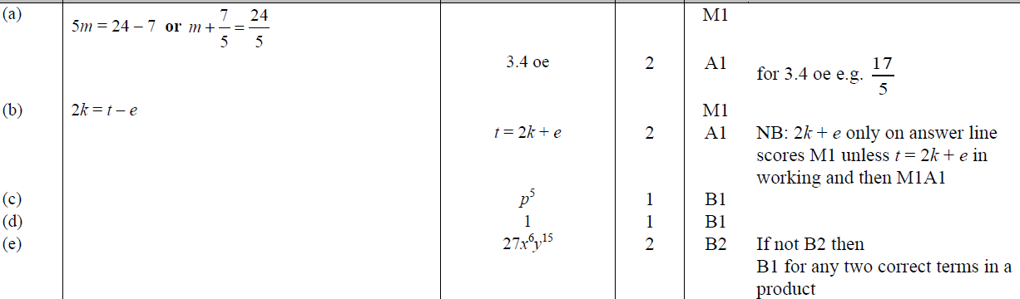

**Question 8**

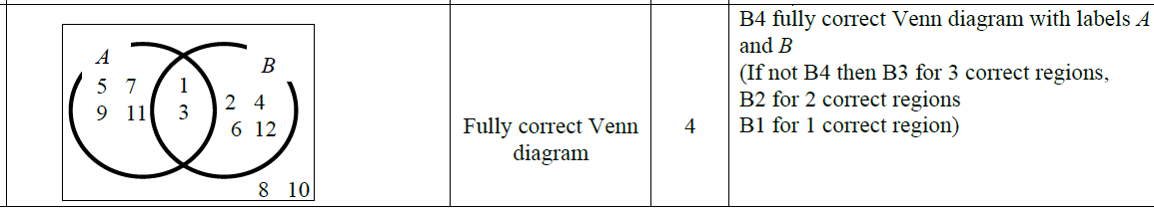

**Question 9**

