**3.1.1 Atomic structure**

**Developing ideas of the atom**

The idea that all matter consists of particles called atoms has been developed over thousands of years, starting with the Greek philosophers. This continued with the discovery of sub-atomic particles and how these are arranged in an atom.

BC Greek philosophers matter made of 4 substances (earth, air, water, fire)

Democritus matter made up of indivisible particle (atomos)

1661 Robert Boyle some substances couldn’t be made simpler

1803 John Dalton atomic theory: elements were made of atoms

1896 Henri Becquerel discovered radioactivity – showed particles could come from inside atoms

1897 J.J. Thompson discovered the electron – plum pudding model

1911 Ernest Rutherford gold foil experiment led to discovering most of mass of atom and all positive change was in the nucleus

discovers the neutron

1913 Niels Bohr positive nucleus orbited by negative elections in shells

1926 Erwin Schrodinger electrons has properties of waves as well as particles

1932 James Chadwick discovered the neutron

***Video: In search of giants – building blocks of matter***

**The atom**

|  |  |
| --- | --- |
| 3 fundamental  sub-atomic particles for chemists:   * Proton * Neutron * Electron |  |

**The arrangement of sub-atomic particles**

|  |  |
| --- | --- |
|  | The protons and neutrons are held together by a **strong nuclear force**, which **overcomes the repulsive forces** between the protons in the nucleus and only acts over **short distances** within the nucleus. This is much stronger that the **electrostatic forces** of attraction that hold the electrons and protons together. Electrons are found in a **series of levels, orbits or shells** which go further from the nucleus. |

***RSC Interactive Periodic table -*** [***Link***](https://www.rsc.org/periodic-table)

***Definition***: **Mass number**, **A,** is the total number of protons and neutrons in the nucleus of one atom of an element

***Definition***: **Atomic (proton) number**, **Z**, is the number of protons in the nucleus of an atom

An **atom is neutral**, so atomic number is also equal to number of electrons.

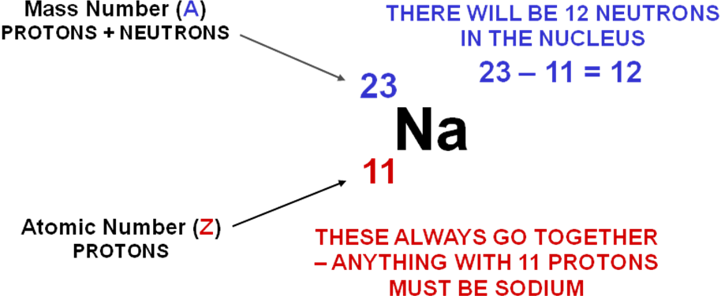

***Fact recall: CGP14 Q1-4***

***CGP14 PQ1-5***

Isotopes

***Definition***: **Isotopes** are atoms of the same element with the same atomic number but different mass numbers

Protons identify an atom.

Isotopes have:

* identical chemical properties – same number of electrons
* different physical properties – different number of neutrons (affect mass)  
  e.g. diffusion rates, boiling points, nuclear properties

**Example: CGP13** – chlorine and magnesium

***Sheet: Atomic structure***

***Sheet: The structure of atoms & ions***

**Relative mass**

The actual mass of an atom is very very small, too small to weigh. So the **mass of atoms are compared** to the mass of **one atom of carbon** with a mass of exactly **12.0**, to give a **relative mass**.

The **relative atomic mass** of an element, ***A*r**, is shown on the **periodic table**. How these are calculated is covered later in the mass spectrometer section. This is not always a whole number due to it being an average for the relative abundances of isotopes of the atom.

The **relative molecular mass**, ***M*r**, is **the average mass of a molecule**, to find *M*r, just add up the relative atomic masses of all the atoms in the molecule.

The **relative formula mass**, ***M*r**, is **the average mass of an ionic compound.**

**Example: CGP17**

**Calculate the relative molecular mass of C2H6O.**

*M*r C2H6O = (2 x 12.0) + (6 x 1.0) + (16.0) = **46.0** **N.B. Always quote to 1 d.p.**

***Task: Calculate the relative molecular mass of C4H10.***

*M*r C4H10 = (4 x 12.0) + (10 x 1.0) = **58.0**

***Fact recall: CGP18 Q1-3***

***CGP18 PQ1-3***

**Mass spectroscopy**

The mass spectrometer is the most useful instrument for accurate determination of the **relative atomic masses, Ar** of elements **and relative molecular masses, Mr** of molecules. It is measured on a scale on which the mass of an atom of carbon is defined as **exactly 12.0**.

The mass spectrometer determines the relative mass of separate atoms or molecules. They work on the following principles:

* **ionisation** - formation of **positive ions**
  + electron impact
  + electrospray
* **separation** - according to the **ratio of their charge to their mass, *m/z***
* **acceleration** - along the flight tube
* **detection** - abundance and m/z of each isotope is determined

Time of flight (TOF) spectroscopy

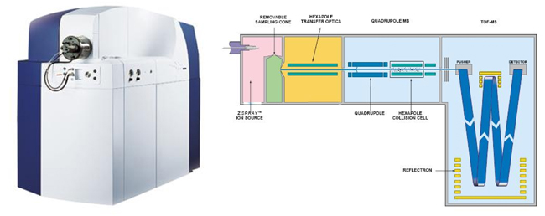

*Picture of TOF mass spec instrument*

The mass spectrometer is kept under vacuum so that the ions don’t collide with air molecules.

|  |  |  |
| --- | --- | --- |
| **Ionisation** | **Electron impact**:   * sample vaporised * high energy electrons fired at sample from **electron gun** * **electron knocked out** of sample to give **positive ion** | |
|  | |
| ***Elements***:  X(g) → X+(g) + e- e.g. Na  It’s possible to remove 2 electrons giving ions with a 2+ charge - usingthe **minimum energy required** helps to prevent this  ***Diatomic*** molecular elements:  X2(g) → X2+(g) + e- e.g. Cl2 | ***Low mass molecules***:  XY4(g) → XY4+(g) + e- e.g. CH4  X2+/XY4+ referred to as molecular ion  Molecules can fragment giving peaks with mass lower than m/z of molecular ion |
| **Electrospray ionisation**:   * dissolved in volatile solvent (water or methanol) * injected through a fine hypodermic needle giving a fine mist /aerosol * tip of needle has high voltage power supply * each molecule gains a proton from the solvent as it leaves the needle | |
| ***High mass molecules***:  M(g) + H+→ MH+(g)  Known as a soft technique as molecules aren’t fragmented | |
|  | |
| **Acceleration** | **Acceleration**:   * **positive ions** are **attracted** towards a **negatively charged electric field**, forming a beam which is accelerated along the flight tube to the detector * the flight tube has a **fixed distance** * the **positive ions** all have the **same kinetic energy** (KE) * the **velocity of each particle depends on its mass**   + lighter ions have a faster velocity   + heavier ions have a slower velocity   This is explained by this equation:  **KE = ½ mv2** *KE = kinetic energy (J)* *m = mass (kg) v = velocity (ms-1)*  Velocity of each particle is v = **√2KE / m** given that **all particles** have the **same** **kinetic energy**, the **velocity** of each particle **depends** on its **mass**. | |
| **Separation** | **Flight tube**:   * positive ions pass through hole in negatively charged plate * **time of flight depends on velocity which depends on the mass**   + lighter ions travel faster   + heavier ions travel slower   This is explained by this equation:  **t = d/v** *t = time of flight (s) d = length of flight tube (m) v = velocity (ms-1)*  substitute velocity with v = gives t = d  √2KE/m  Re-arrange:  Shows **time of flight** is **dependent** on **length** of flight **tube** (same for all ions) to the **square root of the mass** of the ions **divided** by their **kinetic** **energy** (same for all ions). | |

**Additional information on mass of ions**

1 mole of atoms = 6.022 x 1023 (Avogadro constant, *L*)

mass of 1 mole atoms (g) = Ar

so mass 1 atom = Ar in g

*L*

Units for mass in mass spec is kg so need to convert grams to kilograms

To find mass of 1 atom in kg x 10-3

**Example**

Find the mass, in kg, of one ion of 35Cl+

m 35Cl+ = 35 = 5.81 x 10-23 g

6.022 x 1023

mass in kg = 5.81 x 10-23 x 10-3 = 5.81 x 10-26 kg

|  |  |  |  |
| --- | --- | --- | --- |
| **Separation** |  | | |
| **Detection** | * **positive ions hit a negatively charged plate** * **accept an electron** from the plate * this generates a movement of electrons and hence an **electric current** that is measured * **size** of the **current** gives a **measure** of the **number** of **ions** hitting the plate   + greater abundance gives bigger current generating bigger peak * signal produces a peak on spectrum | | |
|  | | |
| **Spectrum** | **Electron impact**  Element e.g. Mg (24Mg, 25Mg, 26Mg)  Ar isotope = m/z  Ar element  = mass isotope x abundance  total abundance isotopes | | **Electrospray ionisation**  Molecule e.g. protein  Mr molecule = m/z – 1 (loss of H+)  molecular ion |
|  | Molecule e.g. propane  Mr molecule = m/z (molecular ion) | | Small peak with m/z 1 mass unit greater than molecular ion is due to molecules containing either 2H or 13C isotopes |
| fragmentation peaks | molecular ion |  |

***Sheet: TOF calculation questions***

***Sheet: TOF calculation exam questions***

Identifying elements

All elements give a characteristic pattern that shows the relative abundances of their isotopes and so can be used to identify an atom. Chlorine has 2 isotopes, mass 35Cl and 37Cl, occurring in a ratio of 3:1, this gives a relative atomic mass of 35.5. Its mass spec will show 5 peaks:

* Atoms 35Cl and 37Cl
* Molecules 35Cl2, 35Cl-37Cl and 37Cl2

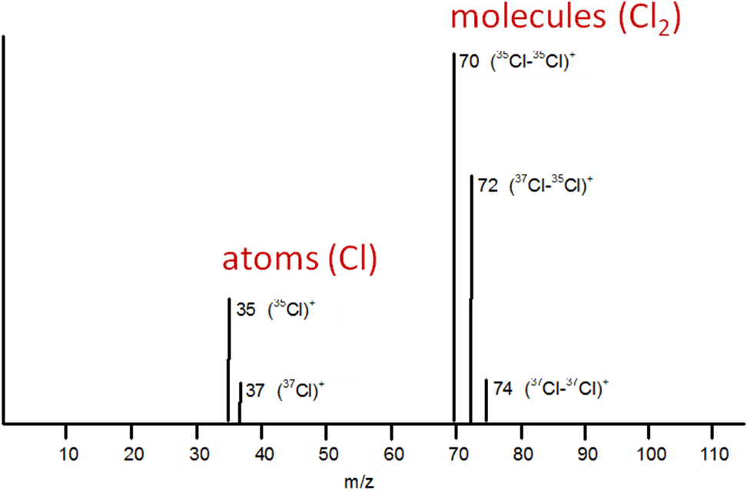

The peak with the greatest m/z corresponds with Mr of the atom or molecule.

***Fact recall: CGP21 Q1-4***

***CGP18 PQ4-5***

***CGP20 PQ1***

***CGP21 PQ1***

Uses of mass spec

It can be used to identify different isotopes that make up an element. They are detected separately because they have different masses. As well as being used in laboratories they have also being used in the space probes such as the Mars Rover Curiosity and Huyens spacecraft that landed on Titan (one of Saturn’s moons) to analysis samples for elements.

**Low resolution**

Often masses are measured to the nearest whole number; this is called **low resolution**.

**Example: CGP20**

The spectrum shows produced when a sample of chlorine is passed through a mass spec is shown.

There are two peaks, so there are two isotopes. The spectrum shows the peaks have a mass/charge ratio of 35 and 37 which is equivalent to their relative isotopic mass. The % abundance shows that there is 75.5% 35Cl and 24.5% 37Cl.

**Example: CGP20**

A natural sample of chlorine contains a mixture of two isotopes. Calculate the relative atomic mass.

isotopic masses x %

Relative atomic mass = (35 x 75.5) + (37 x 24.5)

total abundance

(75.5 + 24.5)

Relative atomic mass = **35.5**

Sometimes a relative abundance is given rather than the percentage.

E.g. 35Cl : 37Cl in ratio 3:1

***Task: Neon***

The spectrum shows 3 isotopes of neon, with a mass of 20, 21 and 22 and abundances of 90.92%, 0.26% and 8.82%. From this the **average relative atomic mass** can be calculated.

|  |  |
| --- | --- |
|  | ***CGP23 PQ1-4*** |

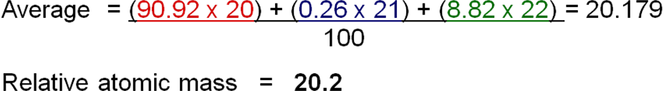

***Task: Naturally occurring potassium consists of potassium-39 and potassium-41.***

***Calculate the percentage of each isotope present if the average is 39.1.***

Assume there are x nuclei of 39K in every 100; so there will be (100-x) of 41K

so 39x + 41 (100-x) = 39.1

100

therefore 39 x + 4100 - 41x = 3910

thus - 2x = - 190

and x = 95

There will be **95% 39K 5% 41K**

**High resolution**

Mass specs that can measure relative atomic masses to several decimal places are called **high resolution** mass spectrometers. These allow elements to be identified using the exact masses of their atoms.

**Electron arrangement or configuration**

***Notes: Electron arrangement***

Electrons in different shells have different amounts of energy, so can show them on an energy level diagram.

|  |  |
| --- | --- |
|  | ***Link PP: Electronic structure*** |

The shells are called main energy levels labelled 1, 2, 3 etc and each can **hold a maximum number of electrons given by the formula 2n2**, where n is the number of the main energy level.

***Task: Work out the maximum number of electrons that each main level can hold***

Level 1 2 x 12 = 2

Level 2 2 x 22 = 8

Level 3 2 x 32 = 18

Level 4 2 x 42 = 32

The main energy levels are divided into **sub-levels,** also known as **orbitals** or **sub-shells.** They are identified as **s, p, d, f**, which have slightly different energies and different shapes, which represent a volume of space in which there is a probability of finding an electron.

The number of sub-levels is different for each level. Each sub-level contains orbits; **each orbit can hold a maximum of 2 electrons**, which have **opposite spin**.

This is summarised in the table below.

|  |  |  |  |  |  |  |  |  |  |  |
| --- | --- | --- | --- | --- | --- | --- | --- | --- | --- | --- |
| Main energy level | 1 | 2 | | 3 | | | 4 | | | |
| Sub-levels | s | s | p | s | p | d | s | p | d | f |
| Orbitals in sub-level | 1 | 1 | 3 | 1 | 3 | 5 | 1 | 3 | 5 | 7 |
| Electrons in orbitals | 2e- | 2e- | 6e- | 2e- | 6e- | 10e- | 2e- | 6e- | 10e- | 14e- |
| Total electrons in main energy level | 2 | 8 | | 18 | | | 32 | | | |

|  |  |  |  |
| --- | --- | --- | --- |
|  | s = 1 x 2 = 2 |  | d = 5 x 2 = 10 |
| p = 3 x 6 = 6 |

Orbital can be shown as boxes with electrons as arrows, up and down to show opposite spin.

| 1s2 |  | 2s2 |  | 2p6 | | |  | 3s2 |  | 3p6 | | |  | 4s2 |  | 3d10 | | | | |  | 4p6 | | |
| --- | --- | --- | --- | --- | --- | --- | --- | --- | --- | --- | --- | --- | --- | --- | --- | --- | --- | --- | --- | --- | --- | --- | --- | --- |
| ↑ ↓ |  | ↑ ↓ |  | ↑ ↓ | ↑ ↓ | ↑ ↓ |  | ↑ ↓ |  | ↑ ↓ | ↑ ↓ | ↑ ↓ |  | ↑ ↓ |  | ↑ ↓ | ↑ ↓ | ↑ ↓ | ↑ ↓ | ↑ ↓ |  | ↑ ↓ | ↑ ↓ | ↑↓ |

Order of filling

The **electron** is considered to be a **cloud** of **negative charge** rather than a particle which is most probably (95% confidence) found within a volume in space called its **atomic orbit**.

Each type of orbit has a different amount of energy. The **nucleus pulls the orbits** and so **affects the energy** of them and **dictates the order of filling**. The orbitals closest to the nucleus **shield** the outer ones from the nuclear charge. This is known as the **Aufbau principle**.

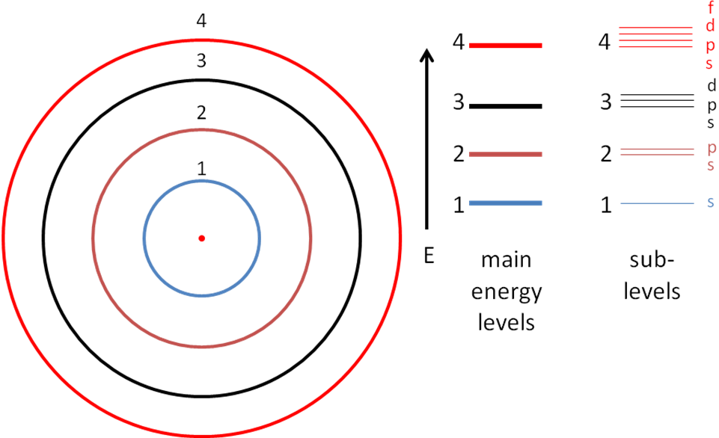

This is a simplified picture, in actual fact the **4s orbital fills before the 3d**, because it is lower in energy. Similarly, **5s fills before 4d** and **5p and 6s before 4f**.

|  |  |
| --- | --- |
| So the true picture looks like this. |  |

This links to the periodic table, different sections are called **blocks**; representing the **highest energy level in which electrons occupy**.

|  |  |
| --- | --- |
|  |  |

Spin

Electrons have a property called **spin**:

N.B. Electrons don’t actually spin

* 2 electrons in the same orbit have opposite spin
* Electrons are represented with arrows pointing up and down

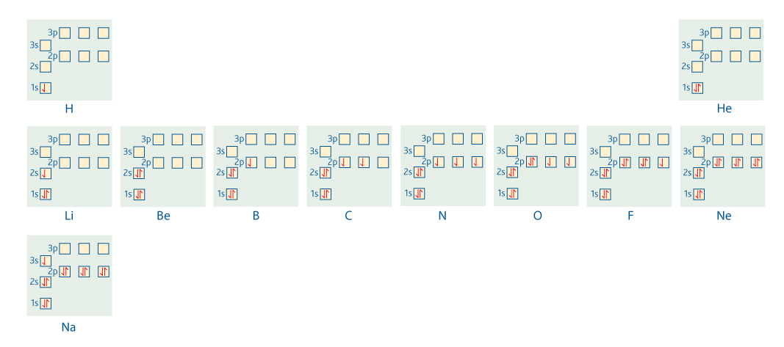

Three rules to filling (Hund’s rule):

* Electrons will always **occupy the lowest energy** orbital first
* Orbitals of the same level **fill unpaired** before pairing, because then electrons repel each other
* Orbital hold a **maximum of 2** electrons

***Analogy: Double seat on a bus***

Electron configuration (up to z=36)

Electronic diagrams of atoms can be shown in shorthand:

* write the number of electrons in each shell, starting with the inner one and work outwards
* separate each number by a comma

**Examples:**

Carbon 2,4

Na+ 2,8

Potassium 2,8,8,1

The same system is used to show the sub-levels.

**Examples**

Potassium

K19 1s2 2s22p6 3s23p6 4s1

| 1s |  | 2s |  | 2p | | |  | 3s |  | 3p | | |  | 4s |
| --- | --- | --- | --- | --- | --- | --- | --- | --- | --- | --- | --- | --- | --- | --- |
| ↑ ↓ |  | ↑ ↓ |  | ↑ ↓ | ↑ ↓ | ↑ ↓ |  | ↑ ↓ |  | ↑ ↓ | ↑ ↓ | ↑ ↓ |  | ↑ |

Iron

Fe26 1s2 2s22p6 3s23p6 4s2 3d6 or1s2 2s22p6 3s23p6 3d6 4s2

| 1s |  | 2s |  | 2p | | |  | 3s |  | 3p | | |  | 4s |  | 3d | | | | |
| --- | --- | --- | --- | --- | --- | --- | --- | --- | --- | --- | --- | --- | --- | --- | --- | --- | --- | --- | --- | --- |
| ↑ ↓ |  | ↑ ↓ |  | ↑ ↓ | ↑ ↓ | ↑ ↓ |  | ↑ ↓ |  | ↑ ↓ | ↑ ↓ | ↑ ↓ |  | ↑ ↓ |  | ↑ ↓ | ↑ | ↑ | ↑ | ↑ |

**Exceptions to the expected pattern** - both of which stem from the 4s and 3d levels being very close in energy:

Cr 1s2 2s2 2p6 3s2 3p6 4s1 3d5 (**NOT** 1s2 2s2 2p6 3s2 3p6 4s2 3d4)

| 1s |  | 2s |  | 2p | | |  | 3s |  | 3p | | |  | 4s |  | 3d | | | | |
| --- | --- | --- | --- | --- | --- | --- | --- | --- | --- | --- | --- | --- | --- | --- | --- | --- | --- | --- | --- | --- |
| ↑ ↓ |  | ↑ ↓ |  | ↑ ↓ | ↑ ↓ | ↑ ↓ |  | ↑ ↓ |  | ↑ ↓ | ↑ ↓ | ↑ ↓ |  | ↑ |  | ↑ | ↑ | ↑ | ↑ | ↑ |

This is a slightly **lower energy arrangement** as the reduced e--e- repulsion makes up for the fact one electron is in a slightly higher energy level.

Cu 1s2 2s2 2p6 3s2 3p6 4s1 3d10 (**NOT** 1s2 2s2 2p6 3s2 3p6 4s2 3d9)

| 1s |  | 2s |  | 2p | | |  | 3s |  | 3p | | |  | 4s |  | 3d | | | | |
| --- | --- | --- | --- | --- | --- | --- | --- | --- | --- | --- | --- | --- | --- | --- | --- | --- | --- | --- | --- | --- |
| ↑ ↓ |  | ↑ ↓ |  | ↑ ↓ | ↑ ↓ | ↑ ↓ |  | ↑ ↓ |  | ↑ ↓ | ↑ ↓ | ↑ ↓ |  | ↑ |  | ↑ ↓ | ↑ ↓ | ↑ ↓ | ↑ ↓ | ↑ ↓ |

This is a slightly **lower energy arrangement**.

Shortened electron configuration

Replace electron structure identical to nearest noble gas with its symbol in square brackets.

***Task: Write the electronic structure for the Noble gases***

He2 1s2

Ne10 1s2 2s2 2p6

Ar18 1s2 2s2 2p6 3s2 3p6

Kr36 1s2 2s2 2p6 3s2 3p6 4s2 3d10 4p6 or 1s2 2s2 2p6 3s2 3p6 3d10 4s2 4p6

**Example**

Potassium

K19 1s2 2s22p6 3s23p6 4s1

[Ar] 4s1

***Task: Write the short hand electronic structure***

C6 1s2 2s22p2

[He] 2s22p2

Mg12 1s2 2s22p6 3s2

[Ne] 3s2

***Link PP: Electronic structure – Electronic configuration notation***

***Sheet: Electronic structure of the elements or Electron configuration (up to Br)***

***Fact recall: CGP28 Q1-8***

***CGP27 PQ1-5***

Electron configuration of ions

Same notation is used; electrons are consecutively added or removed. You must remember the order of filling. Transition metal ions the **3d is lower in energy than the 4s so remove the 4s first**.

**Examples**

Potassium

K+ From 1s2 2s22p6 3s23p6 ~~4s~~~~1~~ to1s2 2s22p6 3s23p6

Iron

Fe2+ From 1s2 2s22p6 3s23p6 3d6 ~~4s~~~~2~~ to 1s2 2s22p6 3s23p6 3d6

***Link PP: Electronic structure – Ionisation***

***Sheet: Electron configuration (ions)***

***Starter: 2.3 Electrons and orbits***

***Starter: 2.2 Isoelectronic species***

***CGP28 PQ1-3***

**Ionisation energies**

Electrons can be removed from atoms and the energy it takes to remove them is called **ionisation energy**; abbreviated **IE** and is measured in **kJ mol-1**.

Ionisation energies **provide evidence for the arrangement of electrons** in an atom.

***Definition***: **First ionisation energy** of an element is the energy required to remove **one mole of electrons** from **one mole of atoms** in the **gas phase**:

**X(g) → X+(g) + e-**

Ionisation is an endothermic process because it takes energy to overcome the electrostatic forces between the negative electron and positive nucleus.

|  |  |
| --- | --- |
| **3 factors affect the ionisation energy:**   * Distance form nucleus * Nuclear charge * Shielding by electrons in inner shells between  nucleus and outer electron |  |

**Example: CGP29**

There are only **two electrons** between the nucleus and outer shell of a **lithium** atom and there are **ten** electrons between the nucleus and outer shell of a **sodium** atom, it has **greater shielding**. The **distance** between the nucleus and outer electron being removed is **greater in the sodium** atom. The **nuclear charge is greater in sodium** then lithium.

**Lithium** has a higher first ionisation energy because it has less shielding and a **shorter distance** from the nucleus, these two factors have a greater effect than the nuclear charge.

Successive ionisation energies

The 2nd and 3rd ionisation energy is the energy required to remove the second and third electrons **one electron at a time**; starting from the **outside and working inwards**. So they always follows after the 1st ionisation energy. They are dependent on nuclear charge, distance and shielding but will **always be higher** than the 1st ionisation energy because an **electron is being removed from a positively charged ion**. There is **less repulsion** amongst the remaining electrons, so they are **held more strongly** by the nucleus. The **electronic** **configuration** will also **plays a role**.

**Example: CGP30**

The **first electron** removed from lithium comes from the **second shell (2s1)** and the **second electron** is from the **first shell (1s2)**. So the **second electron** removed is **closer** to the nucleus and so has a **greater nuclear attraction** than the first. This **first electron** to be removed **experiences shielding** from the electrons on the first shell, whereas the electrons removed from the **first shell do not experience any shielding**. So the **second** **ionisation energy is much greater**. Also the **second electron** is being **removed** from a **positively charged ion**.

**General equation for nth ionisation:** X(n-1)+ (g) → Xn+ (g) + e-

|  |  |
| --- | --- |
|  | 1st IE: X(g) → X+(g) + e–  2nd IE: X+(g) → X2+(g) + e-   NOT X(g) → X2+(g) + 2e–  (this would be 1st + 2nd IE together)  3rd IE: X2+(g) → X3+(g) + e- |
| * 1st IE requires the **least energy** because it is being **removed from a neutral atom** * 2nd IE needs **more energy** than the 1st because it is being **removed from a 1+ ion** * 3rd IE needs **more energy** than the 2nd because it is being **removed from a 2+** **ion** | |

**Example: CGP30**

Write the equation for the fifth ionisation energy of oxygen.

**O4+(g) → O5+(g) + e-**  N.B. Must show state symbols for ions

***Task: Plot the successive ionisation energies for sodium (use the log values)***

|  |  |  |  |  |  |  |  |  |  |  |  |
| --- | --- | --- | --- | --- | --- | --- | --- | --- | --- | --- | --- |
| **Electron removed** | **1st** | **2nd** | **3rd** | **4th** | **5th** | **6th** | **7th** | **8th** | **9th** | **10th** | **11th** |
| IE/kJ mol-1 | 496 | 4563 | 6913 | 9544 | 13352 | 16611 | 20115 | 25491 | 28934 | 141367 | 159079 |
| **Log IE** | **2.7** | **3.7** | **3.8** | **4.0** | **4.1** | **4.2** | **4.3** | **4.4** | **4.5** | **5.2** | **5.2** |

1. ***What atom is this? Explain your answer.***
2. ***What patterns do you see? Explain your answer.***
3. ***What does this tell you about the energy levels in this atom?***
4. ***What does it tell you about the group this atom is in? Explain your answer.***

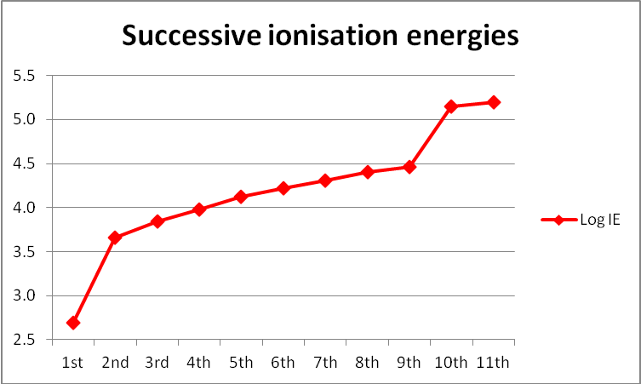

1. Sodium  
   It has 11 electrons
2. Ionisation energies increase as successive electrons are removed  
   Increase in energy after removal of 1st, 4th & 9th electron  
   The closer the electron is to the nucleus the more energy is required to remove it as the distance decreases and there is less shielding, also it takes more energy to remove an electron from a positive ion
3. This atom has electrons on 3 energy levels - increase in energy after removal of 1st, 4th & 9th electron In this arrangement: 1.8.2
4. It’s in group 1   
   After the 1st electron was removed there was a large jump in energy showing there was only one electron on the outer shell

The **first electron is fairly easy to remove**, then there is a **large jump** in energy needed to remove the next electron, there are **small increases** in energy for the **next seven electrons** then **another large jump** resulting in the **last two electrons** being removed.

The **number of electron allows the element to be identified** and the **large increases** in ionisation energy show that **electrons are being removed from different main energy** **levels**, i.e. third (1 electron), then second (8 electrons) and finally the inner shell (2 electrons). So this is **sodium** with the electronic arrangement **2, 8, 1**.

**Always work from left to right.**

This provides **evidence** for **number of electrons on each energy level** and the **group** of the element.

***Task: Which element is this graph of ionisation energies showing?***

***Explain the pattern***

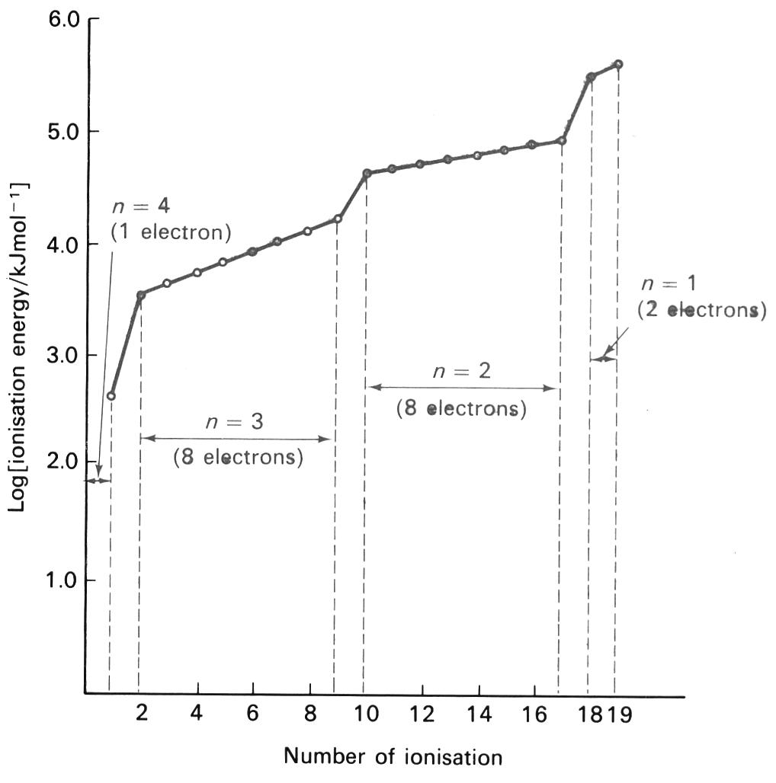

Potassium – 19 electrons

* 1st electron furthest from nucleus is easy to remove – 4th shell
* Next electron requires more IE so it must be in a different shell, closer to the nucleus, 8 electrons with similar IE – 3rd shell
* Next electron requires more IE so it must be in a different shell, closer to the nucleus, 8 electrons with similar IE – 2nd shell
* Last 2 electrons require the most IE - 1st shell

Trends down a group

|  |  |
| --- | --- |
|  | Down the group:   * Nuclear charge increases * Shielding same |

Looking at group 2 elements their **1st ionisation energies decreased down the group** because:

* **More shielding** by inner electrons
* Therefore **weaker attraction** from nucleus to electron in outer shell

Although the **nuclear charge is increasing**, the **attraction** for the outer electrons is **less** due to **shielding** by the inner electrons.

This provides **evidence** that the **electrons are arranged in different energy levels** increasing in distance from the nucleus.

Trends across a period

Looking at the pattern of 1st ionisation energies of any element as you go **across a period** gives information how the **electrons are arranged in the sub-levels**.

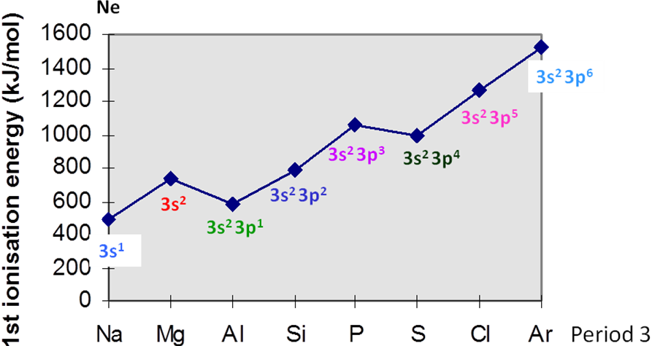

There is a **general increase in ionisation energy** across a period because the **nuclear charge is increasing** so the electrons are more **strongly attracted** and it takes **more energy to remove** one. The **outer electrons** are all in the **same main energy level**.

However the **increase is not regular**.

|  |  |
| --- | --- |
| Looking at each atom:   * Na – low IE – smallest nuclear charge and little shielding * Mg – higher IE – same shielding as Na but nuclear charge has increased * **Al – IE falls (would expect higher) – electron is removed from 3p orbital which is higher in energy than 3s so it is easier to remove and so IE is lower** | **Example: CGP 31** - Magnesium & Aluminium |
|  |
| * Si – higher IE – same shielding as Al but nuclear charge has increased * P – higher IE – same shielding as Al & Si but nuclear charge has increased * **S – IE falls – electron is removed from paired 3p orbital which has some repulsion, which increases their energy, making it easier to remove and hence lower IE** | **Example: CGP 31** - Phosphorus & Sulphur |
|  |

This provides **evidence** for the arrangement if the **electrons in** **sub-levels**.

***Task: Identify the elements in each period which show a drop in ionisation energy***

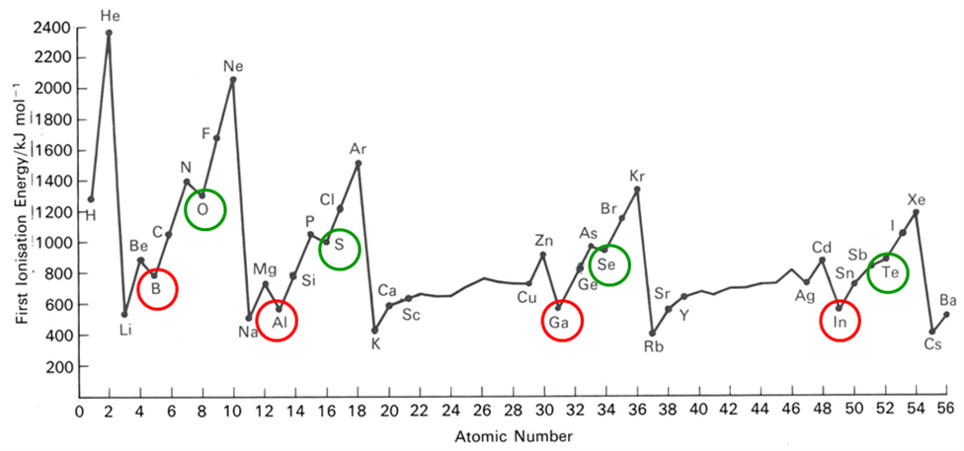

***Sheet: HSW - What do ionisation energies reveal about the atom?***

***Starter: 2.4 Trends in ionisation energy***

***PPQ: Atomic structure***

***Fact recall: CGP33 Q1-7***

***CGP32/33 PQ1-7***

***CGP32 PQ1-2***

***Homework: Oxford p20-21: EQ1-5***