**PREPARATORY WORK FOR LATIN A LEVEL 2020**

**1. A little bit of Grammar…**

**VERB ENDINGS – ACTIVE VOICE**

|  |  |  |  |  |  |  |
| --- | --- | --- | --- | --- | --- | --- |
| **Person** | **PRESENT**  **TENSE** | **FUTURE**  **TENSE**  **1st & 2nd**  **Conjugation** | **FUTURE TENSE**  **3rd & 4th Conjugation** | **IMPERFECT TENSE** | **PERFECT**  **TENSE** | **PLUPERFECT**  **TENSE** |
|  |  |  |  |  |  |  |
| SINGULAR 1 | -o | -bo | -am | -bam | -i | -eram |
| 2 | -s | -bis | -es | -bas | -isti | -eras |
| 3 | -t | -bit | -et | -bat | -it | -erat |
| PLURAL 1 | -mus | -bimus | -emus | -bamus | -imus | -eramus |
| 2 | -tis | -bitis | -etis | -batis | -istis | -eratis |
| 3 | -nt | -bunt | -ent | -bant | -erunt | -erant |

* Learn these endings. Then apply them to the following verbs (one from each conjugation), translating each form as you go. Remind yourself how the principal parts work, too.
* 1 amo, amare, amavi, amatum 2 moneo monere monui monitum

3 rego regere rexi rectum 4 audio audire audivi auditum

* Now do the same thing with the passive:

**VERB ENDINGS – PASSIVE VOICE**

|  |  |  |  |  |  |  |
| --- | --- | --- | --- | --- | --- | --- |
| **Person** | **PRESENT**  **TENSE** | **FUTURE**  **TENSE**  **1st & 2nd**  **Conjugation** | **FUTURE TENSE**  **3rd & 4th Conjugation** | **IMPERFECT TENSE** | **PERFECT**  **TENSE** | **PLUPERFECT**  **TENSE** |
|  |  |  |  |  | SUPINE + | SUPINE + |
| SINGULAR 1 | -or | -bor | -ar | -bar | -us -a -um  sum | -us -a -um  eram |
| 2 | -ris | -beris | -eris | -baris | es | eras |
| 3 | -tur | -bitur | -etur | -batur | est | erat |
| PLURAL 1 | -mur | -bimur | -emur | -bamur | -i -ae -a  sumus | -i -ae -a  eramus |
| 2 | -mini | -bimini | -emini | -bamini | estis | eratis |
| 3 | -ntur | -buntur | -entur | -bantur | sunt | erant |

**Principal Parts**

Everyone’s favourite bit of Latin grammar! Here is a list of some of the most common and important irregular principal parts. Have a go at learning them, concentrating particularly on recognising the perfect and supine forms. You are welcome to add any favourites of your own! ☺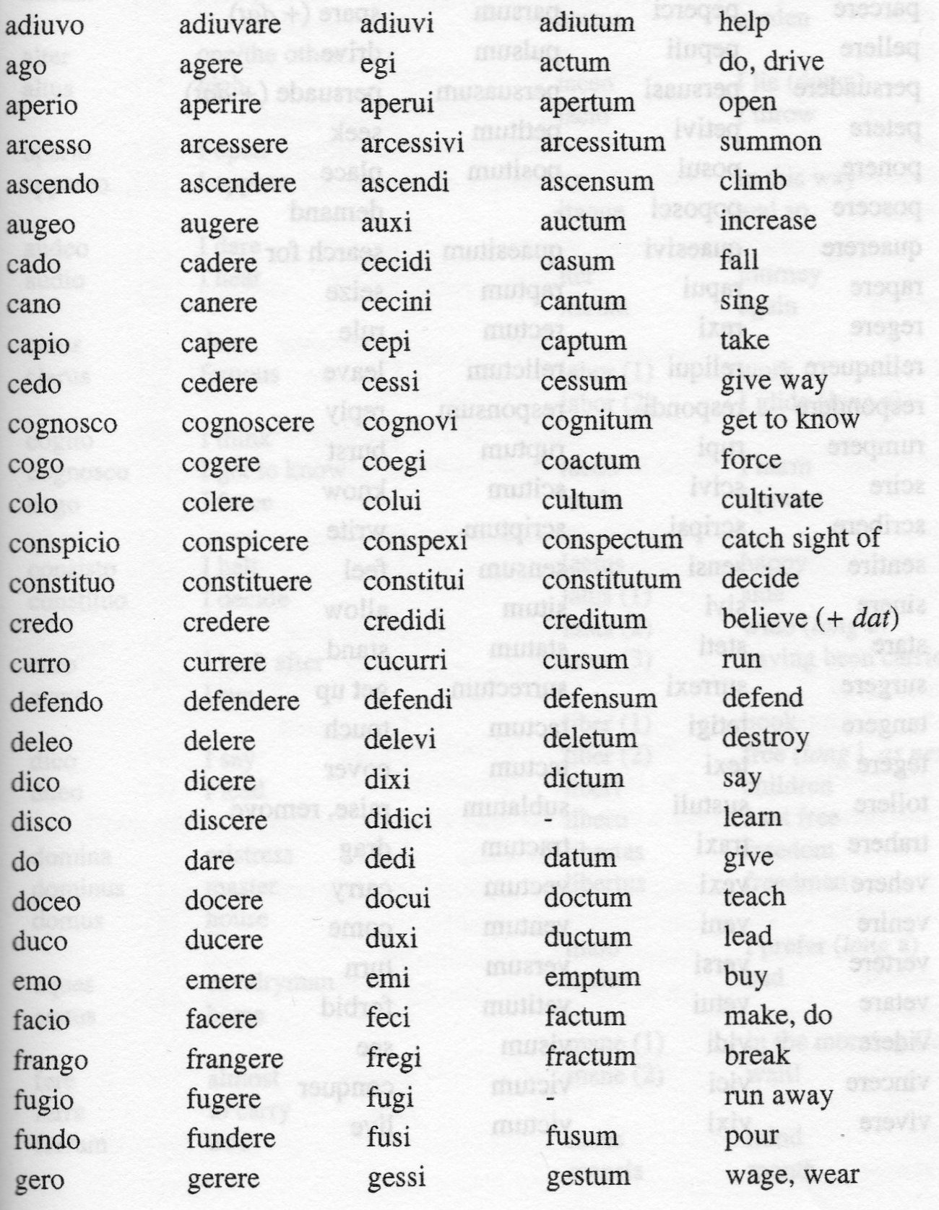

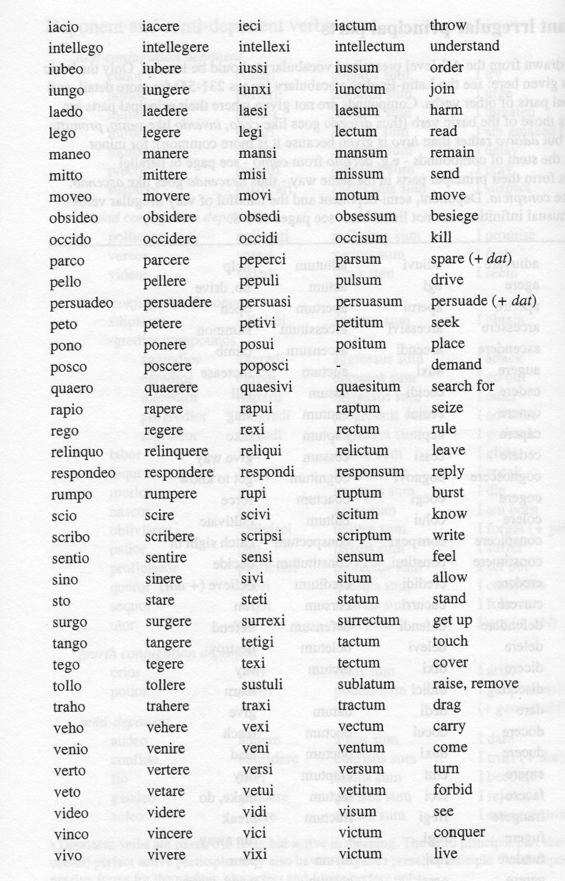

**NOUNS – CASE ENDINGS**

|  |  |  |  |
| --- | --- | --- | --- |
| **Case** | **1st DECLENSION f.** | **2nd DECLENSION m.** | **2nd DECLENSION n.** |
| SINGULAR |  |  |  |
| Nominative | -a | -us | -um |
| Vocative | -a | -e | -um |
| Accusative | -am | -um | -um |
| Genitive | -ae | -i | -i |
| Dative | -ae | -o | -o |
| Ablative | -a | -o | -o |
| PLURAL |  |  |  |
| Nominative | -ae | -i | -a |
| Vocative | -ae | -i | -a |
| Accusative | -as | -os | -a |
| Genitive | -arum | -orum | -orum |
| Dative | -is | -is | -is |
| Ablative | -is | -is | ­ -is |

|  |  |  |
| --- | --- | --- |
| **Case** | **3rd DECLENSION m./f.** | **3rd DECLENSION n.** |
| SINGULAR |  |  |
| Nominative | -- | -- |
| Vocative | -- | -- |
| Accusative | -em | -- |
| Genitive | -is | -is |
| Dative | -i | -i |
| Ablative | -e | -e |
| PLURAL |  |  |
| Nominative | -es | -a |
| Vocative | -es | -a |
| Accusative | -es | -a |
| Genitive | -um | -um |
| Dative | -ibus | -ibus |
| Ablative | -ibus | -ibus |

* Learn these endings! Look up the following nouns and remind yourself how to work out their declension by looking at the genitive case (second ending given). Write out a complete example of each declension and gender above.
* annus -i *m* corpus corporis *n* mensa mensae *f*

bellum belli *n* rex regis *m*

**2. Vocabulary**

Try to set aside 10 minutes each day to relearn your GCSE vocabulary. There is a new list for AS – but many of the words on it you have already learnt at GCSE and it will really help you to be as secure as possible with these before you start. This is a good Quizlet set, which has all the vocabulary and some helpful pictures!

[**https://quizlet.com/144057825/latin-gcse-vocabulary-flash-cards/**](https://quizlet.com/144057825/latin-gcse-vocabulary-flash-cards/)

**3. Translation practice**

Look over the following translation hints before looking at the story below:

* Some of the unfamiliar vocab. is given here – but not all! Do NOT panic if you see a word that you do not know – and do NOT launch in and guess wildly, at the expense of the sense of the rest of the sentence!
* Instead, USE what you know to help work out what you don’t know – often you will be able to make sense of the unknown word(s) in CONTEXT when you have worked out all you can in a sentence.
* BREAK UP a long sentence into smaller, more manageable sections – it is easier to slay a mighty monster claws by claws (get it?!) than all at once!
* Work GRAMMATICALLY – don’t translate a singular verb as plural, or a genitive noun as the subject…
* READ lots of mythology (often the subject of unseen translations) and USE your knowledge to PICTURE and make sense of the story.
* Make sure what you write MAKES SENSE! This might well involve simply THINKING HARD!

Now have a go at translating the story, and identify the following constructions:

* purpose clause
* indirect command
* result clause
* pluperfect subjunctive (explain why)
* passive verb
* deponent verb
* present participle
* perfect passive participle
* ablative absolute
* indirect statement (accusative and infinitive).

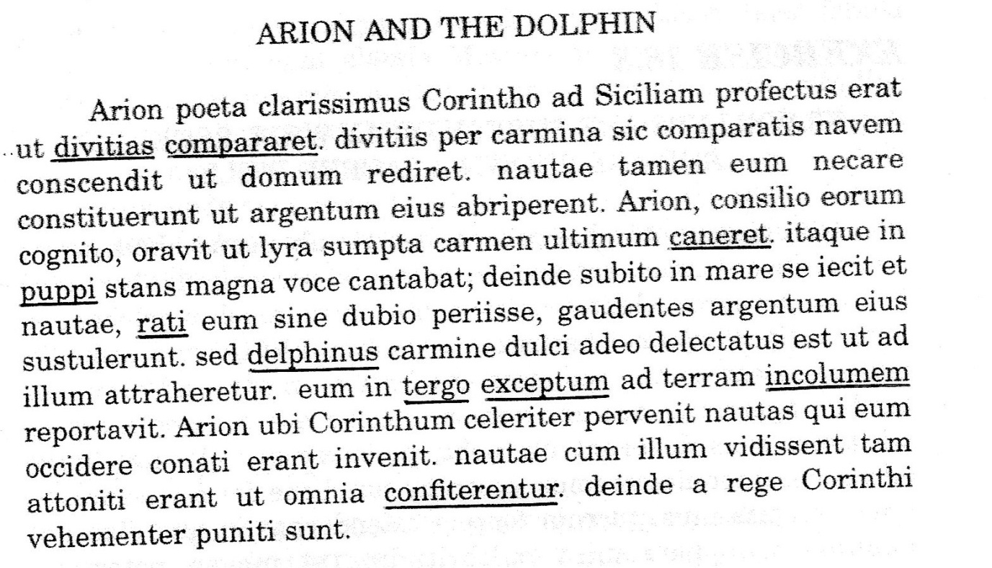divitiae, -arum *f.pl.* - *riches, wealth*

comparo, -are - *obtain*

cano, -ere, cecini, cantum - *sing*

puppis, -is *f.* - *stern, ship*

reor, reri, ratus sum - *think*

delphinus, -i *m.* - *dolphin*

tergum, -i *n.* - *back*

excipio, -ere, -cepi, -ceptum - *take up, pick up*

incolumis, -e - *safe*

confiteor, -eri, confessus sum - *confess*

**4. Translating from English into Latin**

This is an option at AS – not compulsory, but an excellent way of learning grammar – and great fun! Success depends on:

* identifying the construction you need to use in each sentence, and checking in your grammar notes the rules for it;
* close attention to detail in getting the form and ending of every word correct:
* check the conjugation and principal parts of every verb. Check tense, person, mood and voice;
* check the gender and declension of every noun. Take particular care with the stem change in 3rd declension nouns. Ask yourself what case a noun needs to be in, and why. Look out for prepositions (which case do they take?) and agreement of adjectives.

We will revise the other moods of the verb (infinitives, imperatives, participles, subjunctives – remember all those joys?!) at the beginning of the AS course – but they do all appear in the translation you have just done! For now, study the constructions you have identified in the translation above and use them to help you have a go at translating the following examples into Latin:

i) I set out from Sicily in order to return to Rome.

ii) The master was so delighted by the beautiful slave girl that he sang a sweet song.

iii) The astonished sailors begged to return home.

iv) The poet, when he found out their plan, believed that he would die.

v) The dolphin, rejoicing, picked up the poet and carried him on his back.

**5. Preparatory work on set texts**

We are awaiting confirmation of the texts we will be studying in Year 12, but they are likely to include Cicero and either Virgil or Catullus. Here is a bit of background to whet your appetite on these fantastic Roman writers.

**Cicero**

**58** Accused by Clodius for execution of Catilinarian conspirators without trial - driven into exile

**57** Returns to Rome – supported by Pompey.

**52** *pro Milone* – Cicero fails in defence of Milo for murder of Clodius.

**49** Civil War – Caesar crosses Rubicon.

Cicero allies himself with Pompey/Senate against Caesar.

**48** Victory for Caesar at Pharsalus

**47** Cicero, though pardoned by Caesar, withdraws from politics and concentrates on philosophy.

**44** Murder of Caesar – Antony as consul seizes control of Rome.

Cicero delivers *Philippics* attacking Antony.

**43** Cicero murdered by Antony, whose wife Fulvia pierces the tongue in his severed head with her hairpin…

* Try to get a sense of the outline of Cicero’s life from the panels here. Look particularly at his gradual rise to political power in Rome and the evidence of his powerful rhetorical skill. Note how his ideals and allegiances during the Civil War of 49-48 BC set him against Julius Caesar, and set him up in opposition to Antony after Caesar’s assassination in 44 BC, leading ultimately to his death.

**89** Army service under Pompey’s father

**80** *pro Roscio* – first political speech

**75-74** Quaestor in Sicily – enters Senate.

**70** Prosecution of Verres

**66** Praetor – *de imperio* speech supports Pompey in his command against Mithridates *(lex Manilia).*

**63** Consul

Catilinarian conspiracy

**61** Bona Dea scandal – gives evidence against Clodius.

**60** Forced to adopt a neutral stance towards the Triumvirate

**CICERO**

**106 – 43 B.C.**

* Good books on this fascinating period of Roman history:
* *SPQR* – Mary Beard – excellent and entertaining romp through Roman history
  + - *Rubicon: The Triumph and Tragedy of the Roman Republic* – Tom Holland – beautifully written and researched
    - *Imperium, Lustrum, Dictator* – Robert Harris – a fantastic trilogy about Cicero’s life – historical fiction, but very well researched and a really good read
* Podcasts:
* In Our Time on Julius Caesar:

<https://www.bbc.co.uk/programmes/b04jlygw>

* In Our Time on Cicero:

<https://www.bbc.co.uk/sounds/play/b09nrsfg>

**Virgil – The *Aeneid***

(Roman numerals refer to books.)

c12th century BC

Trojan War, Aeneas’ escape from Troy (II), arrival in Latium and battle to establish future Romans through alliance of Trojans and Latins (VII-XII), foundation of first city – Alba Longa.

753 BC

Foundation of the city of Rome by Romulus – see prophecy I and shield VIII for depictions of the Romulus and Remus story.

753-510 BC

Rome ruled by 7 kings (VI – pageant) – first king Romulus, last king Tarquinius Superbus, who is banished by Brutus (VI – pageant), who establishes the Roman Republic.

509-45 BC

Roman Republic – ruled by 2 consuls, elected annually, and the senate – the great age of the toga (I - prophecy)!

key events in roman history seen in the *aeneid*

**Background**

Publius Vergilius Maro was born in 70 B.C. and wrote the *Aeneid* at the end of his life. He had not finished revising it when he died in 19 B.C. and left orders in his will for it to be destroyed - which, luckily for us, his executors ignored. Virgil was writing during the reign of the Emperor Augustus, who had brought peace and prosperity to Rome after long and turbulent years of civil war (much of this turbulence is seen in Cicero’s *Philippics*). Virgil, in terms meant to inspire the Romans of his own day, praises the character of Aeneas, the Trojan prince who set out from the destruction of Troy at the end of the Trojan War with a divine mission to found a new Troy: Rome. Virgil makes the trials, struggles and triumphs of Aeneas' journey symbolic of the achievements of Augustus and contemporary Rome.

**Summary of the story**

The *Aeneid* tells the story of the migration of the survivors of the Trojan War, led by Aeneas, from Troy to Italy, their long wanderings on the way and the war which they had to fight on their arrival in Italy. The story embraces many events and seven years of time, including the fall of Troy and the Trojans' final victory in Italy and all that came between.

Book I starts with the Trojans just off the coast of Sicily and nearly at their destination (Italy), when a storm (sent by the goddess Juno, who hates the Trojans) blows them off course to Carthage, on the coast of North Africa. The Queen of Carthage, Dido, welcomes them with sympathy and kindness, and, in Book II, Aeneas tells her the story of the terrible last hours of Troy and his difficult adventures since. Dido and Aeneas fall in love, but Aeneas is reminded by a message from Jupiter, delivered by the messenger god Mercury, of his divine mission to found Rome. In Book IV, Aeneas abandons Dido to sail for Italy. Virgil shows huge sympathy for Dido, who kills herself, calling for a future avenger from Carthage to punish the Romans (Virgil's Romans would have recognised this instantly as Hannibal, who brought Rome almost to its knees during the Punic Wars of the 3rd century B.C.).

After a stop in Sicily, where Aeneas holds funeral games for his father, Anchises, and another in Cumae on the bay of Naples, from where Aeneas descends to the Underworld and sees a pageant of future Roman heroes, including Augustus himself (Book VI), the Trojans land in Latium. They are welcomed by the Latin king, Latinus, who sees Aeneas as the fulfilment of an oracle prophesying that his daughter, Lavinia, would marry a stranger from abroad, who was to be the founder of a great nation. Signs from the gods confirm that Aeneas is the one.

However, the goddess Juno, who is hostile to the Trojans, starts a war between the Latins and the Trojans by working on the feelings of Turnus, king of the Rutuli and formerly suitor for Lavinia's hand. After an incident during a hunt, two of the Latins are killed and war breaks out. Aeneas is visited again by his mother, the goddess Venus, who brings him armour she has commissioned for him from Vulcan: Virgil describes in great detail the shield, on which are engraved scenes of Rome's future glory (Book VIII).

27 BC – AD 14

Octavian becomes Augustus, Rome’s first emperor. Virgil hails his reign as a period of peace, expansion and civilisation (see the great prophetic sections in I, VI, VIII, XII) – but is also sympathetic to the personal cost of Rome’s glory. Try to see something of the perspective of Rome’s enemies through the sufferings and struggles of many of the characters in the *Aeneid* whom circumstances make simply to get in the way of Aeneas’ mission…

[Sidebar Title]

49 BC

Julius Caesar crosses the Rubicon – civil war against Pompey and the senate (numerous references to horrors of civil war, e.g. I - picture of Bellona, VI – picture of Discord).

45-44 BC

Caesar declared Dictator, effectively ending the Republic – he is then assassinated by Brutus (descendant of the first Brutus, who established the Republic – VI), leaving further political chaos and Civil War between Caesar’s heir, Octavian, and Marc Antony.

31 BC

Battle of Actium - Octavian defeats Antony and Cleopatra (VIII - vivid description on Aeneas’ shield), ending long years of Civil War. Virgil symbolises this with references to the shutting of the gates of the temple of Janus, which were left open during war (I, VI, VIII).

[Sidebar Title]

Aeneas leaves the Roman camp and sails up the River Tiber to Pallanteum (the site of the future Rome) to seek an alliance with the enemy of the Latins, King Evander. During Aeneas' absence, Turnus attacks the Trojan camp and sets fire to their ships. Aeneas has told the Trojans not to do battle outside their camp and both sides dig in. The young Trojan warriors Nisus and Euryalus disobey Aeneas’ orders and launch a heroic but ultimately doomed mission against Turnus and the Rutuli (Book IX).

Books VIII-XII are full of fighting between the Trojans and the Latins. There are heroes on both sides: Pallas, son of the Arcadian king Evander, is slain by Turnus (Book X); the Volscian maiden warrior Camilla slays many Trojans with her bow and arrows before being slain herself (book XI). In the end, however, it all comes down to single combat between Aeneas and Turnus (Book XII). Jupiter and Juno prophesy the greatness of the future Rome, which will unite Trojans and Latins, descended from Aeneas and Lavinia. All that is left is Aeneas' victory over Turnus, which is double-edged: the poem ends with Aeneas killing Turnus in angry vengeance for the death of Pallas. Rome's future is secured, but the honour *(pietas)* it demands comes at a terrible cost.

Following the turbulent political situation you will see in Cicero, Virgil reflects the relative peace and prosperity of the subsequent *pax Augusta*. Julius Caesar traced his ancestry through the Julian clan back to Aeneas’ son, Iulus, thus claiming descent from the goddess Venus. As Caesar’s adopted son and heir, this ancestry also therefore applied to Augustus, whose achievements as Rome’s first Emperor Virgil is praising through Aeneas’ story. Consider how Virgil celebrates in the *Aeneid* the key events in Rome’s history listed in the panels on this page and the previous page.

Podcasts: In Our Time on the Augustan Age: <https://www.bbc.co.uk/programmes/b04jlygw>

In Our Time on the *Aeneid*: <https://www.bbc.co.uk/programmes/p003k9c1>

**Catullus**

The Roman poet Catullus (84–54 B.C.) wrote some of the most famous and intense love poetry ever written. His affair with his mistress Lesbia (a pseudonym – we know little about her, but suspect her to have been a high-class, married Roman lady) was turbulent to say the least – full of exuberant, joyous highs and desperately unhappy lows. Catullus charts all of this in the most beautifully crafted, learned and polished (and sometimes quite rude…) poetry. Here are a couple of famous examples:

**V.**

Vivamus, mea Lesbia, atque amemus,

**LXXXV.**

Odi et amo. quare id faciam, fortasse requiris.  
 nescio, sed fieri sentio et excrucior.

The first quote is the opening line of one of the most joyful poems. The second is a complete poem – one of the shortest but most poignant and heart-rending poems ever written. Can you work out any of the Latin?

Podcasts:

In Our Time on Love Poetry:

<https://www.bbc.co.uk/programmes/b0077744>

In Our Time on Catullus:

<https://www.bbc.co.uk/programmes/m000d1rg>

All the In Our Time episodes referred to in this document have reading lists attached, which are worth dipping into as well as listening to the discussions. The programmes always feature very learned and interesting academics – there are episodes on all sorts of other subjects, too – they are always worth listening to if you have an idle moment!

Enjoy exploring all this and I look forward to starting Latin A Level with you!

*Mrs A. Nightingale*

*April 2020*

a.nightingale@allsaints.york.sch.uk