**Plate Tectonics Mock Questions**

1. Starting with the centre of the Earth, what is the correct order for the layers of the Earth?

a) Inner core, Outer core, Mantle, Crust

b) Mantle, Inner core, Outer core, Crust

c) Inner core, Outer core, Crust, Mantle

d) Crust, Mantle, Outer core, Inner core

(1 mark)

2. The lithosphere consists of:

a) The outer part of the core and mantle

b) The outer part of the mantle and crust

c) The outer part of the crust and the atmosphere

d) The outer part of the mantle and core

(1 mark)

3. Define what a natural hazard is. Include an example in your answer. (1 mark)

……………………………………………………………………………………………………………………………………………………………

…………………………………………………………………………………………………………………………………………………………….

4. Contrast the characteristics of continental and oceanic crust. (3 marks)

……………………………………………………………………………………………………………………………………………………………

…………………………………………………………………………………………………………………………………………………………….

……………………………………………………………………………………………………………………………………………………………

…………………………………………………………………………………………………………………………………………………………….

……………………………………………………………………………………………………………………………………………………………

…………………………………………………………………………………………………………………………………………………………….

Look at **Figure 1**, a map showing the global distribution of earthquakes and volcanoes.

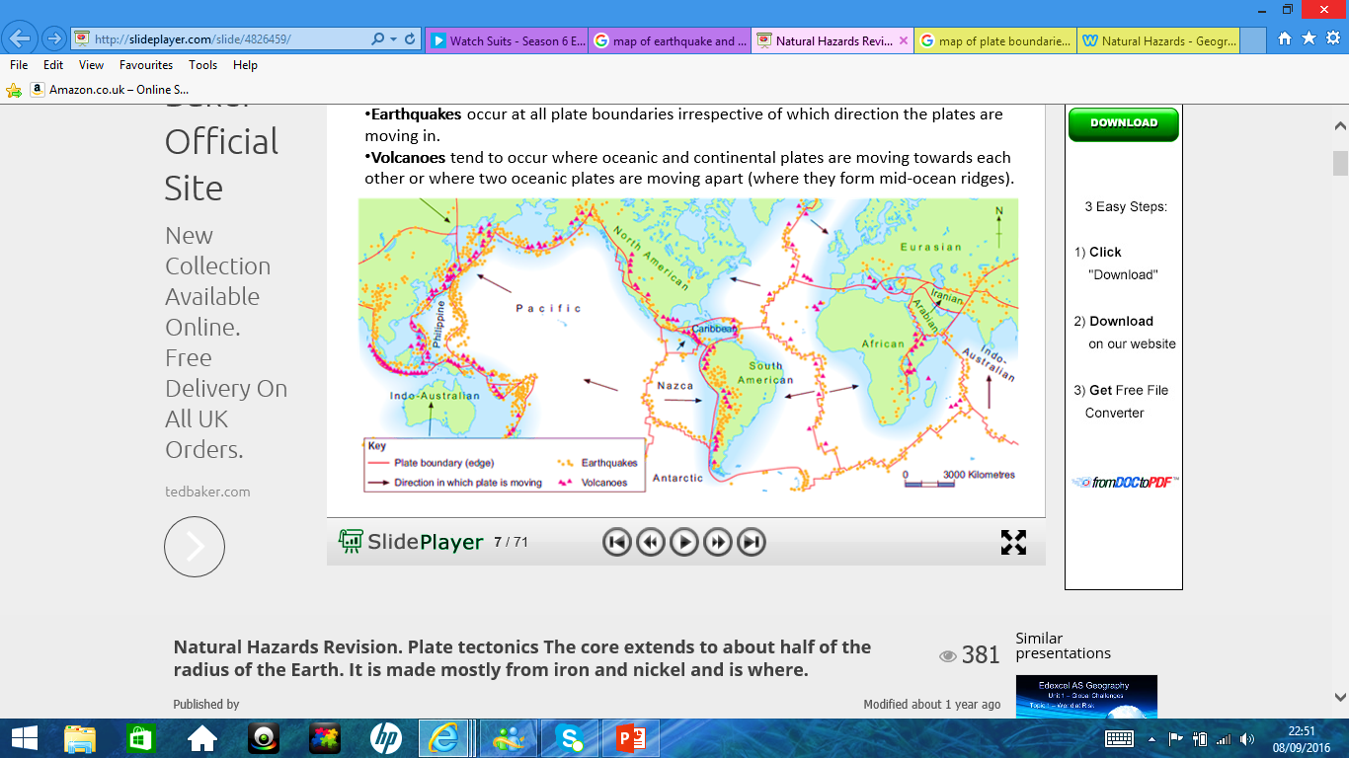**Figure 1**

5. Describe the distribution of volcanoes. (4 marks)

……………………………………………………………………………………………………………………………………………………………

…………………………………………………………………………………………………………………………………………………………….

……………………………………………………………………………………………………………………………………………………………

…………………………………………………………………………………………………………………………………………………………….

……………………………………………………………………………………………………………………………………………………………

…………………………………………………………………………………………………………………………………………………………….

……………………………………………………………………………………………………………………………………………………………

…………………………………………………………………………………………………………………………………………………………….

……………………………………………………………………………………………………………………………………………………………

…………………………………………………………………………………………………………………………………………………………….

6. Explain the distribution of earthquakes. (4 marks)

……………………………………………………………………………………………………………………………………………………………

…………………………………………………………………………………………………………………………………………………………….

……………………………………………………………………………………………………………………………………………………………

…………………………………………………………………………………………………………………………………………………………….

……………………………………………………………………………………………………………………………………………………………

…………………………………………………………………………………………………………………………………………………………….

……………………………………………………………………………………………………………………………………………………………

…………………………………………………………………………………………………………………………………………………………….

7. Explain what causes tectonic plates to move. (6 marks)

……………………………………………………………………………………………………………………………………………………………

…………………………………………………………………………………………………………………………………………………………….

……………………………………………………………………………………………………………………………………………………………

…………………………………………………………………………………………………………………………………………………………….

……………………………………………………………………………………………………………………………………………………………

…………………………………………………………………………………………………………………………………………………………….

……………………………………………………………………………………………………………………………………………………………

…………………………………………………………………………………………………………………………………………………………….

……………………………………………………………………………………………………………………………………………………………

…………………………………………………………………………………………………………………………………………………………….

……………………………………………………………………………………………………………………………………………………………

…………………………………………………………………………………………………………………………………………………………….

**Total: 20 marks**