**3.3.9 Carboxylic acids & derivatives**

**AS Link:**

**3.3.1 – Introduction to organic chemistry (mechanisms & nomenclature)**

**3.3.4 – Alkenes (polymers)**

**A level link:**

**3.3.7 – Optical isomers**

**3.3.8 – Aldehydes & ketones**

**Carboxylic acids**

The **most familiar carboxylic acid** is **ethanoic acid** or acetic acid is found in vinegar. Pure ethanoic acid sometimes called ‘*glacial’* because it can freeze on a cold day (f.p. 13oC). They have distinctive smells.

They can be written as **R-COOH** or **R-CO2H** and can **only** be at the **end** of a carbon chain. They have **two functional groups** attached to same carbon; this **changes** the **properties of each group**:

* C=O the carbonyl group
* O−H the hydroxyl group, this much more acidic than –OH in alcohols

|  |  |
| --- | --- |
| Carboxylic acids contain the carboxyl functional group | And also contain a carbonyl and hydroxyl functional group |
|  |  |

Naming

**Carbon atom of functional group** is counted as **part of the carbon chain** and is **numbered** **one**; other groups or side chains are numbered counting from carbon of carboxylic acid.

***Task: Name***

HCOOH methanoic acid

CH3COOH ethanoic acid

CH3CHBrCOOH 2-bromopropanoic acid

CH3CH(CH3)CH2COOH 3-methylbutanoic acid

When the functional group is attached to a **benzene** ring the **suffix carboxylic acid** is used and **carbon of functional group is not counted as part of root**.

C6H5COOH benzenecarboxylic acid (non-IUPAC name is benzoic acid)

***Task: Draw***

benzene-1,2-dicarboxylic acid

2-chlorobenzene carboxylic acid

Properties

Carboxylic acids can form **hydrogen bonds** with each other to form **dimers**, this double the Mr and gives a higher than expected melting point.

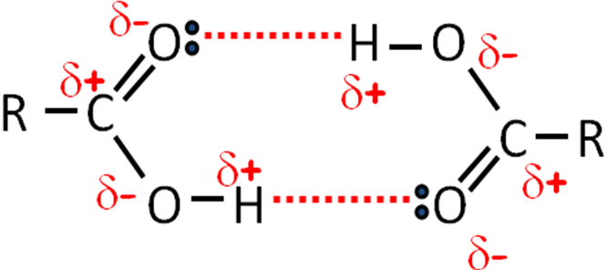

Carboxylic acid groups **form hydrogen bonds** **with water** so molecules up to 4 carbon atoms long are completely soluble.

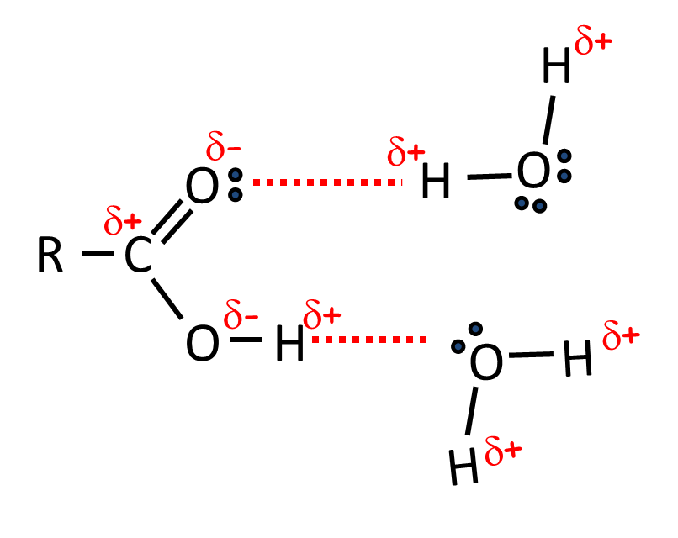

Although the solubility is high they only **form weak acids** as they are only **slightly dissociated** (the equilibrium is well over to the left), so it is only 0.3% ionised. The **carbonyl group attracts electrons away from alcohol group** so **O-H bond** is **weakened** and able to break **releasing a proton** and producing a **carboxylate anion**.

CH3COOH (aq) CH3COO- (aq) + H+ (aq)



HA A- + H+

(weak acid) (anion)

**The charge** on **carboxylate ion** is **shared** between the **two oxygen atoms** due to delocalisation **of the electron**. Thismakes the **ion more stable** and so it is **less likely to gain a proton.**

|  |  |  |
| --- | --- | --- |
|  | N.B.  Double headed resonance arrow is not equilibrium |  |

In alcohols, the O-H bond doesn’t break easily so they don’t show any acidic properties.

Reactions

Salt formed is called sodium ethanoate

Carboxylic acids **react like other acids** with:

* alkali + acid → salt + water

Carboxylate salts are ionic so are water soluble

* + NaOH (aq) + CH3COOH (aq) → CH3COONa (aq) + H2O (l)
* metals + acid → salt + hydrogen

Carboxylate ions have   
1- charge – work out formula for different metal salts

* + 2Na (s) + 2CH3COOH (aq) → 2CH3COONa (aq) + H2 (g)
* carbonates + acid → salt + water + carbon dioxide
  + NaHCO3 (s) + CH3COOH (aq) + → CH3COONa (aq) + H2O (l) + CO2 (g)

This last reaction is used as the **general test for carboxylic acids**.

**Test for carboxylic acids**: add sodium hydrogencarbonatesolution

**Result**: effervescence (due to CO2)

***Prac: Properties of carboxylic acids***

***Sheet: Carboxylic acids (also on Power Point)***

**Esters**

Esters are **made from carboxylic acids and alcohols**. The hydrogen from the OH on the carboxylic acid is replaced by a hydrocarbon group – either an alkyl or aryl (aromatic carbon ring).

|  |  |
| --- | --- |
|  | They have the **suffix – oate** and **general formula RCOOR’**. |
|  |

Making esters

They are formed by a **reversible** reaction between a **carboxylic acid** and an **alcohol**, the reaction is speeded up with a **strong acid** **catalyst** (usually concentrated sulphuric acid, hydrochloric or phosphoric acid can also be used) and **heat**. It’s called **esterification**.

Forward: esterification

Backward: hydrolysis

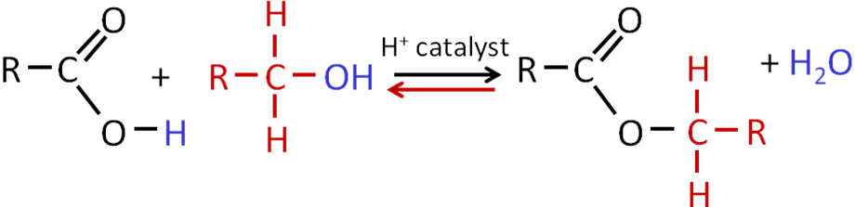

CH3COOH + CH3OH CH3COOCH3 + H2O



***Sheet: Esters - formation***

***Demo: Making esters (AQA)***

***Starter: 4.4 – Reactions of carboxylic acids***

Naming esters

The name is derived from the **carboxylic acid** and **alcohol** used to synthesis the ester.

Acid catalyst: phosphoric or sulphuric acid

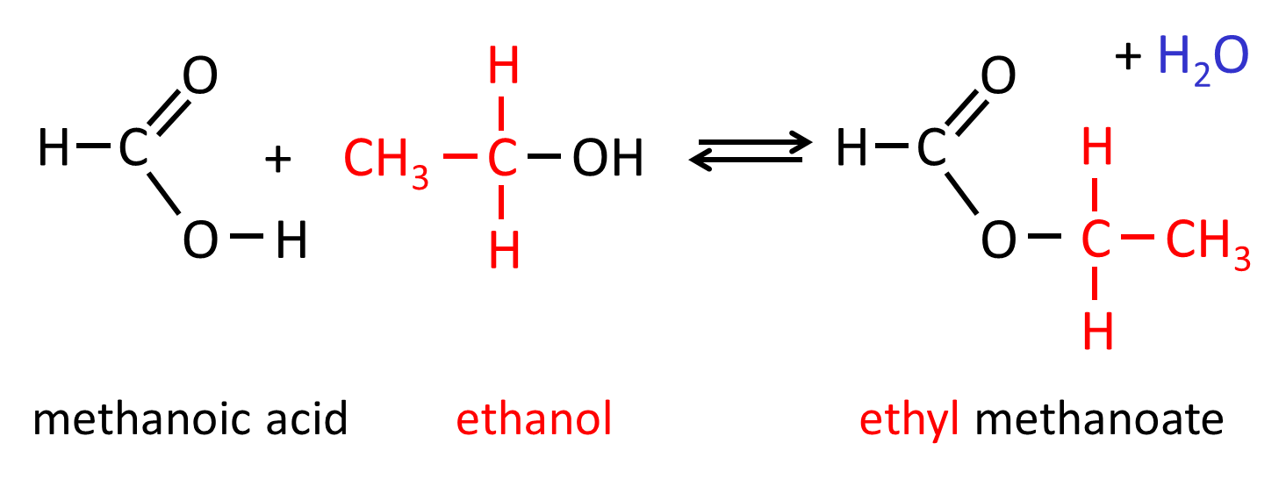

**Help with naming:**A before C – alcohol forms 1st part of name followed by carboxylic acid

**Help with drawing:**

C before A – carboxylic acid part is drawn 1st followed by alcohol chain

The same rule applies if the molecule contains a benzene ring.

|  |  |
| --- | --- |
|  | The **methyl** group comes from the **alcohol** and the **carboxylic acid** was **benzene carboxylic acid**, containing the benzene ring.  It’s therefore called **methyl benzoate**. |

If there are branches on either of the carbon chains these must be numbered.

|  |  |
| --- | --- |
|  | The **ethyl** group comes from the **alcohol** and the **carboxylic acid** was branched containing a **2-methyl butanyl** group.  It’s called **ethyl 2-methylbutanoate**. |
|  |  |
|  | This ester has a **1-methyl propyl** group from the **alcohol** and the **carboxylic acid** was **methanoic acid**.  It’s called **1- methylpropyl methanoate.** |

***Sheet: Esters - esterification***

Uses of esters

**1. Solvents**

There are no free OH groups so no hydrogen bonding is possible and this makes them more volatile and almost insoluble in water. They are polar so are a good solvent for polar organic molecules; the low boiling point allows them to be easy separation by fractional distillation.

E.g. ethyl ethanoate is the solvent in glues and printing inks, butyl propanoate is the solvent used in the pharmaceutical industry and lacquers.

**2. Plasticisers**

Thermoplastics (e.g. PVC) have weak forces between chains but they are not soft or flexible. Adding a plasticiser allows the chains to move, different amounts gives different degrees of flexibility. Over time they escape and so the plastic becomes stiff and brittle.

**3. Food flavourings & fragrances**

Esters have sweet, fruit smells so can be used as artificial flavourings and in perfumes.

***Application: CGP183 PQ1-3***

***Fact recall: CGP183 Q1-2***

Hydrolysis of esters

Making esters is a **reversible** reaction; the **backward** reaction is **hydrolysis** and also requires a **catalyst**. The **oxygen** on carbonyl is **δ+** and **water** acts as a **weak** **nucleophile**. It **doesn’t go to completion** so it produces an **equilibrium mixture** containing the ester, water, acid and alcohol.

**Acid hydrolysis**

Acid hydrolysis splits the ester into an acid and an alcohol; this is the reverse of esterification. **Lots of water is needed** to **push** the **equilibrium** to the **right**.

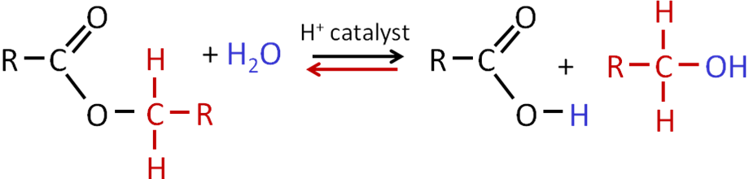

# Reactant: ester + water

# Conditions: acid catalyst – H2SO4 or HCl - reflux

Products: carboxylic acid + alcohol

Equation: RCOOR’ + H2O → RCOOH + ROH

Example: ethyl ethanoate + water → ethanoic acid + ethanol

CH3COOC2H5 + H2O → CH3COOH + C2H5OH

**Base hydrolysis**

A **base** can also be used; this reaction is known as **saponification** and the **salt of the carboxylic acid is produced** rather than the acid itself. The ester is refluxed with a dilute alkali such as sodium hydroxide. The **carboxylate is removed** from the reaction so equilibrium **is not** **established** and the reaction **goes to completion** giving more product.

This method is   
used to make soaps

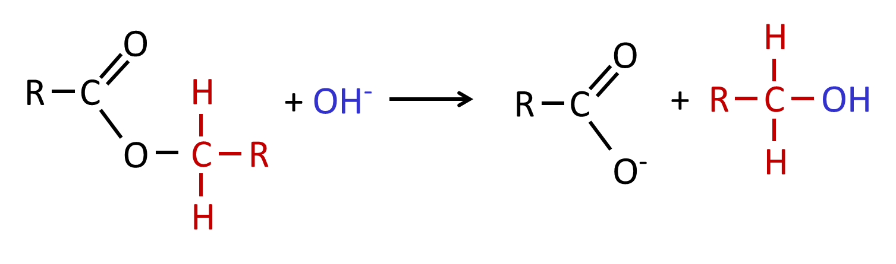

# Reactant: ester + alkali

# Conditions: heat - reflux

Products: carboxylate salt + alcohol

Equation: RCOOR’ + OH- → RCOO- + ROH

Example: ethyl ethanoate + sodium hydroxide → sodium ethanoate + ethanol

CH3COOC2H5 + NaOH → CH3COONa + C2H5OH

**Examples**

propyl ethanoate + potassium hydroxide → propan-1-ol + potassium ethanoate

methylethyl methanoate + sodium hydroxide → propan-2-ol + sodium methanoate

***Sheet: Esters - hydrolysis***

***Required practical 10b: Preparation of a pure organic liquid***

Fats and oils

Acid hydrolysis is widely used with **naturally-occurring esters** such as animal and vegetable **oils and fats**, to **produce** useful products such as **soaps** and **glycerol**. Fats and oils have similar structures just with different melting points so fats are solid and oils liquid at room temperature.

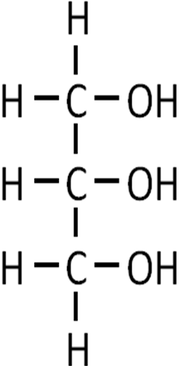

***Task: Draw the displayed formula of propane-1,2,3-triol***

***What is its common name?***

***Demo: Glycerol***

**Formation of oils and fats**

Most oils and fats are formed when esters of the alcohol **propane-1,2,3-triol** react with three long-chain (C12-C18) carboxylic acids commonly called **fatty acids**. The resulting fat or oil are often referred to as **triglycerides** because they are based on glycerol.

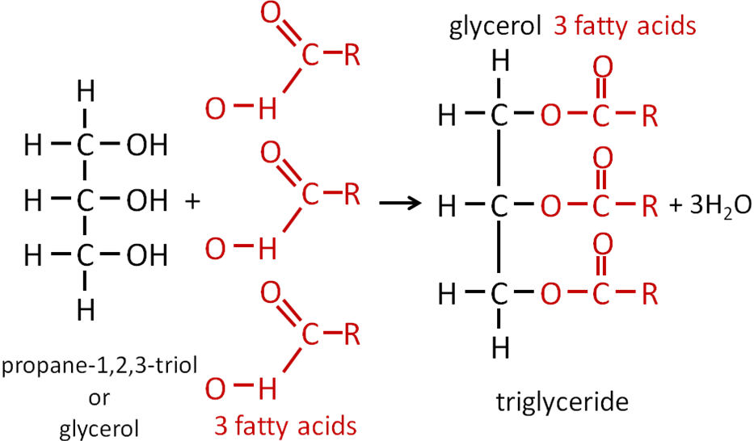

Esterification with loss of 3 water molecules

They can be saturated or unsaturated depending on the fatty acids used.

|  |  |  |
| --- | --- | --- |
| Saturated |  | **Fats** are mainly **saturated** and the chains fit neatly together **increasing** the **van der Waals’** forces so they have **higher melting points** and are **solid** at room temperature. |
| Monounsaturated |  |  |
| Polyunsaturated |  | **Oils** are mainly **unsaturated** and the double bond means they don’t fit neatly together so they are **easier to melt** and are **liquid** at room temperature. |

**Base hydrolysis of fats and oils**

Fats and oils can be **hydrolysed** in **acid** conditions to give a mixture of **glycerol** and **sodium salts of the carboxylic acid**. This is how **soaps** are **made**.

Soaps

Oils and fats can also be **hydrolysed** in the presence of **sodium hydroxide** to **give soaps**. When **fats or oils** are **boiled** with **sodium hydroxide,** **hydrolysis** takes place with 2 useful products; **glycerol** and a mixture of **sodium salts** of thecomponent **carboxylic acids**, these are **soaps**. The type of soap depends on the fatty acids present in the ester.

|  |  |  |  |  |
| --- | --- | --- | --- | --- |
|  |  |  | + |  |
|  |  | **Glycerol**  Readily forms hydrogen bonds so very soluble in water.  **Uses:** pharmaceutical & cosmetics preparations – prevents ointments drying   * solvent in medicines & toothpaste * solvent in food industry e.g. colourings * plasticisers in plastics * wine – increases viscosity & sweetness | | **Sodium salts of carboxylic acids**  Ionic so dissociates to form Na+ and carboxylate ion RCOO- which has 2 distinct ends:   * long hydrocarbon is **non-polar** so mixes with grease, it is **hydrophobic** * RCOO- is **polar** and **ionic** mixes with water   it is **hydrophilic**  **Uses:**   * Allows water and oil/grease to mix – used as cleaning agents |

The **sodium salt** can be **converted** back into the **carboxylic acid** by **reacting** it with and **acid** such hydrochloric acid. The hydrogen ion displaces the sodium ion.

RCOONa + H+ → RCOOH + Na+

sodium salt (soap) fatty acid**Properties of soaps**

|  |  |
| --- | --- |
|  | |
| hydrophilic | hydrophilic |
| water loving | water hating |

How they work:

|  |  |
| --- | --- |
| Remove grease  – form micelles | Lower surface tension of water  – ‘wetting agent’ |
| micelle |  |

***Demo: Properties of soaps***

Biofuels

**AS Link:**

**3.3.2 – Alkane (combustion)**

**Biodiesel** is a **renewal**, **non-petroleum-based** fuel obtained by acid or base-catalysed **transesterification** of vegetable **oils**, most commonly rapeseed or soya bean oil. Waste vegetable oil and discarded animal fats can also be used.

The most common form is methyl esters of long-chain fatty acid, the following reaction uses a **strong alkali as a catalyst**:

oil + methanol → glycerol + methyl ester (biodiesel)

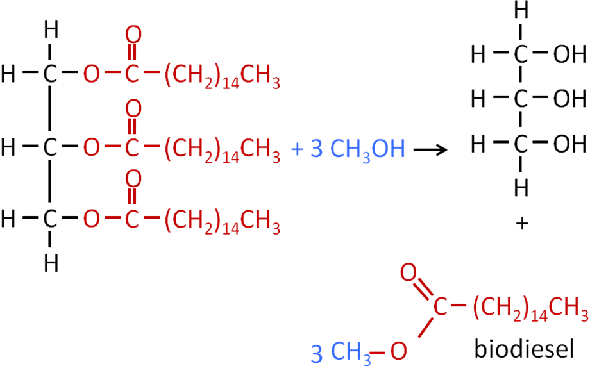

Biodiesel evaluation compared to standard diesel

|  |  |
| --- | --- |
| **Advantages** | **Disadvantages** |
| Renewable – made from plants | Low availability |
| Carbon neutral – no net change | More expensive |
| Burns more cleanly - fewer pollutants/particulate emissions | Poorly made biodiesel can cause engine problems |
| Non-toxic | **Other problems** |
| Biodegradable | Crops grown for biodiesel use land for food crops – could lead to shortage of food |
| High flash point (temperature at which it ignites) – so safer to store | Not enough used cooked oil to produce large quantities so relies on grown sources of oil |
| Can be used directing in unmodified diesel engine | Not completely carbon neutral because other processes release carbon dioxide – energy needed to produce fertilizer, transport when planting and harvesting, also in converting it to biodiesel |
| Can be used neat or blended in any ratio with standard diesel |
| Simple to manufacture |

***Application: CGP187 PQ1-3***

***Fact recall: CGP187 Q1-7***

**Acylation**

**AS Link:**

**3.3.3 – Halogenoalkanes (nucleophilic substitution in haloalkanes)**

Acylation is a process by which the **acyl group** is **introduced** into **another molecule**. An acyl group looks like this:

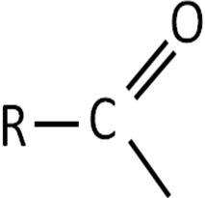

**Aldehydes, ketones, carboxylic acids** and **esters** all contain an **acyl group**.

|  |  |  |  |
| --- | --- | --- | --- |
| Aldehydes |  | Carboxylic acids |  |
| Ketones |  | Esters |  |
| Other series that contain an acyl group | |  | Amides |

Acid derivatives

Another group of compounds which contain an **acyl group** are called **acid derivatives**. They are **derived from carboxylic acids** (hence the name) and have this structure:

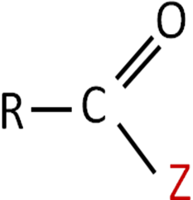

Examples are, where Z is:

* **acyl chlorides** − Cl
* **acid anhydrides** − OCOR

Acyl chlorides and acid anhydrides react in a similar way.

|  |  |  |
| --- | --- | --- |
|  | **Acyl chloride** | **Acid anhydride** |
| Information | Alternative name:  acid chloride | Made from 2 identical carboxylic acid molecules, they join via an oxygen with the elimination of water |
| − Z | − Cl | − OCOR |
| General formula | CnH2n-1OCl | CnH2n-1OOCOR |
| Formula | ROCl | RCOOCOR |
| Displayed formula |  |  |
| Naming | Suffix: -oyl  Carbon atom with acyl functional group is number 1  Branches must be numbered | Name the same as carboxylic acids but replace acid for anhydride |
| Example | ethanoyl chloride  CH3COCl | ethanoic anhydride  CH3COOCOCH3 |

***Starter: 4.3 – Carbonyl functional groups***

***Task: Identify the function group***

***Sheet: Nomenclature***

Reactions

The **carbonyl group** of an acid derivative is **polarised** and so can undergo **attack by** **nucleophiles** on the Cδ+ which **replaces** the **Z** component and the **nucleophile acquires** an **acyl group**.

|  |  |
| --- | --- |
|  | The nucleophile is **acylated**. |

The **Z groups** of acyl chlorides and acid anhydrides are **good leaving** groups because they **withdraw electrons** from the carbonyl group. This makes the **carbon more positive** and **reactive** towards the nucleophiles.

|  |  |
| --- | --- |
|  |  |

Acyl chlorides and acid anhydrides are therefore **good acylating agents** and **useful as synthetic intermediates** for the preparation of other compounds.

**How readily the reaction occurs depends on:**

* magnitude of δ+ (this depends on electron-releasing or attracting power of Z)
* how easily Z is lost
* how good the nucleophile is

Factors 1 and 2 are linked – **groups which strongly attract electrons form stable ions (Z-) and are good leaving groups**.

Nucleophilic addition-elimination reactions

**General equation for acylation**

leaving group - stable species liberated during a reaction

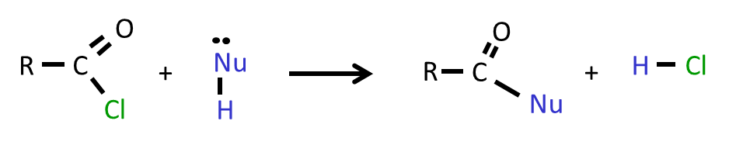

The **nucleophile** is **added** to the carbonyl group followed by **elimination** of a small molecule(the **leaving group, Z**). This is called an **acylation** **reaction** because an acyl group is introduced to the nucleophile but the **mechanism is nucleophilic addition-elimination**. Acyl chlorides and acid anhydrides react in the same way.

Acyl chlorides and acid anhydrides will **react** with the following **nucleophiles**, listed in **order of reactivity**:

|  |  |  |  |  |  |  |  |
| --- | --- | --- | --- | --- | --- | --- | --- |
| Nucleophiles: |  | **>** |  | **>** |  | **>** |  |
| ammonia |  | 1o amine |  | alcohol |  | water |
|  | These nucleophiles are **all neutral** and rely on the **lone pairs** on either an **O or N** so they **must lose an H+** during the reaction – the H atom (active hydrogen) of the nucleophile is **replaced by an acyl group** from the acyl chloride or acid anhydride. | | | | | | |
| Reactants: | acyl chloride or acid anhydride | | | | | | |
| Conditions: | Room temperature and atmospheric pressure | | | | | | |
| Products: |  |  |  |  |  |  |  |
| amide |  | N-substituted amide |  | ester |  | carboxylic acid |
|  |  |  |  |  | A faster way to produce an ester than esterification.  Not reversible. | | This is a hydrolysis reaction. |

Equations: RCOCl + **2**NH3 → RCONH2 + NH4Cl excess ammonia used to react with H+

(RCO)2O + **2**NH3 → RCONH2 + RCOONH4 salt formed from Cl- + NH4+

RCOCl + RNH2 → RCONHR + HCl *1

(RCO)2O +RNH2 → RCONHR + RCOOH *2

RCOCl + ROH → RCOOR + HCl *1

(RCO)2O + ROH → RCOOR + RCOOH *2

RCOCl + H2O → RCOOH + HCl *1

(RCO)2O + H2O → 2RCOOH *2

*1 misty fumes - base added to neutralise HCl*2 weak acid so no fumes

General mechanism: (only need to be able to draw the mechanisms for acyl chlorides)

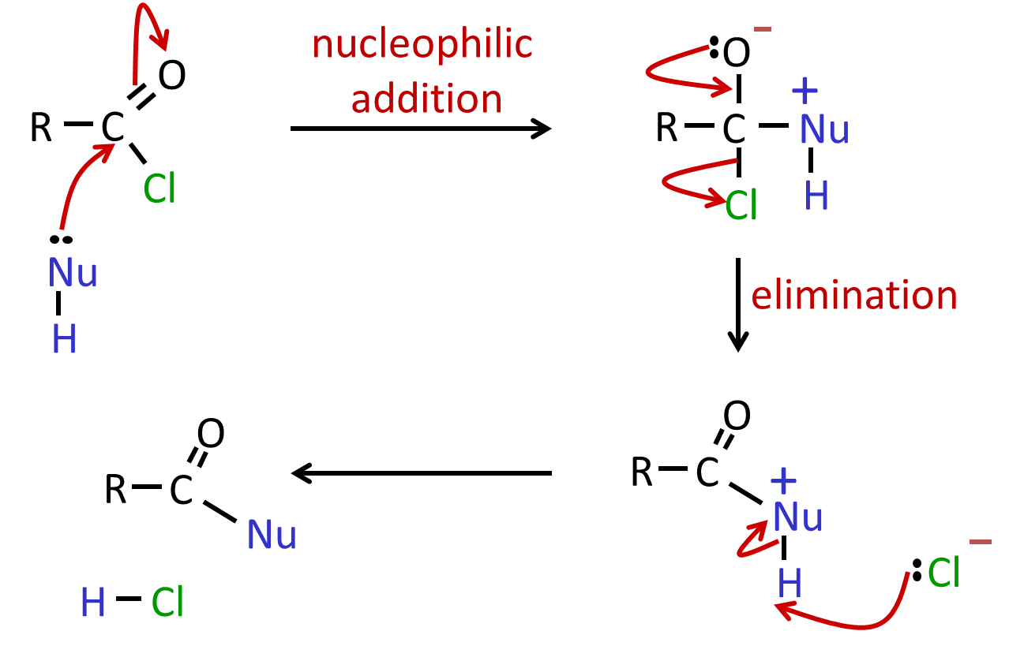

General mechanism with ammonia:

base

– proton acceptor

nucleophile

– electron pair donor

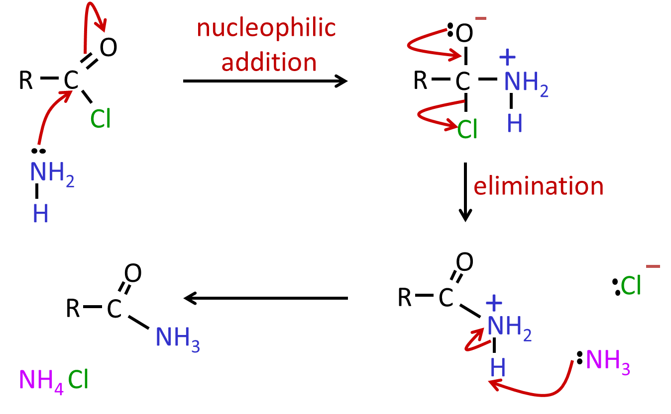

***Note***: Two molecules of ammonia are used – initially it acts as a **nucleophile** then as a **base** to accept the proton

Comparing acyl chlorides and acid anhydrides

|  |  |  |
| --- | --- | --- |
|  | **Acyl chloride** | **Acid anhydride** |
| Advantages | * Faster * Not reversible * Higher yield * Purer product * No acid catalyst required | * Less reactive * Less corrosive * Safer - by-product is carboxylic acid rather than hydrogen chloride gas |
| Disadvantages | * **Extremely reactive\*** (more than acid anhydride) * Corrosive by-product HCl gas   *Carbon is* ***strongly δ****+ because it’s* ***bonded*** *to* ***oxygen*** *and* ***chlorine*** *which both have a* ***high******electronegativity*** *so* ***withdraw electrons*** *from the carbon* | * Slower * By-product difficult to separate |

***Task: Complete acylation reaction summary***

***Task A: Acylation reactions – complete products, equations & mechanisms:***

1. ethanoyl chloride + water → ethanoic acid + hydrogen chloride  
   CH3COCl + H2O → CH3COOH + HCl
2. ethanoyl chloride + ethanol → ethyl ethanoate + hydrogen chloride  
   CH3COCl + CH3CH2OH → CH3COOCH2CH3 + HCl
3. ethanoyl chloride + ammonia → ethanamide + ammonium chloride  
   CH3COCl + 2NH3 → CH3CONH2 + NH4Cl
4. ethanoyl chloride + methylamine → N-methylethanamide + hydrogen chloride

CH3COCl + CH3NH3 → CH3CONHCH3 + HCl

***Task B: Acylation reactions – complete products & equations:***

1. ethanoic anhydride + water → ethanoic acid  
   (CH3CO)2O + H2O → 2 CH3COOH
2. ethanoic anhydride + ethanol → ethyl ethanoate + ethanoic acid

(CH3CO)2O + CH3CH2OH → CH3COOCH2CH3 + CH3COOH

1. ethanoic anhydride + ammonia → ethanamide + ammonium ethanoate  
   (CH3CO)2O + 2NH3 → CH3CONH2 + CH3COO-NH4+
2. ethanoic anhydride + methylamine →N-methylethanamide + ethanoic acid

(CH3CO)2O + CH3NH3 → CH3CONHCH3 + CH3COOH

***Sheet: Acylation reactions - Stella***

***Application: CGP190 PQ1-2***

***Fact recall: CGP190 Q1-3***

***Task: Animate general mechanism for acylation***

**Useful websites on acylation reactions:**

|  |  |
| --- | --- |
| General information | <http://www.chemguide.co.uk/mechanisms/addelimmenu.html#top> |
| Mechanism animations | <http://cd1.edb.hkedcity.net/cd/science/chemistry/s67chem/reaction_mechanism_animation_e.swf> |

Uses of acylation reactions

A major use of **ethanoic anhydride** is in manufacture of **aspirin**, it’s an analgesic (pain killer) and anti-pyretic (reduces fever); more recently it has been found to have other benefits such as reducing the risk of heart attacks and some cancers. It does have some risks though, such as causing internal bleeding. It has a long history and compounds related to it were originally extracted from the bark of willows (*Latin: Salix*).

Its IUPAC name is **2-ethanoyloxybenzene carboxylic acid** (old name is acetylsalicylic acid). It is **synthesised from 2-hydroxybenzenecarboxylic acid** (known as salicylic acid).

***Task: Draw structures***

|  |  |
| --- | --- |
| 2-hydroxybenzenecarboxylic acid | 2-ethanoyloxybenzenecarboxylic acid |
|  |  |

**Synthesis of aspirin**

Reaction: 2-hydroxybenzenecarboxylic acid + ethanoic anhydride

→ 2-ethanoyloxybenzenecarboxylic acid + ethanoic acid

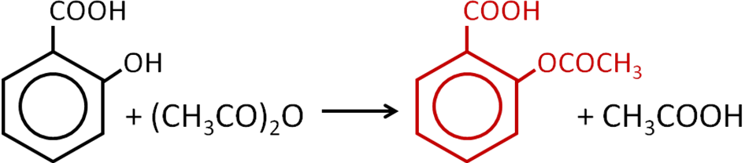

***Required practical 10a: Preparation of an organic solid and test of its purity***

***Task: Required practical 10a research***

***Application: CGP192 PQ1-3***

***Fact recall: CGP192 Q1-2***

Determining purity of products

**Melting point**

One method of **identifying** a substance and determining if it is pure is to measure its **melting point**. This can be done manually using a Thiele tube or using an electronic melting point apparatus.

|  |  |
| --- | --- |
| **Thiele tube** | **Electronic** |
|  |  |

**Infra-red analysis**

Infra-red can be used to precisely identify a substance and confirm the presence of any impurities.

|  |  |
| --- | --- |
| 2-hydroxybenzenecarboxylic acid | 2-ethanoyloxybenzenecarboxylic acid |
|  |  |

***Application: CGP196 PQ1-2***

***Fact recall: CGP196 Q1-4***

***Exam questions: Oxford p169 Q1-4***