3.9.3 Assessing internationalisation

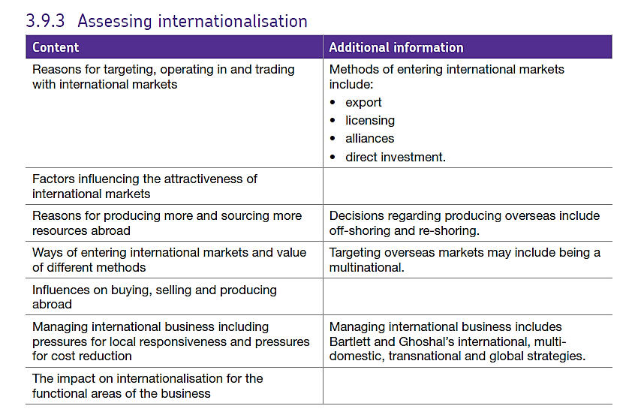

# Strategies for Expanding into International Markets

A business analysing the options suggested by Ansoff’s Matrix might be tempted to focus on the bottom-left quadrant (market development) and try to enter international markets as part of a growth strategy. Selling into international markets is increasingly attractive for UK businesses. For example because of:

* Stronger economic growth in emerging economies such as China, India, Brazil and Russia (BRICs) and Malaysia, Indonesia, Nigeria & Turkey (MINT)
* Market saturation and maturity (slow or declining sales) in domestic markets
* Easier to reach international customers using e-commerce
* Greater government support for businesses wishing to expand overseas

# The main methods of investing in international markets are:

## Exporting direct to international customers

The UK business takes orders from international customers and ships them to the customer destination

**Advantages**

* Uses existing systems – e.g. e-commerce
* Online promotion makes this cost-effective
* Can choose which orders to accept
* Direct customer relationship established
* Entire profit margin remains with the business
* Can choose basis of payment – e.g. terms, currency, delivery options etc

**Disadvantages**

* Potentially bureaucratic
* No direct physical contact with customer
* Risk of non-payment
* Customer service processes may need to be extended (e.g. after-sales care in foreign languages)

## Selling via overseas agents or distributors (including Licensing)

A distribution or agency contract is made with one or more intermediaries, distributors & agents may buy stock to service local demand. The customer is owned by the distributor or agent. Licensing involves giving a local / domestic manufacturer a licence to produce your product and sell it under your brand name in return for a fee or a % of the profits. Companies such as Disney use licensing to give manufacturers the right to produce products using their characters.

**Advantages**

* Agent of distributor should have specialist market knowledge and existing customers
* Fewer transactions to handle
* Can be cost effective – commission or distributor margin is a variable cost, not fixed

**Disadvantages**

* Loss of profit margin
* Unlikely to be an exclusive arrangement – question mark over agent and distributor commitment & effort
* Harder to manage quality of customer service
* Agent / distributor keeps the customer relationship

## Opening an operation overseas (direct investment)

Involves physically setting up one or more business locations in the target markets. Initially may just be a sales office – potentially leading onto production facilities (depends on product). This can be done through organic growth or through acquisition. This can allow firms to become multinational rather than international.

**Advantages**

* Local contact with customers & suppliers
* Quickly gain detailed insights into market needs
* Direct control over quality and customer service
* Avoids tariff barriers

**Disadvantages**

* Significant cost & investment of management time
* Need to understand and comply with local legal and tax issues
* Higher risk

## Joint venture or buying a business overseas (licensing or direct investment or alliances)

The business acquires or invests in an existing business that operates in the target market or forms an alliance (a less formal agreement than a joint venture) to enter the market. Alliances can involve sharing technology as well as market expertise e.g. logistics and supply chain network.

**Advantages**

* Popular way of entering emerging markets
* Reduced risk – shared with joint venture partner
* Buying into existing expertise and market presence

**Disadvantages**

* Joint ventures often go wrong – difficult to exit too
* Risk of buying the wrong business or paying too much for the business
* Competitor response may be strong

Whatever method is used, a business looking at international expansion needs to consider some specific risk factors:

**Cultural differences:** a business needs to understand local cultural influences in order to sell its products effectively. For example, a product may be viewed as a basic commodity at home, but not in the target overseas market. The sales and marketing approach will need to reflect this.

**Language issues:**although the common business language worldwide is now English, there could still be language issues. Can the business market its product effectively in the local language? Will it have access to professional translators and marketing agencies?

**Legislation:** legislation varies widely in overseas markets and will affect how to sell into them. A business must make sure it adheres to local laws. It will also need to consider how to find and select partners in overseas countries, as well as how to investigate the freight and communications options available.

Influences on firms buying from abroad (importing).

Often the unit cost of importing raw materials is significantly lower than the UK domestic cost, however there are other issues to consider such as quality, promptness, reliability of supply and after-sales service.

Influences on firms selling abroad (exporting or manufacturing for foreign markets)

If firms want to move abroad they have to consider whether they have the resources and whether they will have adequate capabilities to make the move successful. These might include finance, HR, marketing budgets etc. have a competitive advantage which will give them a USP e.g. technology or their portfolio of products.

## Offshoring

Offshoring involves the **relocation**of business activities from the home country to a different international location. It is the **changed international location** of where the business activity is performed that is key to understanding offshoring. Offshoring has traditionally been associated with the relocation of manufacturing activities from a domestic economy overseas (e.g. from the US to China, or UK to Poland). However, offshoring is also increasingly common with business services (e.g. UK financial services using call centres based in India).

## The Difference between Offshoring and Outsourcing

Take care with the difference between two similar-sounding terms, they are not the same thing!

Offshoring is **WHERE** the work is done, offshoring involves changing the international location of WHERE work is done for or by a business.

Outsourcing is **WHO** does the work, outsourcing involves changing WHO does work for a business - away from the business itself to an external supplier.

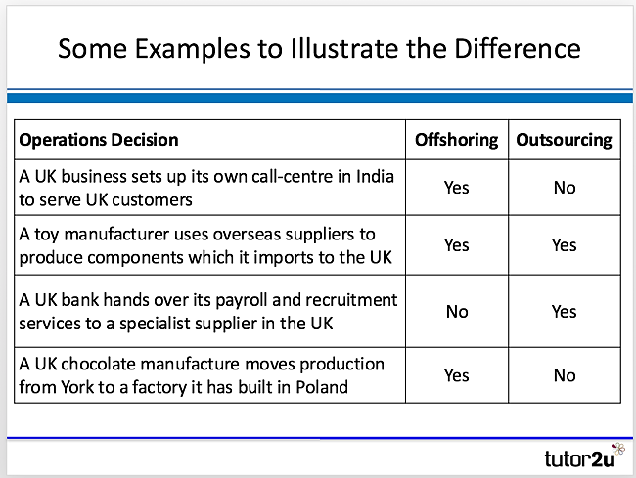The table below illustrates some examples of the distinction between offshoring and outsourcing.

# Key Reasons for Offshoring

Why might a business decide to change the international location of where its business activities are undertaken? Key reasons include:

* To access lower manufacturing costs (particularly in emerging markets which enjoy the advantage of lower labour costs)
* To access potentially better skilled & higher quality supply
* To makes use of existing capacity overseas
* To take advantage of free trade areas
* To make it easier to supply target international markets (where it is important to be located in, or near to, those markets)

# Potential Drawbacks to Offshoring

Like all decisions about where to locate business operations, there are potential drawbacks to offshoring, including:

* Longer lead times for supply & risks of poorer quality
* Implications for CSR (harder to control aspects of operating long distances away from the home country)
* Additional management costs (time, travel)
* Impact of exchange rates (potentially significant)
* Communication: language & time zones

# Reshoring

[](https://www.tutor2u.net/business/blog/reshoring-clarks-moves-show-manufacturing-back-to-the-uk)

This involves the return of production activities to a home country that had previously been offshored.

A firm which has re-shored production back to the UK is Clarks.

# Bartlett & Ghoshal Model of International Strategy

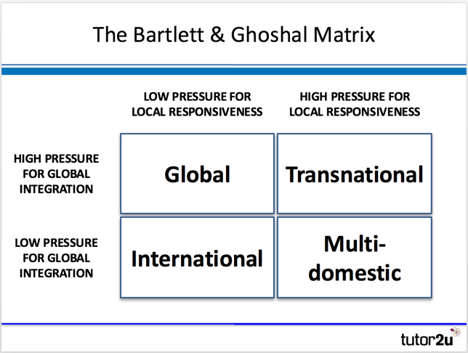The Bartlett & Ghoshal Model indicates the strategic options for businesses wanting to manage their international operations based on two pressures: local responsiveness & global integration.

The two "pressures" or forces on firms wanting to compete in international markets, which determine the four grids in the box above are:

## Force for local responsiveness

This considers questions such as:

* Do customers in each country expect the product to be adapted to meet local requirements?
* Do local (domestic competitors) have an advantage based on their ability to be more responsive?

## Force for global integration

This considers questions such as:

* How important is standardisation of the product in order to operate efficiently (e.g. economies of scale)?
* Is consistent global branding required in order to achieve international success?

The key features of each box in the Bartlett & Ghoshal model are outlined below:

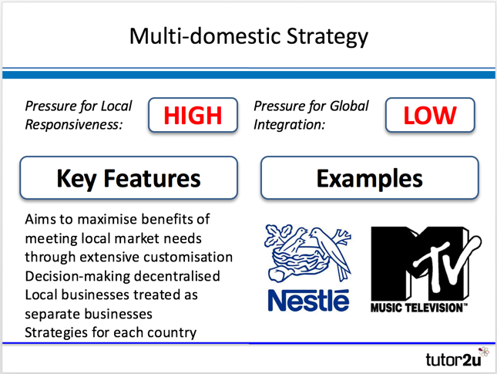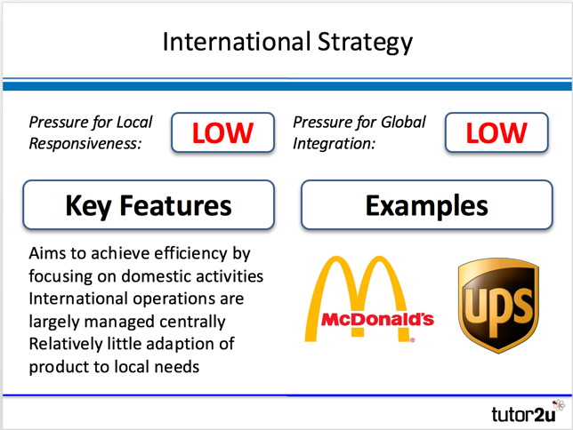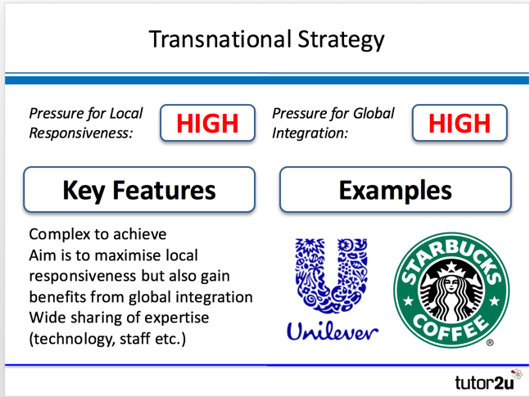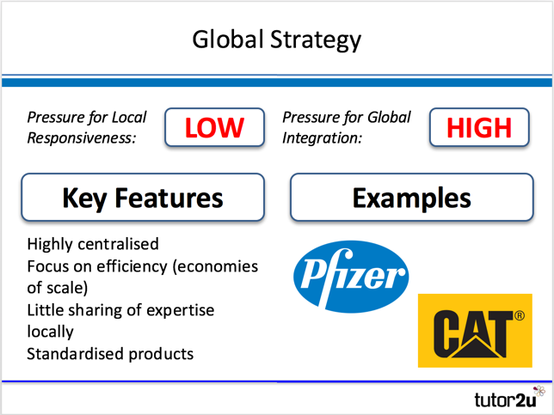

# Impact of internationalism on the functional areas:

|  |  |
| --- | --- |
| Finance   * Costs can be very high and, in some cases, unpredictable. * Borrowing may be necessary so the firm may need to be low-geared. * Budgets, variance analysis and cost management will be important * Diseconomies of scale may occur | Operations   * Firm may need to improve productivity through capital intensive production to make international business viable * Does decision-making need to be centralised or decentralised – might depend on the necessary levels of global integration and local responsiveness * How should a location be chosen? * Quality assurance procedures will become vital |
| Marketing   * Marketing mix may need to be adapted to cater for different markets and social / cultural expectations. * Marketing function will need to grow to cope with strategic marketing differences in different countries * Product development will require investment * More difficult to manage the product portfolio. | People   * Workforces in different countries respond to different management styles so methods of working may have to change. * Recruitment, training and rewarding will be different in different countries * Employment laws will be different and need to be adhered to offshoring will lead to redundancies. |