**The Aeneid – Book 7**

**Read lines 1-39**

What does Virgil do with the place name of Caieta that he has done before?

What details in *The* *Odyssey*, Book 10, are alluded to when Virgil references Circe?

|  |  |
| --- | --- |
| **Virgil** | **Homer** |
| ‘daughter of the Sun’ |  |
| ‘untrodden groves’ |  |
| ‘ringing with never-ending singing’ |  |
| ‘fragrant cedar wood’ |  |
| ‘proud palace’ |  |
| ‘sounding shuttle runs across’ |  |
| ‘…lions…wolves’ |  |
| ‘irresistible herbs’ |  |

Why do you think Virgil feels no need to elaborate on these details?

How does Virgil make Aeneas’ first sight of Italy idyllic?



**Read lines 40-107**

Virgil invokes the Muse a second time, this time naming ‘Erato’, the Muse of Love. Why do you think this is the case given the second half of the *Aeneid* focuses on war?

What Homeric theme does this continue?

Why do you think Virgil is going to tell us about the history of Latium?

Why do you think Virgil states the second half of the *Aeneid* is ‘a higher order of things’ and ‘a greater work’?

Create a small family tree for Latinus:

Complete the following diagram:

**Omen 2**

**Omen 1**

**Read lines 108-285**

What do we learn about the oracle under Mount Albunea?

What is the message for Latinus?

Complete the following:

What was happening?

Ascanius, ‘Look! We are eating even our tables!”

How was the saying interpreted?

To whom does Aeneas pray at this point?



What omens does Jupiter send and how are they interpreted?

As Aeneas’ men leave to see Latinus, what does he do to build his camp? What is the significance of this?

What activities and buildings do we see at the city of the Latins?

**Buildings**

**Activities**

What features remind us of Roman civilization? Why are the Latins made to look Roman already?

What details are included about the statues of the following ancestors?

|  |  |
| --- | --- |
| **Ancestor** | **Details** |
| Sabinus |  |
| Picus |  |

How does Latinus brag about the Latin’s ancestral past to the Trojans? How does Ilioneus do likewise? Use quotes and explain their importance.

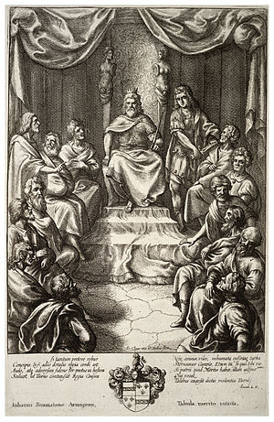

**Latinus**

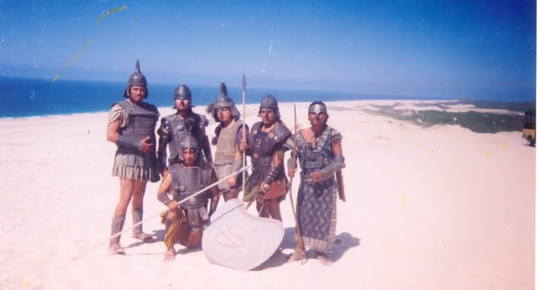

**Ilioneus**

What does Ilioneus say to Latinus to convince him to help them?

|  |  |
| --- | --- |
| **Quote** | **How would it be convincing?** |
|  |  |
|  |  |
|  |  |
|  |  |
|  |  |
|  |  |
|  |  |

What did Latinus think to Ilioneus’ speech?



|  |  |
| --- | --- |
| **What does Latinus say he will give the Trojans?** | **What does he expect from Aeneas?** |
|  |  |

How does Latinus show his belief in Aeneas’ illustrious destiny?

**Read lines 286-405**

Compare what Juno has made the Trojans suffer to what she intends to do to them in the future:

**Future**

**Past**

Why do you think Virgil uses Homer’s Charybdis and Scylla but as tools for Juno rather than independent opponents?

Reread Book 1.34-49. How is Juno’s point similar to the one she makes in Book 7 about Mars and Diana?

How does Virgil use a parallel to the Trojan War to create the impression of a ‘tragic cycle’?

Throughout Book 7, annotate around the picture with Virgil’s graphic depictions of Alecto and the effects she has on Amata and Turnus. Use a different colour for each character:

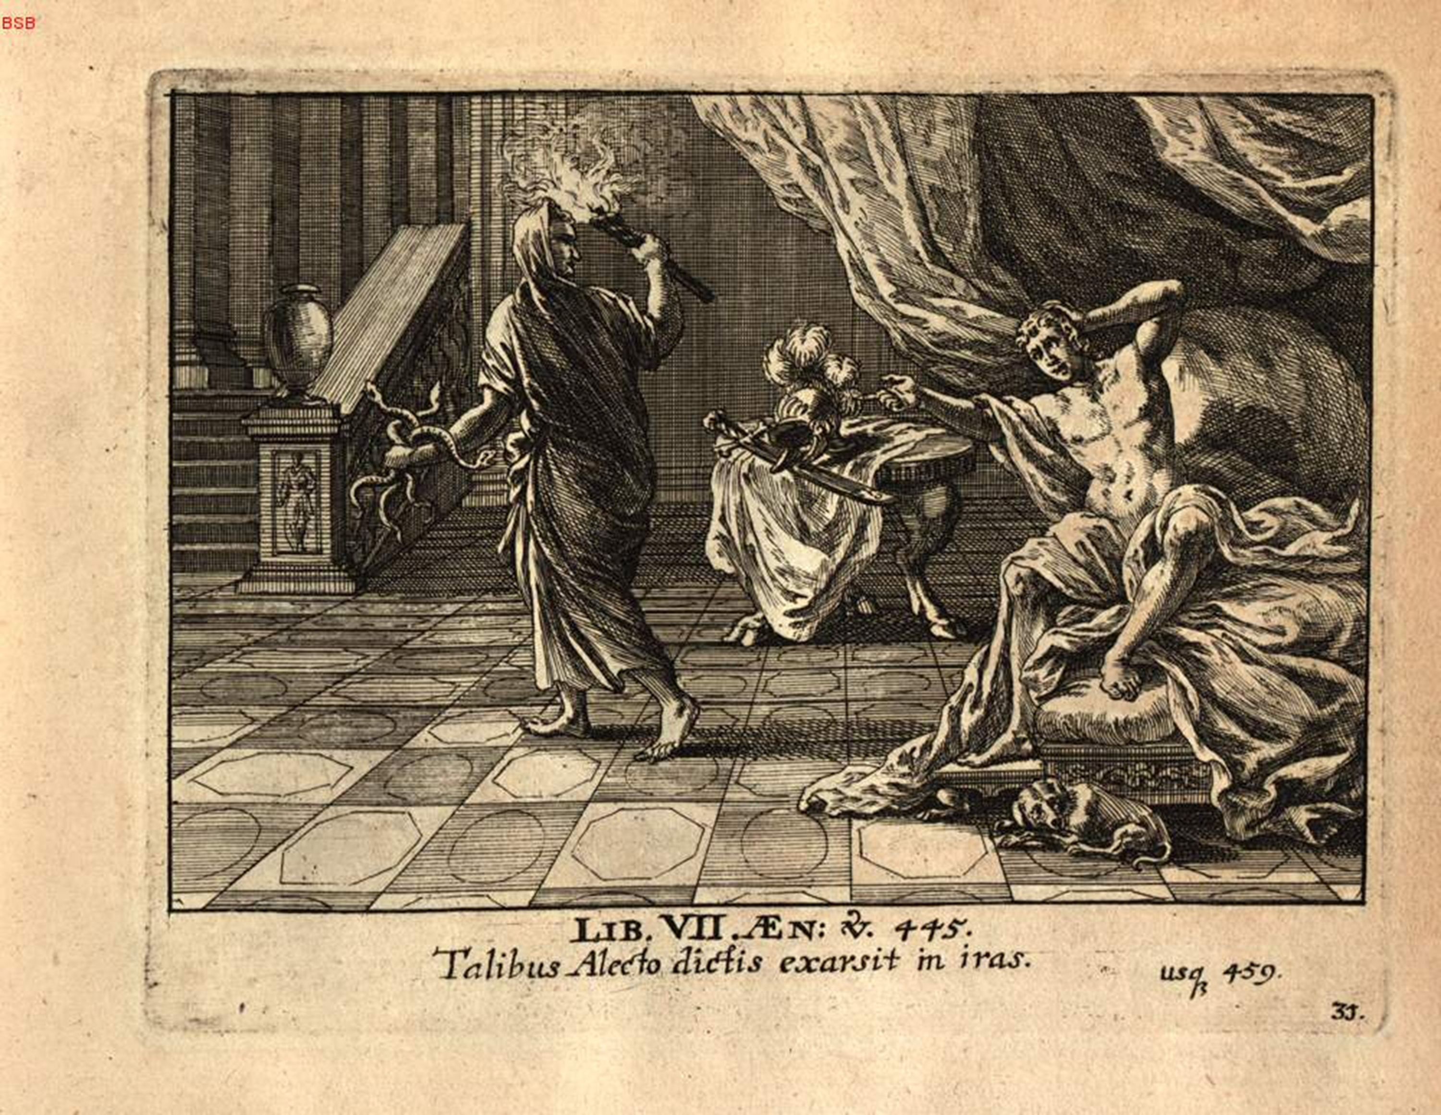

What are the final four questions Amata asks Latinus? Why might these make the Romans feel uneasy about the story?

**?**

1)

**?**

2)

**?**

3)

**?**

4)

List all the ways Amata and the other Latin women are shown as crazed Bacchants:



Where else has Virgil used a parallel with Bacchanalian revelry? Why, in both cases, is this parallel appropriate?

**Read lines 406-475**

During this passage, continue your annotation of Allecto’s depiction.

What do we learn about Allecto’s new disguise?

How does Allecto try to convince Turnus of the following?

|  |  |
| --- | --- |
| **He has been betrayed** | **He should take action** |
|  |  |

How is Turnus shown as impetuous both before and after Allecto reveals herself?

**After**

**Before**

‘It was as though a heap of brushwood…flying into the air.’ How does the language in this simile reflect Turnus’ mood?

‘The peace was violated.’ Why does Virgil use such a succinct phrase here?

What three things do the Rutulians admire in Turnus?

1)

2)

3)

What do you think Virgil’s audience would think of these?

**Read lines 476-539**

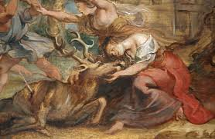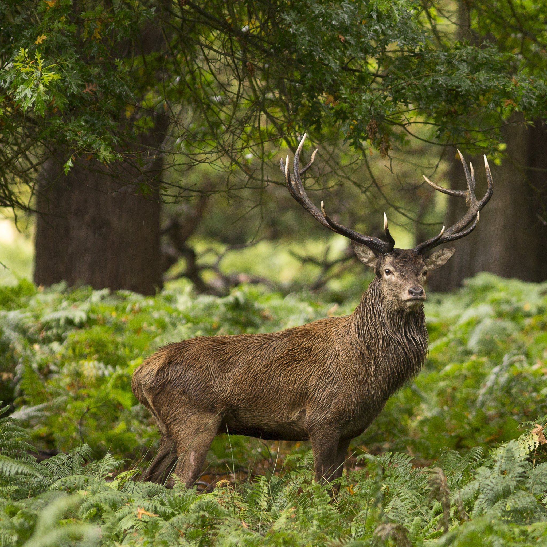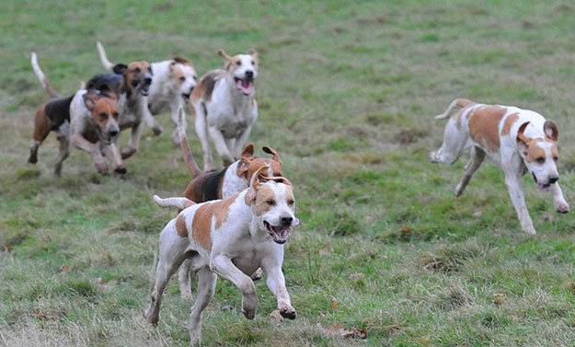Complete the following to show how Ascanius’ hunt escalates into conflict:

|  |  |  |
| --- | --- | --- |
|  |  |  |
|  |  |  |
|  |  | **X** |
|  |  |  |

How does Virgil’s sea simile convey the escalation of the situation?

Why do you think Virgil provides a background story for Galaesus?

**Read lines 540-571**

What does Allecto suggest could happen next? How does Juno reply?

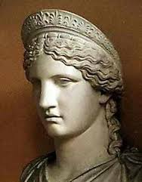

Draw the scene you imagine when you read the description of the entrance to Dis. Use colour and label it with details from the passage:

**Read lines 572-641**

Annotate this quote to explain Virgil’s simile:

**‘…standing fast with the waves howling round it…’**

How and why are the Gates of War shown as so strong?

The gates were open through most of Rome’s history, but closed twice during Augustus’ reign (29 BC and 25 BC). Why is that significant?

Why does Virgil tell us about the tradition of opening the gates, first performed by Quirinus (i.e. Romulus)?

Why do you think Virgil has Juno herself force open the doors?

List the ways the Italians prepare for war:



**Read lines 642-810**

How does Virgil mark out this section as separate?

Here Virgil gives a catalogue of forces in the tradition of Homer’s Iliad, but chooses to describe the Italians (Aeneas’ enemies). What does this tell us about Virgil?

Complete the following table:

|  |  |  |
| --- | --- | --- |
| Hero | What do we learn about their family? | What do we learn about the way they fight? |
| Lausus | He deserved a better father than Mezentius |  |
| Aventinus | He was the son of Hercules and Rhea. He had Hercules’ blazon (the Hydra) on his shield and he dressed like him (with a lion’s skin) | His men used javelins and pikes, throwing them into the enemy. |
| Catillius and Coras |  |  |
| King of Praeneste |  |  |
| Messapus |  |  |
| Clausus |  |  |
| Halaesus |  |  |
| Oebalus |  |  |
| Ufens |  |  |
| Umbro |  |  |
| Virbius |  |  |
| Camilla |  |  |

How does Virgil show Turnus is the most prominent Italian?

Why is the story of Clausus so significant to Virgil?

List all the mythological links to these different heroes:

**Appendix – A Guide to the Factions of the War in Italy**

|  |  |  |  |
| --- | --- | --- | --- |
| **Turnus’ Army** | | **Aeneas’ Army** | |
| **Latinus** | | **Aeneas** | |
| People: | The Latins of Latium | People: | Trojan exiles |
| Capital: | Laurentum | Capital: | In search of one |
| Motivations: | Latinus does not wish to fight himself, believing that the gods have decided Aeneas must marry his daughter, Lavinia. | Motivations: | Aeneas has been offered Lavinia as a bride by Latinus. He wants to forge a peace with the Italians but is forced to fight Turnus. |
| **Turnus** | | **Evander** | |
| People: | The Rutulians | People: | The Arcadians |
| Capital: | Ardea | Capital: | Pallanteum |
| Motivations: | Turnus was the primary suitor of Lavinia before Aeneas arrived. He now feels he must fight for her and has assumed control of the Latins as Latinus steps down. | Motivations: | Evander had known Anchises and learnt that he shared a common ancestry with Aeneas. He sends his army under the command of his son, **Pallas**. |
| **Mezentius** | | **Tarchon** | |
| People: | The Etruscans | People: | The Etruscans |
| Capital: | Argylla | Capital: | Tarchna |
| Motivations: | Mezentius had been exiled by his people for his cruelty. He is a guest friend of Turnus and goes to war with him alongside his son, **Lausus**. | Motivations: | Tarchon commands the Etruscan league of cities (including some Ligurians too). They are wishing to bring Mezentius to justice. |
| **Other Italians** | |  | |
| The following people also contribute to Turnus’ army:   * Some other Etruscans * The Sabines * The Samnites * The Volsci, led by **Camilla** | |