Gender and crime



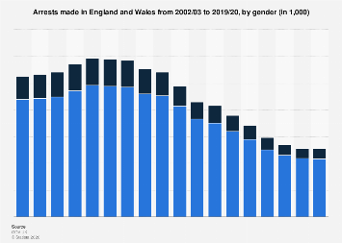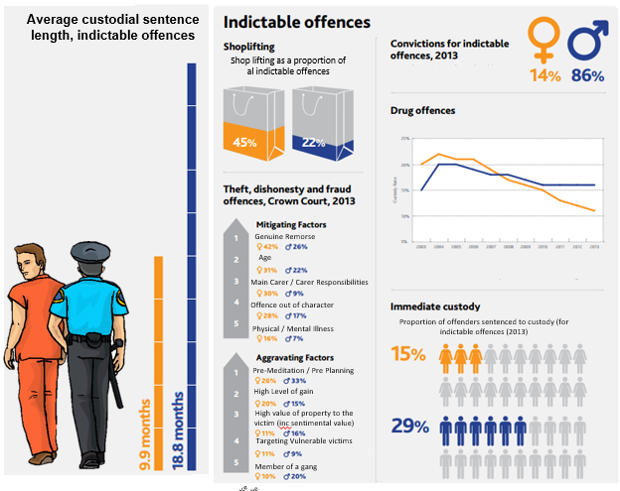

To begin, what do you think the statistics might show?

Summarise the trends in these statistics.

How might you explain these trends?

**Difference in Gender and Crime – possible explanations.**

There is so little female crime that much criminology and sociology has ignored it and focussed exclusively on men.

**Do women commit more crime that the statistics suggest?**

Where have we met the idea that our statistics may be wrong before?

Maybe the statistics underestimate female crime.

Because typical ‘female’ crimes are less likely to be reported. Shoplifting may not be noticed or reported in contrast to male violent or sexual crimes. Prostitution is also unlikely to be reported by either party.

Women may be less likely to be prosecuted.

**Another explanation – the chivalry thesis**

This is the claim that most criminal justice agents are men and they are socialised to act in a chivalrous way towards women.

Otto Pollak *‘Men hate to accuse women and thus send them to their punishment, police officers dislike to arrest them, district attorneys to prosecute them, judges and juries to find them guilty and so on.’* Men are socialised to be protective of women.

So the criminal justice system is more lenient with women, women are less likely to be arrested and are treated more fairly if they are arrested.

**Self-reported studies** these ask individuals to disclose their own dishonest and violent behaviour. These suggest that women are treated more leniently. Graham and Bowling found that men are more likely to offend but the difference is smaller than recorded in official statistics. They found men are 2.33 times more likely than women to commit a crime whereas official statistics suggest this figure is 4 times more likely. Flood-Page et al found that 1 in 11female self-reported offenders had been cautioned or prosecuted in contrast to 1 in 7 men.

**Official statistics** court statistics appear to support the chivalry thesis



**BUT** The Chivalry thesis has been criticised – some sociologists argue that women’s crimes are less serious (for example they are less likely to be violent) which is why they are punished less harshly than men. Women also often show remorse which means they are likely to be treated more leniently.

**Feminists say that** women are treated more harshly when they deviate from gender norms,

What does society expect of women and why might they society them more harshly when they are not like this?

Feminists claim that double standards exist as society is patriarchal. Consider rape cases. Male judges may make sexist, victim blaming remarks.

Judge Wild said *‘Women who say no do not always mean no. It is not just a question of how she says it, how she shows and makes it clear. If she doesn’t want it she only has to keep her legs shut.*

Sandra Walklate argues that in rape cases it is not the defendant who is on trial but the victim. She has to prove her respectability in order to have evidence accepted.

Recap – how can patriarchy be used to suggest bias in favour of women and bias against women in crime?

So how do we explain female crime?

1. **Sex Role Theory - Functionalists**

How are boys and girl brought up? Think about early socialisation.

Parsons looks at the traditional nuclear family claiming that boys reject traditional feminine models of behaviour. How do boys try to be instead?

Why might this lead boys committing more crime?

How might this theory be criticised?

1. **Social Control**

Do parents treat boys and girls differently? How might this explain crime?

**Heidensohn** suggests that women have less opportunity than men to commit crime. We live in a patriarchal, male dominated society so women can’t commit fraud for example as do not have access to large sums of money so female crimes are more related to the home (eg shoplifting).

1. **Liberation Thesis**

Perhaps society is becoming less patriarchal which may suggest female crime will increase.

**Adler** argues that women’s offending behaviour is changing. This will lead to more female white collar crime. This can be supported by media coverage of girl gangs and suggestions that young women are more willing to take risks.

Criticisms of this theory?