**3.3.4 Alkenes**

**AS Link:**

**3.3.1 - Introduction to organic chemistry**

**3.1.3 - Bonding**

**Structure**

Alkenes are **unsaturated** hydrocarbons, made of hydrogen and carbon only with one or more carbon-carbon double bond. They form a **homologous series**.

N.B. This is also general formula for cycloalkane

**General formula** CnH2n

There can be **two double bonds**, e.g. pent-1,3-diene (CH2CHCHCHCH3) and **cyclical** **alkenes** also exist, e.g. cyclopentene (C5H8), these have a different general formula.

The double bond makes them **more reactive than alkanes**, as it is an area of **high electron density**. They are **produced** in large quantities when crude oil is **thermally cracked**. The spacial arrangement around the **C=C bond** is **planar** and the **bond angles** are **120°**.

They are **non-polar** so are **insoluble** in **water**.

**Bonding**

***Demo: Electron cloud model ethene***

Carbon electronic configuration is **1s2 2s2 2p2**. If you provide a bit of energy you can promote one of the **s electrons into a p orbital**, the new configuration is **1s2 2s12p3**. The process is favourable because the new arrangement of electrons gives rise to **4 unpaired electrons with less repulsion**, which is **more stable**.

|  |  |
| --- | --- |
| 1s2 2s2 2p2 | 1s2 2s12p3 |
|  |  |

**Covalent** **bonds** are formed by the **overlap of orbitals** from each carbon to form a **single C-C** bond.The resulting bond is called a **sigma (δ) bond**.

|  |  |  |
| --- | --- | --- |
|  |  |  |

The singly filled 2p orbitals also overlap to form a **second bond**. This is known as a **pi (π) bond**. For maximum overlap and to give the strongest bond, the 2p orbitals are **in line**; this gives rise to the **planar** arrangement around C=C bonds. The pi bond has an **electron cloud above** and **below** the molecule, giving an area of **high electron density**.

|  |  |
| --- | --- |
|  |  |

|  |  |
| --- | --- |
| This leads to 2 types of covalent bonds which give rise to the double bond.   * σ (sigma) – shared electron density between nuclei * π (pi) – parallel above and below the plane so it prevents bond rotating   You will not be tested on the specifics of how the double bond forms. |  |

**Isomers**

**Demo: Models**

**Structural** isomers have the same molecular formula different structures

Reminder:

* Chain e.g. butane & methylpropane
* Positional e.g. but-1-ene & but-2-ene
* Functional group e.g. hexane & cyclohexane

**Stereoisomers** are compounds which have the same structural formula but the bond are arranged differently in space

* Stereoisomer e.g. *E*-but-2-ene & *Z-*but-2-ene

**Electrophilic addition reactions**

The **double bond in alkenes** makes a big difference to its reactivity. Looking at the bond enthalpies:

May predict alkanes more reactive but electron-rich alkene is more easily attacked by positively charged reagents

* Alkane 347 kJ mol-1
* Alkene 612 kJ mol-1

**Alkenes are more reactive** than alkanes because they have an **electron-rich** area in the molecule which is **easily attacked by electrophiles (electron pair acceptors).**

Remember the different types of mechanisms:

***Definition***:

**Electrophile** is an **electron pair acceptor**.

***Definition***:

**Addition** is **adding** an **electrophile** to a **double** **bond** changing it from **unsaturated to saturated**.

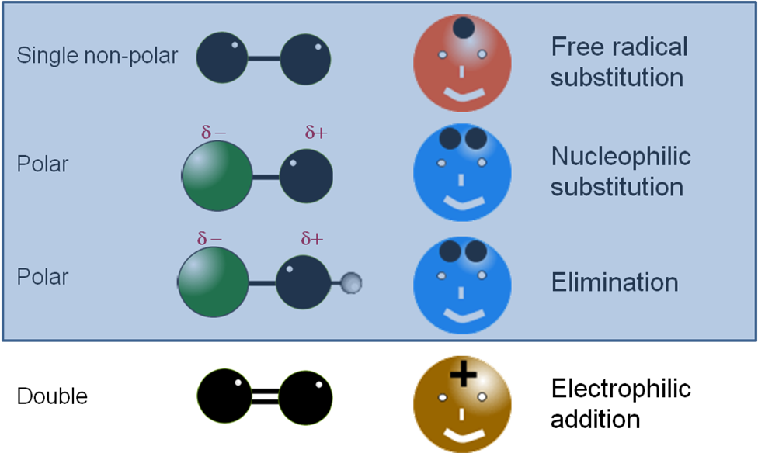

So **alkenes** undergo **electrophilic addition**. The **electrophiles** are **attracted** to the 4 **electrons** in the double bond; they are **able to form a bond** using 2 of the 4 electrons.

The reagents are called **electrophiles** because they are **electron pair accpetors**. They are **positive ions** or **electron-deficient atoms** act as **electron acceptors**.

Mechanism is always the same:

* **Electrophile** attacks **double bond**
* It **accepts** a **pair of electrons** from the double bond
* The **bond** in the **electrophile breaks** **heterolytically** (uneven splitting) so both electrons go to one of the atoms in the electrophile (leaving a **negatively charged ion)**
* Produces an **intermediate** species called a **carbocation** (a species containing a carbon atom with a positive charge)
* Negatively charged **ion** from the split electrophile forms a **bond** with the **carbocation**

General mechanism

unsaturated saturated

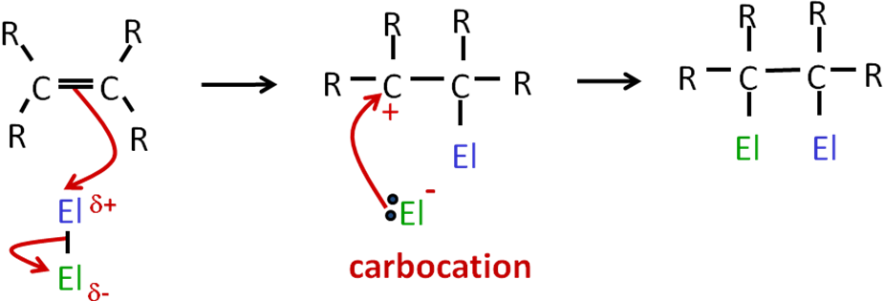

Electrophiles

only one product made

whole electrophile molecule is added

|  |  |  |  |  |  |
| --- | --- | --- | --- | --- | --- |
|  |  |  |  |  |  |
| Sulphuric acid  H2SO4 | *Displayed formula showing lone pairs* | | Bromine  Br2 | *Repulsion between electrons occurs as molecule approaches the double bond so dipole is induced* | Hydrogen halide  HX  e.g. HBr |

Alkenes & sulphuric acid

# **Electrophile**: sulphuric acid

**Reactant**: alkene

**Conditions**: cold & concentrated acid

**Product**: alkyl hydrogensulphate

**Example**: ethene + sulphuric acid → ethyl hydrogen sulphate

**Equation**: CH2=CH2 + H2SO4 → CH3CH2OSO3H

**Mechanism**:

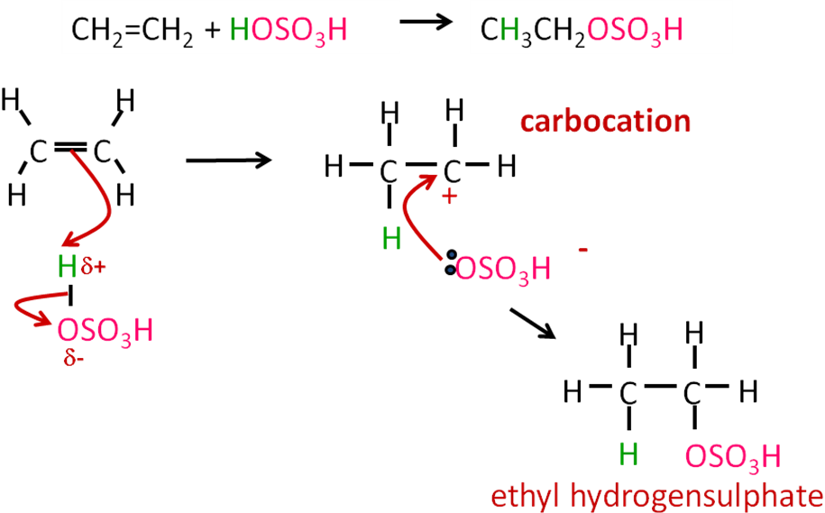

***Task: Own example***

Alkenes & bromine

Alkenes **react rapidly** with **chlorine** gas, **bromine** water and **iodine** in an organic solvent, to give **dihaloalkanes**.

Induced dipole created when halogen approaches the double bond which has a high electron density

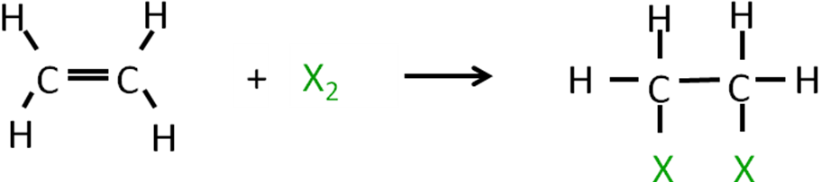

# The **halogen** is **added** across the double bond. When the **alkene and halogen collide** the electron rich **double bond repels electrons** in the halogen and **induces a dipole**. So the **halogen** can now acted as an **electrophile**. Two of the electrons from the double bond form a **bond with one of the halogen atoms** and the other forms a **halide** **ion**. This is then **attracted** to the positively charged **carbocation** to form the **dihaloalkane**.

# **Electrophile**: bromine

# **Reactant**: alkene

**Conditions**: warm & dilute Br2 (bromine water)

**Product**: di-bromoalkane

**Example**: ethene + bromine → 1,2-dibromoethane

**Equation**: CH2=CH2 + Br2 → CH2BrCH2Br

**Mechanism**:

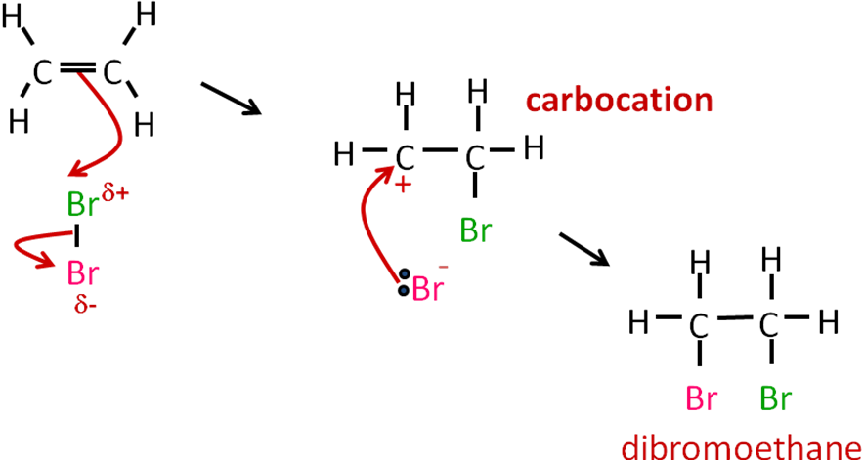

***Task: Own example***

Test for unsaturated hydrocarbons

This addition reaction of alkenes with bromine water is used as a **test for unsaturated** hydrocarbons.

**Test**: Bromine water (orange solution)

**Result**: Decolourises because the products are colourless

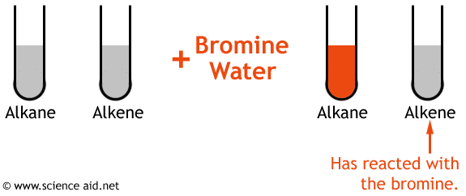

**N.B.** **Alkanes** don’t react with bromine under these conditions; they **need UV light** to produce a haloalkane in a **free-radical substitution** reaction.

***Demo: Test for alkenes***

***Application: CGP217 PQ1***

***Fact recall: CGP217 Q1-6***

Alkenes & hydrogen bromide

**AS link:**

**This is another way of making a halogenoalkane**

**Free-radical substitution of alkane with halogens**

# **Electrophile**: hydrogen bromide

# **Reactant**: alkene

**Conditions**: gaseous or concentrated aqueous HBr

**Product**: bromoalkane

**Example**:ethene + hydrogen bromide → bromoethane

**Equation**: CH2=CH2 + HBr → CH3CH2Br

**Mechanism**:

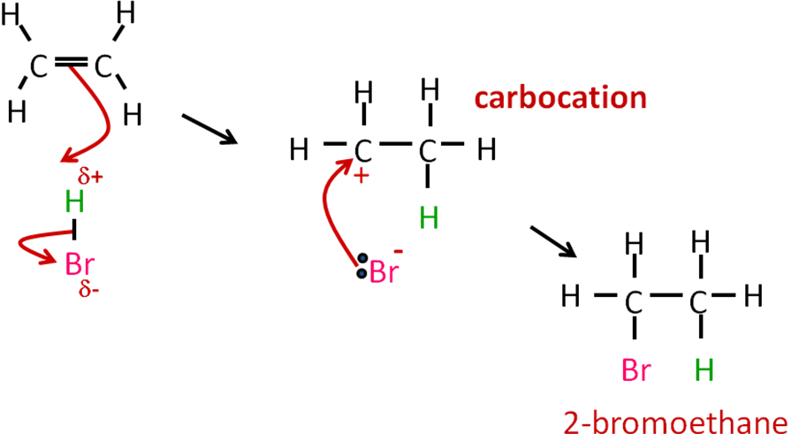

***Task: Own example***

***Task: Electrophilic addition summary***

***Task : Electrophilic addition – unanimated***

Electrophilic addition to unsymmetrical alkenes

If the **alkene** is **unsymmetrical** (i.e. the double bond is not in the middle) and the **electrophile** being added is also **unsymmetrical** (i.e. HBr & H2SO4) then **two possible products** can be formed. The **major product** is formed via **most stable carbocation**.

The **order of stability** for the **carbocations** is **3o>2o>1o**. This is due to a **positive inductive effect** of the **attached alkyl groups**. Induction is an **electron-releasing effect** and tends to **stabilise the positive charge of the carbocation**. The **more alkyl groups** there are **attached** to the positively-charged carbon atom, the **more stable the carbocation**. So a positively-charged carbon atom with 3 alkyl groups attached will be more stable than one with only 1 alkyl group.

|  |  |
| --- | --- |
|  | *The arrows show the positive inductive effect of electrons form the alkyl groups towards the carbon cation.*  *The more alkyl groups the more stable the carbocation intermediate.* |

Primary 1° < Secondary 2° < Tertiary 3°

1 alkyl group 2 alkyl groups 3 alkyl groups

*least stable most stable*

**Propene** is an unsymmetrical alkene so when it reacts with **hydrogen bromide** it forms mostly a **secondary carbocation** and then it reacts with the bromide ion to produce  
**2-bromopropane**. A little **1-bromopropane** will also be produced **via the least stable primary** **carbocation.** So **major** and **minor** products are made.

**Example**: propene + hydrogen bromide 2 possible isomers

|  |  |
| --- | --- |
| **Mechanism**: 2-bromopropane (major) | **Mechanism**: 1-bromopropane (minor) |
|  |  |
| *The product most likely to form is via the most stable carbocation* |  |

***Application: CGP220 PQ1-2***

***Fact recall: CGP220 Q1-2***

Alkenes & water

**AS Link: 3.3.5 – Alcohols (Hydration of alkenes studied in this topic – mechanism covered)**

**Water** can also **add** on across the double bond in **alkenes** in an **electrophilic addition** reaction. This reaction is used **industrially** to make **alcohols**

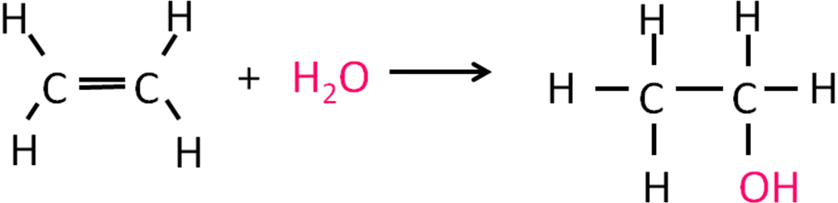

**Polymerisation**

Polymers are **long** chain **molecules** made by **joining** together **small** **molecules**, called **monomers**, these add to the end of the molecules in growing chain reaction. They are named after the monomer to give **poly(X)**, where **X** is the name of the **monomer**.

There are 2 types of synthetic polymers:

* **Addition** polymers such as polyethene
* **Condensation** polymers such as polyester and polyamide.

Addition polymerisation

|  |  |  |
| --- | --- | --- |
| monomer | → | polymer |
| alkene |  | polyethene |
| unsaturated |  | saturated |
| decolourises bromine water |  | no change with bromine water |

**Alkenes** can polymerise, in the presence of a catalyst, to form long chains with very high relative molecular masses. The **addition of monomers** to the end of the chain gives rise to the **name** **addition polymers**; they can also be called **chain-growth polymers**.

The **end of the chain** is **reactive** because it is a **free-radical that is formed** at the beginning of the reaction **with a catalyst** such as **organic peroxides** (ROOR). **Peroxide** molecules **readily split into free-radicals** to **initiate** the **chain growth**. A **radical re-forms** at the **end** of the chain **after** each **addition** of a **monomer**.

Examples

|  |  |  |
| --- | --- | --- |
|  | Poly(ethene) |  |
| Poly(chloroethene)  *Usually called PVC* |  |
| Poly(propene) |  |

Polyethene

Polymerisation of **ethene**, an **unsaturated monomer** produces **poly(ethene**), a **saturated** **polymer**.

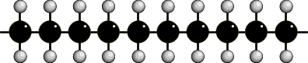

All polymers have a **repeating unit**, which is the smallest group of atoms that produce the polymer when repeated over and over again. It is usual to **show the formation** of polymers like this:

Points to note when drawing:

* Draw C=C bond along horizontal
* Bonding groups above & below
* All single bonds in polymer
* Bonds extend beyond brackets
* Remember ***n***

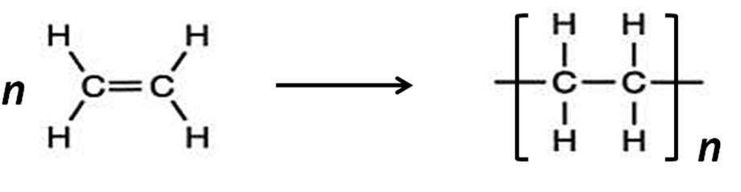

Other polyalkenes

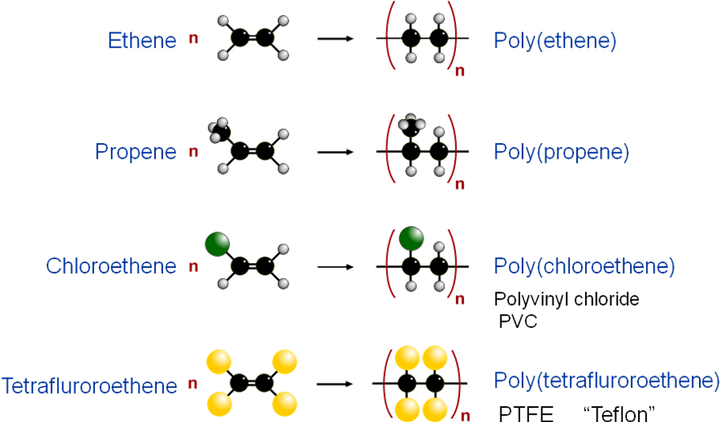

***Video: Polyethene***

Low-density and high-density polymers

Polymers with some **branching** means the chains do **not pack** together particularly well and the product is **flexible**, **stretches** well and had a **low density**.

If the polymer has **less branching** it **can pack** together well, resulting in a plastic that is **more** **rigid** and **stronger** because it has a **higher density**.

|  |  |  |  |
| --- | --- | --- | --- |
| Low-density | | High-density | |
|  |  |  |  |

Plasticisers

Chemicals can be added to polymers to **modify their properties**; these are called **plasticisers**. They make the polymer more **flexible** because the **plasticiser molecules** get in **between** the **polymer chains** pushing them apart. This **reduces** the **strength** of the **intermolecular forces** between the chains, so they **slide around** more.

**Poly(chloroethene)**, commonly called PVC consists of **C-Cl** bonds which are **polar** so **dipole-dipole forces** exist between the polymer chains, this make it **hard but brittle**. It can be used to make window frames and drain pipes. If a **plasticiser** is added the PVC **becomes** more **flexible** and it can be used for electrical cable insulation, floor tile and clothing.

|  |  |  |
| --- | --- | --- |
|  |  |  |

Problems associated with their disposal (Second year content)

**Polyalkenes** are **saturated** and therefore **unreactive** due to **strong covalent bonds** and **lack** of **polarity**. This makes them **non-biodegradable** and presents **problem**. If they are buried in **landfill** sites they will remain there for many hundreds of years and **plastic litter** can be a problem to **wildlife** if they ingest it.

However, they are **highly flammable**, so could be burnt which **saves** on **landfill** sites and **produces** **energy**, however it can **produce toxic** **fumes**.

They can be **recycled**. They are **collected**, **cleaned** and **cut into small pieces** before being **melted** and **remoulded**. An alternative is to heat them to **very high temperatures** so that they **break down** into their **monomers** which can be **reused** to make new polymers.However, there are **high costs** associated with the **collection** and **re-processing**

***Application: CGP224 PQ1-3***

***Fact recall: CGP224 Q1-4***

***Sheet: Alkene PPQ 1-5***

***Exam questions: Oxford p228-229 Q1-9***