

**Foundation IGCSE (9 – 1) Revision Pack**

**Areas and Perimeters**

**Name --------------------------------**

**Questions**

**Q1.**

The diagram shows three points *P*, *Q* and *R* on a 1 cm grid.

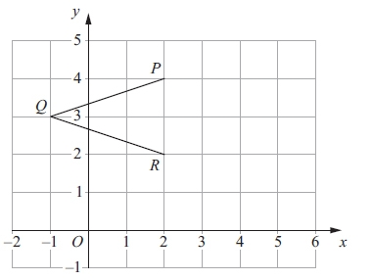

(a) Write down the coordinates of *P*.

(.............................. , .............................)

**(1)**

(b) Write down the coordinates of *Q*.

(.............................. , .............................)

**(1)**

(c) On the grid, mark the point *S* so that *PQRS* is a rhombus.

**(1)**

(d) Work out the area of the rhombus *PQRS*.

........................................................... cm2

**(2)**

(e) Write down the equation of the line *PR*.

...........................................................

**(1)**

**(Total for question = 6 marks)**

**Q2.**

The diagram shows a quadrilateral *PQRS* on a centimetre grid.

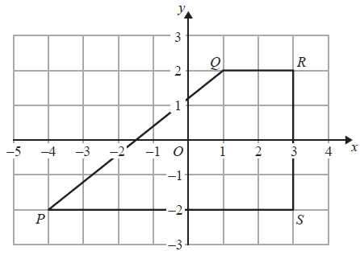

(a)   Write down the coordinates of *R*.

(........................................................... , ...........................................................)

**(1)**

(b)   Write down the coordinates of *P*.

(........................................................... , ...........................................................)

**(1)**

(c)   What is the mathematical name of the quadrilateral *PQRS*?

...........................................................

**(1)**

(d)   Measure the length of the side *PQ*.   
Give your answer in centimetres to 1 decimal place.

........................................................... cm

**(1)**

(e)   Find the perimeter of the quadrilateral *PQRS*.

Give your answer in centimetres to 1 decimal place.

........................................................... cm

**(2)**

(f)   Work out the area of the quadrilateral *PQRS*.

........................................................... cm2

**(2)**

**(Total for Question is 8 marks)**

**Q3.**

A circle has radius 9 cm.

(a)  Work out the circumference of the circle.

Give your answer correct to 1 decimal place.

cm

**(2)**

The diagram shows the pentagon *ABCDE*.

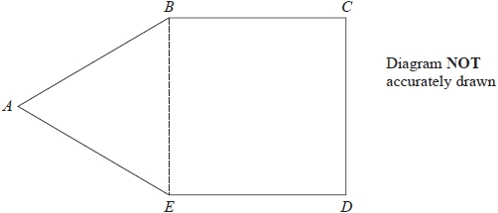

*ABE* is an equilateral triangle.

*BCDE* is a square with area 169 cm2

(b)  Work out the perimeter of *ABCDE*.

cm

**(3)**

**(Total for question = 5 marks)**

**Q4.**

The diagram shows a shape on a centimetre grid.

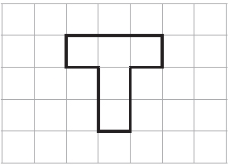

(a) Find the area of the shape.

........................................................... cm2

**(1)**

(b) Find the perimeter of the shape.

........................................................... cm

**(1)**

(c) Shade 60% of the shape.

**(1)**

**(Total for question is 3 marks)**

**Q5.**

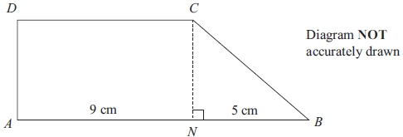

The shape *ABCD* is made from a rectangle *ANCD*  
 and the right-angled triangle *NBC*.  
*ANB* is a straight line.  
*AN* = 9 cm.  
*NB* = 5 cm.  
 The area of rectangle *ANCD* is 36 cm2.

Work out the area of shape *ABCD*.

........................................................... cm2

**(Total for question = 4 marks)**

**Q6.**

The length of a rectangle is 12 cm.  
 The width of the rectangle is 7 cm.

Work out the area of the rectangle.

...........................................................cm2

**(Total for question = 2 marks)**

**Q7.**

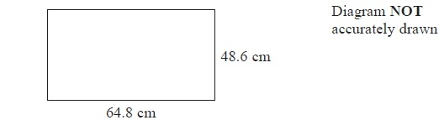

A TV screen is rectangular.

The width of the rectangle is 64.8 cm and the height is 48.6 cm.

(a)  Calculate the area of the rectangle.

Give your answer correct to 3 significant figures.

........................................................... cm2

**(3)**

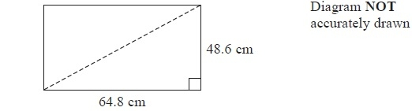

The length of a diagonal of the rectangle gives the 'size' of the TV screen.

(b)  Calculate the 'size' of the TV screen.

........................................................... cm

**(3)**

**(Total for Question is 6 marks)**

**Q8.**

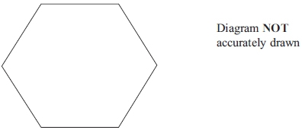

The diagram shows a regular hexagon.  
The perimeter of the hexagon is 42 cm.

Calculate the area of the hexagon.  
 Give your answer correct to 3 significant figures.

...........................................................cm2

**(Total for question = 5 marks)**

**Q9.**

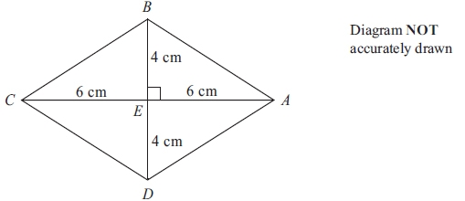

*ABCD* is a rhombus.   
The diagonals *AC* and *BD* cross at the point *E*.   
*AE* = *CE* = 6 cm.   
*BE* = *DE* = 4 cm.   
Angle *AEB* = 90°

(a) Work out the area of the rhombus.

...........................................................cm2

**(3)**

(b) Work out the length of *AB*.   
Give your answer correct to 3 significant figures.

........................................................... cm

**(3)**

**(Total for question is 3 marks)**

**Q10.**

The diagram shows a trapezium *PQRS*.

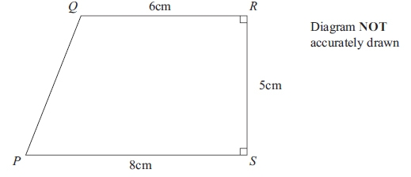

(a) Calculate the area of the trapezium *PQRS*.

...........................................................cm2

**(2)**

(b) Calculate the length *PQ*.   
Give your answer correct to 3 significant figures.

........................................................... cm

**(4)**

**(Total for question = 6 marks)**

**Q11.**

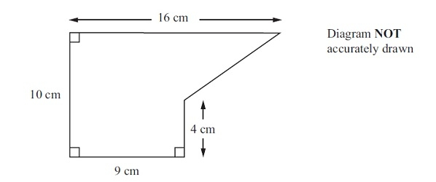

The diagram shows a shape.

Work out the area of the shape.

........................................................... cm2

**(Total for question = 2 marks)**

**Q12.**

Here is a rectangle made from 12 square tiles.

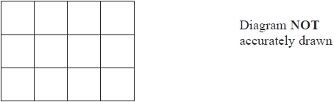

The perimeter of each tile is 20 cm.

Work out the area of the rectangle.

........................................................... cm2

**(Total for question = 3 marks)**

**Q13.**

The diagram shows a quadrilateral *ABCD* on a centimetre grid.

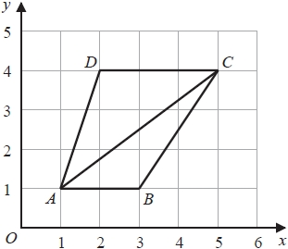

(a)  Work out the area of triangle *ABC*.

You must include the units with your answer.

...........................................................

**(3)**

(b)  Give a reason why angle *ACD* is equal to angle *CAB*.

.............................................................................................................................................

**(1)**

(c)  Write down an equation for the straight line that passes through *D* and *C*.

...........................................................

**(1)**

**(Total for question = 5 marks)**

**Q14.**

Here is an isosceles triangle.

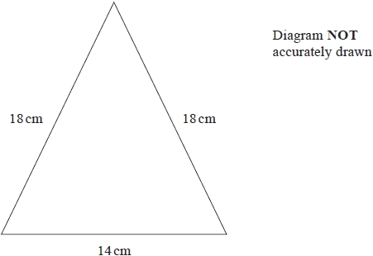

Work out the area of the triangle.   
Give your answer correct to 3 significant figures.

........................................................... cm2

**(1)**

**(Total for question = 4 marks)**

**Q15.**

The diagram shows a shape.

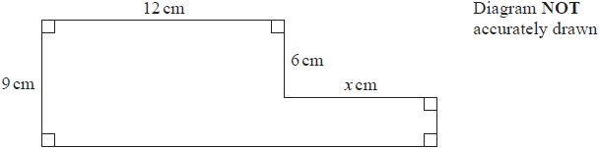

The shape has area 129 cm2

Work out the value of *x*.

*x* = ...........................................................

**(Total for question = 4 marks)**

**Q16.**

The diagram shows a right-angled triangle and a rectangle.

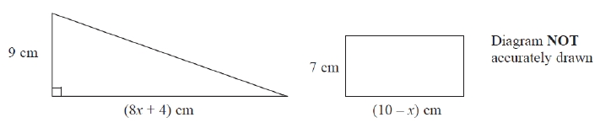

The area of the triangle is twice the area of the rectangle.

(i)  Write down an equation for *x*.

.............................................................................................................................................

(ii)  Find the area of the rectangle.

Show clear algebraic working.

........................................................... cm2

**(Total for question = 7 marks)**

**Q17.**

(a)  On the centimetre grid, draw a rectangle with an area of 8 cm2

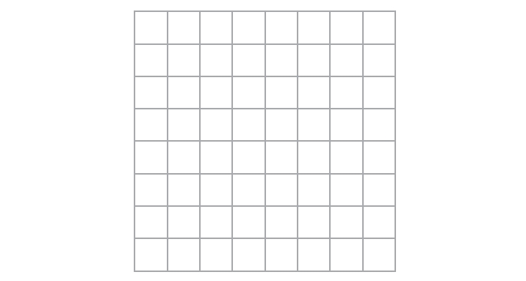

**(1)**

(b)  On the centimetre grid, draw an isosceles triangle with an area of 8 cm2



**(2)**

**(Total for question = 3 marks)**

**Q18.**

The diagram shows a shape on a centimetre grid.

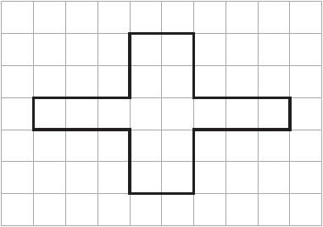

(a)  Find the area of the shape.

........................................................... cm2

**(1)**

(b)  Find the perimeter of the shape.

........................................................... cm

**(1)**

(c)  Write down the order of rotational symmetry of the shape.

...........................................................

**(1)**

(d)  On the shape, draw all the lines of symmetry.

**(2)**

**(Total for question = 5 marks)**

**Q19.**

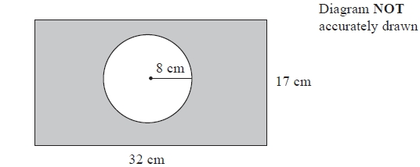

The diagram shows a circle inside a rectangle.

Work out the area of the shaded region.   
Give your answer correct to 3 significant figures.

........................................................... cm2

**(Total for question = 3 marks)**

**Q20.**

Here are two circles.

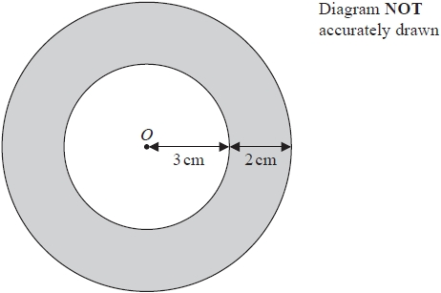

The circles have the same centre *O*.   
The radius of the inner circle is 3 cm.   
The width of the shaded region between the inner circle and outer circle is 2 cm.

Work out the area of the shaded region.   
Give your answer correct to 3 significant figures.

........................................................... cm2

**(Total for question = 3 marks)**

**Q21.**

Here is a rectangle.

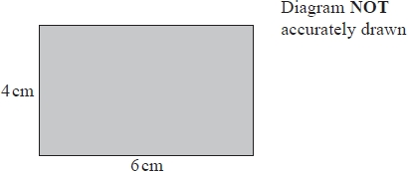

(a)  Work out the area of the rectangle.

...........................................................cm2

**(1)**

Two of these rectangles are placed together without overlapping to make this shaded shape.

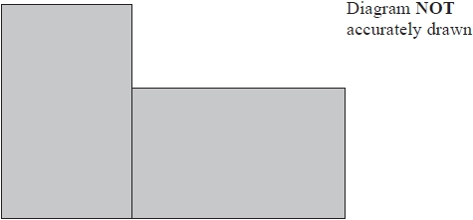

(b)  Work out the perimeter of the shaded shape.

...........................................................cm

**(2)**

**(Total for question = 3 marks)**

**Q22.**

The diagram shows a circle inside a rectangle.

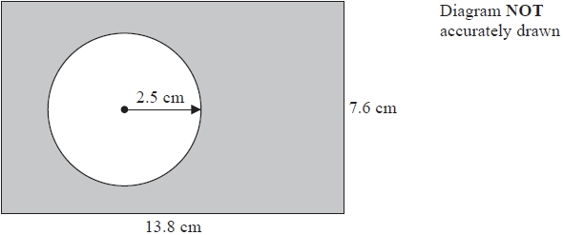

Work out the area of the shaded region.   
Give your answer correct to 3 significant figures.

...........................................................cm2

**(Total for question = 3 marks)**

**Q23.**

Here is a trapezium *ABCD*.

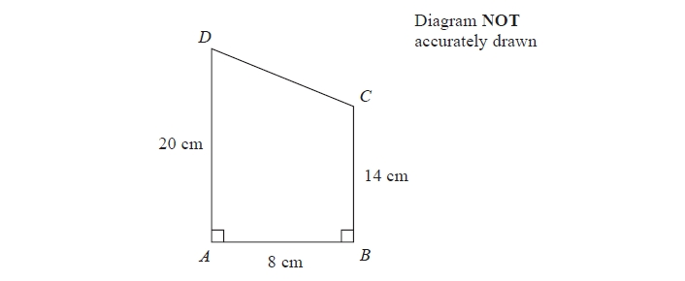

Angle *DAB* = angle *ABC* = 90°

*AD* = 20 cm   
*AB* = 8 cm   
*BC* = 14 cm

(a)  Calculate the area of the trapezium *ABCD*.

.......................................................... cm2

**(2)**

(b)  Calculate the length of *CD*.

.......................................................... cm

**(4)**

**(Total for question = 6 marks)**

**Q24.**

The diagram shows a rectangle and a right-angled triangle.

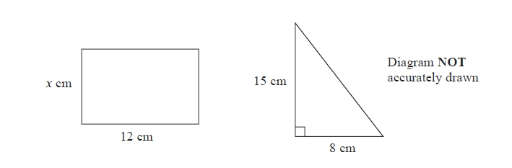

The area of the rectangle is the same as the area of the triangle.

Work out the value of *x*.

*x* =...........................................................

**(Total for question = 3 marks)**

**Q25.**

The diagram shows a rectangle and a circle.

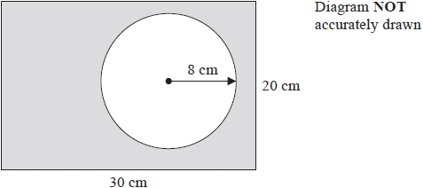

The rectangle has length 30 cm and width 20 cm.   
The circle has radius 8 cm.

Work out the area of the shaded region.   
Give your answer correct to 3 significant figures.

........................................................... cm2

**(Total for question = 4 marks)**

**Mark Scheme**

Q1.

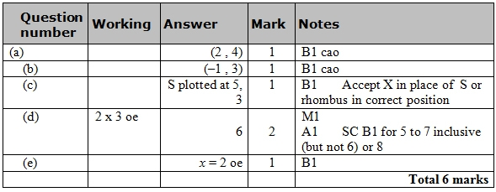

**Q2.**

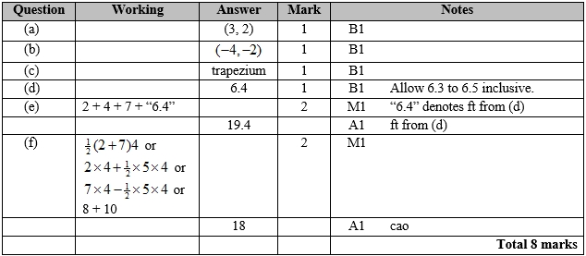

**Q3.**

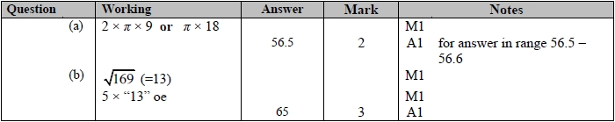

**Q4.**

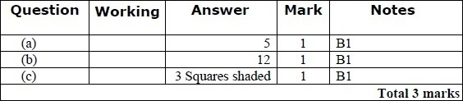

**Q5.**

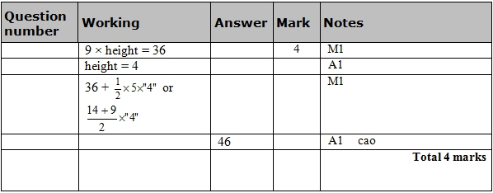

**Q6.**

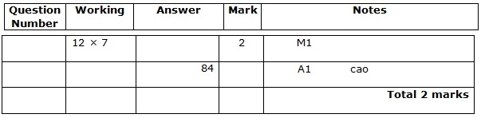

**Q7.**

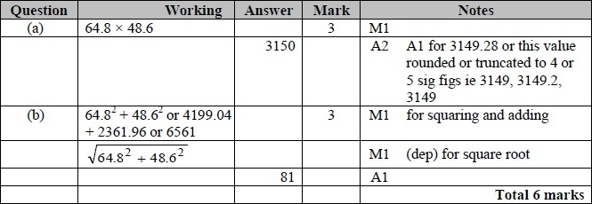

**Q8.**

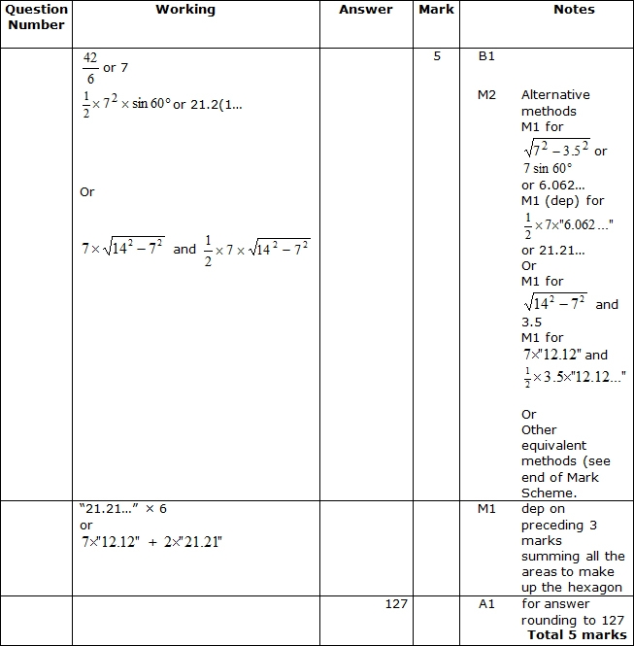

**Q9.**

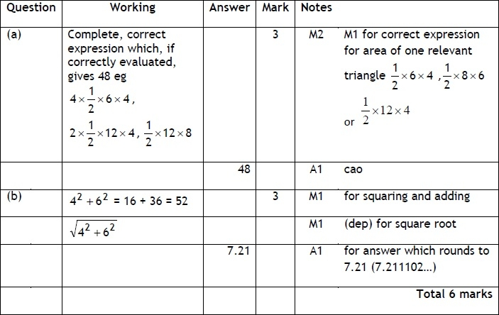

**Q10.**

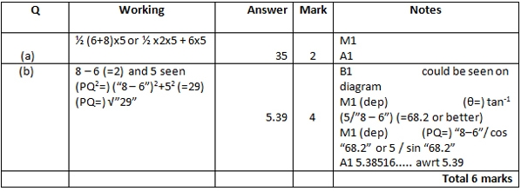

**Q11.**

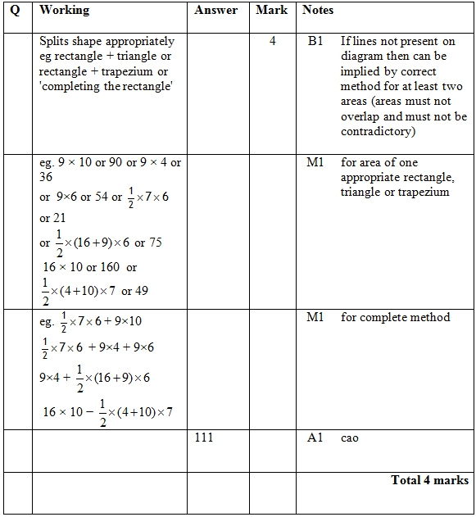

**Q12.**

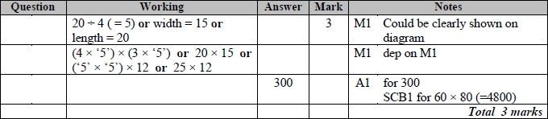

**Q13.**

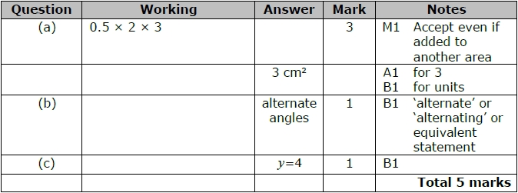

**Q14.**

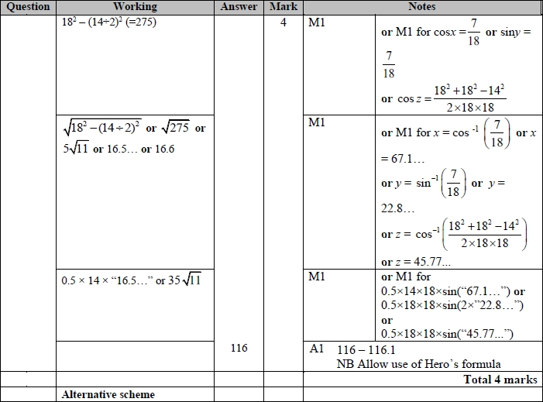

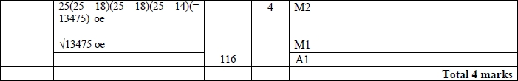

**Q15.**

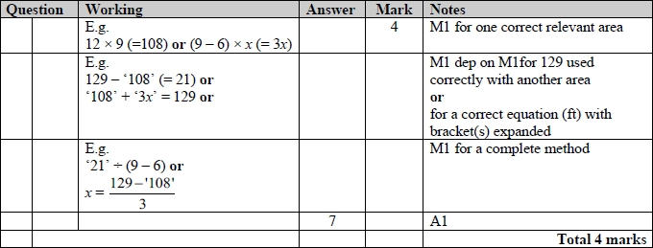

**Q16.**

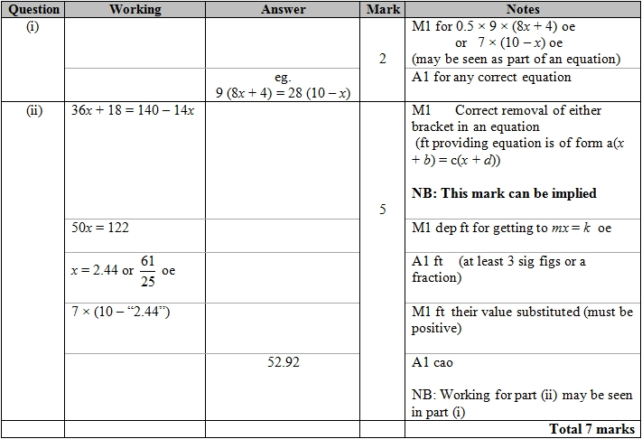

**Q17.**

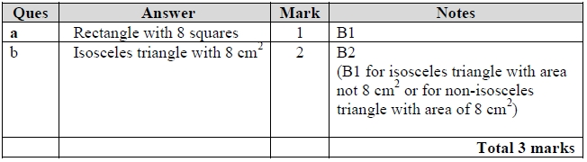

**Q18.**

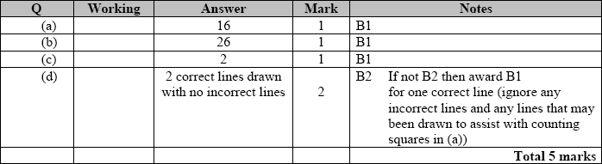

**Q19.**

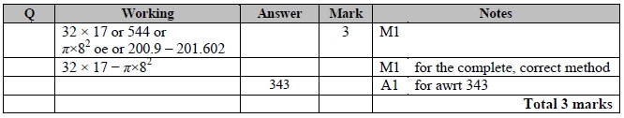

**Q20.**

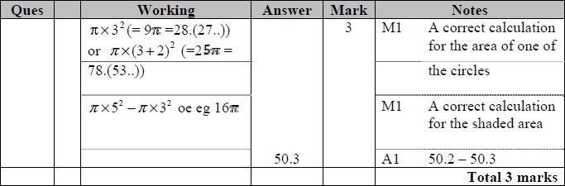

**Q21.**

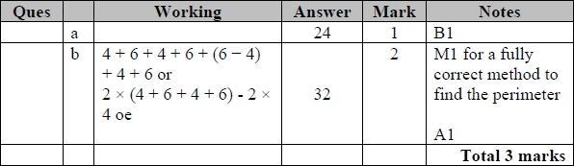

**Q22.**

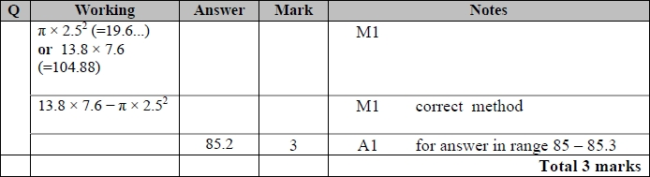

**Q23.**

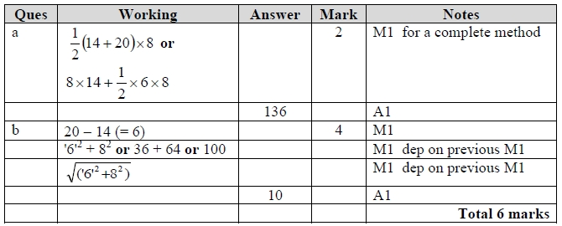

**Q24.**

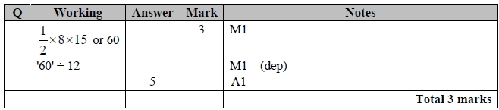

**Q25.**

