**1.1.1 Eukaryotes & Prokaryotes**

**Specialised Cells**

* You, as a human being, are made from trillions of cells, but only of about 250 different types
* A specialised cell is a cell that has a particular structure and composition of subcellular structures
* Structural differences between different types of cells enable them to perform specific functions within the organism
* Cell specialise by undergoing a process known as differentiation

**Specialised Cells in Animals**

**The nerve cell**

[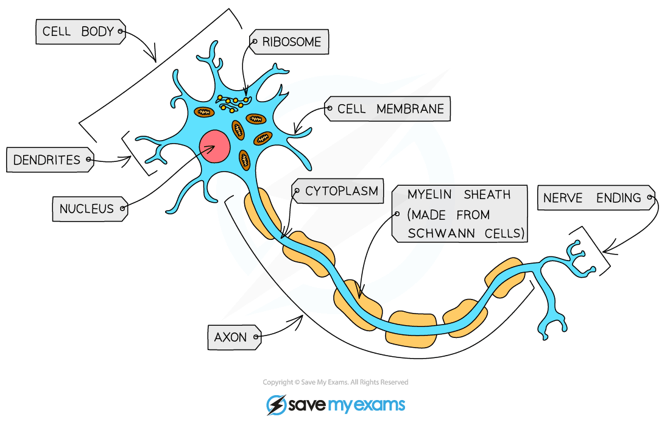](https://cdn.savemyexams.co.uk/wp-content/uploads/2020/01/Nerve-Cell.png)

***Nerve cells (neurones) have a characteristically elongated structure which allows them to coordinate information from the brain and spinal cord with the rest of the body***

* Function: conduction of impulses
* Adaptations:
  + Has a **cell body** where most of the cellular structures are located and most protein synthesis occurs
  + **Extensions**of the cytoplasm from the cell body form dendrites (which receive signals) and axons (which transmit signals), allowing the neurone to **communicate** with other nerve cells, muscles and glands
  + The axon (the main extension of cytoplasm away from the cell body) is covered with a fatty sheath**,** which **speeds up** nerve impulses. Axons can be up to 1m long in some animals

**Muscle cells**

[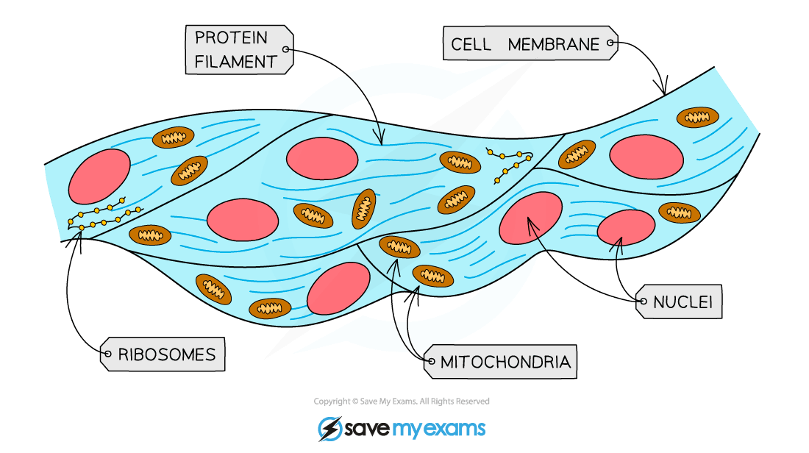](https://cdn.savemyexams.co.uk/wp-content/uploads/2020/06/1.1.3-Muscle-cells.png)***Muscle cells contain layers of fibres which allow them to contract. The image above shows skeletal muscle cells***

* Function: contraction for movement
* Adaptations:
  + There are **three** different types of muscle in animals: skeletal, smooth and cardiac (heart)
  + All muscle cells have layers of protein filaments in them. These layers can slide over each other causing muscle **contraction**
  + Muscle cells have a high density of **mitochondria** to provide sufficient energy (via respiration) for muscle contraction
  + Skeletal muscle cells fuse together during development to form multinucleated cells that contract in unison

**A sperm cell**

[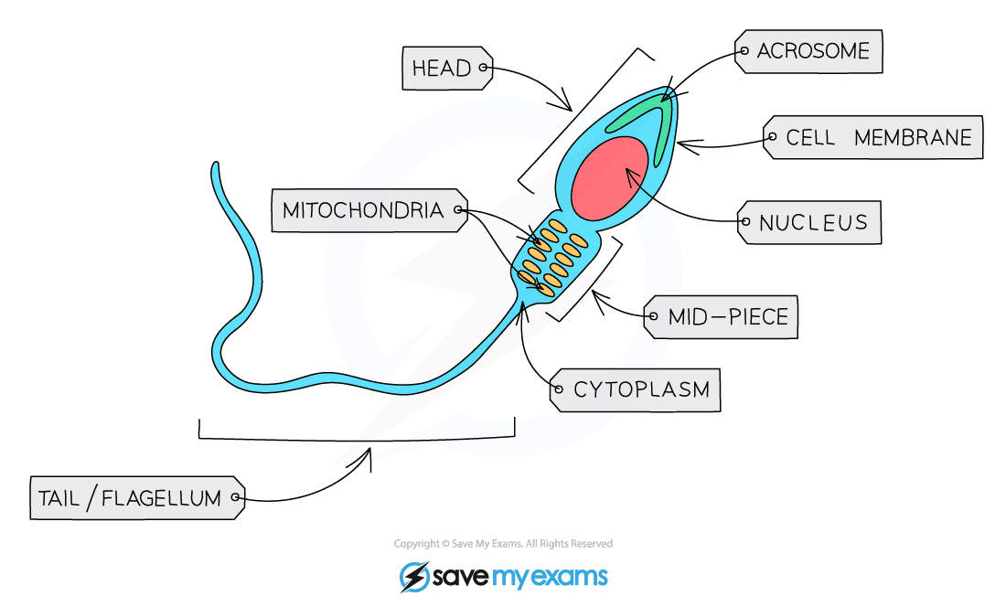](https://cdn.savemyexams.co.uk/wp-content/uploads/2020/01/Sperm-Cell.png)***Sperm cells are motile – their tail helps propel them forward in search of an egg to fertilise***

* Function: reproduction (pass on fathers genes)
* Adaptations:
  + The head contains a **nucleus** which contains **half** the normal number of **chromosomes** (haploid, no chromosome pairs)
  + The **acrosome** in the head contains **digestive enzymes** that can break down the outer layer of an egg cell so that the haploid nucleus can enter to fuse with the egg’s nucleus
  + The mid-piece is packed with **mitochondria** to release **energy** (via respiration) for the tail
  + The **tail** rotates, propelling the sperm cell forwards (allowing it to **move**/swim)

**Specialised Cells in Plants**

**A root hair cell**

[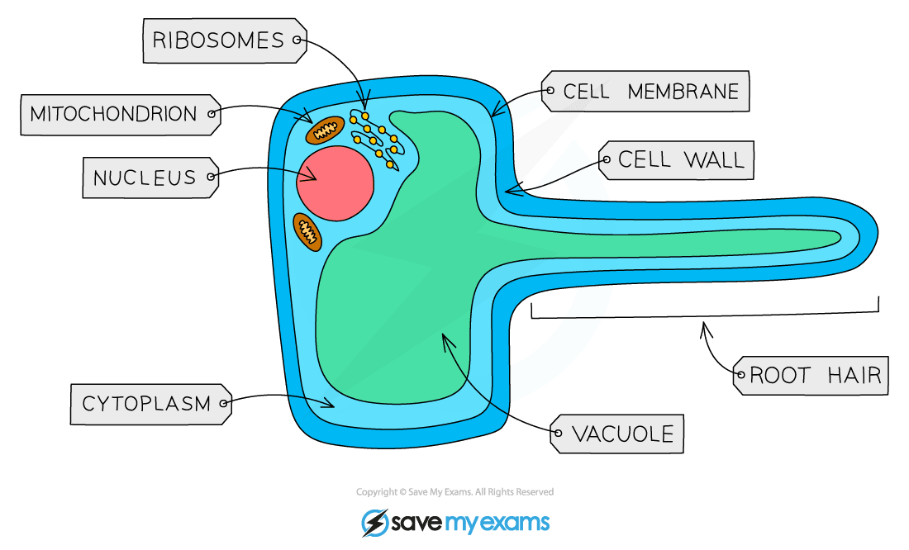](https://cdn.savemyexams.co.uk/wp-content/uploads/2020/01/Root-Hair-Cell.png)***The root hair is an extension of the cytoplasm, increasing the surface area of the cell in contact with the soil to maximise absorption of water and minerals***

* Function: absorption of water and mineral ions from soil
* Adaptations:
  + **Root hair**to increase **surface area**(SA) so the rate of water uptake by osmosis is greater (can absorb more water and ions than if SA were lower)
  + **Thinner walls**than other plant cells so that water can move through easily (due to **shorter** diffusion distance)
  + Permanent vacuole contains cell sap which is more **concentrated** than soil water, maintaining a water potential **gradient**
  + **Mitochondria** for active transport of mineral ions
  + Remember that chloroplasts are not found in these cells – there’s no light for photosynthesis underground!

**A xylem vessel**

*[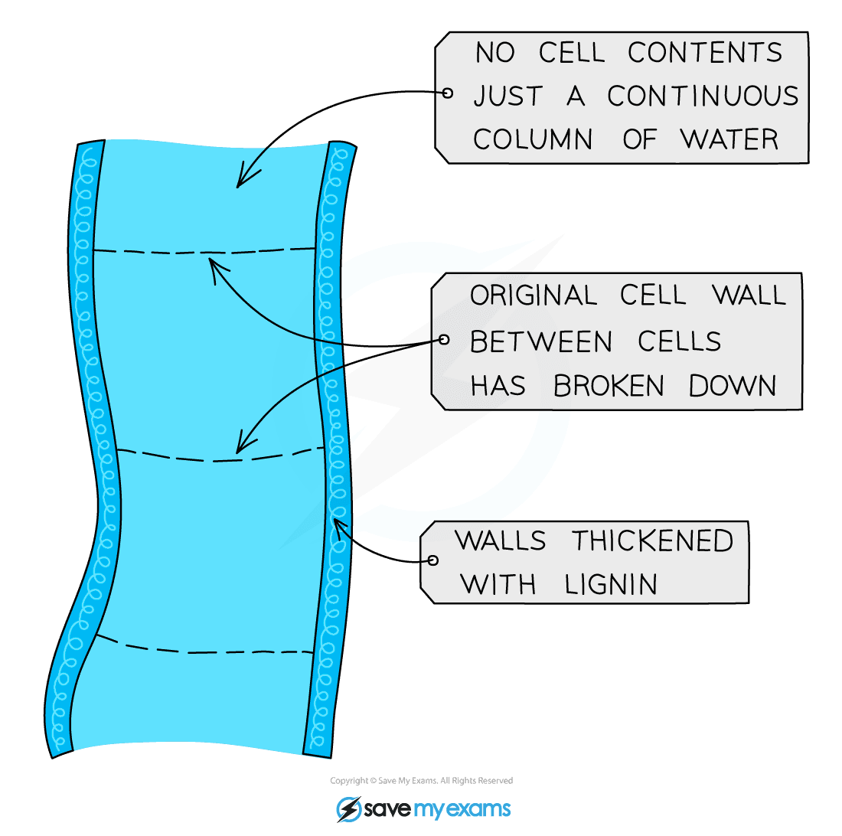](https://cdn.savemyexams.co.uk/wp-content/uploads/2020/01/Xylem-Structure.png)****Xylem cells lose their top and bottom walls to form a continuous tube through which water moves through from the roots to the leaves***

* Function: transport tissue for water and dissolved ions
* Adaptations:
  + **No top and bottom walls** between cells to form continuous hollow tubes through which water is drawn upwards towards the leaves by transpiration
  + Cells are essentially **dead,** without organelles or cytoplasm, to allow **free passage of water**
  + Outer walls are **thickened** with a substance called **lignin,**strengthening the tubes, which helps **support** the plant

**Phloem cells**

[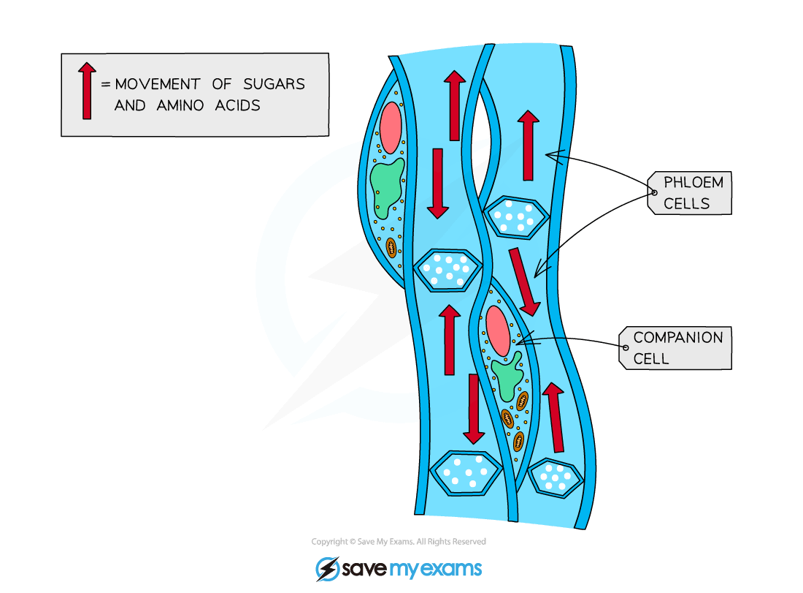](https://cdn.savemyexams.co.uk/wp-content/uploads/2020/06/1.1.3-Phloem-cells.png)***Phloem cells form tubes similar to xylem vessels, except the cells still retain some subcellular structures and are therefore living***

* Function: transport of dissolved sugars and amino acids
* Adaptations:
  + Made of living cells (as opposed to xylem vessels which are made of dead cells) which are supported by companion cells
  + Cells are**joined** end-to-end and contain holes in the end cell walls (sieve plates) forming tubes which allow sugars and amino acids to**flow easily** through (by translocation)
  + Cells also have very**few subcellular**structures to aid the flow of materials

**Exam Tip**

You may be given some information (including an image) about an unfamiliar cell in an exam, and asked to describe how it’s able to carry out its function. This shouldn’t faze you – just look at the shape of the cell and its subcellular structures.

Does the cell have a shape which increases its surface area? Are there lots of ribosomes to make proteins (such as enzymes or hormones), or lots of mitochondria (to transfer lots of energy via respiration)?

**Cells**

[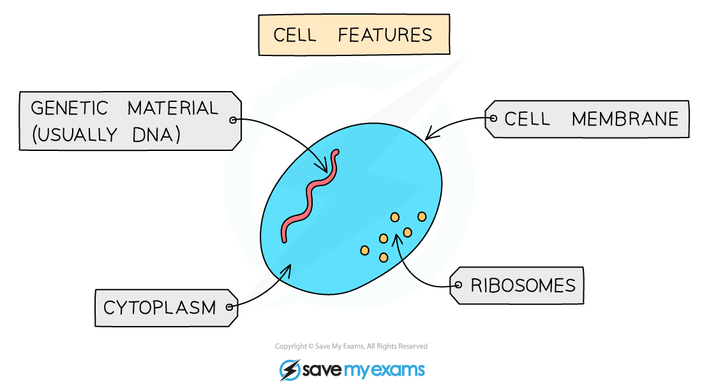](https://cdn.savemyexams.co.uk/wp-content/uploads/2020/01/General-Cell-Features.png)

***All cells have a number of features in common with each other***

* For a cell to be a cell, it has to have the following components:

**Cellular components & functions table**

[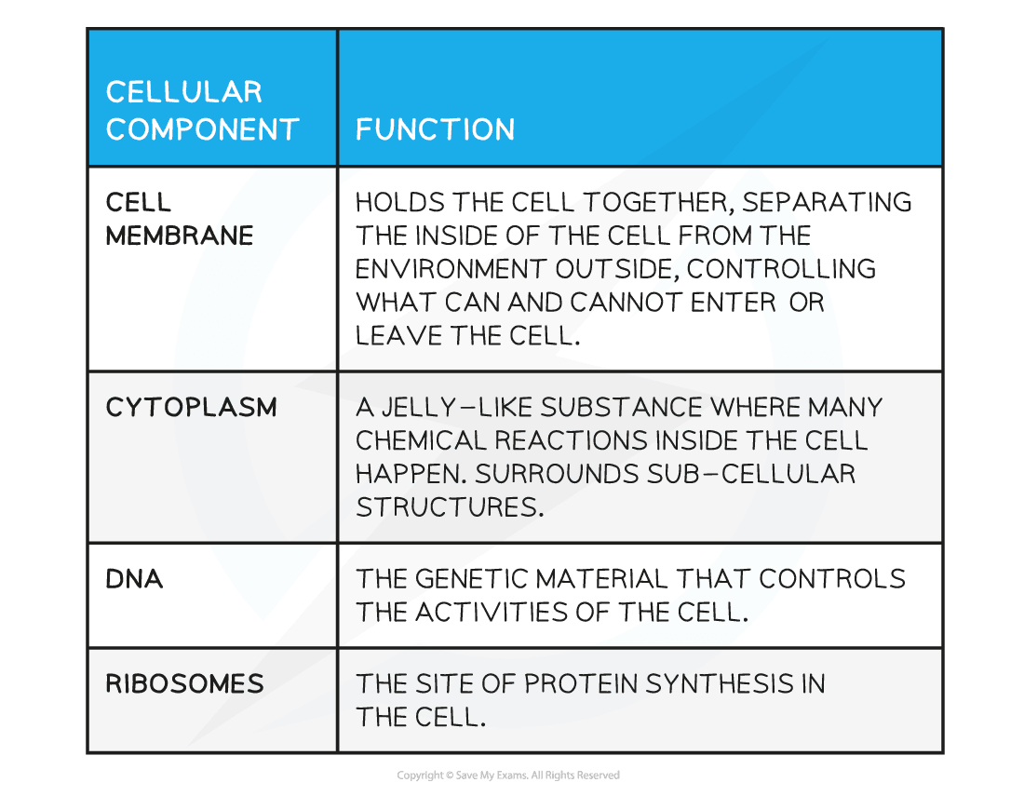](https://cdn.savemyexams.co.uk/wp-content/uploads/2020/06/Cellular-components-functions-table.png)

* There are two distinct types of cell – eukaryotic and prokaryotic

**Eukaryotic Cells**

* Plant and animal cells are both eukaryotic cells
* They have the components listed in the table above (so a cell membrane, cytoplasm and ribosomes), as well as others
* A defining feature of eukaryotic cells is that their genetic material (DNA) is enclosed within a nucleus
* Eukaryotic cells vary in size, usually between 10 and 100 µm

[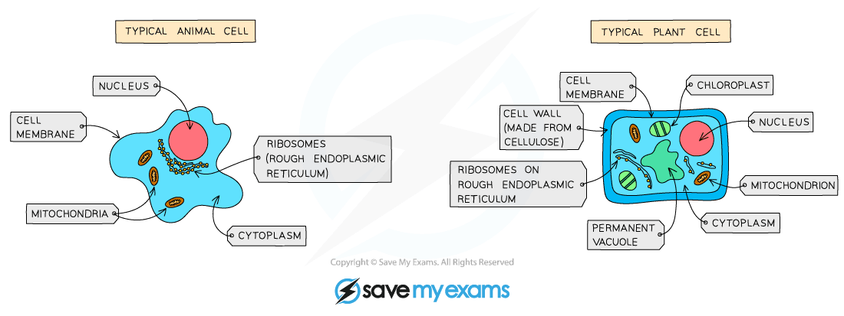](https://cdn.savemyexams.co.uk/wp-content/uploads/2020/01/A-typical-animal-and-plant-cell.png)

***Animal and plant cells are both eukaryotic cells as their genetic material is packaged in a nucleus***

**Prokaryotic Cells**

* Bacterial cells are a type of prokaryotic cell
* A defining feature of prokaryotic cells is that their genetic material is not enclosed within a nucleus, it is found as a single loop of DNA within the cytoplasm
* Additional smaller, circular pieces of DNA called plasmids may also be present
* The cell membranes of all prokaryotic cells are surrounded by a cell wall (usually made from a substance called peptidoglycan)
* Prokaryotic cells are much smaller in comparison to eukaryotic cells, with many measuring ~ 1 µm in size

[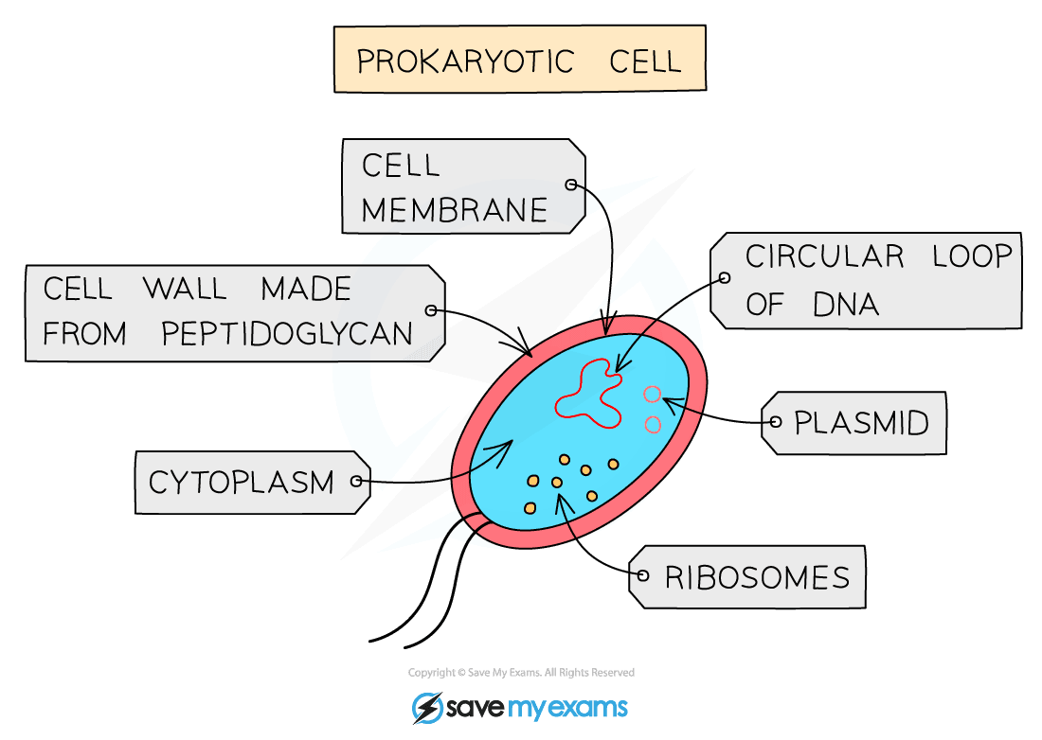](https://cdn.savemyexams.co.uk/wp-content/uploads/2020/01/A-typical-prokaryotic-cell.png)

***Prokaryotic cells do not have a nucleus, and are much smaller than eukaryotic cells***

**Prokaryotic cells table**

[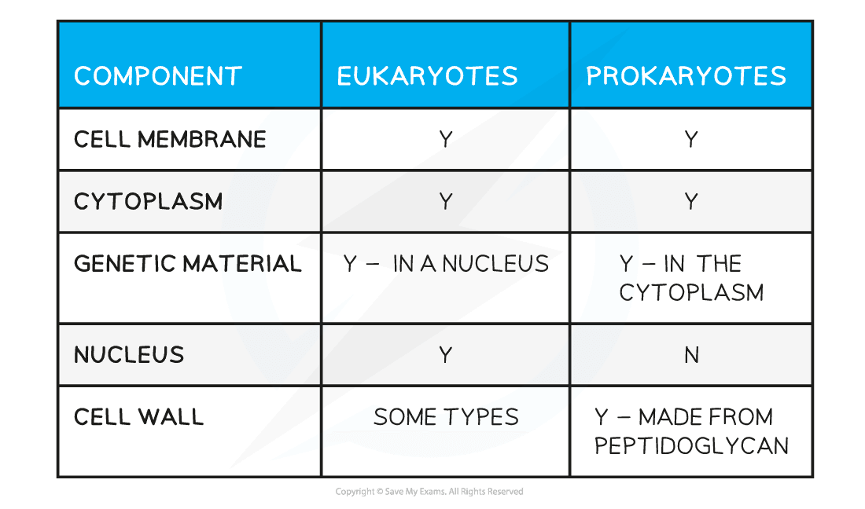](https://cdn.savemyexams.co.uk/wp-content/uploads/2020/06/Prokaryotic-cells-table-1.png)

**Scale & the Size of Cells**

* Cells are very small and require a microscope to be seen
* Scientists measure the size of cells in micrometers (µm)
* 1 µm is equivalent to 001 mm, or 1 x 10-3 mm (or alternatively 1 millionth of a metre,  1 x 10-6 mm)
* You need to be able to convert between different units of measurement, particularly mm and µm

[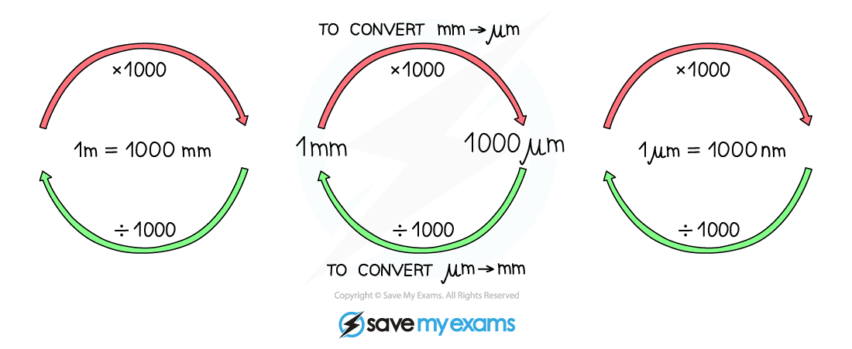](https://cdn.savemyexams.co.uk/wp-content/uploads/2020/06/1.1.1.-Converting-Units-AQA.png)

***Make sure you are comfortable converting between different units***

* You need to show an understanding of the size and scale of cells (and the subcellular structures within them)

[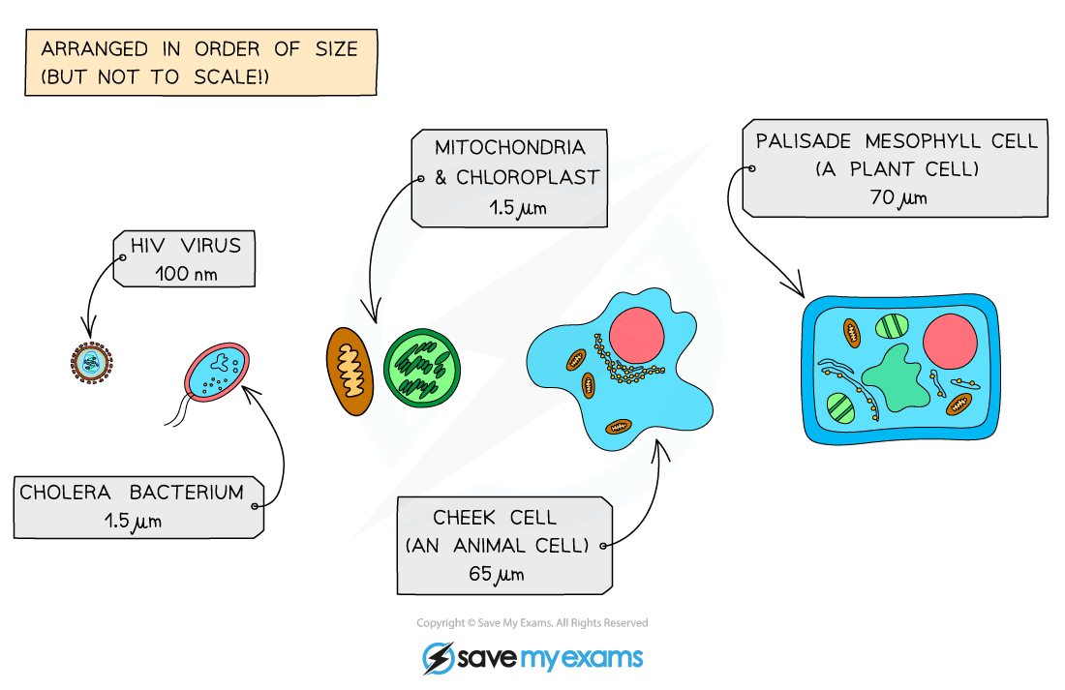](https://cdn.savemyexams.co.uk/wp-content/uploads/2020/06/1.1.1-Comparison-of-size-AQA.png)

**You need to be aware that many subcellular structures in eukaryotic cells are the same size as or bigger than prokaryotic cells!**

* Differences in size can be described as differences in **order of magnitude**, essentially the difference in size calculated by a factor of 10

**Size of cells table**

[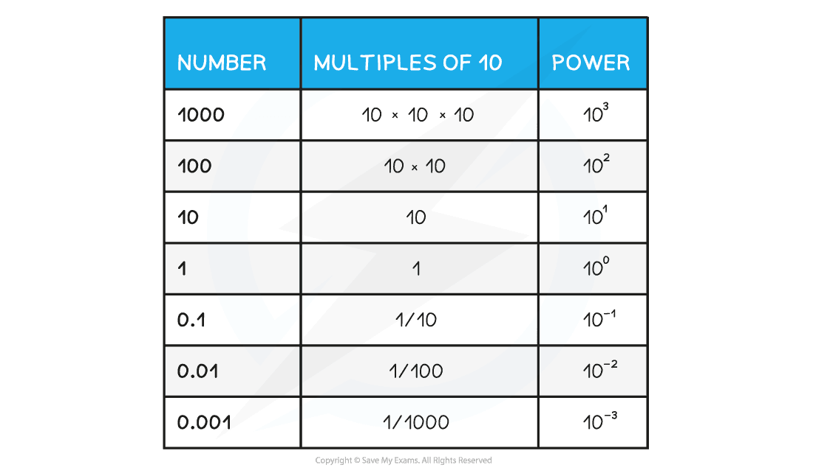](https://cdn.savemyexams.co.uk/wp-content/uploads/2020/06/Size-of-cells-table.png)

**Exam Tip**

A common exam question is to ask you to calculate the size of subcellular structures and then to suggest why they may or may not be present in a certain type of cell.

For example:

Why do bacterial cells not contain mitochondria?

**How to Use Standard Form**

* When biologists talk about the size of cells and the structures within them, they are dealing with very small numbers. Very small (or very big) numbers are represented using standard form – this helps to avoid confusion
* Let’s say we want to represent the length of a*Vibrio cholerae* cell which is 1.5µm in mm
* First, we need to convert the measurement in µm into mm (see image in Scale & the Size of Cells)
* 5 µm = 0.0015 mm
* To write this in standard form:

[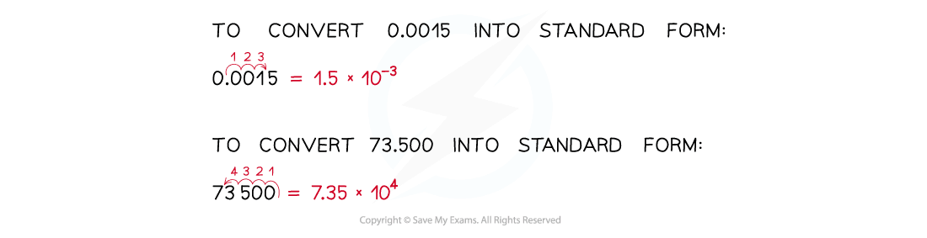](https://cdn.savemyexams.co.uk/wp-content/uploads/2020/08/Worked-Example-Standard-Form-1.png)

***Practise converting numbers into standard form – you may be asked to do this in the exam!***

**Exam Tip**

Take care to look at the units that measurements of cells and subcellular structures are given in.

**1.1.2 Animal & Plant Cells**

**Subcellular Structures**

* Eukaryotic cells have subcellular structures, each carrying out a particular function
* Organelles are subcellular ‘compartments’ where specific processes take place within the cell

**Animal Cells**

* The main subcellular structures in animal cells are:
  + The nucleus
  + Cell membranes
  + Mitochondria
  + Ribosomes
  + Cytoplasm

[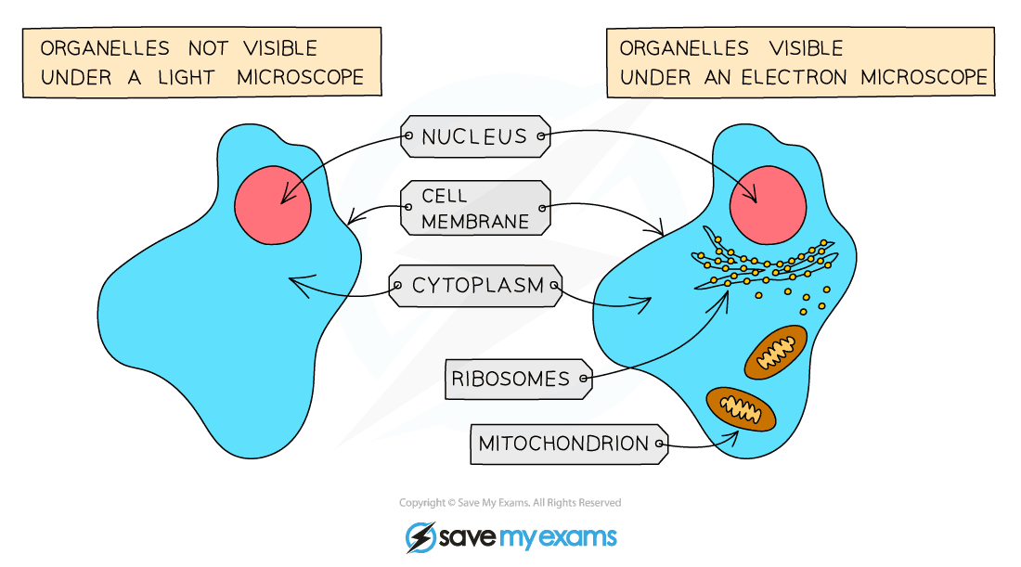](https://cdn.savemyexams.co.uk/wp-content/uploads/2020/01/Structures-in-an-animal-cell-visible-under-a-light-microscope-an-electron-microscope.png)

***Some cellular structures can only be seen when viewed with an electron microscope***

**Cell structures table**

[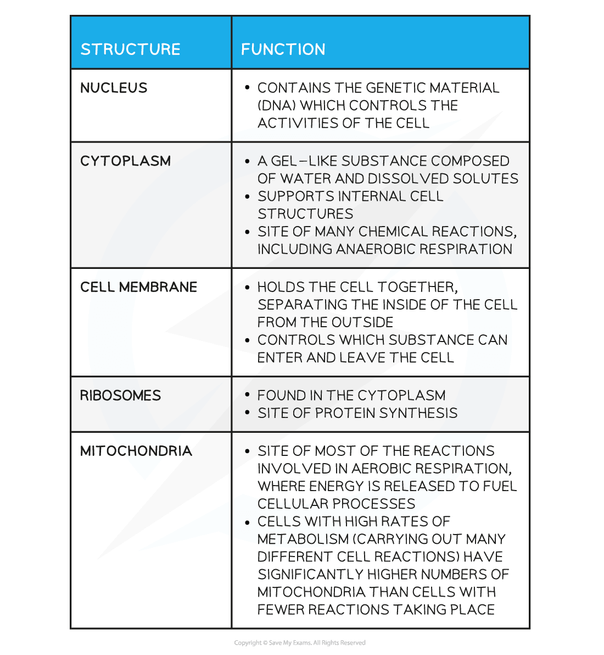](https://cdn.savemyexams.co.uk/wp-content/uploads/2020/06/Cell-structures-table.png)

**Plant Cells**

* In addition to the subcellular parts found in animal cells, plant cells have:
  + A cell wall made of cellulose (algal cells also have this structural feature)
  + A permanent vacuole filled with cell sap
* Plant cells found in the leaf and stem may also contain chloroplasts

[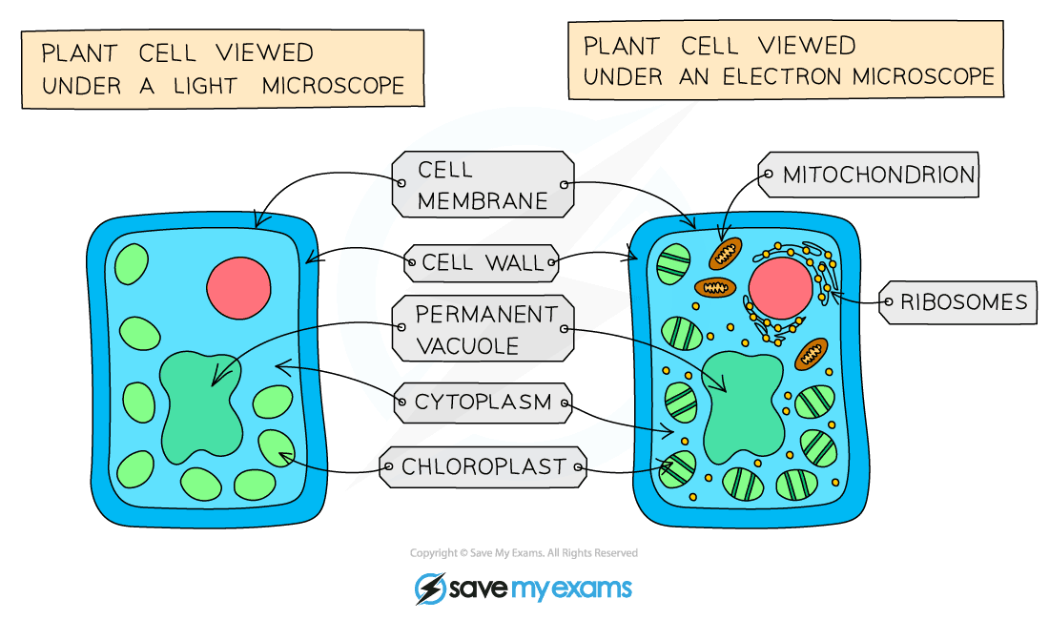](https://cdn.savemyexams.co.uk/wp-content/uploads/2020/01/Structures-in-a-plant-cell-visible-under-a-light-microscope-an-electron-microscope.png)

***The plant cell shown above contains chloroplasts, so it would be found in the leaves of a plant***

**Plant cell structure & function table**

[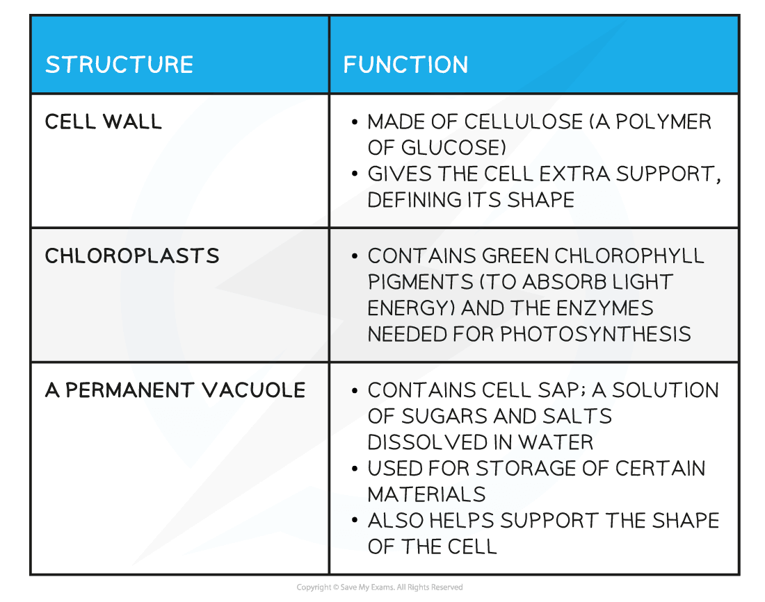](https://cdn.savemyexams.co.uk/wp-content/uploads/2020/06/Plant-cell-structure-function-table.png)