**3.3.1 Introduction to organic chemistry**

**Carbon compounds**

**Organic chemistry** is the **chemistry of carbon compounds**. Life is based on carbon compounds and organic means ‘to do with living things’. There are more carbon compound than all other compound put together (about 10 million – many are synthetic).

**Carbon** is special:

* 4 outer electrons so can form **4 covalent bonds**
* **C-C** bond relatively **strong** and **non-polar**
* Can be arranged in:
  + **Straight** chains e.g. butane
  + **Branched** chains e.g. methylpropane
  + **Rings** e.g. cyclohexane
* Carbon can **bond to other atoms** or groups of atoms – so there are **many compounds**
* Can form:
  + **Single** bonds e.g. methane CH4
  + **Double** bonds e.g. ethene CH2=CH2
  + **Triple** bonds e.g. ethyne CH≡CH

**Formulae**

Empirical formula – *simplest ratio of atoms*

**AS Link:**

**3.1.2 – Amount of substance**

***Definition***: **Empirical formula** is the formula that represents the **simplest ratio** of atoms of each element in a compound.

***Task: Work out the empirical formula***

3.00g ethane contains 2.40g C & 0.60g H

C H

Mass 2.40 0.60

Moles (n=m/Mr) 0.20 0.60

Ratio 1 3

**Empirical formula CH3**

Molecular formula – *actual number of atoms*

***Definition***: **Molecular formula** gives the actual number of atoms of each element in a compound.

Always a whole number multiple of empirical formula, but they can be that same.

Need:

* Empirical formula
* Molecular mass of empirical formula
* Relative molecular mass (Mr) of molecule

***Task: Work out the molecular formula***

Empirical formula is CH3 with molecular mass of 30.0

* Empirical formula CH3

MF = Mr x MF

Mr EF

* Molecular mass of empirical formula 12.0 + 3.0 = 15.0
* Relative molecular mass (Mr) of molecule 30.0

**Molecular formula** = (30.0/15.0) x CH3 = 2 x (CH3) **C2H6**

**Other examples CGP172**

Displayed formula – *shows every atom and every bond (symbols & lines)*

Bonds are show with sticks:

**All bonds must be shown**

An easy one to forget is between O and H in alcohols:

│

─ C ─ O ─ H

│

─ single bond

= double bond

≡ triple bond

**Examples & CGP173**

***Task: Draw displayed formula***

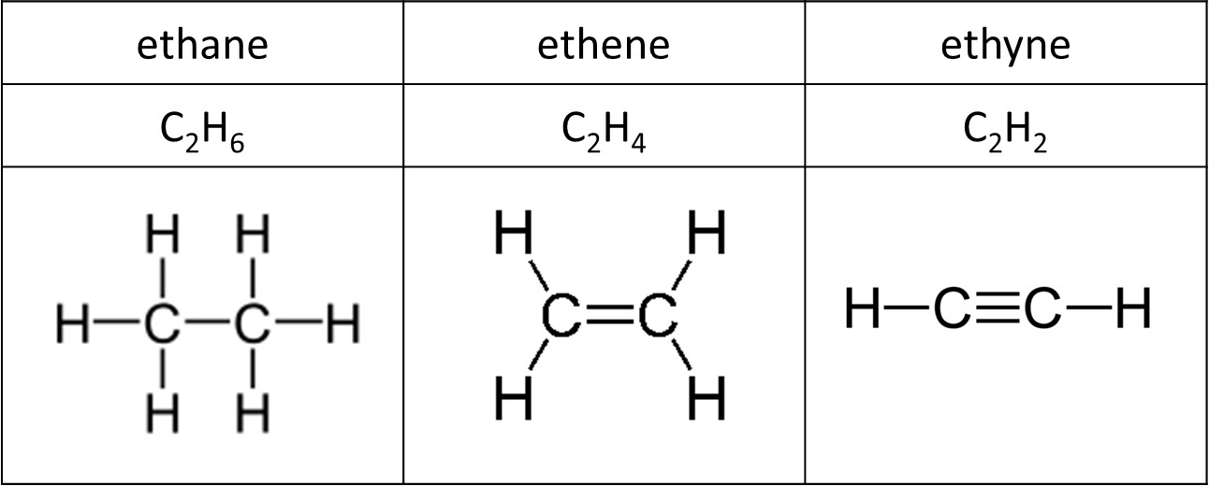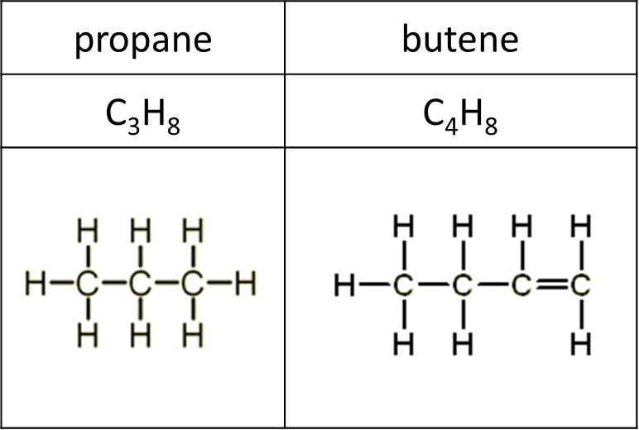

Structural formula – *shows the atoms carbon by carbon, with the attached hydrogens and functional groups*

It’s not necessary to show all bonds in a molecule to give a true picture of its structure. The unique arrangement of atoms can be shown in a simplified way, without showing all bonds **Branches in chains are shown in brackets** so this allows isomers to be identified. Each **carbon atoms is written with atoms or groups attached.** Sometimes some bonds are shown.

**Examples & CGP172**

If there are branched groups these are put inside brackets.

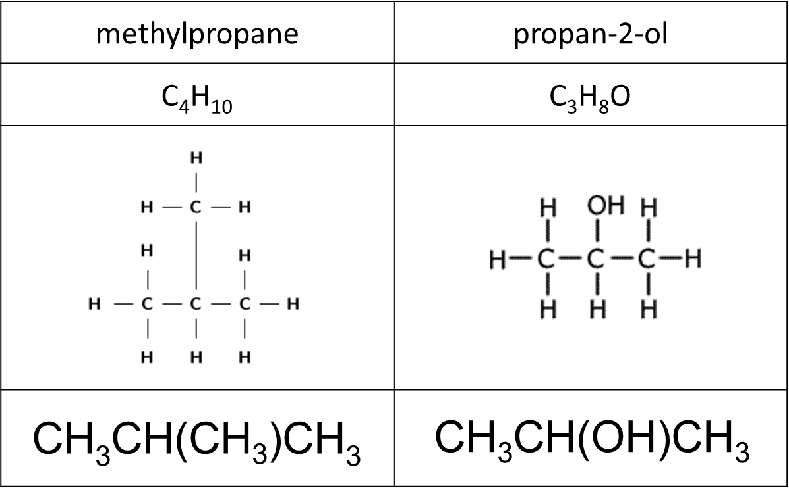

***Task: Write the structural formula***

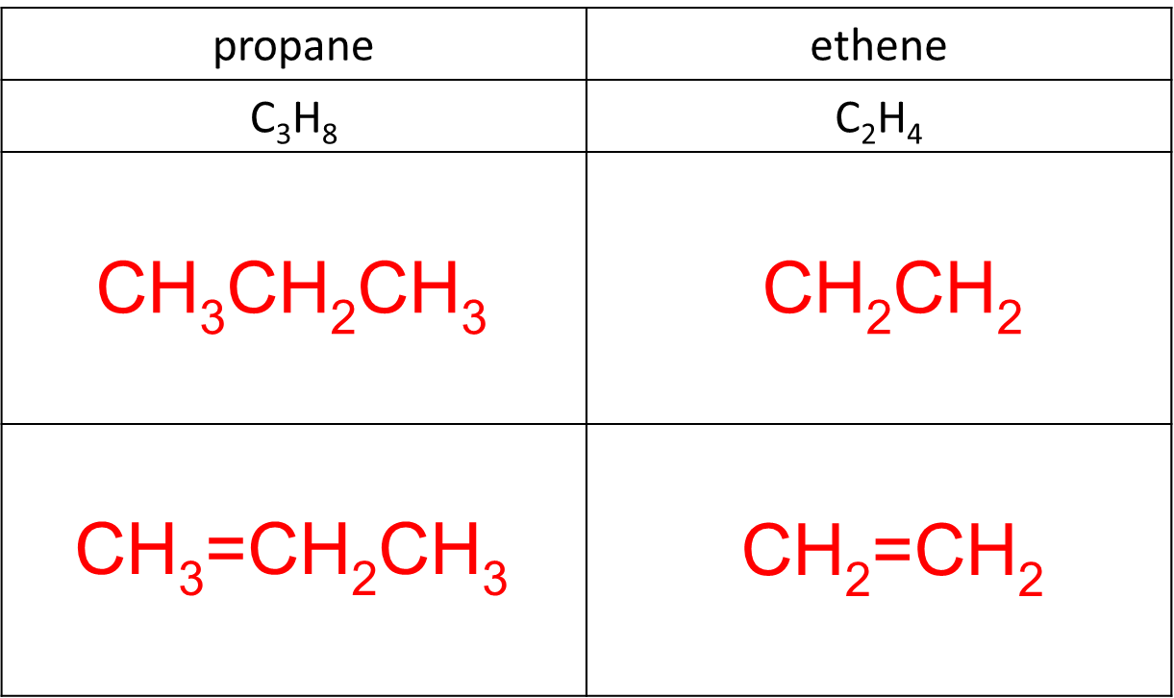

In **equations** this formula is usually used as it is less cumbersome. This is important as it **distinguishes between different isomers**.

**Example**

CH3COOH + CH3CH2OH → CH3COOCH2CH3 + H2O

ethanoic acid ethanol ethyl ethanoic acid

Using molecular formula does not show the precise structure.

C2H4O2 + C2H6O → C4H8O2 + H2O

acid alcohol ester

Take care when showing which atom is bonded:

C-OH not C-HO

C-CN not C-NC

Skeletal formula – *shows the bonds of the carbon skeleton only, with any functional groups*

The carbons and any hydrogen atoms bonded to them aren’t shown so it’s useful for drawing very complicated structures, like cyclical organic molecules. The **carbons** are at **each junction** and **end of the bonds**, **unless** there’s a **functional group** there. They show the **shape** of molecules.

|  |  |
| --- | --- |
| **Examples & CGP174** | ***Task: Draw skeletal formula*** |
|  |  |

***Starter: 5.1.3 – Formulae***

***Application: CGP174 PQ1-8***

***Fact recall: CGP175 Q1-4***

**Functional groups**

***Sheet: Homologous series***

***Definition***: **Functional group** is an atom or group of atoms which, when present in different molecules, causes them to have similar chemical properties.

Most organic compounds are made of a **hydrocarbon chain** which has one or more **functional** **groups** attached. The same functional group will **react in the same way** whatever the length of the chain. This means once the reactions of a functional group are learn it can be applied to any example.

**Functional group:**

* Reactive part
* Determines properties of molecule

A family of molecule with the same functional group but different length carbon chains are called an **homologous series** and can be represented with a **general formula**.

**Homologous series:**

* Same functional group
* Same general formula
* Similar chemical properties (due to functional group)
* Differ by CH2 group
* Trend in physical properties as carbon chain increases or if side chains are present
  + For example melting points increase as the chain length increases because the intermolecular forces increase, so small molecules are gases and large ones solids

***Models: Alkane, branched alkane, halogenalkanes, cycloalkane, alkene, alcohol, aldehydes, ketone, carboxylic acid***

Alkanes

|  |  |  |  |
| --- | --- | --- | --- |
| **General formula** | **Name** | **Information** | **Reactions** |
| CnH2n+2 | - ane | Saturated hydrocarbons  No functional group  Non-polar molecules | *Combustion*  *Free-radical substitution* |

**Example CGP176**

|  |  |  |
| --- | --- | --- |
| **methane** | **ethane** | **propane** |
| CH4 | CH3CH3 | CH3CH2CH3 |

Branched alkanes

|  |  |  |  |
| --- | --- | --- | --- |
| **General formula** | **Name** | **Information** | **Reactions** |
| CnH2n+2 | alkyl-ane | Saturated hydrocarbons  Doesn’t have all the carbons in a straight chain  Branches are called alkyl groups | *Combustion*  *Free-radical substitution* |

**Example CGP177**

|  |  |
| --- | --- |
| **methylpropane** | **3-ethylpentane** |
| CH3CH(CH3)CH3 | CH3CH2CH(C2H5)CH2CH3 |

Halogenoalkanes

|  |  |  |  |
| --- | --- | --- | --- |
| **General formula** | **Name** | **Information** | **Reactions** |
| CnH2n+1X  X = halogen | halo-ane | Saturated | *Nucleophilic substitution*  *Elimination* |

**Example CGP176**

|  |  |  |
| --- | --- | --- |
| **fluoromethane** | **chloroethane** | **1-bromopropane** |
| CH3F | CH3CH2Cl | CH3CH2CH2Br |

Cycloalkanes

|  |  |  |  |
| --- | --- | --- | --- |
| **General formula** | **Name** | **Information** | **Reactions** |
| CnH2n  R-X | cyclo-ane | Saturated ring  Same general formula as **alkenes**  Isomers of **alkenes** | *Combustion* |

**Example CGP177**

|  |  |
| --- | --- |
| **cyclopropane** | **chlorohexane** |
| C3H6 | C6H12 |

Alkenes

|  |  |  |  |
| --- | --- | --- | --- |
| **General formula** | **Name** | **Information** | **Reactions** |
| CnH2n | -ene | Unsaturated  Contain one double bond  Same general formula as **cycloalkanes**  Isomers of **cycloalkanes** | *Electrophilic addition*  *Polymerisation* |

**Example CGP177**

|  |  |
| --- | --- |
| **ethene** | **propene** |
| CH2=CH2 | CH2CH=CH3 |

Alcohols

|  |  |  |  |
| --- | --- | --- | --- |
| **General formula** | **Name** | **Information** | **Reactions** |
| CnH2n+1OH  R-OH | -ol | Saturated ring  Contain hydroxyl group (─OH) | *Combustion*  *Oxidation* |

**Example CGP178**

|  |  |
| --- | --- |
| **methanol** | **butan-2-ol** |
| CH3OH | CH3CH2CH(OH)CH3 |

Aldehydes

|  |  |  |
| --- | --- | --- |
| **General formula** | **Name** | **Information** |
| CnH2n+1CHO  R-CHO | -al | One carbon forms double bond with oxygen  Called a carbonyl group C=O  Isomers of **ketones**  Hint: aldeHydes have H |

**Example CGP178**

|  |  |
| --- | --- |
| **propanal** | **2-methylbutanal** |
| CH3CH2CHO | CH3CH2CH(CH3)CHO |

Ketones

|  |  |  |
| --- | --- | --- |
| **General formula** | **Name** | **Information** |
| R-CO-R’  R  C O  R | -one | Contain carbonyl group like aldehydes  R and R’ could be the same or different length  Isomers of **aldehydes** |

**Example CGP178**

|  |  |
| --- | --- |
| **propanone** | **pentan-2-one** |
| CH3COCH3 | CH3CH2CH2COCH3 |

Carboxylic acids

|  |  |  |
| --- | --- | --- |
| **General formula** | **Name** | **Information** |
| R–COOH  O  R*–*C  OH | -oic acid | Weak acids  Contain carbonyl group like aldehydes & ketones  When naming 1st carbon is the carbonyl group |

**Example CGP178**

|  |  |
| --- | --- |
| **methanoic acid** | **2-methylproanoic acid** |
| HCOOH | CH3CH(CH3)COOH |

***Starter: 5.1.1 – Functional groups***

***Task: Organic chemistry – Some definitions***

***Task: Organic chemistry – Homologous series & Alkanes***

***Fact recall: CGP179 Q1-7***

**Nomenclature – rules for naming organic compounds**

Organic compounds are named according to international rules of the International Union of Pure and Applied Chemistry or **IUPAC**. These **systematic names** give **information** **about** the **structure** of compounds rather than just formula.

Made up of 2 parts:

* Root or stem – describes the parent alkane – longest unbranched carbon chain or ring
* Prefix or suffix – indicates the functional group present or that it is an alkane

Roots

|  |  |  |
| --- | --- | --- |
| **Carbon atoms** | **Root** |  |
| **1** | meth |  |
| **2** | eth |  |
| **3** | prop |  |
| **4** | but |  |
| **5** | pent |  |
| **6** | hex | etc. |

Functional group prefixes & suffixes

**Prefixes** – added to beginning – branches or other atoms/groups

|  |  |  |
| --- | --- | --- |
| **Branch names** | **Root** |  |
| **1** | methyl |  |
| **2** | ethyl |  |
| **3** | propyl |  |
| **4** | butyl | etc. |

**Examples**

If more than one functional group is present then one will become a prefix with a change in name

Prefix: alkyl- branched hydrocarbon

halo- haloalkane

hydroxyl- alcohol

**Suffixes** – added to end – single bond (-ane), double bond (-ene) or functional group

**Examples**

Suffix: -ane alkane

-ene alkene

- ol alcohol R–OH

- al aldehydes R–CHO

- one ketone R–COR’

- oic acid carboxylic acid R–COOH

***Starter: 5.1.2 – Nomenclature***

***Sheet: 5.1.2 – Nomenclature***

Rules

1. Name **alkane** derivative – longest chain – number of carbon atoms determines name  
     
   CH3CH2CH2CH2CH3 pentane
2. **Branches** – name side chains depending on number of carbon atoms

CH3CH(CH3)CH3 methylpropane

***Task: How long is the longest carbon chain?***

|  |  |
| --- | --- |
|  |  |
|  |  |
|  |  |

1. **Prefix or suffix** on root chain – functional groups  
     
   CH2=CH2CH3 propene suffix  
     
   CH3CH2Cl chloroethane prefix

CH3CH2OH ethanol suffix

1. **Position** of functional group or branches by **numbering**  
   Must use the lowest combination of numbers possible.

1 2 3 4 1 2 3 4  
CH2=CHCH2CH3 but-1-ene CH3CH=CHCH3 but-2-ene

3 2 1 1 2 3  
CH3CH2CH2Cl 1-chloropropane CH3CHClCH3 2-chloropropane

3 2 1 1 2 3  
CH3CH2CH2OH propan-1-ol CH3CHOHCH3 propan-2-ol

1 2 3 4 5  
CH3CH(CH3)CH2CH2CH3 2-methylpentane NOT 4-methylpentane

If there is **only one position** for a branch or functional group then **no number** is needed.

CH3CH(CH3)CH3 methylpropane

N.B. In **carboxylic acid** the **carbon** of the **carbonyl** is always **number 1**.

1. **Two or more** of **same branch or functional group** – di, tri, tetra  
   Each numbered with commas between numbers & hyphens between numbers & letters

CH3C(CH3)2CH3 dimethylpropane

CH3CCl3 1,1,1-trichloroethane

CH2ClCHCl2 1,1,2-trichloroethane

1. **Two or more different branches or functional groups**

Names in alphabetical order (position of group shown with number)  
  
CH3CH(CH3)CH(CH2CH3)CH2 CH2CH3 3-ethyl-2-methylhexane

CH3CHBrCH2Cl 2-bromo-1-chloropropane

CH3CBr2CH2Cl 2,2-dibromo-1-chloropropane (b for bromo not di)

1. **Multiple functional groups**

If there are more than one functional group the one with the **highest priority** is used to **derive the root hydrocarbon** chain and it has the **lowest number** possible.

|  |  |  |  |
| --- | --- | --- | --- |
| Halogens | alkyl groups | alkenes | other groups |
| *lowest priority* |  | | *highest priority* |
| highest number |  | | lowest number |

3 2 1

ClCH2CH2CH2OH 3-chloropropan-1-ol NOT 1-chloropropan-3-ol

3 2 1

H2C=CHCH2OH prop-2-en-1-ol

**Suffix –ene** can be placed in front of other suffixes & is s**hortened to ‘en’ if followed by a number**.

1. **Cycloalkanes**

They have the same name as their straight chain equivalent, with the **prefix cyclo**-. If there are any **branches** they come **in front of the cycloalkane** name, following the numbering and alphabetical rules above. The alkyl which is listed **first** **alphabetically** becomes **number 1**.

|  |  |
| --- | --- |
|  |  |
| 1-ethyl-3-methylcyclopentane | 1,1-dimethylcyclohexane |

***Starter: 5.1.3 – Formulae***

***Task: Naming hydrocarbons***

***On-line quiz:*** [***http://nomenclature101.com/en/***](http://nomenclature101.com/en/)

Drawing a structure from a name

1. Identify **longest carbon** chain - draw the **carbon** atoms, include any **double** **bonds**
2. Add **functional** groups or **branches**
3. Add **hydrogen** atoms last – each carbon has 4 bonds

**Example**

3-methylpent-2-ene

pent- C⎯C⎯C⎯C⎯C

pent-2-ene C⎯C=C⎯C⎯C

H H CH3H H

│ │ │ │ │

3-methylpent-2ene H⎯C⎯C=C⎯C⎯C⎯ H

│ │ │

H H H

***Task: Organic chemistry – Naming alkanes, alkenes & haloalkanes***

***Sheet: Organic chemistry – Exercises for practise***

***Sheet: Skeletal formula***

***Application: CGP183 PQ1-3***

***Fact recall: CGP183 Q1-2***

**Organic mechanisms**

A **mechanism** is a method used by organic chemists to **show how a reaction occurs**. It breaks the reaction down into a **series of steps**. All reactions involve **movement of the electrons** as covalent bonds are broken and new bonds formed. As negatively charged particles they tend to **move** from areas of **high negative charge** **to more positively charged** areas.

To **make or break bonds** in a reaction **electrons must move**.

In organic mechanisms the **route** taken by the **electrons** is sometimes shown using **curly arrows** and is **very precise**. The **tail** of the arrow **starts** where the **electrons** **begin** and the **head** of the arrow **ends** where the **electrons** **go** to.

So **curly arrows show the movement of electron pairs**.

The drawing of them must be **very precise**.

|  |  |
| --- | --- |
| Electron pairs – tail of the arrow starts here |  |
| Atoms –  head of the arrow stops here |  |

**Example - Nucleophilic substitution**

iodomethane + sodium hydroxide → methanol + sodium iodide

CH3I + OH- → CH3OH + I-

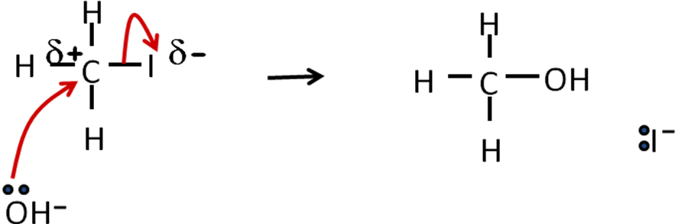

Sometimes a covalent bond may break in such a way that **one electron goes to each atom** that formed the bond. This gives an **unpaired electron** that is **very reactive** and referred to as a **free-radical**.

***Definition***: **Free-radical** is an unpaired electron.

There are **different mechanisms** and the **type** depends on the **reactant** and **molecules receiving** the reactant.

The following mechanisms will be covered in other topics.

|  |  |  |  |
| --- | --- | --- | --- |
| **Reactant** | **Receiving molecule** | **Mechanism name** |  |
| Free radical  – an unpaired electron | Anything  e.g. single non-polar bond | Free-radical substitution |  |
| Nucleophile  – electron pair donor | Electron deficient areas (+ or δ+)  i.e. atom in polar bond or with a positive charge | Nucleophilic substitution |  |
| Base  – proton acceptor | Hydrogen atom | Elimination |  |
| Electrophile  – electron pair acceptor | Electron rich areas  e.g. C=C double bond | Electrophilic addition |  |

***Starter: 5.1.5 - Mechanisms and curly arrows***

***Fact recall: CGP184 Q1-2***

**Isomerism**

Molecules can be put together in different ways, so they may have the same molecular formula but their structural and displayed formula would look very different.

2 types:

* structural isomerism
* stereoisomerism

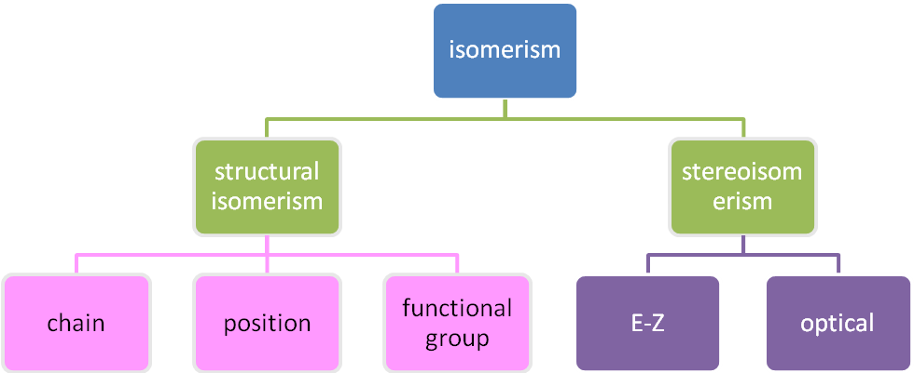

Optical isomerism studied in 2nd year

Structural isomerism

***Definition***: **Structural isomers** are compounds with the same molecular formula but different structures (different structural formula)

**1**. **Chain isomers** – *2 or more ways of arranging carbon skeleton through branching*

C4H10 CH3CH2CH2CH3 CH3CH(CH3)CH3

butane methylpropane

C4H9OH CH3CH2CH2CH2OH CH3CH(CH3)CH2CH2OH

butan-1-ol 2-methylpropan-1-ol

The functional group remains in the same position

Chain isomers have:

* **similar chemical** properties
* slightly **different physical** properties
  + **branched isomers** will have **lower boiling points** due to **weaker van der Waals forces** because they are **unable to pack as closely** together as their equivalent straight chain isomers.

**2.** **Position isomers** – *functional group is the same but in a different position on the**carbon skeleton is different*

C3H6Br CH3CH2CH2Br CH3CHBrCH3

1-bromopropane 2-bromopropane

C4H8 CH2=CHCH2CH3 CH2CH=CH2CH3

but-1-ene but-2-ene

Position isomers:

* **similar chemical** properties
* slightly **different physical** properties

**3.** **Functional group isomers** – *different functional groups*

C6H12 CH3CH2CH2CH2CH=CH2

cyclohexane hex-1-ene

C3H6O CH3CH2CHO CH3COCH3

propanal propanone

(aldehyde) (ketone)

Functional group isomers:

* **different chemical** properties
* **different physical** properties

***Task: Structural isomerism***

***Task: Isomers***

***Application: CGP187 PQ1-4***

***Fact recall: CGP187 Q1-3***

Stereoisomers

These are sometimes called **geometric** isomers.

***Definition***: **Stereoisomers** are compounds which have the same structural formula but the atoms or bond are arranged differently in space.

E-Z isomerism

***Demo: Alkenes molymods***

Alkenes can form **E-Z** **stereoisomer** because there is **restricted rotation** around the **C=C double bond**, the bond or any atoms attached to the C=C bond **can’t rotate**. There must be **two different groups attached to each carbon across the double bond**.

This forms a **planar molecule** **across** the **double bond**. The bond angles between the carbon of the double bond and other atoms will be **120O** and each forms a **trigonal planar** shape. Any **alkyl chains** attached to the carbons of the double bond **can rotate**.

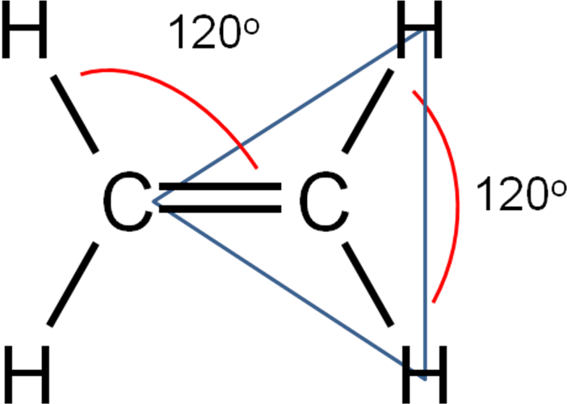

If the **alkyl groups** or **other atoms** are on the **same side** of the double bond it referred to as the **Z- isomer**, if they are on **opposite** sides it is called the **E- isomer**. Sometimes called

**E-Z isomerism**.

|  |  |
| --- | --- |
| ***E* – entgegen (opposite)**  **Help: E is for "Enemies" so are on opposite sides** | ***Z* – zusammen (together)**  **Help: Say "*zee zame zide*" with a German accent** |
| *trans\** | *cis\** |
|  |  |

*\*Old name system*

**But-2-ene**

|  |  |  |
| --- | --- | --- |
| Structure |  |  |
| Name | ***E*-but-2-ene** | ***Z-*but-2-ene** |
| Molecular formula | C4H8 | C4H8 |
| Structural formula | CH3CH=CHCH3 | CH3CH=CHCH3 |
| Physical properties | lower boiling point | slightly higher boiling point |
| less polar | more polar |

***Task: Name these alkenes & identify the type of isomerism***

|  |  |  |  |
| --- | --- | --- | --- |
|  | methylpropene |  | but-1-ene |
| chain isomer | position isomer |

If there are **2 identical groups attached to the same carbon it’s not E-Z stereoisomerism**, this is only with **groups attached to each of the carbon** atoms in the double bond.

Naming priority

E-Z isomers with a number of groups attached to the C=C bond are harder to work out. A system of priority rules is used, called the **Cahn-Ingold-Prelog (CIP) priority rules**:

* Assign a **priority** to the **carbon** atoms of the double bond, this is done by looking at the **atoms attached directly to the carbon atoms at each end of the double bond**.
* The atom which has the **higher atomic number is given the higher pr**i**ority**.
* If the **subsequent atoms** are the **same** use the **sum** of the **adjoining** **atoms**.
* If the **two groups** with the **higher priorities** are on the **same side** of the double bond it’s the **Z-isomer**. If the two groups with the higher priorities are on **opposite sides** of the double bond, then it’s the **E-isomer**.

|  |  |
| --- | --- |
| Highest values opposite = E | Highest values together = Z |
|  |  |
| ***Z*** 2-bromo-3-fluorobut-2-ene | ***E*** 3-methylpent-2-ene |

***Starter: 5.1.4 – Isomerism***

***Task: E-Z Stereoisomerism***

*Hint: Always start with the C=C, then add the groups.*

*Try out another displayed formula – does it still have the same name?*

***Task: Extension - Geometric isomerism***

***Application: CGP191 PQ1-2***

***Fact recall: CGP191 Q1-3***

***Exam questions: Oxford p188-189 Q1-5***