GCSE Religious Studies



# Paper 2: Thematic Studies

# Relationships and Families

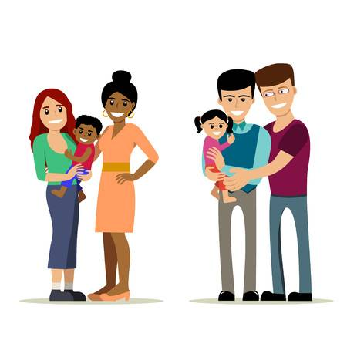







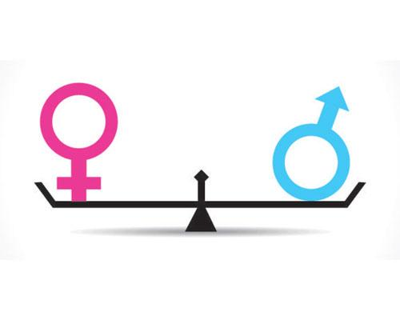

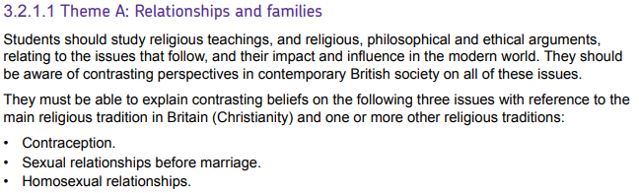

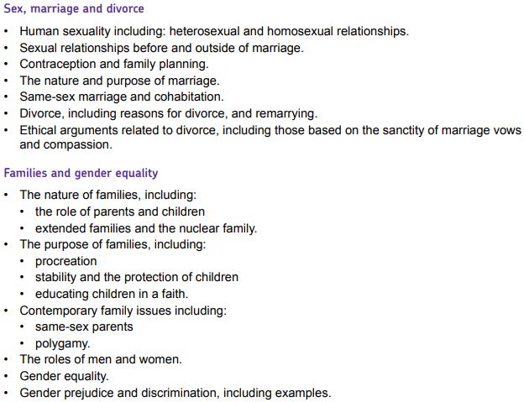



|  |  |
| --- | --- |
| **Key Term** | **Definition** |
| **Adultery** | Voluntary sexual intercourse between a married person and someone who is not their spouse (husband or wife) |
| **Bigamy** | Marrying someone while already married. |
| **Civil partnerships** | A legal union between two people as partners in a relationship with all the same legal implications as marriage. |
| **Cohabitation** | A couple living together without being married. |
| **Contraception** | A method used to prevent pregnancy. |
| **Extended family** | A family that extends beyond just parents and their children by including grandparents and other relatives. |
| **Family planning** | Couples making informed decisions about how many children they have and when they have them. |
| **Gender discrimination** | Acting against someone on the basis of their gender |
| **Gender equality** | Giving people the same rights and opportunities regardless of whether they are male or female. |
| **Gender prejudice** | Holding opinions about an individual based on their gender. |
| **Heterosexual** | [***Straight***] To be sexually attracted to members of the opposite sex. |
| **Homosexual** | **[*Gay*]** To be sexually attracted to members of the same sex. |
| **Human sexuality** | How people express themselves as sexual beings. |
| **Marriage** | A legal union between two people as partners in a relationship. |
| **Nuclear family** | A couple and their children; the basic social family unit. |
| **Polygamy** | The practice or custom of having more than one wife at the same time. |
| **Premarital sex** | Sex between two unmarried people. |
| **Procreation** | Bringing babies into the world; producing children. |
| **Same-sex marriage** | Marriage between partners of the same sex |
| **Same-sex parents** | People of the same sex who are raising children together. |
| **Sexual stereotyping** | Having a fixed general idea or image of how men and women behave. |
| **Spouse** | Husband or wife |
| **Stepfamily** | A family that is formed on the remarriage of a divorced or widowed person that includes a child/children. |

Human Sexuality

Human sexuality refers to the way people express themselves as sexual beings. Human sexuality takes many forms but most people usually identify as either:

**Heterosexual:** *being sexually attracted to members of the opposite sex.*

**Homosexual:** *being sexually attracted to members of the same sex.*

Some people also identify as **bisexual** meaning that they experience sexual attraction to people of both sexes.

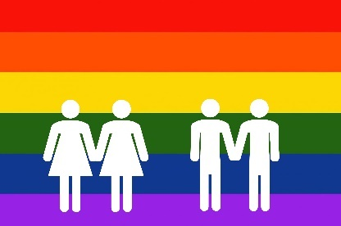Estimates put the incidence of homosexuality (or at least non-heterosexuality) at somewhere between 5-10% of the population although the rate is higher among men than women. Homosexuality has also been observed in almost all animal species. While the biological reasons for heterosexual attraction can be appreciated in terms of reproduction, homosexual preferences are less well understood. Scientists do not know what determines an individual's sexual orientation, but they theorize that it is caused by a complex interplay of [genetic](https://en.wikipedia.org/wiki/Genetics), [hormonal](https://en.wikipedia.org/wiki/Hormonal), and [environmental influences](https://en.wikipedia.org/wiki/Environment_and_sexual_orientation). There is however widespread scientific consensus that sexual preference is not chosen.

Attitudes towards sexual relationships have changed over time and the UK law has been gradually adapted over time to reflect public sentiment on these issues. The timeline below shows some of the significant laws governing sexual relationships in the UK.

|  |  |
| --- | --- |
| 1275: | The age of consent is first put into law and set at age 12 for heterosexual relationships. |
| 1875: | Age of consent is raised to 13. |
| 1885: | The age of consent is raised to 16 for heterosexual relationships and homosexual sexual acts are made illegal. |
| 1967: | Homosexual acts are declared legal for people over 21, except in the armed forces. |
| 1994: | The age of consent for homosexual acts is reduced to 18. |
| 2000: | Homosexuals are allowed to serve in the armed forces. |
| 2001: | The age of consent for homosexual acts is reduced to 16, in line with the law on heterosexual acts. |
| 2004: | Civil partnerships for homosexuals are recognised in law. |
| 2013: | Same-sex marriage is recognised in law. |
| 2019: | Heterosexual civil partnerships are recognised by law. |

Christianity and Homosexuality

It is a surprise to many people to discover that there are only a handful of passages in the Bible that talk about homosexuality. In fact, only six discuss the topic explicitly, but they do all seem to reiterate the same view.

*“You shall not lie with a male as with a woman; it is an abomination.”* (Leviticus 18:22)

*“Do not be deceived: neither the sexually immoral, nor idolaters, nor adulterers, nor men who practise homosexuality, nor thieves, nor the greedy, nor drunkards, nor swindlers will inherit the kingdom of God.”* (1 Corinthians 6:9-10)

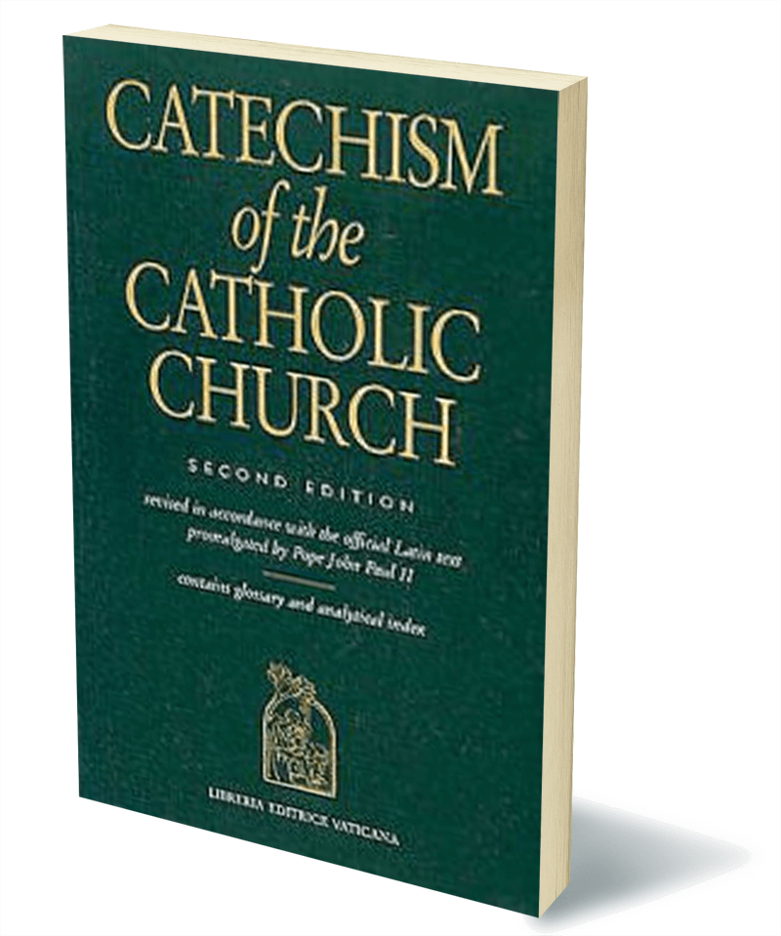The Catechism of the Catholic Church is a record of the official teaching of the Catholic Church. Below is what it says about homosexuality:

***2358****The number of men and women who have deep-seated homosexual tendencies is not negligible. This inclination constitutes a challenge for them. They must be accepted with respect, compassion, and sensitivity. Every sign of unjust discrimination in their regard should be avoided. These persons are called to fulfil God's will in their lives and, if they are Christians, to unite to the sacrifice of the Lord's Cross the difficulties they may encounter from their condition.*

[***2359***](javascript:openWindow('cr/2359.htm');)*Homosexual persons are called to chastity. By the virtues of self-mastery that teach them inner freedom, at times by the support of disinterested friendship, by prayer and grace, they can and should gradually and resolutely approach Christian perfection.*

Jesus never makes any explicit mention of homosexuality. He stated that the greatest commandment was to love God, and secondly, to “love your neighbour”. Love was, overwhelmingly Jesus’ priority.

Jesus did however make mention of marriage:

*“Haven’t you read,” he replied, “that at the beginning the Creator ‘made them male and female,’**and said, ‘For this reason a man will leave his father and mother and be united to his wife, and the two will become one flesh’.* (Matthew 19:4-5)

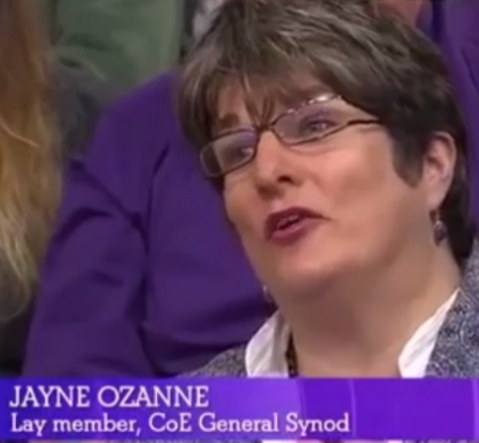

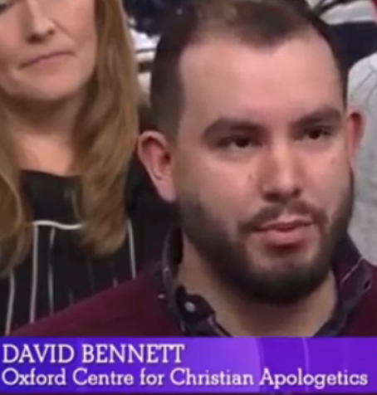

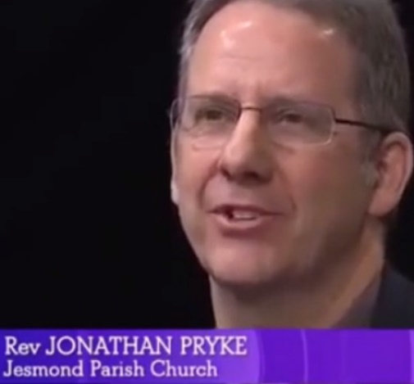



Which of these views do you think is the best understanding of the Christian view on homosexuality?

Islam and Homosexuality

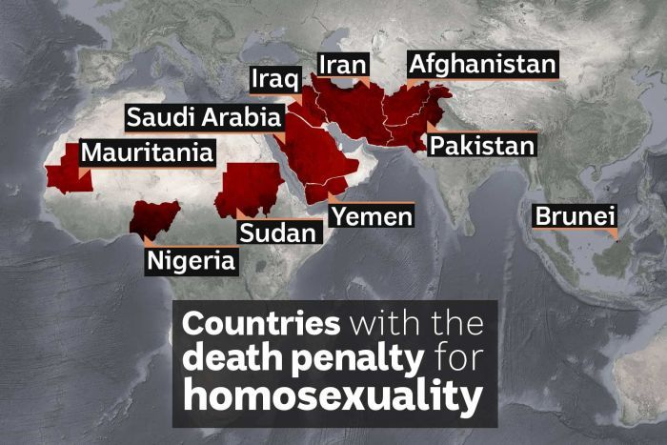Generally speaking, Islam does not tolerate homosexuality. Almost all schools of Shari’ah law view homosexual acts as sinful and should be punished. In most Islamic countries homosexuality is illegal and, in many cases, punishable by death. In a 2016 survey done for a C4 documentary found that almost all British Muslims disapproved of homosexuality and over half (52%) believed that homosexuality should be illegal in the UK.

These attitudes are based on teachings in the Qur'an which argue that it is unnatural and against the will of Allah:

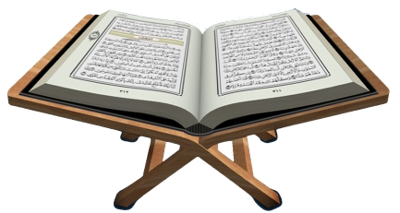*“And as for the two of you men who are guilty of* [homosexual acts], *punish them both. And if they repent and improve, then let them be. Lo! Allah is Merciful.”*

*“Must you, unlike other people, lust after males and abandon the wives that God has created for you? You are exceeding all bounds.”*

Although the punishments for homosexual acts are not prescribed in the Qur’an, the Hadith states, on more than one occasion:

*“If you find anyone doing as Lot's people did, kill the one who does it, and the one to whom it is done.”*

-----------------------------------------------------------------------------------------------------------------------------------------------------------

Despite widespread condemnation of homosexuality within Islam, there are some who are accepting of gay relationships. The Inclusive Mosque Initiative was founded in 2012, in London. It is a grassroots activist organisation which works toward “*Establishing a place of worship for the promotion and practice of an inclusive Islam.”*

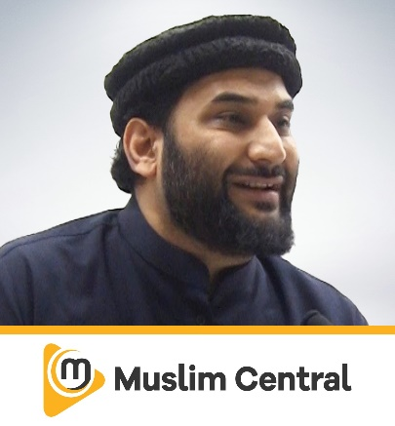The initiative has faced a lot of opposition from more traditional Muslims however, including Imam Adnan Rashid who said:

*"The orthodox values of Islam are very clear. Muslims already believe in things that have been established for them for centuries and they are not going change. The Koran is not going to change, the prophetic position is not going to change. Muslim thinking and practices are not going to change. So I don't know what the point of this mosque is."*

Sex before marriage

In the past, sex before marriage was considered shocking, particularly for a woman. This is demonstrated in the Old Testament where, in Deuteronomy, it says:

*“If, however, the charge* [of not being a virgin upon being married] *is true and no proof of the young woman’s virginity can be found, she shall be brought to the door of her father’s house and there the men of her town shall stone her to death. She has done an outrageous thing in Israel by being promiscuous while still in her father’s house. You must purge the evil from among you.”* Deuteronomy 22:20-22

In the last 50 years however, attitudes towards premarital sex have shifted dramatically to the point where studies suggest that over 80% of the UK first have sex in their teenage years.

The increase in societal acceptance of premarital sex is also reflected in films, TV programmes, books and magazines which reflect the common belief that it is both common and acceptable for people who are unmarried to have sex.

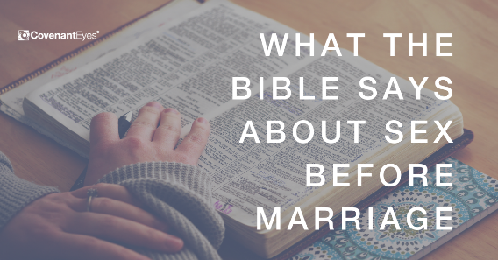

The Bible teaches that the only appropriate circumstance for two people to have sex is within marriage. Many Christians believe that the act of having sex expresses a deep, loving, lifelong union that first requires the commitment of marriage. This is in keeping with Jesus’ teaching that:

*“A man will be united with his wife and the two will become one flesh. So they are no longer two, but one flesh. Therefore, what God has joined together, let no man separate.”*

A common analogy for understanding the Christian view on the impact that sex has on a couple is to imagine gluing two pieces of paper together. Once you have done this, the two pieces essentially become one, much like the above quotation. If you then try to separate the two pieces again, it is impossible to do without damaging both sheets of paper.

This is not to say that Christians believe sex to be damaging *per se*, but believe that should be an important part of a lifelong, loving, trusting relationship in marriage.

Islamic teachings on sex before marriage is very clear and it is expressly forbidden in the Qur’an.

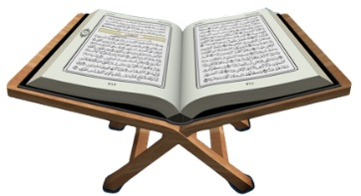 *“Do not even approach fornication (non-marital sex) for it is an outrageous act, and an evil way.”*

Qur’an 17:32

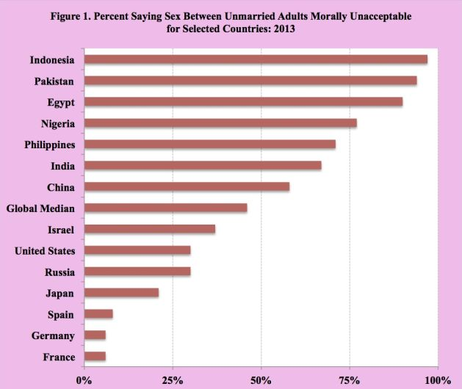

Under the Shari’ah (Islamic law) sex before marriage is considered to be a major sin and is punishable by death in some Islamic countries. The graph to the right demonstrates the stricter attitudes towards premarital sex that are held in Islamic countries in comparison to western and European countries.

The contrast is just as stark within British society. In a 2009 study, 82% of non-religious Britons said sex before marriage was acceptable, compared with only 3% of Muslims.

Muslims believe that sex is a gift from God but that it needs to be treated responsibly. Sex is considered by many Muslims to be a crucial aspect of marriage and that marriage is the cornerstone of a good society. Therefore, any non-marital sex should be considered damaging to society.

**Author on Islamic theology, Abdul Wahid Hamid puts it like this:

*“The only way to protect all within society is to maintain a society where only a man and his wife share the act of sex.”*

Sex Outside of Marriage

Sex outside of marriage should be understood as a married person having sexual relations with someone other than their spouse. This can also be referred to as **adultery**.

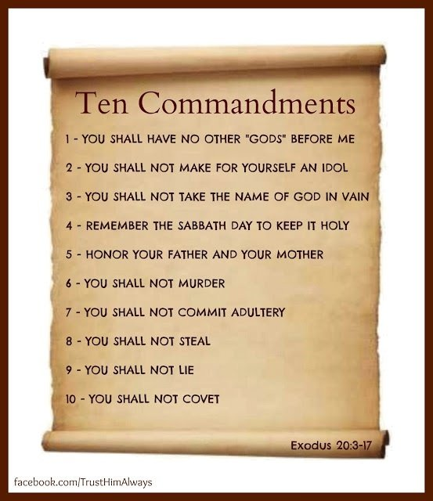

Christianity is very clear in its condemnation of adultery. In the Old Testament, not only is adultery condemned in the Ten Commandments (see right), in Leviticus, the punishment for adultery is death:

*“If a man commits adultery with another man’s wife - with the wife of his neighbour - both the adulterer and the adulteress are to be put to death.”*

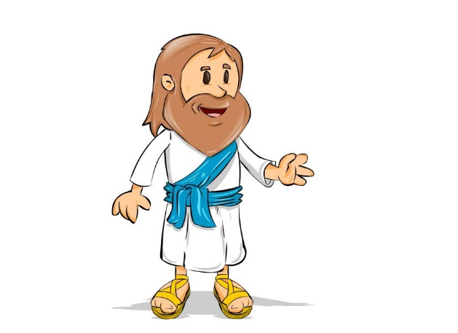Jesus even goes a step further, and teaches that lust for another person is also a sin:

*“You have heard that it was said, ‘You shall not commit adultery.’**But I tell you that anyone who looks at a woman lustfully has already committed adultery with her in his heart.”*

Jesus does forgive a woman who is about to be stoned to death after having been found to have committed adultery, challenging her accusers to only cast a stone if they can say they are without sin. However, he does the command her to “Go, and sin no more”, reiterating the view that adultery is sinful.

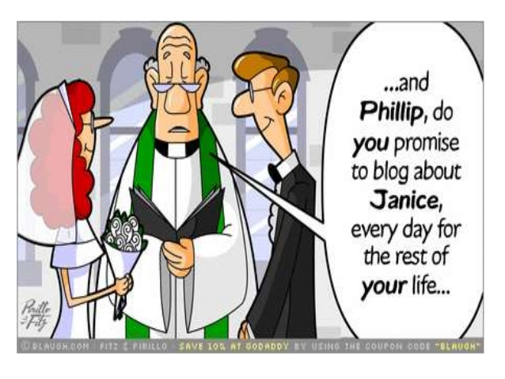At a Christian marriage service, the bride and groom will make solemn vows to one another before God. Adultery is in clear violation of these. In the Anglican liturgy for a marriage service, both the bride and the groom will confirm “I will”, when asked by the presiding priest:

[Name] *will you take*[Name]*to be your husband/wife?*

*Will you love him/her, comfort him/her, honour and protect him/her,*

*and,* ***forsaking all others****,* ***be faithful*** *to him/her as long as you both shall live?*

Contraception

Contraception is a method of trying to prevent pregnancy when having sex. Different methods of contraception exist and some of these differences are considered important when considering the ethical implications.

**Natural methods**

Methods which do not involve any artificial intervention in the fertilisation of an egg.

**Examples:** - Withdrawal

- Rhythm method

**Artificial Methods**

Artificial methods of contraception fall into two categories:

|  |  |  |
| --- | --- | --- |
| Barrier methods  (Methods which stop sperm and egg meeting and therefore prevents fertilisation)  Examples:   * Condoms * ‘The pill’ * Spermicidal jellies or creams * Sterilisation |  | Implantation prevention methods  (Methods which prevent even fertilised eggs from implanting and developing.)  Examples:   * The coil / IUD * Some forms of ‘the pill’ * The ‘morning-after pill’ |

Catholic Views on Contraception

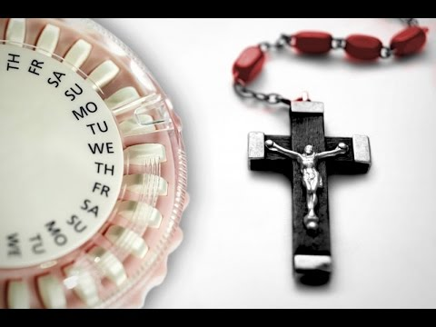The teaching of the Catholic Church is very clear when it comes to contraception. The Church teaches that:

*“Every sexual act should have the possibility to creating new life.”*

This means that every method of contraception is forbidden, with the exception of the rhythm method.

Unsurprisingly, contraception is barely mentioned in the Bible but there is a single passage in Genesis which appears to condemn withdrawal as a method of avoiding pregnancy.

*“Judah said to Onan, ‘Go in to your brother’s wife, and perform the duty of a brother-in-law to her, and raise up offspring for your brother.’ But Onan knew that the offspring would not be his; so when he went in to his brother’s wife he spilled the semen on the ground, lest he should give offspring to his brother. And what he did was displeasing in the sight of the Lord, and he slew him also”* (Gen. 38:8–10).

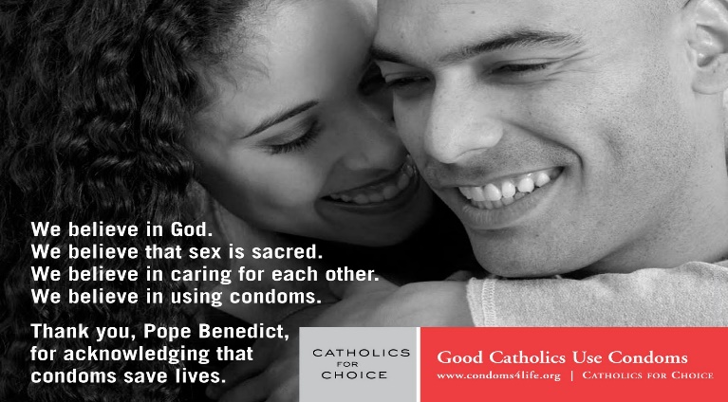Many people, including many Catholics (see the poster on the right made by a group calling themselves ‘Catholics for Choice’) have criticised the Catholic Church for this teaching, arguing that discouraging the use of condoms has led to a far greater spread sexually transmitted diseases such as AIDS, as well as stopping couples from being able to reliably plan their family.

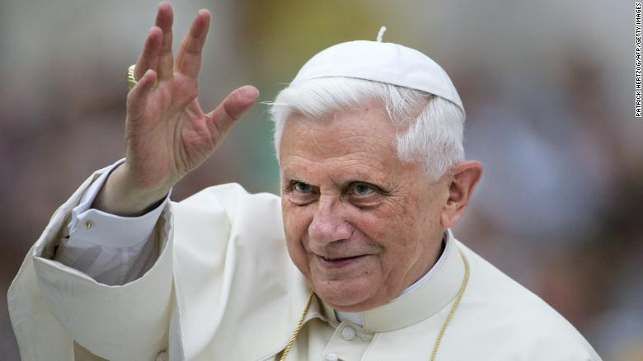In fact, Pope Benedict (the Pope before the current one) softened the Church’s stance on condom use, stating that their use could be justified “in some cases”. He gave the example of a male prostitute using a condom to prevent the spread of AIDS which “*can be a first step in the direction of moralisation, a first assumption of responsibility, on the way toward recovering an awareness that not everything is allowed and that one cannot do whatever one wants”.*

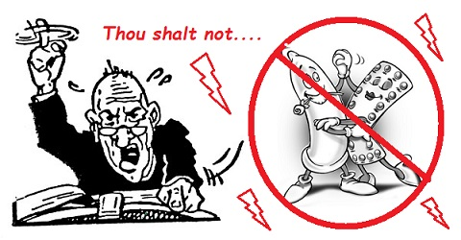

The traditional Catholic view, however, is that to use any form of contraception is to try to interfere with God’s plan for children and that it should be left up to God when a pregnancy should occur.

The Church also teaches that contraception could lead to promiscuity and infidelity, therefore breaking down foundations of marriage.

Other Christian views on contraception vary. Many will share the Catholic view that one of the primary functions of sex should be procreation and that Christians are called to have many children. In the book of Genesis, God instructs Adam and Eve to *“Be fruitful and multiply”* which can be understood as a command to have lots of children.

Others however, will say that since you have a responsibility to care for your children, you should only have children when you are able to sufficiently care for them, both emotionally and financially. They might argue that it is unfair to bring a child into deprivation, but that sex is still an important part of developing and maintaining a loving marriage and therefore the use of contraception should be accepted.

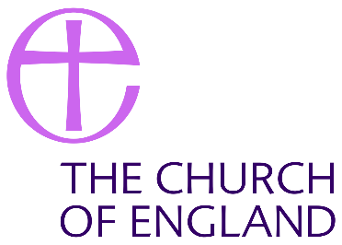The Church of England approved the use of artificial contraception in 1930 at the Lambeth Conference stating:

*“The Conference agrees that other methods may be used, provided that this is done in the light of Christian principles.”*

This declaration however, is understood by many Anglican Christians to still forbid certain forms of contraception. Many Christians view methods on contraception which prevent implantation, rather than fertilisation, to be early forms of abortion which they may feel is immoral (see Religion and Life booklet).

For Muslims, as for most Christians, contraception should only be considered within the context of marriage since any other sex is considered sinful. In Islam, children are considered a gift from God and there is an expectation on Muslim couples to have children if they can. Within marriage however, most Muslims accept the use of artificial contraception as a form of family planning.

The Qur’an contains no direct teaching about contraception, but some scholars use the following quotation to argue that Islam does not want to impose hardship on people and so would be sympathetic to the use of contraception as a form of family planning:

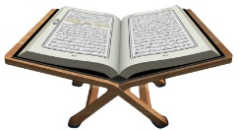*“Allah wishes to lighten your burden; man was created weak.”*

Evidence from some Hadith shows that the Prophet Muhammad knew of birth control and seemed to approve of it in appropriate circumstances. Avicenna, a Muslim doctor in the 11th century, listed 20 different substances used for birth control.



Use the table below to compile the ethical arguments for and against the use of contraception.

|  |  |
| --- | --- |
| For | Against |

 Marriage

Marriage is considered to be the union of two people. In the UK, it is a legal contract between two people that brings security, providing various legal and financial benefits.

According to Christianity, marriage was one of God’s gifts at creation and is considered a sacred act. Some forms of Christianity such as Catholicism, Orthodox and Anglican churches believe marriage to be a sacrament.

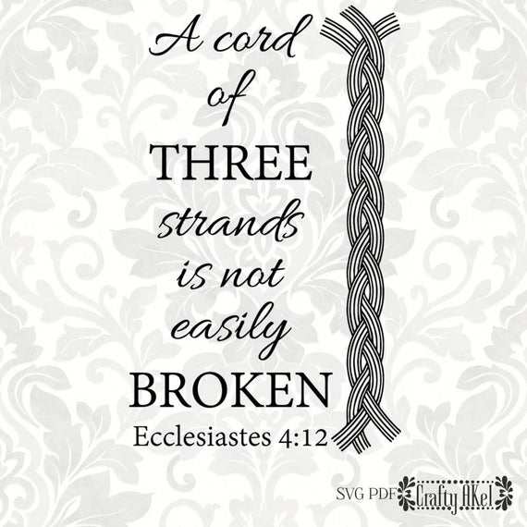

Christians believe that marriage takes place before God and is a holy commitment which involves God throughout. The Bible states that *“a cord of three strands is not easily broken”* which signifies that God is a part of a couple’s marriage and that the vows that are made in a marriage service are not just to one another, but to God also.

The purpose of marriage within Christianity is to provide a stable, secure environment for family life. It is the proper circumstance for bringing up children within the Christian faith and provide lifelong support and companionship for a partner.

Same-sex marriage

In the UK, after much campaigning, same-sex marriage was legalised in the UK in 2013. Prior to that, a very similar legal institution called civil partnership was introduced in 2004 to give same-sex couples the same legal rights as married couples, although the word marriage was not used.

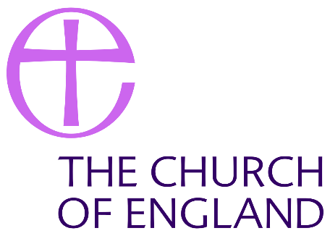Most Christian churches do not recognise same-sex marriage, arguing that the term is in fact a contradiction because marriage is, by definition between a man and a woman.

*“A man leaves his father and mother and becomes united to his wife, and they become one flesh.”*

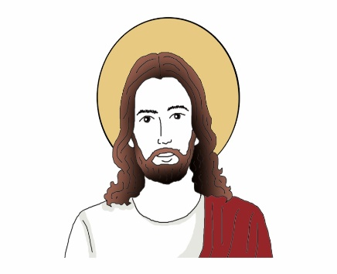

*“The Church sees marriage between a man and a woman, as central to the stability and health of human society.”*

-----------------------------------------------------------------------------------------------------------------------------------------------------------



However, some Christian churches, such as the Quakers, do now accept same-sex marriage:

*“It is the nature and quality of a relationship that matters… the same criteria seem to us to apply whether a relationship is heterosexual or homosexual.”*

Polygamy

Most Christians reject polygamy and believe that marriage was established by God as between one man and one woman at creation. Following the six days of creation in Genesis, the Bible states:

 *“The Lord God said, “It is not good for the man to be alone. I will make a helper suitable for him.” […] Then the Lord God made a woman from the rib he had taken out of the man, and he brought her to the man. […] That is why a man leaves his father and mother and is united to his wife, and they become one flesh.”*

In the New Testament, Jesus appears to repeat this principle (see page 8 of this booklet).

Despite this, there are some Christian and Jewish groups that do practise **polygamy.** Many of the major prophets in the Old Testament, including Abraham and Moses, are described to have more than one wife.

Arguments in favour of polygamy

Polygamy in Islam

Polygamy is accepted within Islam, even the Prophet Muhammad practised polygamy and was married 11 times in total with many of his marriages overlapping. Polygamy is justified in the Qur’an which states:

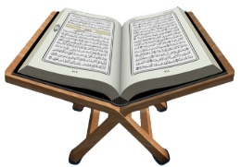*“Marry women of your choice, Two or three or four; but if you fear that you shall not be able to deal justly (with them), then only one, that will be more suitable, to prevent you from doing injustice.*”

Cohabitation

It is increasingly common for couples to live together without being married, this is called **cohabitation.**

|  |  |
| --- | --- |
| Arguments in favour of cohabitation | Arguments against cohabitation |

Divorce

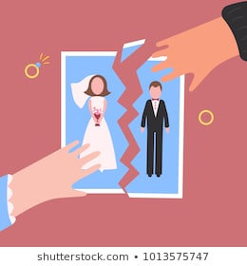**Divorce** is the ending of a marriage. In the UK it is estimated that somewhere in the region of half of all marriages end in divorce. In order to obtain a divorce, the individual applying for the divorce must demonstrate the marriage has “irretrievably broken down” on one of five grounds:

* Adultery
* Desertion
* 2 years separation (with spouse’s consent)
* 5 years separation (spouse’s consent not necessary)
* Unreasonable behaviour

What kinds of things lead to a divorce on the grounds of ‘unreasonable behaviour’?

Some couples, instead of seeking a divorce, will ask for an **annulment** to their marriage. This is a declaration that a marriage was never actually valid. A marriage can be legally annulled for any of the following reasons:

* it was not consummated - you have not had sexual intercourse with the person you married since the wedding (does not apply for same sex couples)
* you did not properly consent to the marriage - for example you were forced into it
* the other person had a sexually transmitted disease (STD) when you got married
* your spouse was pregnant by someone else when you got married
* one spouse is in the process of transitioning to a different gender

**Remarriage** is when someone marries again following a divorce. Remarriage is allowed as many times as people wish, to a new partner or to a previous spouse. Polygamy, however, is illegal in the UK.

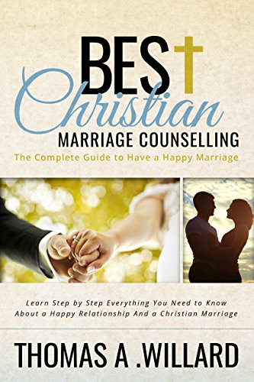As we have seen, Christians believe marriage to be a lifelong commitment to another person (see pages 10 & 14). For these reasons, divorce is seen as something that should only ever be considered as a very last resort. The church will encourage couples who are struggling in their marriage to try to work through their problems and will often offer help in the form of marriage guidance and counselling. In addition to this, many churches will offer courses to couples who are planning to get married to help prepare them for how to make a marriage work.

The Bible does however appear to condone divorce under certain circumstances. Jesus taught that *“if a man divorces his wife for any cause other than adultery, he makes her a victim of adultery.”*

Many Christian churches, for example the Catholic Church, teach that although it may be necessary for a couple to separate, nothing can break the sacrament of marriage in the eyes of God. When getting married, couples make solemn vows to one another and to God which can never be broken. For this reason, although they may be accepting of civil divorce, this is not recognised in a religious sense. Therefore, since marriage is permanent, remarriage is not accepted by Catholics.

This is supported by Jesus’ teachings that:

*“Anyone who divorces his wife and marries another woman commits adultery against her. And if she divorces her husband and marries another man, she commits adultery.”*

*“For this reason a man will leave his father and mother and be united to his wife,**and the two will become one flesh.’ So they are no longer two, but one flesh.**Therefore what God has joined together, let no one separate.”*

Many Protestant churches however accept divorce and allow remarriage in church as long as the couple take their vows seriously and do not undermine the sanctity of marriage. They think that the church should reflect the forgiveness of God and allow people who have made mistakes the opportunity to find happiness in a second marriage. They may point to Jesus’ focus on love in his teaching and argue that people should not be forced to stay in a loveless marriage and instead should be free to pursue love by remarrying,

The Nature and Purpose of Families

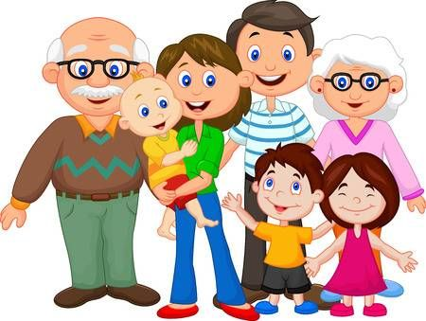Family life has changed over the years but the family is still considered by many people to be the best environment for bringing up children and maintaining a stable society.

In the West, the nuclear family (the basic unit of mother, father and children) is the still the most common although approximately 25% of children now grow up in single-parent families. The increase of divorce and remarriage has also led to a big rise in the number of step-families.

In the past, families were larger and often included grandparents and other relatives within the extended family living together. This is still common among many non-Western cultures.

*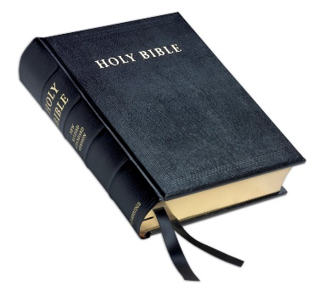“Anyone who does not provide for their relatives, and especially for their own household, has denied the faith and is worse than an unbeliever.”* 1 Timothy 5:8

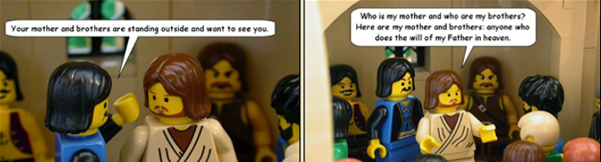----------------------------------------------------------------------------------------------------------------------------------

The Role of Parents

Good parents love, care for and raise their children to know right from wrong. Within a Christian family, parents are also generally expected to **raise their children within their faith**. The Bible states:

*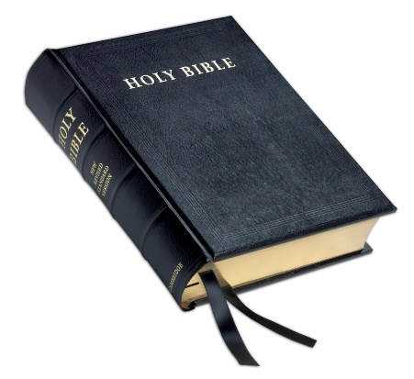“These commandments that I give you today are to be upon your hearts. Impress them on your children. Talk about them when you sit at home and when you walk along the road, when you lie down and when you get up.”*

The Bible also impresses responsibilities on children and their attitudes to their parents. The fifth of the Ten Commandments, and interestingly, the first one not about God, is to *Honour your father and mother*. Other passages reaffirm this teaching:

*“Listen to your father, who gave you life, and do not despise your mother when she is old.”*

*“Children, obey your parents in everything, for this pleases the Lord. Fathers, do not embitter your children, or they will become discouraged.”*

Same-sex parents

With the increasing acceptance of same-sex relationships, there has also been a steady rise in the number of same-sex couples raising children.

Studies have suggested that children raised by single parents generally perform more poorly in a huge range of areas, from academic achievement to mental health issues. Many would argue therefore that being raised in a two-parent household, even if both parents are the same sex, is preferential to single parenthood. They would argue that it is the love and provision of two parents which is important, not their sex.

However, many Christians would argue that the ideal is to grow up with a male and female role model and therefore disapprove of same-sex parenting.

Gender Equality

*“Men and women are different but equal”* (12 marks)

Possible exam questions

Question 1: (1 mark)

1) Which term describes the practice of having more than one wife?

1) Which term expresses the religious view that one purpose of marriage is to have children?

1) Which term refers to methods to prevent a pregnancy taking place?

Question 2: (2 marks)

2) Give two religious beliefs about the use of contraception.

2) Give two religious beliefs about the nature of the family.

2) Give two religious beliefs about same-sex marriage.

Question 3: (4 marks)

3) Explain two contrasting religious beliefs about same-sex parents.

3) Explain two contrasting beliefs in contemporary British society about the use of artificial contraception within marriage.

3) Explain two contrasting religious beliefs about the roles of men and women.

Question 4: 5 marks

**You must** refer to scripture or sacred writings in your answer.

4) Explain two religious beliefs about sexual relationships outside of marriage (adultery).

4) Explain two religious beliefs about the role of parents in a religious family

4) Explain two religious beliefs about divorce.

Question 5: (12 marks)

Evaluate the statement. In your answer you should:

• refer to Christian teaching

• give developed arguments to support this statement

• give developed arguments to support a different point of view

• reach a justified conclusion.

5) ‘Men and women should not have equal rights.’

5) ‘Divorce is never right.’

5) ‘For religious believers, sexual relationships should take place only within marriage.’