

**Higher IGCSE (9 – 1) Revision Pack**

**Non-right angled Triangles**

**Name --------------------------------**

**Questions**

**Q1.**

Here is triangle *ABC*.

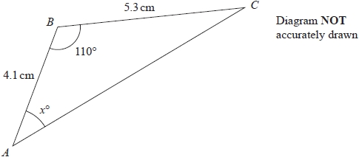

Calculate the value of *x*.   
Give your answer correct to 3 significant figures.

**(Total for question = 5 marks)**

**Q2.**

A triangle has sides of length 8 cm, 10 cm and 14 cm.

Work out the size of the largest angle of the triangle.   
Give your answer correct to 1 decimal place.

........................................................... °

**(Total for question = 3 marks)**

**Q3.**

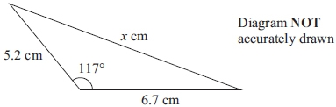

Calculate the value of *x*.  
 Give your answer correct to 3 significant figures.

*x* = ...........................................................

**(Total for question = 3 marks)**

**Q4.**

The diagram shows triangle *PQR*.

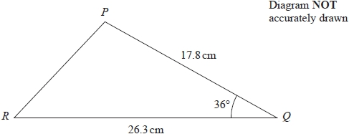

Calculate the length of *PR*.   
Give your answer correct to 3 significant figures.

........................................................... cm

**(Total for question = 3 marks)**

**Q5.**

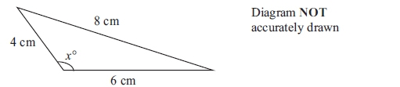

Calculate the value of *x*.   
Give your answer correct to 1 decimal place.

*x* = ...........................................................

**(Total for question is 3 marks)**

**Q6.**

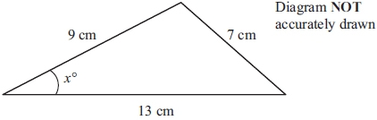

Calculate the value of *x*.  Give your answer correct to 1 decimal place.

*x* = ...........................................................

**(Total for question = 3 marks)**

**Q7.**

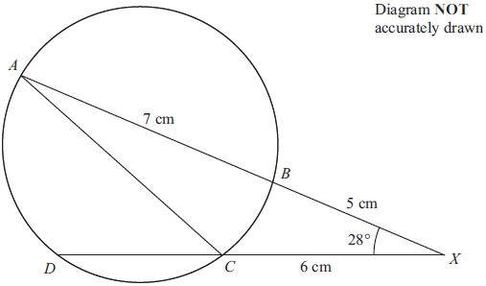

*A*, *B*, *C* and *D* are four points on a circle.  
*ABX* and *DCX* are straight lines.  
*AB* = 7 cm, *BX* = 5 cm and *CX* = 6 cm.  
 Angle *BXC* = 28°

(a) Calculate the length of *AC*.   
Give your answer correct to 3 significant figures.

...........................................................cm

**(3)**

(b) Calculate the length of *DC*.

...........................................................cm

**(3)**

**(Total for question = 6 marks)**

**Q8.**

*ABC* is a triangle.   
  
*AB* = 12 cm   
*AC* = 14 cm   
The area of triangle *ABC* is 72 cm2  
  
Find, in degrees, the two possible sizes of angle *BAC*.   
Give your answers correct to the nearest degree.

...........................................................

**(Total for question = 4 marks)**

**Q9.**

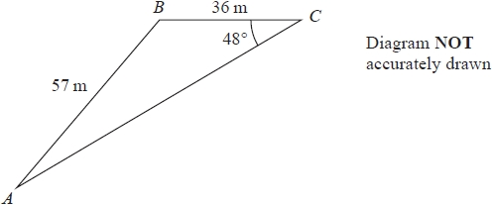

Work out the area of triangle *ABC*.   
Give your answer correct to 3 significant figures.

........................................................... m2

**(Total for question = 4 marks)**

**Q10.**

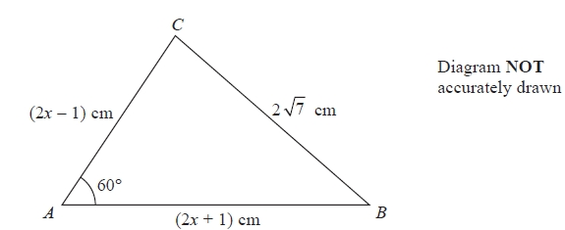

The diagram shows a triangle *ABC*.   
*AB* = (2*x* + 1) cm, *AC* = (2*x* − 1) cm and *BC* = 2 7 cm.   
Angle *BAC* = 60°

Work out the value of *x*.   
Show clear algebraic working.

*x* = ...........................................................

**(Total for question = 3 marks)**

**Q11.**

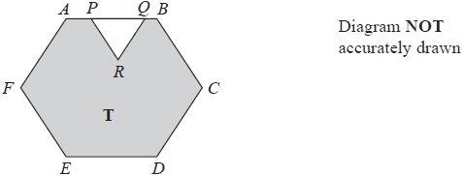

The diagram shows a shaded region **T** formed by removing an equilateral triangle *PQR* from a regular hexagon *ABCDEF*.

The points *P* and *Q* lie on *AB* such that *AB* = 1.5 × *PQ*

Given that the area of region **T** is 72  cm2

work out the length of *PQ*.

........................................................... cm

**(Total for question = 4 marks)**

**Q12.**

*ABCD* is a quadrilateral.

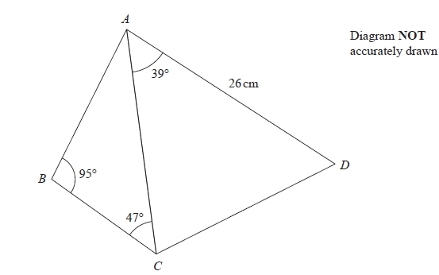

The area of triangle *ACD* is 250 cm2

Calculate the area of the quadrilateral *ABCD*.   
Show your working clearly.   
Give your answer correct to 3 significant figures.

........................................................... cm2

**(Total for question = 6 marks)**

**Q13.**

A circular clock face, centre *O*, has a minute hand *OA* and an hour hand *OB*.   
*OA* = 10 cm.   
*OB* = 7 cm.

Calculate the length of *AB* when the hands show 5 o'clock.   
Give your answer correct to 3 significant figures.

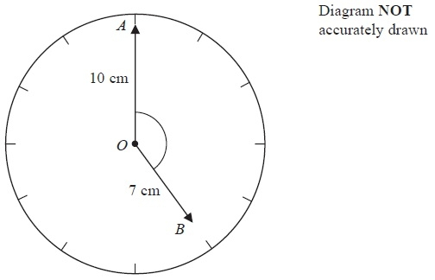

........................................................... cm

**(Total for Question is 4 marks)**

**Q14.**

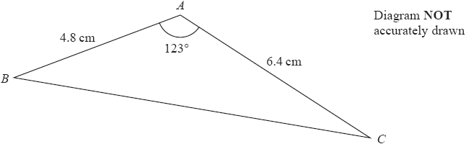

Calculate the length of *BC*.   
Give your answer correct to 3 significant figures.

........................................................... cm

**(Total for question = 3 marks)**

**Q15.**

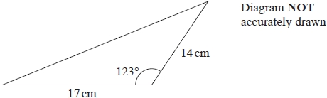

Calculate the perimeter of the triangle.   
Give your answer correct to 1 decimal place.

........................................................... cm

**(Total for question = 4 marks)**

**Q16.**

The diagram shows triangle *ABC*.

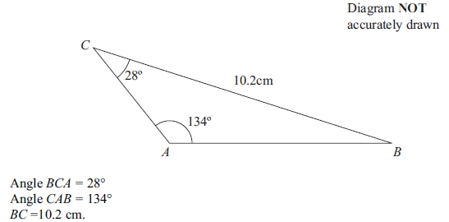

Calculate the length of *AB*.   
Give your answer correct to 3 significant figures.

........................................................... cm

**(Total for question = 3 marks)**

**Q17.**

*ABCD* is a kite.

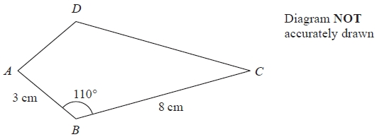

*AB* = 3 cm   
*BC* = 8 cm   
Angle *ABC* = 110°

Calculate the area of the kite *ABCD*.   
Give your answer correct to 3 significant figures.

........................................................... cm2

**(Total for question = 3 marks)**

**Q18.**

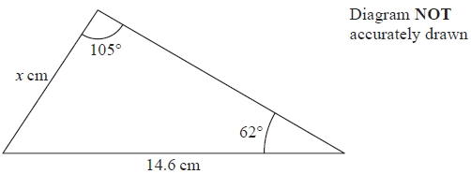

Work out the value of *x*.   
Give your answer correct to 1 decimal place.

*x* = ...........................................................

**(Total for question = 3 marks)**

**Q19.**

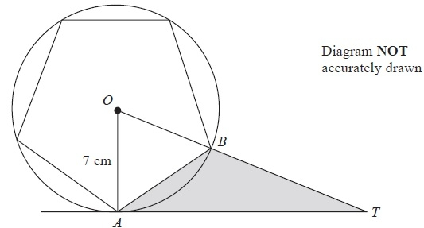

The diagram shows a regular pentagon inside a circle, centre *O*.   
The points *A* and *B* lie on the circle such that *AB* is a side of the pentagon.   
*OA* = 7 cm.   
*TA* is a tangent to the circle and *OBT* is a straight line.

Calculate the area of triangle *ABT*.   
Give your answer correct to 3 significant figures.

........................................................... cm2

**(Total for Question is 5 marks)**

**Q20.**

Here is triangle *LMN*, where angle *LMN* is an obtuse angle.

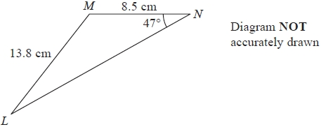

*ML* = 13.8 cm   
*MN* = 8.5 cm   
Angle *MNL* = 47°

Work out the area of triangle *LMN*.   
Give your answer correct to 3 significant figures.

...........................................................cm2

**(Total for question = 6 marks)**

**Q21.**

The diagram shows two triangles, **A** and **B**.

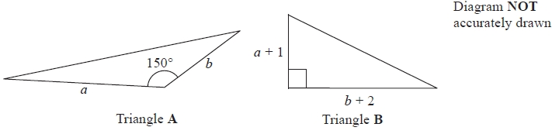

The area of triangle **B** is 3 times the area of triangle **A**.

Given that *b* > 4, find an expression for *a* in terms of *b*.

*a* = ...........................................................

**(Total for question = 5 marks)**

**Q22.**

Here is a shape *ABCDE*.

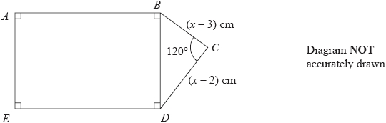

*ABDE* is a rectangle in which *AB* = 2*BD*  
*BCD* is a triangle in which angle *BCD* = 120°

*BC* = (*x* − 3) cm      *CD* = (*x* − 2) cm

The area of the rectangle *ABDE* is *S* cm2

Show that *S* can be expressed in the form *S* = *ax*2 + *bx* + *c*  
where *a*, *b* and *c* are integers to be found.

*S* = ...........................................................

**(Total for question = 5 marks)**

**Q23.**

*ABCD* is a kite.

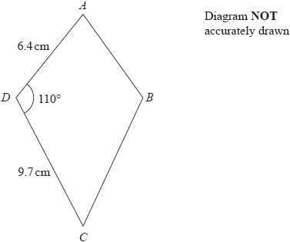

Work out the area of the kite.   
Give your answer correct to 3 significant figures.

........................................................... cm2

**(Total for question = 3 marks)**

**Q24.**

The diagram shows a pentagon.

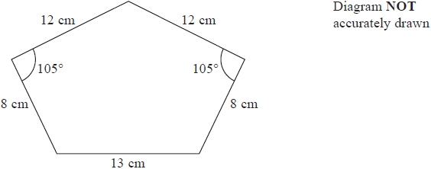

Work out the area of the pentagon.   
Give your answer correct to 3 significant figures.

........................................................... cm2

**(Total for question = 6 marks)**

**End of questions**