

**Foundation IGCSE (9 – 1) Revision Pack**

**Averages and Range**

**Name --------------------------------**

**Questions**

**Q1.**

Here are six numbers.

8     3      1      7      6      5

Work out the mean of these numbers.

...........................................................

**(Total for question = 2 marks)**

**Q2.**

The table shows information about the mark scored on an examination question by each  
 of 40 students.

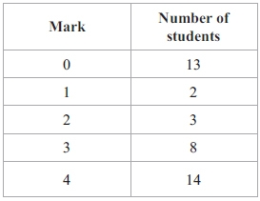

(a) Which mark is the mode?

...........................................................

**(1)**

(b) Find the median mark.

...........................................................

**(2)**

(c) Work out the mean mark.

...........................................................

**(2)**

**(Total for question = 6 marks)**

**Q3.**

Here are the number of runs scored by a cricket player in each of 9 games of cricket.

13        89        36        8        4        55        40        22        16

(a)  Find the median number of runs.

...........................................................

**(2)**

(b)  Work out the range.

...........................................................

**(2)**

**(Total for question = 4 marks)**

**Q4.**

The temperature at midnight in Oslo on 31st January 2015 was −7°C The temperature at midnight in Athens on 31st January 2015 was 20°C higher than the temperature in Oslo.

(a)  Work out the temperature at midnight in Athens on 31st January 2015

...........................................................°C

**(2)**

Here are the temperatures in Madrid at midnight for one week.

−7°C          −6°C          −1°C          4°C          0°C          0°C          3°C

(b)  Work out the mean temperature.

...........................................................°C

**(2)**

(c)  Work out the range.

...........................................................°C

**(2)**

**(Total for question = 6 marks)**

**Q5.**

Three positive whole numbers have a mean of 4 and a range of 7

Find the three positive whole numbers.

................... .................... ...................

**(Total for question = 2 marks)**

**Q6.**

Ben throws a dice 20 times.   
He records the score for each throw.   
Here are his scores.

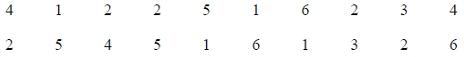

(a)  Complete the frequency table for his scores.

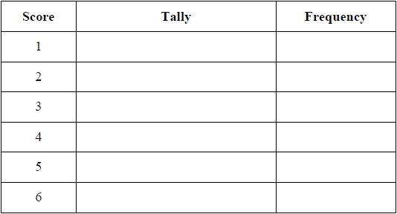

**(2)**

(b)  Write down the mode of his scores.

...........................................................

**(1)**

(c)  Find the range of his scores.

...........................................................

**(1)**

Ben throws the dice again.

(d)  Draw a circle around the word in the box that best describes the likelihood that his score will be 6.



**(1)**

**(Total for question = 5 marks)**

**Q7.**

Ian plays 7 games of cricket.   
His mean score per game for these 7 games is 42 runs.

Ian is going to play one more game of cricket.   
He wants his mean score per game for the 8 games to be exactly 50 runs.

How many runs must he score in his 8th game?

...........................................................

**(Total for question = 3 marks)**

**Q8.**

The mean of four numbers is 2.6   
One of the four numbers is 5

Find the mean of the other three numbers.

...........................................................

**(Total for Question is 3 marks)**

**Q9.**

The table shows information about the times, in minutes, taken by 50 people to get to work.

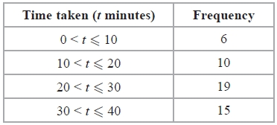

Work out an estimate for the mean time taken to get to work.

........................................................... minutes

**(Total for Question is 4 marks)**

**Q10.**

Zara must take 5 tests.   
Each test is out of 100   
After 4 tests, her mean score is 64%.

What score must Zara get in her 5th test to increase her mean score in all 5 tests to 70%?

...........................................................

**(Total for Question is 4 marks)**

**Q11.**

Rayna has a fair 4-sided spinner.   
The spinner can land on 3, 5, 7 or 9

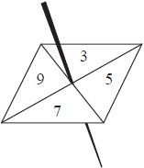

Rayna spins the spinner 20 times.   
She records the score for each spin.   
Here are her scores.



(a)  Complete the frequency table for these results.

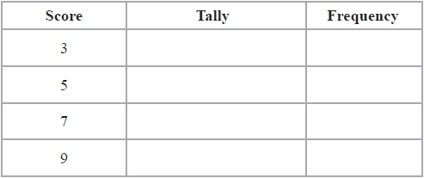

**(2)**

(b)  Write down the mode of her scores.

...........................................................

**(1)**

(c)  Find the range of her scores.

...........................................................

**(1)**

Rayna says that 3, 5, 7 and 9 are all prime numbers.

(d)  Explain why Rayna is wrong.

.............................................................................................................................................

.............................................................................................................................................

**(1)**

Rayna now spins her spinner twice.   
She adds the two numbers together to get the total.

(e)  Complete the table to show the total for each possible outcome.   
Five of the totals have been done for you.

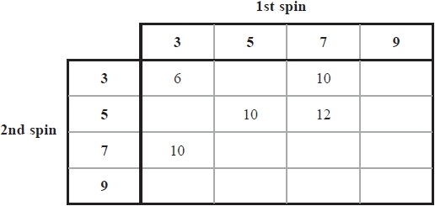

**(2)**

Rayna spins the spinner twice.

(f)  (i)  Write down the probability that she will get a total of 10

...........................................................

(ii)  Write down the probability that she will get a total greater than 12

...........................................................

**(3)**

**(Total for question = 10 marks)**

**Q12.**

The table gives information about the number of vehicles passing a point on a road in   
each of 70 intervals of equal length.

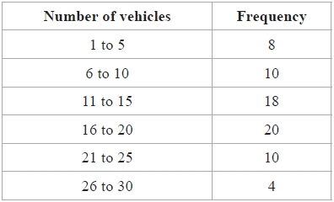

Calculate an estimate for the mean.

..........................................................

**(Total for question = 4 marks)**

**Q13.**

The table shows information about the weights of 80 parcels.

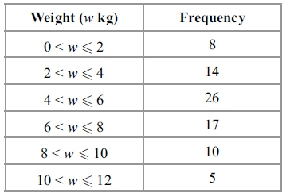

Work out an estimate for the total weight of the 80 parcels.

............................................................kg

**(Total for question = 3 marks)**

**Q14.**

The table shows information about the snowfall in Ottawa in January one year.

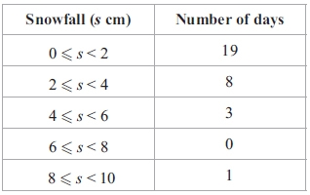

Work out an estimate for the total snowfall in January.

........................................................... cm

**(Total for question = 3 marks)**

**Q15.**

The table shows information about the amount of money, in dollars, spent in a shop in  
 one day by 80 people.

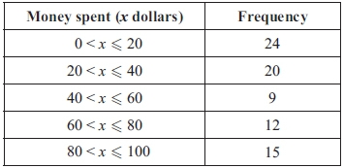

Work out an estimate for the total amount of money spent in the shop that day.

............................................................dollars

**(Total for question = 3 marks)**

**Q16.**

Julie asked 50 children how many exercise sessions they each took part in last month.   
The table shows information about her results.

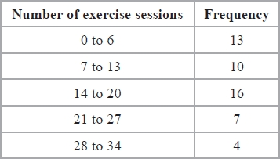

Calculate an estimate for the total number of exercise sessions the children took part in last month.

...........................................................

**(Total for question = 3 marks)**

**Q17.**

Six numbers have a mean of 5

Five of the numbers are



The other number is *x*.

Work out the value of *x*.

*x* =...........................................................

**(Total for question = 3 marks)**

**Q18.**

Kim asked 40 people how many text messages they each sent on Monday.   
The table shows her results.

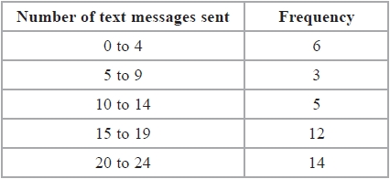

Kim is going to draw a pie chart for this information.

(a)  Work out the size of the angle on the pie chart for the sector representing 0 to 4 text messages.

...........................................................°

**(2)**

(b)  Write down the modal class.

...........................................................

**(1)**

(c)  Calculate an estimate for the mean number of text messages sent.

...........................................................

**(4)**

(d)  What percentage of these 40 people sent 20 or more text messages?

........................................................... %

**(2)**

**(Total for question = 9 marks)**

**Q19.**

The mean height of a group of 6 children is 165 cm.

One child, whose height is 155 cm, leaves the group.

Find the mean height of the remaining 5 children.

........................................................... cm

**(Total for question = 3 marks)**

**Q20.**

The table shows information about the numbers of fish caught by 40 people in one day.

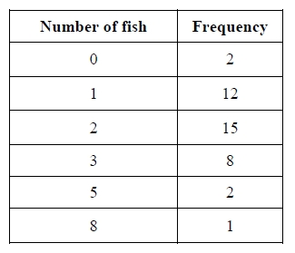

Work out the mean number of fish caught.

...........................................................

**(Total for question = 3 marks)**

**Q21.**

The table shows information about the marks of 20 students in a science test.

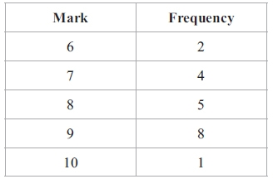

Work out the mean mark of the 20 students.

...........................................................

**(Total for question = 3 marks)**

**Q22.**

There are 32 students in Mr Newton's class.

20 are boys and 12 are girls.

The mean height of the boys is 151 cm.

The mean height of the girls is 148 cm.

Calculate the mean height of all the students in Mr Newton's class.

........................................................... cm

**(Total for question = 3 marks)**

**Q23.**

The table gives information about the numbers of goals scored by a football team in 30 matches.

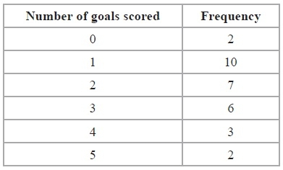

(a)  Find the median number of goals scored.

...........................................................

**(2)**

(b)  Find the mean number of goals scored.

...........................................................

**(3)**

**(Total for Question is 5 marks)**

**Q24.**

Here are 6 cards.   
Each card has a number on it.



(a)  Find the median of the numbers on the cards.

...........................................................

**(2)**

Uzma places two extra cards next to the six cards.



She wants the mean of the numbers on the 8 cards to be 4   
She wants the range of the numbers on the 8 cards to be 9

(b)  Find the numbers that she should write on the two extra cards.

........................... and ...........................

**(3)**

**(Total for question = 5 marks)**

**Q25.**

Jordan's school awards certificates for outstanding work.   
The table shows information about the numbers of certificates awarded in Jordan's class during a term.

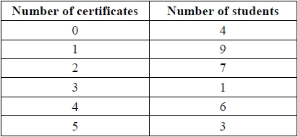

Work out the median number of certificates awarded.

...........................................................

**(Total for question = 2 marks)**

**Q26.**

Mr Rowland has a class of 30 students.   
He gave them 24 words to spell.   
The table shows information about the number of correct spellings for each student.

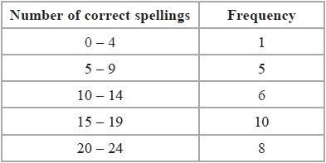

(a)  Write down the modal class.

...........................................................

**(1)**

(b)  Work out an estimate for the mean number of correct spellings.   
Give your answer to 1 decimal place.

...........................................................

**(4)**

**(Total for question = 5 marks)**

**Q27.**

The frequency table shows information about the distances 60 office workers travel to work each day.

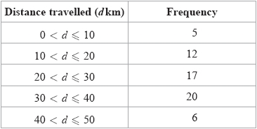

(a)  Write down the modal class.

...........................................................

**(1)**

(b)  Work out an estimate for the mean distance travelled to work by these office workers.

Give your answer correct to 1 decimal place.

........................................................... km

**(4)**

**(Total for question = 5 marks)**

**Q28.**

The table shows information about the lengths, in cm, of 40 leaves.

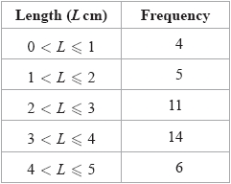

(a)  Write down the modal class.

...........................................................

**(1)**

(b)  Work out an estimate for the mean length of the 40 leaves.

Give your answer correct to 1 decimal place.

........................................................... cm

**(4)**

**(Total for question = 5 marks)**

**Q29.**

The table gives information about the weights of 20 rugby players.

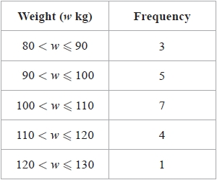

(a)  Write down the modal class.

...........................................................

**(1)**

(b)  Work out an estimate for the total weight of these 20 rugby players.

........................................................... kg

**(3)**

**(Total for question = 4 marks)**

**Q30.**

In a survey, Wendy asked nine of her friends how many foreign countries they had visited.  
 Here are her results.



(a) Find the mode of her results.

............................................................

**(1)**

(b) Work out the mean of her results.

............................................................

**(3)**

**(Total for question = 4 marks)**

**Q31.**

Here are 9 cards. Each card has a number on it.

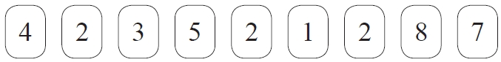

(a)   Write down the mode of the numbers on the cards.

...........................................................

**(1)**

(b)   Work out the median of the numbers on the cards.

...........................................................

**(2)**

Sally takes at random one card.

(c)



Write down a word from the box that best describes the probability of each outcome.

(i) Sally takes a card with the number 6

...........................................................

(ii) Sally takes a card with the number 5

...........................................................

**(2)**

(d)   Here is a probability scale.

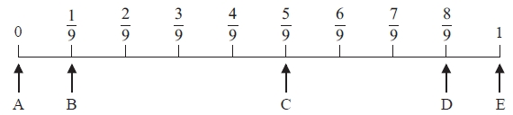

Write down the letter of the arrow that points to the probability that Sally

(i) takes a card with the number 8

...........................................................

(ii) takes a card with a number greater than 0

...........................................................

(iii) takes a card with an even number.

...........................................................

**(3)**

**(Total for Question is 8 marks)**

**Q32.**

The table shows information about the number of eggs in each of 40 birds' nests.

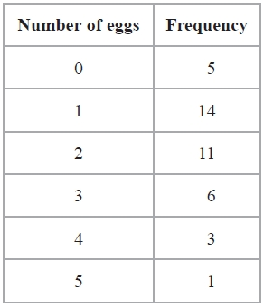

(a)  Write down the mode.

...........................................................

**(1)**

(b)  Find the median.

...........................................................

**(2)**

(c)  Work out the total number of eggs.

...........................................................

**(2)**

One of these nests is chosen at random.

(d)  Find the probability that there are more than 2 eggs in the nest.

...........................................................

**(2)**

**(Total for question = 7 marks)**

**Q33.**

Becky counted the number of matches in each of 50 boxes.   
The table shows information about her results.

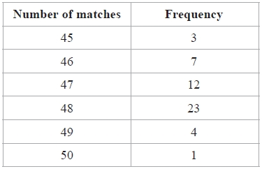

(a)  Write down the mode of the number of matches.

...........................................................

**(1)**

(b)  Work out the range of the number of matches.

...........................................................

**(2)**

(c)  Work out the mean number of matches.

...........................................................

**(3)**

**(Total for question = 6 marks)**

**Q34.**

Here are the number of goals scored by a netball team in each of its first 9 games of the   
season.

5          8          5          2          2          1          3          2          8

(a)  Find the mode.

...........................................................

**(1)**

(b)  Work out the range.

...........................................................

**(2)**

(c)  Work out the mean number of goals scored.

...........................................................

**(2)**

(d)  The number of goals scored by the team in its 10th game was 7

(i)  Will the mean number of goals scored in all 10 games be more, less or the same   
       as the mean found in (c)?

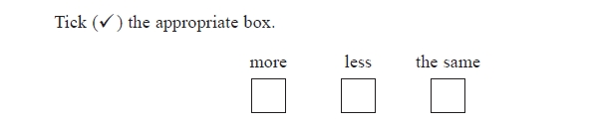

(ii)  Give a reason for your answer.

.............................................................................................................................................

.............................................................................................................................................

**(2)**

**(Total for question = 7 marks)**

**Q35.**

Becky has a biased 6-sided spinner.   
She spins the spinner 25 times.   
She records the score for each spin.   
The table shows information about her scores.

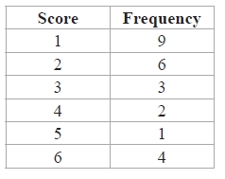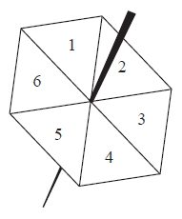

(a)  Which score is the mode?

...........................................................

**(1)**

(b)  Work out the range of her scores.

...........................................................

**(2)**

(c)  Find her median score.

...........................................................

**(2)**

(d)  Work out her mean score.

...........................................................

**(3)**

Becky spins the spinner one more time.

(e)  Find an estimate for the probability that the spinner will land on the number 4

...........................................................

**(2)**

**(Total for question = 10 marks)**

**Q36.**

The table shows information about the number of pets owned by each of 25 people.

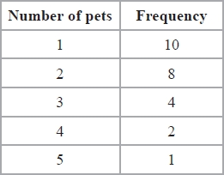

(a)  Work out the range of the number of pets.

...........................................................

**(2)**

(b)  Work out the median number of pets.

...........................................................

**(2)**

**(Total for question = 4 marks)**

**Q37.**

Here are Mika's scores in nine French tests.

6         7         6         9         8         6         4         10         9

(a)  Find the range of her scores.

...........................................................

**(2)**

(b)  Find her median score.

...........................................................

**(2)**

Here are Ryan's scores in nine French tests.

4         6         4         7         8         *a*         6         7         7

The mean of Ryan's nine scores is 6

(c)  Work out the value of *a*.

*a* = ...........................................................

**(3)**

**(Total for Question is 7 marks)**

**Q38.**

Here are the distances cycled, in km, on the first 6 days of the 2015 Tour de France cycle race.

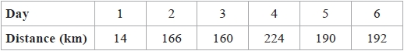

(a)  Work out the range of these distances.

........................................................... km

**(1)**

(b)  Work out the median distance.

........................................................... km

**(2)**

Michel says,

"The median is a better average to use for these 6 distances than the mean."

(c)  Explain why Michel is right.

.............................................................................................................................................

.............................................................................................................................................

**(1)**

**(Total for question = 4 marks)**

**Q39.**

Three positive whole numbers have a median of 7 and a mean of 5

Find the range of these three numbers.

...........................................................

**(Total for question is 3 marks)**

**Q40.**

Three integers have a mean of 7, a median of 5 and a range of 14

Find the three integers.

..........................................   .................

**(Total for question = 2 marks)**

**Q41.**

Here is a list of numbers written in order of size.

3          6          *x*          *y*

The numbers

have a median of 8

have a mean of 11

Find the value of *x* and the value of *y*.

*x* = ...........................................................

*y* = ...........................................................

**(Total for question = 3 marks)**

**Q42.**

A group of students take a test.  
 The group consists of 12 boys and 8 girls.  
 The mean mark for the boys is 18  
 The mean mark for the girls is 16.5

Calculate the mean mark for the whole group.

...........................................................

**(Total for question = 4 marks)**

**Q43.**

The table shows temperatures recorded on five planets.

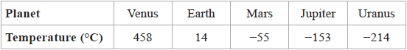

(a)  What is the difference between the temperatures recorded on

(i)  Earth and Mars,

........................................................... °C

(ii)  Jupiter and Mars?

........................................................... °C

**(2)**

A temperature recorded on Pluto is 693°C less than the temperature recorded on Venus.

(b)  Work out the temperature on Pluto.

........................................................... °C

**(1)**

(c)  Work out the mean of

458           14           −55           −153           −214

...........................................................

**(2)**

**(Total for question = 5 marks)**

**Q44.**

*w*, *x*, *y* and *z* are 4 integers written in order of size, starting with the smallest.

The mean of *w*, *x*, *y* and *z* is 13

The sum of *w*, *x* and *y* is 33

(a)  Find the value of *z*.

*z* = ...........................................................

**(2)**

Given also that the range of *w*, *x*, *y* and *z* is 10,

(b)  work out the median of *w*, *x*, *y* and *z*.

...........................................................

**(2)**

**(Total for question = 4 marks)**

**Q45.**

Three positive whole numbers are all different.   
The numbers have a median of 8 and a mean of 6   
Find the three numbers.

...........................................................

**(Total for question = 2 marks)**

**Q46.**

Ahmed, Beth and Cleo are three friends.

The mean age, in years, of Ahmed, Beth and Cleo is 21   
The mean age, in years, of Ahmed and Beth is 19

(a)  Work out Cleo's age.

........................................................... years

**(3)**

Ahmed is the youngest of the three friends.   
The median age, in years, of the three friends is 20

(b)  Find the range of their ages.

........................................................... years

**(3)**

**(Total for question = 6 marks)**

**Q47.**

30 students in a class sat a Mathematics test.   
he mean mark in the test for the 30 students was 26.8

13 of the 30 students in the class are boys.   
The mean mark in the test for the boys was 25

Find the mean mark in the test for the girls.   
Give your answer correct to 3 significant figures.

...........................................................

**(Total for question = 3 marks)**

**Q48.**

The students in Class A and in Class B take the same examination.

There are 28 students in Class A and 32 students in Class B.   
The mean score for all the students in both classes is 72.6   
The mean score for the students in Class A is 75

(a)  Work out the mean score for the students in Class B.

...........................................................

**(4)**

The lowest score in Class A is 39   
The range of scores for Class A is 57   
The lowest score in Class B is 33   
The range of scores for Class B is 60

(b)  Find the range of scores for all the students in both classes.

...........................................................

**(3)**

**(Total for question = 7 marks)**

**Q49.**

A shop, *Furniture 4U*, had a sale.

(a) In the sale, normal prices were reduced by 15%.

(b) (i) Work out the mean number of letters in the first names of the 50 people.

(i) The normal price of a table was $280

Work out the sale price of the table.

$...........................................................

(ii) The normal price of a chair was reduced in the sale by $24

Work out the normal price of the chair.

$...........................................................

**(6)**

(b) Ruth, Suha and Yasmin went to the sale.   
The amounts of money spent by Ruth, Suha and Yasmin were in the ratios 2 : 3 : 7  
Ruth and Suha spent a total of $320 in the sale.

Work out the amount of money Yasmin spent in the sale.

$...........................................................

**(3)**  
**(Total for question = 9 marks)**

**Mark Scheme**

Q1.

The correct answer, unless clearly obtained by an incorrect method, should be taken to imply a correct method.

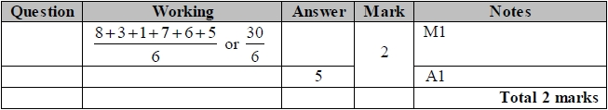

**Q2.**

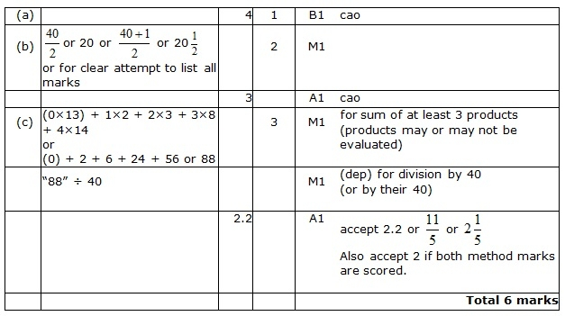

**Q3.**

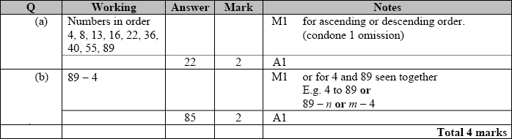

**Q4.**

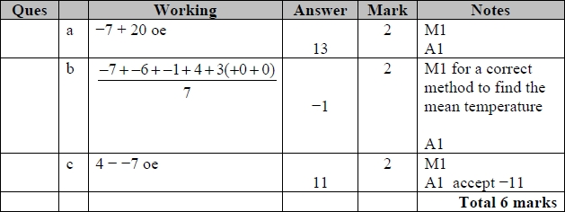

**Q5.**

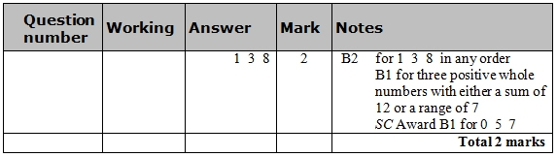

**Q6.**

The correct answer, unless clearly obtained by an incorrect method, should be taken to imply a correct method.

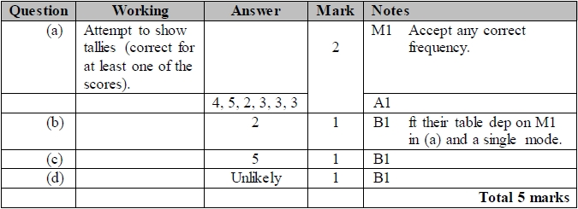

**Q7.**

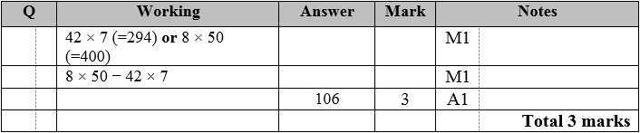

**Q8.**

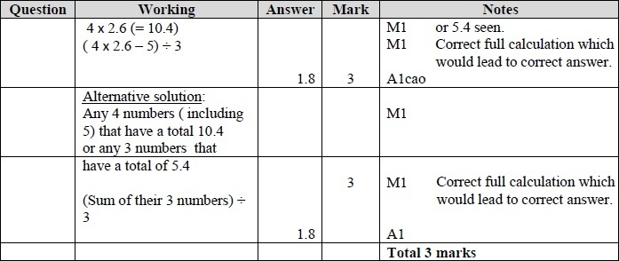

**Q9.**

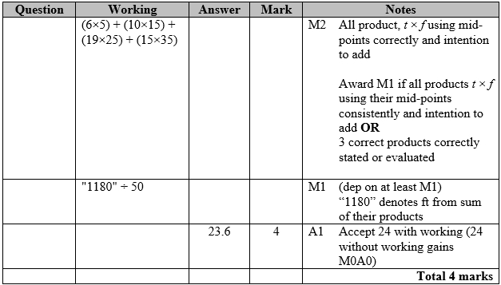

**Q10.**

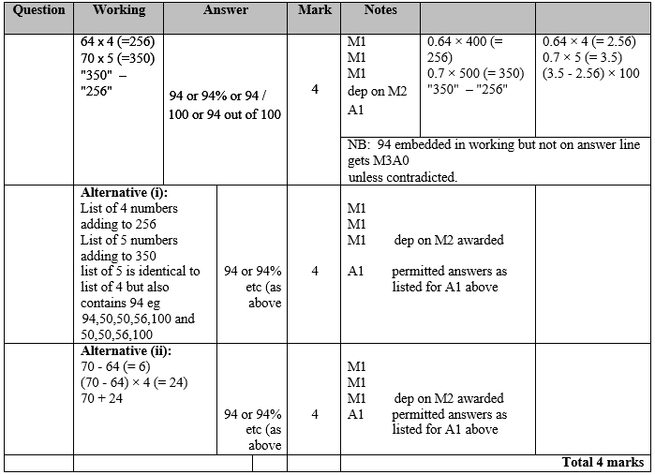

**Q11.**

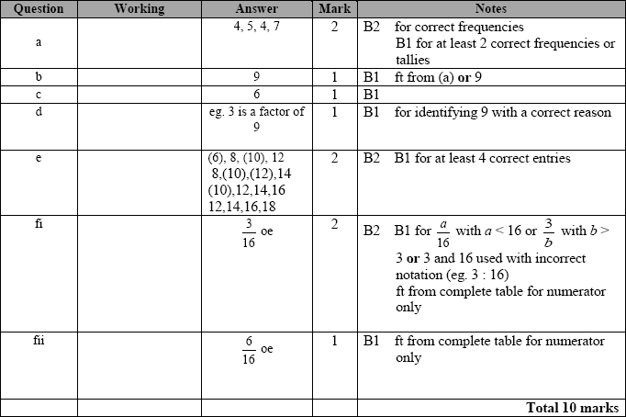

**Q12.**

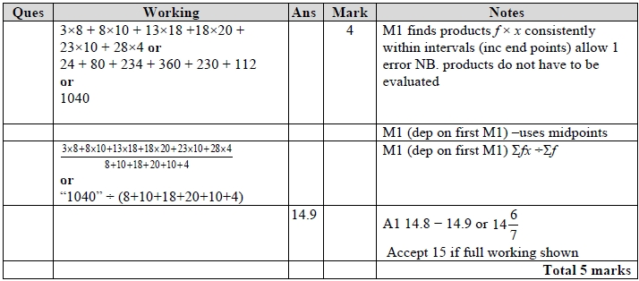

**Q13.**

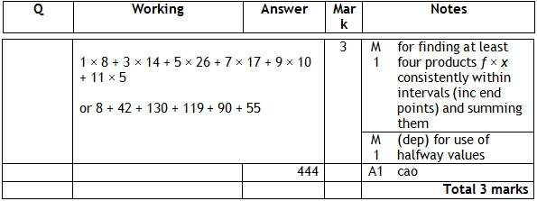

**Q14.**

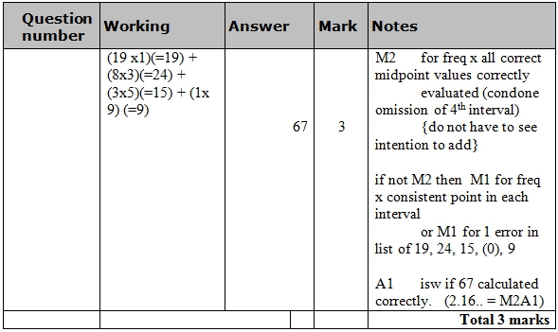

**Q15.**

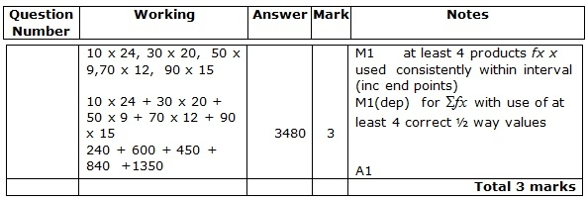

**Q16.**

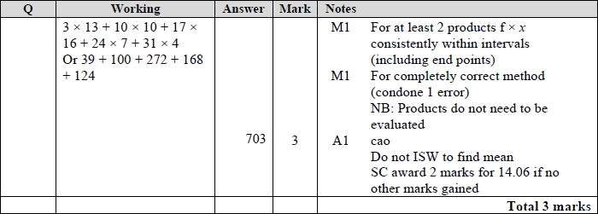

**Q17.**

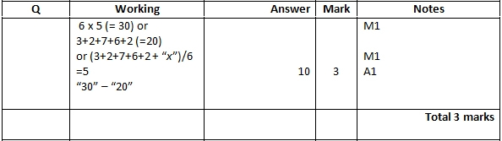

**Q18.**

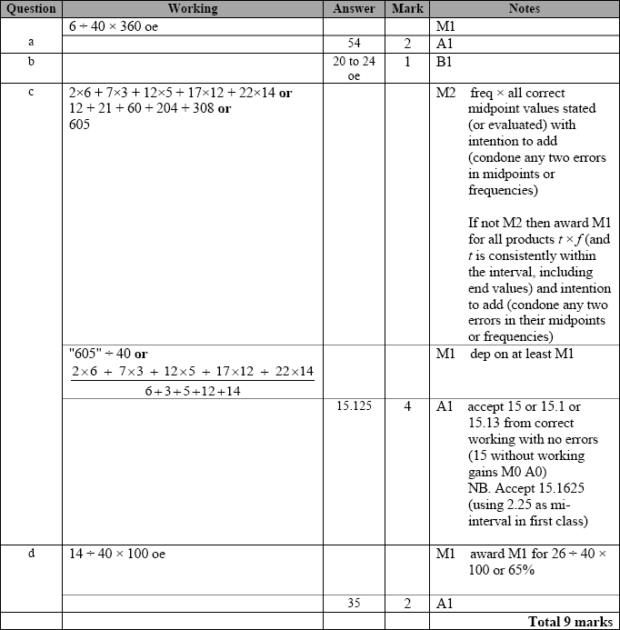

**Q19.**

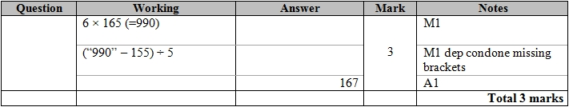

**Q20.**

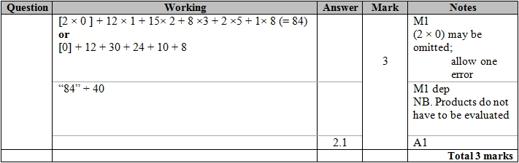

**Q21.**

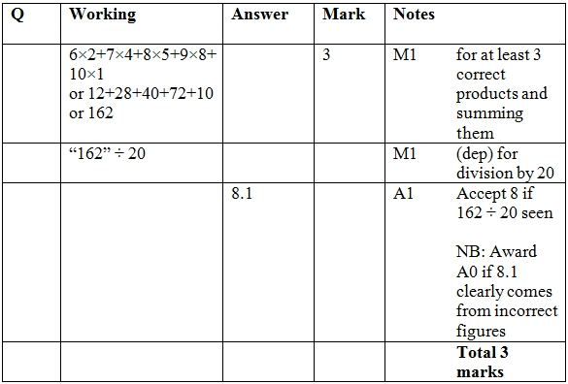

**Q22.**

For all questions, the correct answer, unless clearly obtained by an incorrect method, should be taken to imply a correct method.

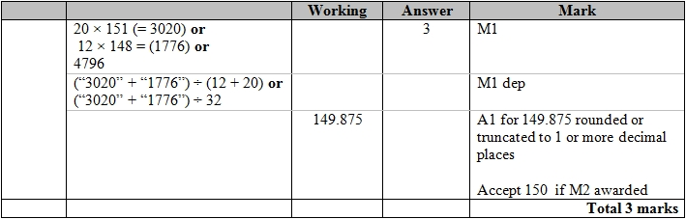

**Q23.**

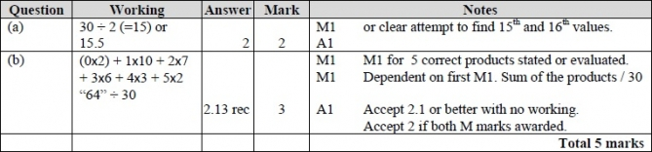

**Q24.**

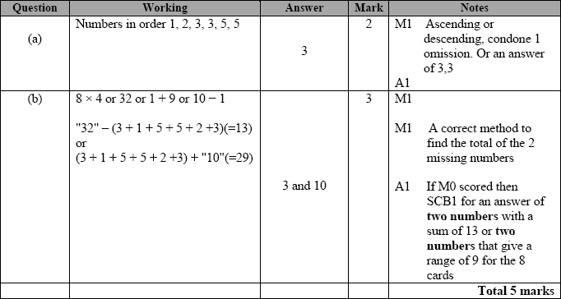

**Q25.**

The correct answer, unless clearly obtained by an incorrect method, should be taken to imply a correct method.

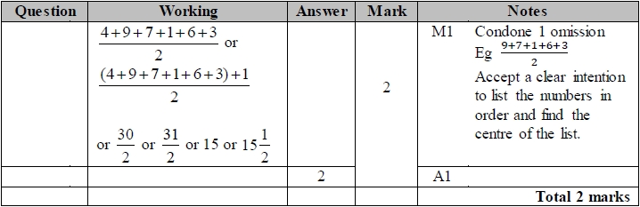

**Q26.**

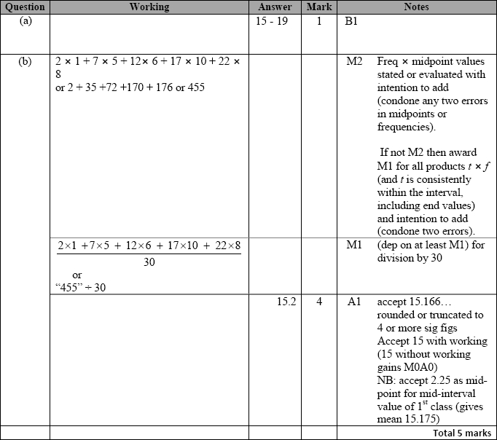

**Q27.**

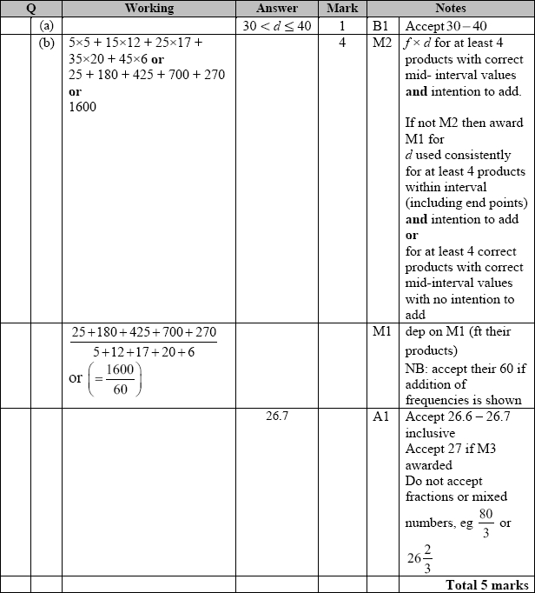

**Q28.**

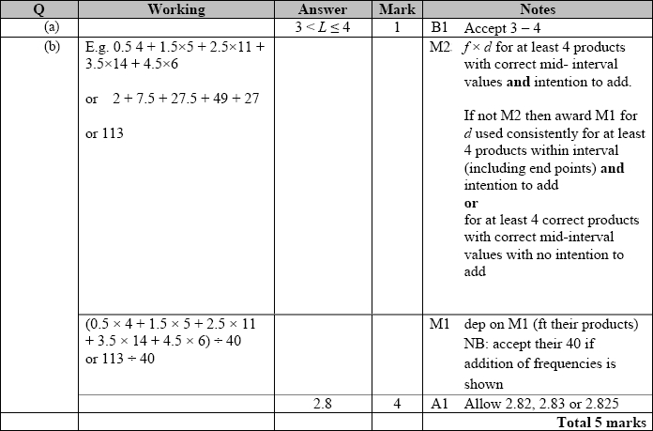

**Q29.**

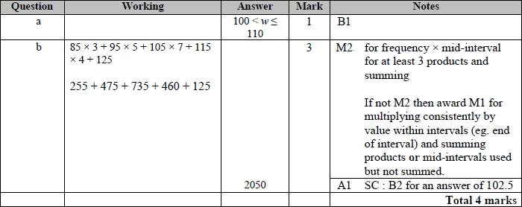

**Q30.**

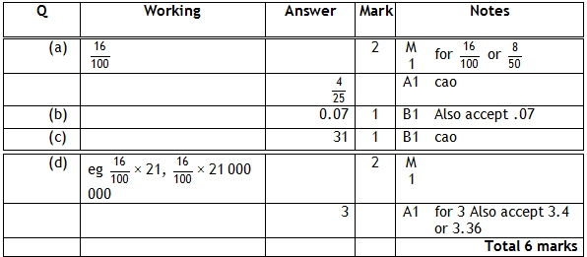

**Q31.**

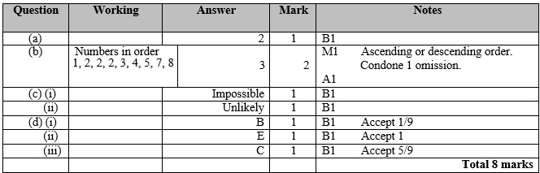

**Q32.**

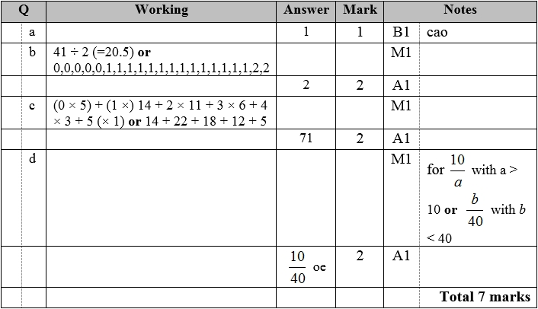

**Q33.**

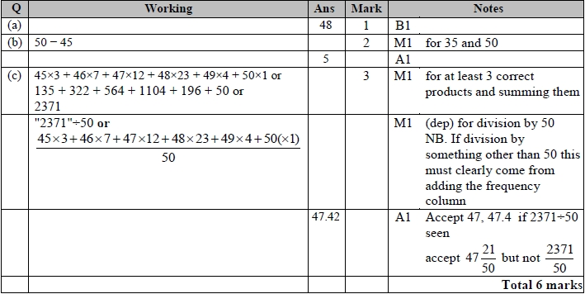

**Q34.**

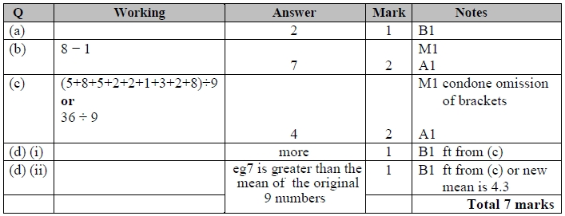

**Q35.**

Apart from question 18c where the mark scheme states otherwise, the correct answer, unless clearly obtained by an incorrect method, should be taken to imply a correct method.

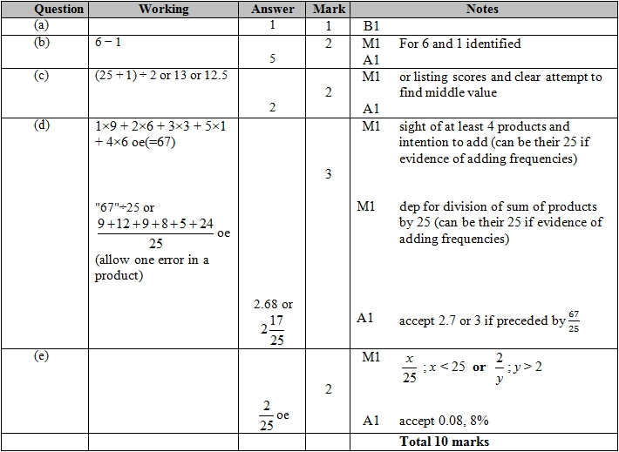

**Q36.**

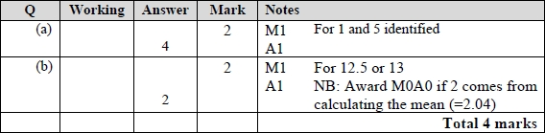

**Q37.**

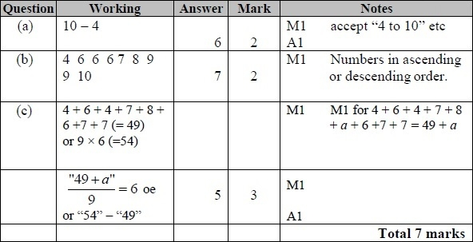

**Q38.**

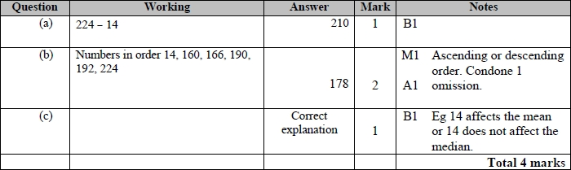

**Q39.**

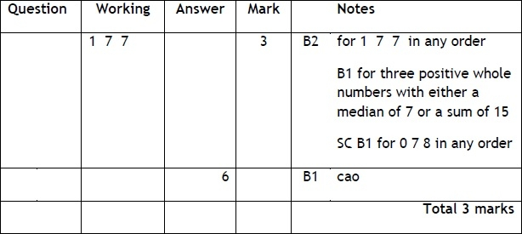

**Q40.**

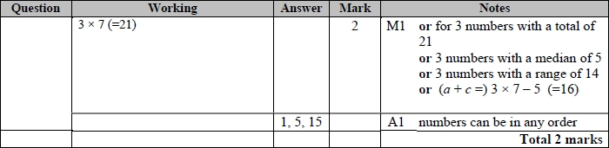

**Q41.**

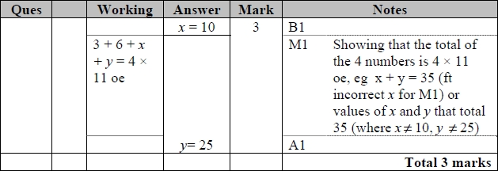

**Q42.**

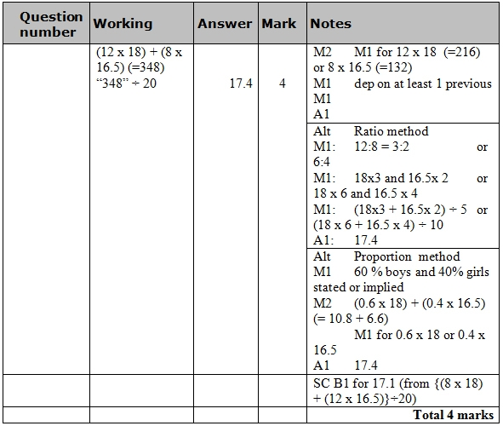

**Q43.**

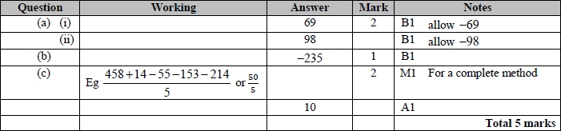

**Q44.**

For all questions, the correct answer, unless clearly obtained by an incorrect method, should be taken to imply a correct method.

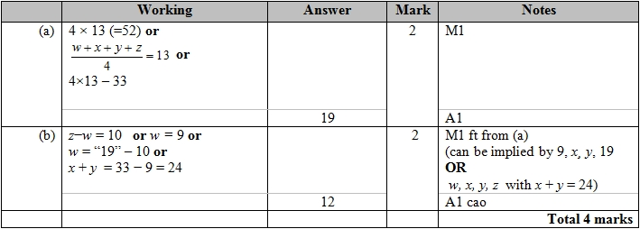

**Q45.**

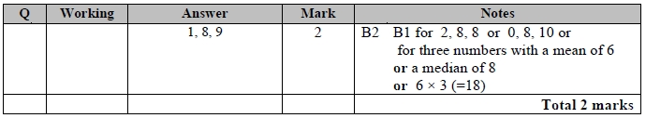

**Q46.**

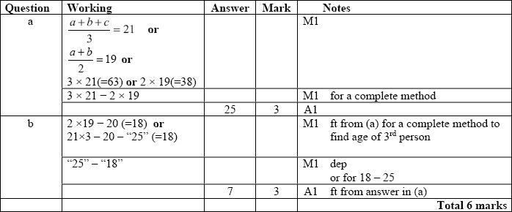

**Q47.**

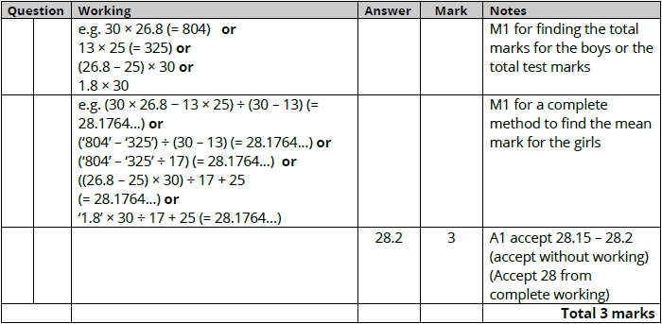

**Q48.**

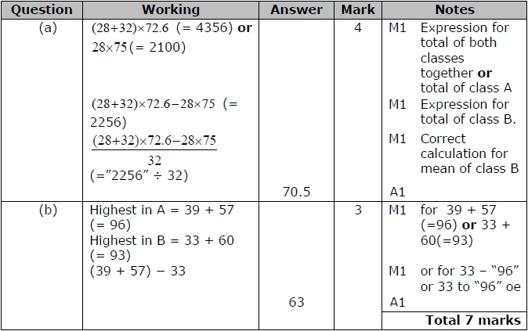

**Q49.**

