

**Foundation IGCSE (9 – 1) Revision Pack**

**Sequences (Foundation)**

**Name --------------------------------**

**Questions**

**Q1.**Here is a sequence of shapes drawn on a square grid.

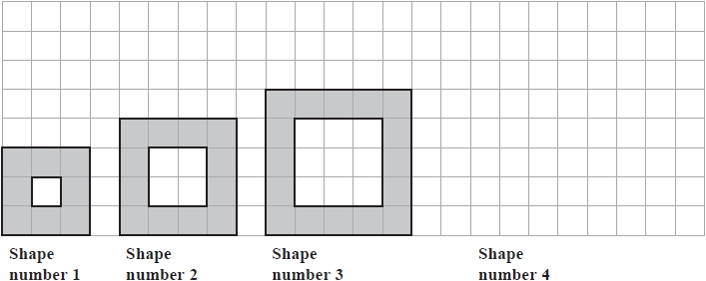

(a)  On the grid, draw Shape number 4

**(1)**

The table shows the number of shaded squares in the first three shapes.

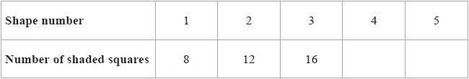

(b)  Complete the table to show the number of shaded squares in Shape number 4 and Shape number 5

**(1)**

(c)  Work out the number of shaded squares in Shape number 9

...........................................................

**(2)**

The width of Shape number 1 is 3 squares.   
The width of Shape number 2 is 4 squares.

(d)  Find the width of Shape number 8

........................................................... squares

**(1)**

The width of Shape number *n* is *W* squares.

(e)  Write down a formula for *W* in terms of *n*.

...........................................................

**(2)**

**(Total for question = 7 marks)**

**Q2.**

Here is a sequence of patterns made from short sticks and long sticks.

The short sticks make squares and the long sticks are diagonals of the squares.

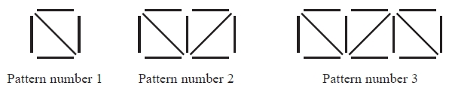

(a)  In the space below, draw Pattern number 4

**(1)**

(b)  Complete the table.

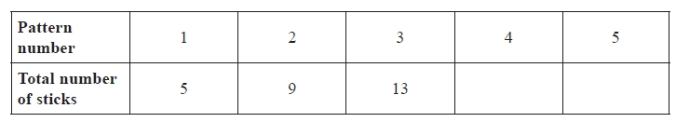

**(1)**

(c)  Find the total number of sticks in Pattern number 7

...........................................................

**(1)**

(d)  Work out the number of **short** sticks in Pattern number 12

...........................................................

**(1)**

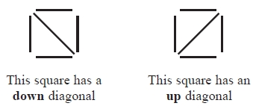

(e)  How many **up** diagonals are there in Pattern number 21?

...........................................................

**(1)**

**(Total for question = 5 marks)**

**Q3.**

Here are the first five terms of a number sequence.

7        11        15        19        23

(a)  Find an expression, in terms of *n*, for the *n*th term of this sequence.

...........................................................

**(2)**

The *n*th term of a different number sequence is given by 80 – 2*n*

(b)  Write down the first 3 terms of this sequence.

................ , ................ , ................

**(2)**

Yuen says there are no numbers that are in both of the sequences.   
Yuen is correct.

(c)  Explain why.

.............................................................................................................................................

.............................................................................................................................................

**(1)**

**(Total for question = 5 marks)**

**Q4.**

Here is a sequence of patterns made from white centimetre squares and grey centimetre squares.

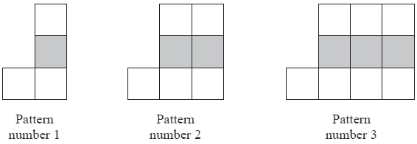

This rule can be used to find the total number of centimetre squares in each pattern.



(a)   Work out the total number of centimetre squares in Pattern number 6

...........................................................

**(1)**

(b)   Work out the number of white centimetre squares in Pattern number 20

...........................................................

**(1)**

A pattern in this sequence has a total of 88 centimetre squares.

(c)   Work out the Pattern number of this pattern.

...........................................................

**(2)**

**(Total for Question is 4 marks)**

**Q5.**

Here are the first five terms of a number sequence.

7          10          13          16          19

(a)  Write down the next term of the sequence.

...........................................................

**(1)**

(b)  Explain how you found your answer.

.............................................................................................................................................

**(1)**

(c)  Find the 11th term of the sequence

...........................................................

**(1)**

(d)  Explain why 60 cannot be a term of the sequence.

.............................................................................................................................................

.............................................................................................................................................

**(1)**

**(Total for question = 4 marks)**

**Q6.**

Here are the first five terms of a number sequence.

18          22          26          30          34

(a)  Write down the next two terms of the sequence.

..............................     ..............................

**(2)**

(b)  Explain how you found your terms.

.............................................................................................................................................

**(1)**

(c)  Work out the 20th term of the sequence.

...........................................................

**(2)**

**(Total for question = 5 marks)**

**Q7.**

Here is a sequence of patterns made from dots.

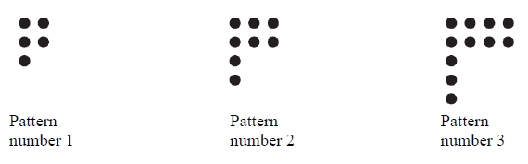

(a)  In the space below, draw Pattern number 4.

**(1)**

This rule can be used to find the number of dots in a pattern of the sequence.



(b)  Work out the number of dots in Pattern number 7.

...........................................................

**(2)**

A pattern has exactly 41 dots.

(c)  Work out the Pattern number.

...........................................................

**(2)**

*T* is the number of dots in Pattern number *n*.

(d)  Write down a formula for *T* in terms of *n*.

...........................................................

**(3)**

**(Total for question = 8 marks)**

**Q8.**

Here are the first five terms of a number sequence.



(a) Write down the next two terms of the sequence.

............................. , ..............................

**(2)**

(b) Explain how you worked out your answer.

      ..............................................................................................................................................

**(1)**

(c) Find the 15th term of the sequence.

...........................................................

**(1)**

(d) Explain why 0 cannot be a term of the sequence.

      ..............................................................................................................................................

**(1)**

**(Total for question is 5 marks)**

**Q9.**

Here are the first five terms of a number sequence.



(a)  Work out the next two terms of the sequence.

........................... , ...........................

**(2)**

(b)  Explain how you worked out your answer.

.............................................................................................................................................

**(1)**

The 15th term of this sequence is –10

(c)  Work out the 14th term of this sequence.

...........................................................

**(1)**

**(Total for question = 4 marks)**

**Q10.**

Here are the first five terms of a number sequence.

1          2          4          8          16

(a)  Write down the next term of the sequence.

...........................................................

**(1)**

(b)  Explain how you found your answer.

.............................................................................................................................................

**(1)**

(c)  Find the 10th term of the sequence.

...........................................................

**(1)**

**(Total for question = 3 marks)**

**Q11.**

Here is a sequence of patterns made from dots.

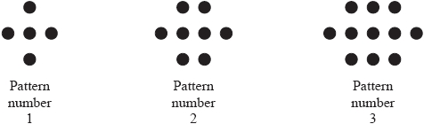

(a)  In the space below, draw Pattern number 4

**(1)**

(b)  Find the number of dots in Pattern number 11

...........................................................

**(2)**

**(Total for question = 3 marks)**

**Q12.**

Here are the first five terms of a number sequence.



(a) Write down the next two terms of the sequence.

...........................................................

**(2)**

(b) Explain how you worked out your answer.

.............................................................................................................................................

**(1)**

(c) Work out the 20th term of the sequence.

...........................................................

**(2)**

**(Total for question = 5 marks)**

**Q13.**

Here are the first five terms of a number sequence.

3          10          17          24          31

(a)  Write down the next two terms of the sequence.

.........................    .........................

**(2)**

(b)  Explain how you worked out your terms.

.............................................................................................................................................

**(1)**

(c)  Work out the 18th term of the sequence.

...........................................................

**(2)**

The 35th term of the sequence is 241

(d)  Work out the 34th term of the sequence.

...........................................................

**(1)**

**(Total for question = 6 marks)**

**Q14.**

Jean gets home at 7 o'clock in the evening.



The 5th term and the 8th term are missing.

(a)  (i)  Write down the 5th term of the sequence.

...........................................................

(ii)  Write down the 8th term of the sequence.

...........................................................

**(2)**

(b)  Write down the rule for working out the terms of this sequence.

.............................................................................................................................................

**(1)**

The 13th term of the sequence is 3.

(c)  Work out the 14th term of the sequence.

...........................................................

**(1)**

A new sequence is made by adding 5 to each term of the first sequence.

(d)  Write down the 13th term of this new sequence.

...........................................................

**(1)**

The sum of the first four terms of the first sequence is 348.

(e)  Work out the sum of the first four terms of the new sequence.

...........................................................

**(1)**

**(Total for question = 6 marks)**

**Q15.**

Here are some rows of a number pattern.

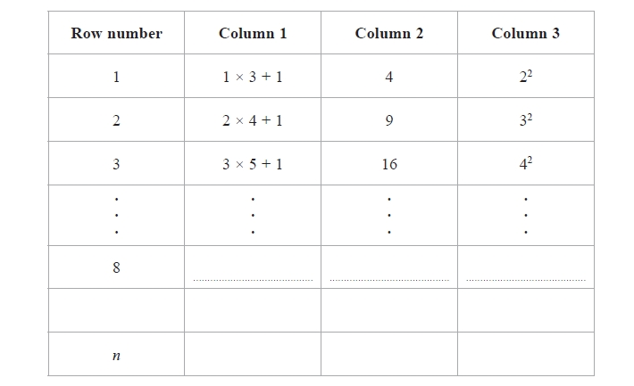

(a)  Complete Row number 8

**(2)**

(b)  Write down the Row number of the row that has 400 in Column 2

..........................................................

**(1)**

(c)  For Row number *n*,

(i)  write down an expression, in terms of *n*, that should go in Column 1

..........................................................

(ii)  write down an expression, in terms of *n*, that should go in Column 3

..........................................................

**(2)**

**(Total for question = 5 marks)**

**Q16.**

(a)  Find the next two terms of this number sequence.

17         21          25          29          33          37          ..............         ..............

**(2)**

(b)  Explain how you found your terms.

.............................................................................................................................................

**(1)**

(c)  The 1st term, 17, and the 6th term, 37, of the number sequence both end with the   
number 7

What number does the 32nd term of the sequence end with?

...........................................................

**(1)**

**(Total for Question is 4 marks)**

**Q17.**

Here is a sequence of patterns made from white dots and black dots.

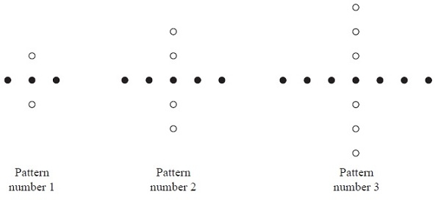

(a)  Draw Pattern number 4

**(1)**

(b)  Complete the table.

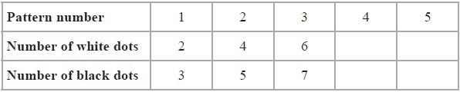

**(2)**

(c)  Work out the number of white dots in Pattern number 19

...........................................................

**(1)**

(d)  (i)  Work out the number of black dots in Pattern number 27

...........................................................

(ii)  Explain how you found your answer to part (d)(i).

.............................................................................................................................................

.............................................................................................................................................

**(2)**

(e)  Work out the Pattern number of the pattern with 65 black dots.

Pattern number ...........................................................

**(2)**

(f)  *W* is the number of white dots in Pattern number *n*.

Write down a formula for *W* in terms of *n*.

...........................................................

**(2)**

**(Total for Question is 10 marks)**

**Q18.**

Here is a sequence of patterns made from small triangular tiles.

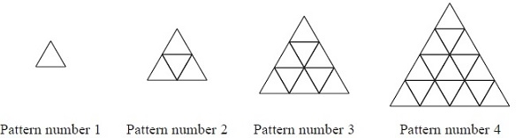

The table shows the number of tiles used to make each pattern.

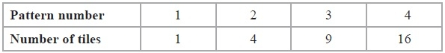

(a)  How many tiles are used to make

(i)  Pattern number 5

...........................................................

(ii)  Pattern number 10

...........................................................

**(2)**

A pattern in the sequence is made from 144 tiles.

(b)  Find the Pattern number for this pattern.

...........................................................

**(1)**

(c)  On the diagram below, shade  of Pattern number 3.

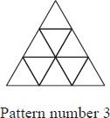

**(1)**

Some tiles in Pattern number 4 are shaded.

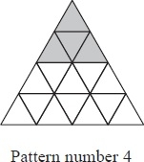

(d)  What fraction of Pattern number 4 is shaded?

Give your fraction in its simplest form.

...........................................................

**(2)**

**(Total for Question is 6 marks)**

**Q19.**

Here are the first five terms of a number sequence.



(a) Work out the next two terms of the sequence.

..............................,  ..............................

**(2)**

(b) Explain how you worked out your answer.

      ..............................................................................................................................................

**(1)**

(c) The 5th term, 256, of the sequence ends with the number 6   
What number does the 29th term of the sequence end with?

............................................................

**(1)**

**(Total for question = 4 marks)**

**Q20.**

Here are the first four terms of a sequence.

5          9          13          17

One of these four terms is a square number.

(a)  Write down this square number.

...........................................................

**(1)**

(b)  Write down the next term of the sequence.

...........................................................

**(1)**

150 cannot be a term of this sequence.

(c)  Explain why.

.............................................................................................................................................

**(1)**

**(Total for question = 3 marks)**

**Mark Scheme**

Q1.

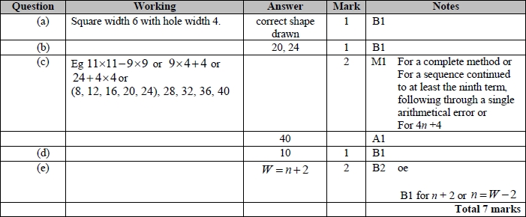

**Q2.**

For all questions, the correct answer, unless clearly obtained by an incorrect method, should be taken to imply a correct method.

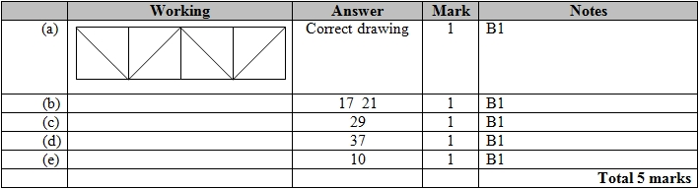

**Q3.**

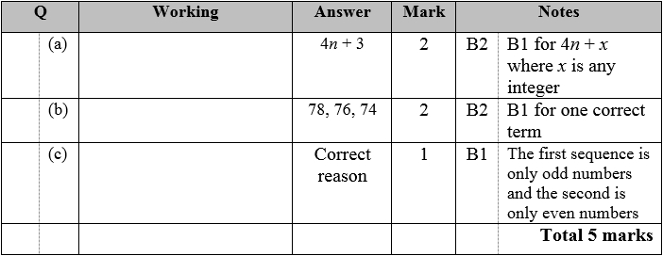

**Q4.**

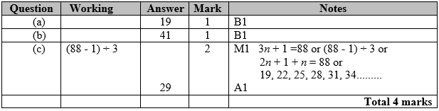

**Q5.**

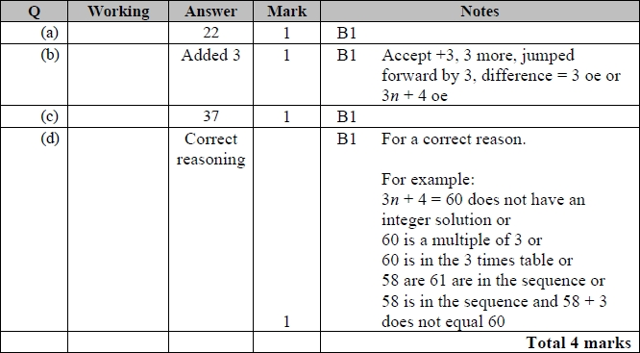

**Q6.**

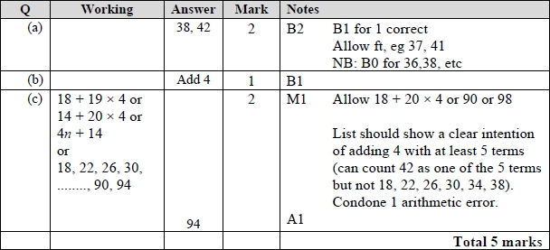

**Q7.**

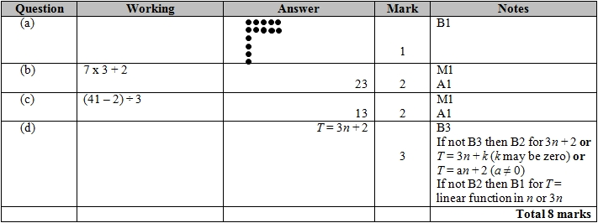

**Q8.**

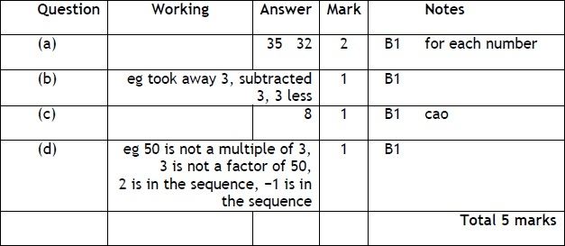

**Q9.**

Apart from question 18c where the mark scheme states otherwise, the correct answer, unless clearly obtained by an incorrect method, should be taken to imply a correct method.

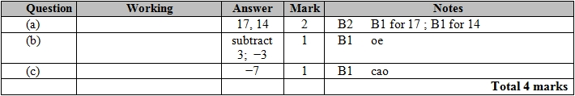

**Q10.**

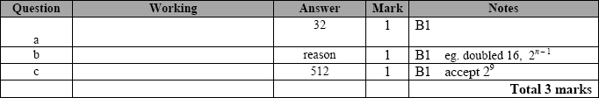

**Q11.**

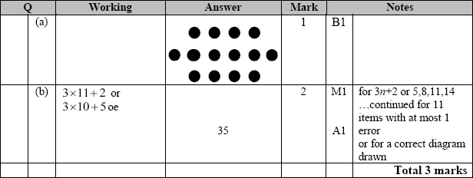

**Q12.**

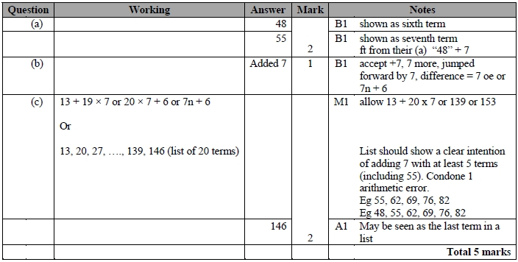

**Q13.**

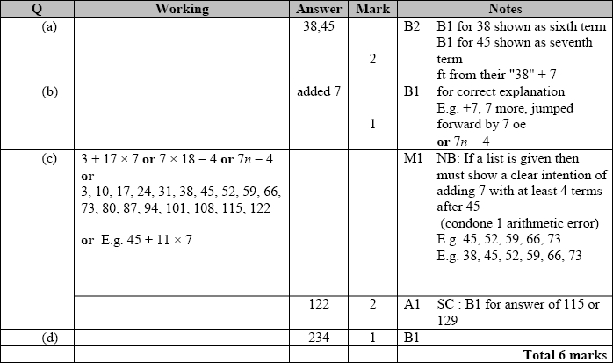

**Q14.**

The correct answer, unless clearly obtained by an incorrect method, should be taken to imply a correct method.

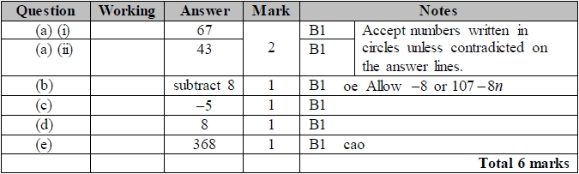

**Q15.**

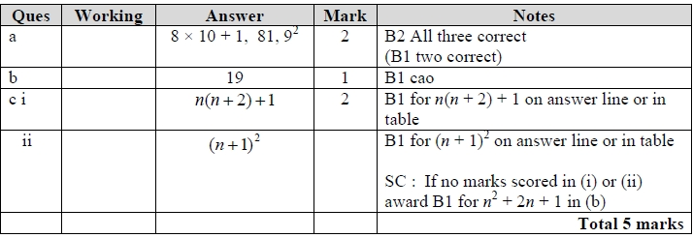

**Q16.**

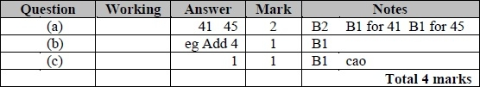

**Q17.**

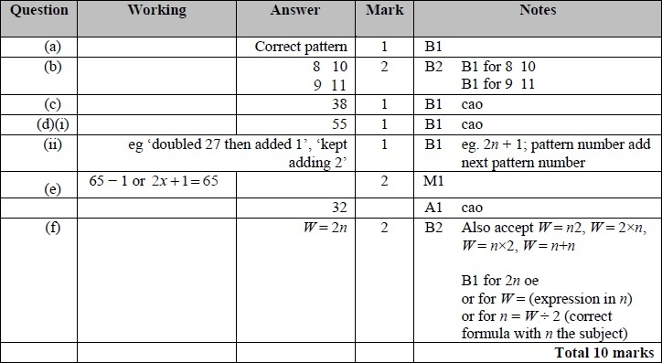

**Q18.**

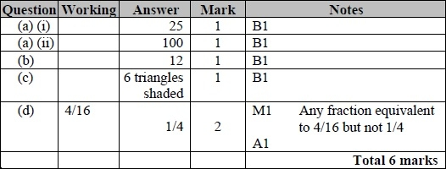

**Q19.**

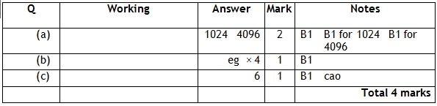

**Q20.**

