**3.3.2 Alkanes**

**Alkanes** are **saturated hydrocarbons**, containing **carbon-carbon** and **carbon-hydrogen** bonds only. They are the **least reactive** organic molecules; there uses are limited to being used as **fuels**, **lubricants** and as **starting** **material** for other compounds. So they are **very important**. The main source of alkanes is **crude oil**.

They exist as:

**General formula**

Straight/branched: CnH2n+2

Ring: CnH2n

* Straight chains
* Branched chains
* Rings

They can exist as isomers, the **more carbon** atoms the **more isomers exist**.

***Starter: 5.2.4 – Alkanes***

**Physical properties**

* **Non-polar** molecules – the **electronegativities** of carbon (2.5) and hydrogen (2.1) are **very similar** so the bonds between carbon and hydrogen are not polar and the

**C-C bonds** are also **non-polar** so are **not easily hydrolysed**.

* **Boiling points** – they only have **weak van der Waals’ forces** between the molecules resulting in low boiling points. These **increases as the chain length increases** due to the **increasing** size of the molecules so the strength of the **van der Waals’ forces** increases. Up to 4 carbon atoms the alkanes are gases, pentane is a liquid and at a chain length of 18 carbons they become solids and have a waxy feel. **Branched alkanes have a lower melting point** than straight chains of the same number of carbon atoms; this is because there is **less surface contact between the molecules** so the **van der Waals’ forces are weaker**.
* **Solubility** – **insoluble in water** because the **hydrogen bonds** holding the water molecules together are **stronger** than the van der Waals’ forces. However, they will mix with other non-polar liquids.

|  |  |  |
| --- | --- | --- |
| **Polarity** | **Boiling Point** | **Solubility** |
|  |  |  |

***Sheet: Alkanes – part 1 Alkanes***

**Chemical properties**

Alkanes are **relatively unreactive** due to their **strong carbon-carbon** and **carbon-hydrogen bonds**. They are **non-polar** molecules.

However, they will undergo these reactions:

* **Combustion** (oxidation or burning)
* **React with halogens** under suitable conditions (free-radical substitution).

**Fractional distillation**

**Crude oil** is a fossil fuel because it was formed millions of years ago by the breakdown of plant and animal remains at high pressures and temperatures, in the absence of air deep below the Earth’s surface. It is **not renewable**. It’s a mixture of mostly **alkanes**, **branched** and **unbranched**. It also contains other compounds which contain other elements such as **sulphur**.

To make crude oil useful it has to be **separated** by heating and collecting the fractions**,** this is a **physical process**.

***Definition***: **Fraction** is a mixture of hydrocarbons of **similar chain length** and **boiling point**

The process is called **fractional distillation** and takes place in a **fractionating column** or tower; this is a long vertical tube.

|  |  |  |
| --- | --- | --- |
|  |  | Rhyme:  little  people  never  keep  dogs  like  foxhounds  with  bull dogs |

***Demo: Box of fractions***

**Process:**

* Crude oil is **heated** and **vaporised**
* Passes into the **tower** which is **cooler at the top** than the bottom; this allows the fractions to be **separated according to their boiling points**
* **Vapours pass up the tower** via a series of trays containing bubble caps until they arrive at a tray that is sufficiently cool (at a temperature lower than its boiling point) for it to **condense**
* The mixture of **liquids that condense** at each tray is piped off, each **fraction** **condenses** at a **different temperature** according to its **boiling point**
* The **shorter chained** hydrocarbons with the **lowest boiling points don’t condense**, they are collected as **gases**
* The **residue** that collects at the bottom is called **tar or bitumen**; it is also **processed** **further** to give other valuable products.

***Animation: Fractional distillation***

***Sheet: Alkanes – part 2 Fractional distillation***

Supply and demand

The **amount of each fraction** produced by distillation **does not meet the demand**. A higher proportion of high-value products, such as petrol is used commercially than occurs naturally. There is **not enough demand for the heavier (longer) fractions**. High demand fractions are more valuable

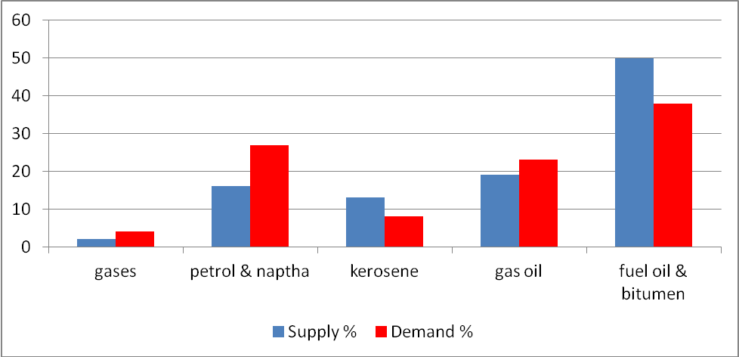

To solve this imbalance the **large alkanes** are **broken into smaller molecules** in a process called **cracking**.

**Cracking**

**Breaking** the **carbon-carbons** bonds **chemically changes** the alkanes and has useful results:

* Produces **shorter** more useful **alkanes**
* Produces **alkenes**, which are more reactive than alkanes and can be used to make other compounds, particularly plastics
* Sometimes **hydrogen** is produced.

Alkanes are very **unreactive** so harsh conditions are needed to break them down. The **carbon-carbon bond is strong** so **a lot of energy** is required, this makes it **costly** but the supply is sufficient to make it **economically viable**.

When cracking occurs the long alkanes may break up into **several different products**, the **mixture** can be **separated** by **fractional distillation**.

**Example**

C14H30 → C7H16 + C3H6 + 2C2H4

C14H30 → C12H24 + C2H4 + H2

***Demo: Catalytic cracking***

|  |
| --- |
|  |
| Diagram of equipment used to crack hydrocarbons in the lab |

Thermal cracking *No catalyst used so a high temperature and pressure are needed*

**Thermal** produces mostly **alkenes**. These are useful for making **polymers**.

C14H30 → C8H18 + 2C3H4

It involves very **high temperature** (400-900OC) and **pressures** (7000 kPa). By changing the temperature the length of alkane produced can be controlled. **Lower temperatures** result molecules **breaking nearer to the middle** of the chain, **higher temperatures** result in **breaks** nearer to the **ends** giving a greater percentage of **alkenes** with a **low mass**. Exposure to high temperature is very short in order to prevent the molecule breaking up into its elements.

The **carbon-carbon bond breaks** in such a way that **one electron** from the pair **goes** to **each carbon** atom, these are called **free radicals** because they have an **unpaired** **electron**. These free radicals are formed by a process called **homolytic fission** (a split resulting in an odd number of electrons) and they are **highly reactive** intermediates, so they react in a number of ways to **form a variety of shorter molecules**. Since there are **not enough hydrogens** to produce all alkanes, one of the new molecules must have a double bond and therefore an **alkene** is produced.

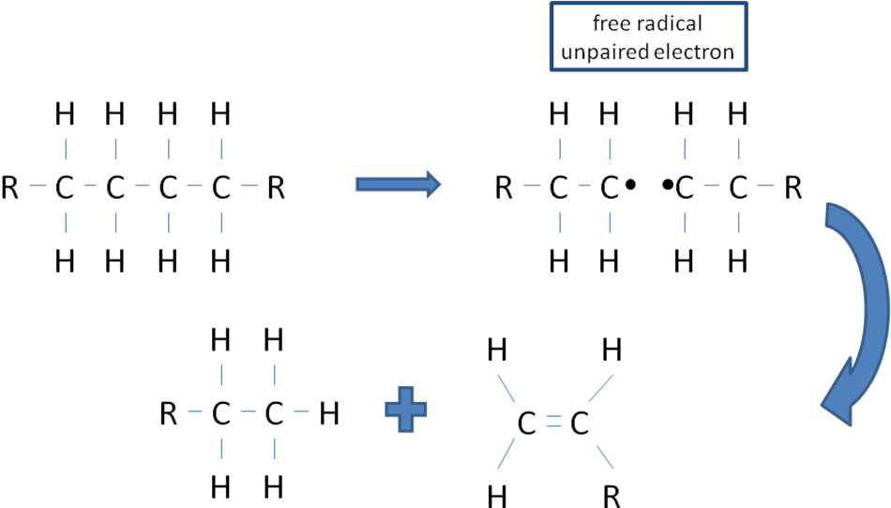

Catalytic cracking *Catalyst allows a lower temperature and pressure to be used*

**Catalytic** produces mostly **branched alkanes, cycloalkanes** and **aromatic hydrocarbons**. It produces **motor fuels** as **branched chain** alkanes **burn** **more smoothly** than unbranched.

CH3 CH3

│ │

C14H30 → H3C⎯C⎯CH2 ⎯CH⎯CH3 +

│

CH3

straight-chain alkane branched-chain octane cycloalkane

*tetradecane 2,2,3-trimethylpentane cyclohexane*

The catalysts used are called **zeolites** and consist of **silicon** **dioxide** and **aluminium oxide** in the form of a **honeycomb** structure to **increase** the **surface area**.

|  |  |  |
| --- | --- | --- |
|  |  | T = 450OC  P = atm |

The use of a **catalyst** allows **lower temperatures** and **pressure** to be used, as well as **speeding up the reaction**. This **saves energy** and so reduces costs.

***Starter: 5.2.1 – Fractional distillation and cracking***

***Sheet: Alkanes – part 3 Cracking***

***Fact recall: CGP197 Q1-7***

**Combustion**

Alkanes **burn** in air or oxygen in a **very exothermic reaction** so they are **useful as fuels**. The **more carbon atoms** in the molecule the **more energy** they **give out**.

***Definition***: **Fuel** is substance that **releases heat energy** when it undergoes combustion

***Demo: Complete & incomplete combustion (Bunsen burner/calor gaz stove/candle)***

|  |  |  |  |
| --- | --- | --- | --- |
| Complete combustion |  | Incomplete combustion |  |

When writing combustion equations they usually show just **1 mole of fuel** burning, so the moles of oxygen used may be written a decimal or fraction.

Complete combustion – *plenty of oxygen*

In complete combustion **water** and **carbon dioxide** are produced. As **more carbon** atoms are added **more oxygen** is required per mole of hydrocarbon for complete combustion.

**Example**

CH4 (g) + 2O2 (g) → CO2 (g) + 2H2O (l)

Incomplete combustion – insufficient oxygen

In **incomplete combustion** there is **insufficient** **oxygen** so **carbon** or **carbon monoxide** are produced. This can be seen in a Bunsen burner, when the air hole is closed the flame is **yellow** due to the **carbon present** and would coat anything heated in it with **soot**. **Large hydrocarbons** tend to **burn incompletely** due the requirement for larger quantity of oxygen which air is unable to supply.

**Example**

CH4 (g) + O2 (g) → C (s) + 2H2O (l)

CH4 (g) + 1.5O2 (g) → CO (g) + 2H2O (l)

The formation of **carbon monoxide** is a **hazard**, as it binds irreversibly to haemoglobin in the red blood cells and prevents oxygen binding, resulting in **death**.

***Sheet: Alkanes – part 4 Combustion***

Internal combustion engines

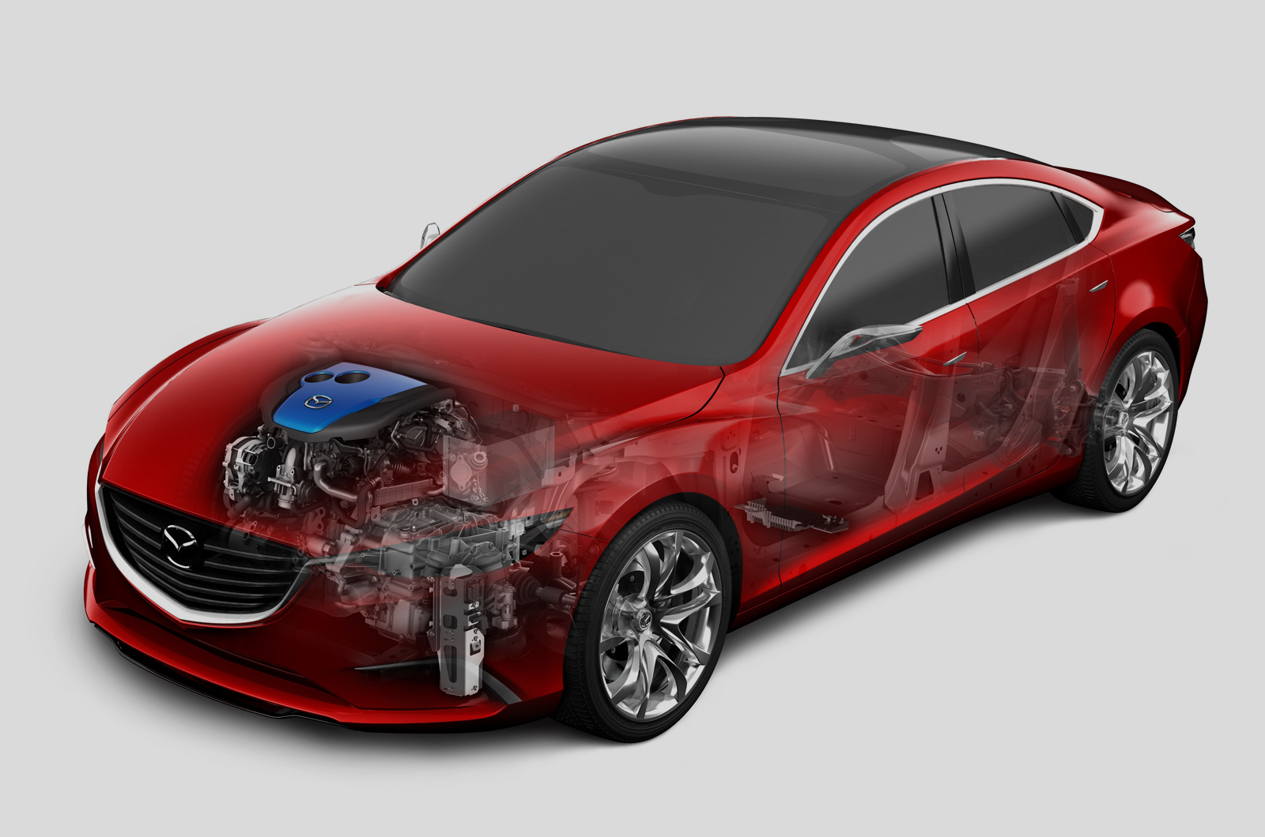

All hydrocarbon based fuels derived from crude oil may produce **polluting products** when they burn.

Pollutants from combustion

* **Carbon monoxide** – poisonous gas from incomplete combustion.

C8H18 + 8½O2 → 8CO + 9H2O

* **Nitrogen oxide** – toxic gases NO, NO2, N2O4 – they are abbreviated to **NOX**. These are produced when there is **enough energy** for **nitrogen** and **oxygen** to combine.

N2 + O2 → 2NO

2NO + O2 → 2NO2

2NO2 → N2O4

This can happen in a petrol engine due to the **high temperatures** present when sparks ignite the fuel. These oxides may then **react with water vapour and oxygen** in the air to form **nitric acid**. This contributes to **acid** **rain.**

4NO2 + 2H2O + O2 → 4HNO3

Nitrogen oxide also reacts with oxygen or hydrocarbons in the presence of sunlight to form an irritating **photochemical smog**.

* **Sulphur dioxide** – if the fuel contains **sulphur containing compounds** then sulphur dioxide will form when it reacts with oxygen. The sulphur dioxide is a toxic gas and can **combine with water vapour** and **oxygen** in the air to produce **sulphuric acid**, another contributor to **acid rain**.

Forming sulphur dioxide:

CH3SH + 2.5O2 → CO + 2H2O + SO2

methanthiol

Forming sulphuric acid (both cause acid rain):

SO2 + H2O → H2SO3 followed by 2H2SO3 + O2 → 2H2SO4

* **Carbon particles** & **unburnt hydrocarbons** – these are called **particulates** they can enter the atmosphere contributing to **photochemical** smog, can make asthma worse, cause cancer and **global dimming** (reflection of sun’s light into space).
* **Carbon dioxide** – this will always be produced when fuels burn but it is a **greenhouse gas** and increased levels are causing concerns that the globe is warming up.
* **Water** vapour – this will always be produced but it too is a **greenhouse gas**.

***Starter: 5.2.2 – Air pollution***

***Application: CGP199 PQ1-2***

***Fact recall: CGP199 Q1-4***

Catalytic converters

All new cars must be fitted with a **catalytic convertor** in their exhaust system. These reduce the output of **carbon monoxide**, **nitrogen oxides** and **unburnt hydrocarbons**.

|  |  |  |  |
| --- | --- | --- | --- |
|  |  |  |  |

It is a **honeycomb** made of a **ceramic material** coated with a thin layer of **platinum, palladium** and **rhodium** metals, which are the **catalysts**. The **honeycomb** provides a **large surface area** so the expensive metal can go a long way. As the polluting gases pass over it they are converted into these less harmful gases; **carbon dioxide, nitrogen** and **water**.

2CO+ 2NO → 2CO2 + N2

C8H18 + 25NO → 8CO2 + 9H2O + 12½N2

Removing sulphur

**Sulphur** compounds are **removed** from **petrol** **before** it is **sent to the fuel stations**.

**Power station** burn either coal or natural gas to produce electricity. Any **acidic** **sulphur dioxide** produced is passed up a chimney and **removed** by a process called **flue-gas desulphurisation**.

**Alkaline** substances are used to **remove the acidic sulphur dioxide**. Calcium oxide (quicklime) can be used; this is easily obtained by **thermal decomposition** of **calcium** **carbonate** (limestone). The reaction between **calcium oxide** and **sulphur dioxide** is **calcium sulphite**. This is **easily oxidised** to form **hydrated calcium sulphate** (gypsum), which is used to make **plasterboard** for the building trade. So the removal of a pollutant gives rise to a **commercial product**, which is a great **advantage**.

CaCO3 → CaO + CO2

CaO + SO2 → CaSO3

***Starter: 5.2.5 – Alkanes summary***

***Sheet: Alkanes – part 4 Combustion (Pollutants & Removing sulphur)***

**Synthesis of chloroalkanes**

**Alkanes** do **not react** with **chlorine** at **room temperature** or in the dark, they **need UV** light (very high energy radiation that is able **to break Cl-Cl** bond) and allow the **hydrogen** atoms on the alkane to be **substituted** for a **chlorine** atom.

To make a haloalkane an **alkane will react with a halogen** if **UV light** is present.

The **mechanism** is called **free-radical substitution**. The reaction between any alkane and a halogen goes by the same mechanism.

**halogen + alkane → halogenoalkane**

There are **3 stages** to producing haloalkanes:

* **Initiation**– makes the free-radical (species with an unpaired electron)
* **propagation** – reaction between alkane and free-radical – it’s a chain reaction
* **termination** – final products made when 2 free-radicals join

The mechanism for **making halogenoalkanes** is called **free-radical substitution**.

A **free-radical** (radical for short) is a species with an **odd number of electrons** with **one unpaired electron**; they can be single atoms or groups of atoms. They are represented with a **dot** to **indicate** the **unpaired electron**.



This is a chlorine atom.

Radicals are formed when a **covalent bond breaks** with an **equal splitting** of the electron pair (i.e. one electron going to different atoms). This is called **homolytic** (equal) **fission** (splitting).

Mechanism

**Example**: CH4 + Cl2 → CH3Cl + HCl

Any alkane and halogen use the same **multi-stepped** mechanism and starts off a **chain reaction**:

* **Initiation** – *starts*
  + The **UV** light **provides the energy** to start the reaction by **splitting** the chlorine **molecules** **into** **atoms**
  + This results in **free radicals** which are **highly reactive**
  + The **Cl-Cl bond breaks** rather than the C-H bond because it is **weaker**
  + UV light can’t break a C-H bond

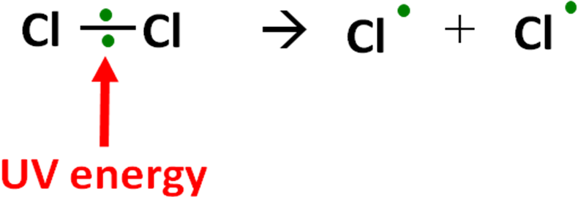

Reaction: Cl2 → 2Cl•

* **Propagation** – *grows*
  + 2 steps are **repeated** 1000 of times until it is terminated
  + A **radical** is **used** and a **new radical** is **formed** which leads to a **chain reaction**
  + It is **exothermic**

|  |  |
| --- | --- |
| a | free-radical is on the carbon atom |
| b |

Individual steps: Cl• + CH4 → •CH3 + HCl

•CH3 + Cl2 → CH3Cl + Cl•

Overall reaction: CH4 + Cl2 → CH3Cl + HCl

* **Termination** – *stops*
  + When **two radicals combine**, they form a **stable molecule** (no unpaired electrons)
  + The sequence of **reactions** **stops**
  + The **unpaired electrons** in the radicals **pair** up to **form** a **covalent** **bond**

2 possible termination steps: Cl• + •CH3 → CH3Cl

•CH3 + •CH3 → CH3CH3

Another termination step is theoretically possible: Cl• + Cl• → Cl2

But it’s **unlikely** because the chlorine radicals **collide** with **enough energy** to **separate** again immediately.

***Task: Complete the following free-radical substitutions***

|  |  |
| --- | --- |
| CH3CH3 + Cl2  Initiation  Cl2 → 2Cl•    Propagation  Cl• + CH3CH3 → •CH2CH3 + HCl  •CH2CH3 + Cl2 → CH3CH2Cl + Cl•  Termination  Cl• + •CH2CH3 → CH3CH2Cl  •CH2CH3 + •CH2CH3 → CH3CH2CH2CH3  Overall equation for the reaction  CH3CH3 + Cl2 → CH3CH2Cl + HCl | CH3Br + Br2  Initiation  Br2 → 2Br•    Propagation  CH3Br + Br• → •CH2Br + HBr  •CH2Br + Br2 → CH2Br2 + Br•  Termination  •CH2Br + Br• → CH2Br2  •CH2Br +•CH2Br → CH2BrCH2Br  Overall equation for the reaction  CH3CH3 + Br2 → CH2BrCH2Br + HBr |

***Sheet: Free radical substitution equations (page 1)***

***Task: Free-radical substitution - unanimated***

Further substitutions

The substitution of hydrogen for a halogen can lead to **further substitution reactions** if there are **other hydrogen atoms**.

In the example above **chloromethane** can undergo further substitution to **produce**:

|  |  |
| --- | --- |
| * Dichloromethane (CH2Cl2) * Trichloromethane (CHCl3) * Tetrachloromethane (CCl4) | Mixture of products possible  Separate by fractional distillation |

The likelihood of further **substitution beyond trichloromethane** can be **reduced** with an **excess of methane**.

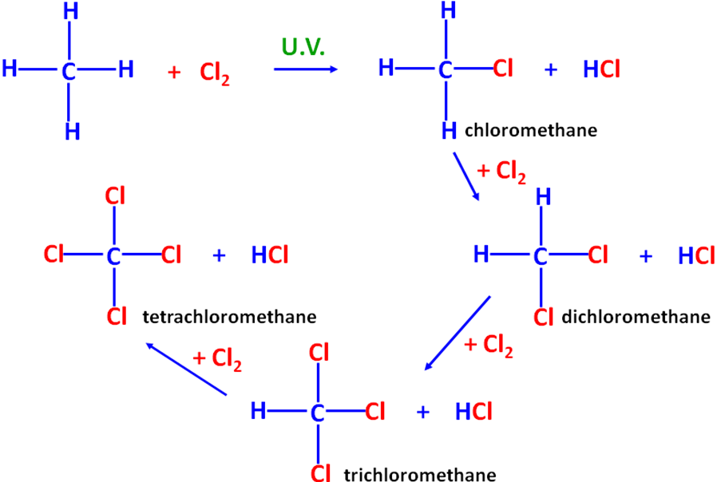

Overall reaction: CH4 + 4Cl2 → CCl4 + 4HCl

***Sheet: Free radical substitution equations (page 2)***

***Starter: 5.2.6 – Free radical mechanisms***

***Fact recall: CGP199 Q1-4***

***Exam questions: Oxford p204-205 Q1-5***