**3.2.5 Transition metals**

**AS & A Level Link:**

**3.1.1 – Atomic structure**

**3.1.3 – Bonding (co-ordinate bonding, shapes of simple molecules and ions)**

**3.1.5 – Kinetics (catalysts)**

**3.1.7 – Redox (oxidation states, oxidation, reduction, redox equations)**

**3.2.1 – Periodicity**

**3.3.5 – Alcohols (Tollen’s test for aldehydes)**

**3.1.11 – Electrode potential & electrochemical cells**

**3.3.13 – Amino acids, proteins & DNA**

**Introduction**

The **transition elements** are found in the central block of the periodic table, called the   
**d-block** because electrons are added to the **d sub-level**. They are **metals** and have typical **physical** **properties** for metals. Theyhave a fairly **low chemical reactivity** andso have many **uses**.

***Definition***

A **transition element** is an element that forms at least one **stable** **ion** with an incomplete **d** **sub-level** of electrons.

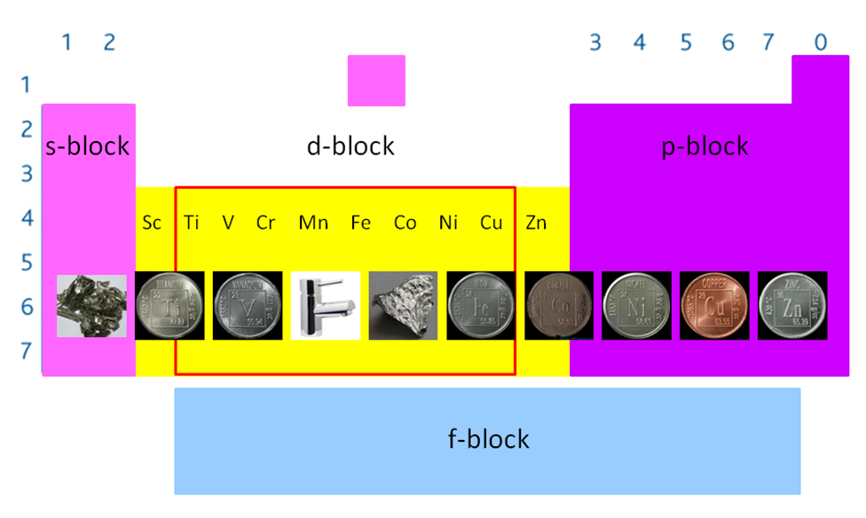

***Task: Write the electronic configuration for elements Sc & Zn and Sc3+ & Zn2+***

Sc21 [Ar] 3d14s2 Sc3+ [Ar]

Zn30 [Ar] 3d104s2 Zn2+ [Ar] 3d10

**Scandium** and **zinc** **aren’t transition metal** because their **stable ions do not** have **incomplete d sub-levels**.

**Electronic configurations**

Remember the **4s fill before the 3d** sub-level because it has a **lower energy** level. The rule is the electrons fill singly before pairing but there are two exceptions (chromium and copper). When working out the electronic configuration of the transition metal **ions** remember the **4s** electronsare **lost before the 3d** electrons.



|  |  |
| --- | --- |
| **Atoms** | **Common ions** |

|  |  |  |  |  |  |  |  |  |  |  |
| --- | --- | --- | --- | --- | --- | --- | --- | --- | --- | --- |
| Sc | 21 | 1s2 | 2s22p6 | 3s23p63d1 | 4s2 |  |  | | | |
| Ti | 22 | 1s2 | 2s22p6 | 3s23p63d2 | 4s2 |  | Ti2+ | 1s2 | 2s22p6 | 3s23p63d2 |
| V | 23 | 1s2 | 2s22p6 | 3s23p63d3 | 4s2 |  | V3+ | 1s2 | 2s22p6 | 3s23p63d1 |
| *Cr | 24 | 1s2 | 2s22p6 | 3s23p63d5 | 4s1 |  | Cr3+ | 1s2 | 2s22p6 | 3s23p63d3 |
| Mn | 25 | 1s2 | 2s22p6 | 3s23p63d5 | 4s2 |  | Mn4+ | 1s2 | 2s22p6 | 3s23p63d3 |
| Fe | 26 | 1s2 | 2s22p6 | 3s23p63d6 | 4s2 |  | Fe3+ | 1s2 | 2s22p6 | 3s23p63d5 |
| Co | 27 | 1s2 | 2s22p6 | 3s23p63d7 | 4s2 |  | Co2+ | 1s2 | 2s22p6 | 3s23p63d7 |
| Ni | 28 | 1s2 | 2s22p6 | 3s23p63d8 | 4s2 |  | Ni2+ | 1s2 | 2s22p6 | 3s23p63d8 |
| **Cu | 29 | 1s2 | 2s22p6 | 3s23p63d10 | 4s1 |  | Cu2+ | 1s2 | 2s22p6 | 3s23p63d9 |
| Zn | 30 | 1s2 | 2s22p6 | 3s23p63d10 | 4s2 |  |  | | | |

*3d & 4s ½ full – more stable [Ar = 1s22s22p63s23p6]

**3d full & 4s ½ full – more stable

***Sheet: General properties of transition metals***

**Physical properties**

They all have **similar** physical properties.

* Good conductors heat & electricity
* Shiny & sonorous
* Hard & strong
* Malleable & ductile
* High melting & boiling points (exception mercury – liquid at room temperature)
* High density

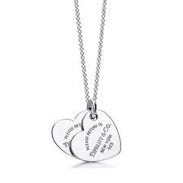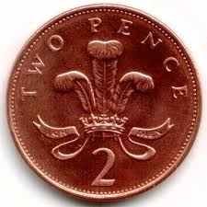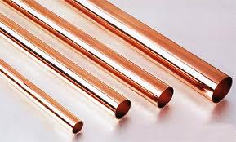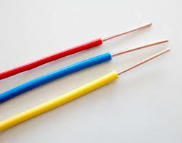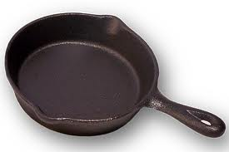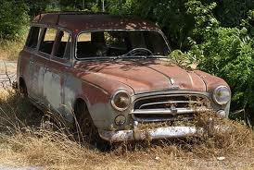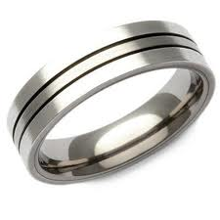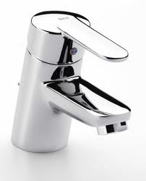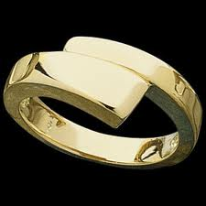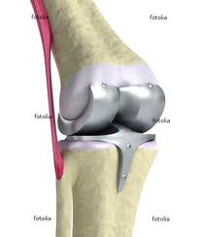

**Chemical properties**

The **partly filled d sub-orbital** is responsible for the **chemical characteristics**.

|  |  |  |
| --- | --- | --- |
| * Formation of complexes |  |  |
| * Formation of coloured compounds and solutions |  | |
| * Variable oxidation states |  | |
| * Catalytic activity |  | |

***Sheet: General properties of transition metals***

***Application: CGP133 PQ1-3***

***Fact recall: CGP133 Q1-7***

**Complex formation**

***Sheet: Complex formation***

All transition metal ions can form **co-ordinate bonds** or **dative** by **accepting electron lone pairs** from other ions or molecules. The **ions or molecules** are called **ligands**.

The transition ions can complex with ligands of different charges but the metal ion doesn’t change its charge, its electronic configuration stays the same. So the **charge of the complex ion can change with different ligands**.

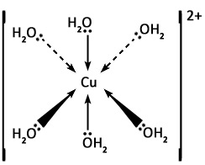

***Task: Define a co-ordinate bond***

A covalent bond formed when a pair of electrons originates from one atom

***Definition***

A **ligand** is any atom, ion or molecule which can donate a pair of electrons to a metal ion.

There can be **2, 4 or 6 ligands bonded** to a single transition metal ion; the resulting species is called a **complex ion**.

***Definition***

A **complex** is a compound formed when one or more ligands form a co-ordinate bond to a metal ion.

Naming complexes

Their name is dependent on the number and type of ligand that is bonded to the metal ion and includes the charge of the metal ion.

**Example:** Hexaaqua copper(II) ion [Cu(H2O)6]2+

hexa = 6

aqua = water ligands

(II) = 2+ metal ion

Co-ordination number

The **number of bonds** formed by the ligands results in a **co-ordination number** for each complex.

This is **not necessarily the same as the ligand number** because ligand can form more than one co-ordinate bond to the ion.

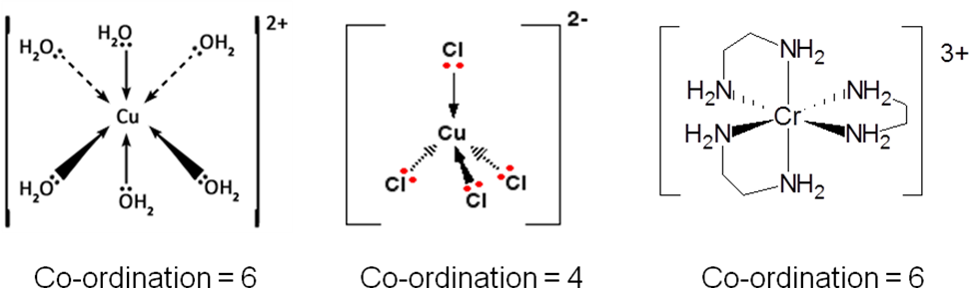

***Definition***

**Co-ordination number** is the **number of atoms bonded** to a metal ion or **number of co-ordinate bonds formed**.

So the co-ordination number is:

* Number of **atoms** bonded to form a **co-ordinate bond**
* **NOT** number of **ligands**

Types of ligands

***Demo: Molymod complex ions***

‘Dentate’ comes from the Latin for tooth, so ligands ‘bite’ the metal ions.

**Monodentate –** *a molecule or ion that donates one lone pair of electrons to form one co-ordinate bond*

**Examples:** H2O**:**, **:**OH-, **:**NH3, **:**CN-, **:**Cl-

In the **hexaaquacopper(II) ion** each water molecule donates an electron pair (one of its lone pairs) to the copper(II) ion to form a complex ion.

H2O

CuSO4(s) [Cu(H2O)6]2+(aq)

copper(II) sulphate hexaaqua copper(II) ion



white blue

anhydrous co-ordinate number of Cu = 6

oxidation state Cu = +2

Remember the hexaaqua **complex** is an **ion** but the **bonds** within the complex are **covalent**, and so **reactions** of the complex ion **involve** **breaking** **one** or **both** of these **types** of **bonds**.

**Bidentate ligands –** *a molecule or ion that donates two lone pairs of electrons to form two   
co-ordinate bonds*

|  |  |  |
| --- | --- | --- |
| **Examples:** | ethane-1,2-diamine or  1,2-diaminoethane (en)  *N.B. neutral ligand*  NH2CH2CH2NH2 | ethanedioate (C2O42-)  (from ethanedioic acid)  *N.B. charged ligand* |
|  |  |  |
| Complex ions | [Cr(en)3]3+ | [Cr(C2O4)3]3- |
|  |  |  |

**Multidentate ligands –** *a molecule or ion that donates many lone pairs of electrons to form many co-ordinate bonds*

**Example:** Anion of bis[di(carboxyymethyl)amino]ethane, commonly known as **e**thylene**d**iamine**t**etra**a**cetic acid or H4EDTA.

The anion **EDTA4-** is able to bond to metal ions from **six atoms** - four oxygens and two nitrogens.



EDTA4- can be taken as an antidote to transition metal poisoning and as an anti-coagulant when blood samples are taken.

Complex ions with multidentate ligands are called **chelates** (*key-lates*) from the Greek work for claw.

***Definition***

A **chelate** is the formation of a complex with **bidentate** or **multidentate ligands**.

**Oxidation states**

The overall **charge** on a complex ion is put **outside** the **brackets**. So [Cu(H2O)6]2+ has a total charge of 2+. To determine the oxidation state of the central metal atom it’s easier to use the **overall charge** **of the ligand** rather than each atom.

**Oxidation state of metal ion = total charge of complex – sum of charges of ligands**

|  |  |  |
| --- | --- | --- |
| **Name** | **Ligand** | **Overall charge of ligand** |
| Water | H2O | 0 |
| Ammonia | NH3 | 0 |
| Hydroxide | OH- | -1 |
| Chloride | Cl- | -1 |
| Cyanide | CN- | -1 |
| Ethane-1,2-diamine | H2NCH2CH2NH2 | 0 |
| Ethanedioate | C2O42- | -2 |
| Bis[di(carboxymethyl)amino]ethane | EDTA4- | -4 |

**Example**

Determine the oxidation state of silver in complex ion [Ag(CN)2]-

Oxidation state Ag + (2 x charge on CN-) = -1

Ag -2 = -1

So oxidation state **Ag = +1 Ag(I)**

***Task: Determine the oxidation state of chromium in complex ion [CrCl2(H2O)4]+***

Oxidation state Cr + (2 x charge on Cl-) + (4 x charge on H2O) = +1

Cr -2 + 0 = +1

So oxidation state **Cr = +3 Cr(III)**

***Sheet: Complex formation***

**Shapes of complex ions**

The **shape** of the complex ion **depends** on **its co-ordination number**, the number of co-ordinate bonds formed with the central metal ion. If the **ligands** are **small** then **6 can bond** but if they are **large** **only** **4** may be able to **bond**.

|  |  |
| --- | --- |
| ***Six co-ordinate bonds***  **Octahedral** -the most common shape, it has **6 points** and  **8 faces**.  All the first-row transition metals form octahedral hexaaqua ions with water and ammonia as it’s a similar size. |  |
| ***Four co-ordinate bonds***  **Tetrahedral** – the next common shape, it has **4 points** and  **4 faces**.  If the ligand is **large** and **negatively** **charged** (e.g. Cl-, Br-, I-) there will be **inter-ligand repulsion** as well as **bond-pair repulsion** in the complex. A **tetrahedral** arrangement means the **ligands** **are further apart**. |  |
| ***Four co-ordinate bonds***  **Square-planer** - a less common shape, frequently found in **platinum** complexes.  **Example: *cis*-platin**, [PtCl2(NH3)2)]  A **platinum ion** with **2 ammonia** and **2 chlorine** ligands. It’s a successful **anti-cancer drug**, believed to work by binding the DNA. Its isomer *trans*-platin has no anti-cancer effect. |  |
| ***Two co-ordinate bonds***  **Linear** – again less common but frequently found in **silver** complexes.  **Example:** **Tollens’ reagent**, [Ag(NH3)2]+  Used to **identify aldehydes**. |  |

***Application: CGP137 PQ1-5***

***Fact recall: CGP137 Q1-3***

**Isomerism in complex ions**

Two types of isomerism exist:

* **Geometric** isomerism – called *cis-trans* (*E-Z*) – same molecular formula but different orientation of bonds in space.
* **Optical** isomerism – a type of stereoisomerism exist as two non-superimposable mirror images – isomers known as enantiomers.

|  |  |
| --- | --- |
| Geometric Isomerism  Different monodentate ligands  *Cis* – same side  *Trans* – across  (like trans-atlantic)  e.g. [PtCl2(NH3)2] |  |

Cis-platin *cis*-[PtCl2(NH3)2]

**For more details on the application see 3.3.13 – Amino acids, proteins & DNA**

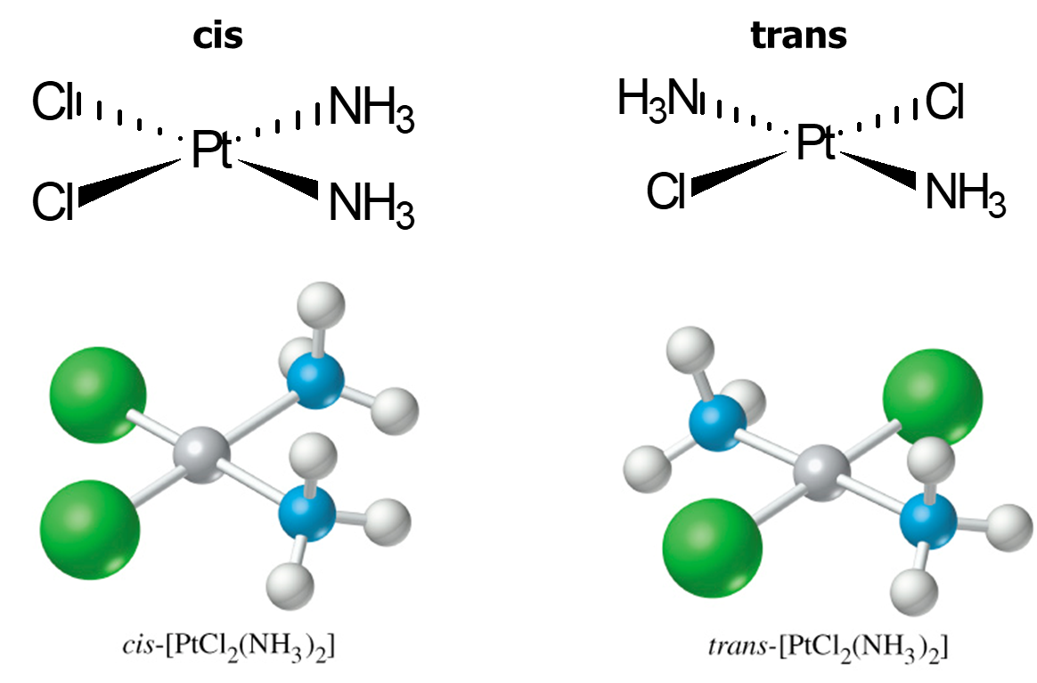

The **anti-cancer drug**, cis-platin has a remarkable success rate. It works by forming bonds with guanine bases in DNA, causing cross-linkage between strands. This **prevents** unwinding and **replication**, so **inhibits cell division** but not cell growth. Unfortunately, it has some **side-effects** such as **loss of hair** and is **toxic**. The risk of using the drugs is minimised by using **small quantities** targeting the application and **monitoring the patient**, the patients are given **large quantities of water** before and after treatment to dilute it in the kidneys.

|  |  |
| --- | --- |
| Optical isomerism  Bidentate or multidentate ligands only  e.g. [Co(en)3]3+  en = 1,2-diaminoethane or ethan-1,2-diamine |  |

***Sheet: Shapes of complexes - Isomerism***

***Starter: 13.2 - Transition metal complexes***

***Sheet: HSW - Cis-platin (help NT219)***

***Task: Stretch & Challenge - Cis-platin***

***Application: CGP139 PQ1-2***

***Fact recall: CGP139 Q1-2***

**Coloured ions**

***Demo: Transition metal compounds & solutions***

Origin of colour

|  |  |
| --- | --- |
| Many transition metal compounds are **coloured**. This is caused by the compound **absorbing** **energy** that corresponds to **light** in the **visible region** of spectrum. |  |

White light is a spectrum of different colours from red through green to violet. If a **solution** looks **blue**, it is **absorbing all light** from the white light **except blue**, which is **transmitted** **through** the solution making it appear blue.

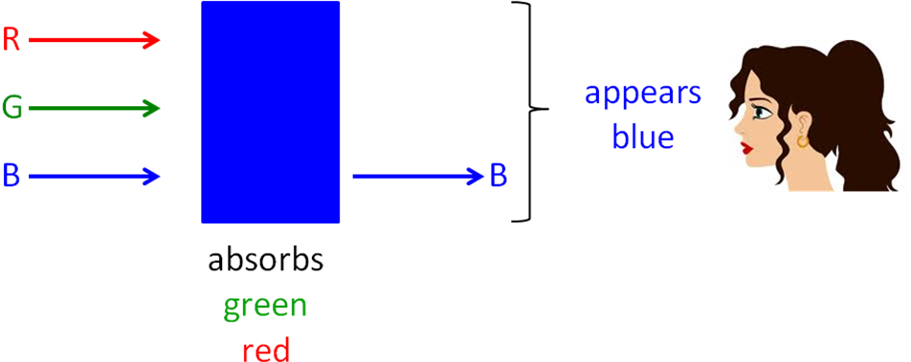

**Normally** the **3d orbitals** of transition metal ions have the **same energy**, but when **ligands** bond to the ions some **orbitals** are **given** more **energy**. So they **split** into different energy levels.

|  |  |
| --- | --- |
|  | The **part-filled d-orbitals** allow **electrons** (in the ground state)to **move** to a higher d-orbital (excited state) if they are **supplied with energy** that is **equal** **to** the **energy gap**, **ΔE**. They **absorb energy in the** **visible** region **equal** to the **energy between the levels**. |
|  |

Depending on the gap between the d orbitals **different** **wavelengths of light** are **absorbed** by the **electrons** resulting in the metal ions **complexes** appearing as **different** **colours**. The **d electrons are excited** and so move to the higher energy sub-levels and the **colour observed** is the **light reflected** off the solid surface or **transmitted** through a solution.

The **frequency of the light** is **related to the energy difference** of the d-orbitals and is shown by the expression

**ΔE = *hʋ***

ΔE = energy absorbed (J)

ʋ = frequency of light absorbed (Hz)

*h* = Planck’s constant (6.63 x 10-34 Js)

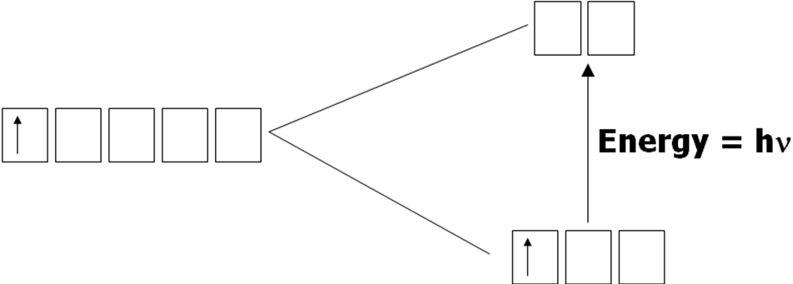

If there are **no 3d orbitals** or the **3d sub-level is full**, then **no electrons jump** and no energy is absorbed. The compound will look **white or colourless** as a solution because **all** the **light is reflected**. The amount of **energy needed to excite** electrons **depends** on the **central metal ion** and its **oxidation state**, the **ligands** and **co-ordination number**. The diagram below shows how the d orbitals are split in different shapes complexes.

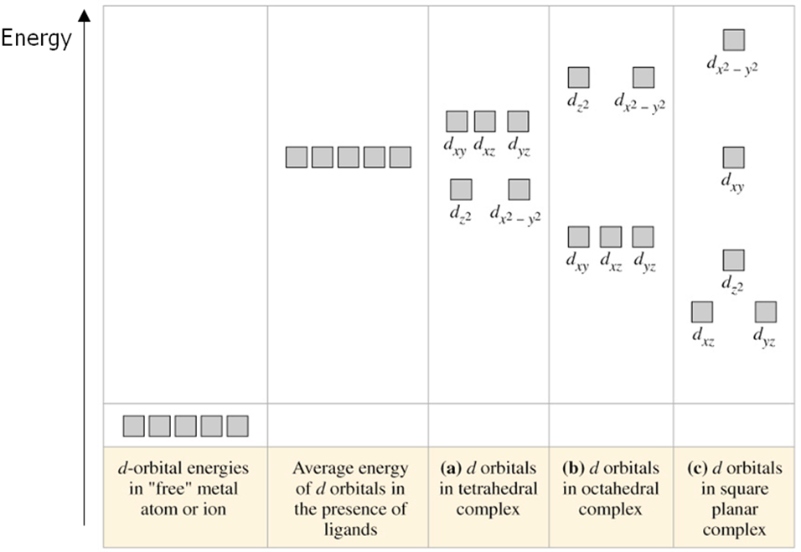

***Demo: Complex formation***

***Starter: 13.3 - Colours of complex ions***

***Sheet: Stretch & challenge – Why are transition metal complexes coloured?***

Colour change

Metal ion complexes are not one **colour**; it **can be altered** by things that **change** the **size** of the **energy gap** (ΔE). So reactions of transition metal ions often result in colour changes

Factors that change the colour of a complex:

* Oxidation state of metal ion
* Co-ordination number
* Ligand

In **some reactions** colour **changes** are **due** to **all three changes**.

**Oxidation state** – if the metal ion changes then the oxidation state can change.

|  |  |  |  |  |  |
| --- | --- | --- | --- | --- | --- |
| [FeII(H2O)6]2+ | → | [FeIII(H2O)6]3+ |  | → |  |
| **pale green** |  | **very pale violet**  appears straw yellow due to hydrolysis of the water ligands |
| ON = +2 |  | ON = +3 |
|  |  |  |  |  |  |
| [CrII(H2O)6]2+ | → | [CrIII(H2O)6]3+ |  | → |  |
| **blue** |  | **red-violet** |
| ON = +2 |  | ON = +3 |

**Co-ordination number** – a change in the number of nearest neighbours will lead to a change in the co-ordination number, this is usually through a **change in the ligands**.

|  |  |  |  |  |  |
| --- | --- | --- | --- | --- | --- |
| [Cu(H2O)6]2++ 4Cl- | → | [CuCl4]2- + 6H2O |  | → |  |
| **blue** |  | **yellow-green** |
| octahedral |  | tetrahedral |
| co-ordination 6 |  | co-ordination 4 |
|  |  |  |  |  |  |
| [Co(H2O)6]2+ + 4Cl- | → | [CoCl4]2- + 6H2O |  | → |  |
| **pink** |  | **blue** |
| octahedral |  | tetrahedral |
| co-ordination 6 |  | co-ordination 4 |

**Ligand** – a change in the ligand gives rise to colour changes.

|  |  |  |  |  |  |
| --- | --- | --- | --- | --- | --- |
| [Cr(H2O)6]3+ + 6NH3 | → | [Cr(NH3)6]3+ + 6H2O |  | → |  |
| **red-violet** |  | **purple** |
| octahedral |  | octahedral |
| ON = +3 |  | ON = +3 |
| co-ordination 6 |  | co-ordination 6 |
|  |  |  |  |  |  |
| [Cu(H2O)6]2+ + 4NH3 | → | [Cu(NH3)4(H2O)2]2+ + 4H2O |  | → |  |
| **blue** |  | **royal blue** |
| octahedral |  | octahedral |
| ON = +2 |  | ON = +2 |
| co-ordination 6 |  | co-ordination 6 |

***Demo: Copper complex ions***

***Sheet: Coloured ions***

Visible spectrophotometry

A spectrophotometer can be used to determine the **concentration** of a transition **metal ion** by measuring the **how much light is absorbed** by a solution. In a **visible spectrophotometer**, light of **increasing** (or decreasing) **frequency** is passed through the sample; the **light emerging** is received by a **detector** and recorded.

|  |  |
| --- | --- |
|  |  |

The amount of **light absorbed** is **proportional** to the **concentration** of the species in the solution. The **Beer-Lambert** law is used:

*A* = absorbance

C = concentration

l = cell-path

*ɛ* = molar absorption coefficient

***A = ɛcl***

Very simple spectrophotometers called **colorimeters** can be used to measure the **intensity of absorption** at a **particular frequency**. They are fairly cheap and provide a rapid, non-destructive way of testing a sample. A **more concentrated** solution will **absorb more** **light**. This is a **quicker** method of determining the concentration of a solution and uses **smaller volumes**.

|  |  |
| --- | --- |
|  |  |

They can be used to find the **formula of a transition metal complex**, by finding the **ratio** of **metal** **ions** to **ligands**. **Different proportions** of metal ion and ligand are **mixed**; when they are mixed in the **same ratio as the complex** it will give a **maximum absorption** and the formula can be worked out.

|  |  |
| --- | --- |
| **Using a colorimeter:**   * Make up solutions of known concentration * Measure absorption * Plot graph of results - **calibration curve** * Measure absorption of unknown * Read concentration from graph |  |

***Prac: Colorimetry***

***Starter: 13.4 - Colorimetry***

***Application: CGP143 PQ1-3***

***Fact recall: CGP143 Q1-5***

**Ligand substitution reactions**

One **ligand** can be **substituted** for another; this involves **breaking the M-O bond**, where the **water molecule is replaced** **by other ligands.** These reactions are in **equilibrium**.The ligands are replacedeither because the **other ligand** **forms** a **stronger co-ordinate bond** or they are **present in higher** **concentrations** and so **displace the equilibrium**.

If the ligand is a **similar size** the **co-ordination** number of the complex **doesn’t change**.

It’s a **nucleophilic substitution** reaction but is usually just called **ligand substitution**.

The **enthalpy change** for substitution reactions that don’t change co-ordination number is often **almost zero** because the co-ordinate bonds that break and form have a similar enthalpy and the same number of bonds are broken and made.

**There are three types of substitution:**

* Similar sized ligands – co-ordination number same
* Different sized ligands – co-ordination number different
* Partial substitution – co-ordination number same

***Demo: Ligand substitution***

***Copper sulphate + 2 mol dm-3 NH3 & conc. HCl***

Substitution of similar sized ligands

These reactions can be broken down into six steps, with one water molecule being replaced in each step:

[M(H2O)6]2+ + NH3 [M(NH3)(H2O)5]2+ + H2O

No need to learn all these equations they simply show the substitutions one step at a time



[M(NH3)(H2O)5]2+ + NH3 [M(NH3)2(H2O)4]2+ + H2O



[M(NH3)2(H2O)4]2+ + NH3 [M(NH3)3(H2O)3]2+ + H2O



[M(NH3)3(H2O)3]2+ + NH3 [M(NH3)4(H2O)2]2+ + H2O



[M(NH3)4(H2O)2]2+ + NH3 [M(NH3)5(H2O)]2+ + H2O



[M(NH3)5(H2O)]2+ + NH3 [M(NH3)6]2+ + H2O



**The general equation for the replacement of water in an aqua ion by neutral ligands:**

[M(H2O)6]2+ + **6NH3** [M(NH3)6]2+ + **6H2O**



The first equation starts with the **hexaaqua** (water bonded) ion and the last ends with the **hexaammine** (ammonia bonded) ion.

**Note**: The double ‘m’ – don’t confuse it with amine (R-NH2)

**Example CGP144**

**Water** and **ammonia** are **similar sized** ligands and are both **uncharged**, so water can be substituted for ammonia **without** any **change** in the **co-ordination** **number** or **shape**. There **is a colour change** because the **ligands have changed**.

|  |  |
| --- | --- |
|  |  |

Adding **ammonia to cobalt(II) ions** initially forms a **green-blue precipitate** of **cobalt(II)****hydroxide** because **hydrolysis** of some of the water molecules.

When an **excess** of **concentrated aqueous ammonia** is added the **precipitate dissolves** to give a **pale straw coloured solution** of hexaamminecobalt(II). Air quickly darkens it to the **dark-brown mixture** containing **cobalt(III) ammines**.

Equation: [Co(H2O)6]2+(aq) + **6NH3(aq)** [Co(NH3)6]2+(aq) + **6H2O(l)**



Colour: pink soln straw soln

Shape: octahedral octahedral

Co-ordination: 6 6

Substitution of different sized ligands

All **anions** can act as **ligands**. The **chloride ion** has **four lone pairs**, so when it bonds to a metal ion, **one** of the **lone pairs** forms a **co-ordinate** bond and the remaining three pairs do not. These are **large ligands** so when substitution takes place the **co-ordination** **number** and **shape** **changes**.

**The general equation for the substitution of metal(II)-aqua ions with chloride ions:**

[M(H2O)6]2+ + **4Cl-** [MCl4]2- + **6H2O**



octahedral tetrahedral

**Example CGP144**

In a copper-aqua complex, the **water** ligand can be **exchanged** for **chloride** **ions**. **Concentrated hydrochloric acid** is a **good source of chloride ions** as it is almost completely **dissociated**. This is used in preference to ionic chlorides such as sodium chloride because hydrogen chloride in a lot more soluble in water and so higher concentrations can be achieved.

The **shape changes** because the chloride ligands are:

* **Negatively charged** – causes repulsion
* **Large** – fewer ligands can physically fit around the metal ion

As the **size of ligands increases** a point is reached when the **electron clouds** around the ligands **repel each** other and so the **octahedral** structure **becomes less stable**.

In a **tetrahedral** structure the **ligands are 109o** apart **compared to 90o** in an **octahedral** arrangement and so don’t experience repulsive forces as great.

|  |  |
| --- | --- |
|  |  |

The blue solution of hexaaqua copper(II) ions **turn yellow-green once an excess of hydrochloric acid** has been added and the tetrachlorocuprate(II) ion is formed:

Equation: [Cu(H2O)6]2+(aq) + **4Cl-**(aq) [CuCl4]2-(aq) + **6H2O**(l)



Colour: blue soln yellow-green soln

Shape: octahedral tetrahedral

Co-ordination: 6 4

When a solution is **diluted** with water, the **decrease** in **concentration of chloride** ions forces the **equilibrium back** to the hexaaqua ion and the **solution turns blue** again. The **charge** on the **complex ion changes** because **neutral** water molecules have been **substituted** for negatively **charged** chloride ions.

When **excess concentrated hydrochloric acid** is added to a **blue** solution of a cobalt(II) salt, a **blue** solution **is formed**:

|  |  |
| --- | --- |
|  |  |

Equation: [Co(H2O)6]2+(aq) + **4Cl-**(aq) [CoCl4]2-(aq) + **6H2O** (l)



Colour: pink soln blue soln

Shape: octahedral tetrahedral

Co-ordination: 6 4

If the **blue solution** is **diluted** with water it **turns pink** again. The **chloride ions drive** the **equilibrium** either to the right or the left **depending on the concentration**. A high concentration gives the blue solution, a lower concentration results in the pink solution. The **change in colour** is due to a **ligand change** and a **change in the** **co-ordination number** of the cobalt ion. The **shape** of the ligands around the cobalt also **changes** from **octahedral** to **tetrahedral**.

Partial substitution of ligands

Sometimes **substitution is only partial**, the example below shows this with the substitution of water ligands for ammonia ligands.

***Information only***

*The reason there is only partial substitution is because of the preferential bonding of the ligands to the metal ion in either the equatorial and axial ligand positions. The equatorial plane is more electron-rich, which is a more stable environment for a ligand with fewer lone pairs. Conversely, the axial positions are more electron-deficient, and they attract ligands with more lone pairs. The lone pairs on the ligands; NH3 has one lone pair so preferentially bonds in the equatorial positions, H2O has 2 lone pairs so it will either bond in the equatorial or axial position depending on the other ligands, and OH− has 3 lone pairs so preferentially bonds in the axial positions.*

**Example: CGP145**

When **aqueous ammonia** is added to a solution of a copper(II) salt initially a **blue precipitate** of the **hydroxide** appears due to **hydrolysis**

**For more details see Topic 3.2.6 Reactions of ions in aqueous solution**

[Cu(H2O)6]2+(aq) + 2NH3(aq) [Cu(H2O)4(OH)2](s) + 2NH4+(aq)



blue soln blue ppt

This **dissolves** when an **excess of ammonia** is added to give a **deep-blue solution** of the **tetraamminebisaquacopper(II) ion complex**.

|  |  |
| --- | --- |
|  |  |

Equation: [Cu(H2O)6]2+(aq) + **4NH3**(aq) [Cu(NH3)4(H2O)2]2+(aq) + **4H2O**(l)



Colour: blue soln deep-blue soln

Shape: octahedral octahedral

Co-ordination: 6 6

***Starter: 14.3 – Ligand substitution reactions***

Haem and haemoglobin

**Haemoglobin** is a **protein** found in blood that **carries oxygen around the body**. It consists of an **Fe2+ ions** with a **co-ordination number of six**. **Four** of the co-ordination sites are taken up by **nitrogen atoms** from a large organic molecule called **haem**, this is a ring system called a **porphyrin**, acting as a **tetradentate** ligand. **Further co-ordination** occurs with the iron **above** the plane from a **nitrogen** atom in the **protein** called **globin** and then **below** from **molecular** oxygen or the **oxygen** of a **water** molecule.

|  |  |
| --- | --- |
| haem | haemoglobin |
|  |  |
| ***Information only***  *Haemoglobin changes shape from a high-affinity R state (oxygenated) to a low-affinity  T state (deoxygenated) to improve oxygen uptake and delivery. When oxygen concentration levels are high, as in the lungs, the R state is favoured, enabling the maximum amount of oxygen to be bound to the haems. In the capillaries, where oxygen concentration levels are lower, the T state is favoured, in order to facilitate the delivery of oxygen to the tissues.* | |

**Oxygen transport process**

The **bond** **between** the **iron** and the **oxygen** is **weak** because **:O2 is not a good ligand**, so it allows the **oxygen** to be **easily given up** to the cells. This allows oxygen to be transported around the body to where it is needed and exchanged for a water molecule.

|  |  |
| --- | --- |
| **Lungs** | **Site oxygen is needed** |
|  | |
| * Oxygen high concentration * Water substituted for oxygen * Oxyhaemoglobin formed | * Oxygen low concentration * Oxygen substituted for water * Deoxyhaemoglobin formed |

**Carbon monoxide poisoning**

If **carbon monoxide** is inhaled, the haemoglobin can **exchange** its water ligands for carbon monoxide ligands (C≡O), forming **carboxyhaemoglobin**. These ligands are a similar size to oxygen but **bond irreversibility** with the Fe2+ ion in the haemoglobin, so **oxygen** is **unable** **to bind** and be transported around the body. **Carbon monoxide poisoning** causes headaches, dizziness, unconsciousness and even death.

Complex ion stability

**Ligand exchange** reactions can be **easily reversed** by changing the concentration of the ligands. However, if the **new complex ion** is much **more stable** or the **ligands** form **stronger bonds** with the central metal ion then the **exchange** is **less easily reversed**.

**Bidentate** or **multidentate** ligands form **more stable complexes** than monodentate ligands.

**Example CGP146**

Cyanide ions can form stronger co-ordinate bonds than water.

[Fe(H2O)6]3+ + **6CN-** → [Fe(CN)6]3- + **6H2O**

**Example CGP146**

Complexes that form with the bidentate ligand ethane-1,2-diamine are more stable than complexes with water ligands.

[Cu(H2O)6]2+ + **3H2NCH2CH2NH2** → [Cu(H2NCH2CH2NH2)3]2+ + **6H2O**

Ligands that form stronger co-ordinate bonds will be more stable.

**Enthalpy change**

When a ligand exchange reaction occurs, **bonds are broken** and **new bonds formed**. The **strength** of the **bond broken** is often **very similar** to the **new bonds** being **made**. So the **enthalpy change** for the reaction is **very small**.

**Example CGP147**

Substituting ammonia with ethan-1,2-diamine in a nickel complex shows 6 co-ordinate bonds are broken between the Ni2+ ion and N atoms in the ammonia ligands and 6 co-ordinate bonds are formed between the Ni2+ ion and N atoms in the ethan-1,2-diamine ligands.

[Ni(H2O)6]2+ + **3H2NCH2CH2NH2** → [Ni(H2NCH2CH2NH2)3]2+ + **6H2O ∆H = -13 kJ mol-1**

This is a reversible reaction but the equilibrium lies very far to the right so it’s thought to be irreversible.

**Entropy change**

When **monodentate** ligands are **substituted** with **bidentate** or **multidentate** ligands there so an **increase** in the **number** of **particles** produced at the end of the reaction. This leads to an **increase** in **entropy** and so the reaction is **more likely to occur**. **Multidentate** ligand complexes are always **more stable** than monodentate complexes.

This **extra** **stability** is known as the **chelate** **effect** because complexes in which **bi**- and **multidentate ligands** **bond** to **one metal** ion are known as **chelates**. The **ligand** forms a **five**- or **six-membered** **ring** with the metal ion.

***Definition***

A **chelate** is the formation of a complex with **bidentate** or **multidentate ligands**.

***Definition***

**Chelate effect** is the **stability** due to a reaction **producing** a **more stable complex** when a **bidentate** or a **multidentate** ligand **reacts** with a **co-ordination compound** surrounded by **monodentate ligands**

**Ethan-1,2-diamine (en) is an example of a chelate ligand.**

|  |  |
| --- | --- |
|  | [Cr(en)3]3+ |
|  |

**Chelating ligands can also be present with** **unidentate ligand** in a complex, for example, trans-dichlorobis(ethylenediamine)cobalt(III).

Co3+ = 3+

2 x Cl- = 2-

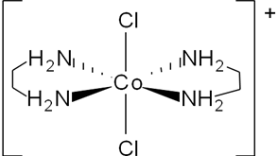

Another common bidentate ligand is the **di-anion ethanedioate, C2O42-.** This forms a very stable complex with **iron(III) ions**, [Fe(C2O4)3]3-.

|  |  |  |
| --- | --- | --- |
|  |  | Fe3+ = 3+  3 x C2O42- = 2- |

**Example**

Ethane-1,2-diamine (ethylenediamine or en) - the substitution reactions are shown stepwise:

[M(H2O)6]2+ + H2NCH2CH2NH2 ↔ [M(H2O)**4**(H2NCH2CH2NH2)]2+ + **2H2O**

[M(H2O)**4**(H2NCH2CH2NH2)]2+ + H2NCH2CH2NH2 ↔ [M(H2O)**2**(H2NCH2CH2NH2)2]2+ + **2H2O**

[M(H2O)**2**(H2NCH2CH2NH2)2]2+ + H2NCH2CH2NH2 ↔ [M(H2NCH2CH2NH2)3]2+ + **2H2O**

|  |  |  |
| --- | --- | --- |
|  |  |  |

The overall equation:

[M(H2O)6]2+ + **3H2NCH2CH2NH2** [M(H2NCH2CH2NH2)3]2+ + **6H2O**



4 particles 7 particles

The **equilibrium** position **lies** well over to the **RHS** and the **equilibrium constants** for the formation of tris(en) complexes are in the order of **Kc =** **1020**. This large values means the complexes are **more stable than the aqua ions**. Also the **donor atoms** are **small** so there is **no change in shape**, they remain **octahedral**.

The **metal(III)-tri(ethan-1,2-diamine)** complexes are **even more stable** than the metal(II) complexes, with an **equilibrium constant** in the order of **Kc = 1030**.

**Multidentate ligands** form **even more stable** complexes. Haem in blood is an example.

**Example CGP147**

The **hexadentate** ligand **EDTA4**- will react with **metal(II)-aqua ions** to form an **octahedral** complex and **liberates six water** molecules, so there is a greater **increase in entropy**.

[M(H2O)6]2+ + **EDTA4-** [M(EDTA)]2- + **6H2O**



2 particles 7 particles

|  |  |
| --- | --- |
| **e**thylene**d**iamine**t**etra**a**cetic acid  forms the anion: |  |

Stability of metal chelates

There is a **thermodynamic** **reason** **for** the **stability** of metal chelates. These reactions are examples of an **entropy-driven reaction**, where there a **large positive entropy** change which **dominates** a much **smaller** **enthalpy** change, ∆H~0. This is due to **little net change in bond enthalpy** due to the **same number of bonds** being **broken** and **formed** between the metal ion and **similar atoms** on the ligands. This makes the value of **ΔG large** and **negative** so the reaction is **very** **feasible**.

∆G = ∆H -T∆S

**With bidentate and multidentate substitution reactions:**

* Small ΔH (small release of energy)
* Large positive ΔS (increase in entropy)
* Therefore large negative ΔG (Gibbs free energy
* Reaction is very feasible
* Products are thermodynamically more stable than reactants.

***Prac: The chelate effect***

***Application: CGP148 PQ1-4***

***Fact recall: CGP148 Q1-5***

Uses of metal chelates

The EDTA4- ligand has many **industrial** and **analytical** **uses**. The **complexes** are **very stable** and the **equilibria** is completely to the **RHS** with **very few aqua ions** present. So **reactions involving aqua-ions are not possible** if there is an **excess of EDTA4-**. The **metal ions** can be **kept in solution** even when anions (e.g. OH- or CO32-) which would normally cause precipitation are added. This is described as **sequestered**, which means the **complex ion is in solution**.

So addition of an **excess** of the sodium salt of **EDTA4**-, followed by aqueous **sodium hydroxide** does **not lead** to any **precipitation** because the **metal ions** have been **sequestered**.

EDTA4- can be taken as an **antidote** to **transition metal poisoning**; it complexes with the metal ions in the body and the complex is excreted. It’s also used as an **anti-coagulant** in **blood**; it bonds to Ca2+ ions in the blood.

It can also be used in **titrations** with a solution of the metal ions, where **ligand substitution** takes place and an **indicator shows the end point** when substitution is complete.

**Variable oxidation states**

**Transition metals** can use their **3d** and **4s** **electrons** in **bonding**, which gives them a greater **variety of oxidation states** in different compounds. The **most common** are shown in **red**. Compared to **group 1 and group 2** metals which can **only use their**

**s-orbital** electrons for bonding and so have **one oxidation state**.

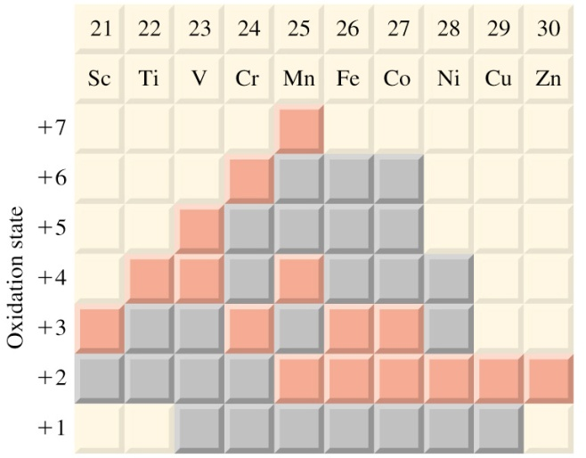

In a **redox** reaction the transition metal ion is either **oxidised or reduced**, **changing** its **oxidation state**. **Many redox reactions** occur with transition metal ions because they show **variable oxidation states**.

**Zinc metal** is a **good reducing agent** (electron donor) and can reduce aqueous transition **ions to low oxidation states**, they will move through the oxidation states in sequence, so **each colour is often seen**.

**Zinc reacts with acids (HCl or dil.H2SO4) to form zinc ions and 2 electrons:**

Zn → Zn2+ + 2e-

Oxidation states of vanadium

Vanadium: [Ar] 4s13d5

Reduced by Zn/H+ from V: +5 → +4 → +3 → +2

|  |  |
| --- | --- |
|  |  |

|  |  |  |  |
| --- | --- | --- | --- |
| **Oxidation state of vanadium** | **Species** | | **Colour** |
| +5 | VO2+ | | **yellow** |
| +4 | VO2+ | | **blue** |
| +3 | V3+ | [V(H2O)6]3+ | **green** |
| +2 | V2+ | [V(H2O)6]2+ | **violet** |

**Example CGP149**

Vanadium(V) can be reduced by adding zinc metal in an acidic solution. The solution turns yellow to blue as vanadium(V) is reduced to vanadium(IV).

2VO2+(aq) + Zn(s) + 4H+(aq) → 2VO2+(aq) + Zn2+(aq) + 2H2O(l)

The solution then changes colour from blue to green as vanadium(IV) is reduced to vanadium(III).

2VO2+(aq) + Zn(s) + 4H+(aq) → 2V3+(aq) + Zn2+(aq) + 2H2O(l)

Finally, vanadium(III) is reduced to vanadium(II), and the solution changes from green to violet.

2V3+(aq) + Zn(s) → 2V2+(aq) + Zn2+(aq)

***Demo: Variable oxidation states of vanadium***

Redox potentials

The **redox potential** of an ion or atom indicates how **easily** it is **reduced** to a lower oxidation state. They’re measured in the same was as **standard** **electrode potentials**, and the value indicates whether a species will be reduced or oxidised. The **more positive** the **redox potential**, the **less stable** the ion will be and so **more likely to be reduced**.

**Example CGP149**

Copper(II) has a redox potential of +0.15V, so is less stable and more likely to be reduced than chromium(III) which has a redox potential of -0.74V.

|  |  |
| --- | --- |
| **Half equation** | **Standard electrode potential (V)** |
| Cr3+(aq) + e- ↔ Cr2+(aq) | -0.74 |
| Cu2+(aq) + e- ↔ Cu+(aq) | +0.15 |

The **redox potential** can be **different** to its **standard electrode potential** as it depends on the **environment** the **ion** is in.

**Ligands affect redox potential**

Standard electrode potentials are measured in **aqueous solutions**, so any ions will be surrounded by **water ligands**. If **different ligands** are bonded to the metal ion the **redox** **potential** can be **larger** or **smaller** depending on how **strongly** the **ligands** **bond**.

**pH affects redox potential**

For some reactions the metal ions **need hydrogen ions** to be present **to be reduced** and others will **produce hydroxide ions** when they are reduced.

**Example CGP150**

Vanadium(V) need hydrogen ions to be reduced.

2VO2+(aq) + 4H+(aq) + 2e- → 2VO2+(aq) + 2H2O(l)

**Example CGP150**

Chromium(VI) produces hydroxide ions when it’s reduced.

CrO42-(aq) + 4H2O(l) + 3e- → Cr(OH)3(s) + 5OH-(aq)

Tollens’ reagent

**Silver** is a transition metal most commonly found in a **+1 oxidation state** as **Ag+**, so it’s **easily reduced** to **silver** metal.

Ag+(aq) + e- → Ag(s)

**Tollens’** **reagent** uses this reduction reaction to **distinguish** **between** **aldehydes** and **ketones**. It’s a **silver metal ion complex** with **two ammonia ligands** and can be prepared by adding just enough ammonia solution to a silver nitrate solution to form a colourless solution of the diammine silver(I) ion complex. This is a **linear complex**.

***Demo: Making diammine silver(I) ion complex***

|  |  |
| --- | --- |
| **[Ag(NH3)]+** | **Silver mirror test** |
|  |  |

When added to **aldehydes** they are **oxidised** to a **carboxylate anion** and the **silver ion** is **reduced** to **silver metal**, giving the characteristic **silver mirror**.

RCHO+ 2[Ag(NH3)2]+ + 3OH- → RCOO- + 2Ag + 4NH3 + 2H2O

**Tollens’ can’t oxidise ketones**, so there’s no reaction and no silver mirror forms.

***Application: CGP151 PQ1***

***Fact recall: CGP151 Q1-4***

**Redox titration**

Redox reactions can be used in **quantitative volumetric analysis**, to **determine** the **concentration** of an **oxidising** or **reducing** **agent**. It is similar to an acid-base titration. If the **oxidising agent shows a colour change** when it is reduced, then **no indicator** is needed. If the reaction **doesn’t involve a distinct colour change** then **end-point** can be determined using either an **indicator** or by an electrical method. **Potassium manganate(VII) is an oxidising agent** and can be used to determine the quantities of **iron(II) ions**.

Potassium manganate(VII) titrations

The **manganate(VII)**, MnO4- ion has a **maximum oxidation state** of **+7**. This ion is a **powerful oxidising agent** which can be **reduced** directly to the **manganese(II) ion** by **zinc** (Zn→Zn2+), **iron** (Fe→Fe2+), **iron(II) ions** (Fe2+→Fe3+) or **ethanedioate ions** (C2O42-→CO2) **in acid** solution.

|  |  |
| --- | --- |
|  |  |

The **[Mn(H2O)6]2+** ion is **very pale pink** which **appears colourless** in aqueous solution. So there is a **distinct colour change** when **manganate(VII)** ions are **reduced** to **manganese(II)** ions from **purple** to **colourless**.

When **potassium manganate(VII)** is used as an **oxidising agent** in **acidic** solutions, no additional indicators is required because the **reduction product**, [Mn(H2O)6]2+ is essentially **colourless**. No colour is seen until an **excess of manganate(VII)** is **added**, then only a slight excess of the **dark purple** solution will be **readily seen** as a **pale pink** colour.

**Titration procedure (CGP152):**

|  |  |
| --- | --- |
|  | * Add a standard solution of **known concentration** of **potassium manganate(VII**) to a **burette**. * In a **conical** **flask** add a solution of the **reducing agent** (e.g. Fe(II) salt) which has been **acidified** by adding an excess of dilute sulphuric acid. * From the burette the **potassium manganate(VII) ions** are **added** to the **acidified iron(II)** solution. * The **purple colour disappears** and the pale pink manganese(II) ion is produced. * In the flask - once just enough manganate(VII) has been added **one more drop** will turn the **colourless** solution **pink**. This is the **end point**. |

***Task: Construct the half-equation for the reaction and work out the oxidation states***

MnO4- + 8H+ + 5e-→ Mn2+ + 4H2O

+7 +2

***Task: Construct the half-equation for the reaction of iron(II) to iron(III)***

Fe2+ → Fe3+ + e-

***Task: Construct the redox for the reaction of manganate(VII) ions with iron(II)***

Fe2+ → Fe3+ + e- x 5

MnO4- + 8H+ + 5e-→ Mn2+ + 4H2O

--------------------------------------------------------------

**5Fe2+ + MnO4- + 8H+ → 5Fe3+ + Mn2+ + 4H2O**

***Task: Construct the half-equation for the reaction of ethanedioate ions to carbon dioxide***

C2O42- →2CO2 + 2e-

***Task: Construct the redox for the reaction of manganate(VII) ions with ethanedioate ions***

C2O42- →2CO2 + 2e- x 5

MnO4- + 8H+ + 5e-→ Mn2+ + 4H2O x 2

--------------------------------------------------------------

**5C2O42- + 2MnO4- + 16H+ → 10CO2 + 2Mn2+ + 8H2O**

**Calculating the concentration (CGP153):**

* Balanced equation gives molar ratio
* Moles of MnO4- solution

n = cv

* Moles of unknown iron(II) ions or ethanedioate ions
* Calculate the concentration

c = n/v

* Look out for dilutions

**Example CGP153**

27.5cm3 of 0.0200 mol dm-3 aqueous potassium manganate(VII) reacted with 12.5cm3 of acidified sodium ethanedioate. Calculate the concentration of C2O42- ions in the solution.

5C2O42- + 2MnO4- + 16H+ → 10CO2 + 2Mn2+ + 8H2O

|  |  |
| --- | --- |
| Method | Answer |
| n = cv gives nMnO4- reacted | nMnO4- = 0.0200 x 27.5 x 10-3 = 5.50 x 10-4 |
| So nC2O42- = 5/2 x MnO4- | nC2O42- = 5/2 x 5.50 x 10-4 = 1.375 x 10-3 |
| c = n/v to find concentration C2O42- | cC2O42- = 1.375 x 10-3 /12.5 x 10-3 = **0.110 mol dm-3** |

**Example CGP154**

Aqueous potassium manganate(VII) with a concentration of 8.00 x 10-3 mol dm-3 was used to completely oxidise 25.0 cm3 of 0.0600 mol dm-3 acidified iron(II) sulphate solution. Calculate the volume of potassium manganate(VII) solution that was used in the reaction.

5Fe2+ MnO4- + 8H+ → 5Fe3+ + Mn2+ + 4H2O

|  |  |
| --- | --- |
| Method | Answer |
| n = cv gives nFe2+ reacted | nFe2+ = 0.0600 x 25 x 10-3 = 1.50 x 10-3 |
| So nFe2+ = MnO4- / 5 | nMnO4- = 50 x 10-3 / 5 = 3.00 x 10-4 |
| v = n/c to find volume MnO4- | v MnO4- = 3.00 x 10-4 / 8.00 x 10-3 = 0.0375 dm-3 |
| Convert to cm-3 dm-3 x 103 | 0.0375 x 103 = **37.5 cm3** |

***Task: Calculate the percentage by mass of Fe2+ ions in the lawn sand.***

3.00g of lawn sand containing an iron(II) salt was shaken with dilute sulphuric acid. The resulting solution required 25.00 cm3 of a 0.0200 mol dm-3 solution of KMnO4 to oxidise all the Fe2+ ions in the solution to Fe3+ ions.

5Fe2+ MnO4- + 8H+ → 5Fe3+ + Mn2+ + 4H2O

|  |  |
| --- | --- |
| Method | Answer |
| n = cv gives nMnO4- reacted | nMnO4- = 0.0200 x 25.0 x 10-3 = 5.00 x 10-4 |
| So nFe2+ = 5 x MnO4- | nFe2+ = 5 x 5.00 x 10-4 = 2.50 x 10-3 |
| n = m/Ar then mFe2+ = nAr | mFe2+ = 2.50 x 10-3 x 55.8 = 0.140 g |
| % mass = mass in titration / total mass x 100 | % mass = 0.140 / 3.00 x 100 = **4.65%** |

Comment

It’s not necessary to filter off the sand as it is inert and so does not interfere.

***Task: Calculate the mass of iron(II) sulphate in iron tablets***

A brand of iron tablets stated on the pack that ‘Each tablet contains 0.200 g of iron(II) sulphate’. The following experiment was carried out to check this. One tablet was dissolved in dilute sulphuric acid and made up to 250 cm3 in a volumetric flask. 25.00 cm3 of this solution was pipette into a flask and titrated with 0.00100 mol dm-3 potassium manganate(VII) solution until the solution just became purple. Taking an average of several titrations, 26.30 cm3 was needed.

Note

25.0cm3 of the original solution containing one tablet was used in the titration

The mass of iron(II) sulphate is to be calculated not just Fe2+ ions.

5Fe2+ MnO4- + 8H+ → 5Fe3+ + Mn2+ + 4H2O

|  |  |
| --- | --- |
| Method | Answer |
| n = cv gives n(MnO4-) reacted | n(MnO4-) = 0.00100 x 26.3 x 10-3 = 2.63 x 10-5 |
| So nFe2+ = 5 x MnO4- | nFe2+ = 5 x 2.63 x 10-5 = 1.315 x 10-4 |
| Dilution – 25 cm3 aliquot taken so 10 x nFe2+ to find moles in original flask | nFe2+ (in 1 tablet) = 10 x 1.315 x 10-4 = 1.315 x 10-3 |
| 1 mol FeSO4 contains 1 mol Fe2+ | So each tablet contains 1.315 x 10-3 moles FeSO4 |
| n = m/Ar then mFeSO4 = nMr | mFeSO4 = 1.315 x 10-3 x 151.9 = **0.200 g FeSO4** |
| Comment | This agrees with the label on the bottle |

The presence of an acid in redox titrations

The addition of acid is essential for 2 reasons:

1. Prevent manganese (VII) being reduced to manganese (IV) in this reaction  
     
   MnO4- + 4H+ + 3e- → MnO2 + 2H2O  
     
   **Manganese dioxide** is a **brown solid**, which will **interfere** with the redox **titration** if it is present by **giving a larger titre** and **preventing the end point being seen clearly**.
2. **Iron salts** in solution form an **aqua complex**, this can undergo **hydrolysis** to form a different complex which is **harder to oxidise** and the addition of the **acid** (H+) **moves** the **equilibrium to the left** preventing its formation.  
     
   [Fe(H2O)6]2+ + H2O [Fe(H2O)5(OH)]+ + H3O+



base

**The type of acid is important. It must:**

* **Be strong**

– fully ionised to ensure a high concentration of hydrogen ions

* **Not be an oxidising agent**

– it might react with the reagent being determined (Fe2+ or C2O42-)

* **Not be a reducing agent**

– anions from the dissociated acid would be oxidise by the manganate(VII) ions

* **Dilute sulphuric acid is the main choice.**

**The following acids cannot be used:**

* Hydrochloric – reducing agent
* Nitric – oxidising agent
* **Concentrated** sulphuric – oxidising agent
* Ethanoic – a weak acid (too low a concentration of hydrogen ions)

***Task: Use the e.m.f data to explain why HCl and HNO3 can’t be used***

MnO4– + 8H+ + 5e-→ Mn2+ + 4H2O Eθ = +1.51V

Cl2 + 2e- → 2Cl– Eθ = +1.36V

NO3– + 3H+ + 2e– →HNO2 + H2O Eθ = +0.94  
Fe3++ e– →Fe2+ Eθ = +0.77

Eθ(MnO4-/Mn2+) is more positive than Eθ(Cl2/ Cl-) so MnO4- will oxidise the Cl– to Cl2

Eθ(NO3–/ HNO2) is more positive than Eθ(Fe3+/ Fe2+) so HNO3 will oxidise Fe2+ to Fe3+

The electrode potential of the acid needs to be less positive than Fe2+ and more positive than MnO4-.

***Prac: Carry out a redox titration – analysis of iron tablets***

***Sheet: Iron redox titrations 1 & 2***

***Starter: 13.5 - Redox titrations***

***Sheet: Stretch & challenge – Redox titration***

***Application: CGP154 PQ1-3***

***Fact recall: CGP154 Q1-2***

**Catalysis**

***Definition***

Catalysts **affect the rate** of a reaction **without** being **chemically changed** themselves.

They work by providing an **alternative pathway** with a **lower activation energy**.

|  |  |
| --- | --- |
|  | They are very **important** in **industrial** processes, allowing **reactions** to **proceed** at **lower** **temperatures** and **pressures**. This allows **valuable resources to be saved**.  Catalysts do **not alter ΔG, ΔH or ΔS** for a reaction, only the activation energy. They **speed u**p the **rate** at which **equilibrium** is **reached** by speeding up both the forward and reverse reactions but they **do not alter the position of the equilibrium**. |

Many catalysts are **transition metals** or **their compounds**; they are classified according to whether they **act in the same phase** or **different phase** from the reactants. Elements in other blocks generally aren’t used to catalyse redox reactions because they don’t have an incomplete 3d sub-level and so don’t have variable oxidation states.

**Catalysts** can either be in the **same phase** or a **different phase** to the **reaction** it is catalysing.

Heterogeneous catalysts

***Definition***

A **heterogeneous catalyst** acts in a **different phase** from the reactants.

***Demo: Lighting up copper***

They are **usually solids** with the **reactants** as **liquids** or **gases**, so their catalytic action takes place on the solid **surface**. One of the reactants is **adsorbed** (attached to the catalyst by a weak chemical bond) at an **active site** on the catalyst.

This can sometimes weaken the reactant bonds, or cause the reactant to break up into very reactive fragments. **Adsorption** can also allow a reactant to be **held so it is in exactly the right configuration** to make the reaction easier.

|  |  |
| --- | --- |
|  | 1. Reactants **adsorbed** onto **active sites** - weakens bonds   - brings molecules closer  - more favourable orientation.   1. **Reaction** takes place. 2. Products are **desorbed**. |

The **amount of adsorption** onto the surface is important in determining whether a catalyst is good. If **adsorption is too weak**: **not many molecules will be adsorbed** so the catalyst will have very little effect. If **adsorption is too strong**: **molecules will not be able to move around the active sites**, and so be less likely to meet another reactant and so be less likely to react (also any product will tend to remain adsorbed on the surface).

**Surface catalysts are highly specific** - this means that a particular catalyst may catalyse a certain reaction but will not catalyse other similar reactions, or other similar catalysts may not catalyse the same reaction.

In some cases the **same reactants** will give **different products** with **different catalysts**.

|  |  |
| --- | --- |
| Catalyst: Copper  Dehydrogenation (oxidation) | Catalyst: Alumina Dehydration |
|  |  |
| C2H5OH → CH3CHO + H2 | C2H5OH → C2H4 + H2O |

Making catalysts more efficient

With heterogeneous catalysts the **reaction occurs at the surface** so **increasing** the **surface area** will make the catalyst **more efficient** by allowing **more molecules** to **react** at the same time. This will **increase** the **rate** of the reaction. Catalysts are often **expensive**, so making them more efficient will **minimise costs**. **Increasing** the **surface area**, **less catalyst** is **needed** to produce the same effect.

|  |  |
| --- | --- |
|  | The **surface area-to mass ratio is maximised** by using a **very thin coating** of the catalyst **on** **an inert** **support medium**. A support is required as the layer is too thin to support itself - often a ceramic ‘**honeycomb**’ structure is used as support, the catalyst must be able to bind to the support. |

**Examples CGP155/156 - learn**

* **Catalytic convertors** in cars – platinum and rhodium are very expensive so they have a high surface area by spreading on a cheap ceramic support.  
    
  2CO(g) + 2NO(g) → 2CO2(g)+ N2(g)
* **Haber process** – pea-sized lumps of iron catalyst is used to increase the surface area, it last approximately 5 years before becoming poisoned by impurities, such as sulphur in the gas stream.

N2(g) + 3H2(g) 2NH3(g)



* **Contact process** – this produces sulphuric acid from sulphur, oxygen and water, the key step is catalysed by vanadium(V) oxide, V2O5(s)

**Overall:** SO2(g) + 1/2O2(g) SO3(g)



The variable oxidation states of vanadium are important in the process:

+5 +4  
**Step 1:** SO2 + V2O5 → SO3 + V2O4

The vanadium(IV) is then oxidised back to vanadium (V):

+4 +5  
**Step 2:** V2O4 + 1/2O2 → V2O5

Catalyst poisons

Some surface catalysts are **prone to poisoning**, where **other substances adsorb strongly** to the surface, **blocking the active sites**. This lowers the efficiency of the catalyst, or makes it totally ineffective depending on the extent of the poisoning because **less surface area** is **available** to the reactants. These poisons are **extremely difficult to remove** and the **catalyst is ruined**, which can be very **costly** to replace.

**Catalytic poisoning** can be **reduced** by **purifying** the **reactants** to **remove** any **impurities** which might poison the catalyst.

**Examples CGP156**

* **Lead poisoning** of **catalytic converters** in cars - both the Rh and Pt catalysts are poisoned by lead compounds (from leaded petrol) and are very expensive to replace. So vehicles with catalytic converters must use unleaded fuel.
* **Sulphur poisoning** in the **Haber process** - the hydrogen is obtained from methane which is obtained from natural gas which often contains sulphur compounds. If these are not removed they will poison the iron catalyst by forming iron sulphide.

Homogeneous catalysts

***Definition***

A **homogeneous catalyst** acts in a **same phase** as the reactants.

**Most reactions** involving **homogeneous** catalysts take place **in solution** where all species are either liquids or are dissolved, so they are all in the same phase. Reactions involving homogeneous catalysis proceed **via an intermediate species** formed **from a reactant and the catalyst**, which **then reacts further** to **form** the **product** and **regenerates** the **catalyst**. They usually involve a **change in the oxidation state** of the transition metal.

|  |  |
| --- | --- |
|  | This causes the **enthalpy** profile to have **two bumps** in it corresponding to the two reactions.  Some reactions produce their own catalyst and are known as **autocatalysis reactions**. |

**Example CGP157**

* **Variable oxidation state**

Oxidation of iodide ions by peroxodisulphate(VI) ions catalysed by iron(II) ions – the reaction is very slow, even though it is energetically favourable:

S2O82- + 2I- → I2 + 2SO42-  
  
**Both ions are negatively charged and so are unlikely to make effective collisions**.

When iron(II) ions are added the reaction occurs rapidly as the cations can make effective collisions with the anions. Iron(II) is oxidised to iron(III) which can then oxides the iodide ions to iodine:

Step 1: 2Fe2+ + S2O82- + → 2Fe3+ + 2SO42- Fe2+ oxidised

Step 2: 2Fe3+ + 2I- → 2Fe2+ + I2 Fe3+ reduced

----------------------------------------------

**S2O82- + 2I- → I2 + 2SO42-**

**Again, both ions are negatively charged and so are unlikely to make effective collisions without a catalyst**.

The **variable oxidation state of iron** allows the reaction to proceed with a lower activation energy.

|  |  |
| --- | --- |
| **Autocatalysis – a product is the catalyst**  Manganese ions in reaction between ethanedioate ions and manganese (VII) ions – when the **catalyst** in a reaction is one of the **products** the rate is **slow initially**. As the concentration of the **catalyst** product **increases** the **rate** **increases** and it **proceeds** as a **normal reaction**, gradually slowing as the reactants are used up.  **Manganese(II) ions catalyse** this reaction. |  |

The reaction between a solution of **ethanedioic acid** and an **acidified** solution of **manganate(VII)** ions is an example of an autocatalysed reaction. It can be **used to determine the concentration of potassium manganate(VII)** solution

2MnO4- + 5C2O42- + 16H+ → 2Mn2+ + 10CO2 + 8H2O

This reaction is **very slow in the absence of a catalyst** because it involves the **reaction of two negative ions** (they repel each other so collision is difficult).

However, it is **catalysed by Mn2+(aq)**, which can act as a catalyst because it easily changes between the oxidation states Mn (+2) and Mn (+3).

The **catalyst is a product of the reaction**, so this reaction is slow until some Mn2+ is formed, but **then it speeds up as catalyst is formed**.

Step 1: Mn2+ reducing MnO4- to Mn3+

4Mn2+ + MnO4-  + 8H+ → 5Mn3+ + 4H2O x 2 Mn2+ oxidised

Step 2: Mn3+ then oxidises C2O42- to CO2, reforming Mn2+

2Mn3+ + C2O42- → 2CO2 + 2Mn2+ x 5 Mn3+ reduced

Overall equation

**2MnO4- + 5C2O42- + 16H+ → 2Mn2+ + 10CO2 + 8H2O**

***Application: CGP158 PQ1***

***Fact recall: CGP158 Q1-6***

***Exam questions: Oxford p119 Q1-3***