The Foundation of Alba Longa

 |   DM  LatinVs |  | 
Latinus, king of the Latins had pledged his daughter, Lavinia, to Turnus, prince of the Rutulians | Latinus gives his daughter to Aeneas in marriage, who has arrived with his Trojans. Angered, Turnus attacked. Although the Rutulians lose, Latinus is killed. | Turnus is easily able to convince an Etruscan king, Mezentius, to join him in his war. | Meanwhile, Aeneas brings the Latins and Trojans closer together. They adopt the name of the former.
  DM  AENEAS |   Ascanius/Iulus  Aeneas |  | 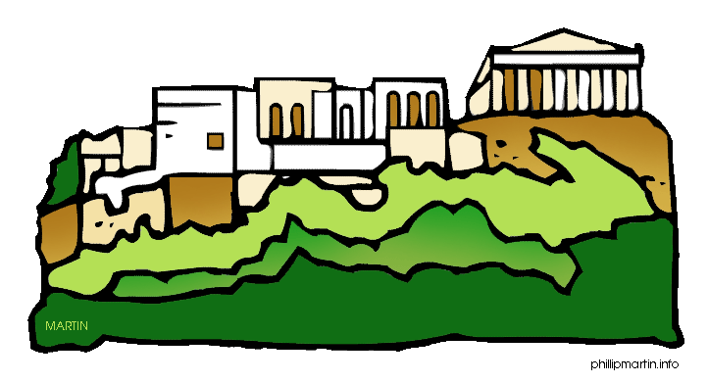
Aeneas attacked the enemy and won a second time, this time dying himself. He was buried by the river Numicus. | Lavinia acted as regent of Lavinium whilst Ascanius was a boy. Livy discusses who his mother was: Lavinia or Creusa | Ascanius leaves Lavinium, now with many inhabitants, and heads to the Alban hills. | Ascanius founds the city of Alba Longa and a treaty between the Latins and Etruscans defined their border at the river Tiber.

Romulus Founds Rome

Proca, king of Alba Longa had two sons: Numitor and Amulius. But Amulius drove out Numitor, and killed his nephews. | Amulius made his niece into a Vestal Virgin. But she had twin boys, according to some, by the god Mars. | Amulius ordered the boys be cast into the Tiber. But the river was flooded and they were left by the shallows in a basket. | Along came a she-wolf, who suckled the boys until they were found by a shepherd named Faustulus | The boys grew up under Faustulus and his wife, Larentia’s, care, becoming shepherds and hunters.
Romulus and Remus began seizing treasure from robbers and sharing it with their shepherds | The robbers trapped Remus and handed him over to Amulius. The king believed that he had been attacking his brother’s land and handed him over. | Meanwhile, suspecting the truth, Faustulus revealed to Romulus his identity, whilst Numitor works out that Remus is his son. | Romulus and Remus surprise and kill king Amulius, and place their grandfather back on the throne. | The twins set out to found a city of their own. But they argue over who should rule it based on ambiguous auspices. Remus is killed and Rome gains its name.

