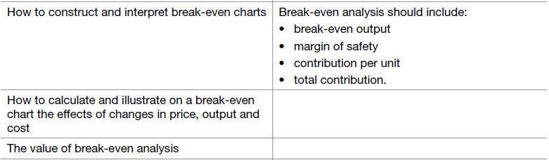3.5.2 (part 2) Break-even analysis.

# What is break-even analysis?

Break-even analysis is a technique widely used by production management and management accountants. It is based on categorising production costs between those which are "variable" (costs that change when the production output changes) and those that are "fixed" (costs not directly related to the volume of production).

Total variable and fixed costs are compared with sales revenue in order to determine the level of sales volume, sales value or production at which the business makes neither a profit nor a loss (the "break-even point").

## The Break-Even Chart

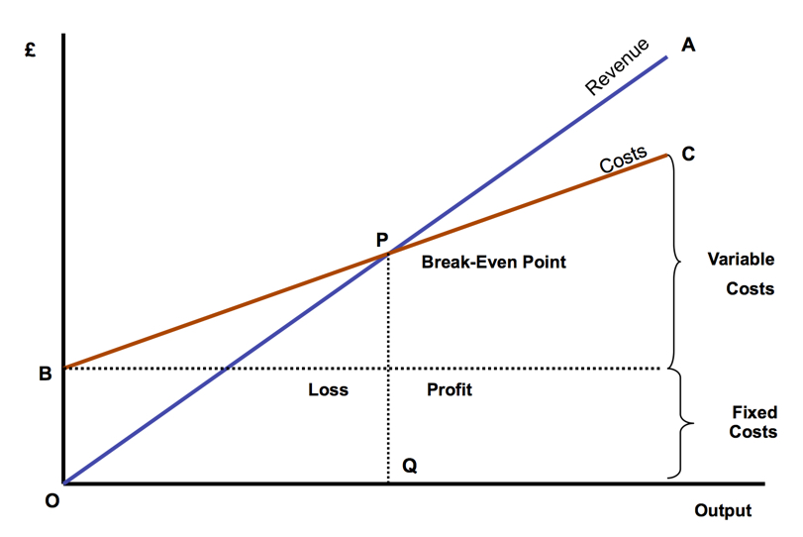In its simplest form, the break-even chart is a representation of costs at various levels of activity shown on the same chart as the variation of income (or sales, revenue) with the same variation in activity. The point at which neither profit nor loss is made is known as the "break-even point" and is represented on the chart below by the intersection of the two lines.

Here we can see revenue at varying levels of sales (output). The total fixed costs in the business and the total costs of the business (fixed plus variable).

At low levels of output, costs are greater than revenue but we can see the point where the 2 bisect – where they are equal – at this point costs are exactly equal to revenue and neither profit nor loss is made.

## Semi-Variable Costs

Whilst the distinction between fixed and variable costs is a convenient way of categorising business costs, in reality there are some costs which are fixed in nature but which increase when output reaches certain levels. These are largely related to the overall "scale" and/or complexity of the business. For example, when a business has relatively low levels of output or sales, it may not require costs associated with functions such as human resource management or a fully-resourced finance department. However, as the scale of the business grows (e.g. output, number people employed, number and complexity of transactions) then more resources are required. If production rises suddenly then some short-term increase in warehousing and/or transport may be required. In these circumstances, we say that part of the cost is variable and part fixed – i.e. it is semi-variable.

# Calculating break-even.

The break-even point is the level of output where the firm will just cover its costs. If it sells any more it will make a profit. In other word it is the point where a business stops making a loss and starts making a profit.

Break-even is the point at which Revenue = Total cost

The formula for calculating break-even point is:

Fixed Costs

Selling Price - Variable Cost per unit

The bottom part of that calculation (Selling Price-Variable Cost) is called **Contribution** or, more correctly, “Contribution towards fixed costs and profit” – it is the money left after all the variable costs have been deducted from revenue.

Contribution = Selling Price – variable cost per unit

Total contribution = Revenue – Total variable costs

# Example:

Here is a table showing the sales, variable costs, fixed costs and profits from various levels of output for a one-product business:

The product is sold for £10 per unit.

The variable cost per unit is £4.

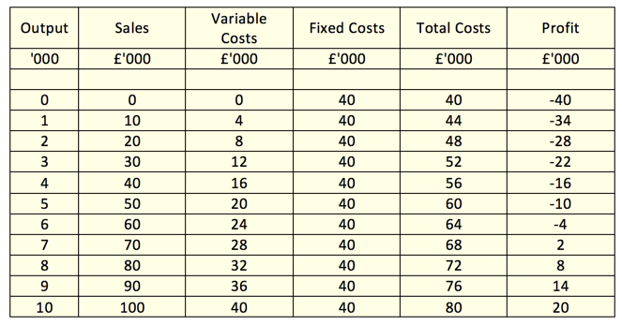Fixed costs are £40,000 (the same at each level of output).

Let's use the same information as above to show how a formula can be used to quickly calculate the break-even output. Before we can work out break-even point we need to calculate contribution:

Contribution per unit = £10 - £4 = £6 per unit

Break-even output (units) = Fixed costs (£)

Contribution per unit (£)

So, break-even output = £40,000 divided by £6 = 6,666 units

**Note: break-even output is always expressed in terms of units**

So break-even output = **6,666 units**

If the information is available, it is always quicker and easier to use this formula rather than use a table or draw a chart.

Some firms will be operating above break-even – i.e. they are making a profit, the difference between the units they need to sell to break-even and their current sales (above breakeven level) is called **the margin of safety.**

## Margin of Safety.

This is the difference between the actual level of production and the break-even point. For example, if the break-even point of product A is 400 units and the current sales are 700 units then the margin of safety is = 700 - 400 = 300 units.

## Using break-even to calculate profit.

We already know that total contribution = total revenue – total variable costs, this means that total contribution represents fixed costs and profit. Therefore by subtracting fixed costs from total contribution we can find profit.

Profit = total contribution – fixed costs.

## Break-even analysis is useful because it:

* Focuses entrepreneur on how long it will take before a start-up reaches profitability – i.e. what output or total sales is required
* Helps entrepreneur understand the viability of a business proposition, and also those who will lend money to, or invest in the business
* Include the margin of safety calculation which shows how much a sales forecast can prove over-optimistic before losses are incurred
* Helps the Entrepreneur understand the level of risk involved in a start-up
* Illustrates the importance of a start-up keeping fixed costs down to a minimum (higher fixed costs = higher break-even output)
* Involves calculations which are quick and easy – great for giving quick estimates

## Break-even analysis also has its limitations:

Break-even is based on a number of quite unrealistic assumptions including:

* that the firm can sell any quantity of the product at the current price. In practice the firm may need to reduce prices to sell at high levels of output.
* fixed costs never change - but as output increases the firm may need to buy more machines, get bigger premises, take on extra sales and administration staff.
* that all products can be sold. This doesn’t always happen; some products may only be sold at lower prices or need to be thrown away.
* products are all sold at the same price – in reality they are not sold at the same price at different levels of output; fixed costs do vary when output changes
* that variable costs stay the same at all levels of output - Variable costs do not always stay the same. For example, as output rises, the business may benefit from being able to buy inputs at lower prices (buying power), which would reduce variable cost per unit.
* That the business only sells one product - most businesses sell more than one product, so break-even for the business becomes harder to calculate for the firm as a whole.

Due to these assumptions, break-even analysis should be seen as a planning aid rather than a decision-making tool.

# Questions:

Calculate the following for each of the datasets shown below

(a) the contribution per unit

(b) the revenue at sales of 3000 units

(c) the break-even point

(d) the margin of safety

|  |  |
| --- | --- |
| Fixed Cost per week = £5,000  Variable Cost each = £ 5  Selling Price each = £ 25 |  |
| Fixed Cost per week = £250  Variable Cost each = £ 25  Selling Price each = £ 37.50 |  |
| Fixed Cost per week = £10,000  Variable Cost each = £ 50  Selling Price each = £ 75 |  |
| Fixed Cost per week = £20,000  Variable Cost each = £ 5  Selling Price each = £ 9 |  |