The Iliad – Book 16

Read lines 1-100
How do the opening lines use the following techniques to build up sympathy for Patroclus?
Method | Effect
Homeric Simile
Mention of Menoetius
Second Person Address
Dramatic Irony

How does Patroclus attempt to convince Achilles to allow him to take his armour into battle? You should start and end with the concept of the Achaeans being worn out.

Fill in the thoughts of Achilles before and after the quote in the middle to help evaluate the credibility of his statement:

“But that’s over and done with: let it go. I was wrong in supposing a man could nurse his anger forever.”

Read lines 101-154
Surround this picture of Ajax with quotes that create pathos for him as he is worn down at last:

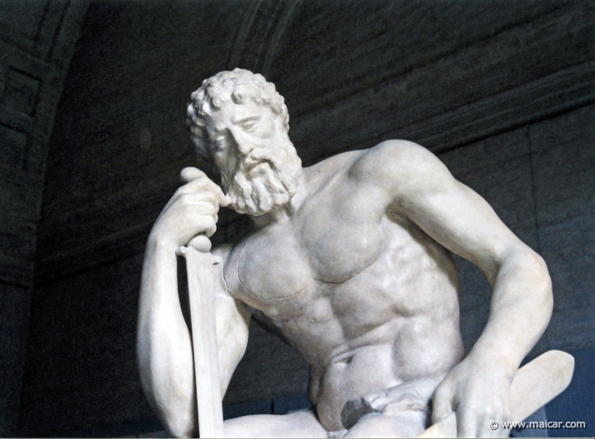

Why do you think Homer invokes the Muse again here?

Use the template below to illustrate Patroclus’ arming. Next to it, add Automedon and his chariot. Label with as much detail as possible (including background information).

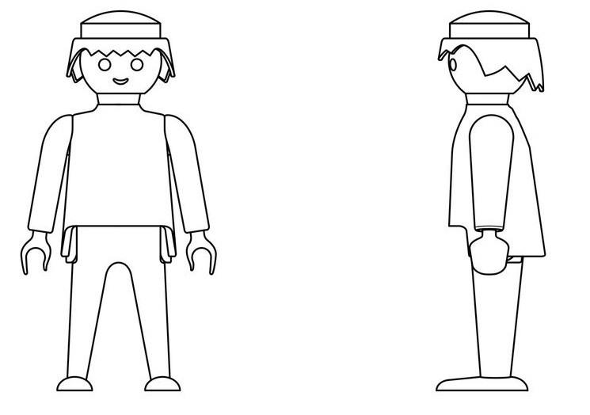

Read lines 155-220
Annotate this picture to show how it reflects the simile used to describe the Myrmidons in one colour. In another colour, explain what Homer’s use of words might suggest about them.

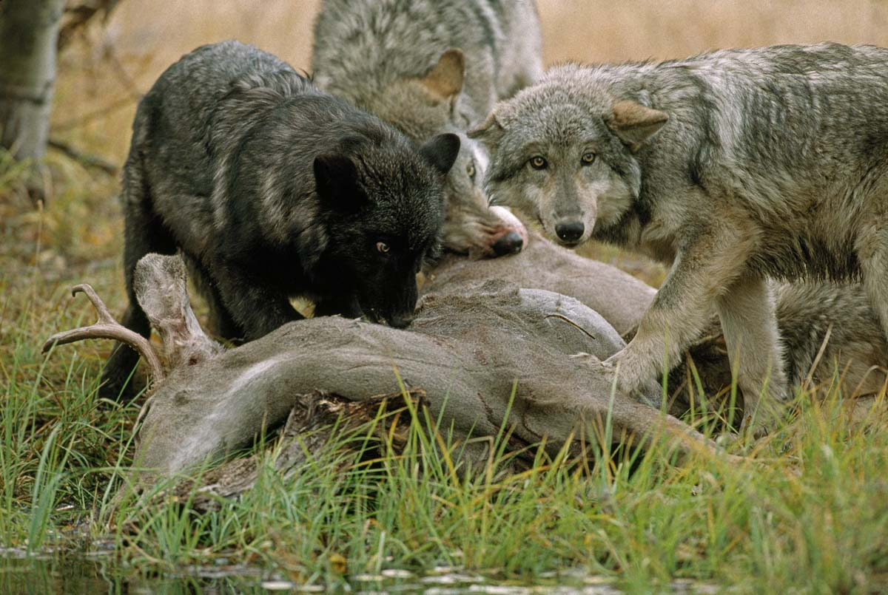

What do we learn about the ancestry of these two Myrmidon captains?

Eudorus
Menesthius

In what ways do the Myrmidons appear to be the most formidable of the Achaean soldiers?

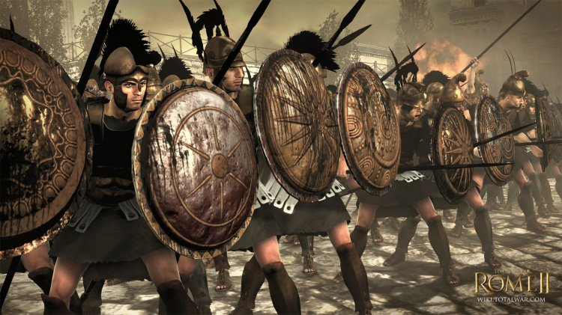

Read lines 221-256

Inside the cup, add the descriptions Homer provides of this treasured item. Outside it, note down all of Achilles’ requests.

How does Homer continue to build up to Patroclus’ death?

Read lines 257-350
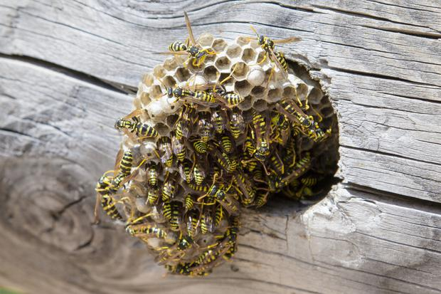
Which Homeric simile do you prefer? Explain your answer.
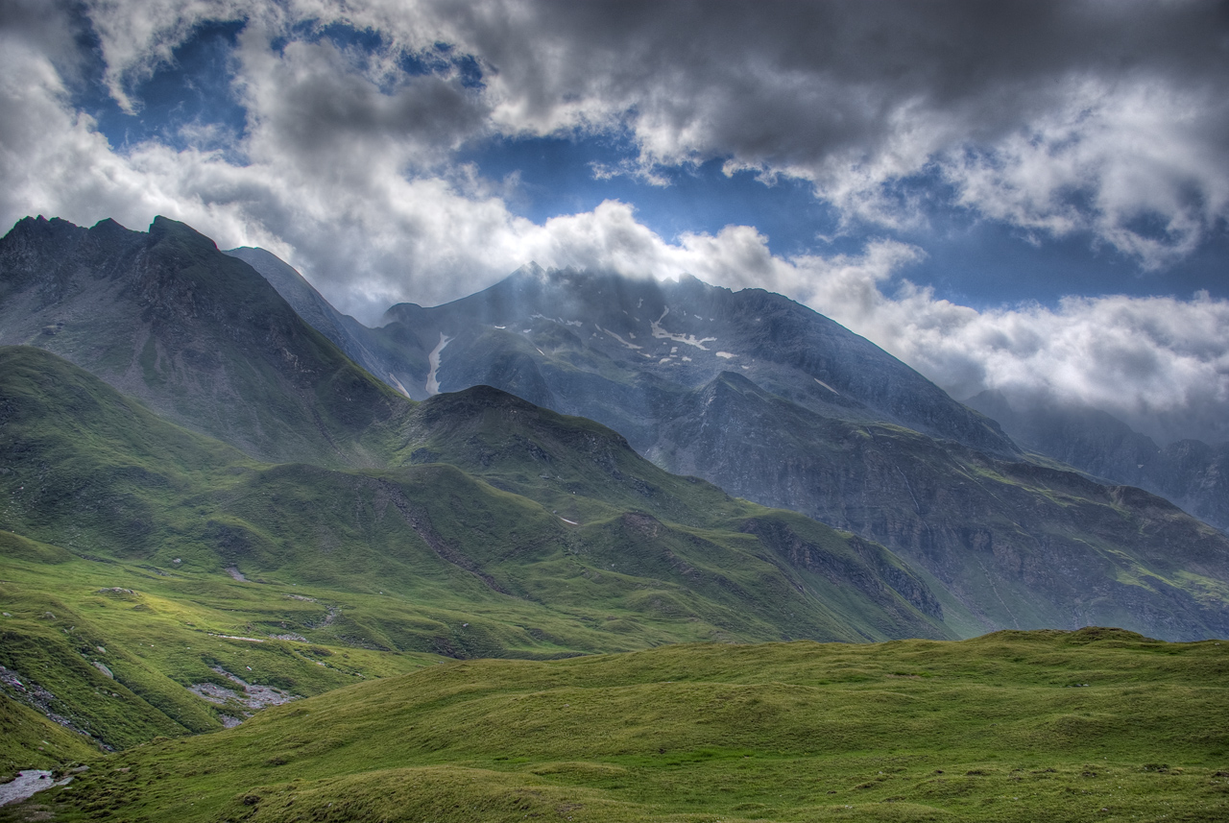

Clouds Disperse
Wasps

Does Patroclus’ speech to the Myrmidons reflect what Achilles said to him earlier?

Complete the following table and shade in the three most graphic descriptions of death in your opinion:
Achaean | Opponent | Description | Additional Information
Patroclus (1) | Pyraechmes
Patroclus (2) | Areilycus
Menelaus

Meges

Antilochus

Thrasymedes

Ajax son of Oileus

Peneleos (King of Boeotians)
Meriones

Idomeneus

Read lines 351-394
Place the words below into the diagram to show the similarities and differences between this wolf simile and the one used previously:

Lines 351-357
Lines 157-67

Why do you think that it is Ajax who attempts to kill Hector?
pack -hunters violent cruel

eager predatory opportunists

Annotate the margins with as many points as possible that show the Trojans are in chaos and panic:

As Zeus unleashes a tempest after clear weather, driving storm-clouds into the skies from Olympus, so the Trojans started yelling and panicking, and they fled across the Greeks’ defensive ditch in no semblance of order. Hector’s speedy horses carried him off, arms and all, and he left to their fate the men who had become intentionally ensnared by the ditch. For many a pair of swift war-horses snapped off their shafts at the yoke as they tried to climb the ditch, leaving their master’s chariot behind.

Patroclus chased them with slaughter in his heart, urging on the Greeks relentlessly, while yelling, panicking Trojans, now separated from each other, filled every track. Swirls of dust went rolling up to the clouds as their strong horses made at full speed for the town, leaving the Greek ships and their huts behind them. Wherever Patroclus saw the greatest numbers of chariots in wild retreat, there he followed up, yelling threats. Men tumbled headlong from their chariots beneath his axels, and the splendid gift given by the gods to Achilles’ father Peleus, pressed on without a check and cleared the ditch at a single bound. It was Hector he was after, Hector he yearned to kill. But Hector’s swift horses carried him to safety.

As in autumn the whole countryside grows dark and heavy with rain under a stormy sky when Zeus sends torrential downpours; he is angry, and rages at men who deliver crooked rulings in public assembly and drive justice out, regardless of the eye of the gods. All the streams run in spate, torrents scar the terraced hillsides, and rivers rush headlong down from the mountains with a great roar into the turbid sea, washing away the fields – such was the din that went up from the Trojan chariots as they fled.

Read lines 395-419
Write the names of the victims of Patroclus above the dice, to indicate how powerful his attack on each was. Explain your placements underneath:

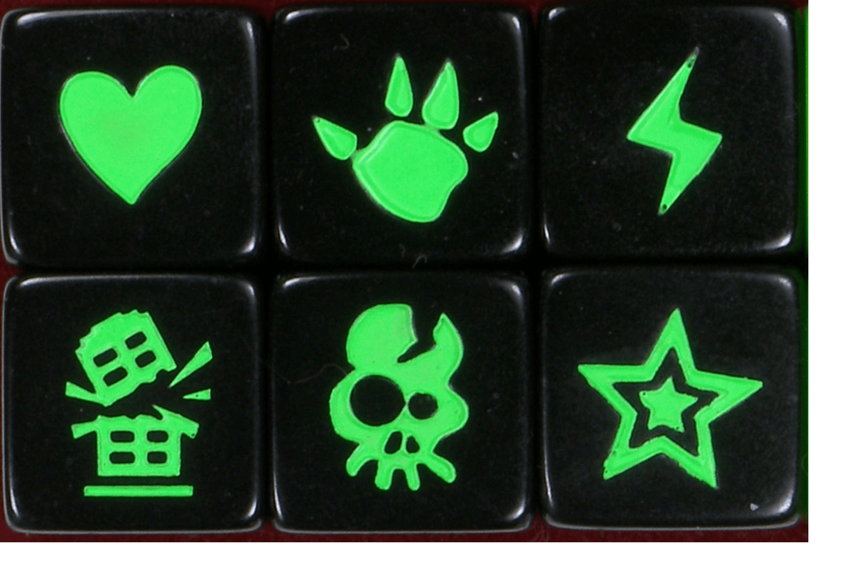

Read lines 420-554
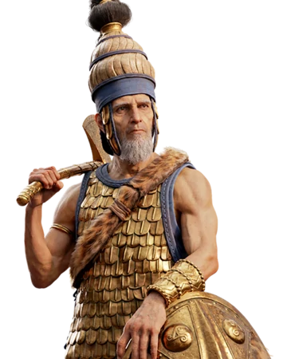
How does Sarpedon inspire his Lycian followers?

How does the vulture simile reflect the standoff between Sarpedon and Patroclus? Consider the language used and what the vultures might invoke in the audience.

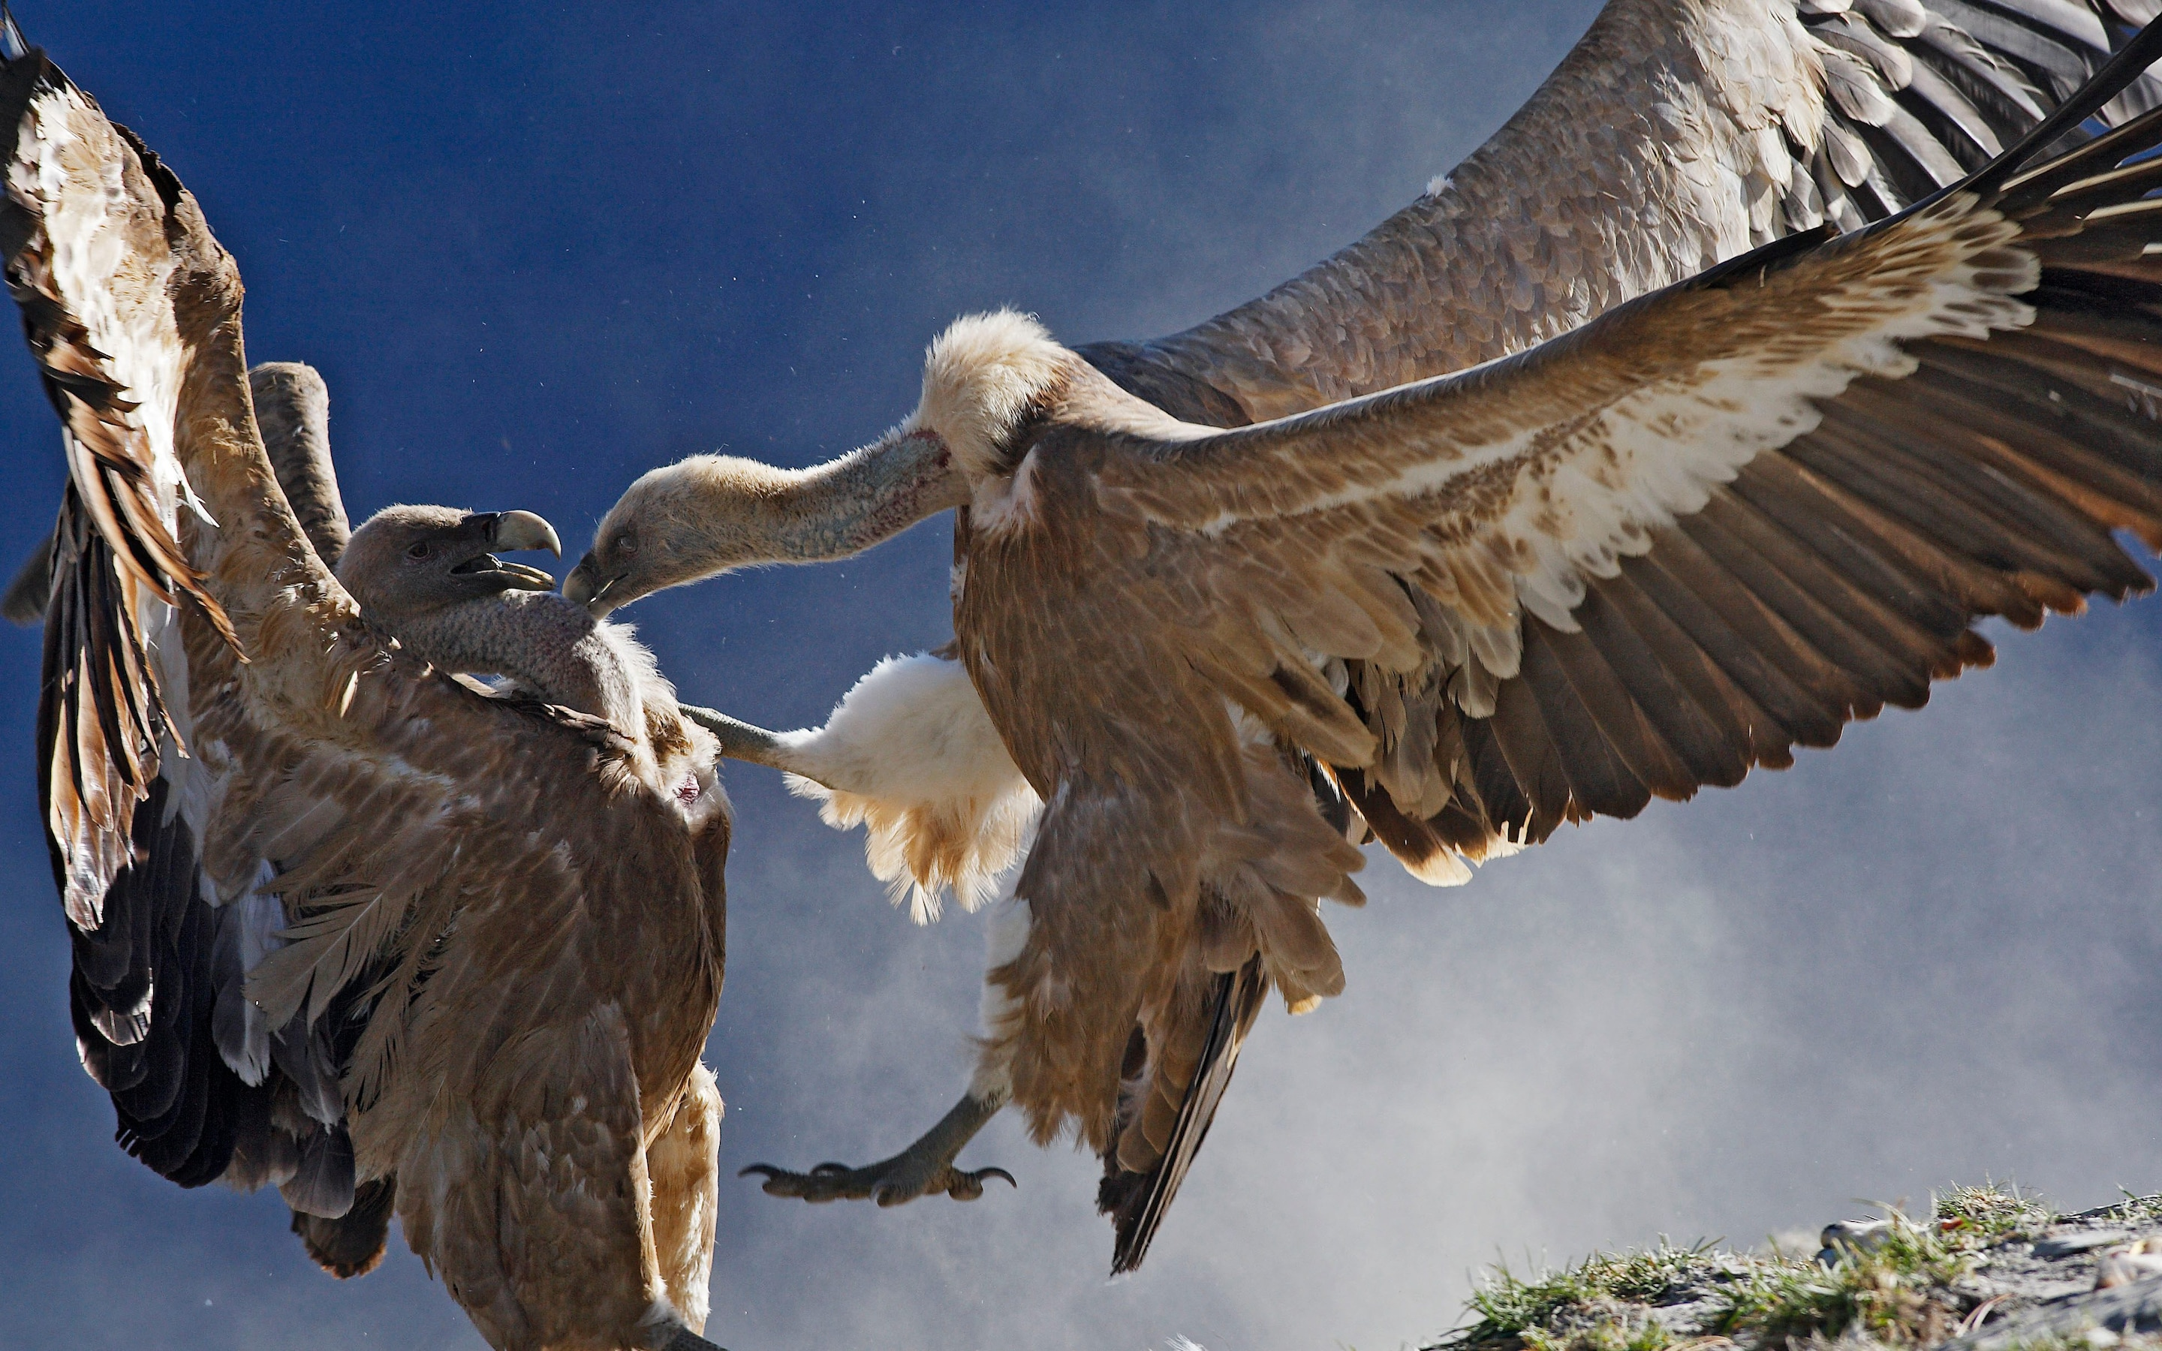

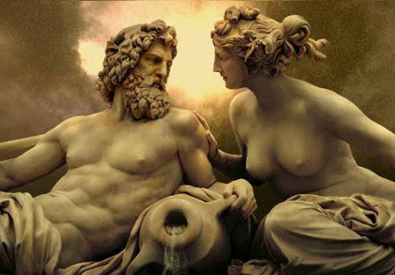
How does Hera challenge Zeus?

What does she do to win him around?
How is Zeus in turmoil?

Patroclus’ 1st Spear

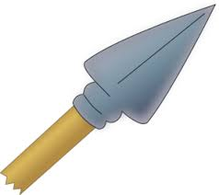
What is the effect of this spear throw?

Sarpedon’s 1st Spear
What does this cause?

What have we been told about Pedasus previously?

Sarpedon’s 2nd Spear
What is the effect of this spear throw?

Patroclus’ 2nd Spear

What is the effect of this spear throw?

How do the following create pathos for Sarpedon as he dies?

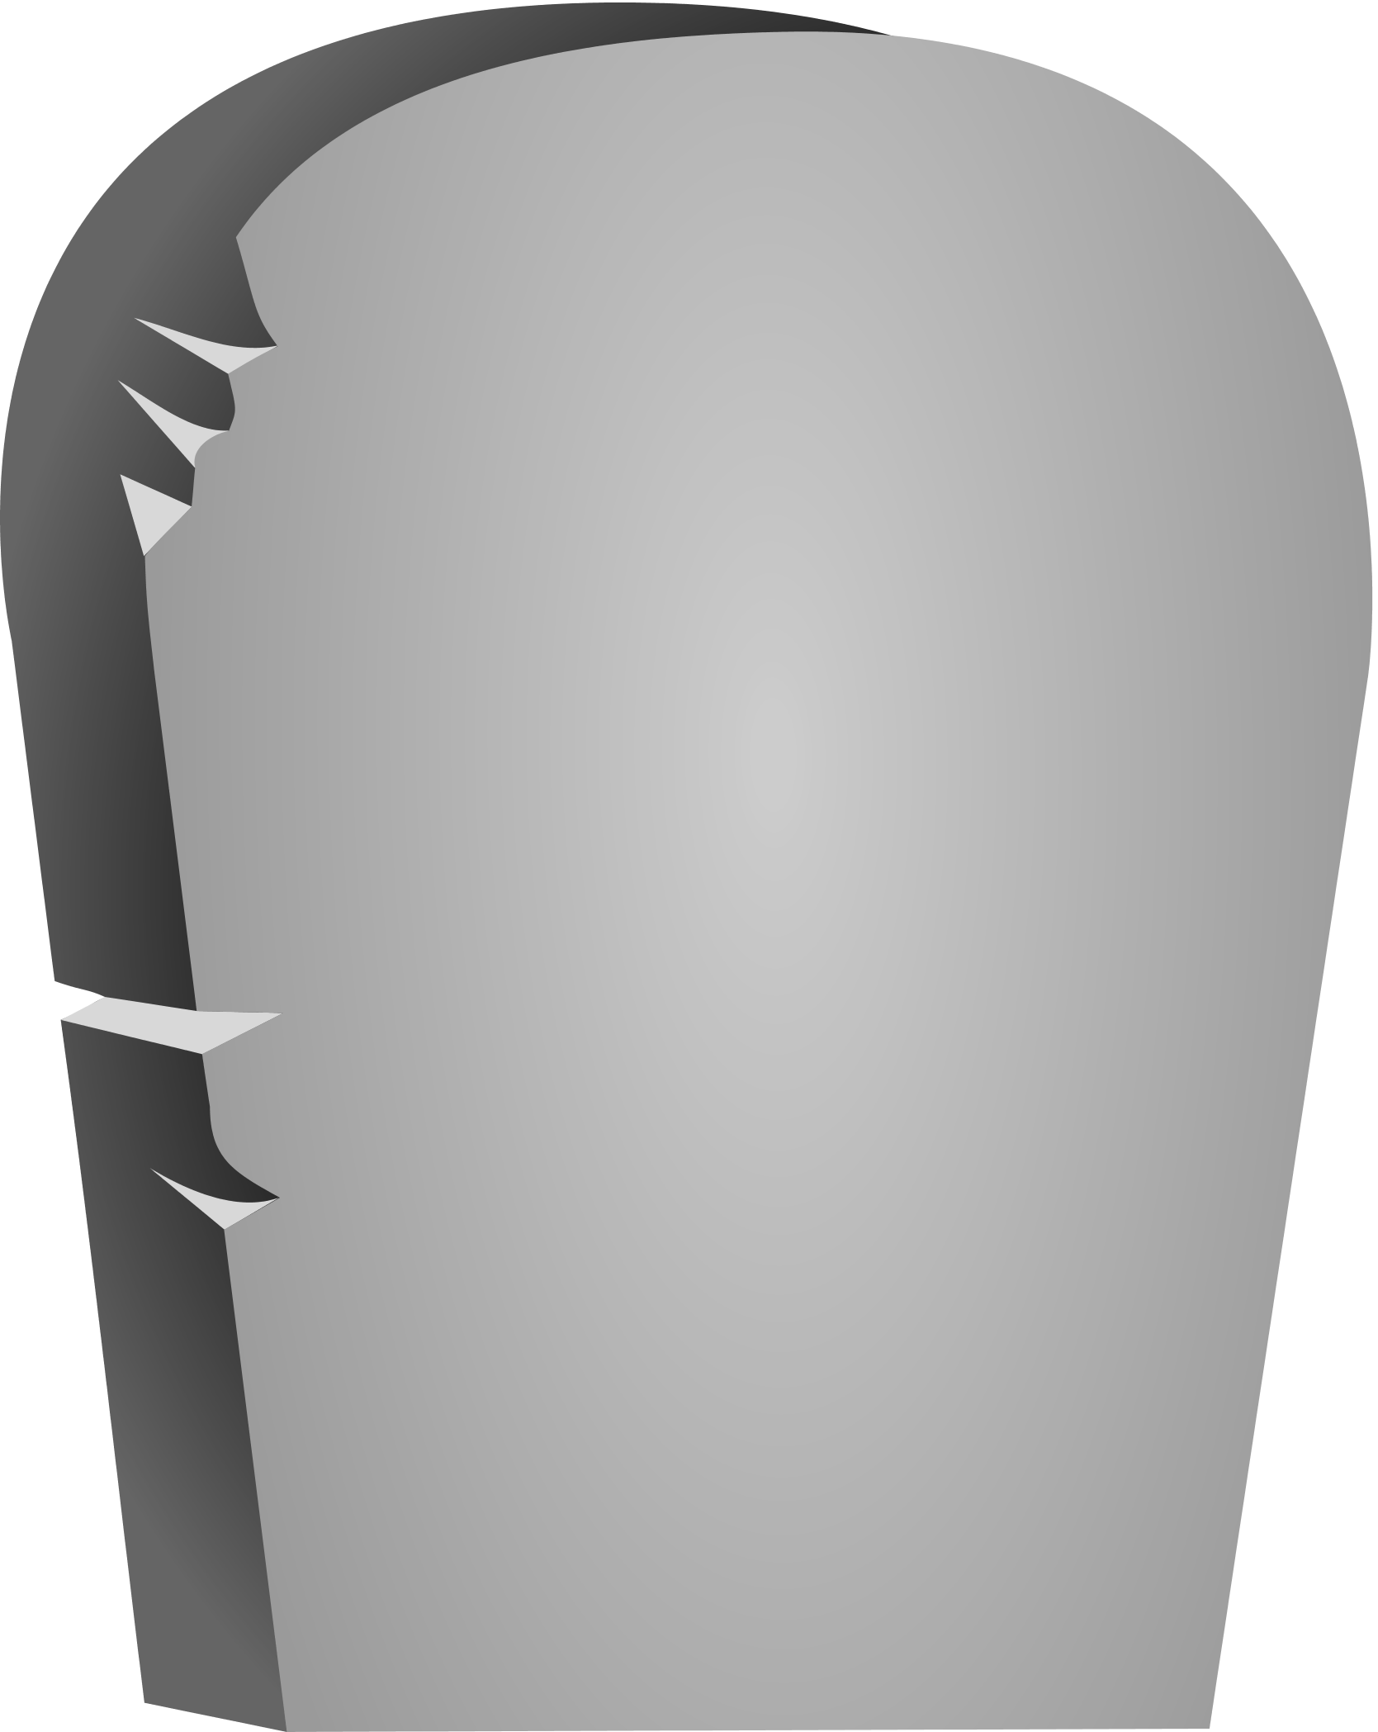
θεοις καταχθενοις
Sarpedon


How does Glaucus make his prayer to Apollo convincing?

Suggest as many reasons as possible why Apollo is the right god to intervene here:

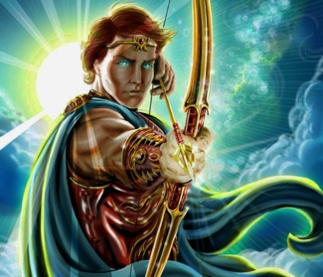

Write a short memorial to Sarpedon from the Trojans, based on Glaucus’ words to Hector and the Trojan response:

Read lines 555-643
What do we learn about these Achaean heroes from the way Patroclus chooses to encourage them?
The Two Ajaxes | Meriones

What do we learn about the lives and deaths of these two Myrmidons?
θεοις καταχθενοις
Epeigeus

θεοις καταχθενοις
Bathycles

How does Homer again foreshadow Hector’s killing of Patroclus?

Create three memes to summarise to interchange of Aeneas, Meriones and Patroclus:

How many quotes can you find to suggest that the fighting was thick and furious around Sarpedon’s body?

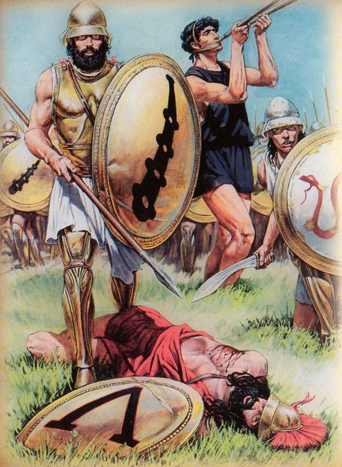

Read lines 644-691
List all the ways it appears Zeus is in control of the situation:

What story telling device does Homer use when Apollo follows Zeus’ instructions?

Read lines 692-782
Using the previous paragraph as well, find six ways Patroclus demonstrates hubris towards the end of this book. Begin each example with the letters below:
H
U
B
R
I
S

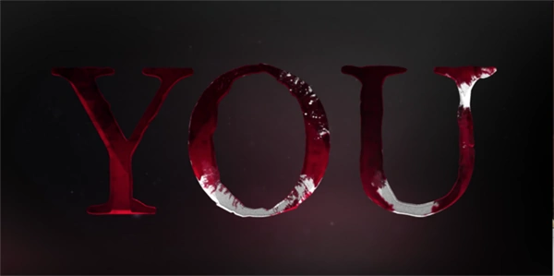
How many times can you spot Patroclus being addressed directly in this section?

What is ironic in the way Apollo addresses Hector?

Create one final meme for Patroclus’ put down of Cebriones:

How are Patroclus and the Achaeans balanced with Hector and the Trojans before and after the death of Cebriones?
Hector (+ Trojans)
Patroclus (+ Achaeans)

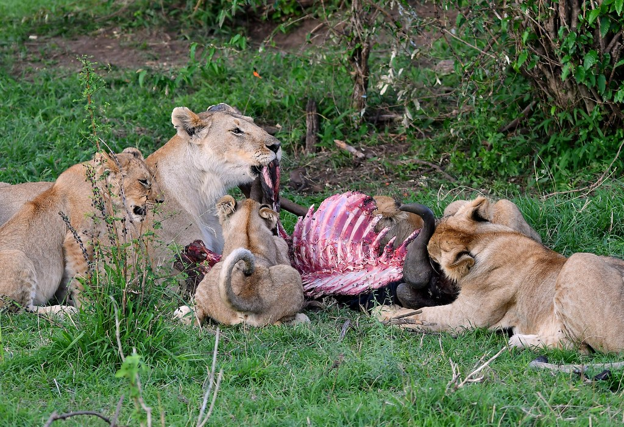

Read lines 783-867
Annotate these pictures to show how Patroclus is killed by the work of three opponents:

“You are the third of them all to kill me.”





Who do you think wins in the final exchange of words between Hector and Patroclus? Make points for both sides:
Patroclus | Hector
How does this book end with an ominous tone for Hector?

