**3.4.16 Chromatography**

**AS Link:**

**3.1.1 – Atomic structure (mass spec)**

**3.1.3 – Bonding**

**3.3.6 – Organic analysis (mass spec)**

**A level link:**

**3.3.13 - Amino acids, proteins & DNA**

Introduction

Chromatography is a collective term for similar techniques that allow the **separation and identification of components in a mixture**, the simplest form being paper chromatography.

They depend on the principle that a **mixture** can be **separated** if it is **dissolved** in a **solvent** (often called the **eluent**) and the **solution** (called the **mobile phase**) moves over a **solid** (the **stationary phase**).

**Separation** is achieved because the components of the mixture **distribute themselves** differently **between** the **two phases** depending on their **affinity** for each phase.

* **Mobile phase** - **carries** the **soluble components** of the mixture, the **more soluble** the component the **faster it moves** and so moves further up the plate.
* **Stationary phase** - **components** in the mixture **adsorbed** to surface (weak attraction), the **greater the affinity** a component has for the stationary phase the **slower it will move** with the solvent.

If any **component does not move** it must be **insoluble in the solvent** used and a **different solvent must be found**.

If suitable mobile and stationary phases are chosen, a **mixture** of similar substances can be **separated completely**.

***Definition***:

**Chromatography** is a technique for separating the components of a mixture on the basis of differences in their affinities for a stationary and a mobile phase.

There are three **types of apparatus** that can be used:

* **thin-layer** (TLC)
* **column**
* **gas** (GC)

***Definition***:

**A chromatograph** is the apparatus used for chromatographic separation.

***Definition***:

**Chromatogram** is a pattern of separated substances obtained by chromatography.

***Required practical 12: Separation of species by thin-layer chromatography***

Uses

|  |  |
| --- | --- |
| **Analytical chromatography** | **Preparative chromatography** |
| Uses **small amounts** of material and aims to **separate**, **identify** and **measure the relative proportions** of the components in the mixture. It often used **comparison** between **known samples** to allow identification through calculating **Rf values** or **retention** **time**. | Carried out on a **large scale** and is a technique that **purifies** through **separation** and allows the **collection** of the separated component. Identification can be achieved by measuring **retention** **times**. |
| TLC  GLC | Column |

Methods of separation

|  |  |  |  |
| --- | --- | --- | --- |
| **Partition** | | **Adsorption** | |
| **Solute** molecules **equilibrate** or **partition** **between** the two **phases**: the **solid** (stationary phase) and **solvent** (mobile phase). So separation is dependent on **solubility**.  stationary phase ↔ mobile phase | | **Solute** molecules become **attached** to ***adsorption* sites** on the stationary phase, **strongly adsorbed** molecules **travel more slowly** in the moving phase than those that are only weakly adsorbed. **Solubility** in the solvent also plays a part.  \includegraphics[clip,scale=0.2]{O2MDvh600_start.eps}  **More polar** the substance the **shorter** the distance it will travel  **Less polar** the substance the **further** distance it will travel. | |
| Stationary phase | Mobile phase | Stationary phase | Mobile phase |
| **Thin layer** of **non-volatile liquid** film held on the surface of an inert solid or within the fibres of a supporting solid matrix. | **Gas** | **Polar solid** **surface**, the **surface area** is **maximised** by using **finely-divided** particles.  Either:  silica SiO2  alumina Al2O3 | **Liquid solvent** |
| GLC | | TLC  Column | |

**Thin-layer chromatography (TLC)**

This technique is used to **separate** and **identify** components in a mixture. It is similar to paper chromatograph in the way it is carried out but the separation method is different.

|  |  |  |  |  |  |
| --- | --- | --- | --- | --- | --- |
| tlc1 | | Process of TLC Thin Later Chromatography) | | | |
| **Separation:** | Adsorption (weak bonding to stationary phase) | | | | |
| **Stationary phase:** | Thin-layer **polar** matrix such as **silica** (SiO2) or **alumina** (Al2O3) coated on a glass or aluminium or plastic sheet | | | | |
| **Mobile phase:** | Solvent or solvent mixture | | | | |
| **Technique:** | A **concentrated** solution of the **mixture** is applied as a **spot** along a **baseline** near the bottom of the plate. This is then **dipped** in a shallow layer of **solvent** inside a **sealed** **container**; producing an atmosphere that is **saturated with solvent vapour**. This **stops** the **solvent** from **evaporating** as it rises up the **plate**. The beaker is often lined with some filter paper soaked in solvent.  Separation occurs with the **components travelling different distances** depending on how **strongly they interact** with the **solid phase** and how **soluble** they are in the **solvent**.  The **more polar** the component the **greater the adsorption** and so they travel **shorter distance** up the plate with the solvent. Components that are **more soluble** will **travel** **further** up the plate.  The **solvent** **rises** **up** the plate by **capillary** **action** **carrying the solute components**.  Image result  It is **stopped** when the leading edge of the solvent, the **solvent front**, gets close to the top of the paper. The resulting **chromatogram** is taken out and **dried**, often in a **fume cupboard** due to toxic or flammable fumes from the solvent.  The **plate** is **removed** and **dried** when the **solvent front** has **almost** **reached** the **top**. The **Rf values** can be calculated and the separated **components** can be **identified**. | | | | |
| **Visualisation:** | **Colourless** components can be seen by different methods to make them **visible**: | | | | |
| * Plates that contain a **fluorescent dye** in the stationary phase can be placed under a **UV light**, then draw around the spots with a pencil. | | | | Image result |
| **Treating** the plates with a **locating agent** at the end **colours** components. | | | | |
| * + **Iodine** vapours stick to the components and stain them brown. | |  | | |
| * + **Ninhydrin** is used for **amino acids**; it is sprayed on the plate and stains them purple. | | | C:\Users\Lesley\Documents\Teaching\Lessons\KS5\Lessons - LW\3.3 Organic\3.3.16 Chromatography\3.3.16 Practicals\AA Chromatography.jpg | |

**Advantages**:

* Quick
* Efficient
* Reproducible (under same conditions)
* Adsorbents (different stationary phases) on the plate can be varied.

***Starter: 8.7 - Thin layer chromatography***

Identifying the components

Chromatography produces a chromatogram.

To identify each component their **retention factor**, **Rf** must be calculated, this is the **ratio** of the **distance travelled** up the paper by a **component** **relative** to the **solvent**.

Rf = distance travelled by compound

Rf values are always between 0 and 1

Must be quoted to 2 d.p.

distance travelled by solvent

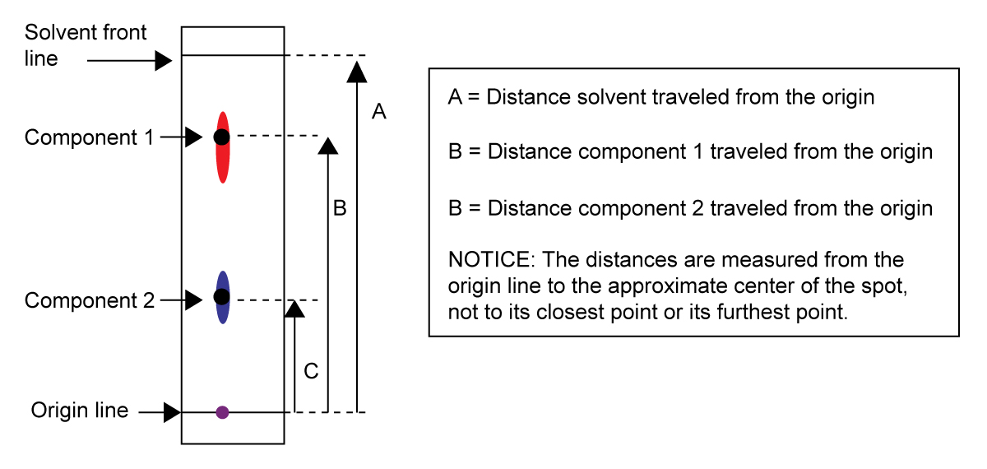

.

Under **standard conditions** **Rf values** can be **used** to **identify** compounds. Rf values are **dependent** on the **solvent**, **stationary** **phase** and the room **temperature** not the length of the plate or how far the solvent travels. So they can be looked up in data tables in order to identify a component. Keeping these conditions identical can be difficult so a **more reliable method** is to **compare known with unknown on the same chromatogram**.

**Example CGP267**

A sugar solution containing a mixture of three sugars is separated using TLC. The chromatogram is shown.

1. Calculate the Rf value of spot X.

Rf  = distance travelled by spot 2.5 = **0.24**

distance travelled by solvent 10.4

|  |  |  |  |  |  |  |  |  |  |
| --- | --- | --- | --- | --- | --- | --- | --- | --- | --- |
| 1. The table shows the Rf values of three sugars under the conditions used in the experiment. Use the table to suggest a sugar present in spot X.   Spot X has an Rf value of 0.24 which matches with the Rf value for **fructose**. | |  |  | | --- | --- | | **Sugar** | **Rf value** | | Glucose | 0.20 | | Fructose | 0.24 | | Xylose | 0.30 | |

Two-dimensional chromatography

In some cases, it’s **difficult to get complete resolution** (separation) of the components, this can be resolved by **repeating** the process using a **different solvent** and **rotating** the paper through **90o** to produce a **two-dimensional** chromatogram.

|  |  |  |
| --- | --- | --- |
| File:Two dimensional TLC.svg | Chromatogram **rotated 90o** and run again using a **differnet solvent**.  This give a **better resolution** if the componets are close togther.  **Two Rf values** obtained for each component. | File:Two dimensional TLC.svg |

**Column chromatography**

This is a simple technique, often used to **separate** and **purify** individual **organic** **compounds** from a **mixture**.

|  |  |  |  |
| --- | --- | --- | --- |
| A **glass tube** is **filled** with the **stationary phase** usually silica or alumina in **powder** form to **increase** the **surface area**. An alternative stationary phase is ion exchange resin in the form of small granules. A filter or plug is used to retain the solid in the tube. A **solvent** is then **added** to **cover** the **solid**. | | Image result |  |
|  | | *Packed column* | |
| The mixture to be analysed is **dissolved** in a **minimum** of a **solvent** and added to **top** the column. A **solvent** or **mixture of solvents** is then **run** **through** the **column**, this is called **elution**. The components travel **down** the column and the **time** for each component **to reach the end** of the column is **recorded**; this is known as the **retention time**. | | http://i139.photobucket.com/albums/q297/aonomus/IMG_3453.jpg | less polar  weakly adsorbed  shorter retention time |
|  | | *Column after a mixture has been separated* | |
| **Separation:** | Adsorption (weak bonding to stationary phase) | | |
| **Stationary phase:** | Finely-divided silica or alumina gel | | |
| **Mobile phase:** | Organic solvent **pure solvent** or a **mixture** (the eluent) | | |
| **Technique:** | As in TLC, the **solubility** of a substance in the solvent and how **strongly** it is **adsorbed** onto the stationary phase is **important** as this determines the **retention** of each component through the column.  The component will **move faster down** the column if it is **more soluble** in the **solvent** and **not as strongly adsorbed** to the **solid** phase. The most **strongly adsorbed** components take the **longest time** to flow through the column. The **more polar** the molecule the **slower** it **travels** **down** the column and so the **greater** the **retention** **time**.  The **solution emerging** from the column is called the **eluent** and is **collected** as a **series of fractions** which can be collected and analysed **separately**. They can be also be **identified** using their **retention time**.  ***Definition***:  **Retention time** is the time each component remains in the column  **Coloured** substances can be **seen** through the glass wall as moving bands.  Process can be **speeded** up by **forcing** the solvent through the system **under pressure** – called **flash chromatography**. | | |
| **Visualisation:** | **Colourless components** can be **visualised** using a **UV light** | | |

Videoclip: [<https://www.youtube.com/watch?v=P8Mmpb4OShw>](https://www.youtube.com/watch?v=P8Mmpb4OShw)

**Advantages**:

* Fairly **large amounts** can be **separated**
* Separated samples can be isolated and **collected**

***Application: CGP268 PQ1-2***

***Fact recall: CGP268 Q1-4***

**Gas chromatography**

This is one of the most important modern and powerful techniques for the **separation** and **identification** of mixtures of **volatile** **compounds**. Just like other chromatography methods it consists of a **mobile phase and stationary phase**.

The **mobile** phase this time is a **continuous** steady **flow** of carrier **gas** passes through a column. The **faster** it **flows** the **faster** the **analysis**, but **lower** the **resolution** (the poorer the information).

|  |  |  |  |
| --- | --- | --- | --- |
| The **stationary** phase is a **silica** or **alumina** **powder**, coated with a viscous **non-volatile liquid** such as oil, which is either **packed into** or **coated** on the inside of a long **capillary tube**, known as the **column**. These can be between 60-100m long and very thin (0.5-1.0mm diameter). | | Plain_column_cutaway.jpg | |
| The **column** is coiled to save space and placed in an oven; this allows different temperatures to be used. It’s usually carried out **under pressure** or at a **high temperature**. | | Colonne capillaire dans un four GC - cliquer pour agrandir | |
|  | | *Column inside GC oven* | |
| gcdiag  *Schematic diagram of GC* | | | Gaschromatograph.jpg |
|  | | | *Outside of GC* |
| **Separation:** | Partition (solubility in stationary & mobile phase) | | |
| **Stationary phase:** | Long, narrow-bore stainless steel or glass coiled capillary tube packed with an **inert powder** (silica or alumina) **coated with a film of non-volatile liquid**. | | |
| **Mobile phase:** | **Inert gas** – helium, argon or nitrogen (the eluent) | | |
| **Technique:** | The **vaporised sample** is **injected** into the port at the head of the column and the **components** are **carried** through the system and appear later, **in sequence**, at the **exit**.  **Solubility** of the components in the **non-volatile liquid** (on stationary phase) is a **major** **factor**. In the separation. A component that is **highly soluble** in the liquid phase takes considerably **longer to elude** (time to travel through the column) from the column than one having a low solubility. It will have a longer **retention time**.  Each **component** has a **characteristic retention time** that **depends** on:   * the nature of the **stationary phase** * the **operating temperature** * the **flow rate** of the carrier gas * the **length** of the column.   The retention times can be measured and **compared to standards** to **identify** the components. | | |

|  |  |
| --- | --- |
| **Detection:** | A **detector** is **used** to **identify each component** as it exits the column. The **flame ionisation detector** is the most popular detector because it is reliable and sensitive. Analytes combust in a hydrogen-air **flame** as they exit the column, producing carbon **ions** that induce a current. This is linked to a recorder and retention time of each component is recorded. It appears as a **peak on a chart** called the **chromatogram**. If **standards** also used, then the **retention times** can be used to **identify the components.** The area of the **peaks** are **proportional** to the **relative** **amount** of the component. |
| **Chromatogram:** | This chromatogram shows the retention times and the area gives the amount of each component.  GC chromatogram of non-adducted esters |
| **Retention times:** |  |

**Advantages**:

* Used to **measure very small quantities**
* **Distinguish** between **closely related molecules**.

**Uses:**

* Forensic analysis e.g. crime scene samples
* Drug use analysis e.g. urine or blood samples looking for illegal drugs
* Environmental analysis.

**Gas chromatography mass spectroscopy (GCMS)**

|  |  |
| --- | --- |
| A very powerful type of GC is **gas chromatography-mass spectrometry** (GCMS), which is gas chromatograph coupled to a mass spectrometer, where the **mass spectrometer** is used as the **detector** for the GC. The **separated components** are **ionised** as they emerge from the column and both the **identity** and **quantity** are **determined** by mass spectrometry. | File:GCMS closed.jpg |

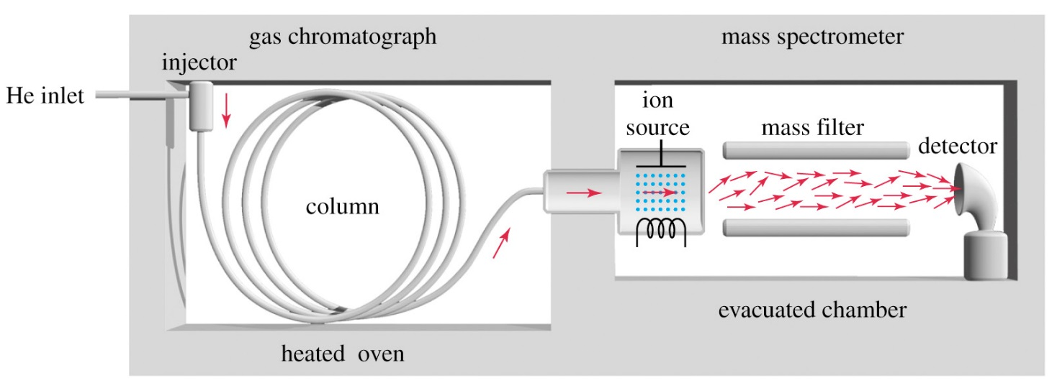

**Advantages**:

* Separated components can be **positively identified**.

**Comparing the techniques**

|  |  |  |  |
| --- | --- | --- | --- |
|  | **TLC** | **Column** | **GC** |
| **Mobile phase** | Solvent or solvent mixture | Organic solvent | Inert carrier gas – helium or nitrogen |
| **Stationary phase** | Thin-layer polar matrix such as silica gel or alumina | Finely-divided silica gel or alumina gel | Capillary tube packed with an inert powder coated with a film of  non-volatile liquid |
| **Method of separation** | Adsorption | Adsorption | Partition |

***Video: Chemical analysis techniques – Chromatography***

***Sheet: Chromatography***

***Application: CGP270 PQ1-3***

***Fact recall: CGP270 Q1-4***

***Exam questions: Oxford p242-243 Q1-3***