**3.1.2 Amount of substance**

The actual mass in grams of any single atom or molecule is too small to find by weighing, so they are **compared** and **relative masses** are used. The actual mass of an atom or ion of an element can be **calculated** if the mass of the sub-atomic particles are known.

***Task: Calculate the mass (in g) of the following atoms/ions using the masses sub atomic particles, quoting answers to a suitable number of significant figures for data provided.***

Calculated results can only be reported to the limits of the **least accurate** measurement.

|  |  |  |  |
| --- | --- | --- | --- |
|  | Proton | Neutron | Electron |
| Mass/g | 1.673 x10-24 | 1.673 x 10-24 | 9.11 x 10-28 |
|  |  |  | 0.000911 x 10-24 |

|  |  |  |  |
| --- | --- | --- | --- |
| H = 1.67 x 10-24 g | x1 |  | x1 |
| Be = 1.49 x 10-23 g | x4 | x5 | x4 |
| H+ = 1.673 x 10-24 g | x1 |  |  |

In the past hydrogen, then oxygen was used as the standards for comparison but now the isotope **carbon-12** is used.

***Why 12C was chosen as the standard***

Extension - not in specification.

The original standard of atomic weight, established in the 19th century, was hydrogen, with a value of 1. From about 1900 until 1961, oxygen was used as the reference standard, with an assigned value of 16. The unit of atomic mass was thereby defined as 1/16 the mass of an oxygen atom. In 1929 it was discovered that natural oxygen contains small amounts of two isotopes slightly heavier than the most abundant one and that the number 16 represented a weighted average of the three isotopic forms of oxygen as they occur in nature. In 1961 the isotope carbon-12 was selected to replace oxygen as the standard relative to which the atomic weights of all the other elements are measured. It was chosen because of its coherence to Avogadro's Principle, its stability, abundance and it is unbound in its ground state and could be measured particularly accurately.

**Relative atomic mass**

The relative atomic mass is the **weighted average mass** of an element taking into account its **naturally occurring isotopes**, **relative to 1/12** the **relative atomic mass** of an atom of **carbon-12**. The relative mass of molecules can be defined in the same way.

***Definition***: **Relative atomic mass (Ar)** = average mass per atom of an **element**   
 1/12 the mass of one atom of 12C

= average mass per atom of an **element** x 12  
 the mass of one atom of 12C

Elements

***Definition***: **Relative molecular mass (Mr)** = average mass per atom of a **molecule**  
 1/12 the mass of one atom of 12C

= average mass per atom of a **molecule** x 12  
 the mass of one atom of 12C

Covalent molecules

The term **relative formula mass** is used for **ionic compounds** but the same symbol, **Mr** is used and they are calculated in exactly the same way.

**N.B. Always quote Ar or Mr to 1decimal place**

***Task: Calculate Ar/Mr***

Oxygen atom O 16.0

Oxygen molecule O2 32.0

N.B. no units

Glucose C6H12O6 180.0

Sodium carbonate Na2CO3 106.0

Magnesium oxide MgO 40.3

**Maths techniques**

***Refer to CGP Maths skills p256-262***

***Refer to Oxford Section 5 – Mathematical skills p260-267***

***Notes: Maths 4 chemists***

***Sheet: Significant figures & standard form***

**Moles and Avogadro’s constant (*L*)**

***Definition***: **One mole** of a substance is the **atomic or molecualr mass in grams**

When carrying out chemical reactions it is important to know exactly how much of each reactant you need. E.g.

**Fe (s) + S (s) → FeS (s)**

A balanced equation shows that 1 atom of iron combines with 1 atom of sulphur to form iron (II) sulphide. But how much of each do you need to weigh? You would need to count out equal numbers of atoms of iron and sulphur.

***Prac: Measure out 1 mole of the following substances – C, Mg, NaCl, H2O***

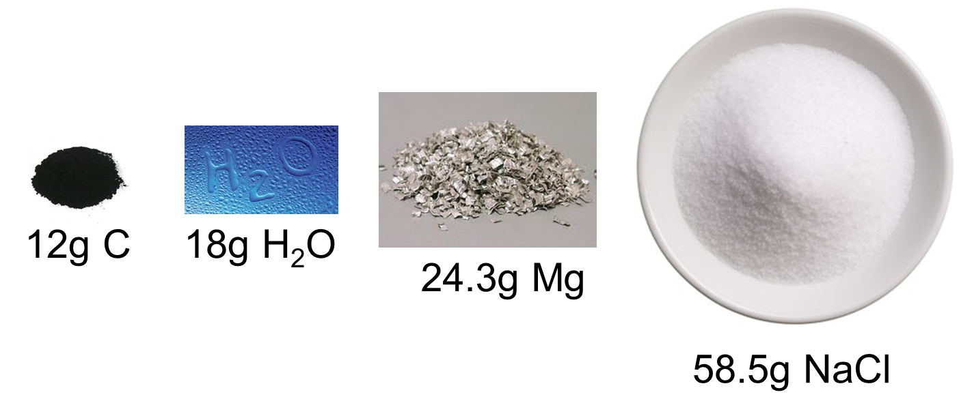

***Task: Calculate mass of one mole then half mole***

Oxygen atom O 16.0g 8.0g

Oxygen molecule O2 32.0g 16.0g

N.B. units in g

Glucose C6H12O6 180.0g 90.0g

Sodium carbonate Na2CO3 106.0g 53.0g

Magnesium oxide MgO 40.3g 20.15g

These masses are approximate because different isotopic forms of the atoms exist.

In 1811 an Italian called Amedeo Avogadro set about solving this problem. Came up with a simple argument:

**Relative atomic mass of carbon is 12 times relative atomic mass hydrogen.**

Therefore:

If 1 atom C is 12 times as heavy as 1 H atom

then 1 dozen C atoms are 12 times as heavy as 1 dozen H atoms

and 1 hundred C atoms are 12 times as heavy as 1 hundred H atoms

and 1 million C atoms are 12 times as heavy as 1 million H atoms

It then follows that **any mass of C that is 12 times heavier than a mass of H will both contain the same number of atoms**. Banks use the same principle with coins, they weigh them rather than count them, so a specific mass equates to a certain number of coins.

So 12g C and 1g H contain equal number of atoms, Avogadro calculated this to be   
**6.022 x 1023** it is called the **Avogadro constant or number** and given the symbol ***L*** and has the **unit mol-1**. **One mole** (abbreviated to **mol** and given letter **n**) contains this many particles (atoms, molecules, compounds, ions, or electrons).

***Definition***: **Avogadro constant (*L*)** is the number of atoms in 12g of carbon-12

(**6.022 x 1023**)

A mole is the **standard unit of amount of a substance** – it is just a number, a very big number. It is a way of saying a number in words, just like...

DOZEN for 12 SCORE for 20 GROSS for 144

The **relative** atomic, molecular or formula **mass in grams** of any substance **contains one mole**.

**Additional information on mass of atoms**

1 mole of atoms = 6.022 x 1023 (Avogadro constant, *L*)

mass of 1 mole substance (g) = Ar or Mr

so mass 1 atom = Ar

*L*

To find mass of 1 atom in kg x 10-3

**Example**

Find the mass, in g, of one ion of 35Cl+

m 35Cl+ = 35 = 5.81 x 10-23 g

6.022 x 1023

Now find the mass, in kg, of one ion of 35Cl+

mass in kg = 5.81 x 10-23 x 10-3 = 5.81 x 10-26 kg

***Sheet: Avogadro calculations – Part 1***

Calculations involving Avogadro constant

The Avogadro number can be used to convert between the number of particles and number of moles using this equation:

**number of particles = number of moles x Avogadro’s constant = n*L***

**Example: GCP38**

How many atoms are in 0.450 moles of pure iron?

Number of atoms = 0.450 x 6.02 x 1023 = **2.71 x 1023**

***Task: How many ions are in 0.724 moles of calcium ions?***

Number of atoms = 0.724 x 6.02 x 1023 = **4.36 x 1023**

The equation can be re-arranged so that the number of moles can be calculated.

n = number of particles

*L*

***Task: Calculate how many moles are in 1.14 x 1024 molecules of NH3***

Number of moles = 1.14 x 1024= **1.89**

6.02 x 1023

***Sheet: Avogadro calculations – Part 2***

Calculations with moles

If one mole of any substance has a mass that’s the same as its relative molecular mass (Mr) in grams then.

|  |  |  |
| --- | --- | --- |
| For a known mass of substance: | moles (mol) = mass (g)  Mr | **n = m**  **Mr** |

**Example: CGP39**

How many moles of aluminium oxide are present in 5.10g of Al2O3?

Mr(Al2O3) = (2 x 27.0) + (3 x 16.0) = 102.0

n(Al2O3) = 5.10 / 102.0 = **0.05 mol**

***Task: How many moles of calcium bromide are present in 39.98g CaBr2?***

Mr(CaBr2) = 40.1 + (2 x 79.9) = 199.9

n(CaBr2) = 39.98 / 199.9 = **0.2000 mol (4 significant figures)**

Must be able to rearrange the equation to work out the mass or relative molecular mass.

***Task: Rearrange n = m/Mr***

To give mass m = nMr

To give Mr Mr = m/n

**Example: CGP39**

What is the mass of 2 moles of NaF?

Mr(NaF) = 42.0

m(NaF) = 2 x 42.0 = **84.0g**

***Task: 0.05 moles of a solid weighs 2.60g. Find its relative molecular mass.***

Mr = 2.60 / 0.05 = **52.0**

***Sheet: The mole***

***Sheet: Avogadro calculations – Part 3***

***CGP39 PQ1-6***

Moles and concentration

|  |  |
| --- | --- |
| The concentration of a solution is how many moles are dissolved per 1 dm3 of solution. The units are mol dm-3. |  |

|  |  |  |
| --- | --- | --- |
| For solutes in a solution, if the volume of solution is known: | moles of solute (mol)  = concentration (mol dm-3) x volume of solution in (dm3) | **n = cv** |

Concentration of solutions is given as:

**moles of solute per cubic decimetre* of solution\*\*** Units: **mol dm-3**

* cubic decimetre is now the international name for the unit of volume (same as litre)

** concentrations expressed as number of moles in 1 dm3 of ***solution* not *solvent***

1 decimetre (dm) = 10 cm

∴1 dm3 = (10 cm)3 = 1000 cm3

***Task: Rearrange n=vc***

To give concentration c = n/v

To give volume v = n/c

When you put numbers into equations they must have the **same units**, this is how you convert between cm3 and dm3.

|  |  |  |
| --- | --- | --- |
|  | x 10-3 |  |
| cm3 |  | dm3 |
|  | x103 |  |

**Example: CGP40**

How many moles of lithium chloride are present in 25 cm3 of a 1.2 mol dm-3 solution of LiCl?

n(LiCl) = 1.2 x 25x10-3 = **0.03 mol**

***Task: A solution of FeCl3 contains 0.2 moles of iron(III) chloride in 0.4 dm3.   
What is the concentration?***

c(FeCl3) = 0.2 / 0.4 = **0.5 mol dm-3**

***Task: A 0.5 mol dm-3 solution of zinc sulphate contains 0.080 moles of ZnSO4. What volume does the solution occupy?***

v(ZnSO4) = 0.08 / 0.5 = **0.16 dm3 or 160 cm3**

**Example: CGP40 – combining concentration with moles and mass**

What mass of sodium hydroxide needs to be dissolved in water to give 50.0 cm3 of solution with a concentration of 2.00 mol dm-3?

From the concentration and volume work out the number of moles:

n(NaOH) = 2.00 x 50.0x10-3 = 0.100 mol

Now using the Mr work out the mass:

m(NaOH) = 0.1 / 40.0 = **4.00g**

***Fact recall: CGP41 Q1-6***

***CGP31 PQ1-11***

**Gases and the mole**

The volume of a gas is not fixed; it changes with temperature and pressure. However, there are a number of simple **relationships that connect pressure, temperature and volume**.

* Boyle’s law PV = constant

No need to learn these

* Charles’ law V T V/T = constant



* Gay-Lussac’s law P T P/T = constant



Ideal gases

|  |  |
| --- | --- |
| An **ideal gas** obeys the kinetic theory of gases. They are treated as **hard spheres** of **negligible size** which move in **rapid random motion** and experience **no intermolecular forces**. |  |

|  |  |  |
| --- | --- | --- |
| For gases the ideal gas equation: | pressure (Pa) x volume (m3)  = mole (mol) x gas constant (J K-1 mol-1) x temperature (K) | **PV = nRT** |

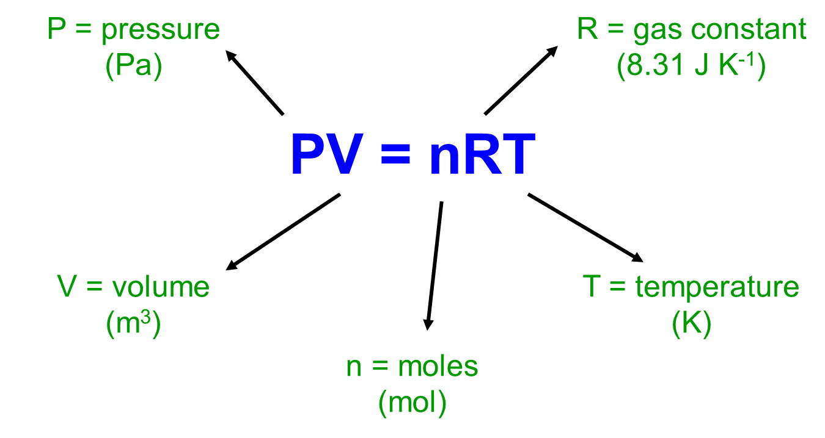

The **correct units** must be used.

|  |  |  |  |  |  |
| --- | --- | --- | --- | --- | --- |
| **Parameter** | **Unit** | **Conversion** | | | **Notes** |
| P – pressure | Pa* |  | x103 |  | 1kPa = 1000Pa or 103  *1 atm = 100kPa |
| kPa |  | Pa |
|  | x 10-3 |  |
| V – volume | m3 |  | x10-6 |  | If 1m = 100cm  1m3 = 1000,000 cm3  i.e. 106 |
| cm3 |  | m3 |
|  | x106 |  |
| n – moles | mol |  |  |  |  |
|  |  |  |  |
|  |  |  |  |
| R – gas constant | J K-1 mol-1 |  |  |  |  |
| = 8.31 |  |  |  |
|  |  |  |  |
| T – temperature | K |  | +273 |  | RT = 25oC = 298K |
| oC |  | K |
|  | -273 |  |

***Task: Re-arrange PV = nRT***

To give volume V = nRT/P

To give pressure P = nRT/V

To give moles n = PV/RT

To give temperature T = PV/nR

Once the number of moles of a gas are known the **mass** **or Mr** of a gas **can be calculated using n = m/Mr.**

**Example: CGP42**

How many moles are there in 0.0600 m3 of hydrogen gas at 283 K and 50000 Pa?

n = PV/RT = 50000 x 0.06 / 8.31x 283 = **1.28 mol**

**Example**

Find the relative molecular mass of 0.129g of gas occupying 200cm3 at 25oC and 100kPa.

n = PV/RT (100 x 103 x 200 x 10-6) / (8.31 x 298) = 0.00808 mol

Mr = m/n 0.129 / 0.00808 = **16.0**

***Task: Calculate the volume of 1 mole of gas if the temperature is 20.0oC and pressure is 100000 Pa.***

T = 293 K

V = nRT / P = (1 x 8.31 x 293) / 100000 = 0.0243 m3 or 0.0243 x 106 cm3 = **24300 cm3**

***Task: Calculate the pressure of 0.5 moles of a gas at 10oC and 250cm3.***  
V = 250 x 10-6

T = 10 + 273 = 283K

P = nRT/V 0.5 x 8.31 x 283 = 4703460 Pa = **4703.5 kPa**

250 x 10-6

***Task: Calculate temperature of 5 moles of a gas if the pressure is 505 kPa and the volume is 5000 cm3.***

P = 505000 Pa

V = 5000 x 10-6 m3 = 0.005

T = PV/nR 505000 x 0.005 = **60.8K or 333.8oC**

5 x 8.31

***Sheet: The ideal gas equation***

***Fact recall: CGP43 Q1***

***CGP43 PQ1-7***

Finding the relative molecular mass of a gas

If the number of **moles present are known** **for a given mass of gas**, the **mass of one mole** of gas can be found and so the **relative molecular mass**.

|  |  |
| --- | --- |
| This apparatus is used to find the relative molecular mass of a gas. The gas canister was weighed, then 1000cm3 of gas dispensed into the measuring cylinder. The level of water inside and outside the measuring cylinder is kept the same so that the pressure of the gas is the same as atmospheric pressure. The canister was then reweighed. Atmospheric pressure and temperature were recorded. |  |

These were the results:

PV = nRT so n = PV / RT

Loss of mass of can = 2.29g

Temperature = 14oC = 287K

Atmospheric pressure = 100,000Pa

Volume of gas = 1000cm3 = 1000 x 10-6 m3

n = PV/RT = 100000 x 1000x 10-6 / 8.31 x 287 = 0.042 mol with a mass of 2.29g

Mr = m/n = 2.29 / 0.042 = **54.5**

**Chemical formula**

A chemical formula shows the actual ratio of atoms. It actually shows the quantities in **moles**, as a **whole number** **ratio**.

**Example:** CH4 contains 1 mole C atoms & 4 moles H atoms

The formula of ionic compounds can be worked out using the **crossover method**.

**Example**: Calcium chloride

Charge of compounds is ZERO

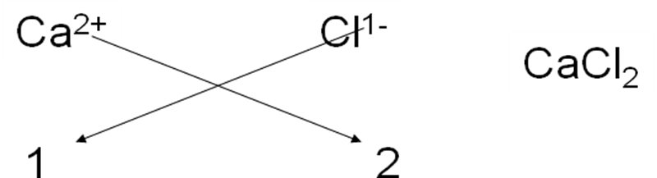

Cross-over method:

Written formula and roman numerals

When writing the names of ionic compounds **roman numerals** after an element show the **charge of the ion**.

**Example**: Copper(I) oxide and copper(II) oxide

***Sheet: Formula***

**Equations**

Equations represent what happens in chemical reactions, with the reactants written on the left and products on the right. Word equations give the names only.

REACTANTS → PRODUCTS

In reactions **atoms react** together in simple **whole number ratios**. The ratio is called the **stoichiometry** (*Etymology: Greek meaning element measure*) of the reaction.

A **chemical** (or symbol) **equation** uses chemical **formula** and since **atoms** can’t be created or destroyed there must be the **same number** on **each side** of the arrow. So they show the **amount of substances** in **moles** (usually whole numbers) that react together.

State symbols

**State symbols** can be added to give the state of the substances.

Solid (s)

Liquid (l)

Gas (g)

Aqueous solution (aq)

**Example:** Mg(s) + 2HCl(aq) → MgCl2(aq) + 2H2(g)

1 mol 2 mol 1 mol 2 mol

In this example HCl(aq) is hydrochloric acid not hydrogen chloride which is a gas and would be shown as HCl(g).

Balancing equations

They must have the same number of each type of atom on each side of the equation.

1. Count atoms of each element on reactants and products side
2. Write number (called a coefficient) in front to balance atoms on each side – each atom at a time
3. Check for fractions and multiply out
4. State symbols

A method that might help is to **balance the atoms in this order**, the more practice the more confident you will become.

|  |  |
| --- | --- |
| **M**etals  **A**ny other  **C**arbon  **H**ydrogen  **O**xygen |  |

**Remember:**

* Use the correct formulae – do not change them
* Change the number of atoms by putting a number in front of a formulae
* It often takes more than one step, but too many suggests there may be incorrect formulae.

**Example:**

Unbalanced equation: Al + NaOH → Na3AlO3 + H2

Al + 3NaOH → Na3AlO3 + 3/2H2 x 2 to avoid fraction

2Al + 6NaOH → 2Na3AlO3 + 3H2

***Task: Balance the equations and add state symbols***

H2SO4 + NaOH → Na2SO4 + H2O

H2SO4(aq) + 2NaOH(aq) → Na2SO4(aq) + 2H2O(l)

C2H6 + O2 → CO2 + H2O

Part moles are allowed if you need to show the reaction of one mole of a particular reactant

C2H6 (g)+ 3.5O2(g)→ 2CO2(g)+ 3H2O(l)

***Sheet: Balancing equations***

Ionic equations

When an **ionic substance dissolves**, the **ions separate** and mix in with the water.

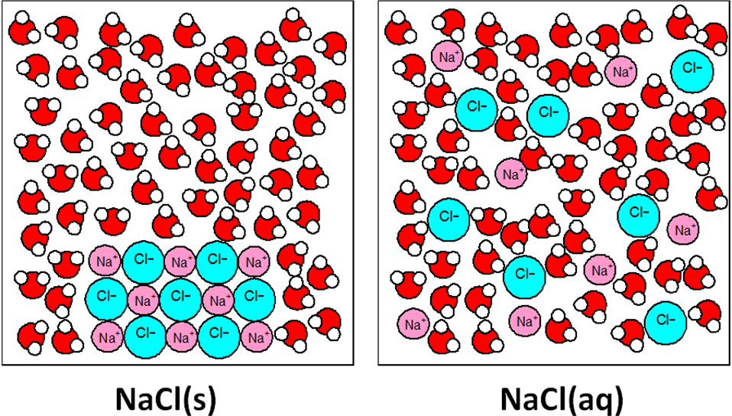

An **ionic equation** can be written for reactions involving ions, **only the reacting ions** and the **products they form** are **shown**. Sometimes there are ions that don’t take part in the overall reaction, these are called **spectator ions**.

**Charges** in ionic equations **must also balance** as well as the number of atoms.

**Example:**

Write a full balanced equation: HCl(aq) + NaOH(aq) → NaCl(aq) + H2O(l)

Then split into ions: H+ + Cl- + Na+ + OH- → Na+ + Cl- + H2O

Cross out ions appearing on both sides: H+ + ~~Cl~~- + ~~Na~~~~+~~ + OH- → ~~Na~~~~+~~ + ~~Cl~~~~-~~ + H2O

Ionic equation: H+(aq) + OH-(aq) → H2O(l) The ion equation for all acid-alkali reactions

Spectator ions: Na+ Cl- These appear on both sides of the equation

**Other examples of ionic equations:**

|  |  |
| --- | --- |
|  |  |

H2SO4(aq) + 2NaOH(aq) → Na2SO4(aq) + 2H2O(l)

As ions: 2H+ + SO42- + 2Na+ + 2OH- → 2Na+ + SO42- + 2H2O

Cross out ions appearing on both sides:

2H+ + ~~SO~~~~4~~~~2~~- + ~~2Na~~~~+~~ + 2OH- → ~~2Na~~~~+~~ + ~~SO~~~~4~~~~2-~~ + 2H2O

Ionic equation: 2H+(aq) + 2OH-(aq) → 2H2O(l) simplified to: H+(aq) + OH-(aq) → H2O(l)

Spectator ions: Na+ SO42-

**Reacting solutions together, may produce a precipitate:**

|  |  |
| --- | --- |
|  |  |

Ba(NO3)2(aq) + Na2SO4(aq) → 2NaNO3(aq) + BaSO4(s)

As ions: Ba2+ + 2NO3- + 2Na+ + SO42- → 2Na+ + 2NO3- + BaSO4

Cross out ions appearing on both sides:

Ba2+ + ~~2NO~~~~3~~~~-~~ + ~~2Na~~~~+~~ + SO42- → ~~2Na~~~~+~~ + ~~2NO~~~~3~~~~-~~ + BaSO4

Ionic equation: Ba2+(aq) + SO42-(aq) → BaSO4(s)

Spectator ions: Na+ NO3-

**Remember:**

* The total of the charges on each side of an ionic equation must be the same
* Molecules and compounds not written as ions:
  + Solid ionic compounds, including precipitates formed
  + Covalent molecules.

***Task: Identify the spectator ions and produce an ionic equation***

CuSO4(aq) + Zn(s) 🡺 ZnSO4(aq) + Cu(s)

Cu2+SO42-(aq) + Zn(s) 🡺 Zn2+SO42-(aq) + Cu(s)

Ionic equation: Cu2+(aq) + Zn(s) 🡺Zn2+(aq) + Cu(s)

SO42- spectator ion

2KBr(aq) + Cl2(aq) 🡺 2KCl(aq) + Br2(aq)

2K+Br-(aq) + Cl2(aq) 🡺 2K+Cl-(aq) + Br2(aq)

Ionic equation: 2Br-(aq) + Cl2(aq) 🡺 2Cl-(aq) + Br2(aq)

K+ spectator ion

***Task: Balance these ionic equations***

Fe3+ (aq) + Zn(s) → Fe(s) + Zn2+ (aq)

Balanced: 2 Fe3+(aq) + 3 Zn(s) → 2 Fe(s) + 3 Zn2+(aq)

Fe2+(aq) + Al(s) → Fe(s) + Al3+(aq)

Balanced: 3 Fe2+(aq) + 2 Al(s) → 3 Fe(s) + 2 Al3+(aq)

***Sheet: Equations***

***CGP45 PQ1-2***

**Equations and calculations**

Balanced equations can be used to work out how much product is produced from a reaction.

Calculating masses

These are the steps to follow:

1. Write out the balanced equation.
2. Work out how many moles of substance you have from the information in the question.
3. Use the molar ratio to work out the number of moles of the substance being asked about.
4. Calculate the mass of that substance.

**Example: CGP46**

Find the mass of iron(III) oxide produced when 28.0g of iron is burnt in air.

1. Equation 2Fe(s) + 1.5O2(g) → Fe2O3(s)
2. n = m/Mr n(Fe) = 28.0 / 55.8 = 0.502 mol
3. Molar ratio Fe : Fe2O3 2:1 n(Fe2O3) = 0.502 / 2 = 0.251 mol
4. m = nMr m(Fe2O3) = 0.251 x 159.6 = **40.1g**

***Task: Hydrogen gas reacts with nitrogen to give ammonia (NH3). Calculate the mass of hydrogen needed to produce 6.8g of ammonia.***

3H2(g) + N2(g) → 2NH3(g)

n(NH3) = 6.8 / 17.0 = 0.4 mol

n(H2) = 0.4 x 3 / 2 = 0.6 mol

m(H2) = 0.6 x 2.0 = **1.2g**

***Sheet: Mole calculations 1***

***Sheet: Mole calculations 2 - Extension***

***CGP47 PQ1-3***

Reacting gas volumes

The method above can be used to calculate the **volume of gases** needed or produced in a reaction by **combining** the method with the **ideal gas equation**.

**Example: CGP47**

What volume of hydrogen gas, in m3, is produced when 15.0g of sodium is reacted with an excess of water at 25.0oC and a pressure of 100 kPa.?

The gas constant is 8.31 J K-1 mol-1.

Equation 2Na(s) + 2H2O(l) → 2NaOH(aq) + H2(g)

n = m/Mr n (Na) = 15.0 / 23.0 = 0.652 mol

Molar ratio n (H2) = 0.652 / 2 = 0.326 mol

Convert units P = 100x103 Pa T = 25 + 273 = 298K

V = nRT / P V (H2) = (0.326 x 8.31 x 298) / 100x103 = **0.00808 m3**

***Task: If 1.00 g of Na2SO3 is reacted with an excess of HCl, calculate:***

1. ***the mass of NaCl produced***
2. ***the volume of SO2 gas produced at 30oC and 100 kPa pressure.***

2HCl + Na2SO3 → 2NaCl + H2O + SO2

n(Na2SO3) = 1.00 / 126.1 = 7.93x10-3

n(NaCl) = 7.93x10-3 x 2 = 1.59x10-2

m(NaCl) = 1.59x10-2 x 58.5 = **0.93 g**

n(SO2) = 7.93x10-3

V = nRT / P

V(SO2) = (7.93x10-3 x 8.31 x 303) / 100x103 = **1.997x10-4 m3** or **199.7 cm3**

***Sheet: Reacting gas volumes***

***Sheet: Gas calculations – extension***

***CGP48 PQ1-5***

**Moles in solutions**

|  |  |
| --- | --- |
| Reminder: solution = solute + solvent  Concentration of solutions is given as:  **moles of solute per cubic decimetre of solution**  Units: **mol dm-3**  **c = n/v** |  |

Using this equation to calculate the concentration of a solution.

**Example**

If 80.0 g sodium hydroxide in 1.0 dm3 of solution, what is the molar concentration?

n = m/Mr n(NaOH) = 80.0 / 40.0 = 2.0 mol

c = n/v c(NaOH) = 2.0 / 1.0 = **2.0 mol dm-3**

***Task: If 3.0 moles of NaOH were dissolved in 500 cm3 of solution, what would the concentration be?***

c(NaOH) = 3.0 / 500x10-3 = **6.0 mol dm-3**

It follows that the number of **moles of solute** can also be calculated: **n = cv**

To calculate the concentration in grams per decimetre cubed – g dm-3

**Use m = nMr**

So 6.0 x 40 = **240 g dm-3**

**Example**

How many moles of hydrogen chloride are there in 40.0 cm3 of 0.2 mol dm-3 solution?

n= cv n(HCl) = 0.2 x 40x10-3  = **8.0x10-3 mol**

***Task: How many moles in 25.0cm3 of a solution with concentration 0.10 mol dm-3?***

n = cv n 0.1 x 25x10-3  = **2.5 x 10-3 mol**

Titrations

Titrations are useful to find the **concentration of a solution**. These are often used in a **neutralisation** reaction between and **acid and a base** and allows the **concentration** of the acid or base to be **determined**. Neutralisation occurs at the **end point** which is shown when an **indicator** **changes colour**.

acid + base → salt + water

The **concentration of one of the solutions** needs to be **known** so a **standard solution** is prepared and used to react with the other solution and then the concentration can be calculated. It involves **dissolving a know mass** of solute in water to **produce a know concentration**.

The solute used must:

* Be available in a very pure form
* Be stable over a long period of time
* Not decompose when dissolved in water
* Not be volatile (so losses due to evaporation do not occur during weighing)
* Not absorb water or carbon dioxide.

The standard solution is then used to react with the solution of unknown concentration.

|  |  |
| --- | --- |
| This is the apparatus used for a titration, which allows the two solutions to react and their **precise volumes measured**. | |
|  |  |

When using a volumetric pipette and burette it’s important to understand how the **measure the volume accurately**, you **read** fromthe **bottom** of the **meniscus**.

|  |  |
| --- | --- |
|  |  |

***Required practical 1:***

Make up a volumetric solution and carry out a simple acid–base titration

Errors in volumetric equipment

Flask: 0.8/1000 x 100 = 0.08%

% error = accuracy x 100

volume used

**Errors can be minimised by using larger volumes**

0.5/500 x 100 = 0.10%

0.2/100 x 100 = 0.20%

Pipette: 0.1/25 x 100 = 0.40%

0.01/10 x 100 = 0.10%

0.05/5 x 100 = 1.00%

Burette: 0.1/25 x 100 = 0.4%

**Total errors = sum individual errors**

flask + pipette + burette = 0.08 + 0.4 + 0.4 = **0.88%**

Calculating concentrations

Summary of steps:

1. Write balanced equation for the reaction
2. Calculate moles of substance with known concentration (n = cv)
3. Use balanced equation to work out the moles of other reactant with unknown concentration
4. Calculate concentration of other reactant using mean volume from the titration

(c = n/v mol dm-3)

Standard units for **concentration** are moles per decimetre cubed (**mol dm-3**). An **alternative** is grams per decimetre cubed (**g dm-3**). To **convert** simply use **m = nMr**.

**Example: CGP51**

In a titration, 25 cm3 of 0.500 mol dm-3 HCl neutralised 35.0 cm3 of NaOH. Calculate the concentration of the NaOH solution.

Equation HCl + NaOH → NaCl + H2O

n = cv n (HCl) = 0.5 x 25.0 x 10-3 = 0.0125 mol

Molar ratio n (NaOH) = 0.0125 mol

c = n/v c (NaOH) = 0.0125 / 35.0 x 10-3 = **0.357 mol dm-3**

concentration in grams 0.357 x 40.0 = **14.28g dm-3**

***Task: 25.0cm3 sodium hydroxide solution of unknown concentration was titrated against 0.5 mol dm-3 hydrochloric acid, it took 20.0 cm3 to exactly neutralise the base. What was the concentration of the sodium hydroxide solution?***

HCl + NaOH → NaCl + H2O

n(HCl) = 0.5 x 20.0 x 10-3 = 0.01 mol

n(NaOH) = 0.01 mol

c(NaOH) = 0.01 / 25.0 x 10-3 = **0.40 mol dm-3**

***CGP52 PQ1-3***

Calculating volumes

The volume of an acid or alkali needed to neutralise can also be calculated by re-arranging the equation.

**Example: CGP52**

20.4 cm3 of 0.500 mol dm-3 solution of sodium carbonate reacts with1.50 mol dm-3 nitric acid. Calculate the volume of nitric acid required to neutralise the sodium carbonate.

Equation Na2CO3 + 2HNO3 → 2NaNO3 + CO2 + H2O

n = cv n(Na2CO3) = 0.5 x 20.4 x 10-3 = 0.0102 mol

Molar ratio n(HNO3) = 0.0102 x 2 = 0.0204 mol

v = n/c v(HNO3) = 0.0204 / 1.50 = 0.0136 dm3 x 103 = **13.6 cm3**

***Task: 25.0 cm3 of 0.102 mol dm-3 NaOH are exactly neutralised by a solution of 0.0830 mol dm-3 H2SO4. Calculate:***

1. ***Volume of sulphuric acid required for the neutralisation***
2. ***Concentration of sodium sulphate in the resulting solution***

H2SO4(aq) + 2NaOH(aq) → Na2SO4(aq) + 2H2O(l)

i)

n (NaOH) 0.102 x 25.0 x 10-3 = 0.00255 mol

n (H2SO4) 0.00255 / 2 = 0.001275 mol

v (H2SO4) 0.001275 / 0.0830 = 0.0154 dm3 x 10-3 = **15.4 cm3**

ii)

n (Na2SO4) 0.001275 mol

Vtotal 25.0 + 15.4 = 40.4 cm3

c (Na2SO4) 0.001275 / 40.4 x 103 = **0.0316 mol dm-3**

***Sheet: Solution calculations***

***Fact recall: CGP53 Q1-4***

***CGP53 PQ1-3***

**Formula**

It’s important to understand the different formula that can be used to represent substances.

Empirical formula

***Definition***: **Empirical formula** is the formula that represents the **simplest ratio** of atoms of each element in a compound.

**Example: CGP54**

|  |  |
| --- | --- |
| Butane has 4 carbon atoms and 10 hydrogen atoms.  The **simplest ratio** of atoms is **C:H 2:5**  So it’s **empirical formula** is **C2H5.** |  |

If the **mass of each element** in a compound is know the **empirical formula** can be **calculated**.

These are the steps to follow:

1. Find masses of each element (this could be from a percentage)
2. Calculate number of moles of each element (divide by Ar for the element)
3. Convert moles to whole number ratio by dividing with the smallest number of moles*
4. Simplest whole number ratio of atoms gives the formula

* If ratios are not whole numbers but nearly e.g. 0.99 or 1.1 – round up or down

If ratio is .5 or .3 or .6 don’t round up as this suggests both numbers need to be multiplied to get whole numbers

**Example: Grams**

A compound contains 3.2 g of sulphur reacts with oxygen to produce 6.4 g of sulphur oxide. What is the formula of the oxide?

S + O2 → SxOy

3.2g 6.4g So mass O2 = 6.4 – 3.2 = 3.2g

**S O**

Mass 3.2 3.2

Moles 3.2 / 32.1 = 0.0997 3.2 / 16.0 = 0.2

Ratio 0.0997 / 0.0997 = 1 0.2 / 0.0997 = 2

Empirical formula **SO2**

**Example: Percentage**

A compound contains carbon, hydrogen and oxygen and has the following mass by percentage C 40% and H 6.7%. What is the formula?

Calculate % oxygen by difference 100 – (40 + 6.7) = 53.3%

Assume there are 100g of the compound:

**C H O**

Mass (g) 40 6.7 53.3

Moles 40/12.0 = 3.3 6.7/1= 6.7 53.3/16 = 3.3

Ratio 3.3/3.3 = 1 6.7/3.3 = 2 3.3/3.3 = 1

Empirical formula **CH2O**

***Task: A white solid weighing 10.01g contains 4.01g Ca, 1.20g C, 4.80g O. Calculate the empirical formula***

**Ca C O**

Mass 4.01 1.20 4.80

Moles 4.01/40.1 = 0.10 1.20/12.0 = 0.10 4.80/16.0 = 0.30

Ratio of moles 0.1/0.1 = 1 0.1/0.1= 1 0.3/0.1= 3

Empirical formula **CaCO3**

**Example: Ratio is not whole numbers**

Several saturated halogenoalkanes contain 17.8% carbon, 3.0% hydrogen and

79.2% bromine by mass. Calculate the empirical formula of these compounds.

**C H Br**

Mass (g) 17.8 3.0 79.2

Moles 17.8/12.0 = 1.48 3.0/1= 3.0 79.2/79.9 = 0.99

Ratio 1.48/0.99 = 1.49 3.0/0.99 = 3.03 0.99/0.99 = 1

Multiply all number by 2 & round up or down

Whole number 3 3 2

Empirical formula **C3H3Br2**

***Starter for 10: 1.4 – Empirical formula***

Molecular formula

***Definition***: **Molecular formula** gives the **actual number** of atoms of each element in a compound.

**Example: CGP54**

|  |  |
| --- | --- |
| Butane has 4 carbon atoms and 10 hydrogen atoms.  So it’s **molecular formula** is **C4H10.** |  |

The **molecular formula can also be the empirical formula**, for example magnesium oxide, MgO. The **molecular formula can be calculated** from the empirical formula as long as the **relative molecular mass** of the substance **is known**. The molecular formula will be a **whole number multiple** of its empirical formula.

These are the steps to follow:

1. Find the empirical mass by adding up the relative atomic masses of the atoms in the empirical formula.
2. Divide the relative molecular mass by the empirical mass.
3. Times the empirical formula by this number.

**Example: CGP54**

A molecule has an empirical formula of C4H3O2, and a relative molecular mass of 166. Work out the molecular formula.

Empirical mass 48.0 + 3.0 + 32.0 = 83.0

relative molecular mass 166.0 / 83.0 = 2

empirical mass

Times empirical formula 2 x C4H3O2

Molecular formula **C8H6O4**

***Task: Work out the molecular formula of the following molecule. It contains carbon, hydrogen and oxygen and has the following empirical formula CH2O. The relative molecular mass is 180.0***

Empirical mass 12.0 + 2.0 + 16.0 = 30.0

relative molecular mass 180.0/30.0 = 6

empirical mass

Times empirical formula 6 x CH2O

Molecular formula **C6H12O6**

***Sheet: Empirical & molecular formula***

***Fact recall: CGP55 Q1-2***

***CGP55 PQ1-4***

Empirical formula from experiment

The mass of individual elements can be obtained by experiment, the empirical formula of the compound can be calculated.

***Demo: Oxidation of magnesium***

**Example: Formula of oxide**

The following results were obtained by experiment when magnesium was heated in the presence of air.

Mg + O2 → MgxOy

Mass of crucible + lid = 30.0 g

Mass of crucible + lid + magnesium = 32.4 g

Mass of crucible + lid + magnesium oxide = 34.0 g

Magnesium = 32.4 – 30.0 = 2.4 g

Magnesium oxide = 34.0 – 30.0 = 4.0 g

Oxygen = 4.0 – 2.4 = 1.6 g

Mg O

Mass 2.4 1.6

Moles 2.4/24 = 0.1 1.6/16 = 0.1

Ratio 1 1

Formula **MgO**

***Demo: Finding the ‘n’ in BaCl2 •nH2O***

**Example: Water of crystallisation**

The following results were obtained by experiment when hydrated barium chloride was heated until constant mass.

BaCl2 •nH2O → BaCl2 + nH2O

Mass of crucible = 30.00 g

Mass of crucible + BaCl2 •nH2O = 32.44 g

Mass of crucible + anhydrous BaCl2 = 32.08 g

BaCl2 H2O

Mass 32.08 – 30.00 = 2.08 g 32.44 – 32.08 = 0.36 g

Moles 2.08/208 = 0.01 0.36/18 = 0.02

Ratio 1 2

Formula: **BaCl2 •2H2O**

***Sheet: Water of crystallisation***

***CGP57 PQ1-9***

**Chemical economics**

Knowing the balanced equation for any reaction **allows the amounts of product made to be calculated**. Most chemical reactions product two or more products but often only one of them is required, so some product may be wasted, although it too may be sold.

Calculating theoretical yield

The **theoretical yield** is the **mass** of product that **should be formed** in a chemical reaction. It assumes no product is ‘lost’ in the process. It’s the same as calculating masses covered earlier.

**Example: CGP58**

1.40g of iron filings react with ammonia and sulphuric acid to make hydrated ammonium iron(II) sulphate. The balanced equation for the reaction is:

Fe(s) + 2NH3(aq) + 2H2SO4(aq) + 6H2O → (NH4)2Fe(SO4)2.6H2O(s) + H2(g)

Calculate the theoretical yield of this reaction.

nFe 1.40 / 55.8 = 0.0251

n(NH4)2Fe(SO4)2.6H2O 0.0251

m(NH4)2Fe(SO4)2.6H2O 0.0251 x 392.0 = 9.84g

**Example: CGP59**

In the ammonium iron(II) sulphate example the theoretical yield was 9.84g. The actual weight of the crystals produced was found to be 5.2g. Calculate the percentage yield.

% yield = 5.2 / 9.84 x 100 = **53%**

Calculating percentage yield

The **yield** of a reaction **compares** the **theoretical** **yield** (assuming nothing is lost) **with** the **actual mass** that is produced. It shows the **practical** **efficiency** of a process, i.e. **how wasteful** a process is. The **actual yield** will always be **less than** the t**heoretical** yield.

The processes involved in a chemical reaction will result in some losses, the **more steps** a process has the **more** product is **possibly lost**.

**Reasons:**

* The practical process of obtaining a product, e.g. transferring, filtering
* Other products made which aren’t wanted
* Reactions that don’t go to completion, e.g. reversible reactions
* Product may breakdown.

The yield of multi-step process can be very low. In this 4 step reaction the individual yields and overall yield is **80% x 80% x 80% x 80% = 41%**

***Task: Calculate the overall yield of this 3 step process:***80%, 60%, 75% = **36%**

Once the theoretical yield and actual yield are know the percentage yield can be calculated.

**% yield = actual yield product x 100**

**theoretical yield product**

yield = mass or moles

The actual and theoretical **yield** can be either **mass or moles of product**. If the theoretical yield isn’t given then this must be calculated first.

***Task: In an experiment 21.3g of CH2Cl2 were produced when 8.0g CH4 reacted with an excess Cl2. Calculate the % yield.***

CH4 + 2Cl2 → CH2Cl2 + 2HCl

Theoretical yield n (CH4) = 8.0 / 16.0 = 0.5 mol

n (CH2Cl2) = 0.5 mol

m (CH2Cl2) = 0.5 x 85.0 = 42.5g

% yield = 21.3 x 100 = **50.1%**

42.5

This answer suggests that the reaction didn’t go to completion or that some of the methane was converted into by-products, or both.

***Task: Percentage yield***

Magnesium (2.40g) was heated in the presence of air, 3.60g of MgO was formed. Calculate the percentage yield.

Mg + O2 → MgO

Theoretical yield n(Mg) = 2.4 / 24.3 = 0.0988 mol

n(MgO) = 0.0988 mol

m(MgO) = 0.1 x 40.3 = 3.98g

% yield = 3.60 x 100 = **90.4%**

3.98

This answer suggests that some magnesium oxide was either lost during the process or that oxidation was incomplete.

***Task: In an experiment 4.00g of lead iodide were obtained when 3.32g potassium iodide reacted with 3.31g lead nitrate, Pb(NO3). Calculate the % yield.***

2KI (aq) + Pb(NO3) (aq) →PbI2 (s) + 2K(NO3) (aq)

Theoretical yield n(KI) = 3.32 / 166 = 0.02 mol

n(PbI2) = 0.02 / 2 = 0.01 mol

m(PbI2) = 0.01 x 461.0 = 4.61g

% yield = 4.00 x 100 = **86.8%**

4.61

***Sheet: Percentage yield and atom economy – Part 1***

***Fact recall: CGP60 Q1-2***

***CGP60 PQ1-7***

Atom economies

The atom economy is one of **working out how efficient a reaction is**. Efficient reactions are **better for the environment** and **save** the chemical industry **money**. Reactions with **high atom economies** have **environmental, economic and ethical benefits**.

Most chemical reactions produce one or two (or more products) but often only one of them is required. This means that some of the products will be wasted. In a world of scarce resources, this is obviously not a good idea. By calculating atom economies for different methods of manufacture the most economical one can be chosen.

**Real example: Ibuprofen**

Tablets of this painkiller were originally manufactured by a process that had an atom economy of 44%.Now a new process is used with a 77% atom economy, so there is less waste.

Advantages of high atom economy

|  |  |  |
| --- | --- | --- |
| **Economic** | **Environmental** | **Ethical** |
| * More efficient use of raw material * Less waste * Less separation of products * Lower costs | * Efficient use of limited raw materials * Less waste products disposed of | * More sustainable – less of Earth’s raw material used & less damaging chemicals put into the environment * Products sold for lower prices * Products made available to more people |

The **atom economy is found directly from the balanced equation**. This equation is used to calculate the amount of product produced in reactions – it is **theoretical**. The **total mass** must be used, think of the **conservation of mass**.

**% atom economy = total Mr of desired product x 100**

**total Mr of reactants**

N.B. If multipliers in balanced equation include these in total mass

**Example: CGP62**

Bromomethane is reacted with sodium hydroxide to make methanol. Calculate the percentage atom economy.

CH3Br + NaOH → CH3OH + NaBr

Mr desired product 12.0 + (3 x 1.0) + 16.0 + 1.0 = 32.0

Total Mr reactants (12.0 + (3 x 1.0) + 79.9) + (23.0 + 16.0 + 1.0) = 134.9

% atom economy CH3OH 32.0 / 134.9 x 100 = **23.7%**

Total = 100%

% atom economy NaBr 102.9 / 134.9 x 100 = **76.3%**

Only **23.7%** of the **starting materials** are **included** in the **desired product**. The equation is shown below with the atoms coloured, the **green** atoms are **included** in the desired product and the **red** ones are **wasted**.

CH3Br + NaOH → CH3OH + NaBr

**Example**

Calculate the percentage atom economy for the production of dichloromethane (CH2Cl2)

CH4 + 2Cl2 → CH2Cl2 + 2HCl

Total Mr reactants 16.0 + (2 x 71.0) = 158.0

Mr desired product 85.0

% atom economy 85.0 / 158.0 x 100 = **53.8%**

Therefore shows that 46.2% of mass of reactants is converted to a by-product, to **increase profits this co-product could be sold**.

***Task: Calculate the atom economy for this reaction***

C2H4 + Br2 → CH2BrCH2Br

Mr desired product 188.0

Total Mr reactants 12.0 + 2.0 + 79.9 + 12.0 +2.0 + 79.9 = 188.0

% atom economy 188.0 / 188.0 x 100 = **100%**

Reactions with only **one product**, in theory, have **no wasted atoms**.

***Sheet: Percentage yield and atom economy – Part 2&3***

***Fact recall: CGP63 Q1-3***

***CGP63 PQ1-4***

***Homework: Oxford p42-43 EPQ1-4***