***Hector’s Ascendancy***

*Your goal is to create a mood board for these books of the Iliad, considering them as a single episode. This is the largest section that we do not study in depth but is crucial for the plot and contributes to every key theme we have studied. Familiarity with it will impress the examiner. Below are some ideas of what to include, but do not lose sight of focusing on the important stuff:*

* *Family relationships are explored a lot (Sarpedon and Glaucus; Idomeneus and Meriones; Ajax and Teucer)*
* *The role of the gods (Zeus and Hera; Poseidon’s help; Apollo’s protection)*
* *Heroics and pathos on the battlefield.*

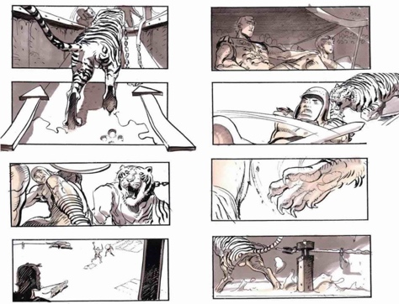*Idea One – Storyboard*

*Perhaps the best way to summarise plot developments. You can put your own spin it, for example by presenting the frames in metopes.*

*Idea Two – Memes*

*These are great for remembering key moments, quotes and relationships of characters.*

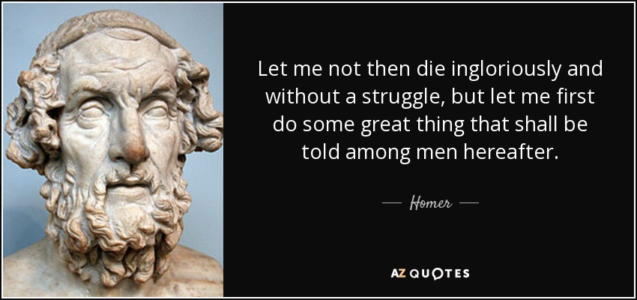*Idea Three – Classical Quote Poster*

*Select or invent a quote from your topic. You can present them as you want (maybe around the mood board), but this website (*[*https://ww**w.canva.com/*](https://www.canva.com/)*) makes them into great posters.*

*Idea Four – Merchandise*

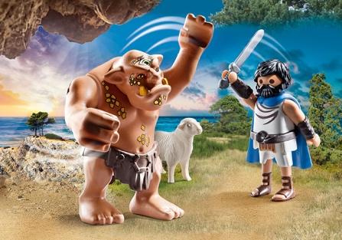

*You can create your own toy range, or maybe put some pithy quote on a mug, cap, or t shirt.*

*Idea Five – Headlines*

*You can remind yourself of some striking events using the following headline generator. Have fun adding images, dates, locations and descriptions.* [*http://www.classtools.net/breakingnews/*](http://www.classtools.net/breakingnews/)

*Idea Six –* Wordle

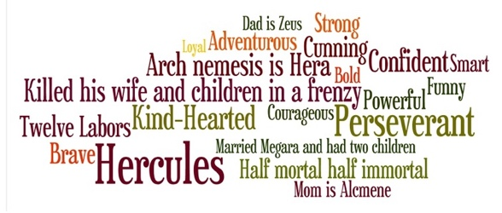You bring together the most memorable characters, terms and emotions into a strikingly visual representation with a wordle. You can get a good app on your phone to make these for free.

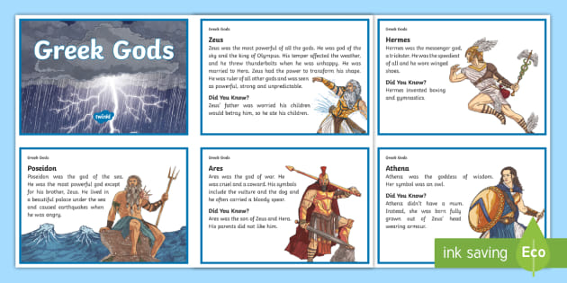*Idea Seven – Character Profiles*

*Everyone has favourite characters. But a real fan knows all about them all. You can make character profiles to show many things: best moments, great quotes, relationships with others, strengths and weaknesses, epithets, and much more.*