|  |
| --- |
| Name: _______________________________________________ |
|  |
|  |
|  |
|  |
| **Protein synthesis and mutations** |
|  |
| **Date:** |
|  |
|  |
|  |
|  |
| **Time:** 30 minutes |
|  |
| **Total marks available:** 28 |
|  |
| **Total marks achieved:** ______ |
|  |
|  |
|  |
|  |
|  |
|  |
|  |
|  |
|  |
|  |
|  |
|  |
|  |
|  |
|  |
|  |
|  |
|  |
|  |
|  |
|  |
|  |
|  |
|  |
|  |
|  |

**Questions**

**Q1.**

Enzymes, messenger RNA (mRNA) and transfer RNA (tRNA) are involved in the synthesis of proteins.

(a) The diagram below represents the structure of an enzyme.  
 Each circle represents an amino acid.

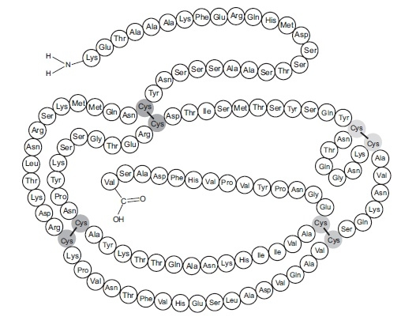

(i) An enzyme is a protein and has a primary structure.  
 Explain the meaning of the term **primary structure**

**(2)**

.............................................................................................................................................

.............................................................................................................................................

.............................................................................................................................................

.............................................................................................................................................

.............................................................................................................................................

(b) Describe the roles of messenger RNA (mRNA) and transfer RNA (tRNA) in protein synthesis.

(i) Messenger RNA

**(3)**

.............................................................................................................................................

.............................................................................................................................................

.............................................................................................................................................

.............................................................................................................................................

.............................................................................................................................................

.............................................................................................................................................

.............................................................................................................................................

.............................................................................................................................................

(ii) Transfer RNA

**(3)**

.............................................................................................................................................

.............................................................................................................................................

.............................................................................................................................................

.............................................................................................................................................

.............................................................................................................................................

.............................................................................................................................................

.............................................................................................................................................

.............................................................................................................................................

.............................................................................................................................................

.............................................................................................................................................

**(Total for question = 8 marks)**

**Q2.**

Read through the following passage on protein synthesis, then write on the dotted lines the most appropriate word or words to complete the passage.

**(6)**

Protein synthesis involves two stages. The first stage is ................................................................. and

takes place in the nucleus of the cell. During this stage, a molecule called

................................................................. is made using the antisense DNA strand as a template.

The second stage, known as ................................................................. , takes place in the cytoplasm of

the cell on structures called ................................................................. . During this stage,

................................................................. molecules enable the amino acids attached to them to line

up in the correct order. The amino acids are joined together by the formation of

................................................................. bonds.

**(Total for question = 6 marks)**

**Q3.**

Messenger RNA (mRNA) and transfer RNA (tRNA) are important nucleic acids involved in the process of protein synthesis.

(a) Describe how a molecule of mRNA is made during transcription.

**(4)**

.............................................................................................................................................

.............................................................................................................................................

.............................................................................................................................................

.............................................................................................................................................

.............................................................................................................................................

.............................................................................................................................................

.............................................................................................................................................

.............................................................................................................................................

.............................................................................................................................................

.............................................................................................................................................

(b) The diagram below represents a tRNA molecule.

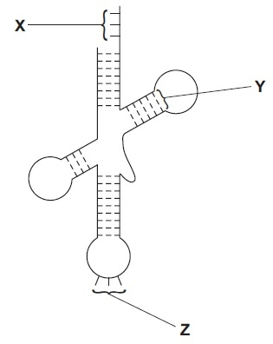

For each of the statements below, put a cross () in the box that corresponds to the correct statement.

(i) Part **X** binds to

**(1)**

   **A**   an amino acid for transcription

   **B**   an amino acid for translation

   **C**   mRNA for transcription

   **D**   mRNA for translation

(ii) Part **Y** is a

**(1)**

   **A**   glycosidic bond

   **B**   hydrogen bond

   **C**   peptide bond

   **D**   phosphodiester bond

(iii) Part **Z** binds to

**(1)**

   **A**   an amino acid during transcription

   **B**   an amino acid during translation

   **C**   mRNA during transcription

   **D**   mRNA during translation

(c) Using the information shown in the diagram, describe two ways in which the structure of a tRNA molecule differs from the structure of a mRNA molecule.

**(2)**

1

.............................................................................................................................................

.............................................................................................................................................

.............................................................................................................................................

.............................................................................................................................................

2

.............................................................................................................................................

.............................................................................................................................................

.............................................................................................................................................

.............................................................................................................................................

**(Total for question = 9 marks)**

**Q4.**

The sequence of amino acids in a polypeptide chain is determined by the sequence of bases in DNA. This sequence of bases is used as a template to synthesise messenger RNA (mRNA).

(a) Describe the structure of an amino acid.

**(2)**

.............................................................................................................................................

.............................................................................................................................................

.............................................................................................................................................

.............................................................................................................................................

(b) The table below shows the amino acids coded for by the codons on **mRNA**.

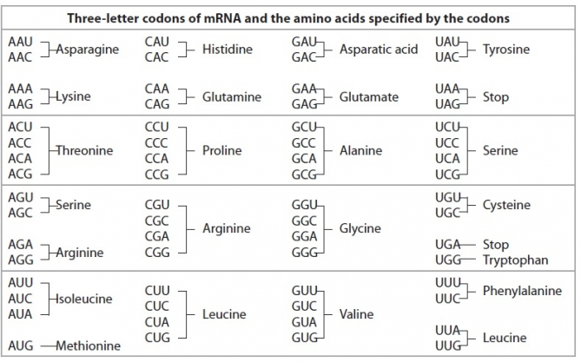

The diagram below shows part of a messenger RNA molecule.



(i) Place a cross  in the box next to the complementary sequence of bases found on the strand of the **DNA** molecule, from which part of this mRNA molecule was synthesised.

**(1)**

  **A**   G  G  T  A  A  G  C  G  C  C  T  T

  **B**   G  G  U  A  A  C  G  C  G  G  A  A

  **C**   A  A  C  G  G  A  U  A  U  U  G  G

  **D**   A  A  C  G  G  A  T  A  T  T  G  G

(ii) Place a cross  in the box next to the sequence of amino acids found in the polypeptide chain that is coded for by this part of the **mRNA** molecule.

**(1)**

  **A**   proline lysine alanine valine

  **B**   proline phenylalanine alanine valine

  **C**   glycine lysine arginine glutamine

  **D**   proline lysine alanine glutamine

(iii) Place a cross  in the box next to the final codon on this mRNA molecule if GUU is the last codon for an amino acid.

**(1)**

  **A**   AGU

  **B**   ACU

  **C**   UCA

  **D**   UGA

**(Total for question = 5 marks)**

**Examiner's Report**

Q1.

**(a) (ii)** This particular question addressed one of the few remaining specification points that we have not directly addressed yet. The mark scheme indicates exactly what we are expecting candidates to appreciate about the primary structure and its influence on the structure and therefore the functioning of a protein.

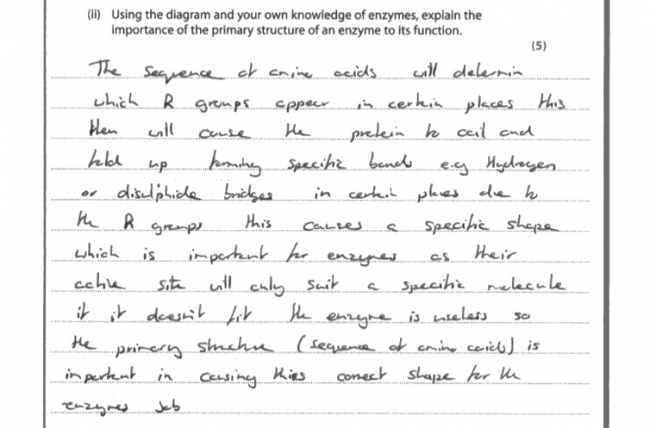

**Results Plus: Examiner Comments**

This illustrates a particularly good answer. This candidate was awarded mark points 1.2.3.5 and 6, in that order.

**Results Plus: Examiner Tip**

When referring to the structure and functioning of an enzyme, always write about the *shape* of the active site.

**(b) (i)** Question (b) parts (i) and (ii) seemed to throw candidates completely, even though we have often asked questions about transcription and translation. Candidates were not being asked to recall anything extra, but to apply their answer such that the context answered the question.

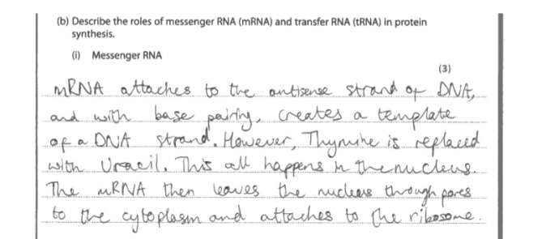

**Results Plus: Examiner Comments**

This candidate described the process of transcription and did not emphasise the role of mRNA.

**Results Plus: Examiner Tip**

Try to apply your knowledge to the question; do not simply write everything you know about a topic.

**(b) (ii)**

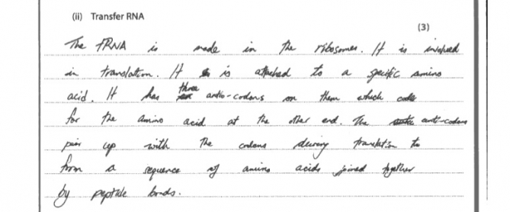

**Results Plus: Examiner Comments**

A good, clear answer.

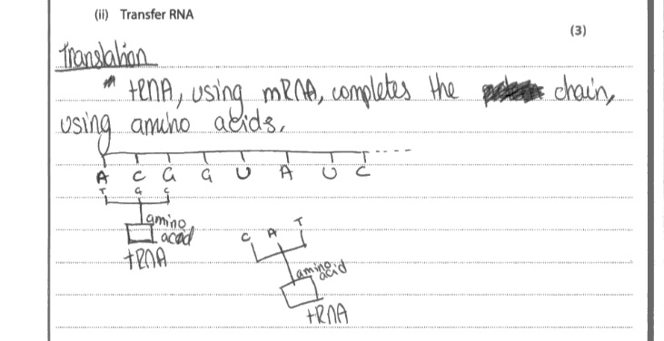

**Results Plus: Examiner Comments**

This illustrates our bottom line for accepting marks from a diagram. We did award mark point 2, although it would have been clearer if the candidate has bracketed the top part as the tRNA .

**Results Plus: Examiner Tip**

Be very cautious about trying to answer questions using diagrams, unless being specifically asked to. If you do, then make your labels very clear and accurate.

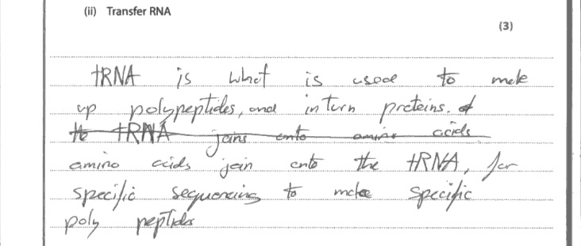

**Results Plus: Examiner Comments**

Unfortunately, although the candidate has the jist of translation, the expression is not clear enough to award any marks. The answer clearly states that more than one amino acid is attached to a tRNA molecule which is simply untrue. Mark point 2 cannot be awarded for wrong Biology.

**Results Plus: Examiner Tip**

Read through every single word of your answer to check that you have actually said what you mean.

**Q2.**

**Results Plus: Examiner Tip**

Candidates need to be as specific as they can; answers should always double checked to ensure that appropriate detail has been included.

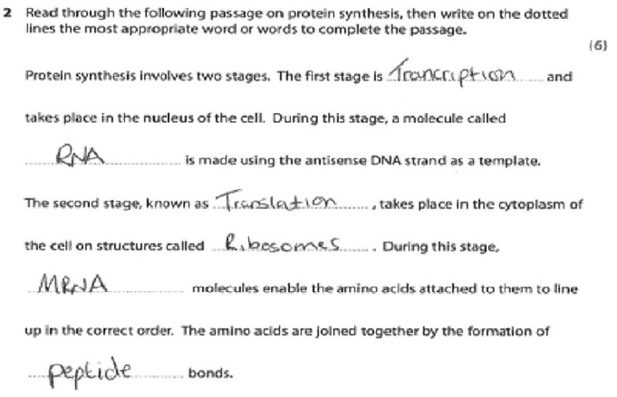

**Results Plus: Examiner Comments**

On the third line of this passage the reference to 'RNA' is too vague. Candidates are supposed to know about the roles of mRNA and tRNA and therefore this degree of specificity is expected in their answers.

**Q3.**

**(a)**  There were a good number of excellent responses from candidates describing the process in detail with correct reference to the specific enzymes and bonds involved. The majority of candidates recognised the need for the DNA double helix to be unwound and that complementary base pairing is involved in the formation of an mRNA molecule.

A significant number of candidates describe the mRNA molecule lining up by complementary base pairing as though it has already been made before transcription starts, or that nucleotides pair up with base pairs. Some candidates are confused about the enzymes involved and many referred to DNA polymerase. Other candidates named peptide bonds joining the nucleotides or strands together.

Only the better accounts clearly recognised that phosphodiester bonds are made via condensation reactions.

Few candidates recognised that mRNA needs to split from the DNA at the end of transcription, although many went onto describe the mRNA leaving the nucleus and the process of protein synthesis which was not relevant to the question asked.

This response gains all four marks available.

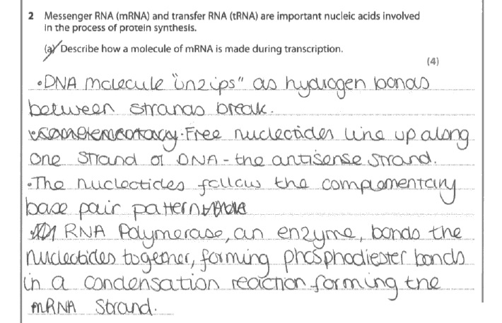

**Results Plus: Examiner Comments**

This response gains credit for: - the DNA strands separating; - free nucleotides lining up against the antisense DNA strand; - complementary base pairing; - the reference to the named enzyme RNA polymerase; - phosphodiester bonds forming; - by condensation reactions.

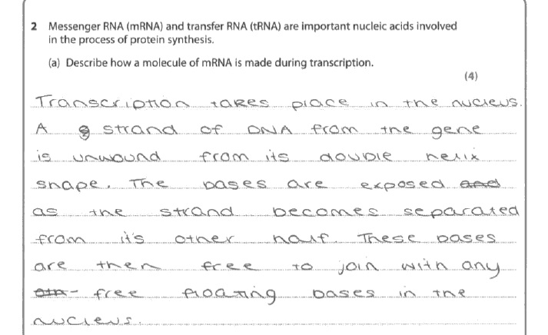

**Results Plus: Examiner Comments**

This response just gains one of the four marks available for the DNA unwinding. The rest is not specific enough for credit.

**Results Plus: Examiner Tip**

When asked to describe a process worth multiple marks aim to make at least as many clear separate points to the number of marks available.

**(c)**  Q(b) The majority of candidates recognised that it was hydrogen bonds holding the shape of the tRNA molecule together, although a significant number got the amino acid binding site and anticodon confused, together with transcription and translation.

Q(c) A number of candidates did not read the question properly and described differences in function rather than structure. Many said that tRNA carried amino acids or that there was an amino acid on the tRNA, without reference to the binding site. Some answers referred to tRNA being double stranded rather than having double stranded sections and a number of candidates referred to tRNA being branched. However, there were some really good, clear answers and the better candidates tended to score more points than needed for a maximum mark of 2. Few candidates recognised that tRNA has a fixed size compared to the variable size of mRNA.

A few candidates thought that a tRNA molecule has anticodon**s** and several candidates thought that tRNA only has three bases in its structure.

This response gains all four marks available.

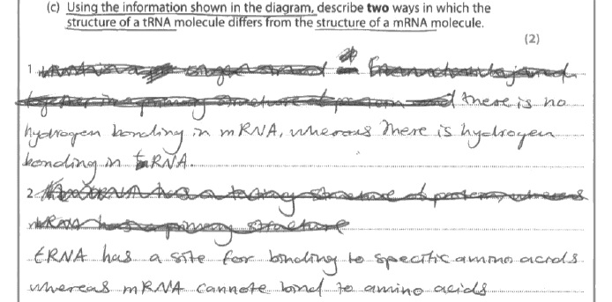

**Results Plus: Examiner Comments**

This is a typical example of a response that gained both marks available for identifying clear differences between tRNA and mRNA.

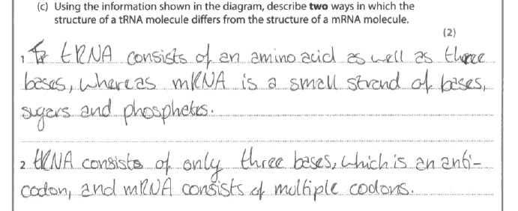

**Results Plus: Examiner Comments**

This is an example of a response that did not gain any marks. tRNA does not consist of an amino acid and only three bases. Candidates are asked to use the information on the diagram and tRNA may be a fixed size but it is certainly bigger than just 3 bases.

**Results Plus: Examiner Tip**

When asked to use the information shown in the diagram make sure you look at the diagram carefully and check that your answer makes sense by comparing it back to the diagram.

**Q4.**

**(a)** Candidates predominantly scored either zero or two marks for this question, depending on the description being of a mononucleotide or of an amino acid.

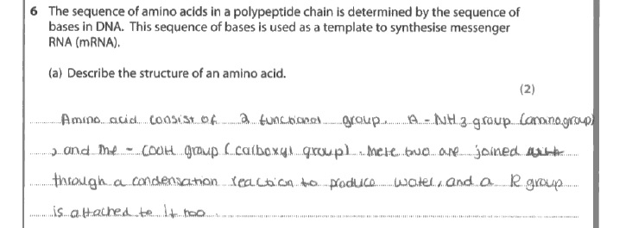

**Results Plus: Examiner Comments**

This response was awarded 2 marks for the reference to the carboxyl group and to the R group. If candidates are going to use chemical formulae, they must be correct.

**Results Plus: Examiner Tip**

Unless specifically asked, it is safer to write out the name of a chemical as opposed to writing out its formula. If the formula is used then it must be correct, including any negative or positive charge it may have.

**(b)** Many good responses, scoring max four marks were seen; candidates are clearly being prepared for the exam using previous mark schemes. There were still some common errors seen from the weaker students.

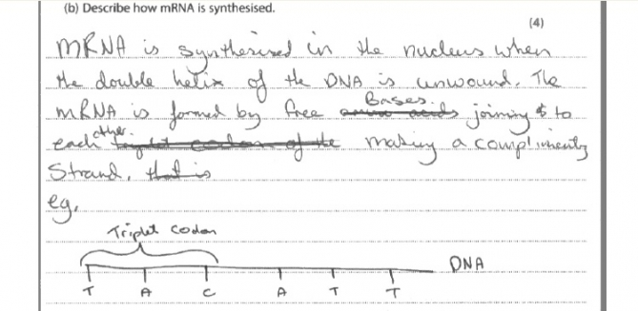

**Results Plus: Examiner Comments**

One common error is seen in this response. Instead of refering to mononucleotides, the candidate has stated that the bases join to each other.

**Results Plus: Examiner Tip**

For questions that frequently come up, such as transcription and translation, use previous mark schemes to learn the correct terminology.

There are candidates that lose marks by not being sufficiently precise in their answer.

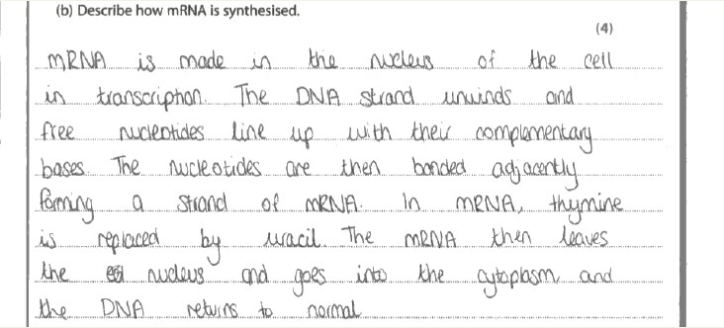

**Results Plus: Examiner Comments**

In this response the candidate clearly understands the process and has scored three marks. However they have not been precise enough in stating where the nucleotides line up and what their bases are complementary to.

**Results Plus: Examiner Tip**

Make sure in your answers involving DNA and mRNA synthesis that it is very clear that mononucleotides line up against the existing DNA strand and that the bases on the nucleotides bind to their complementary bases on the DNA. You must use the term 'complementary' in your response and not just give an example.

**Mark Scheme**

Q1.

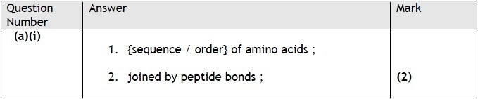

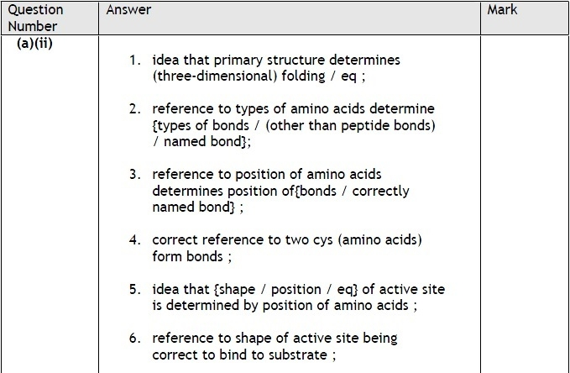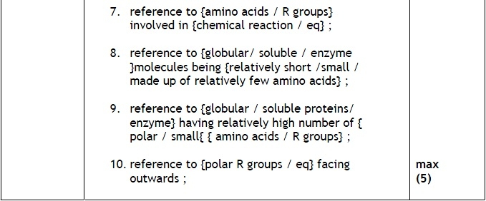

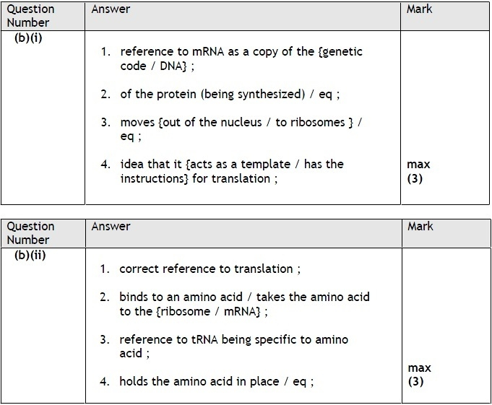

**Q2.**

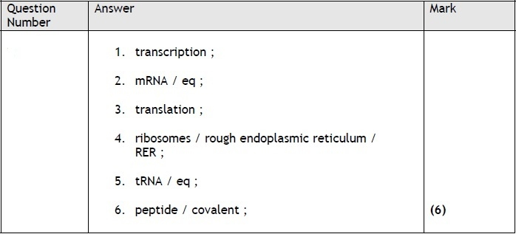

**Q3.**

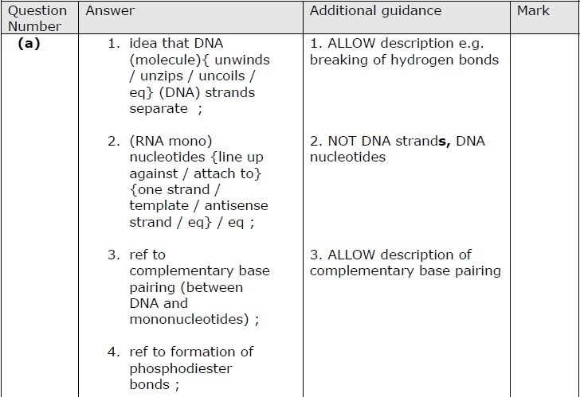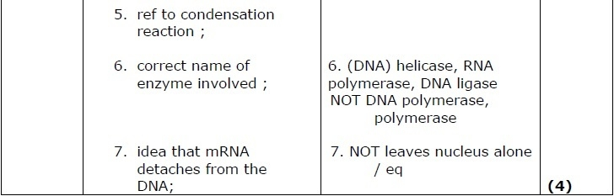

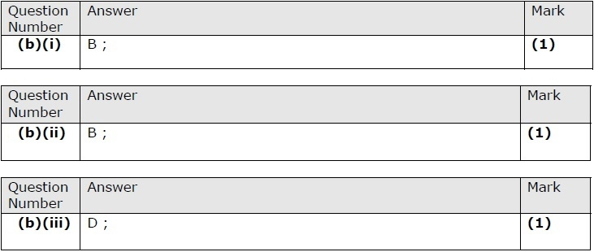

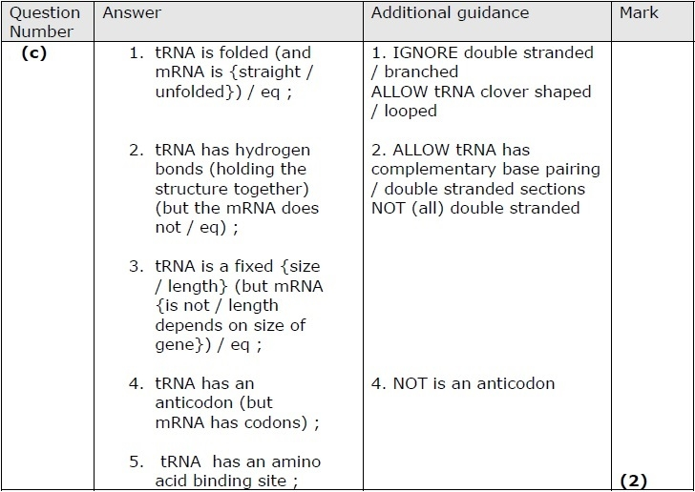

**Q4.**

