Year 2 Sociology

**Paper 3: Crime and Deviance with Theory & Methods**



Booklet 3: Marxist explanations of crime and class, power and crime.

Name ­­ ______________________________

Specification Content:

What you need to know for **Crime and Deviance**  in your Paper 3 exam.

Students are expected to be familiar with sociological explanations of the following content:

* crime, deviance, social order and social control
* the social distribution of crime and deviance by ethnicity, gender and social class, including recent patterns and trends in crime
* globalisation and crime in contemporary society; the media and crime; green crime; human rights and state crimes
* crime control, surveillance, prevention and punishment, victims, and the role of the criminal justice system and other agencies.

|  |  |  |  |  |  |
| --- | --- | --- | --- | --- | --- |
| **Questions may be based specifically on the following areas:** | | Do I have completed Notes? | Have I made revision Notes? | Have I memorised this info? | Have I practised exam style questions? |
| **Different explanations for class differences in crime** | Functionalism, |  |  |  |  |
| Strain theory |  |  |  |  |
| Subcultural theories |  |  |  |  |
| Labelling theory |  |  |  |  |
| **Marxist explanations of crime.** | Crimogenic Capitalism, law making, ideological functions of crime. |  |  |  |  |
| Box – corporate crime  Chambliss and Snider – state and law making  Pearce |  |  |  |  |
| Evaluation of Marxism |  |  |  |  |
| **Neo-Marxist explanations of crime.** | Taylor, Walton and Young critical criminology. |  |  |  |  |
| **Crimes of the powerful** | White collar crime |  |  |  |  |
|  | Selective law enforcement |  |  |  |  |
| **Victims** | Patterns of victimisation in relation to crime. Positivist and critical victimology |  |  |  |  |

Exam Structure:

|  |
| --- |
| **These topics will appear in paper 3 of the A’Level.** 2 hour written exam 80 marks in total (50 for this bit)   * 33.3% of A-level Crime and Deviance: short answer and extended writing, 50 marks (4 marks, 6 marks, 10 marks, 30 marks) |

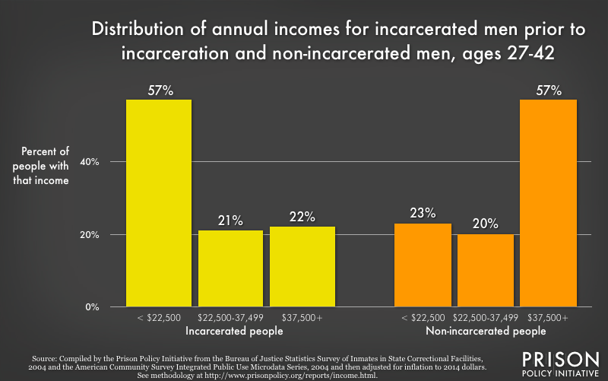

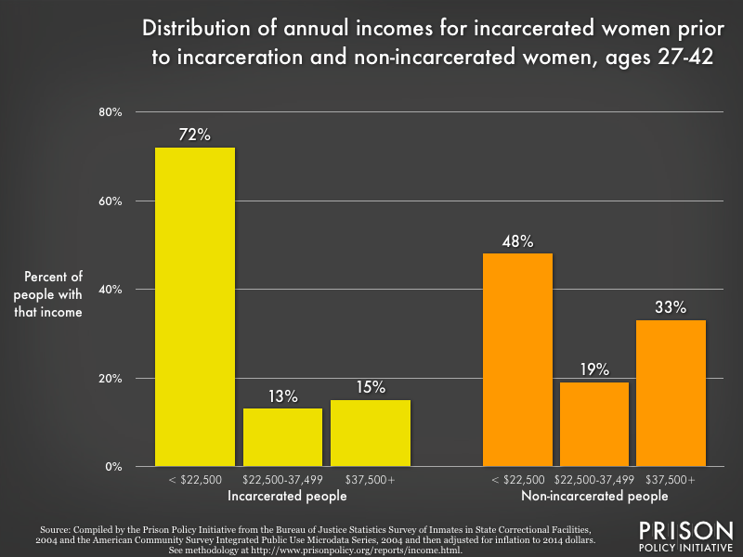

What do you notice? How would you explain this?



What do you notice? How would you explain this?

Possible explanations for class differences in crime……..

What can we remember? Use textbook p 87 – to remind you. Pictures and words for each please.

|  |
| --- |
| Functionalism |
| Strain theory |
| Subcultural theories |
| Labelling |

# What do Marxist think?

Marxist criminologists see power being held by the **Bourgeoisie** and laws are a reflection of **Bourgeois ideology**. The legal system (lawyers, judges and the courts) and the police all serve the interests of the Bourgeoisie. These institutions are used to control the **masses**, prevent **revolution** and keep people in a state of **false consciousness.**

Define the words which are in bold to make sure you understand the paragraph above

Marxist perspective on crime may be summarised into **four** key points:

1. **Capitalism is Crimogenic**
2. **The Law is made by the Capitalist elite**  .
3. **Selective enforcement.**
4. **Ideological functions of Law Enforcement** – The Criminal Justice system mainly concerns itself with policing and punishing the marginalised, not the wealthy, and this performs ideological functions for the elite classes.

*Key Sociologists associated with this perspective are William Chambliss (1978) and Laureen Snider (1993). Examples of more contemporary theorists include Professors Tombs and Whyte (See later).*

[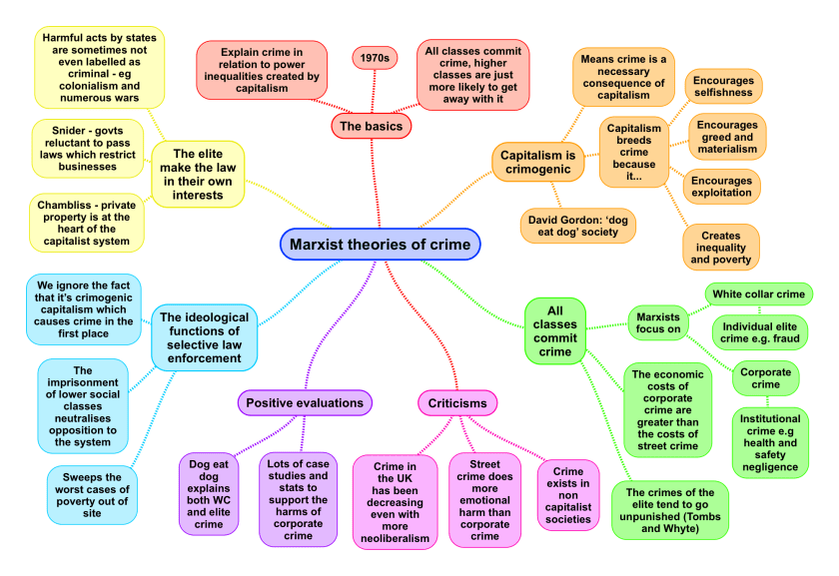](https://sellfy.com/p/juqd/)

# Capitalism is Crimogenic

Define crimogenic

The Capitalist system can be said to be crimogenic in three major ways –

1. Capitalism encourages individuals to look after themselves not others or society.
2. Capitalism encourages individuals to be greedy for money and want a lifestyle they cannot afford.
3. Capitalism created massive inequality and poverty, conditions which are matched with higher crime rates.

Explain how these 3 ways may cause crime

1

2

3

***The first reason that Capitalism is Crimogenic is because it encourages individuals to look after themselves and not society.***

Marxist Sociologist David Gordon says that Capitalist societies are ‘dog eat dog societies’ in which each individual company and each individual is encouraged to look out for their own interests before the interests of others, before the interests of the community, and before the protection of the environment.

Marxists point out that in a Capitalist society, there is competitive pressure to make more money, to be more successful, and to make more profit, because in a competitive system, this is the only way to ensure survival. Breaking the law can seem insignificant compared to the pressure to succeed and pressures to break the law affect all people: from the investment banker to the unemployed gang member.

***Secondly, Capitalism is Crimogenic because it encourages us to want things we don’t need and can’t afford.***

Advertising does not only provide us with information about a product, what is it really trying to do?_____________________________________________________________________________________________________________________________________________________________________________

* The world of advertising presents as normal a lifestyle what may be unattainable for many people in British Society.
* Advertising creates the conditions that can lead to status frustration, which in turn can lead to crime.

Merton and Nightingale have pointed out that for some the desire to achieve the success goals of society outweigh the pressure to obey the law, advertising only adds to this strain between the legitimate means and the goal of material success.

***Thirdly, Capitalism is Crimogenic because it creates inequality and poverty***

Marxists argue that this visible evidence of massive inequalities give people at the bottom a sense of injustice, a sense of anger and a sense of frustration that they are not sharing in the wealth being flaunted in front of them. As a result, Capitalism leads to a flourishing of economic crime as well as violent street crime.

William Chambliss even goes so far as to say that economic crime ‘’represents rational responses to the competitiveness and inequality of life in capitalist societies”. As we have seen from previous studies. Drug dealers see themselves as innovative entrepreneurs. So internalised is the desire to be successful that breaking the law is seen as a minor risk.

*Does Capitalism cause crime?*

# The Law is made by the Capitalist elite and tends to work in their interests.

**Evidence for this can be found in the following:**

* **Property rights are much more securely established in law than the collective rights of, for instance, trade unions**. Property law clearly benefits the wealthy more than those with no property. William Chambliss has argued that ‘at the heart of the Capitalist system lies the protection of Private Property’. Consider the fact that there are roughly 100, 000 people recognised as homeless in the United Kingdom[1](https://revisesociology.com/2016/06/04/marxist-theory-crime/#sdfootnote1sym), and 300, 000 houses lying empty[2](https://revisesociology.com/2016/06/04/marxist-theory-crime/#sdfootnote2sym). The rights of the property owners to keep their properties empty are put before the rights of the needy to shelter.

He also says thatwhen English law was taken to East African colonies Britain prioritised the production of tea & coffee which needed a lot of local labour. Britain forced the local population to work by making them pay a tax in cash which they had to work to earn. Money was not used in their society and could only be earned by working on tea and coffee plantations.

* Laureen Snider (1993) argues that **Capitalist states will not pass laws that regulate activities of businesses.**

A further recent example which could be used to support this is the deregulation of financial markets prior to the financial crisis of 2008 and subsequent ‘credit crunch’ and economic recession. The activities of the vast majority of bankers and financiers were not seen as illegal and, far from being prosecuted, many grew rich through the payments of large bonuses.

* **People have unequal access to the law**. For Marxists, punishment for a crime may depend and vary according to the social class of the perpetrator. Poorer criminals tend to receive harsher punishments than rich criminals. Rich criminals can afford better lawyers.

# Selective enforcement. All classes, not just the working classes commit crime, and the crimes of the Capitalist class are more costly than street crime.

What is white collar crime? Examples?

Marxists argue that although they are hidden from view, the crimes of the elite are worse for society than the crimes of the ‘ordinary people’. Laureen Snider (1993) points out that the cost of White Collar Crime and Corporate Crime to the economy far outweighs the cost of street crime by ‘typical’ criminals.

**Key Concepts**



|  |
| --- |
| **White Collar Crime:** Crimes committed in the furtherance of an individual’s own interests, often against the corporations of organisations within which they work.  **Corporate Crime:** Those crimes committed by or for corporations or businesses which act to further their interests and have a serious physical or economic impact on employees, consumers and the general public. The drive is usually the desire to increase profits. |

**Research about white collar crime. Use pages 494 – 499 of Browne and create a mind map. Include examples of corporate crime, reasons why these crimes are under-represented in statistics and explanations for white collar and corporate crime.**

**Modern day examples of crimes of the powerful (research task).**

** **

|  |  |
| --- | --- |
| Harvey Weinstein |  |
| Nadhim Zahawi |  |
| Boris Johnson |  |
| Prince Andrew |  |
| Jeffrey Epstein |  |

***Are crimes of the rich more harmful to society than (working class) violent crime?***

**Pearce** (1976) argued that even laws that appeared to help workers really helped the bourgeoisie. His focus was on health and safety laws which provided the ruling class with a healthy workforce. Looked at why there were so few prosecutions of corporate crimes, he found that if there were more it would undermine the wrong assumption that most crime is committed by the working classes. If the true extent of their crimes were known to the public it would undermine the legitimacy of the ruling classes.

## Differential Association Theory

Sutherland’s (1939) differential association theory is an influential explanation of how individuals learn to become offenders. According to Sutherland, if individual experiences repeated attitudes that are positively associated with crime, rather than negatively (in terms of punishment), then they are more likely to engage in criminal behaviour. The way in which a person becomes an offender is through learned attitudes and imitation of criminal acts. The theory is described as ‘differential association’ as criminal behaviour can be learned from many different avenues of interactions and experiences, which might be family, peers or the media. Aggressive management cultures in business circles may generate a climate favourable for corporate crime, driven by loyalty to the firm.

# Ideological functions of Law Enforcement

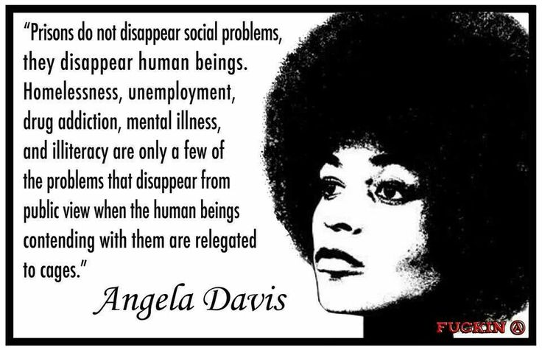

**What does ‘ideology’ mean?**

**Where have we met this before?**

**Some laws are passed which look like the help the working class** eg health and safety laws. BUT these laws actually benefit the ruling class by making them look caring. These laws are not properly enforced. Also the state enforces law selectively so that crime appear to be working class phenomenon. So criminals are blamed for problems not capitalists. Box says that there is a ‘mystification’ created by capitalism (like a story). It has spread the idea that corporate crime is less widespread of harmful than working class crime. Box argues that what is identified as serious crime is ideologically constructed. Serious crimes is identified as property crime and violence, rather than major hard caused by corporations such as environmental damage, or by governments eg human rights violations. Laws can appear to benefit everyone and the ruling class may be occasionally prosecuted. This can have a manipulative effect of providing a smoke screen so that people believe that the law is impartial and even-handed and that ruling class offenders are properly handled when in fact this is not the case.

Evaluation of Marxism (see p 89)

 

|  |  |
| --- | --- |
|  |  |

Neo-Marxism: critical criminology

Theorists you must know are…..Taylor, Walton and Young

What is a Neo – Marxist? Who else do we know and where did we meet them?

Taylor, Walton and Young wrote a book called **The New Criminology (1973)**

They agreed that capitalist society is based on exploitation and class conflict. If we understand this we can understand crime. The agree that the state makes laws that help the capitalist class. They agree that capitalism should be replaced by a classless society BUT they also critique Marxism and they call their approach **critical criminology.**

1. **They think Marxism is too deterministic.** Marxist think workers commit crime because it is necessary for them to get money. BUT T, W and Y think there are many other factors (anomie, subcultures, biological or psychological factors.

**They think we have FREE WILL – crime is a conscious choice. Criminals are not passive puppets.**

**They suggest a fully social theory of deviance**. This combines Marxist theories and ideals from interactionism and labelling theory.

There are 6 parts to this theory of deviance.

|  |
| --- |
| Wider origins |
| Immediate origins |
| The act |
| The immediate origins of society’s reaction |
| Wider origins of society’s reaction |
| Effects of labelling |

Evaluation of **Critical Criminology.**

 

|  |  |
| --- | --- |
|  |  |

Victims

Social class and victimisation

The poorest sections of the working class are the most likely to be victims of crime. The highest rates of victimization are among the

* ‘hard-pressed’ – unemployed, long-term sick and those in rented accommodation.
* In areas of high physical disorder where there is vandalism, graffiti etc
* In areas with high levels of deprivation.

Why is this demographic more likely to be victims?

Positivist victimology

Is there something in the characteristics and circumstances of victims which makes them different from non-victims?

Radical victimology

This is closer to conflict theories. It focusses on how wider social issues and circumstances produce victims. Social deprivation means the weakest and most deprived areas of society are most likely to be victims.

Eye on the exam

**Question Type 1: Outline TWO…….. –4 marks**

Two marks for each of two appropriate ways clearly outlined or one mark for appropriate ways partially outlined.

1. Outline two differences between the Marxist and functionalist theories of crime.
2. Outline two differences between traditional Marxist theories of crime and new criminology.

**Question Type 2: Outline and explain THREE –6 marks**

Two marks for each of three appropriate reasons clearly outlined or one mark for appropriate reasons partially outlined

1. Outline three reasons why white-collar crime may be less likely than working class to be reported to the police.
2. Outline 3 reasons why white-collar and corporate crime may have low rates of prosecution.
3. Outline three reasons why Marxists see capitalism is criminogenic.

10 mark

**Item A17**

*White Collar crime that is committed by middle class individuals who abuse their work positions for personal gain, at the expense of the employers, the government or clients. Many white-collar crimes remain undetected, unreported and unrecorded in criminal statistics, or even managed to escape altogether from being labelled as Criminal acts.*

Applying material from item A17, analyse two reasons why white-collar crime may be less likely to be reported to the police than crimes committed by working class people (10)

30 Marker

**Item B1**

*Some Marxist sociologists argue that crime and deviance are caused by the way in which the capitalist system encourages greed and selfishness amongst all members of society, thereby causing criminality in all social classes. They also argue that the law and criminal justice are biased against those from lower classes, ensuring that the actions of the rich are not defined as Criminal, where as the crimes of the lower classes are often treated as Criminal.*

Applying material from item B1 and your own knowledge, evaluate the usefulness of Marxist approaches in understanding crime and deviance. (30)